Full Stack Engineering

Project Report

Semester-VI (Batch-2022)

**Task Manager**



**Supervised By: Submitted By:**

Rahul Sir Kumar Kundan-2210991822 (G-24)

Koustav Manna-2210991807 (G-24)

## Department of Computer Science and Engineering Chitkara University Institute of Engineering & Technology, Chitkara University, Punjab

**ABSTRACT**

In today’s fast-paced world, efficient task management is crucial for individuals and organizations seeking to optimize productivity. A **Task Manager** is a software solution designed to facilitate the organization, tracking, and completion of tasks through structured workflows. It provides a centralized platform where users can create, assign, categorize, and monitor tasks based on priority, deadlines, and dependencies, ensuring a streamlined workflow.

A task manager enables users to break down work into manageable components, set goals, track progress, and maintain accountability. Tasks can be assigned to specific team members, with deadlines and real-time tracking ensuring timely completion. Advanced features like notifications, reminders, file attachments, and real-time collaboration enhance efficiency. Many task management tools leverage cloud technology for accessibility across multiple devices, supporting remote work.

One of the most significant advantages of a task manager is its ability to prioritize tasks, helping users focus on critical activities and avoid work overload. Automation and task dependencies ensure tasks are completed in the correct sequence.

Collaboration is a key feature of modern task managers, allowing multiple users to work on shared projects, track progress, and communicate seamlessly. Integration with calendar apps, communication platforms, and project management software further enhances efficiency.

Task managers are widely used across industries such as software development, healthcare, education, and marketing. They also serve personal productivity needs, helping individuals organize their daily tasks and goals.

Despite challenges like user resistance and data security concerns, task managers continue to evolve with AI and automation, making them more intuitive. By leveraging a task manager, individuals and organizations can enhance productivity, meet deadlines, and achieve their goals efficiently.

.

# Table of Content

1. Abstract/Keywords
2. Introduction to the project
   1. Background
   2. Problem Statement
3. Problem Definition and Requirements
   1. Methods
   2. Programming/Working Environment
   3. Requirements to run the application
4. Proposed Design / Methodology
5. Results

# Introduction

A **Project Task Manager** is a full-stack application designed to streamline task organization, tracking, and collaboration. It integrates a frontend built with frameworks like React or Angular for a user-friendly interface and a backend using technologies such as Node.js or Django for data management and automation. Features include task prioritization, deadline tracking, and real-time updates. Integration with tools like Slack and Google Calendar enhances productivity. Security measures like authentication and encrypted storage ensure data protection. By implementing a full-stack task manager, organizations improve workflow efficiency, enhance team collaboration, and ensure timely project execution.

# Background and Significance

Task management applications have become essential tools for individuals and businesses to enhance productivity, streamline workflows, and manage deadlines effectively. Traditional task management relied on manual methods such as paper planners and spreadsheets, but with the rise of digital transformation, modern task managers have evolved into robust web and mobile applications.

The importance of **full-stack development** in task manager applications can be understood through several key aspects:

* + **Seamless User Experience** – A full-stack approach ensures smooth integration between the frontend and backend, providing an intuitive and responsive interface for users.
  + **Scalability** – As businesses and teams grow, the task manager must handle increased users, tasks, and concurrent operations without performance degradation. Full-stack development allows for scalability by implementing **microservices, caching, and efficient database queries**.
  + **Security and Authentication** – A task manager often deals with sensitive data such as project details, deadlines, and team responsibilities. Full-stack development ensures robust security through **JWT (JSON Web Tokens), OAuth, role-based access control (RBAC), and encryption techniques**.
  + **Efficient Data Management** – A well-structured database ensures **fast retrieval, indexing, and backup of task-related data**, preventing data loss and enhancing performance.

1. **Objectives**
2. **Develop an Intuitive and Responsive User Interface (UI)**

* Design a **clean, modern, and user-friendly** interface for easy task creation, editing, and organization.
* Ensure **mobile responsiveness** for seamless use on desktops, tablets, and smartphones.
* Implement **drag-and-drop functionality**, task categorization, and color-coded priority levels.

1. **Build a Robust Backend for Task Management**

* Develop a **secure and scalable backend** to handle user requests, data storage, and processing.
* Implement **RESTful or GraphQL APIs** for efficient data communication.
* Ensure **fast response times and low latency** using optimized queries and caching mechanisms.

1. **Enable User Authentication and Authorization**

* Implement **secure login mechanisms** using JWT, OAuth, or session-based authentication.
* Ensure **role-based access control (RBAC)** to differentiate between admin, team members, and guests.
* Protect user data with **encryption, secure API endpoints, and authentication best practices**.

1. **Implement Real-Time Features**

* Enable **real-time task updates and notifications** using WebSockets or Firebase.
* Provide **live collaboration** features such as shared tasks, comments, and activity logs.
* Integrate **email, push, and in-app notifications** for task reminders and deadlines.

1. **Ensure Efficient Data Management and Storage**

* Use a **structured database (PostgreSQL, MySQL) or NoSQL database (MongoDB, Firebase)** to store tasks, deadlines, and user data.
* Optimize data retrieval with **indexing and query optimization** for fast performance.
* Implement **automatic backups** to prevent data loss.

1. **Provide Task Automation and Smart Features**

* Implement **recurring task scheduling** and deadline reminders.
* Use **AI-driven recommendations** for task prioritization and workflow optimization.
* Enable **task dependencies and subtasks** for structured project management.

1. **Ensure Cross-Platform Accessibility**

* Develop a **progressive web app (PWA)** for seamless access across devices.
* Support integration with **mobile frameworks (React Native, Flutter) for native-like mobile experience**.
* Ensure **browser compatibility** and performance optimization for various screen sizes.

1. **Enable Third-Party Integrations**

* Connect with external productivity tools like **Google Calendar, Slack, Trello, and Microsoft Teams**.
* Provide **API support** for businesses to integrate the task manager into their workflow.
* Implement **cloud storage integrations** (Google Drive, Dropbox) for file attachments.

**9. Ensure Scalability and Performance Optimization**

* Use **microservices architecture** (if needed) for better scalability.
* Optimize backend processes to handle **high user loads** and concurrent operations.
* Implement **load balancing and caching** techniques to improve response times.

## Features and Functionality

* + **User Registration & Login - Secure sign-up and login via email/password, OAuth (Google, GitHub, etc.), or social login.**
  + **Two-Factor Authentication (2FA)** – Extra security layer for user accounts.
  + **Role-Based Access Control (RBAC)** – Define user roles such as admin, manager, and team member.
  + **Password Recovery & Reset** – Secure password reset functionality via email or OTP.
  + **Task Creation & Editing** – Users can create, edit, and delete tasks with details like deadlines and priorities.
  + **Task Categories & Labels** – Organize tasks using categories, tags, or color-coded labels.
  + **Task Priority Levels** – Set priority levels (Low, Medium, High, Urgent) to manage workflow.
  + **Subtasks & Dependencies** – Break down large tasks into subtasks and set task dependencies.
  + **Comments & Discussions** – Enable in-task conversations for team communication.
  + **Activity Logs & History** – Track task changes, updates, and user actions.
  + **Desktop Notifications** – Optional browser-based alerts for web users.
  + **Task Creation & Editing – Users can create, edit, and delete tasks with details like deadlines and priorities.**
  + **Calendar Integration** – Sync with Google Calendar, Outlook, or Apple Calendar.
  + **Project Management Tools** – Connect with Trello, Asana, or Jira for enhanced workflow.
  + **Cloud Storage** – Attach files from Google Drive, Dropbox, or OneDrive.
  + **Communication Tools** – Integrate with Slack, Microsoft Teams, or Discord for notifications.
  + **Web Application** – Accessible via browsers with a responsive UI.
  + **Real-Time Data Sync** – WebSockets, Firebase, or GraphQL for instant updates.
  + **Database Optimization** – Fast queries using indexing, caching, and pagination.
  + **Export Data** – Generate reports in PDF, CSV, or Excel format.
  + **Due Dates & Reminders** – Set deadlines and receive notifications for upcoming tasks.
  + **Task Assignment** – Assign tasks to team members and track their progress.
  + **Shared Workspaces** – Create shared project spaces for teams with collaborative task management.

## Technology Stack

To ensure high performance, scalability, and security, Task Manager is developed using the MERN (MongoDB, Express.js, React.js, Node.js) stack:

Frontend: React.js (for a dynamic and responsive UI)

Backend: Node.js and Express.js (for API and business logic handling)

Database: MongoDB (for storing user data, messages, and resources)

AI Integration: Machine learning-based chatbot for virtual assistance

Authentication: JWT (JSON Web Tokens) for secure login and user sessions

Hosting & Deployment: Cloud-based servers for global accessibility.

# Problem Definition and Requirements

## Problem Statement:

There is a need for a **scalable, feature-rich, and intelligent full-stack task management application** that enables users to **create, assign, track, and automate tasks efficiently**, while ensuring **seamless collaboration, real-time updates, and data security**. The solution should integrate with third-party tools, provide **intelligent task recommendations**, and be accessible across multiple platforms to enhance productivity for both individuals and teams.

## Software & Hardware Requirements:

Frontend: React.js (for dynamic UI, responsive design, and optimized performance)

Backend: Node.js, Express.js (handling API requests, authentication, and real-time messaging)

Database: MongoDB (storing user data, chat logs, wellness resources, and system logs)

Security: JWT, bcrypt.js (user authentication and encryption for privacy protection)

Cloud Services: AWS/Firebase (scalability, hosting, real-time updates, and secure cloud storage)

Hardware: Server with a minimum 8GB RAM, SSD storage, and cloud deployment capability to handle high user loads and concurrency.

**Proposed Design / Methodology**

## System Architecture:

Task Manager follows a MERN stack architecture, ensuring scalability and efficient user interactions. The platform consists of:

**Frontend:** Built with React.js, utilizing reusable components, modular design, and state management with Redux for seamless performance. The UI is designed to be minimalistic and distraction-free, ensuring a user-friendly and engaging experience.

**Backend:** Node.js with Express.js, handling authentication, database queries, and API responses with optimized routing and middleware processing. The backend ensures secure and efficient data handling, supporting high-volume concurrent requests.

**Database**: MongoDB, structured for efficient retrieval, high availability, and scalable NoSQL architecture to handle diverse user data. The database is optimized with indexing, caching, and partitioning strategies to enhance performance.

**AI-Powered Modules**: Incorporating machine learning for mood prediction, content personalization, and sentiment analysis. These modules enhance user engagement by dynamically suggesting resources and tracking emotional progress.

## File Structure:

**Frontend**: Organized into Components, Pages, Redux Store, Styles, Utility Functions, and API Services.

**Backend**: Modular structure including Controllers, Routes, Models, Middleware, Services, and Configurations.

**Database Models**: Efficiently structured models for storing User Profiles, Chat Messages, Resource Libraries, Feedback, Analytics, and Session Logs.

## Algorithms Used:

**AI-based Recommendation Engine**: Suggests mental health resources, guided sessions, and expert advice based on user preferences and interactions. This engine is trained on user behaviour data, sentiment analysis results, and historical engagement patterns.

**Real-time Chat System**: Uses Web Sockets for instant messaging, ensuring encrypted and private conversations. The chat system supports multimedia messages, voice notes, and emergency contact features.

**Sentiment Analysis Model:** Uses Natural Language Processing (NLP) to analyses user emotions and provide appropriate recommendations. The model detects mood fluctuations and adjusts content delivery to enhance user support.

**Machine Learning-based Mood Tracker**: Predicts mood patterns based on historical data and user interactions. It employs time-series analysis to monitor emotional changes and suggest relevant coping strategies.

**Anomaly Detection System**: Identifies signs of distress or crisis based on user interaction patterns and triggers alerts for immediate intervention.

**Personalized Learning Model**: Adapts user content recommendations based on feedback, engagement levels, and preferences, ensuring a tailored support experience.

**Results**

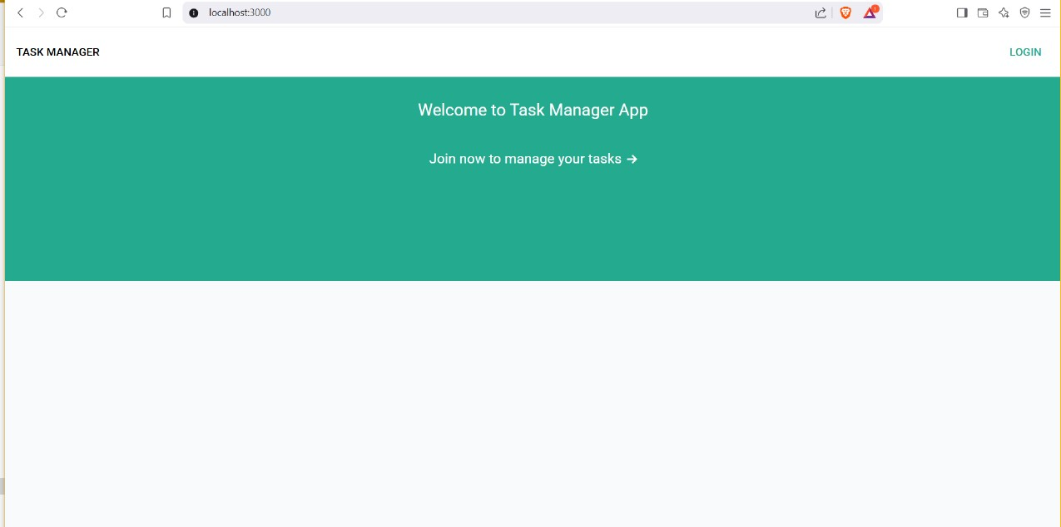

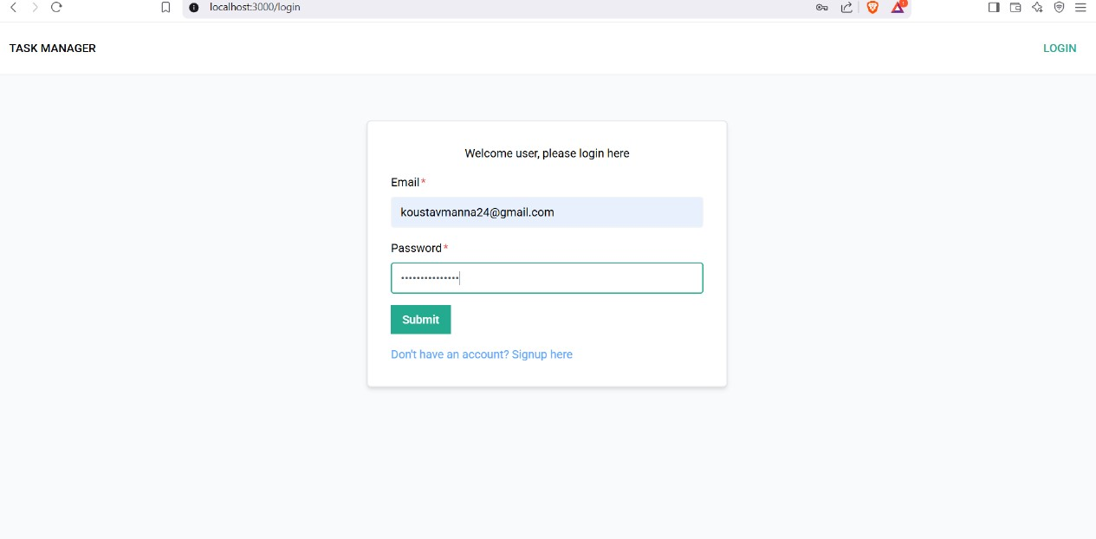

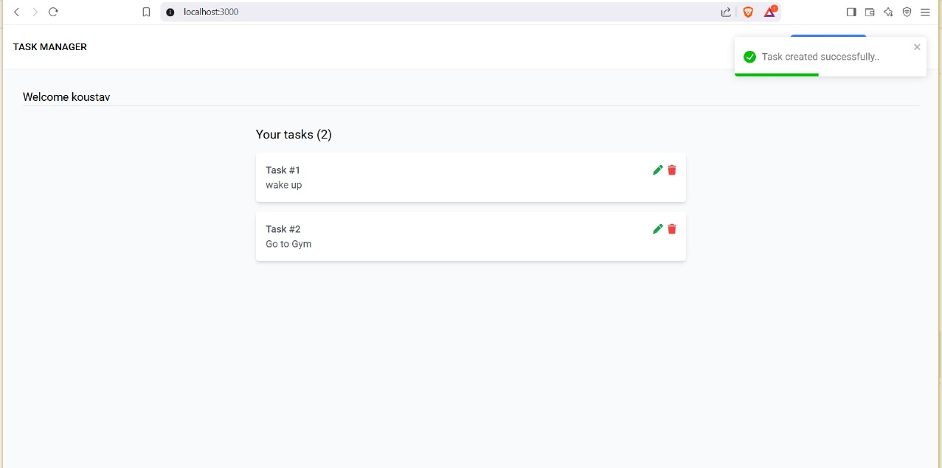

# References:

**Official Documentation**: Documentation for libraries, frameworks, and tools used in the project, as well as APIs or services integrated.

**Tutorials and Guides**: Online tutorials, guides, blog posts, and educational videos that provided assistance or insights during development.

**Code Repositories**: GitHub repositories or other code repositories where code snippets, examples, or inspiration were found.

**Forums and Communities**: Online forums, such as Stack Overfow or Reddit, and developer communities where questions were asked, advice was sought, or discussions were participated in.

**Personal Communication**: Mentors, peers who provided guidance, feedback, or support during development.