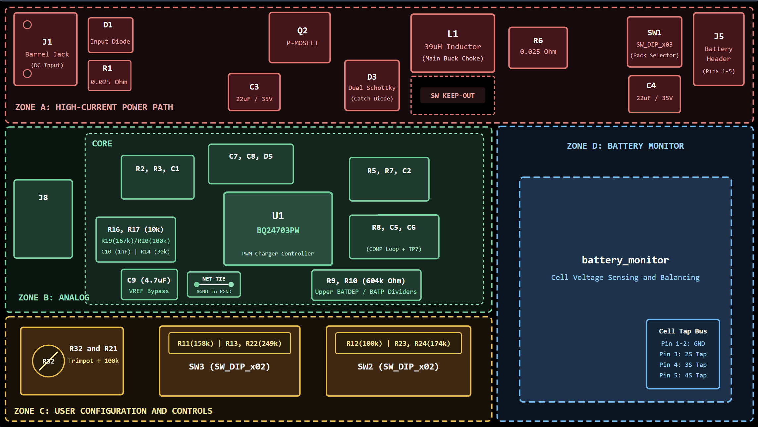

Floorplan design decisions
- Left-to-right power flow (input → switch → output) : current path short and linear, stops noisy and quiet sections from crossing each other.
- Tight C3–Q2–D3 hot loop. The loop’s area sets the radiated emissions and ringing. Minimizing it is the single biggest EMI lever in a buck stage..
- U1 placed below the power stage, analog pins facing away. Gate drive (/PWM) stays short while sensitive pins sit on the far side from the noise source.
- Sense filters (R5/R7/C2, C1/R2/R3) at the IC pins, Kelvin-routed as pairs. Noise is common-mode on a tightly coupled pair and gets rejected. Also prevents power-path voltage drop from corrupting the current measurement.
- COMP network and VREF/ACSET/SRSET dividers kept tight and away from L1. These are high-impedance nodes and the easiest to pick up noise, which would show up as jitter or regulation error.
- VCC decoupling (C7, C8, D5) within a few mm of the pins. Gate-drive current spikes need a local charge source, not a long inductive path.
- J1 and J5 on opposite board edges. Natural flow, and cables stay away from the switching section. Cables make efficient antennas for common-mode noise.
- Control header, DIP switches and battery_monitor on the quiet side. Digital and I/O lines never run past the switch node.

