KOUSTUBH DWIVEDY, 140010016
AE 333 Source Panel Method Assignment
Source Panel Method:
Ideal flow over airfoil (by ideal, it is meant that the flow is incompressible, inviscid and irrotational, in short, the flow is potential flow) can be simulated using a linear combination of potential functions which satisfy the Laplace equation. These potential functions are supposed to satisfy the boundary equations both farfield as well as on boundary of object which we are modelling. Modelling simple objects like cylinders, doublets and ovals are simple enough to do by hand and intuition but for complex objects, intuition doesn’t scale.
This problem is solved using a modelling technique in which we model an airfoil or any body using a line (need not be straight) of continuous source functions in which the strength of source is defined as strength per unit length. This framework creates the mathematical background to go about studying general shapes but doesn’t provide a set algorithm per se.
Within this framework, there exists the source Panel Method which approximates the above construct with straight lines of constant strength with are connected together. The boundary conditions are that at the center of each segment, the net velocity into the body is 0 (normal to surface).
Algorithm Used:
The potential at any point due to all panels is given by:
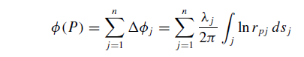
Where r is given by:
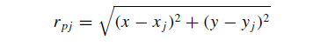
The values of lambda are calculated by equating the normal velocity at the middle of every panel to 0. The n equations of V_normal come out to be the following (including the effects of V_infinity) which upon solving using the linsolve function of MATLAB gives the values of lambda:
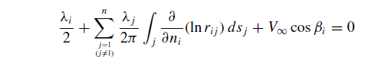
The integral above is given using. This integral will be an n*n matrix (non symmetric with diagonal elements of value 0) where n is the number of panels:
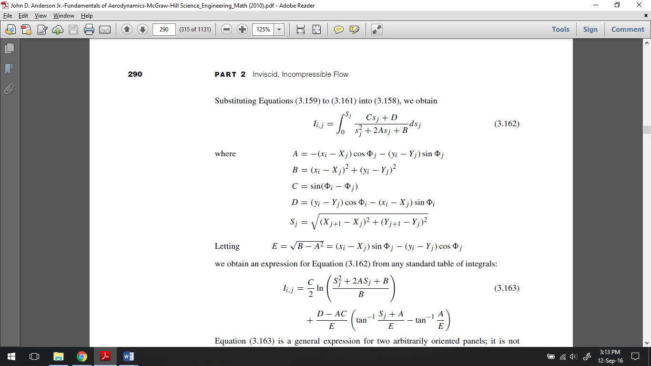
After getting the lambda’s, we get the tangential velocities at the center of every panel using:
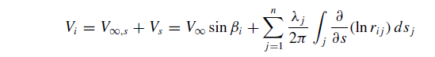
The above equation again required the evaluation of integral which will again be an n*n matrix (non-symmetrical with diagonal elements 0)
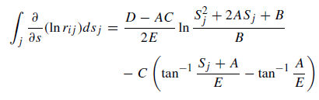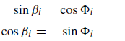
The pressure coefficients can now be calculated from the following:
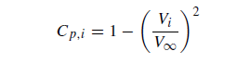
The Lift and Drag Coefficients can now be found out using the following:
$$C_{l}= \frac{\sum_{i}^{n}{\left({Cp}_{i}*l_{i}*\sin\left(β_{i}\right)\right)}}{b}$$
$$C_{d}= \frac{\sum_{i}^{n}{\left({Cp}_{i}*l_{i}*cos⁡(β_{i}\right)}}{b}$$
Where Cpi is the Pressure Coeff, li the length and βi the angle between normal and v_infinity at the i’th panel and b is the chord.
A rough check of accuracy can be made using:
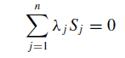
Code Structure:
The code has been written in MATLAB and the version control is done on Github. The code and it’s associated commits can be found on https://github.com/koustubh-dwivedy/AE333
The code has been made modular with the sim_driver.m script being the backbone (or simulation driver) of the code.
- shape.m is a function which defines the shape of the body being simulated.
- panels.m takes output of shape.m and creates the specified number of panels (namely the coordinates of beginning, center and end of panels)
- rotation.m is responsible for rotating the panels created by the angle of attack specified to it.
- panel_normals.m calculates the array of angles made by v_infinity and panel normals.
- I_matrix.m creates the n*n matrix required in the calculation of lambdas.
- solver.m solves for the lambdas using the inbuilt linsolve function of MATLAB.
- I_matrix_new.m creates the n*n matrix required in the calculation of v_tangential at every panel.
- pressure_coeff.m takes output of I_matrix_new.m and evaluates the tangential velocity which it further uses in the evaluation of coefficient of pressure at every panel.
- lift_drag_coeff.m as the name suggests, calculate the coefficient of lift and drag of the body.

Shape:
With 5000 Panels:
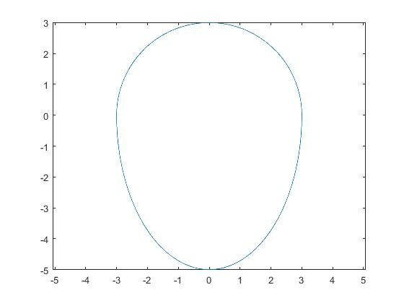
With 38 Panels: 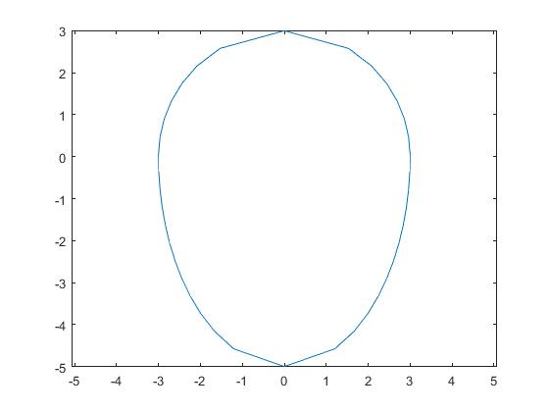
Cp Distribution:
X-Axis: Distance
Y-Axis: Cp
V_infinity = 15 m/s
Angle of Attack: -30º
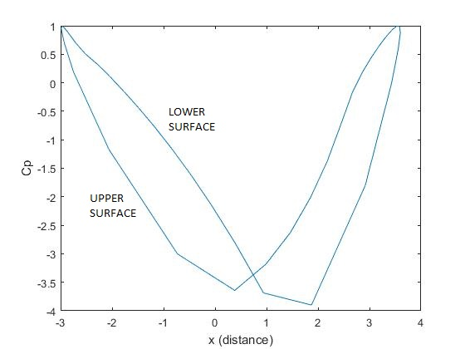
X-Axis: Distance
Y-Axis: Cp
V_infinity = 15 m/s
Angle of Attack: 0º
Plots of upper and lower surface are identical in this case.
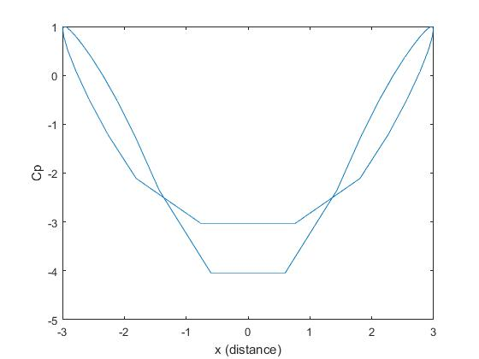
X-Axis: Distance
Y-Axis: Cp
V_infinity = 15 m/s
Angle of Attack: 30º
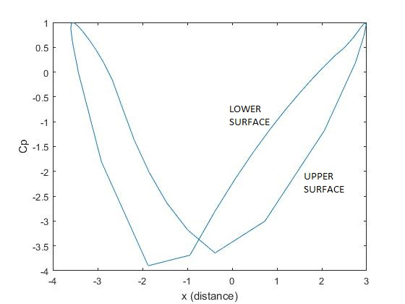
Cl & Cd Distribution:
V_infinity: 15*|cos(t)|
X-Axis: t (time)
AoA: -30º
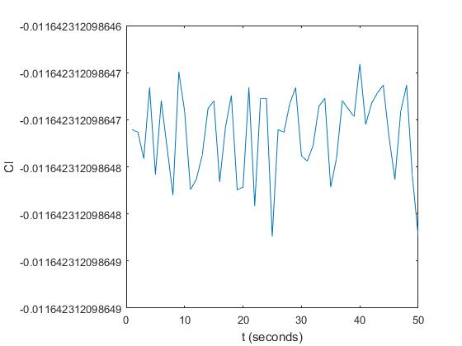
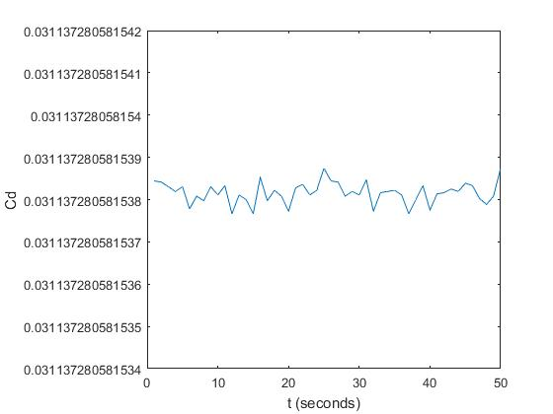
V_infinity: 15*|cos(t)|
X-Axis: t (time)
AoA: 0º
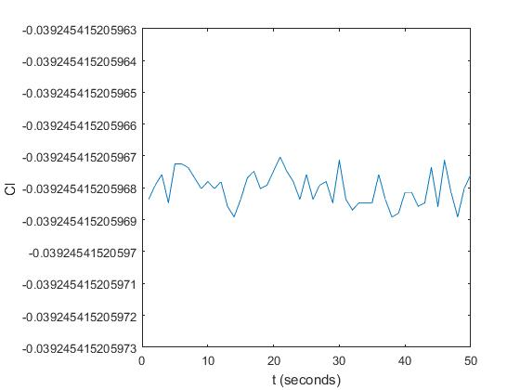
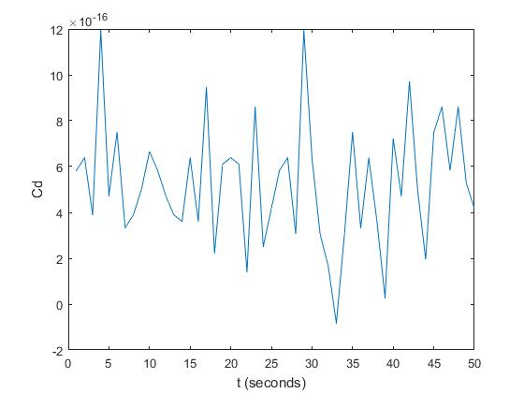
V_infinity: 15*|cos(t)|
X-Axis: t (time)
AoA: 30º
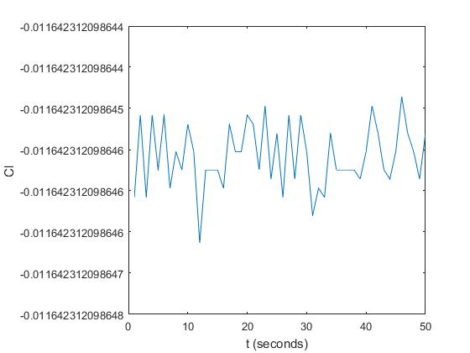
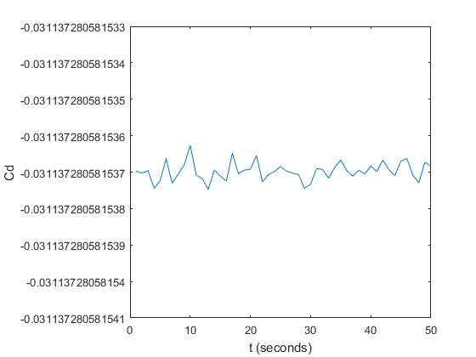
What I Understood:

