Where to modify?
- Set numbers of topics to test
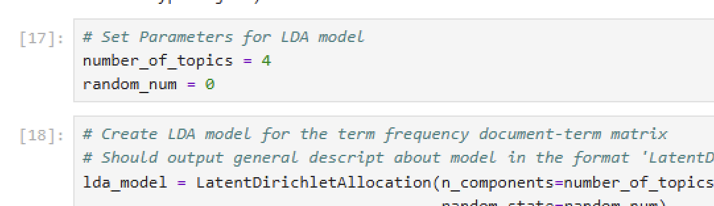
- TOP_N_TERMS = 15 this is to set up how many tokens that are most related to this topic will show up in our csv file (the spreadsheet)
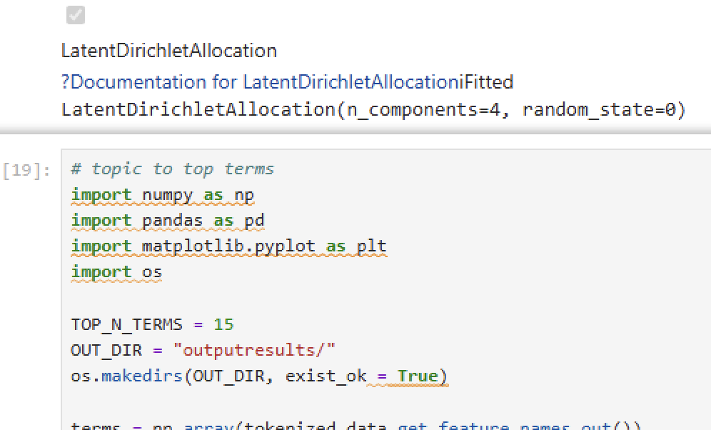
- As python to read the csv and treat it as a dataframe: Here, top_n=8 means this will show you 8 tokens that are most closely related to this topic
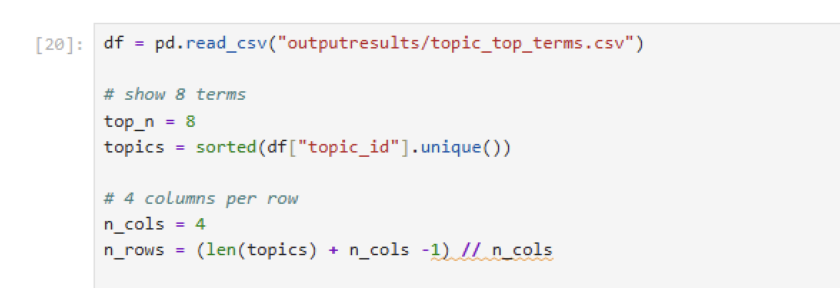
- We are then trying to draw the topic prevalence over time, if you have more topics (e.g. you need to modify ```plt.subplot (4,2, figsize=(12,10))``` 4, 2 means four rows and each row has two images)
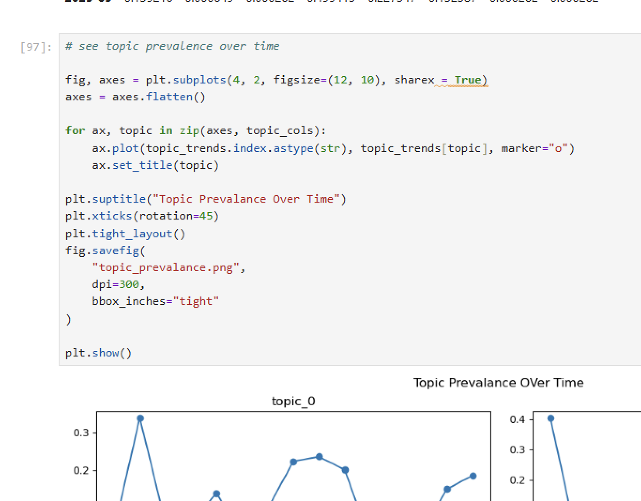
- MOST IMPORTANT ONE:
Pick your topic and just switch this one line ```topic=topic_6```
If you want to check topic 8, do ```topic=topic_8```
You DO NOT need to switch anything else
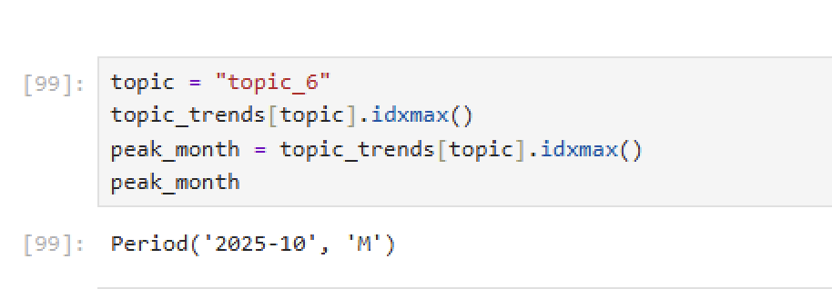
- Last code block:
```Idx = top_topic6_docs.index[1]``` switch this from [1] to [2] or [3] to examine the articles that are most closely related to this topic (the topic you set in the previous step). Remember python starts from 0, so the first article would be idx=topc_topic6_docs.index[0]
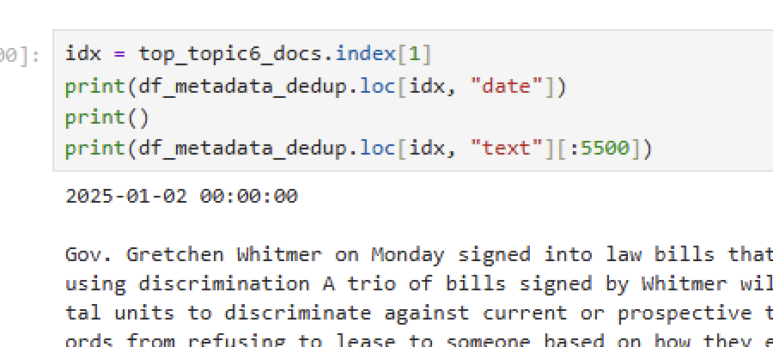

Download our data/results:

Start a new script in Jupyter Lab:
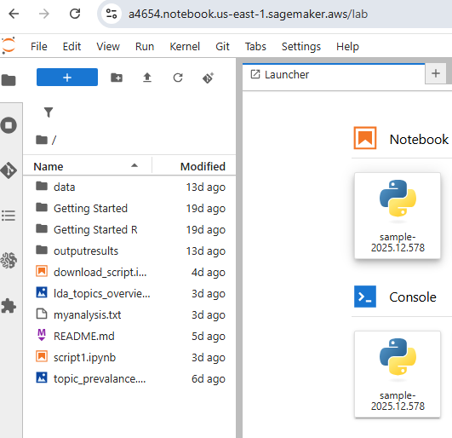
Click the + sign on the top left corner→ make sure to select the notebook, “sample-2025.12.578” one on the right hand side.
You can name it something like “download_scripts” or really whatever you want, remember the file name.

In the first code block: write this
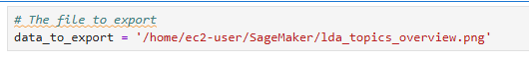
Make sure the file name aligns with how you named your file.
You can write three different blocks with three different files

Write a new code block, copy this code:
NOTE: if your ID is not a4654, swape “a4654” with your own user id:
You can find your user ID either in the ProQuestTDM landing page or in the URL of your Jupyter session:
