Things we still need to do to go through this semester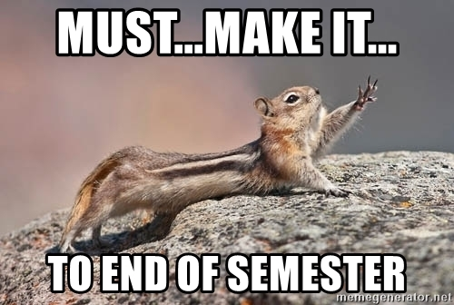

Some events we plan to attend:
- UURAF, Friday 4/17 1-2:30pm @ Breslin
- DH End-of-Year Celebration, Thursday 4/23, 3-5pm @ LEADR/Old Horticulture
  - Do you want to present there?NO.
- Apple Manufacturing Academy Forum, Thursday 4/30 2:30-4pm? @Wharton
  - Rebecca is technically free all day, not a morning person
  - Theo has an exam in the AM
  - Teddy is technically free but not a morning person

How many more classes/how much time do we have?
- Week 12: 4/7 and 4/9
  - Reserved for getting the UURAF poster done
- Week 13: 4/12 and 4/16
  - Reserved for website setting up
  - Rebecca out on the 4/16
- Week 14: 4/21 and 4/24
  - 4/21 reserved for website updates
  - 4/24 is an event
- Finals week: when do we want to say our website is due?
  - Friday May 1, 2026 11:59PM

What are our deliverables?
- Item 1: website
- Item 2: UURAF posters
- Item 3: flyer/digital invitation

What is our game plan?
Items | Deadline | Who is responsible | Notes (tools)
Invitation flyer 1: AI project | Monday, 4/13 | Rebecca, Teddy | Kelly, Nick, Post printing lady Kristina, Olivia Guy, Jianyang Mei
Invitation flyer 2: Comics network analysis | Monday 4/13 | Theo | Kristen Mapes, Ted, Comics person from the lib,
Poster printing | Wednesday 4/15 at 9:30AM
Poster designing and making!

For a poster: text analysis heavy! You want to treat what you have done in the past 11 weeks as a project?

- Intro: text analysis; figure out what AI does what are some implications blablabla
- Research Questions:
- Data
- Method
- Results
- Conclusion or Reflection

