

National & Kapodistrian University of Athens
Department of Economics
Master of Science in
Business Administration, Analytics and Information Systems

Master Thesis

Fraud Detection on Transactional Data with Machine Learning Models

Koutsompinas Konstantinos

Κωνσταντίνος Κουτσομπίνας

Supervisory teacher,
Argyriou Athanasios

Athens, February 2026

Copyright © Koutsompinas Konstantinos, 2026
Με επιφύλαξη παντός δικαιώματος. All rights reserved.
Η έγκριση της διπλωματικής εργασίας από το Τμήμα Οικονομικών Επιστημών (ΠΜΣ Διοίκηση, Αναλυτική και Πληροφοριακά Συστήματα Επιχειρήσεων) του Εθνικού και Καποδιστριακού Πανεπιστημίου Αθηνών δεν υποδηλώνει απαραιτήτως και αποδοχή των απόψεων του συγγραφέα εκ μέρους του Τμήματος.
The approval of this thesis by the Department of Economics (MSc in Management, Analytics and Business Information Systems) of the National and Kapodistrian University of Athens does not necessarily imply acceptance of the author’s views by the Department.
Υπεύθυνη δήλωση του φοιτητή
Ο υποψήφιος βεβαιώνει ότι η υποβληθείσα εργασία είναι προσωπική εκτός από τα σημεία όπου
γίνεται αναφορά στις εργασίες άλλων
Κουτσομπίνας Κωνσταντίνος

Acknowledgements
Firstly, I would like to express my sincere gratitude to Mr. Athanasios Argyriou, my thesis supervisor, for his guidance, constructive feedback, and continuous support throughout this work. His assistance not only improved the quality of this thesis, but also helped me gain valuable knowledge and practical experience in machine learning and data analysis, as well as in developing robust research-driven pipelines.
I would also like to thank all my professors for their time, their contribution to my education, and their support in helping me acquire important skills that proved useful both in the development of this thesis and in my personal growth.
Finally, I would like to thank my colleagues for making this master’s journey such a meaningful experience, their cooperation, mutual support, and the many good moments we shared both inside and outside the classroom.

Table of Contents
Abstract 5
Περίληψη 6
1. Introduction 7
2. Literature Review 9
2.1. Introduction and Overview of the Domain 9
2.2. Machine Learning Approaches to Fraud Detection 9
2.2.1. Supervised Learning (Classification) 10
2.2.2. Unsupervised and Semi-Supervised Learning (Anomaly Detection) 10
2.2.3. Ensemble Methods 11
2.2.4. Deep Learning 11
2.2.5. Comparison of Approaches 12
2.3. Datasets and Benchmarks 13
2.4. Feature Engineering for Fraud Detection 15
2.5. Model Evaluation Metrics 16
2.6. Challenges and Limitations in Machine Learning-Based Fraud Detection 17
2.7. Tools, Libraries, and Frameworks 18
2.7.1 General Programming Languages 18
2.7.2 Data Handling and Scientific Computing Libraries 19
2.7.3 Machine Learning Libraries and Modeling Frameworks 20
2.7.4 Hyperparameter Optimization and Experimentation Tools 21
2.7.5 Tools for Handling Class Imbalance 22
2.7.6 Model Interpretability and Explainable AI Libraries 23
2.7.7 Visualization, Reporting, and Prototyping Environments 23
2.7.8 Deployment and Operationalization Frameworks (Industry Context) 24
2.7.9 Summary: Why Tooling Choices Matter in Fraud Detection 24
2.8. Conclusion 25
3. Methodology 26
4. Data 29
4.1. Exploratory Data Analysis 29
4.1.1. Overview 29
4.1.2. Target Variable Analysis 31
4.1.3. Missing Values 32
4.1.4. Transaction DT (Time) 33
4.1.5. Transaction Amount 35
4.1.6. Transaction Categorical Features 37
4.1.7. Distance, Count and Time features 39
4.1.8. Vesta Features 42
4.2. Feature Preprocessing and Engineering 43
4.2.1. Encoding 43
4.2.2. Feature Engineering 43
5. Results 47
5.1. Full Features and Data 47
5.2. Downsampling 49
5.3. Reduced Features 51
5.4. Decision Threshold Tuning 54
5.5. Overall Experimental Summary 56
6. Conclusions – Future Research 57
6.1. Conclusions 57
6.2. Future Research 57
6.4. Closing Statement 58
7. References 59

Table of Figures

Figure 1: Data Split figure for training - evaluation – testing 20
Figure 2: Target Variable Analysis 24
Figure 3: Missing Values 25
Figure 4: Fraud and Deltatime Relation 26
Figure 5: Daily Fraud Rate 27
Figure 6: Hourly Fraud Rate 27
Figure 7: Fraud and Transaction Amount relation 28
Figure 8: Decimal Places relation to Fraud 29
Figure 9: Product Category and Fraud relation 30
Figure 10: Card Categories and Fraud relation 30
Figure 11: Email Domains and Fraud relation 31
Figure 12: Distance Features and Fraud relation 32
Figure 13: Count Features and Fraud relation 32
Figure 14: Count Features Correlation 33
Figure 15: Timedelta features correlation 34
Figure 16: Vesta Features Correlation 35
Figure 17: Transaction Amount Related to card type generated features 37
Figure 18: Transaction amount to product category generated feature 38
Figure 19: Transaction amount to user id and hour of day 38
Figure 20: Transactuin amount to user id and day of week 39
Figure 21: XGBoost full feature plots 40
Figure 22: LGBM full features plots 41
Figure 23: CatBoost full features plots 41
Figure 24: XGBoost downsampled plots 42
Figure 25: LGBM downsampled plots 42
Figure 26: CatBoost downsampled plots 43
Figure 27: XGBoost reduced features plots 45
Figure 28: LGBM reduced features plots 46
Figure 29: CatBoost reduced features plots 46
Figure 30: XGBoost 0.1 decision threshold plots 47
Figure 31: LGBM 0.1 decision threshold plots 47
Figure 32: CatBoost 0.1 decision threshold plots 48

Table 1: Decimal Places relation to Fraud 29
Table 2: Table of metrics for full features 40
Table 3: Table of Metrics for downsampled data 42
Table 4: Table of Metrics for reduced features 45
Table 5: table of metrics for decision threshold tuning 47

Abstract
Fraud in digital payments is a constantly evolving threat, made more dangerous by the massive volume of transactions nowadays, and the fact that fraudulent cases are rare compared to legitimate ones. This thesis builds and tests a supervised machine learning pipeline for credit card fraud detection using the IEEE-CIS dataset, which includes complex data on devices, identities, and custom-built features. The pipeline is focused on three gradient boosting models (XGBoost, LightGBM, and CatBoost) and a time-based experimental setup is used to simulate a real-world launch. This involved splitting data chronologically and using time-series cross-validation for tuning. To measure success, ROC-AUC is prioritized, but also PR-AUC, precision, recall, and F1-score are examined to understand the practical trade-offs. The research explores four main areas: (i) working with the original imbalanced data, (ii) using a 1:5 downsampling ratio to balance the classes, (iii) cutting down features based on where the different models agreed on importance, and (iv) adjusting decision thresholds to catch more fraud. A key finding is that the engineered behavioral and aggregate features contribute heavily to model performance, often ranking among the most informative predictors by capturing subtle transaction patterns that raw fields miss. The results indicate that LightGBM is the most reliable model (ROC-AUC ≈ 0.918–0.919). Downsampling helped the models learn the "fraud" patterns better, while feature reduction kept the system fast without losing accuracy. Finally, it was found that while lowering the detection threshold can catch over 90% of fraud, it also leads to more false alarms, showing that banks must choose their settings based on their actual budget and staff capacity.

Keywords: Credit card fraud detection, machine learning, gradient boosting, imbalanced classification, IEEE-CIS Fraud Detection dataset, feature engineering, time-series cross-validation, threshold tuning.

Περίληψη
Η απάτη στις ψηφιακές πληρωμές αποτελεί μια διαρκώς εξελισσόμενη απειλή, η οποία γίνεται ολοένα και πιο επικίνδυνη λόγω του τεράστιου όγκου συναλλαγών σήμερα και του γεγονότος ότι τα περιστατικά απάτης είναι σπάνια σε σχέση με τις νόμιμες συναλλαγές. Η παρούσα διπλωματική εργασία αναπτύσσει και αξιολογεί ένα εποπτευόμενο (supervised) pipeline μηχανικής μάθησης για τον εντοπισμό απάτης σε συναλλαγές με πιστωτική κάρτα, χρησιμοποιώντας το σύνολο δεδομένων IEEE-CIS, το οποίο περιλαμβάνει σύνθετα δεδομένα σχετικά με συσκευές, ταυτότητες και προσαρμοσμένα (engineered) χαρακτηριστικά. Το pipeline εστιάζει σε τρία μοντέλα gradient boosting (XGBoost, LightGBM και CatBoost) και χρησιμοποιεί ένα χρονικά βασισμένο πειραματικό στήσιμο ώστε να προσομοιάζει μια ρεαλιστική εφαρμογή στην πράξη. Αυτό περιλάμβανε χρονολογικό διαχωρισμό των δεδομένων και time-series cross-validation για τη ρύθμιση υπερπαραμέτρων. Για τη μέτρηση της απόδοσης δίνεται προτεραιότητα στο ROC-AUC, ενώ εξετάζονται επίσης τα PR-AUC, precision, recall και F1-score, ώστε να αποτυπωθούν καλύτερα οι πρακτικοί συμβιβασμοί. Η έρευνα διερευνά τέσσερις βασικές κατευθύνσεις: (i) εκπαίδευση με τα αρχικά, έντονα μη ισορροπημένα δεδομένα, (ii) χρήση downsampling με λόγο 1:5 για εξισορρόπηση των κλάσεων, (iii) μείωση χαρακτηριστικών με βάση τη συμφωνία των διαφορετικών μοντέλων ως προς τη σημασία τους, και (iv) προσαρμογή των thresholds απόφασης για τον εντοπισμό περισσότερων περιπτώσεων απάτης. Ένα βασικό εύρημα είναι ότι τα παραγόμενα (engineered) χαρακτηριστικά, όπως αθροιστικά και συμπεριφορικά metrics, συμβάλλουν καθοριστικά στην απόδοση, καθώς συχνά κατατάσσονται στα πιο πληροφοριακά predictors και αποτυπώνουν λεπτά μοτίβα συναλλαγών που τα αρχικά πεδία δεν αναδεικνύουν. Τα αποτελέσματα δείχνουν ότι το LightGBM είναι το πιο αξιόπιστο μοντέλο (ROC-AUC ≈ 0.918–0.919). Το downsampling βοήθησε τα μοντέλα να μάθουν καλύτερα τα μοτίβα της απάτης, ενώ η μείωση χαρακτηριστικών διατήρησε το σύστημα γρήγορο χωρίς απώλεια ακρίβειας. Τέλος, διαπιστώθηκε ότι, παρότι η μείωση του threshold ανίχνευσης μπορεί να εντοπίσει πάνω από το 90% των περιστατικών απάτης, οδηγεί και σε περισσότερους ψευδείς συναγερμούς, γεγονός που δείχνει ότι οι τράπεζες πρέπει να ρυθμίζουν το σύστημα με βάση τον πραγματικό τους προϋπολογισμό και τη διαθέσιμη επιχειρησιακή ικανότητα (προσωπικό).
Λέξεις-κλειδιά: Ανίχνευση απάτης σε πιστωτικές κάρτες, μηχανική μάθηση, ενισχυμένη μάθηση δένδρων (gradient boosting), μη ισορροπημένη ταξινόμηση, σύνολο δεδομένων IEEE-CIS, κατασκευή χαρακτηριστικών (feature engineering), διασταυρούμενη επικύρωση χρονοσειρών, ρύθμιση κατωφλίου (threshold).

1. Introduction
Fraud in electronic payments remains a persistent challenge for financial institutions and online merchants. As transaction volumes increase and payment channels become more digital, fraudulent activity continues to evolve, creating direct financial losses as well as indirect costs related to chargebacks, investigations, and customer friction. Therefore, effective fraud detection methods are required, so that suspicious transactions can be identified with high discriminatory power while maintaining an acceptable false-alarm rate in operational settings.
Credit card fraud detection is typically formulated as a binary classification problem in which the goal is to distinguish fraudulent from legitimate transactions. A defining characteristic of this domain is severe class imbalance, since fraud events represent only a small portion of overall activity. This imbalance complicates both learning and evaluation: a model may achieve high accuracy by predicting the majority class, while still failing to detect fraud reliably. For this reason, evaluation should emphasise discrimination metrics that remain informative under imbalance. In this thesis, the primary metric is ROC-AUC, consistent with the evaluation protocol of the Kaggle competition from which the dataset was obtained, where top solutions approached approximately 96% ROC-AUC. Complementary metrics (precision, recall, F1-score, and PR-AUC) are also reported to characterise threshold-dependent trade-offs relevant to practical deployment.
The aim of this thesis is to develop and empirically evaluate a supervised machine learning pipeline for fraud detection on a credit card transaction dataset. The study focuses on gradient boosting models (XGBoost, LightGBM, and CatBoost) and investigates how performance changes under different experimental settings, including training on the original imbalanced data, applying majority-class downsampling, and reducing the feature space. In addition, the thesis examines the effect of decision threshold tuning in order to illustrate the operational trade-off between fraud capture (recall) and false positives (precision).
The work is guided by four research questions: (1) how effectively the evaluated models discriminate fraudulent from legitimate transactions under ROC-AUC evaluation, (2) how majority-class downsampling affects model performance compared to training on the original data distribution, (3) whether a reduced feature set selected via feature importance can preserve discriminatory power, and (4) how altering the decision threshold changes detection behaviour in terms of recall–precision trade-offs. A further objective is to evaluate the contribution of engineered aggregate behavioural features (e.g., variables ending in _mean, _rel, _avg, _std, and _freq), which are designed to capture historical and user-level patterns beyond raw transaction attributes.
This thesis contributes (i) a reproducible comparative evaluation of three widely used gradient boosting frameworks for fraud detection using a ROC-AUC–centred protocol, (ii) an empirical assessment of majority-class downsampling as a practical imbalance-handling strategy, (iii) a feature engineering and reduction analysis that quantifies the predictive value retained in a compact feature set, and (iv) a threshold tuning experiment that connects model outputs to operational decision-making. In the following chapters we discuss the literature on this subject, we describe the methodology that we followed to investigate the effectiveness of machine learning models in this domain, we analyse the dataset that we used, we present the results of our experiments, and finally we discuss the findings and the conclusions of this research.

2. Literature Review

2.1. Introduction and Overview of the Domain
Financial fraud in digital payment systems has become an increasingly significant problem as transaction volumes and online commerce continue to expand. The resulting scale and speed of modern payment flows create favorable conditions for fraudsters to conceal malicious behavior within large populations of legitimate transactions. In parallel, fraud detection systems must operate under strict practical constraints, including the need to make timely decisions, minimize customer disruption, and support investigation workflows.
Early fraud detection systems largely relied on manual review and rule-based policies (e.g. fixed thresholds and expert-defined rules). While such approaches remain useful in specific scenarios, they are often limited in their ability to adapt to changing fraud strategies and complex behavioral patterns. Machine learning methods have therefore become central to modern fraud detection, as they can learn decision boundaries from historical transaction data and produce risk scores that enable prioritization and automated screening. Furthermore, through the retraining process, they can adapt and “rediscover” the fraud patterns, without the manual labor that would be needed in manual review and rule-based policies. Consequently, the research literature has increasingly focused on supervised learning pipelines, feature engineering strategies that encode behavioral signals, and evaluation protocols tailored to the severe class imbalance that characterizes real-world fraud detection tasks. Despite extensive work on fraud detection, existing studies often focus on model comparison in isolation, with limited attention to operational threshold tuning and feature reduction effects on large, high-dimensional e-commerce datasets.

2.2. Machine Learning Approaches to Fraud Detection
A wide range of machine learning approaches has been explored for fraud detection in online financial transactions. These include supervised learning methods, unsupervised and semi-supervised techniques for anomaly detection, ensemble methods, deep learning models, and even emerging paradigms such as reinforcement learning. Each approach has its strengths and weaknesses in the fraud detection context. Below, we summarize the main techniques and compare their utility:

2.2.1. Supervised Learning (Classification)
The majority of fraud detection research has focused on supervised learning, where models are trained on labeled transaction data (fraud vs. non-fraud) (Waleed Hilal, S. Andrew Gadsden, and John Yawney, 2021; Hernandez Aros et al., 2024). Popular algorithms include logistic regression, decision trees, random forests, support vector machines (SVMs), and neural networks. Supervised classifiers tend to achieve high accuracy when ample labeled examples of fraud are available, and they can directly optimize metrics like classification accuracy or F1-score
Strengths: Supervised models can leverage well-understood algorithms and yield high detection performance if trained on representative data. They produce a clear decision output (fraud or not) for each transaction and can incorporate cost-sensitive learning to penalize misclassification of fraud heavily.
Weaknesses: They require large quantities of labeled fraud data, which is often scarce. By nature, supervised models struggle with new fraud patterns not present in the training data, they tend to detect “known” fraud patterns but can miss novel schemes. Moreover, in highly imbalanced datasets, which is quite common on fraud detection cases, supervised learners may be biased toward the majority class without special handling. Many studies address this via resampling or algorithmic techniques but it remains a challenge.

2.2.2. Unsupervised and Semi-Supervised Learning (Anomaly Detection)
Because fraudulent transactions are rare and evolving, unsupervised learning techniques are crucial to detect anomalies without relying on labeled examples (Ali et al., 2022; Waleed Hilal, S. Andrew Gadsden, and John Yawney, 2021). Unsupervised methods attempt to model the distribution of normal transactions and flag outliers as potential fraud. Common approaches include clustering algorithms (k-means, DBSCAN), density estimation, and one-class classification methods (One-Class SVM, Isolation Forest).
Strengths: Unsupervised anomaly detection can potentially identify previously unseen fraud patterns, making it adaptive to emerging threats. It does not require annotated fraud data, which is useful when labels are expensive or delayed (a common situation in financial fraud, where only some frauds are ever confirmed).
Weaknesses: These methods can suffer from higher false positive rates, since not every statistical outlier is fraudulent. Tuning them can be difficult, and evaluating their performance is tricky without ground-truth labels (often requiring manual review). Indeed, surveys report that unsupervised techniques, while studied, have been used less frequently than supervised ones in the literature (Ngai et al., 2011).

2.2.3. Ensemble Methods
Ensemble learning is a special sub-category of supervised learning, which combines multiple models to improve predictive performance. Ensembles are widely used in fraud detection to boost accuracy and robustness. Techniques include bagging (e.g., Random Forest, which aggregates many decision trees), boosting (e.g., XGBoost, LightGBM), and stacking (blending different model types). Ensembles often win data science competitions for fraud detection due to their ability to capture diverse patterns. For example, boosting algorithms have achieved top results on credit card fraud datasets by effectively handling imbalance and nonlinear interactions (Hernandez Aros et al., 2024). Also, top scores on one of the most recent fraud detection Kaggle competitions (IEEE-CIS Fraud Detection) have been achieved with such methods. Ensembles can also incorporate different algorithms for different sub-tasks: one study used a hybrid of SVM, logistic regression, and linear regression as a composite model to classify transactions (Ali et al., 2022).
Strengths: Ensembles usually outperform individual models by reducing variance and bias – this is valuable in fraud detection, where catching as many fraud cases as possible (high recall) while keeping false alarms low (high precision) requires a delicate balance.
Weaknesses: The main downsides are increased complexity and reduced interpretability. A large ensemble (hundreds of trees or mixed models) can be a “black box” that is hard to interpret, which may be problematic in regulated financial environments.

2.2.4. Deep Learning
Deep learning techniques have been increasingly applied to fraud detection, thanks to their ability to model complex data patterns. Artificial Neural Networks (ANNs) in various forms (multilayer perceptrons, convolutional networks, recurrent networks, graph neural networks) have been explored. Early works used basic ANNs to classify fraudulent transactions (Sahin and Duman, 2011; Bouchti et al., 2017; Dang et al., 2021), while newer studies leverage specialized architectures. For example, recurrent neural networks (RNNs) and long short-term memory (LSTM) networks can capture sequential patterns in transaction streams (useful for detecting sequential fraud behavior or repeated offenses). Graph Neural Networks (GNNs) have emerged to detect fraud by modeling transactions as graphs (e.g., linking customers, merchants, IP addresses), graph-based approaches can uncover organized fraud rings or money laundering patterns by relational analysis (Nicholls et al., 2021). Deep learning has also been combined with other methods: autoencoder networks for anomaly detection (unsupervised) or hybrid deep models with feature extraction followed by classification (Jurgovsky et al., 2018).
Strengths: Deep learning models can capture highly nonlinear and intricate patterns that shallow models might miss. They are adept at processing large-scale data and can learn feature representations automatically (reducing the need for manual feature engineering). Some deep models (like GNNs) naturally incorporate network information that is crucial for certain fraud types (e.g., collusive networks).
Weaknesses: Deep models typically require even larger training datasets and computational resources, while, in the same time, performance gains depend on feature availability, scale, and constraints. They also tend to be black-box in nature, raising explainability concerns. Also deep learning algorithms have very high capacity and are more likely to overfit, if not treated with caution.

2.2.5. Comparison of Approaches
In practice, the choice of approach depends on label availability, operational constraints, and the expected rate of novel fraud. Supervised models and ensembles typically perform strongly when representative labeled data are available, while unsupervised methods are often used to surface anomalies and previously unseen patterns, at the cost of higher false-positive rates. Deep learning approaches can be beneficial when richer structure is available (e.g., sequences or relational graphs), but they require careful design and sufficient data to avoid overfitting. Consequently, hybrid systems, combining supervised learning with complementary anomaly signals and continuous monitoring, are common in applied fraud detection settings (Ali et al., 2022). Overall, the literature suggests that no single modeling paradigm is universally optimal for fraud detection, instead, ensemble-based supervised approaches tend to offer the most favorable balance between detection performance and operational feasibility when sufficient labeled data are available, particularly in structured transaction environments.

2.3. Datasets and Benchmarks
Access to quality data is crucial for developing and benchmarking fraud detection models. Over the years, researchers have utilized a variety of datasets, both real-world datasets (often proprietary or released for research) and synthetic datasets, to evaluate ML techniques. In this section, we outline some of the most used datasets and benchmarks in the field:
Credit Card Transaction Datasets: (Credit Card Fraud Detection) The most referenced benchmark is the European credit card fraud dataset made public by researchers from Université Libre de Bruxelles (ULB) in 2013. This dataset contains 284,807 credit card transactions (aggregated over two days), of which 492 are labeled as fraudulent (Dal Pozzolo et al., 2018). The data include numerical features (which are results of PCA transformations for confidentiality) and the transaction amount and time. Despite its anonymization and relatively low fraud ratio (~0.17%), this dataset has become a standard benchmark – it was used by at least 15 studies in recent years for evaluating various ML models (Hernandez Aros et al., 2024). Its popularity stems from being one of the few publicly available real fraud datasets. Models achieving high AUC (>0.95) on this data are considered state-of-the-art, though issues like its static nature and limited feature information are noted.
E-commerce Transactions and Mixed Online Payment Data: (our choice) (IEEE-CIS Fraud Detection | Kaggle) In 2019, a large industry dataset was released through a Kaggle competition (the IEEE-CIS Fraud Detection challenge). This dataset, although proprietary in origin, was made public for the contest and contains over 1 million online transactions with a rich set of features (device information, IP address, product codes, etc.) and a binary fraud label. Researchers sometimes use this dataset to evaluate performance on e-commerce fraud detection, as it reflects modern online payment fraud scenarios. It is highly unbalanced and includes many categorical features, testing an algorithm’s ability to handle feature engineering and big data. (While direct academic papers on it are few, it has indirectly influenced research by revealing which techniques perform well in practice — for example, winning solutions used extensive feature engineering and ensemble models.) From an academic perspective, the IEEE-CIS dataset serves as a proxy for contemporary industry-scale fraud detection problems, enabling reproducible evaluation of models under realistic feature complexity and class imbalance, despite its competitive rather than purely scholarly origin.
PaySim Mobile Money Dataset: (Synthetic Financial Datasets For Fraud Detection) PaySim is a synthetic dataset generated to simulate mobile payment transactions, based on patterns from real financial data. It was created using the PaySim simulator (by Edgar López-Rojas and colleagues) and released on Kaggle. One commonly used version contains about 6.3 million transactions (with a few thousand labeled frauds) across different transaction types (payments, transfers, cash-out, etc.). PaySim is valuable for research because it provides large-scale data with realistic behavior for fraud (though the fraud instances are simulated). Several studies have used PaySim to test algorithms that need big data and to validate the scalability of methods (Hernandez Aros et al., 2024). The synthetic nature means results might not fully translate to a real deployment, but it remains a widely cited benchmark for comparing unsupervised techniques and testing under high class imbalance.
BankSim and Other Simulated Bank Transaction Data: (Synthetic data from a financial payment system) BankSim is another simulator-based dataset (simulated from a Spanish bank’s data sample) that provides transactions with attributes like customer ID, merchant, location, etc., along with fraud labels (Lopez-Rojas et al., 2014). It has been used in studies focusing on fraud detection in banking transactions and often for testing pattern recognition algorithms in a controlled environment (Hernandez Aros et al., 2024). Similar to PaySim, it provides a flexible testbed for new algorithms without privacy concerns.
A common characteristic across public fraud datasets is severe class imbalance, which makes naive metrics such as accuracy unreliable. As a result, many studies report threshold-independent discrimination metrics (e.g., ROC-AUC) and threshold-dependent measures (precision and recall) to better reflect minority-class detection performance and operational trade-offs.
Real vs. Synthetic Data: Recent literature reviews have found that a majority of studies now use real datasets in experiments, with relatively few relying solely on synthetic data (Hernandez Aros et al., 2024). This suggests a push towards evaluating models on realistic data distributions. The availability of open datasets like the ULB credit card data and various Kaggle datasets has facilitated this. However, obtaining real fraud data beyond these public sets remains a challenge – many researchers collaborate with financial institutions to test their models on private datasets (e.g., a bank’s internal transaction logs), but such results may not be fully public. Synthetic datasets (like PaySim) help fill this gap by allowing algorithm development and preliminary testing in a reproducible way. In fact, there are ongoing efforts to generate better simulation datasets.

2.4. Feature Engineering for Fraud Detection
Effective feature engineering is often cited as one of the most crucial steps in building a successful fraud detection model (Ti et al., 2022). Raw transaction logs are usually high-dimensional, heterogeneous, and not immediately suitable for feeding into ML algorithms. Therefore, researchers and practitioners devote significant effort to creating informative features. In this section, we discuss typical feature types and engineering techniques used in fraud detection.
Transactional Behavior Features (RFM): A common framework for thinking about customer transaction behavior is the Recency, Frequency, Monetary (RFM) model. Prior studies often derive features based on how recently transactions have occurred, how frequently they appear in a given period, and the monetary values involved (Ti et al., 2022). For example, features can include the time since last transaction, number of transactions in the past 24 hours (or past week, month, etc.), average transaction amount, and maximum transaction amount. These RFM features help characterize if an account’s recent behavior deviates from its usual pattern.
Anomaly and Derived Features: In addition to straightforward stats, researchers use anomaly detection features. For instance, an “amount deviation score” (how far a transaction’s amount is from the customer’s usual amount distribution) could be a feature. Or the output of an unsupervised model (like an autoencoder’s reconstruction error for a transaction) can be used as a feature input to a supervised model, essentially a meta-feature indicating how anomalous a transaction appears (Ti et al., 2022). Ti et al. (2022) found that anomaly features (like ones based on outlier scores) performed the worst among feature categories in their experiments, possibly because they are redundant with other signals or too noisy. However, they remain part of the feature engineering toolbox as they can highlight novel patterns.
Time and Sequence Features: Timing is critical in fraud. Features capturing temporal patterns include time-of-day or day-of-week of transactions (fraud might happen at unusual times for a given user), velocity features (e.g., number of transactions in the last hour), and sequence patterns (like rapid successive transactions at different merchants). ML models can learn such thresholds if provided with features like “transactions_per_hour”.
Identity and Device Features: In online transactions, information about the user’s device, browser, IP address, etc., can be critical. Fraudsters often use different devices or anonymization. Thus, features like device ID, IP address, email domain, etc., are used to connect transactions. If historical data is available, one might compute “number of distinct devices used by this account in the last N days” or “first time this device is seen for any transaction”. These features aim to detect identity inconsistencies.
Feature Selection and Importance: Given a large pool of candidate features, it’s important to evaluate which are most useful. Techniques like mutual information, correlation analysis, or tree-based feature importance can be used to select a meaningful subset. Some studies report that a handful of carefully engineered features can outperform hundreds of raw attributes. In fact, Butaru et al. (2017) showed that features related to customer behavior stability were top predictors for credit card fraud in a large-scale analysis.
Feature engineering is consistently reported as a critical determinant of fraud detection performance, particularly for structured transaction data (Cheng et al., 2020; Baesens, Höppner, and Verdonck, 2021). Well-designed behavioral aggregates and historical statistics can substantially improve model discrimination by capturing deviations from normal user activity. The key challenge is to design features that are informative for detection while remaining robust to evolving fraud patterns and avoiding excessive false positives.

2.5. Model Evaluation Metrics
In fraud detection, metric selection is critical due to extreme class imbalance and the asymmetric costs of errors. Overall accuracy is often misleading, as a classifier can achieve high accuracy by predicting the majority class while failing to detect fraud. Consequently, this thesis reports discrimination metrics and threshold-dependent metrics to capture both ranking quality and operational behavior.
Many studies adopt ROC-AUC as a primary evaluation metric, particularly in benchmarking contexts, as it measures a model’s ability to rank fraudulent transactions ahead of legitimate ones across varying decision thresholds. Although ROC-AUC can appear optimistic in highly imbalanced settings because it integrates over regions of false positive rate that may not be operationally relevant, it remains widely used and is appropriate for benchmarking and comparability.
To complement ROC-AUC, precision, recall, and F1-score are reported to characterize performance at specific decision thresholds. In practice, fraud detection systems often prioritize recall to reduce missed fraud, while maintaining precision to limit investigation workload and customer friction.

2.6. Challenges and Limitations in Machine Learning-Based Fraud Detection
Despite substantial progress, deploying machine learning for fraud detection in online financial systems faces numerous challenges and limitations. These arise from the inherent nature of fraud (adaptive adversaries, rarity of events) and practical constraints (data privacy, system scalability, etc.). We outline the key challenges identified in the literature and their implications:
Class Imbalance: As noted multiple times, fraud datasets are extremely imbalanced – genuine transactions vastly outnumber fraudulent ones (Hernandez Aros et al., 2024). ML models tend to be biased towards predicting the majority class (“not fraud”), potentially missing many frauds unless carefully trained. Also evaluation of models becomes tricky. High overall accuracy is easy to achieve while missing all fraud. Techniques like resampling (oversampling frauds or undersampling non-frauds), cost-sensitive learning, and specialized algorithms (e.g., one-class classifiers) are used to address imbalance, but none is a panacea.
Evolving Fraud Tactics (Concept Drift): Fraud patterns continuously evolve as fraudsters adapt to bypass known defenses. Many academic studies assume stationarity (training and test from the same distribution), but in real deployments, models must be updated frequently. Ali et al. (2022) observe that addressing concept drift by retraining periodically incurs high overhead, and model performance can suffer between retraining cycles. Online learning algorithms or incremental updates are potential solutions, but are complex to engineer. Reinforcement learning approaches are one idea to handle non-stationarity by continuous adaptation (Patel et al., 2025), but this is still nascent. In practice, a combination of human analyst feedback and model retraining on recent data is used to tackle drift, but this lag means new fraud types can still cause damage before models catch up. The challenge is essentially a cat-and-mouse game with adversaries, a unique aspect of fraud detection compared to many ML tasks.
False Positives vs. False Negatives Trade-off: In fraud detection, false positives result in time cost of investigating a legitimate transaction that has been marked as fraudulent, whereas false negatives result in cost of missed fraud. The above trade-off is constantly being examined as it remains a challenge to create a model that has high recall and precision at the same time.
Explainability and Interpretability: Financial institutions operate in regulated environments and need to explain decisions. ML models, particularly complex ones (deep neural nets, ensembles), are often black boxes that do not provide clear reasoning for why a transaction was flagged (Aljunaid et al., 2025). This lack of transparency can erode trust from fraud analysts and compliance officers. Explainability is crucial for analyst acceptance, as an investigator presented with hundreds of alerts needs clues as to why the model marks them as fraud. Recent research has started addressing this by applying explainable AI (XAI) techniques to fraud detection. For example, safer ML models like decision trees or rule-based systems are inherently interpretable but might be less accurate. Alternatively, post-hoc explanation tools like SHAP or LIME can be used on complex models to highlight influential features (Aljunaid et al., 2025). While progress is being made, achieving a balance between accuracy and interpretability is a significant challenge, many of the best-performing models are ensemble or deep models that inherently lack simple explanations.
These challenges highlight the need for empirical studies that do not solely focus on maximizing aggregate performance metrics, but also examine model robustness, feature efficiency, and operational decision-making under realistic constraints. In response, recent research increasingly advocates for evaluation frameworks that integrate performance, interpretability, and threshold sensitivity—an approach adopted in this thesis.

2.7. Tools, Libraries, and Frameworks
Implementing machine learning for fraud detection leverages a broad ecosystem of tools and software frameworks. Because fraud detection systems often combine multiple tasks (data preparation and feature engineering, model training and hyperparameter tuning, evaluation under class imbalance, interpretability, and finally deployment or decision integration) different tools become relevant at different stages. This section summarizes the main tools, libraries, and frameworks commonly used in the fraud detection domain and clarifies how each category supports the end-to-end lifecycle of an applied machine learning solution.
A practical distinction in this ecosystem is between (i) tooling that supports experimentation and research (rapid iteration, reproducibility, and analysis) and (ii) tooling that supports operationalization (reliable scoring, monitoring, and integration with business systems). In academic and prototype settings, the first category often dominates, but it is important to describe both because fraud detection is ultimately defined by operational constraints: low latency decision-making, changing fraud tactics, and the high cost of false positives.

2.7.1 General Programming Languages
Python is the most widely adopted language in modern machine learning practice and is strongly represented in fraud detection research and industry. Its dominance is driven by the maturity of its scientific computing ecosystem, the availability of high-performance implementations of standard learning algorithms, and the flexibility it provides for experimentation. In fraud detection, Python is commonly used for: (a) data processing and feature engineering, (b) training and evaluating models, (c) interpreting model behavior, and (d) experiment tracking and reproducibility. The literature frequently adopts Python because it lowers the implementation barrier and enables direct reuse of standard evaluation pipelines.
R remains relevant in academic and analytics-driven fraud research, especially in works that emphasize statistical modeling, inference, and classical predictive modeling. In some organizations, R is preferred by teams with a stronger statistical background or existing analytical workflows. However, in many modern fraud detection pipelines, R tends to be used for exploratory or reporting tasks rather than the entire pipeline, especially when large-scale training or production deployment is required.
Beyond Python and R, SQL plays a foundational role in real fraud detection pipelines because transactional data is typically stored in relational databases, data warehouses, or lakehouse systems. Even when model training is performed in Python, dataset construction and feature computation frequently begin with SQL queries. In production environments, feature computation may be performed in SQL-based transformation layers or scheduled ETL pipelines. Therefore, while SQL is not a “machine learning language” per se, it is a core tool in fraud detection because it bridges data storage and the model training layer.

2.7.2 Data Handling and Scientific Computing Libraries
Fraud detection datasets are often high-dimensional and heterogeneous (numerical, categorical, temporal, and identity/device signals). As a result, robust data handling tools are essential.
- pandas is widely used for data manipulation, joining tables, missing value treatment, aggregation, and feature creation. It supports rapid experimentation and readable transformations, which is why it dominates in notebook-based research workflows.
- NumPy is a foundational library that supports numerical computation and array-based operations. Many machine learning libraries rely on NumPy-style arrays internally.
- For larger-than-memory datasets or distributed computation, frameworks such as Dask or Apache Spark are sometimes adopted. In fraud detection, this becomes relevant when transaction logs contain tens or hundreds of millions of records, or when feature engineering requires large-scale group-by computations (e.g., transaction velocity metrics at multiple time windows). Even when distributed frameworks are not used directly, awareness of them is useful because real-world fraud detection deployments frequently operate at a scale where single-machine pandas pipelines become limiting.
In addition, fraud detection datasets often include high-cardinality categorical features (merchant IDs, email domains, device strings, user identifiers). Common supporting tools include categorical encoders and frequency/target encoding strategies, either implemented manually or through specialized libraries.

2.7.3 Machine Learning Libraries and Modeling Frameworks
Fraud detection models range from interpretable baselines (logistic regression) to modern gradient boosting and deep learning approaches. The choice of modeling framework depends on the nature of the data, expected nonlinearity, interpretability constraints, and computational requirements.
scikit-learn is the primary general-purpose machine learning library in Python and is frequently used in fraud detection research. Its importance stems from providing reliable and standardized implementations of classic algorithms such as logistic regression, decision trees, random forests, and support vector machines, along with consistent APIs for training, evaluation, cross-validation, and preprocessing. In fraud detection, scikit-learn is often used to establish baselines and to implement evaluation pipelines that compare models fairly. Because scikit-learn integrates well with other tools (e.g., imbalanced-learn, Optuna, MLflow), it is also a natural backbone for experiment pipelines.
For structured transaction data, gradient boosting decision tree (GBDT) frameworks are among the most successful choices in practice. They handle mixed feature types well, capture nonlinear interactions, and often provide strong performance without requiring the very large labeled datasets typically needed by deep learning. The most widely used GBDT frameworks include:
- XGBoost, which is highly optimized and widely adopted in fraud detection competitions and production systems. It supports regularization, missing value handling, and efficient training, and it has been a common benchmark model in fraud literature.
- LightGBM, known for efficient histogram-based training and strong performance on large, high-dimensional datasets. LightGBM is frequently preferred when training speed and scalability are critical, particularly for large transaction datasets.
- CatBoost, which provides strong support for categorical feature handling and reduces the need for extensive manual encoding. This is particularly relevant for fraud datasets with many categorical signals (device, email domain, product codes, and identity features).
In addition to tree-based frameworks, deep learning frameworks are increasingly used when the data structure demands it. For example, sequential transaction histories may motivate recurrent or transformer-style models, while relational/graph fraud patterns motivate graph neural networks.
- TensorFlow and its high-level API Keras are widely used for building neural networks, especially in research and production contexts where model serving infrastructure is aligned with TensorFlow.
- PyTorch is popular in research due to its flexibility and Pythonic design, and it has become common in industry as well. For fraud detection, PyTorch is used in deep learning approaches including autoencoders for anomaly detection, sequence models for temporal behavior, and graph-based models.
It is important to note that deep learning is not always the default best choice for transaction fraud detection. In many structured tabular datasets, gradient boosting remains a strong baseline or even the top performer. Deep learning tends to show advantages when additional structure exists (e.g., raw sequences, graphs, text, or multimodal signals) or when data scale is extremely large.

2.7.4 Hyperparameter Optimization and Experimentation Tools
Fraud detection performance is sensitive to modeling choices, class imbalance handling, feature selection, and hyperparameters. Modern workflows therefore rely on automated hyperparameter optimization (HPO) and reproducible experiment tracking.
- Optuna is a popular HPO framework used to efficiently search model hyperparameters using techniques such as Bayesian optimization and pruning. In fraud detection, Optuna is helpful because training can be expensive and it is often necessary to tune models under time-aware validation strategies (to avoid temporal leakage).
- Alternative tools in the same category include Hyperopt, Ray Tune, and scikit-optimize. The common purpose is to systematically explore hyperparameter spaces rather than relying on manual trial-and-error.
To ensure reproducibility and transparent comparison, experiment tracking is increasingly used in both academic and industry settings.
- MLflow is a widely used tool for tracking experiments, logging parameters and metrics, and storing model artifacts. For fraud detection research, MLflow provides a structured “lab notebook” that makes results auditable: each run records which features, which hyperparameters, which split strategy, and which evaluation metrics were used. This is particularly valuable in fraud detection because small design changes can produce meaningful shifts in precision–recall trade-offs, and it is easy to unintentionally introduce leakage if experiment tracking is not systematic.
In many fraud detection projects, experiment tracking is not just convenience, it becomes a requirement for governance. Financial institutions often need to demonstrate how a model was trained and evaluated, how it changed over time, and why specific operating thresholds were chosen.

2.7.5 Tools for Handling Class Imbalance
Class imbalance is one of the defining characteristics of fraud detection: fraud cases are rare compared to legitimate transactions. As a result, standard training procedures may bias models toward the majority class, leading to poor minority-class recall unless special strategies are applied.
A widely used library for imbalance handling in Python is imbalanced-learn, which integrates smoothly with scikit-learn pipelines. It includes common resampling methods such as:
- SMOTE (Synthetic Minority Over-sampling Technique)
- ADASYN (Adaptive Synthetic Sampling)
- Random oversampling / undersampling
- Combination strategies (e.g., SMOTE + Tomek links)
In fraud detection, resampling is often used during training, but it must be applied carefully. Synthetic oversampling methods may generate unrealistic “fraud-like” points if the fraud distribution is highly complex or if the feature space contains high-cardinality categorical variables and engineered aggregates. For this reason, many practical workflows prefer undersampling the majority class, cost-sensitive learning, or threshold tuning rather than relying exclusively on synthetic sample generation. Another common approach is to use learning algorithms that support class weights, allowing the model to penalize fraud misclassification more heavily.

2.7.6 Model Interpretability and Explainable AI Libraries
Interpretability is important in fraud detection because model outputs often trigger operational actions (declines, step-up authentication, manual review). Analysts and compliance stakeholders may require explanations about why a transaction is flagged. In addition, interpretability supports debugging and trust: if a model is over-relying on spurious patterns or artifacts, explanation tools can reveal it.
- SHAP (SHapley Additive exPlanations) is one of the most widely used interpretability tools for tree-based models and is common in fraud detection research. It provides global importance (which features matter overall) and local explanations (which features mattered for a specific transaction). This helps connect model behavior to domain intuition, and it can support feature selection decisions.
- LIME is another popular approach that approximates local explanations using interpretable surrogate models. It is often used when SHAP is computationally heavy or when model types are not well supported.
Explainability is not only about “nice-to-have” plots; in fraud detection it can influence operational adoption. Investigators need actionable insights to prioritize cases, and explanation tools can generate features to display in analyst dashboards (e.g., “unusual device for this user”, “amount far above typical”, “rare email domain”, etc.).

2.7.7 Visualization, Reporting, and Prototyping Environments
Fraud detection work involves extensive exploratory analysis because the data is complex and fraud patterns can be subtle. Visualization tools help detect distribution shifts, leakage risks, and feature anomalies.
- Jupyter Notebooks are commonly used for prototyping and exploratory analysis. They enable iterative workflows where data transformation, model training, and plotting are combined in one environment. In academic contexts, notebooks also support transparency because analysis steps are visible.
- matplotlib is the standard plotting library in Python.
- seaborn provides higher-level statistical plotting and is often used to quickly visualize relationships between features and the fraud label.
In addition, reporting tools such as LaTeX (for paper-style reports) or Word-based workflows (as in this thesis) are used to formalize results into tables and figures. Increasingly, reproducible reporting workflows (e.g., Quarto or Jupyter Book) are used in research, but the core idea remains the same: consistent evaluation and transparent visualization are essential because fraud detection is sensitive to analysis decisions.

2.7.8 Deployment and Operationalization Frameworks (Industry Context)
Although academic studies often stop at offline evaluation, fraud detection is ultimately judged by deployment constraints: latency, throughput, model monitoring, and retraining cycles.
In industry, models are typically deployed as:
- Batch scoring pipelines (e.g., daily risk scoring for investigation prioritization)
- Real-time scoring services (transaction-by-transaction decisioning)
Common deployment-related frameworks include:
FastAPI or Flask for lightweight Python model APIs.
- Containerization tools such as Docker to package models consistently.
- Orchestration and scheduling tools such as Airflow for ETL and retraining workflows.
- Monitoring and drift detection tools that track changes in feature distributions and performance proxies over time.
Even when deployment frameworks are not used directly in a thesis, describing them is helpful because it frames the gap between “offline metrics” and “real operational value.” In particular, fraud detection systems must manage concept drift and changing adversarial behavior; therefore, tooling for monitoring and retraining becomes part of the broader ecosystem.

2.7.9 Summary: Why Tooling Choices Matter in Fraud Detection
In fraud detection, tooling decisions shape not only performance but also reliability and reproducibility. A robust pipeline requires: (i) trustworthy data handling and feature engineering tools, (ii) high-performing model frameworks suitable for tabular transaction data, (iii) imbalance-handling strategies, (iv) strong experiment tracking, and (v) interpretability and monitoring support. As a result, the fraud detection ecosystem is best viewed as a connected stack rather than isolated libraries. A model’s performance and metrics are meaningful only when the full workflow (data split strategy, tuning procedure, feature engineering, and threshold decisioning) is controlled and reproducible.

2.8. Conclusion
The literature indicates that fraud detection is a challenging machine learning domain due to class imbalance, evolving fraud patterns, and the need to manage false-positive costs in operational settings. Across studies, supervised learning, particularly ensemble and gradient boosting methods, has remained a strong approach for structured transaction data, especially when combined with effective feature engineering that captures behavioral patterns beyond raw transaction attributes. At the same time, evaluation practices reflect the need for discrimination-focused metrics and explicit precision–recall trade-offs, rather than relying on accuracy.
Building on these findings, this thesis focuses on gradient boosting models for fraud detection on the IEEE-CIS dataset and evaluates performance primarily using ROC-AUC to align with the dataset’s benchmarking protocol. The experimental design further investigates the impact of majority-class downsampling, the effectiveness of engineered aggregate behavioral features through feature reduction and importance analysis, and the operational implications of decision threshold tuning. By focusing on these aspects within a unified experimental framework, this thesis contributes to the literature by bridging the gap between model-centric evaluation and operationally relevant fraud detection analysis.

3. Methodology
This study follows a quantitative, experimental research design aimed at evaluating the effectiveness of supervised machine learning models for credit card fraud detection. The methodology is structured as a sequential pipeline consisting of exploratory data analysis, feature engineering, model training, and performance evaluation under realistic operational constraints.
In this chapter, we explain the course of action followed to analyze the data and develop the final models. Initially, exploratory data analysis (EDA) was conducted to understand the distributional properties of the data, assess class imbalance, and identify relationships between candidate features and the target variable (fraud vs. non-fraud), thereby creating the basis for the subsequent feature engineering and modeling decisions. Following this analysis, we focused on feature engineering, creating new features that enhance the models’ ability to discriminate between fraudulent and legitimate transactions. Details regarding data exploration and feature engineering are presented in the next chapter.
After completing the data analysis phase, we prepared the dataset for model training. No feature scaling or encoding was applied, as all employed algorithms are tree-based and provide built-in support for categorical variables, while also being insensitive to feature scaling. (For other algorithms that were tried, we used one-hot encoding for low cardinality categorical features, and frequency encoding for the rest. Also we used standard scaler). Since the dataset contains transaction timestamps, observations are ordered chronologically. The data are therefore split based on time, with the first 80% used for training and the remaining 20% reserved as a held-out test set. This time-based split prevents information leakage from future transactions into the training process and more accurately reflects real-world deployment, where models are trained on historical data and applied to future transactions. Fraud detection is particularly sensitive to data leakage, where information that would not be available at prediction time inadvertently influences the model during training or evaluation. To reduce this risk, the dataset was split chronologically and performance was evaluated using time-series cross-validation, which better reflects real-world deployment where models are trained on past data and used to predict future transactions. Feature engineering was considered from a time-realistic perspective, aiming to represent signals that could plausibly be available at the time a transaction occurs. This design choice improves the credibility of the evaluation compared to random splitting, which can overestimate performance in temporally evolving domains such as fraud.
Hyperparameter optimization is performed exclusively on the training data using time series cross-validation with an expanding window, implemented through the Optuna framework, ensuring that validation folds respect temporal ordering and that no information from the held-out test set influences model selection. After selecting the optimal hyperparameter configuration, each model is retrained on the full training dataset and subsequently evaluated on the unseen test set.
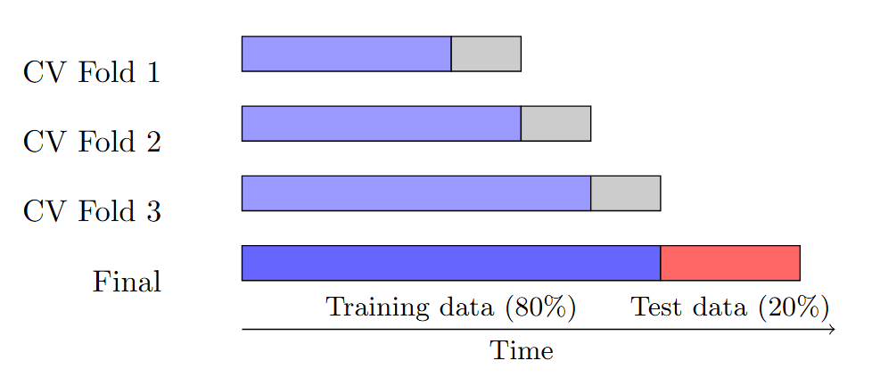
Figure 1: Data Split figure for training - evaluation – testing

For model development, we employ three gradient boosting algorithms: XGBoost, LightGBM, and CatBoost, all of which are variants of gradient boosting decision trees. Hyperparameter optimization is carried out using the previously described strategy. Model performance is evaluated primarily using the Area Under the Receiver Operating Characteristic curve (ROC-AUC), a threshold-independent metric widely used in fraud detection research and benchmarking tasks involving severe class imbalance. ROC-AUC measures a model’s ability to rank fraudulent transactions above legitimate ones across all possible decision thresholds, enabling stable comparison between models without committing to a specific operating point. Accuracy is not emphasized, as it can be misleading in highly imbalanced settings. At the same time, optimizing exclusively for recall or precision may lead to unacceptable operational trade-offs. These considerations motivate the subsequent analysis of decision threshold tuning in the experimental phase.
After training the model on the full dataset using all available features (748 total features), we experimented with different class-balancing techniques. Specifically, we applied downsampling to the non-fraud class, while also testing oversampling of the fraud class using SMOTE. However, oversampling techniques such as SMOTE were found to be less suitable in this context, as synthetically generated samples may not accurately represent real fraudulent behavior and risk introducing artificial patterns into the training data. Synthetically generated samples may not accurately represent real fraudulent behavior and could introduce misleading patterns into the model. In contrast, downsampling the majority class led to improved performance, as further discussed in the results section. After tuning the three models on the final feature set produced during the data analysis and feature engineering phase, SHAP values are used to estimate feature importance for each model. Based on these importance scores, the top 30% of features for each model are identified. A reduced feature set is then constructed by retaining features that appear in the top 30% for at least two of the three models. The three algorithms are subsequently retrained using this reduced feature set (215 total features ≈30% of starting feature set).
Following model retraining, probability threshold tuning is incorporated as part of the evaluation methodology to examine how variations in the decision threshold affect performance metrics under different operational trade-offs.. This step aims to balance the trade-off between precision and recall, as well as between false positive and false negative rates.
All experiments were conducted using the Python programming language. Model development and evaluation leveraged established open-source libraries to ensure reproducibility and reliability. Gradient boosting models were implemented using XGBoost, LightGBM, and CatBoost libraries from sklearn, while hyperparameter optimization was performed with Optuna. To ensure systematic experiment tracking and reproducibility, MLflow was used to log model configurations, hyperparameters, evaluation metrics, and trained artifacts across all experimental runs. This enabled consistent comparison of models and configurations under identical evaluation protocols and facilitated transparent tracking of experimental outcomes. Data manipulation and preprocessing utilized standard scientific computing libraries, while model interpretation and feature importance analysis were carried out using SHAP. All experiments were executed in a notebook-based environment to support iterative analysis and controlled experimentation. The details about the implementation of the research models (training/ tuning/ evaluation etc) can be found in the appendix.

4. Data
For this thesis, we picked the IEEE fraud detection dataset (IEEE-CIS Fraud Detection | Kaggle). This dataset contains real-world anonymized data from card transactions. It consists of a training dataset, with labeled fraudulent data, and a test set that is not labeled. Train dataset has 590540 rows and 434 columns and test dataset has 506691 rows and 433 columns (1 less column, which is the fraud label). Before training our machine learning models, we have to analyze the nature of the data. In the appendix, we have conducted a detailed explanatory data analysis. On the following section we present the most important results.

4.1. Exploratory Data Analysis

4.1.1. Overview
- Two main tables:
  - Transaction Table (core features about transactions)
  - Identity Table (network, device, and digital fingerprint features)
- Target variable: isFraud
  - 1 = reported fraud (chargeback + linked transactions)
  - 0 = legitimate transaction
- Transaction Table Core Features
  - TransactionDT:
    - Timedelta in seconds from a reference point (not actual timestamp).
    - First value = 86,400 (one day).
    - Maximum ~15,811,131 → ~183 days (~6 months).
  - TransactionAMT:
    - Payment amount in USD.
    - Sometimes 3 decimal places → may indicate currency conversion.

  - ProductCD:
    - Product category (not necessarily physical product).
  - card1–card6:
    - card information (type, category, issuer, country, etc.).
  - addr1, addr2:
    - addr1 = billing region,
    - addr2 = billing country.
  - dist1, dist2: Distance measures (between billing, mailing, IP, phone area, etc.).
  - P_emaildomain / R_emaildomain: Purchaser and recipient email domains.
- Engineered / Aggregated Features
  - C1–C14: Counting features. (e.g., number of devices, IPs, phone numbers, billing addresses linked to a card).
  - D1–D15: Timedeltas. (e.g., days since last transaction, days between events).
  - M1–M9: Match flags. (e.g., whether name on card matches billing address).
  - Vxxx (V1–V339): Rich engineered features by Vesta: ranking, counting, entity relationships (e.g., frequency of card + IP + email within 24h).
- Identity Table
  - Description: Contains identity and device-level features (network, device, browser, OS fingerprints). Fields are masked, no dictionary provided (for privacy)
  - Key Fields:
    - DeviceType (e.g., mobile/desktop).
    - DeviceInfo (specific device string).
    - id_01–id_11: numerical signals
    - id_12–id_38: categorical/numerical mix

4.1.2. Target Variable Analysis
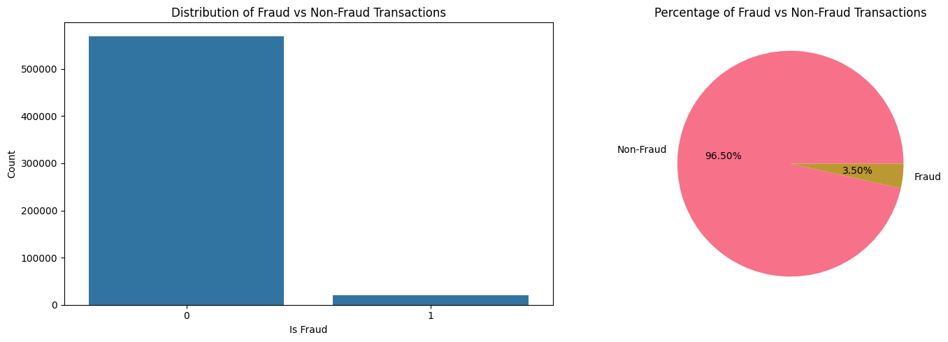
Figure 2: Target Variable Analysis

Detailed Statistics:
- Total Transactions: 590,540
- Fraud Transactions: 20,663
- Non-Fraud Transactions: 569,877
- Fraud Rate: 3.50%
We can see that the class imbalance that is encountered on most fraud detection datasets and is also a phenomenon that is observed in the real world, is shown here too. Only 3.5% of the train data is labeled as fraud.

4.1.3. Missing Values
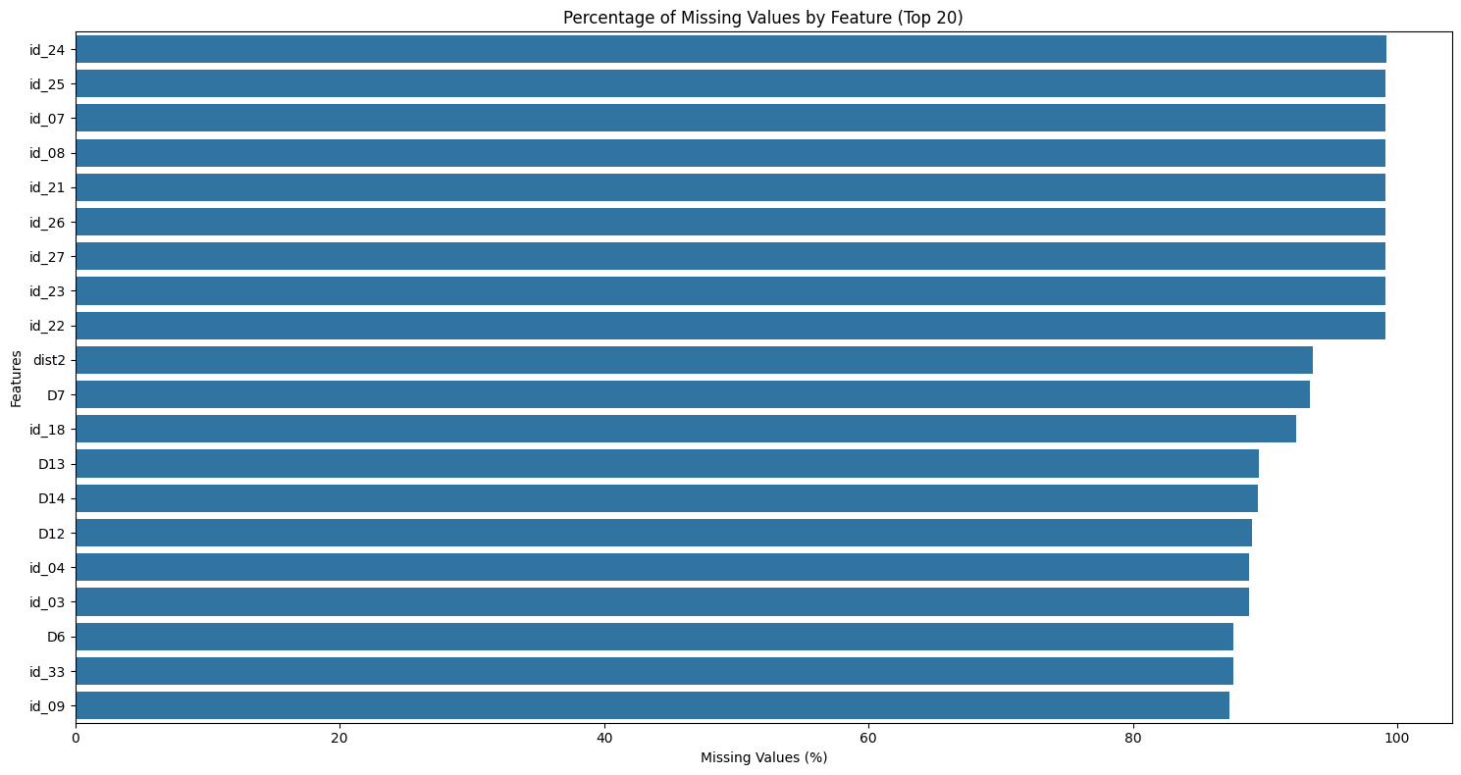
Figure 3: Missing Values

- Features with more than 50% missing values: 214
- Features with 20-50% missing values: 38
We can see that we have a lot of missing values. However, this is expected in a real-world dataset. Often in the real world, the available data is not complete, some info might be missing or corrupted. Especially in the fraud detection case, data missingness might additionally give information about whether a transaction is legit or fraudulent. For example, missingness of user identification data, might mean that the adversary couldn’t provide all the user information. So for our dataset, we drop only the features with > 99% missing values.

4.1.4. Transaction DT (Time)
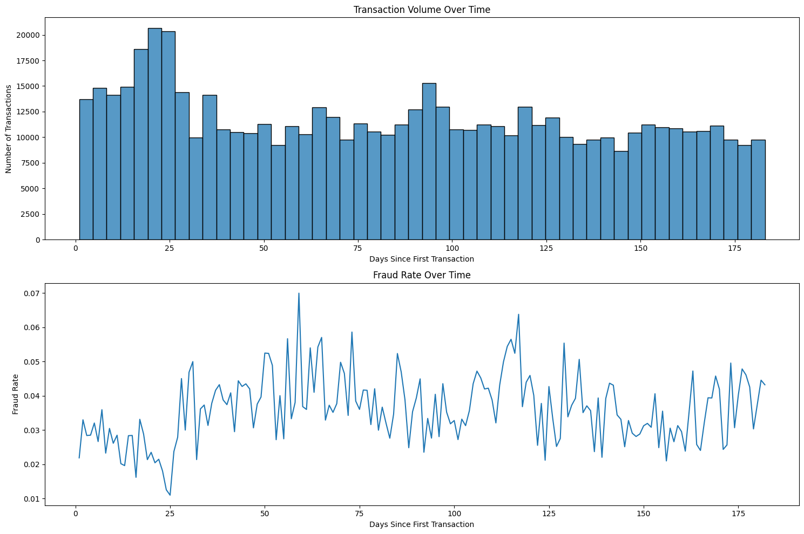
Figure 4: Fraud and Deltatime Relation

Time-based Statistics:
- Total time span: 182.0 days
- Average daily transactions: 3244.7
As we can see, fraud rate and transaction volume over the timespan of the data looks relatively random at first sight. There is no visible pattern. So here we have created 2 new features:
- day_of_week: Day of week that transaction was made
- hour_of_day: Hour of day that transaction was made
These features have a conceptual meaning, as we can later compare each transaction with the relative transaction amount statistics, of the corresponding day of week, or hour of day. So on these features we observe the following:
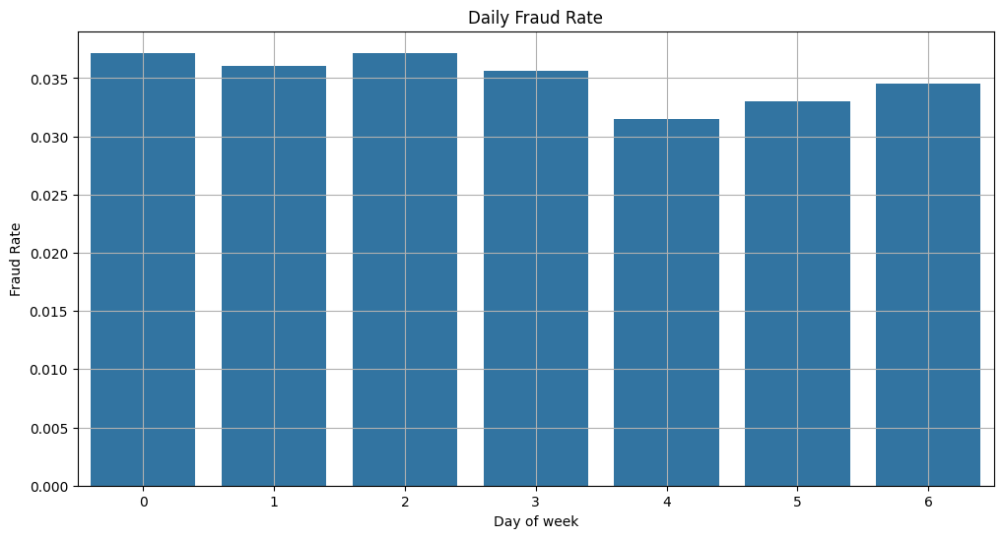
Figure 5: Daily Fraud Rate
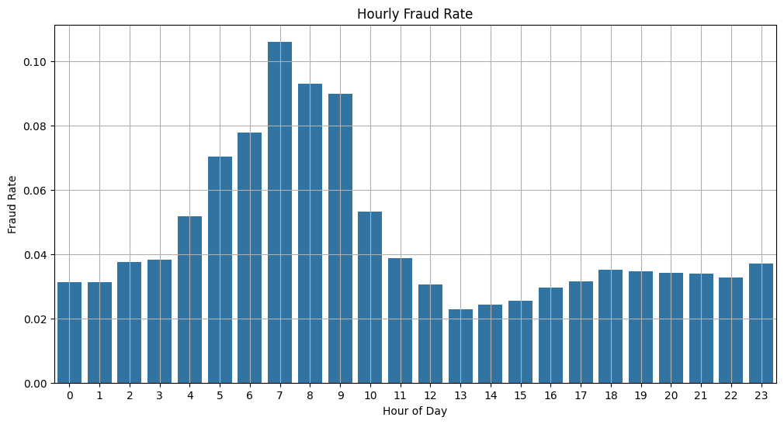
Figure 6: Hourly Fraud Rate
It seems there is a slightly clearer pattern in those features. Also, other features could be aggregated based on these 2 generated features, e.g. transaction amount per hour of day (See later chapters).

4.1.5. Transaction Amount
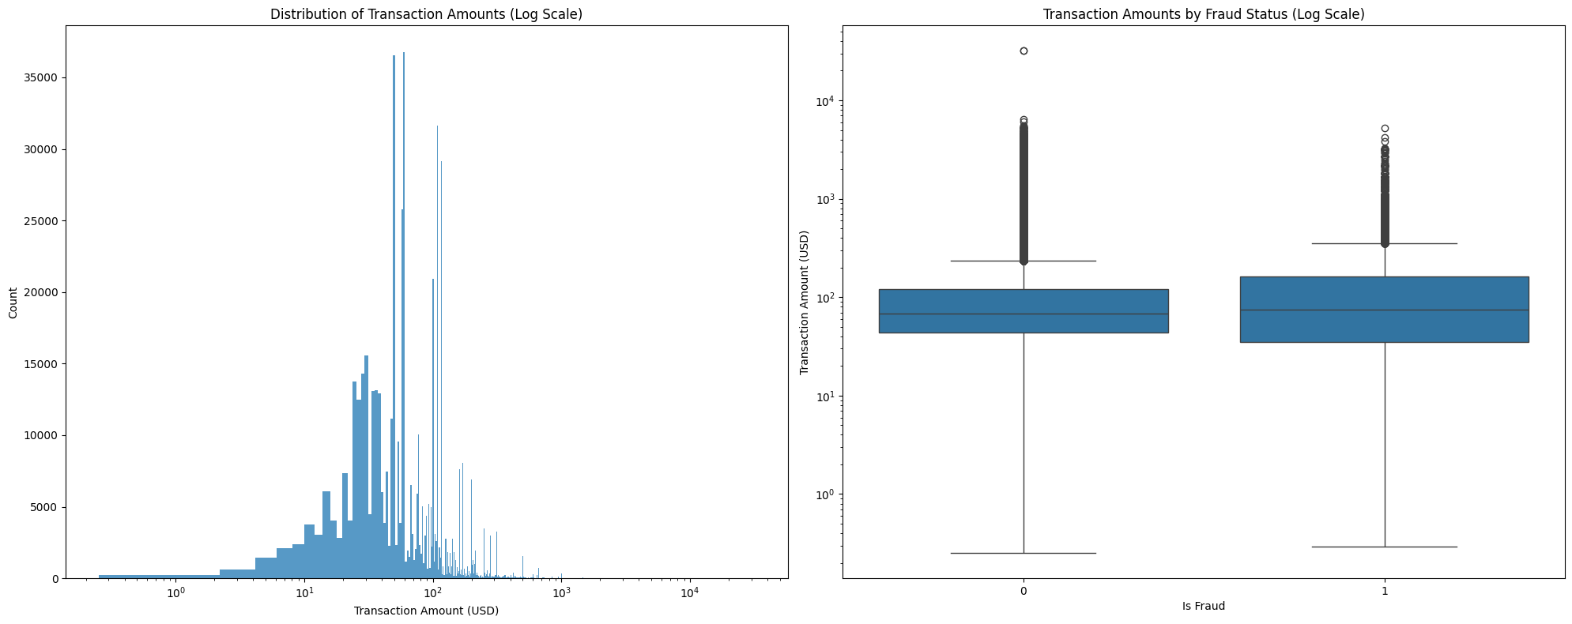
Figure 7: Fraud and Transaction Amount relation

Transaction Amount Statistics:
- Minimum amount: $0.25
- Maximum amount: $31937.39
- Mean amount: $135.03
- Median amount: $68.77
- Q1: $43.32
- Q2: $68.77
- Q3: $125.00
- Q4: $31937.39
Fraud Rate by Transaction Amount Quartile:
- Q1 0.042428
- Q2 0.025090
- Q3 0.028252
- Q4 0.044388
Based on the above Transaction Amount statistics, we can see that the data is extremely skewed to the left, and that there is a higher concentration of fraudulent transactions on the 1st and 4th quartile, (i.e. on the transactions with amount < $43.32 or amount >$125.00)

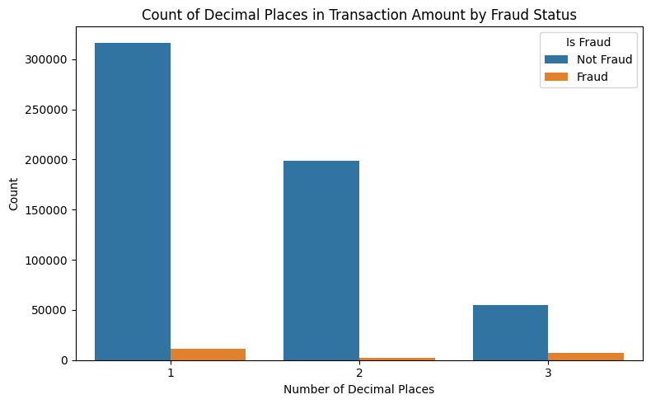
Figure 8: Decimal Places relation to Fraud

Table 1: Decimal Places relation to Fraud
Decimal Places  Is Fraud | 1 | 2 | 3
False | 316638 | 198565 | 54674
True | 11312 (3.45%) | 2092 (1.04%) | 7259 (11.77%)

On the above statistics we can see that transactions that have amount feature logged with 3 decimal places, have a much higher fraud percentage. Note that as we mentioned earlier, 3 decimal places might indicate that the transaction included a currency exchange .

4.1.6. Transaction Categorical Features
The transaction table contains a lot of categorical features. For readability, we do not present all the features here, since a lot of them are anonymized and their results had no significant interpretability. Below follow some interesting results.
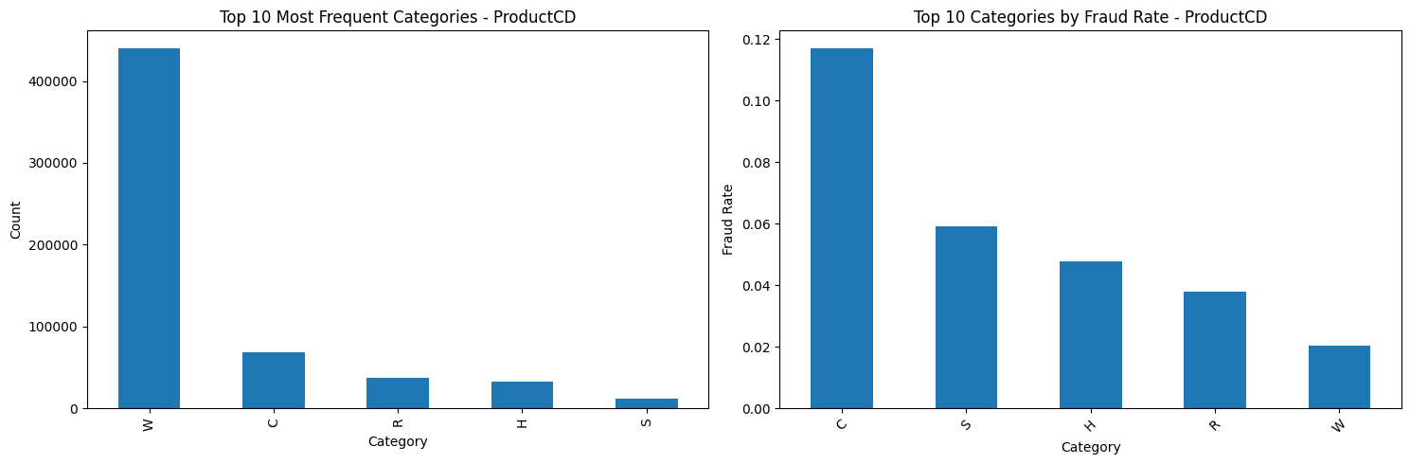
Figure 9: Product Category and Fraud relation
These categories are encoded, but we can see that C category has the largest fraud percentage

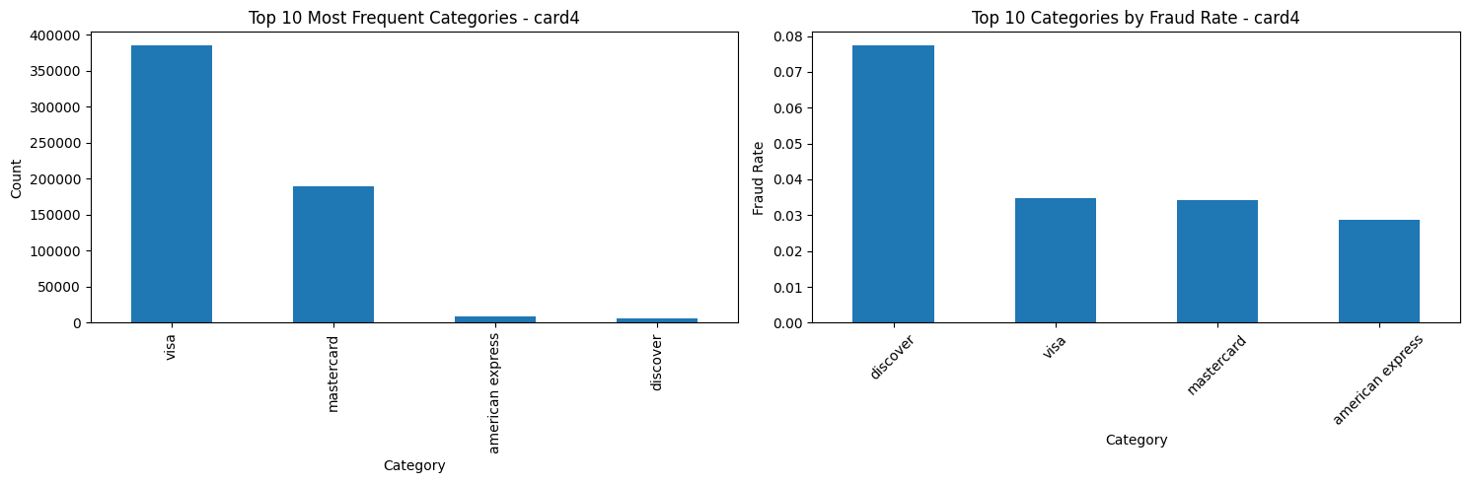
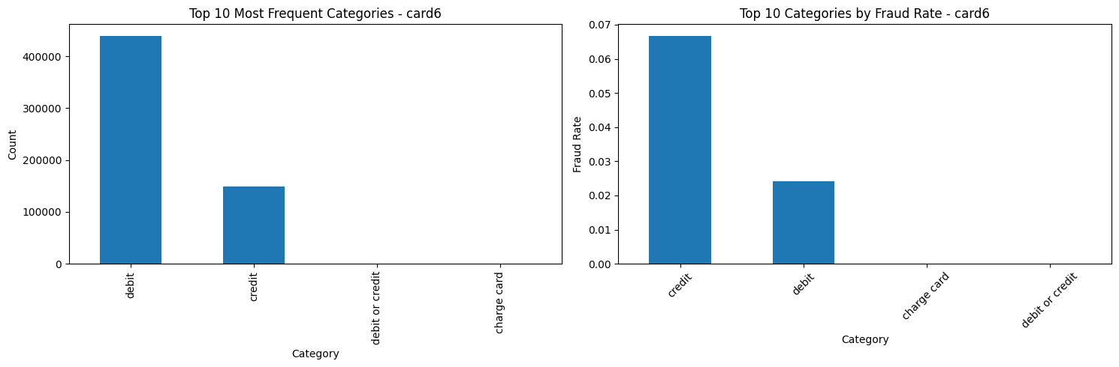
Figure 10: Card Categories and Fraud relation
We can see that some card categories are more likely to be used in fraudulent transactions
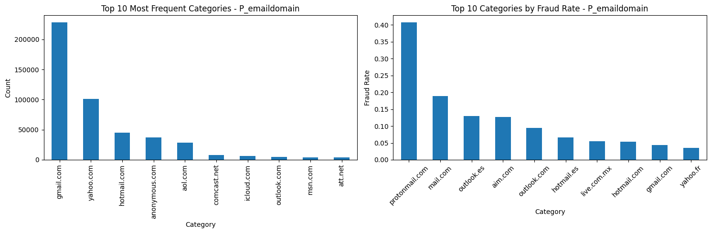
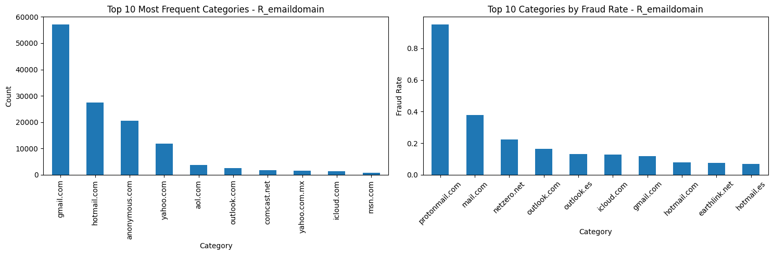
Figure 11: Email Domains and Fraud relation

We can see that some email domains have much higher fraud percentage than others. However, those email domains are relatively rare.

4.1.7. Distance, Count and Time features
Distance Features
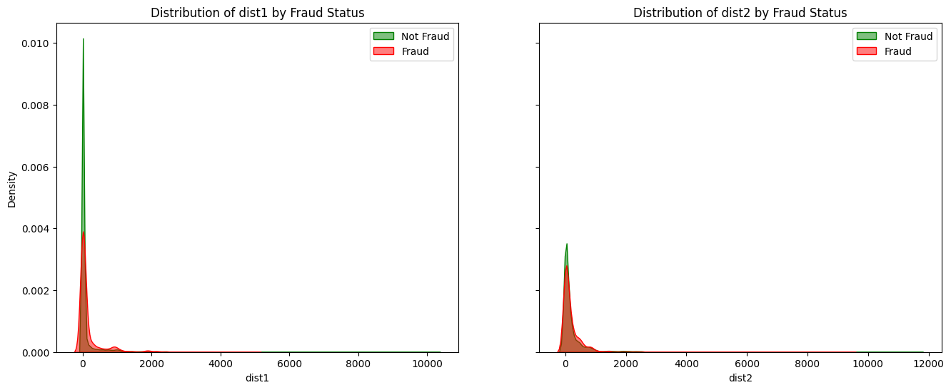
Figure 12: Distance Features and Fraud relation
We can note a bit higher percentage of non-fraud in smaller distances. (Non-fraud transactions tend to have smaller distance features). However, the distance features are not clearly labeled (not documented what distance they are measuring), so we cannot be sure of the interpretation of these graphs.
Count Features
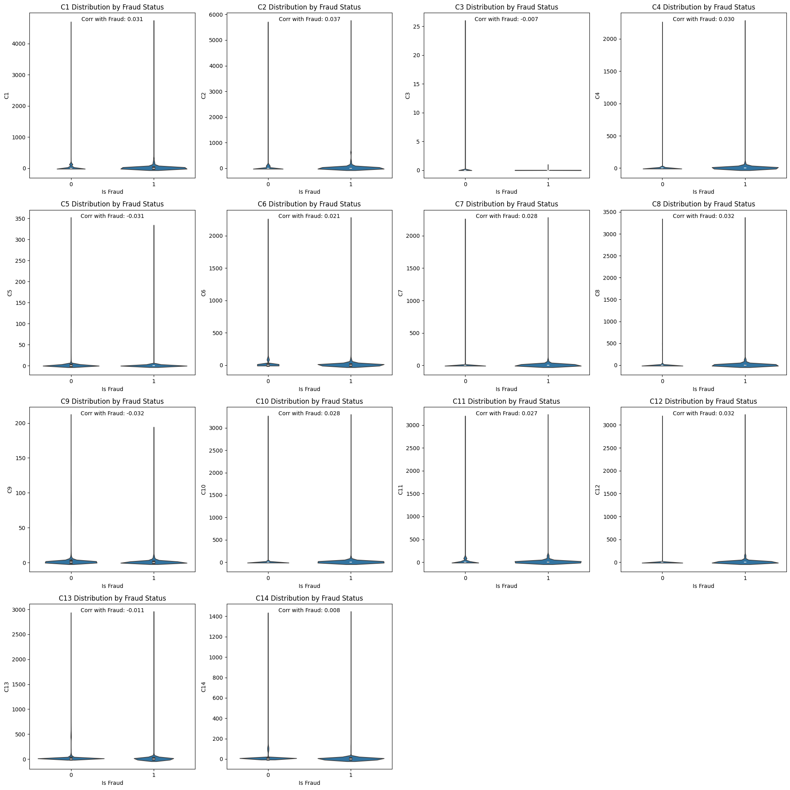
Figure 13: Count Features and Fraud relation
As we can see, none of those count features have a high difference in the fraud and non-fraud distribution or have a notably high correlation with fraud. However, we can see that a lot of count features have similar distribution. So, we perform a correlation analysis on them:
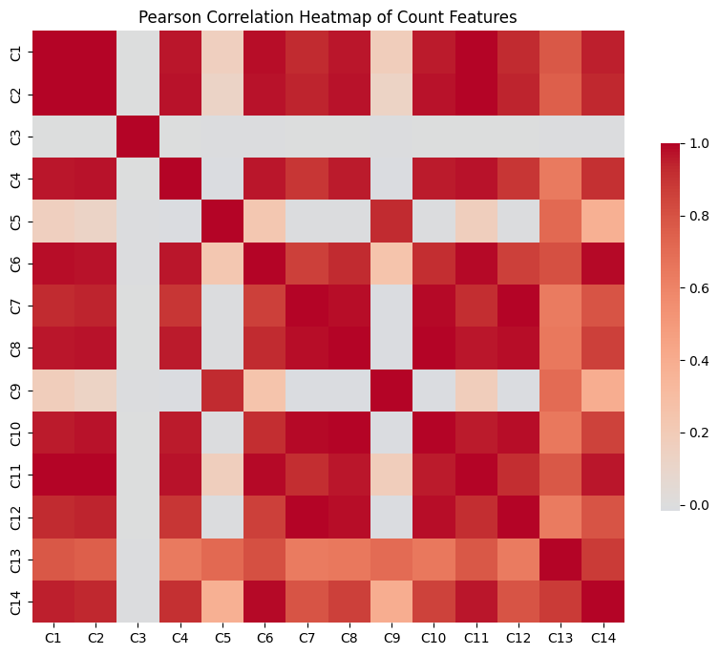
Figure 14: Count Features Correlation
We can see very high correlation between many of them, so we dropped the features with correlation > 90% (10 features dropped: C8, C4, C14, C9, C10, C2, C6, C11, C7, C12)

Time Features
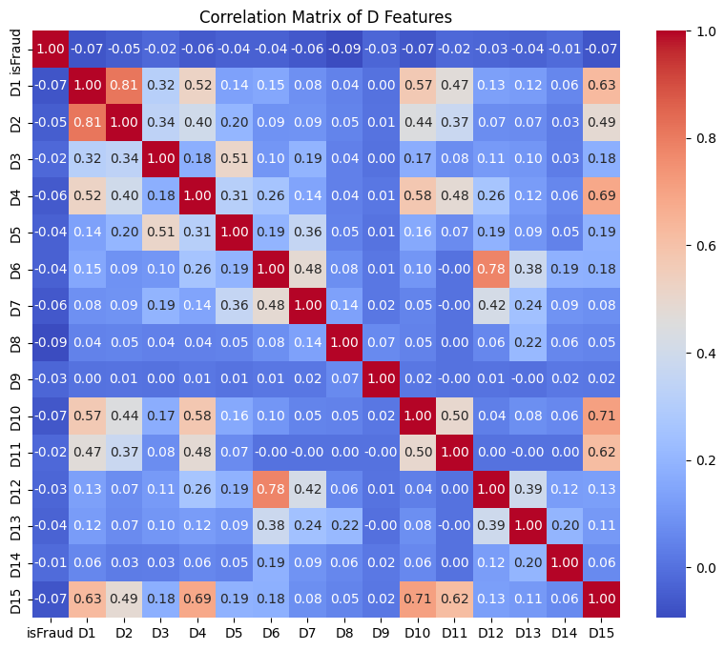
Figure 15: Timedelta features correlation
No timedelta feature is shown to have high correlation with fraud, or high correlation with another feature. We keep them as is, and let later importance calculations decide.

4.1.8. Vesta Features
These features are anonymized aggregated features, they must consist of various aggregations and/or transformations (e.g. sums, averages, or even PCA components). They are numerical and might consist of NaN values. Based on a study by the winners of the Kaggle competition (EDA for Columns V and ID | Kaggle), some features can be dropped, because they were deemed insignificant. So we used the rest of the features. On the following plot we can see that there is really high correlation between the vesta features (even after dropping many of them).
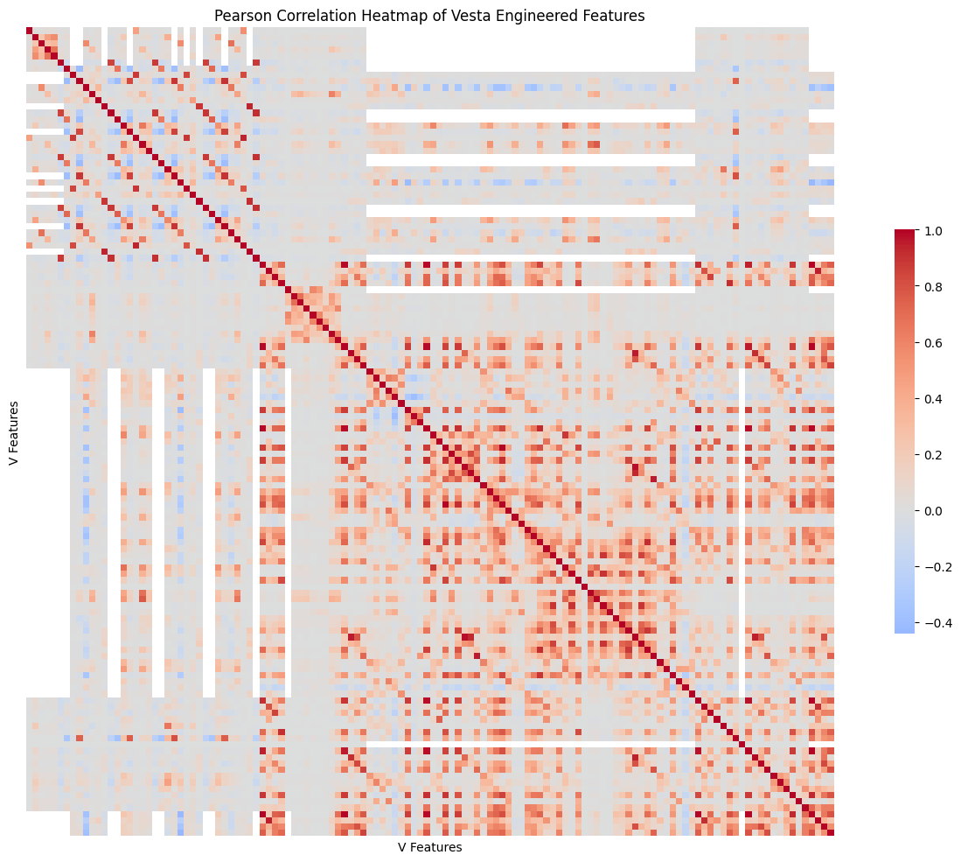
Figure 16: Vesta Features Correlation
The correlation matrix shows us that still a lot of features are very highly correlated. For that reason, we dropped the most correlated features (> 90% correlation score) which reduced the v features by 20.

4.2. Feature Preprocessing and Engineering

4.2.1. Encoding
In sklearn library, the implementation of the gradient boosting trees models (XGBoost, LightGBM and CatBoost) support category features and handle them internally. They only require the marking of such features as category data type. For other models that we tried (but had significantly worse performance) we used one-hot encoding for the smaller cardinality features (up to 10 discrete categories), and frequency encoding for the rest.

4.2.2. Feature Engineering
For feature engineering, we used the following main concepts:
- Concept 1: For various feature pairs where feature A: numeric and feature B: categorical, we grouped feature A based on feature B’s categories, and then calculated mean (μ), standard deviation ($σ^{2}$) and finally z-value $\left(\frac{x-μ}{σ^{2}}\right)$.
- Concept 2: For feature pairs where feature A and B were both categorical, we grouped feature A based on feature B’s categories and then calculated value count and value frequency.
- The user ID concept: In transactional data, in the real world, there is often a user identification available (account ID, or card number, etc.). In our case, for privacy reasons, the data are anonymized. However, in many Kaggle notebooks, there are proposed feature joins/concatenations that can be constructed, so that we can simulate such identification. From the various propositions that we found, we selected the combination of:
  - card1: some card identifier (possibly issuer identification) with a lot of unique values and 0% missingness
  - addr1: billing region
  - D1-TransactionDay (derived from transaction DT): D1 in many Kaggle notebooks, is considered something like “time passed from registration”. So “D1-Transaction Day” is a constant value for a given account.

So given the mentioned concepts, we used Concept 1 for:
- Transaction amount based on Card Categories (features: card1, card4 & card6)
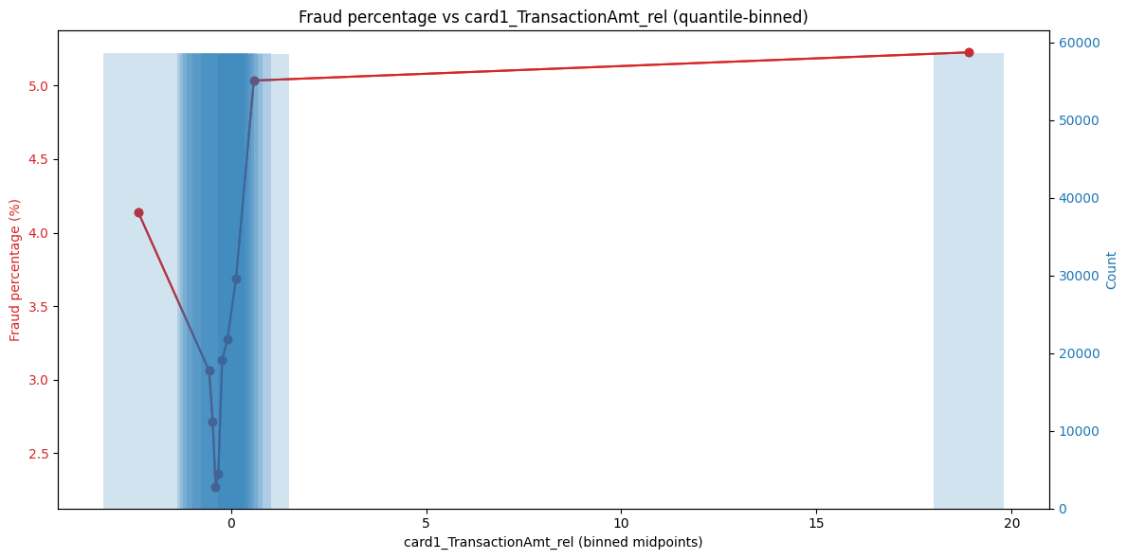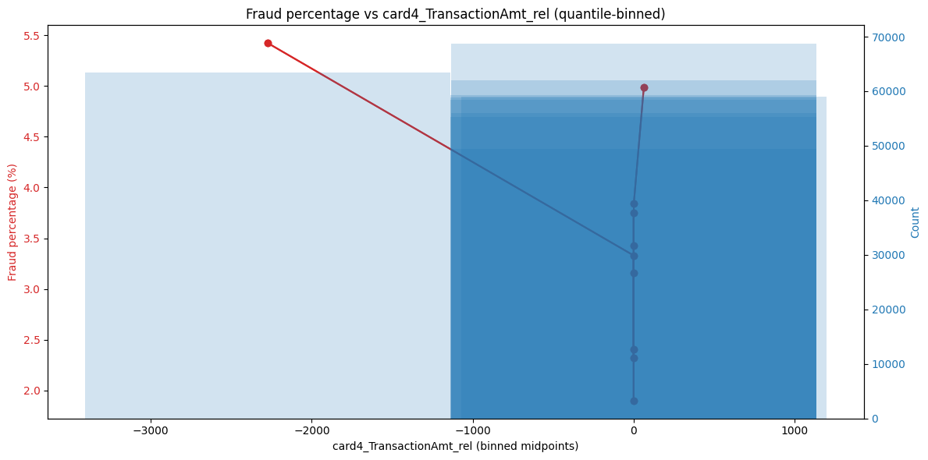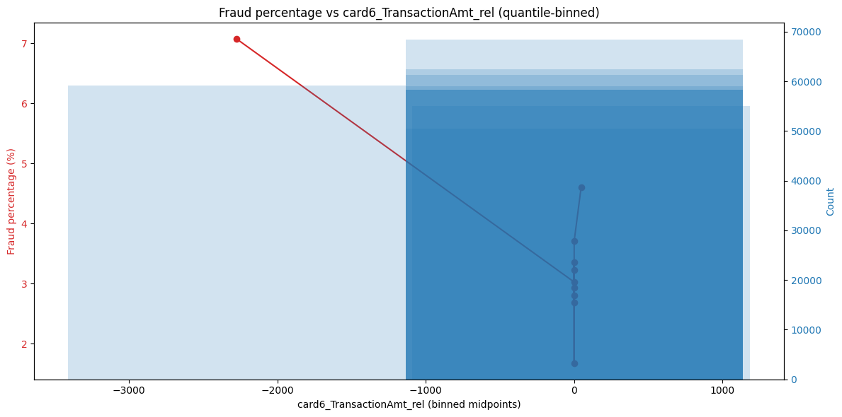
Figure 17: Transaction Amount Related to card type generated features
We can see that the transactions that have Z score closer to 0 (are close to the mean transaction amount per card category) have a smaller fraud rate than those further away.
- Transaction amount based on Product Type
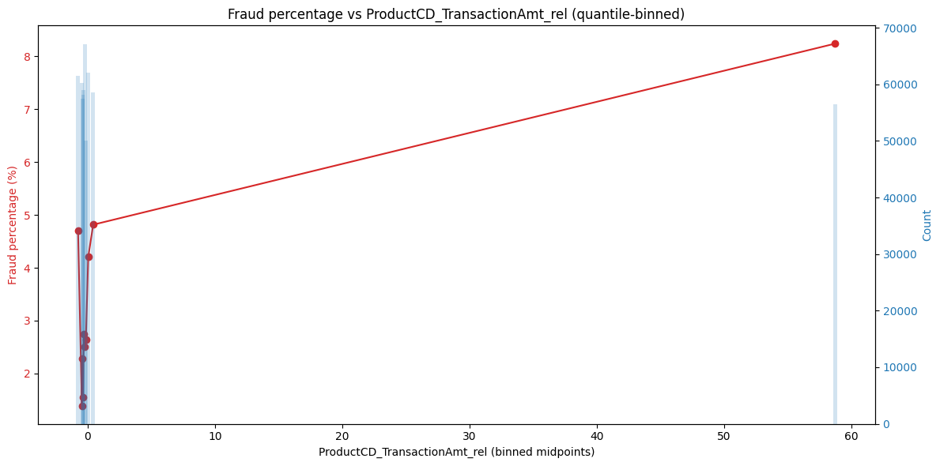
Figure 18: Transaction amount to product category generated feature
Same here, z scores further from 0 show higher fraud percentage
- Transaction amount based on user ID and hour of day
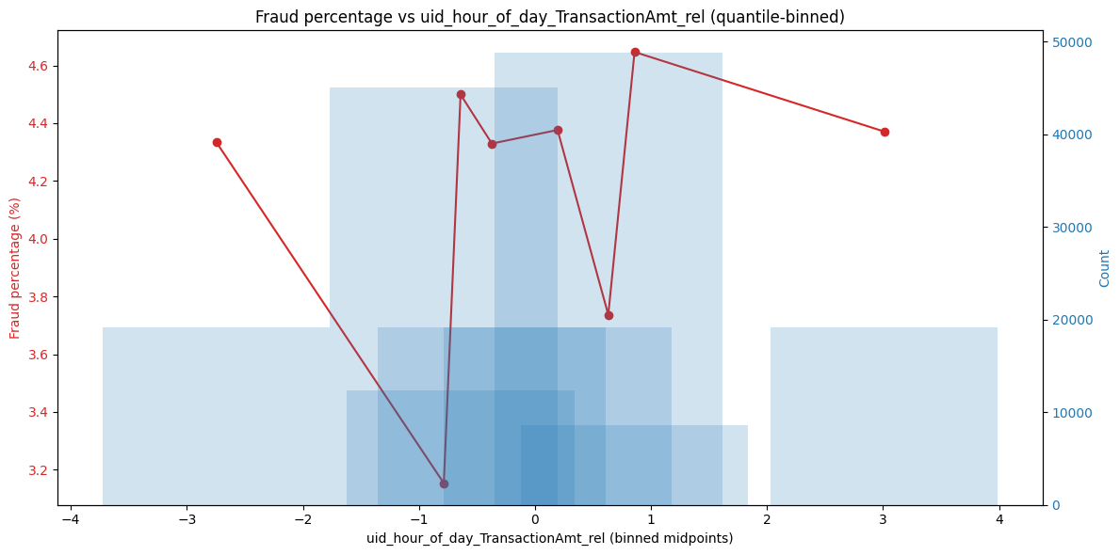
Figure 19: Transaction amount to user id and hour of day

- Transaction amount based on user ID and day of week

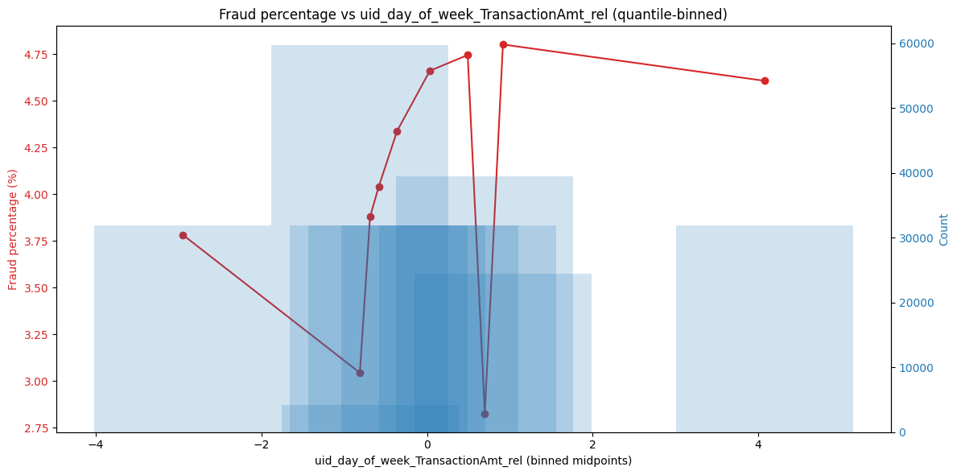
Figure 20: Transaction amount to user id and day of week

- Furthermore, we used the calculated mean std and z-score for all other numerical features based on user ID and Concept 2 for all categorical features based on user ID. This generates a large number of relational features. Many of them are proven to be redundant, but again we rely on later feature importance calculations to dispose of them.

5. Results
This chapter presents the experimental results of the fraud detection models evaluated in this study. All experiments were conducted using the same training–testing split and evaluation protocol described in Chapter 3 to ensure comparability across models and configurations. Model performance is primarily assessed using the ROC-AUC metric, in line with the evaluation protocol of the original Kaggle competition from which the dataset was obtained, where top-performing solutions achieved ROC-AUC scores close to 96%. Secondary metrics, including PR-AUC, precision, recall, and F1-score, are also reported to provide deeper insight into classifier behavior under extreme class imbalance. The experimental results are organized progressively, beginning with baseline models trained on the full imbalanced dataset, followed by downsampling, feature reduction, and decision threshold tuning experiments.

5.1. Full Features and Data
This section presents baseline results for XGBoost, LightGBM, and CatBoost trained using the full feature set and the original imbalanced dataset. These experiments establish a reference point for evaluating the impact of data balancing and feature reduction techniques.
Table of Metrics:
Table 2: Table of metrics for full features
Name | roc_auc | pr_auc | f1 | precision | recall
XGBoost | 0.896 | 0.487 | 0.384 | 0.269 | 0.671
LightGBM | 0.918 | 0.537 | 0.506 | 0.463 | 0.558
CatBoost | 0.910 | 0.519 | 0.380 | 0.258 | 0.725
XGBoost:
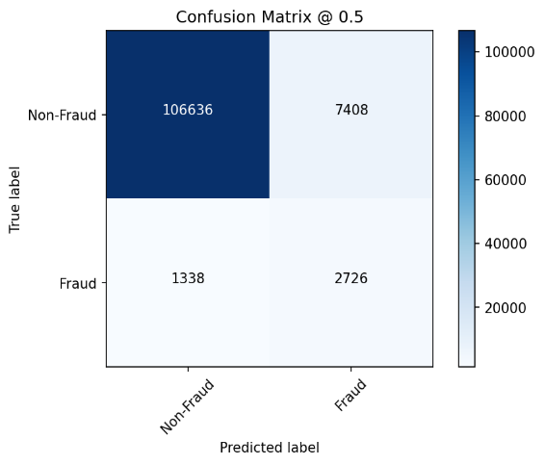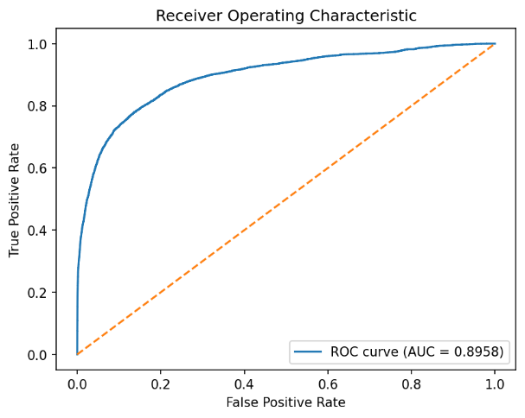
Figure 21: XGBoost full feature plots
LightGBM:
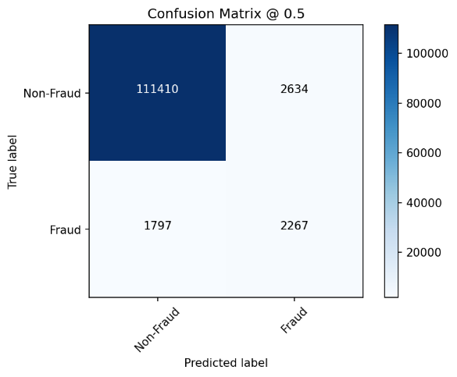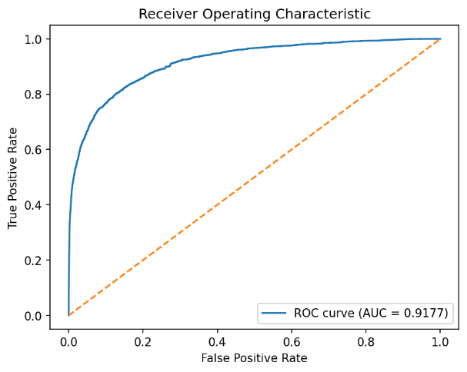
Figure 22: LGBM full features plots
CatBoost:
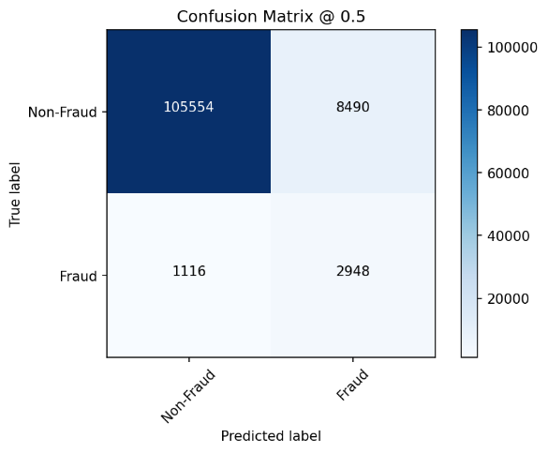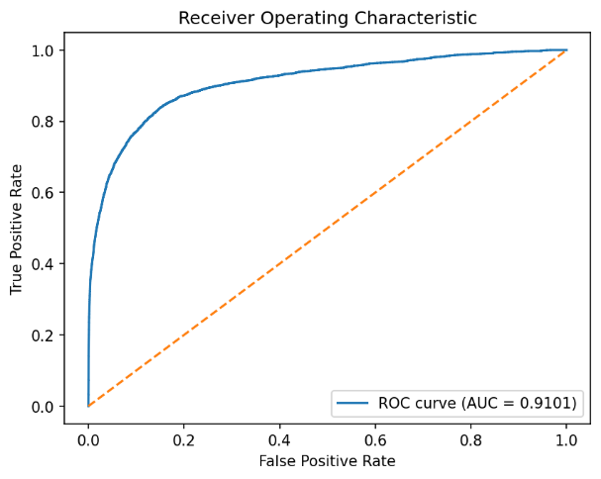
Figure 23: CatBoost full features plots
LightGBM achieved the highest ROC-AUC score of 0.918, outperforming XGBoost (0.896) and CatBoost (0.910), indicating superior ranking ability in distinguishing fraudulent from legitimate transactions. While CatBoost attained the highest recall (0.725), this was accompanied by low precision, reflecting the inherent trade-off between sensitivity and false positive rate in imbalanced classification problems. Overall, modest performance across all models highlights the difficulty of fraud detection under severe class imbalance.

5.2. Downsampling
To mitigate the impact of class imbalance, random downsampling of the majority (non-fraud) class was applied, with final fraud to non fraud ratio 1:5. This section evaluates the effect of this balancing strategy on model performance using the full feature set
Table of Metrics:
Table 3: Table of Metrics for downsampled data
Name | roc_auc | pr_auc | f1 | precision | recall
XGBoost | 0.908 | 0.508 | 0.384 | 0.264 | 0.703
LightGBM | 0.917 | 0.581 | 0.498 | 0.414 | 0.626
CatBoost | 0.916 | 0.525 | 0.386 | 0.264 | 0.724
XGBoost:
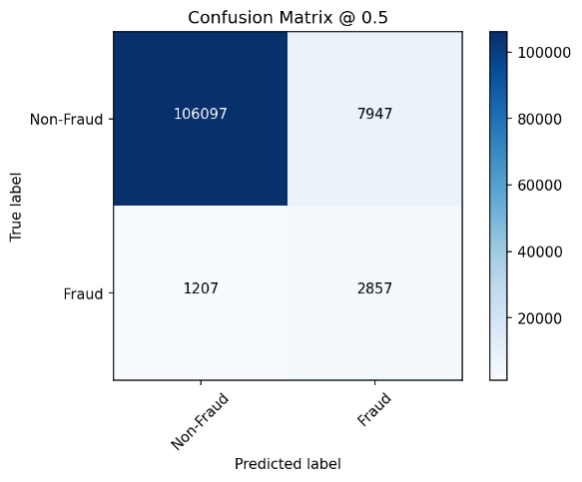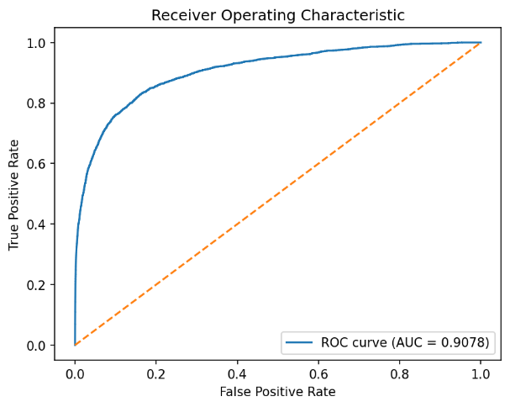
Figure 24: XGBoost downsampled plots
LightGBM:
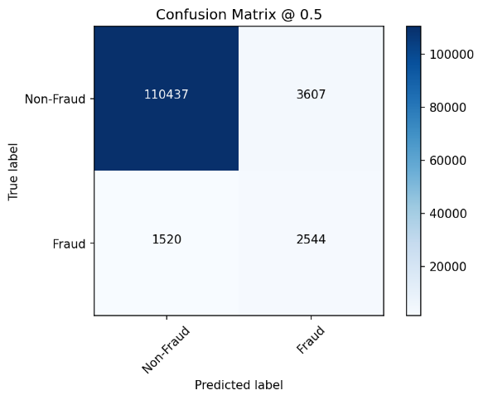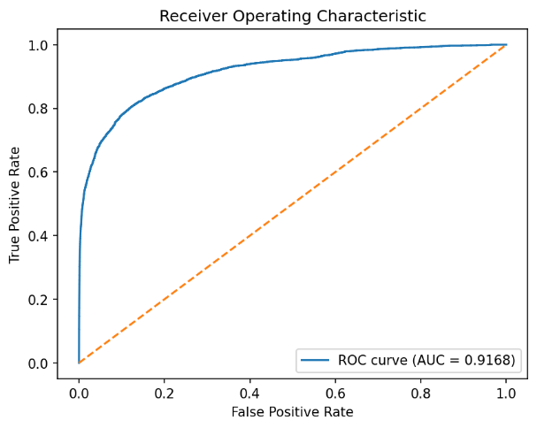
Figure 25: LGBM downsampled plots

CatBoost:
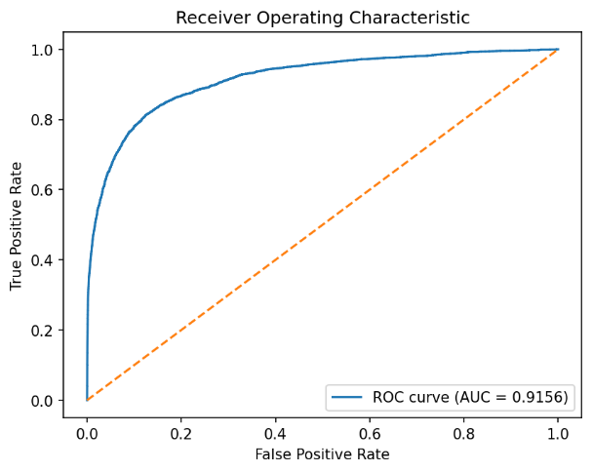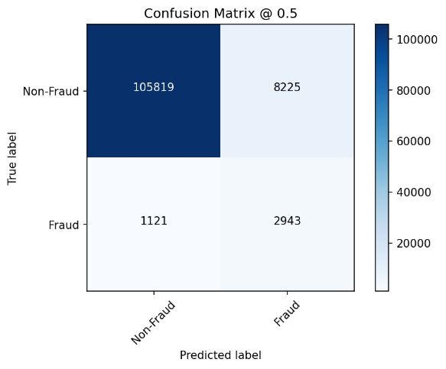
Figure 26: CatBoost downsampled plots
Downsampling resulted in improved classification performance across all models. LightGBM remained the best performant model, even though it’s ROC-AUC did not improve. However we can see that average precision metric (PR-AUC) improved significantly. Also notably, XGBoost and CatBoost exhibited moderate ROC-AUC and PR-AUC improvements, suggesting enhanced discrimination capability after class balancing. These results confirm that downsampling alleviates the bias toward the majority class, enabling models to better learn fraud-related patterns.

5.3. Reduced Features
Feature importance analysis was conducted using all three gradient boosting models to identify the most influential variables. The final reduced feature set was derived by averaging importance scores across models, selecting the most consistently informative features. The final features selected were the ones that were on the top 30% of most important features for at least 2 of the 3 models.
feature | XGBoost | Light GBM | CAT boost | importance mean
C1 | 0.326 | 0.523 | 0.417 | 0.422
C13 | 0.188 | 0.319 | 0.209 | 0.239
V70 | 0.119 | 0.358 | 0.064 | 0.180
uid_V258_mean | 0.175 | 0.206 | 0.049 | 0.143
ProductCD_TransactionAmt_rel | 0.134 | 0.138 | 0.149 | 0.141
uid_C1_mean | 0.127 | 0.119 | 0.162 | 0.136
DeviceInfo | 0.160 | 0.156 | 0.080 | 0.132
V258 | 0.136 | 0.230 | 0.028 | 0.131
uid_V283_mean | 0.120 | 0.173 | 0.098 | 0.130
uid_C13_std | 0.099 | 0.137 | 0.154 | 0.130
uid_C13_rel | 0.119 | 0.139 | 0.130 | 0.129
card1_id_02_mean | 0.101 | 0.134 | 0.108 | 0.114
P_emaildomain | 0.118 | 0.142 | 0.060 | 0.107
uid_C13_mean | 0.073 | 0.151 | 0.088 | 0.104
uid_D2_std | 0.074 | 0.099 | 0.130 | 0.101
uid_M4_freq | 0.118 | 0.053 | 0.125 | 0.099
uid_time_since_prev_mean | 0.089 | 0.109 | 0.092 | 0.097
card1_TransactionAmt_mean | 0.061 | 0.106 | 0.080 | 0.083
card6 | 0.085 | 0.044 | 0.105 | 0.078
R_emaildomain | 0.052 | 0.087 | 0.063 | 0.067
id_31 | 0.071 | 0.085 | 0.043 | 0.067
uid_TransactionAmt_mean | 0.055 | 0.070 | 0.068 | 0.064
V30 | 0.042 | 0.074 | 0.063 | 0.060
uid_D3_mean | 0.040 | 0.076 | 0.063 | 0.060
card1 | 0.048 | 0.061 | 0.063 | 0.057
uid_V187_mean | 0.082 | 0.043 | 0.045 | 0.057
P_emaildomain_1 | 0.038 | 0.035 | 0.076 | 0.050
V187 | 0.046 | 0.079 | 0.024 | 0.050
card1_id_02_std | 0.030 | 0.056 | 0.060 | 0.048

The feature importance analysis indicates that a large proportion of the most influential variables correspond to engineered features introduced in the feature engineering phase, particularly those capturing aggregated and historical user behavior (e.g., features ending in _mean, _rel, _avg, _std, and _freq). These features consistently rank highly across all three models, suggesting that the engineered representations successfully capture informative behavioral patterns relevant to fraud detection. This observation supports the effectiveness of the feature engineering process while maintaining a balanced contribution alongside original transaction-level features. The most influential variables include transaction-level attributes, aggregated user behavioral statistics, and device-related features, indicating that both transactional characteristics and historical user behavior are critical for effective fraud detection. Models were retrained using the reduced feature set on the downsampled dataset to assess whether comparable predictive performance could be achieved with lower dimensionality.
Table of Metrics:
Table 4: Table of Metrics for reduced features
Name | roc_auc | pr_auc | f1 | precision | recall
XGBoost | 0.905 | 0.511 | 0.416 | 0.300 | 0.678
LGBM | 0.919 | 0.566 | 0.456 | 0.348 | 0.661
CatBoost | 0.914 | 0.539 | 0.422 | 0.298 | 0.720

XGBoost:
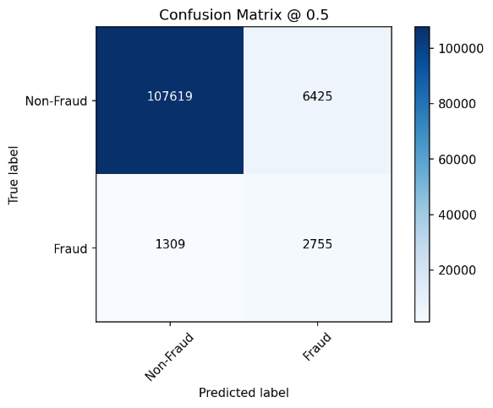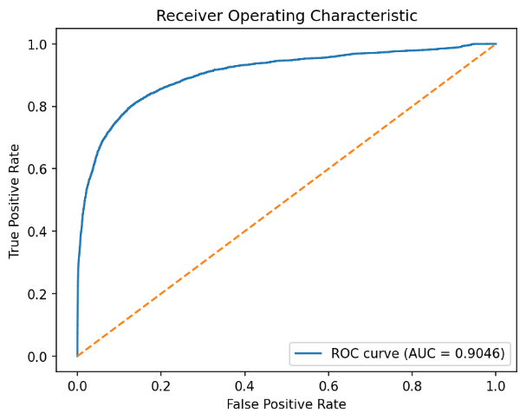
Figure 27: XGBoost reduced features plots

LightGBM:
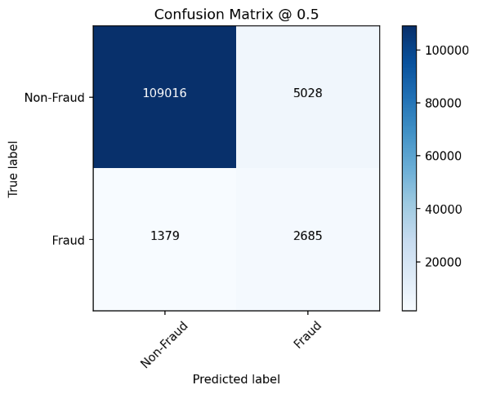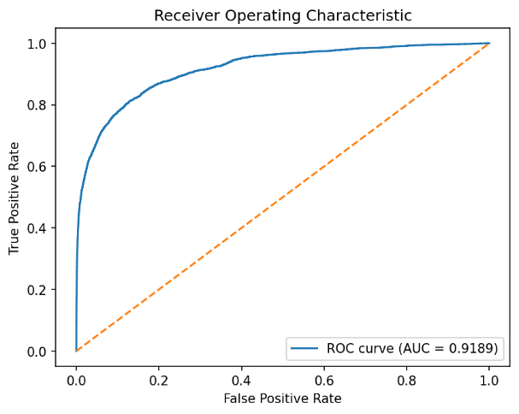
Figure 28: LGBM reduced features plots
CatBoost:
Figure 29: CatBoost reduced features plots
Despite the substantial reduction in feature dimensionality (which also resulted in much faster inference), all models retained strong discriminatory performance. LightGBM achieved the highest ROC-AUC score again (0.919), marginally exceeding its performance using the full feature set. CatBoost and XGBoost maintained comparable ROC-AUC values, demonstrating that the selected features preserve most of the dataset’s predictive information. These results suggest that dimensionality reduction can improve model efficiency without sacrificing detection capability.

5.4. Decision Threshold Tuning
In practical fraud detection systems, maximizing recall is often prioritized to minimize missed fraudulent transactions. To examine this trade-off, additional experiments were conducted by lowering the classification threshold to 0.1.
Table of Metrics:
Table 5: table of metrics for decision threshold tuning
Name | f1 | precision | recall
XGBoost @ threshold = 0.1 | 0.155 | 0.085 | 0.922
LGBM @ threshold = 0.1 | 0.196 | 0.110 | 0.895
CATBoost @ threshold = 0.1 | 0.140 | 0.076 | 0.938
XGBoost:
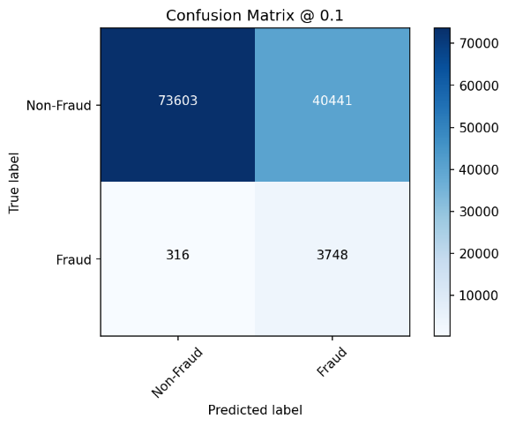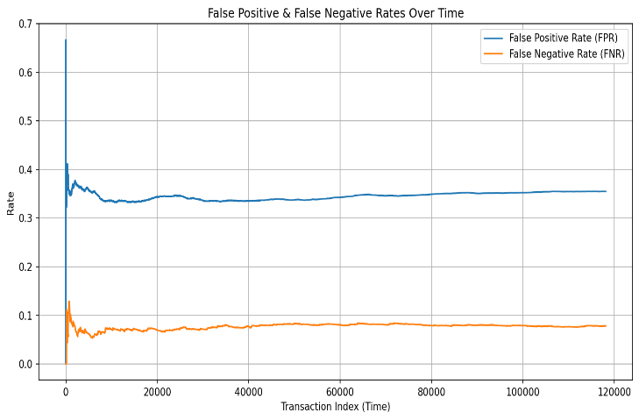
Figure 30: XGBoost 0.1 decision threshold plots
LightGBM:
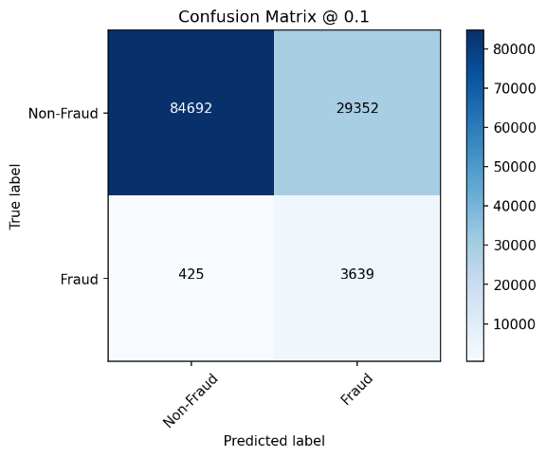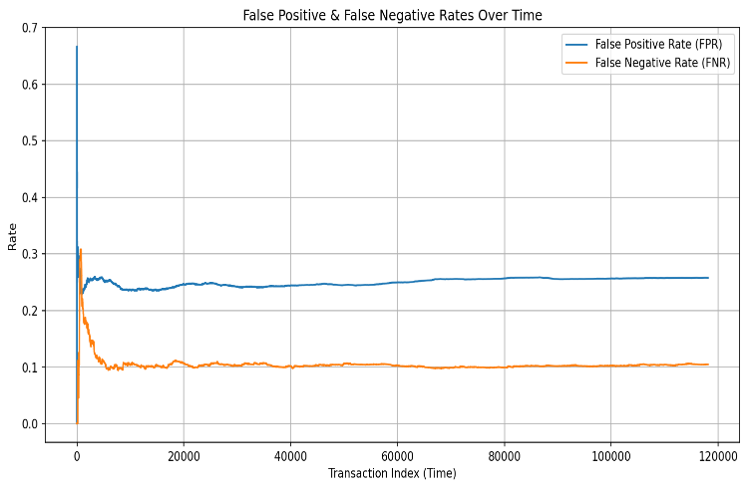
Figure 31: LGBM 0.1 decision threshold plots
CatBoost:
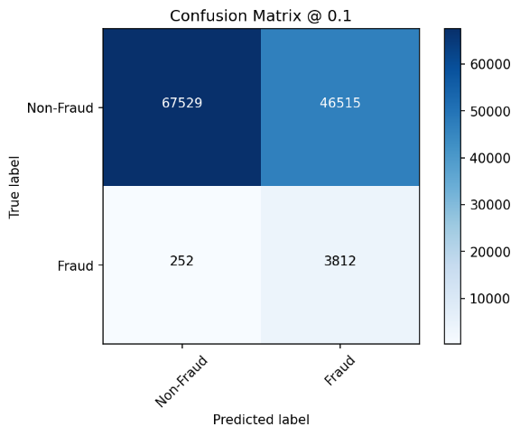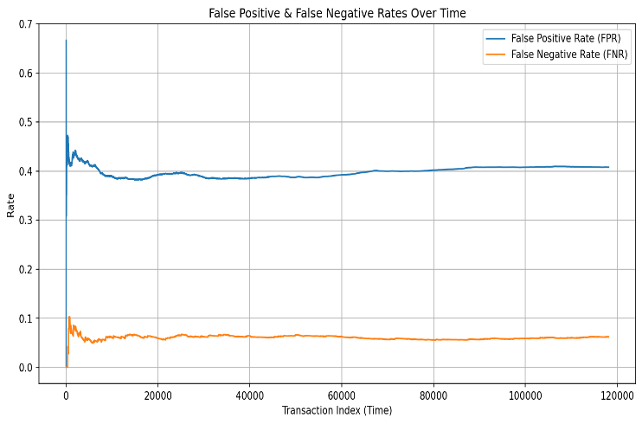
Figure 32: CatBoost 0.1 decision threshold plots

Reducing the decision threshold led to a substantial increase in recall, exceeding 89% across all models. However, this improvement came at the expense of significantly lower precision and F1-score, indicating a high false positive rate. This drastic change can also be seen in the confusion matrix and false positive vs false negative rates plots. For example in the LGBM plots (which is the best performing model), we can see that a significant proportion of fraudulent transactions are identified (3812 from 2985 out of 4120), but there is an extreme increase in false positives (increased to 29352 from 5028!). The false positive and false negative rates are also plotted over time. So, from these plots we can see that the rates are stable over time, so our models are quite robust, at least regarding the timespan that the test dataset covers.These findings highlight the operational trade-off between fraud detection sensitivity and alert volume, emphasizing the importance of threshold optimization based on business constraints and operational capacity. This threshold can be further trained, to achieve optimal balance between precision and recall, based on the cost of each fraud case, and the business environment that these models are applied on.
In practical fraud detection systems, the decision threshold is not selected solely to maximize a single metric, but to balance detection performance with operational constraints. Lowering the threshold typically increases recall (fewer fraudulent transactions missed) while also increasing false positives, which translates into additional manual review workload and potentially higher customer friction. Raising the threshold reduces the number of flagged transactions and review effort, but can allow more fraud to pass undetected. For this reason, the chosen threshold should reflect business priorities (e.g., minimizing missed fraud vs. minimizing unnecessary reviews) and available analyst capacity, and it may require periodic adjustment over time.

5.5. Overall Experimental Summary
Across all experiments, LightGBM consistently achieved the highest ROC-AUC, demonstrating superior ranking performance and stability under different training configurations. Downsampling significantly improved model learning, while feature reduction preserved predictive performance with lower dimensional complexity. Decision threshold tuning further illustrated the sensitivity-precision trade-off inherent in fraud detection systems. The results of this thesis could be further improved by introducing more explanatory features that help identify the fraudulent transactions, or/and by providing more data.

6. Conclusions – Future Research

6.1. Conclusions
This thesis examined the use of supervised machine learning methods for credit card fraud detection in a highly imbalanced binary classification dataset. The experiments focused on three gradient boosting models (XGBoost, LightGBM, and CatBoost) under different configurations: (i) full feature set with the original imbalanced data, (ii) full feature set with majority-class downsampling, (iii) reduced feature set with downsampling, and (iv) decision-threshold tuning for operational priorities. Model performance was mainly evaluated using ROC-AUC, following the protocol of the Kaggle competition from which the dataset was obtained. Additional metrics such as precision, recall, F1-score, and PR-AUC were also reported to better interpret results under class imbalance.
Across all settings, LightGBM showed the most stable discriminatory performance, achieving ROC-AUC values around 0.918–0.919. Downsampling improved detection behavior compared to training on the fully imbalanced dataset. Feature reduction also maintained competitive results while simplifying the feature space. Many of the most important predictors were engineered aggregate features (e.g., mean, frequency, and standard deviation variables), showing that behavioral feature engineering was useful for fraud detection.
Threshold tuning increased recall significantly, reaching values close to 0.90 at low threshold, but also produced more false positives. This highlights the usual trade-off between sensitivity and precision in fraud screening systems.
Overall, four main conclusions can be drawn: (1) gradient boosting models provide strong baseline performance for fraud detection in this dataset, with LightGBM being the most robust approach, (2) majority-class downsampling is a practical strategy for improving learning under extreme imbalance, (3) engineered behavioral aggregate features can preserve predictive power even when the feature set is reduced, and (4) the decision threshold is a key operational lever that controls the trade-off between recall and precision, meaning the appropriate threshold should be selected according to business cost asymmetries and available investigation capacity rather than relying on a default value.

6.2. Future Research
While the proposed approach achieved strong and stable performance across multiple experimental settings, several extensions could further enhance the system and improve its practical applicability. First, future work could explore cost-aware decision making by selecting classification thresholds based on operational constraints (e.g., manual review capacity) or explicit business costs associated with false positives and false negatives. Second, the models could be complemented with probability calibration methods to ensure that predicted risk scores better reflect true fraud likelihood, which is valuable for prioritization and downstream decision support. In addition, performance could be further improved by incorporating richer and more explanatory features, such as behavioral histories, temporal patterns, or relational signals between entities, as well as by training on larger and more diverse transaction datasets. Access to more data could help the models better generalize and detect rare fraud patterns more reliably. Finally, additional experimentation with ensemble strategies (e.g., blending gradient boosting models) and drift-aware evaluation could improve robustness in scenarios where fraud patterns evolve over time.

6.3. Closing Statement
This thesis demonstrated that gradient boosting methods, combined with a targeted feature engineering strategy and appropriate handling of class imbalance, provide strong and stable performance for credit card fraud detection on the examined dataset. LightGBM consistently achieved the highest ROC-AUC across experimental settings, while downsampling and reduced-feature modelling showed that effective behavioral aggregates can retain high discriminatory power with a simpler feature set. The threshold tuning analysis further highlighted that operational deployment requires explicit trade-off management between fraud capture and false positive burden. Collectively, these findings provide a reproducible foundation for future work on cost-aware, drift-robust, and interpretable fraud detection systems.

7. References
- Al-Hashedi, K.G. and Magalingam, P. (2021) “Financial fraud detection applying data mining techniques: A comprehensive review from 2009 to 2019,” Computer Science Review, 40, p. 100402. Available at: https://doi.org/10.1016/j.cosrev.2021.100402.
- Ali, A. et al. (2022) “Financial Fraud Detection Based on Machine Learning: A Systematic Literature Review,” Applied Sciences, 12(19), p. 9637. Available at: https://doi.org/10.3390/app12199637.
- Aljunaid, S.K. et al. (2025) “Secure and Transparent Banking: Explainable AI-Driven Federated Learning Model for Financial Fraud Detection,” Journal of Risk and Financial Management, 18(4), p. 179. Available at: https://doi.org/10.3390/jrfm18040179.
- Awoyemi, J.O., Adetunmbi, A.O. and Oluwadare, S.A. (2017) “Credit card fraud detection using machine learning techniques: A comparative analysis,” 2017 International Conference on Computing Networking and Informatics (ICCNI). 2017 International Conference on Computing Networking and Informatics (ICCNI), pp. 1–9. Available at: https://doi.org/10.1109/ICCNI.2017.8123782.
- Bhattacharyya, S. et al. (2011) “Data mining for credit card fraud: A comparative study,” Decision Support Systems, 50(3), pp. 602–613. Available at: https://doi.org/10.1016/j.dss.2010.08.008.
- Cheng, D. et al. (2020) “Spatio-Temporal Attention-Based Neural Network for Credit Card Fraud Detection,” Proceedings of the AAAI Conference on Artificial Intelligence, 34(01), pp. 362–369. Available at: https://doi.org/10.1609/aaai.v34i01.5371.
- Dal Pozzolo, A. et al. (2018) “Credit Card Fraud Detection: A Realistic Modeling and a Novel Learning Strategy,” IEEE Transactions on Neural Networks and Learning Systems, 29(8), pp. 3784–3797. Available at: https://doi.org/10.1109/TNNLS.2017.2736643.
- Dang, T.K. et al. (2021) “Machine Learning Based on Resampling Approaches and Deep Reinforcement Learning for Credit Card Fraud Detection Systems,” Applied Sciences, 11(21), p. 10004. Available at: https://doi.org/10.3390/app112110004.
- Dornadula, V.N. and Geetha, S. (2019) “Credit Card Fraud Detection using Machine Learning Algorithms,” Procedia Computer Science, 165, pp. 631–641. Available at: https://doi.org/10.1016/j.procs.2020.01.057.
- Hernandez Aros, L. et al. (2024) “Financial fraud detection through the application of machine learning techniques: a literature review,” Humanities and Social Sciences Communications, 11(1), p. 1130. Available at: https://doi.org/10.1057/s41599-024-03606-0.
- Hsin, Y.-Y. et al. (2022) “Feature Engineering and Resampling Strategies for Fund Transfer Fraud With Limited Transaction Data and a Time-Inhomogeneous Modi Operandi,” IEEE Access, 10, pp. 86101–86116. Available at: https://doi.org/10.1109/ACCESS.2022.3199425.
- Jurgovsky, J. et al. (2018) “Sequence classification for credit-card fraud detection,” Expert Systems with Applications, 100, pp. 234–245. Available at: https://doi.org/10.1016/j.eswa.2018.01.037.
- Lopez-Rojas, E.A. and Axelsson, S. (2014) “BANKSIM: A BANK PAYMENTS SIMULATOR FOR FRAUD DETECTION RESEARCH.”
- Malini, N. and Pushpa, M. (2017) “Analysis on credit card fraud identification techniques based on KNN and outlier detection,” 2017 Third International Conference on Advances in Electrical, Electronics, Information, Communication and Bio-Informatics (AEEICB). 2017 Third International Conference on Advances in Electrical, Electronics, Information, Communication and Bio-Informatics (AEEICB), pp. 255–258. Available at: https://doi.org/10.1109/AEEICB.2017.7972424.
- Ngai, E.W.T. et al. (2011) “The application of data mining techniques in financial fraud detection: A classification framework and an academic review of literature,” Decision Support Systems, 50(3), pp. 559–569. Available at: https://doi.org/10.1016/j.dss.2010.08.006.
- Sahin, Y. and Duman, E. (2011) “Detecting credit card fraud by ANN and logistic regression,” 2011 International Symposium on Innovations in Intelligent Systems and Applications. 2011 International Symposium on Innovations in Intelligent Systems and Applications, pp. 315–319. Available at: https://doi.org/10.1109/INISTA.2011.5946108.
- Sofia Patel et al. (2025) Leveraging Reinforcement Learning for Real-Time Fraud Detection in Financial Transactions, ResearchGate. Available at: https://doi.org/10.13140/RG.2.2.12519.15525.
- Thennakoon, A. et al. (2019) “Real-time Credit Card Fraud Detection Using Machine Learning,” 2019 9th International Conference on Cloud Computing, Data Science & Engineering (Confluence). 2019 9th International Conference on Cloud Computing, Data Science & Engineering (Confluence), pp. 488–493. Available at: https://doi.org/10.1109/CONFLUENCE.2019.8776942.
- Ti, Y.-W. et al. (2022) “Feature generation and contribution comparison for electronic fraud detection,” Scientific Reports, 12(1), p. 18042. Available at: https://doi.org/10.1038/s41598-022-22130-2.
- Waleed Hilal, S. Andrew Gadsden, and John Yawney (2021) “Financial Fraud: A Review of Anomaly Detection Techniques and Recent Advances | Request PDF,” ResearchGate [Preprint]. Available at: https://doi.org/10.1016/j.eswa.2021.116429.
- Whitrow, C. et al. (2009) “Transaction aggregation as a strategy for credit card fraud detection,” Data Mining and Knowledge Discovery, 18(1), pp. 30–55. Available at: https://doi.org/10.1007/s10618-008-0116-z.
- Xie, Y. et al. (2019) “A Feature Extraction Method for Credit Card Fraud Detection,” 2019 2nd International Conference on Intelligent Autonomous Systems (ICoIAS). 2019 2nd International Conference on Intelligent Autonomous Systems (ICoIAS), pp. 70–75. Available at: https://doi.org/10.1109/ICoIAS.2019.00019.

