1.提示语问题（创建班课）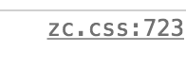

.schoolAdd h3 {   
 width: 305px;  
 margin: 0 auto;  
 height: 32px;  
 line-height: 32px;  
 font-size: 14px;  
 font-weight: 400;  
 color: rgba(0, 0, 0, 85);

}

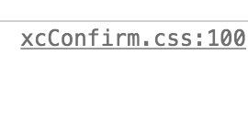

修改地址

.xcConfirm .popBox .txtBox h2 {

* font-size: 12px;
* color: red;
* font-weight: 400;
* letter-spacing: 1.17px;
* height: 20px;
* line-height: 20px;
* text-align: left;

}

2.序号对齐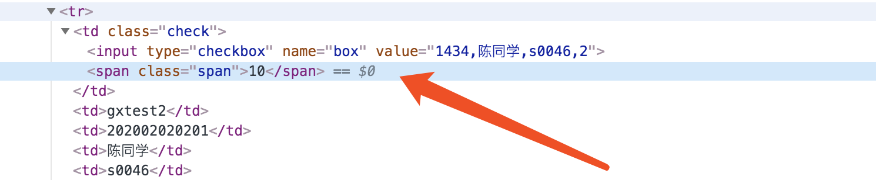

给zc.html里添加css

table td.check .span{

margin-left: 2px;  
 text-align: left;

display: inline-block;  
 width: 18px;

}