MrBeast iPhone Duo
Apple × MrBeast
Unofficial concept ad. Not commissioned or endorsed by MrBeast or Apple. Dialogue, participants and prize are fictional.

Everybody in the photo
40s · 9:16 · Unofficial concept ad

Scene 01 The offer
00:00.0 – 00:06.0
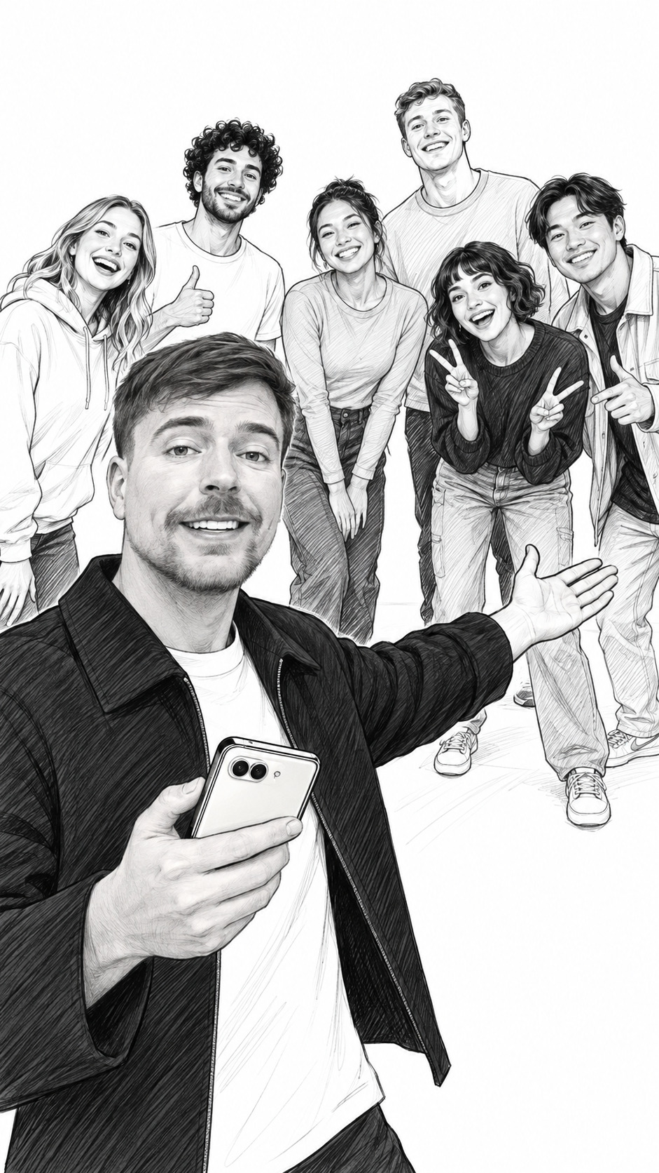
Visual Wide vertical shot. MrBeast stands closest to camera with six adult contestants arranged behind him. He gestures toward the group; a closed phone is in his other hand.
Audio
MRBEAST: All seven of us in one photo, and you six split ten grand.
On screen 7 PEOPLE / 1 PHOTO / $10,000
Note A fictional giveaway setup. Leave a beat for the group reaction.

Scene 02 The catch
00:06.0 – 00:12.0
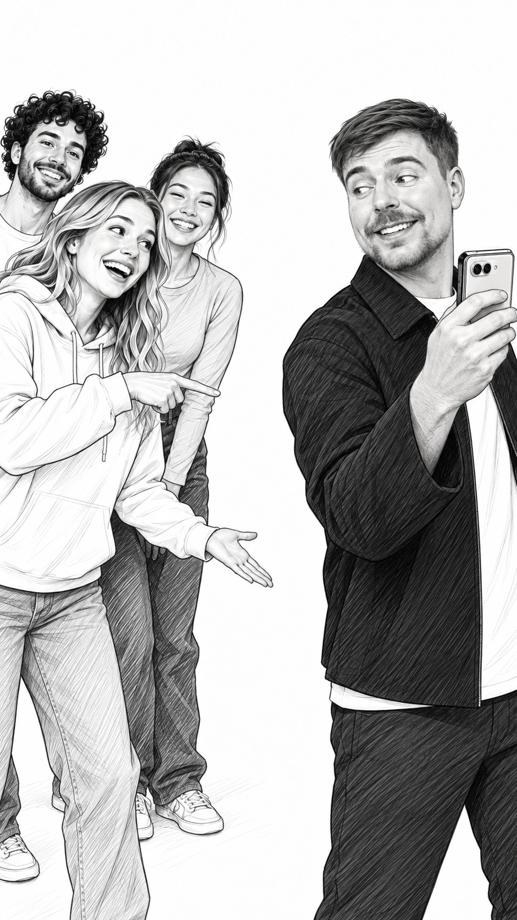
Visual Medium shot from beside the group. MrBeast lifts the closed phone to compose a photo; a contestant points from him toward the empty spot in the lineup.
Audio
CONTESTANT: Wait. You’re not in it.
MRBEAST: And nobody gets to hold the camera.
On screen WHO TAKES THE PHOTO?
Note Use a quick reaction cut. The phone is still folded; no tripod.

Scene 03 The product move
00:12.0 – 00:19.0
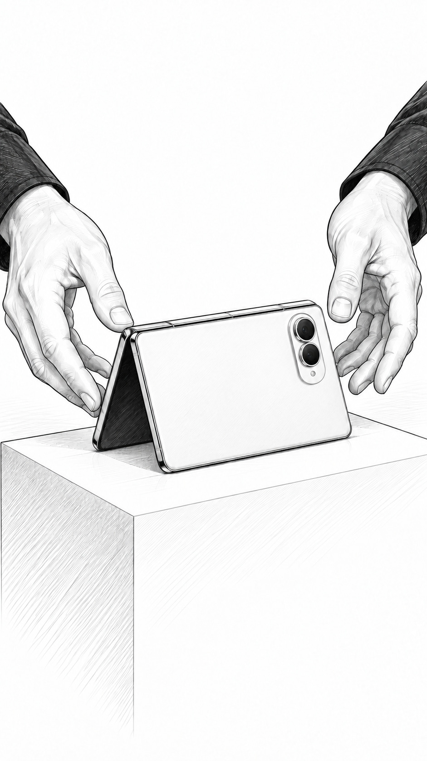
Visual Close insert. Hands open iPhone Duo and set it on a waist-high plinth in a stable self-supporting folded pose, camera oriented toward the group.
Audio
MRBEAST [VO]: iPhone Duo. Fold it, set it down. Smart Take handles the photo.
On screen iPhone Duo / Smart Take
Note Show the actual supported camera setup. UI is schematic in these planning drawings.

Scene 04 Get everyone in
00:19.0 – 00:27.0
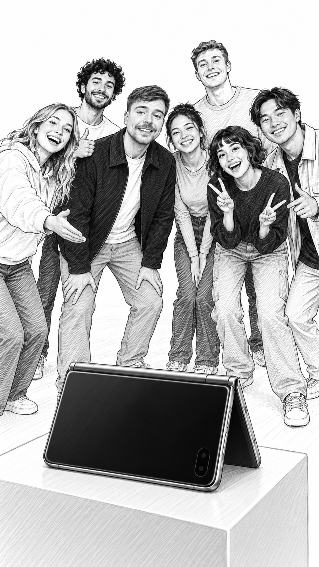
Visual Wide from just behind the phone. MrBeast steps into the center of the six-person group, turns toward the camera and settles into a pose.
Audio
MRBEAST: It takes the shot when everyone’s ready. Even me.
CONTESTANT: Get in here!
On screen EVERYONE IN
Note Allow the pose and capture to happen; do not promise an exact capture latency.

Scene 05 The payoff
00:27.0 – 00:34.0
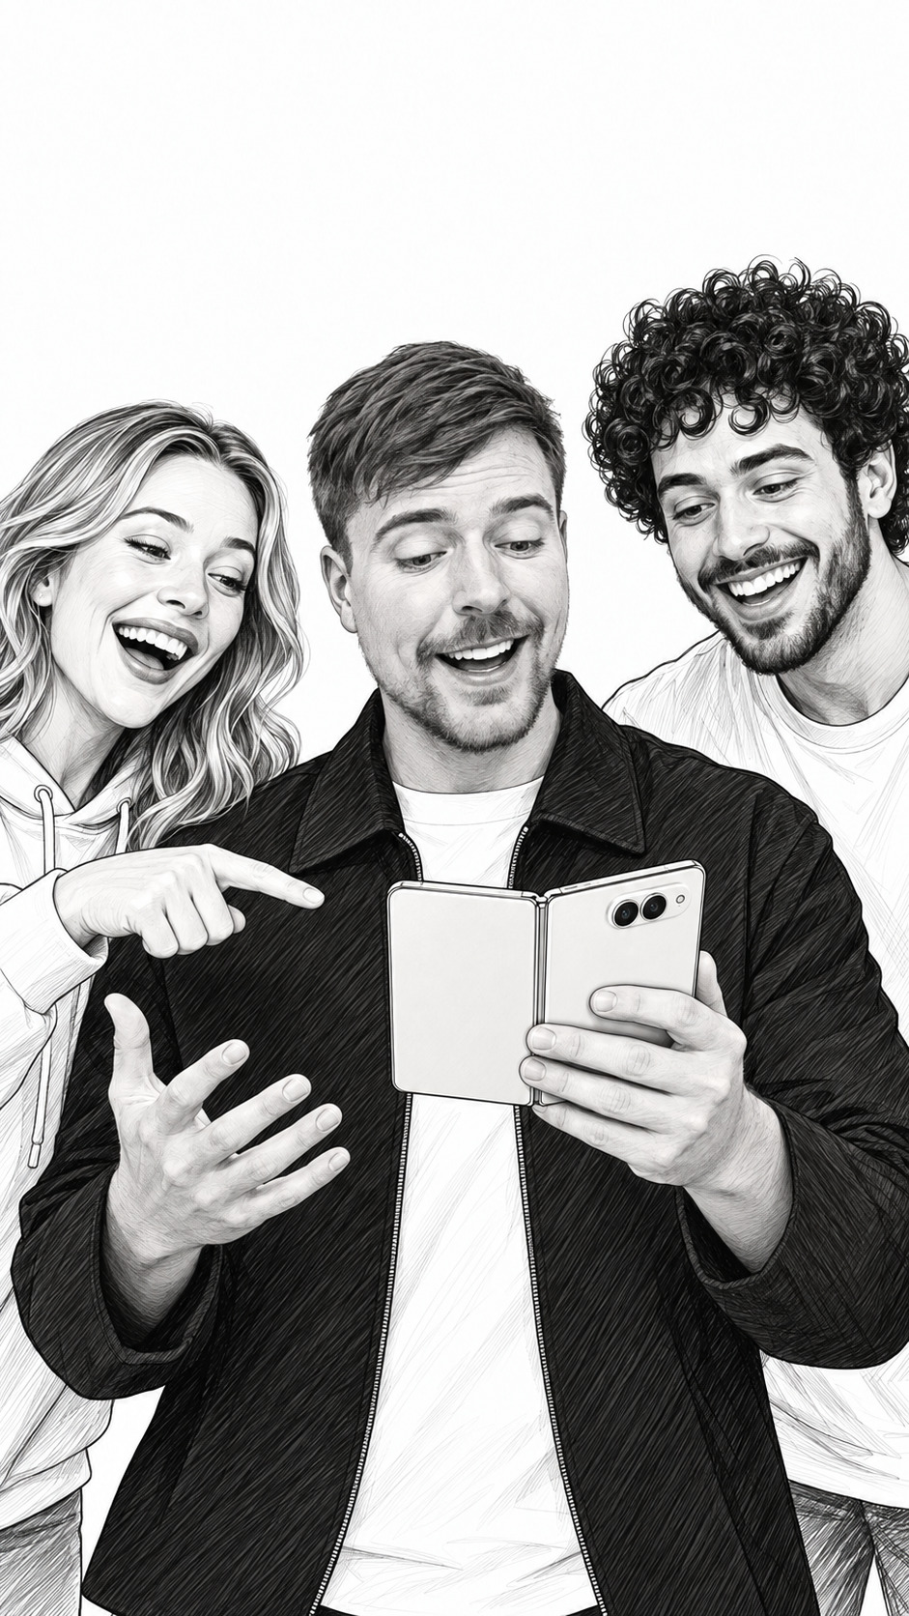
Visual Medium reaction. The group leans toward the opened phone in MrBeast’s hands. One contestant points at the captured group photo; he reacts with an open-handed gesture.
Audio
CONTESTANT: We got everybody!
MRBEAST: That’s ten grand. Split it six ways.
[Group cheers.]
On screen EVERYONE MADE IT
Note The photo and payout are proposed story beats, not documentary footage or a real offer.

Scene 06 The close
00:34.0 – 00:40.0
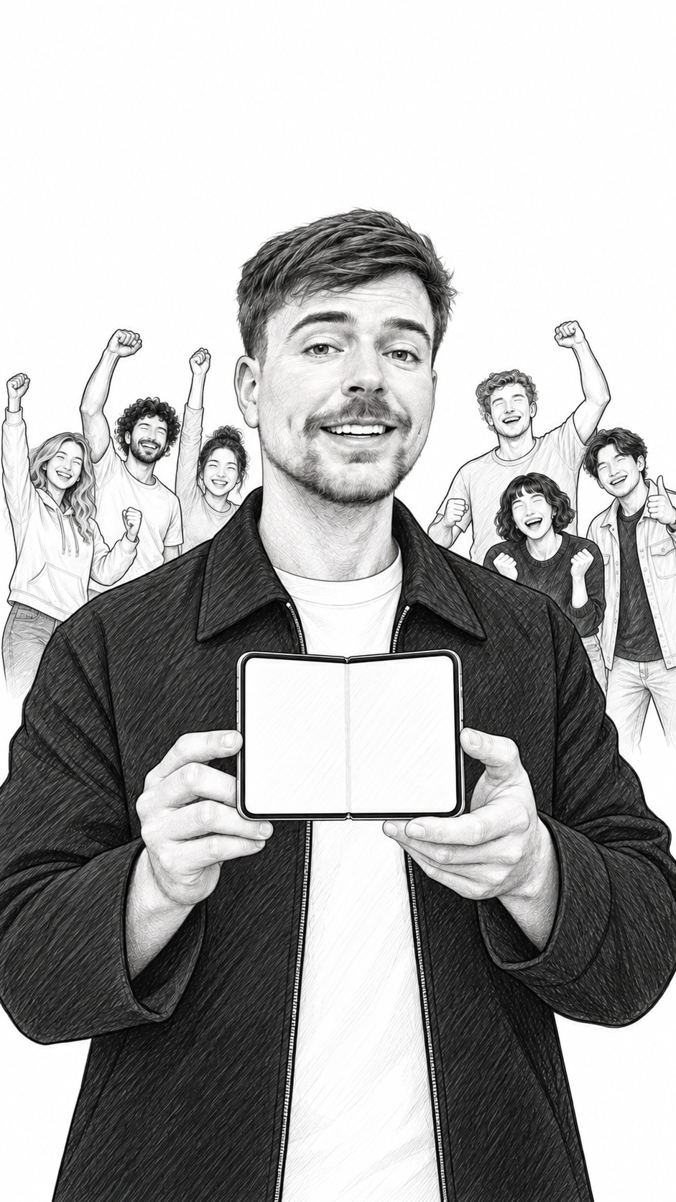
Visual Medium hero shot. MrBeast faces the viewer with the opened phone at chest height. The group celebrates softly behind him; the final product and concept labels sit outside the artwork.
Audio
MRBEAST: Nobody stuck behind the camera. Explore iPhone Duo.
On screen iPhone Duo / Explore at apple.com/iphone-duo
Note End card retains “Unofficial concept ad” outside the sketch. No claim of sponsorship.

