kornel_kovacs_hw_4

Kornel Kovacs

2019 10 01

#1. mutate()

library(nycflights13)  
library(tidyverse)

## -- Attaching packages --------------------------------------------- tidyverse 1.2.1 --

## <U+221A> ggplot2 3.2.1 <U+221A> purrr 0.3.2  
## <U+221A> tibble 2.1.3 <U+221A> dplyr 0.8.3  
## <U+221A> tidyr 0.8.3 <U+221A> stringr 1.4.0  
## <U+221A> readr 1.3.1 <U+221A> forcats 0.4.0

## -- Conflicts ------------------------------------------------ tidyverse_conflicts() --  
## x dplyr::filter() masks stats::filter()  
## x dplyr::lag() masks stats::lag()

## Narrow the tibble to see what mutate() is doing

(flights_small <- select(flights,  
 year:day,   
 ends_with("delay"),   
 distance,  
 air_time))

## # A tibble: 336,776 x 7  
## year month day dep_delay arr_delay distance air_time  
## <int> <int> <int> <dbl> <dbl> <dbl> <dbl>  
## 1 2013 1 1 2 11 1400 227  
## 2 2013 1 1 4 20 1416 227  
## 3 2013 1 1 2 33 1089 160  
## 4 2013 1 1 -1 -18 1576 183  
## 5 2013 1 1 -6 -25 762 116  
## 6 2013 1 1 -4 12 719 150  
## 7 2013 1 1 -5 19 1065 158  
## 8 2013 1 1 -3 -14 229 53  
## 9 2013 1 1 -3 -8 944 140  
## 10 2013 1 1 -2 8 733 138  
## # ... with 336,766 more rows

mutate(flights_small,   
 catchup = dep_delay - arr_delay,  
 speed_miles = (distance/air_time) * 60  
 )

## # A tibble: 336,776 x 9  
## year month day dep_delay arr_delay distance air_time catchup  
## <int> <int> <int> <dbl> <dbl> <dbl> <dbl> <dbl>  
## 1 2013 1 1 2 11 1400 227 -9  
## 2 2013 1 1 4 20 1416 227 -16  
## 3 2013 1 1 2 33 1089 160 -31  
## 4 2013 1 1 -1 -18 1576 183 17  
## 5 2013 1 1 -6 -25 762 116 19  
## 6 2013 1 1 -4 12 719 150 -16  
## 7 2013 1 1 -5 19 1065 158 -24  
## 8 2013 1 1 -3 -14 229 53 11  
## 9 2013 1 1 -3 -8 944 140 5  
## 10 2013 1 1 -2 8 733 138 -10  
## # ... with 336,766 more rows, and 1 more variable: speed_miles <dbl>

## Magic numbers. Great, every one loves them. They are evil.

KM_PER_MILE <- 1.61  
mutate(flights_small,  
 speed_km = (distance * KM_PER_MILE/air_time) * 60)

## # A tibble: 336,776 x 8  
## year month day dep_delay arr_delay distance air_time speed_km  
## <int> <int> <int> <dbl> <dbl> <dbl> <dbl> <dbl>  
## 1 2013 1 1 2 11 1400 227 596.  
## 2 2013 1 1 4 20 1416 227 603.  
## 3 2013 1 1 2 33 1089 160 657.  
## 4 2013 1 1 -1 -18 1576 183 832.  
## 5 2013 1 1 -6 -25 762 116 635.  
## 6 2013 1 1 -4 12 719 150 463.  
## 7 2013 1 1 -5 19 1065 158 651.  
## 8 2013 1 1 -3 -14 229 53 417.  
## 9 2013 1 1 -3 -8 944 140 651.  
## 10 2013 1 1 -2 8 733 138 513.  
## # ... with 336,766 more rows

## Even nicer is to create intermediate results for clarity

mutate(flights_small,  
 distance_km = distance * KM_PER_MILE,  
 air_time_hours = air_time / 60,  
 speed_km = distance_km / air_time_hours  
 )

## # A tibble: 336,776 x 10  
## year month day dep_delay arr_delay distance air_time distance_km  
## <int> <int> <int> <dbl> <dbl> <dbl> <dbl> <dbl>  
## 1 2013 1 1 2 11 1400 227 2254   
## 2 2013 1 1 4 20 1416 227 2280.  
## 3 2013 1 1 2 33 1089 160 1753.  
## 4 2013 1 1 -1 -18 1576 183 2537.  
## 5 2013 1 1 -6 -25 762 116 1227.  
## 6 2013 1 1 -4 12 719 150 1158.  
## 7 2013 1 1 -5 19 1065 158 1715.  
## 8 2013 1 1 -3 -14 229 53 369.  
## 9 2013 1 1 -3 -8 944 140 1520.  
## 10 2013 1 1 -2 8 733 138 1180.  
## # ... with 336,766 more rows, and 2 more variables: air_time_hours <dbl>,  
## # speed_km <dbl>

## transmute only keeps new variables

transmute(flights_small,  
 distance_km = distance * KM_PER_MILE,  
 air_time_hours = air_time / 60,  
 speed_km = distance_km / air_time_hours  
 )

## # A tibble: 336,776 x 3  
## distance_km air_time_hours speed_km  
## <dbl> <dbl> <dbl>  
## 1 2254 3.78 596.  
## 2 2280. 3.78 603.  
## 3 1753. 2.67 657.  
## 4 2537. 3.05 832.  
## 5 1227. 1.93 635.  
## 6 1158. 2.5 463.  
## 7 1715. 2.63 651.  
## 8 369. 0.883 417.  
## 9 1520. 2.33 651.  
## 10 1180. 2.3 513.  
## # ... with 336,766 more rows

You cannot use all transformations inside mutate. It has to be vectorized: it takes a vector and returns a vector of the same length The reason (I believe) is that the operation is done on the column as a whole, For this the operation needs to make sense for a whole column, not just for one number

## SOME VECTORIZED OPERATIONS

transmute(flights,  
 dep_time,  
 dep_hour = dep_time %/% 100,  
 dep_minutes = dep_time %% 100  
 )

## # A tibble: 336,776 x 3  
## dep_time dep_hour dep_minutes  
## <int> <dbl> <dbl>  
## 1 517 5 17  
## 2 533 5 33  
## 3 542 5 42  
## 4 544 5 44  
## 5 554 5 54  
## 6 554 5 54  
## 7 555 5 55  
## 8 557 5 57  
## 9 557 5 57  
## 10 558 5 58  
## # ... with 336,766 more rows

## How can you test whether something is vectorized?

(x <- c(0,1,2,3,4,5,6,7,8,9))

## [1] 0 1 2 3 4 5 6 7 8 9

(y <- 0:9)

## [1] 0 1 2 3 4 5 6 7 8 9

(z <- seq(0,9))

## [1] 0 1 2 3 4 5 6 7 8 9

(lag(y))

## [1] NA 0 1 2 3 4 5 6 7 8

(lag(lag(y)))

## [1] NA NA 0 1 2 3 4 5 6 7

(lead(y))

## [1] 1 2 3 4 5 6 7 8 9 NA

## Some cumulative and aggregate functions

cumsum(x)

## [1] 0 1 3 6 10 15 21 28 36 45

cumprod(x)

## [1] 0 0 0 0 0 0 0 0 0 0

cumprod(lead(x))

## [1] 1 2 6 24 120 720 5040 40320 362880 NA

?cummin

## starting httpd help server ... done

?cummax  
cummean(x)

## [1] 0.0 0.5 1.0 1.5 2.0 2.5 3.0 3.5 4.0 4.5

## Logical operators work

x > 3

## [1] FALSE FALSE FALSE FALSE TRUE TRUE TRUE TRUE TRUE TRUE

x > y

## [1] FALSE FALSE FALSE FALSE FALSE FALSE FALSE FALSE FALSE FALSE

x == y

## [1] TRUE TRUE TRUE TRUE TRUE TRUE TRUE TRUE TRUE TRUE

## Ranking functions

y <- c(10, 5, 6, 3, 7)  
min_rank(y)

## [1] 5 2 3 1 4

## So, what is not a vectorized operation?

c(2,4)^2 # This is vectorized

## [1] 4 16

kk <- function(x) { x[3]}  
kk(1:5) # not vectorized

## [1] 3

mean(x)

## [1] 4.5

## What happens when we try this on a dataframe

transmute(flights, delay = mean(arr_delay, na.rm = TRUE))

## # A tibble: 336,776 x 1  
## delay  
## <dbl>  
## 1 6.90  
## 2 6.90  
## 3 6.90  
## 4 6.90  
## 5 6.90  
## 6 6.90  
## 7 6.90  
## 8 6.90  
## 9 6.90  
## 10 6.90  
## # ... with 336,766 more rows

transmute(flights, delay = kk(arr_delay))

## # A tibble: 336,776 x 1  
## delay  
## <dbl>  
## 1 33  
## 2 33  
## 3 33  
## 4 33  
## 5 33  
## 6 33  
## 7 33  
## 8 33  
## 9 33  
## 10 33  
## # ... with 336,766 more rows

## Exercise: Try out a few of the other commands in the chapter.(KK: Which chapter exactly? I tried some arbitrarily.)

transmute(flights, real_delay = sched_arr_time - arr_time)

## # A tibble: 336,776 x 1  
## real_delay  
## <int>  
## 1 -11  
## 2 -20  
## 3 -73  
## 4 18  
## 5 25  
## 6 -12  
## 7 -59  
## 8 14  
## 9 8  
## 10 -8  
## # ... with 336,766 more rows

lead(c(1,2,3,4,5,6))

## [1] 2 3 4 5 6 NA

## Exercise: Create several ranges with the n:m notation, i.e. 2:4, 4:8, etc.

c(1:13)

## [1] 1 2 3 4 5 6 7 8 9 10 11 12 13

c(1:13,2)

## [1] 1 2 3 4 5 6 7 8 9 10 11 12 13 2

c(13:13)

## [1] 13

c(5:8)

## [1] 5 6 7 8

c(pi:6)

## [1] 3.141593 4.141593 5.141593

c(0:pi)

## [1] 0 1 2 3

## Try to find out whether you can also take negative ranges and descending

c(-3:13)

## [1] -3 -2 -1 0 1 2 3 4 5 6 7 8 9 10 11 12 13

c(13:2)

## [1] 13 12 11 10 9 8 7 6 5 4 3 2

c(-9: pi)

## [1] -9 -8 -7 -6 -5 -4 -3 -2 -1 0 1 2 3

c(-pi: 7)

## [1] -3.1415927 -2.1415927 -1.1415927 -0.1415927 0.8584073 1.8584073  
## [7] 2.8584073 3.8584073 4.8584073 5.8584073 6.8584073

## Exercise: Read ?“:” (the same as help(“:”))

help(":")

## Exercise: Use slice() to choose the first 10 rows of flights.

slice(flights, 1:10)

## # A tibble: 10 x 19  
## year month day dep_time sched_dep_time dep_delay arr_time  
## <int> <int> <int> <int> <int> <dbl> <int>  
## 1 2013 1 1 517 515 2 830  
## 2 2013 1 1 533 529 4 850  
## 3 2013 1 1 542 540 2 923  
## 4 2013 1 1 544 545 -1 1004  
## 5 2013 1 1 554 600 -6 812  
## 6 2013 1 1 554 558 -4 740  
## 7 2013 1 1 555 600 -5 913  
## 8 2013 1 1 557 600 -3 709  
## 9 2013 1 1 557 600 -3 838  
## 10 2013 1 1 558 600 -2 753  
## # ... with 12 more variables: sched_arr_time <int>, arr_delay <dbl>,  
## # carrier <chr>, flight <int>, tailnum <chr>, origin <chr>, dest <chr>,  
## # air_time <dbl>, distance <dbl>, hour <dbl>, minute <dbl>,  
## # time_hour <dttm>

## Do the following exercises from 5.5.2:

### Exercise 1

transmute(flights,  
 dep_time,  
 dep_hour = dep_time %/% 100,  
 dep_minutes = dep_time %% 100  
 )

## # A tibble: 336,776 x 3  
## dep_time dep_hour dep_minutes  
## <int> <dbl> <dbl>  
## 1 517 5 17  
## 2 533 5 33  
## 3 542 5 42  
## 4 544 5 44  
## 5 554 5 54  
## 6 554 5 54  
## 7 555 5 55  
## 8 557 5 57  
## 9 557 5 57  
## 10 558 5 58  
## # ... with 336,766 more rows

### Exercise 2

transmute(flights,  
 air_time = arr_time - dep_time,  
 arr_time,  
 dep_time  
 )

## # A tibble: 336,776 x 3  
## air_time arr_time dep_time  
## <int> <int> <int>  
## 1 313 830 517  
## 2 317 850 533  
## 3 381 923 542  
## 4 460 1004 544  
## 5 258 812 554  
## 6 186 740 554  
## 7 358 913 555  
## 8 152 709 557  
## 9 281 838 557  
## 10 195 753 558  
## # ... with 336,766 more rows

The formats of arr_time and dep_time are not suitable for computation in their current form. It would be wise to convert them to a date or time object in order to properly do computations with them.

### Exercise 4

sort(flights$arr_delay, decreasing = TRUE)[1:10]

## [1] 1272 1127 1109 1007 989 931 915 895 878 875

sort(min_rank(flights$arr_delay), decreasing = TRUE)[1:10]

## [1] 327346 327345 327344 327343 327342 327341 327340 327339 327338 327337

# summarise()

summarise(flights, delay = mean(dep_delay, na.rm = TRUE))

## # A tibble: 1 x 1  
## delay  
## <dbl>  
## 1 12.6

mean(flights$dep_delay, na.rm = TRUE)

## [1] 12.63907

mean(select(flights, dep_delay), na.rm = TRUE)

## Warning in mean.default(select(flights, dep_delay), na.rm = TRUE): argument  
## is not numeric or logical: returning NA

## [1] NA

## Not the same!

flights$dep_delay  
select(flights, dep_delay)

## Still, summarise is way more interesting with its friend, group_by

by_day <- group_by(flights, year, month, day)  
summarise(  
 group_by(flights, year, month, day),   
 delay = mean(dep_delay, na.rm = TRUE)  
 )

## # A tibble: 365 x 4  
## # Groups: year, month [12]  
## year month day delay  
## <int> <int> <int> <dbl>  
## 1 2013 1 1 11.5   
## 2 2013 1 2 13.9   
## 3 2013 1 3 11.0   
## 4 2013 1 4 8.95  
## 5 2013 1 5 5.73  
## 6 2013 1 6 7.15  
## 7 2013 1 7 5.42  
## 8 2013 1 8 2.55  
## 9 2013 1 9 2.28  
## 10 2013 1 10 2.84  
## # ... with 355 more rows

## Again, not the same structure.

by_destination <- group_by(flights, dest)  
delay <- summarise(by_destination,  
 delay = mean(arr_delay, na.rm = TRUE))

# OK, we need the distance too, or else there is not much to plot.

(delay <- summarise(by_destination,  
 delay = mean(arr_delay, na.rm = TRUE),  
 distance = mean(distance, na.rm = TRUE)))

## # A tibble: 105 x 3  
## dest delay distance  
## <chr> <dbl> <dbl>  
## 1 ABQ 4.38 1826   
## 2 ACK 4.85 199   
## 3 ALB 14.4 143   
## 4 ANC -2.5 3370   
## 5 ATL 11.3 757.  
## 6 AUS 6.02 1514.  
## 7 AVL 8.00 584.  
## 8 BDL 7.05 116   
## 9 BGR 8.03 378   
## 10 BHM 16.9 866.  
## # ... with 95 more rows

p <- ggplot(data = delay,  
 mapping = aes(x = distance, y = delay))  
p + geom_point() + geom_smooth()

## `geom_smooth()` using method = 'loess' and formula 'y ~ x'

## Warning: Removed 1 rows containing non-finite values (stat_smooth).

## Warning: Removed 1 rows containing missing values (geom_point).

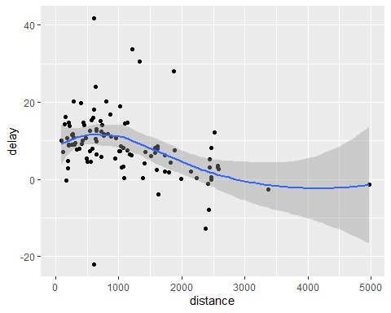

(delay <- summarise(by_destination,  
 count = n(),   
 delay = mean(arr_delay, na.rm = TRUE),  
 distance = mean(distance, na.rm = TRUE)))

## # A tibble: 105 x 4  
## dest count delay distance  
## <chr> <int> <dbl> <dbl>  
## 1 ABQ 254 4.38 1826   
## 2 ACK 265 4.85 199   
## 3 ALB 439 14.4 143   
## 4 ANC 8 -2.5 3370   
## 5 ATL 17215 11.3 757.  
## 6 AUS 2439 6.02 1514.  
## 7 AVL 275 8.00 584.  
## 8 BDL 443 7.05 116   
## 9 BGR 375 8.03 378   
## 10 BHM 297 16.9 866.  
## # ... with 95 more rows

p <- ggplot(data = delay,  
 mapping = aes(x = distance, y = delay))  
p + geom_point(mapping = aes(size = count), alpha = 0.2) +  
 geom_smooth()

## `geom_smooth()` using method = 'loess' and formula 'y ~ x'

## Warning: Removed 1 rows containing non-finite values (stat_smooth).  
  
## Warning: Removed 1 rows containing missing values (geom_point).

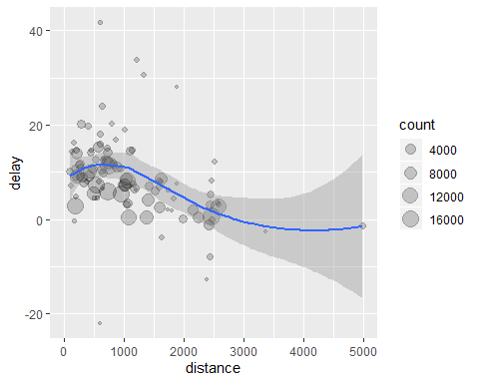

## Dropping some points

delays <- flights %>%   
 group_by(dest) %>%  
 summarise(  
 delay = mean(arr_delay, na.rm = TRUE),  
 count = n(),  
 distance = mean(distance, na.rm = TRUE)  
 ) %>%  
 filter( count > 20, dest != "HNL")

## Getting rid of missing values

not_missing <- flights %>%  
 filter(!is.na(dep_delay), !is.na(arr_delay))

## Average delay by airplane (identified by tailnum), plot density

not_missing %>%  
 group_by(tailnum) %>%  
 summarise(delay = mean(dep_delay)) %>%  
 ggplot(mapping = aes(x = delay)) +   
 geom_histogram(binwidth = 10)

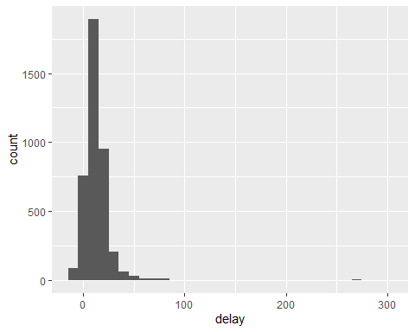

## Plot number of flights per airplane against delay

not_missing %>%  
 group_by(tailnum) %>%  
 summarise(  
 count = n(),  
 delay = mean(arr_delay)  
 ) %>%  
 ggplot(mapping = aes(x = delay, y = count)) +   
 geom_point(alpha = 0.1)

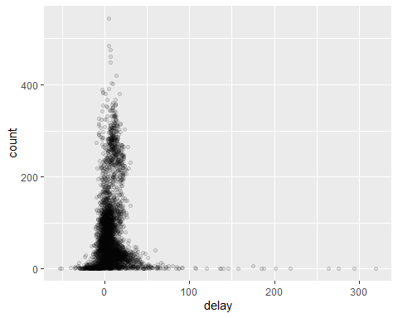

## Since I need to filter the same thing, all the time just store in a variable.

not_missing_planes <- not_missing %>%  
 group_by(tailnum) %>%  
 summarise(  
 count = n(),  
 delay = mean(arr_delay),  
 delay_median = median(arr_delay)  
 )

## Get the median delay for each ariplane

ggplot(data = not_missing_planes) +   
 geom_histogram(mapping = aes(x = delay_median)) +   
 geom_histogram(mapping = aes(x = delay), color = 'yellow', alpha = 0.3)

## `stat_bin()` using `bins = 30`. Pick better value with `binwidth`.  
## `stat_bin()` using `bins = 30`. Pick better value with `binwidth`.

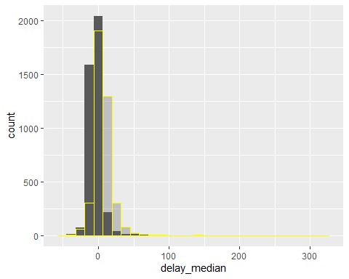

not_missing_planes %>%  
 filter(count > 5) %>%  
 ggplot(mapping = aes(x = delay)) +   
 geom_histogram()

## `stat_bin()` using `bins = 30`. Pick better value with `binwidth`.

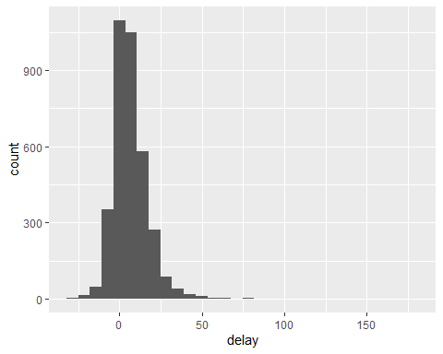

# Assignment 5:

1. Do the exercises in this script file and work through the examples we didn’t cover in class. As usual, turn the script into an .Rmd file, knit it, upload the .html and .pdf. - DONE
2. Read/skim the chapter 5 from ‘R for Data Science’ to see what is available. Don’t try to remember everything, but you should be able to remember what is possible so that you can find the commands again should you need them in the future. - DONE
3. Grade Assignment 4 of your peers. - DONE
4. Document at least 10 errors and warnings you actually hit during the week. If you do *not* hit that many errors or receive such warnings, congratulations. - I did not really have any errors.
5. Pick one of the hotels graphs in Chapter 3, section 6, A1. Case study, finding a good deal among hotels. Replicate it – try it yourself for 10 minutes before you go looking at the code – and then make a variation of it.

hotels <- read.csv(file = "..//da_data_repo/hotels-vienna/clean/hotels-vienna.csv")  
head(hotels)

## country city_actual rating_count center1label center2label neighbourhood  
## 1 Austria Vienna 36 City centre Donauturm 17. Hernals  
## 2 Austria Vienna 189 City centre Donauturm 17. Hernals  
## 3 Austria Vienna 53 City centre Donauturm Alsergrund  
## 4 Austria Vienna 55 City centre Donauturm Alsergrund  
## 5 Austria Vienna 33 City centre Donauturm Alsergrund  
## 6 Austria Vienna 25 City centre Donauturm Alsergrund  
## price city stars ratingta ratingta_count scarce_room hotel_id offer  
## 1 81 Vienna 4 4.5 216 1 21894 1  
## 2 81 Vienna 4 3.5 708 0 21897 1  
## 3 85 Vienna 4 3.5 629 0 21901 1  
## 4 83 Vienna 3 4.0 52 0 21902 1  
## 5 82 Vienna 4 3.5 219 1 21903 1  
## 6 229 Vienna 5 4.5 27 1 21904 1  
## offer_cat year month weekend holiday distance distance_alter  
## 1 15-50% offer 2017 11 0 0 2.7 4.4  
## 2 1-15% offer 2017 11 0 0 1.7 3.8  
## 3 15-50% offer 2017 11 0 0 1.4 2.5  
## 4 15-50% offer 2017 11 0 0 1.7 2.5  
## 5 15-50% offer 2017 11 0 0 1.2 2.8  
## 6 1-15% offer 2017 11 0 0 0.9 3.0  
## accommodation_type nnights rating  
## 1 Apartment 1 4.4  
## 2 Hotel 1 3.9  
## 3 Hotel 1 3.7  
## 4 Hotel 1 4.0  
## 5 Hotel 1 3.9  
## 6 Apartment 1 4.8

hotels_3_4_star <- filter(hotels, stars == 3 | stars == 4, city == 'Vienna', price < 1000, accommodation_type == "Hotel")  
ggplot(hotels_3_4_star, aes(x = price)) +   
 geom_histogram(binwidth = 20, color="darkblue", fill = "lightblue") +  
 labs(x = "Price", y = "Frequency")

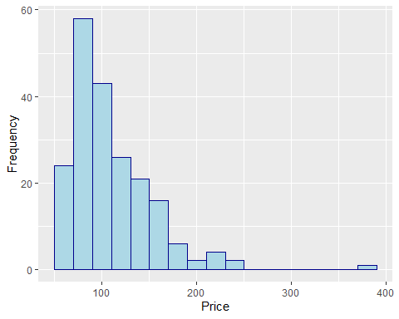

I could not really produce the very same graph, but it is close, I think. Furthemore, I experimented a lot.

1. Instead of using the Vienna data, use the data for another city (pick London if you don’t want to choose). Do a basic data exploration, comparing the city to Vienna in terms of any variables you find interesting. Three plots maximum, don’t spend more than 30 minutes on the analysis, before writing it down (if you are not doing this in parallel).

hotels_ams <- filter(read.csv(file = "..//da_data_repo//hotelbookingdata.csv"), city_actual == "Amsterdam")  
  
hotels <- filter(read.csv(file = "..//da_data_repo//hotelbookingdata.csv"), city_actual == "Vienna")  
  
mean(hotels_ams$price)

## [1] 339.6927

mean(hotels$price)

## [1] 213.8468

vienna_desc <-   
 hotels %>%  
 summarise(n = length(price),   
 mean=mean(price),   
 median=median(price),   
 min = min(price),   
 max = max(price),   
 sd = sd(price),   
 skew= ((mean(price)-median(price))/sd(price)))  
  
ams_desc <-   
 hotels_ams %>%  
 summarise(n = length(price),   
 mean=mean(price),   
 median=median(price),   
 min = min(price),   
 max = max(price),   
 sd = sd(price),   
 skew= ((mean(price)-median(price))/sd(price)))  
ams_desc

## n mean median min max sd skew  
## 1 1819 339.6927 207 50 3620 348.5161 0.3807362

vienna_desc

## n mean median min max sd skew  
## 1 3596 213.8468 138 27 6510 270.4845 0.2804108

ggplot(filter(hotels, price < 2000), aes(x = price)) +   
 geom_histogram(binwidth = 20, color="darkblue", fill = "lightblue") +  
 labs(x = "Price", y = "Frequency", title = "Vienna hotel prices")

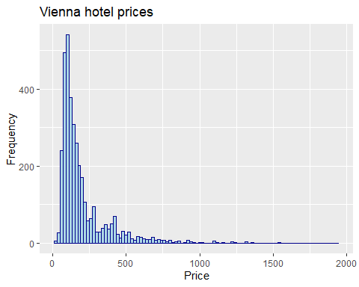

ggplot(filter(hotels_ams, price < 2000), aes(x = price)) +  
 geom_histogram(binwidth = 20, color="darkblue", fill = "lightblue") +  
 labs(x = "Price", y = "Frequency", title = "Amsterdam hotel prices")

