Table of Contents

TechScreen — Architecture Document
Version: 0.2 (draft for review) Owner: Ihor Date: 2026-04-18 Status: Draft

1. Purpose
Describes the high-level architecture of the TechScreen MVP: components, technology stack, key data flows, and architectural decisions. Audience: tech lead and engineering team. Does not include DB schema details (see Data Model Reference) or agent prompt bodies (see Prompts Repository).

2. High-Level Overview
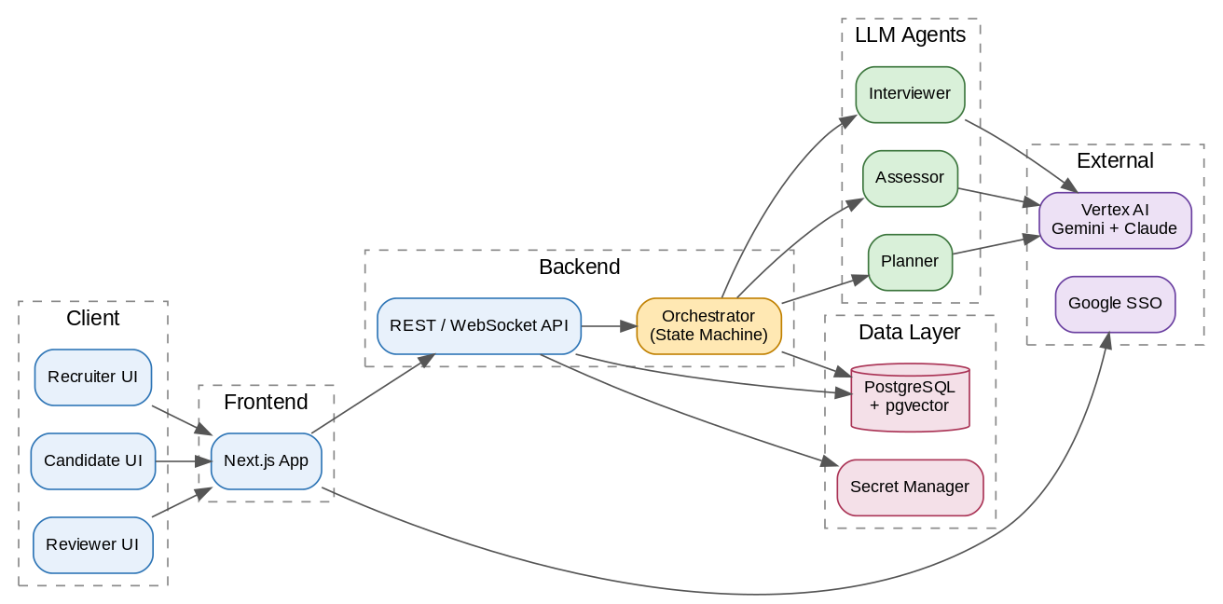
Diagram 1 — System Overview
TechScreen is a three-layer architecture: a Next.js frontend, a FastAPI backend (REST + WebSocket) with a deterministic Orchestrator, and three LLM agents invoked through Vertex AI Model Garden. Persistence is PostgreSQL (state + pgvector for future RAG). Authentication uses Google Workspace SSO via Identity Platform.

3. Technology Stack
Layer | Technology | Rationale
Frontend | Next.js 14 (App Router), TypeScript, Tailwind, shadcn/ui | Fast dev velocity, SSR, SSO-friendly, low learning curve
Backend | Python 3.12, FastAPI, Pydantic v2 | Python-first for ML / prompt work, async-native
LLM platform | Vertex AI Model Garden | Approved internally, GDPR-safe enterprise contract, single endpoint for Gemini + Claude
Models (runtime) | Gemini 2.5 Flash (Interviewer turns), Gemini 2.5 Pro (Assessor / Planner), Claude Sonnet 4.6 (A/B) | Quality / latency / cost balance
Orchestration | Deterministic Python state machine | Predictable, debuggable, not dependent on LLM reliability
Database | PostgreSQL 15 (Cloud SQL) + pgvector | One database for state + embeddings — fewer moving parts
Auth | Identity Platform (Google Workspace SSO) | GCP-native, roles via claims
Deploy | Cloud Run | Serverless, auto-scale, zero-ops
Secrets | Google Secret Manager | GCP-native
Observability | Cloud Logging + Cloud Monitoring + custom TurnTrace | Native GCP plus domain-specific traces
CI/CD | GitHub Actions | Standard, cheap
Config | YAML in Git (Configs-as-Code) | Reviewable, diffable, versionable

4. Components

4.1 Frontend (Next.js)
One application with three role-specific surfaces: - Recruiter — Position Template authoring, InterviewPlan generation and review - Candidate — token-authorized interview session (chat UI) - Reviewer — post-interview review, turn annotation, AssessmentCorrection
SSO via Identity Platform; roles carried as JWT claims. The candidate flow uses a separate magic-link token (candidates are external to the SSO directory).

4.2 Backend API
- FastAPI REST endpoints for CRUD (positions, plans, sessions, annotations)
- WebSocket endpoint for candidate session (bidirectional streaming turns)
- Pydantic models for input / output validation
- Dependency injection for testability (DB, Vertex client, clock)
- Structured JSON logging with correlation IDs

4.3 Orchestrator (State Machine)
Deterministic Python code — not an LLM: - A session moves through phases: INTRO → TECH (per competency → per topic → probes) → QA → CLOSE - Decides when to call Interviewer vs Assessor - Honors plan.priority (must_cover vs nice_to_have) and (from Phase 2) skip_rules - Persists TurnTrace after every agent call - Transitions are pure functions: (current_state, event) → new_state - Timeouts, retries, and recovery are the orchestrator’s responsibility — not the agents’
Why deterministic rather than LLM-driven orchestration. Predictability, reproducibility, unit-testability. LLM-orchestration is just another agent with poor observability.

4.4 Agents
Three LLM agents, all invoked through a shared Vertex client wrapper.
Interviewer Agent. Drives the conversation and generates turns. - Model: Gemini 2.5 Flash (speed is critical for in-turn latency) - Output: structured JSON with message_to_candidate plus metadata (targeted_topic_id, expected_concepts, suggested_next_action, self_checks) - Prompt: prompts/interviewer.md (semver-versioned) - Ukrainian output, English system prompt
Assessor Agent. Scores each candidate answer. - Model: Gemini 2.5 Pro (quality-critical); A/B with Claude Sonnet 4.6 during W10 calibration - Output: structured JSON — concepts_assessment[], red_flags[], confidence, level_demonstrated - Prompt: prompts/assessor.md - Mode: async — does not block the next Interviewer turn (voice-ready)
PreInterviewPlanner Agent. Generates an InterviewPlan from Position Template + rubric snapshot. - Model: Gemini 2.5 Pro (runs once per session; quality matters) - Output: structured JSON plan (competency_order, topics, seed questions, time budget) - Prompt: prompts/planner.md
Vertex client wrapper (shared): - Retries with exponential backoff on transient failures - Pydantic schema validation on output - Automatic one-shot retry on schema mismatch - Role-specific timeouts - Cost tracking middleware - Prompt caching (Vertex feature) for system prompts

4.5 Persistence
PostgreSQL tables (high level; details in Data Model): - users, candidates - Rubric tree: stack, competency_block, competency, topic, level, reference - position_template - interview_session (with rubric_snapshot JSONB) - interview_plan (with plan_json JSONB; status draft / approved / frozen) - message / turn - turn_trace (full prompt / response, tokens, latency, cost) - assessment (per-turn and per-competency) - turn_annotation - assessment_correction - audit_log
pgvector — embeddings for RAG (feature-off in MVP): - annotated_turn_embedding(turn_id, topic_id, embedding vector(768)) - Indexed after reviewer approval

4.6 Observability
Three layers: 1. Application metrics — Cloud Monitoring (latency, error rate, cost, active sessions) 2. TurnTrace store — full record of every agent call in the DB (prompt, response, parsed output, tokens, latency, model, prompt_version) 3. Dashboards — per-agent views, per-session cost breakdown, overall health, model A/B comparison
Alerts: - Cost per session exceeds threshold - Agent p95 latency > 15 s - Error rate > 5% - TurnTrace capture gap (missing trace rows relative to messages)

4.7 Auth / Identity
- Internal users (recruiter, reviewer, admin) — Identity Platform + Google provider. HTTP-only session cookies. Roles as JWT claims.
- Candidate — magic-link token → short-lived session cookie. Token is single-use, invalidated after first use or by TTL (24 h).

5. Key Flows

5.1 Matrix Import & Configs-as-Code
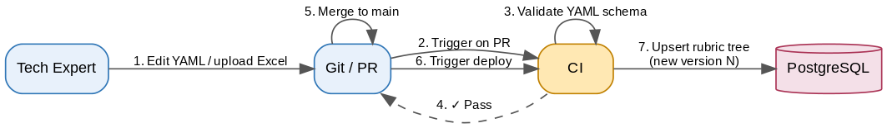
Diagram 2 — Matrix Import & Configs-as-Code
Key invariant: the previous rubric version remains; sessions holding a prior rubric_snapshot are unaffected.

5.2 Pre-interview Flow
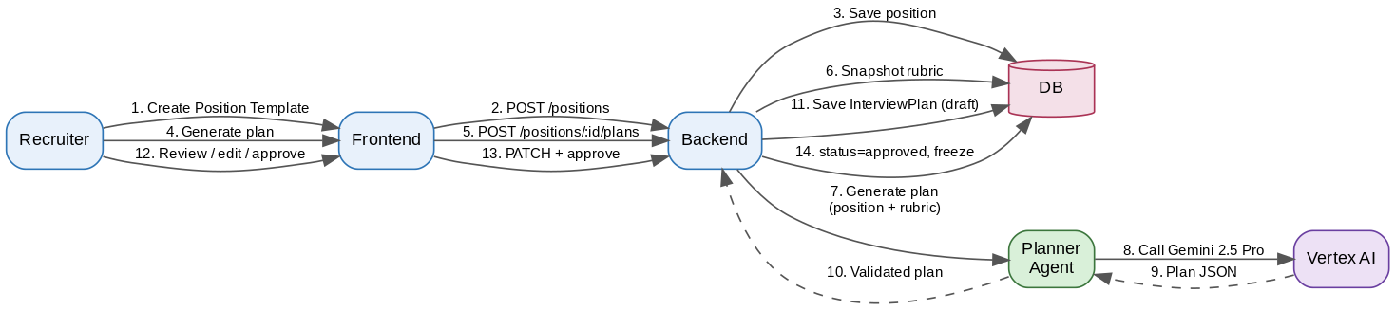
Diagram 3 — Pre-interview Flow

5.3 Runtime Session (turn loop)
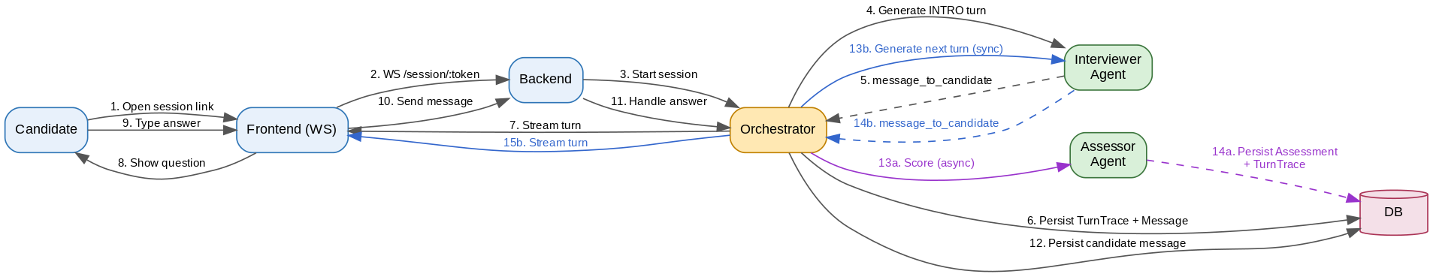
Diagram 4 — Runtime Session (turn loop)
Key details: - Interviewer is sync in the turn loop — the candidate waits for its output - Assessor is async — does not block the next Interviewer turn (voice-ready pattern) - The orchestrator makes transition decisions (probe / move-on / close) based on the plan, remaining time budget, and Assessor results when available

5.4 Annotation Flow (post-interview)
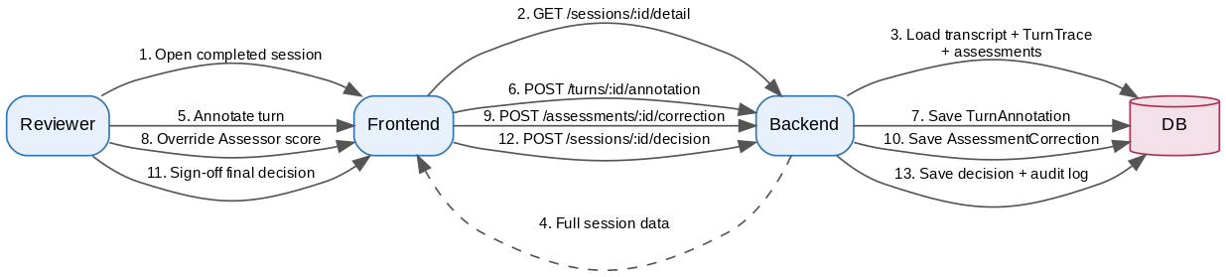
Diagram 5 — Annotation Flow
After sign-off the session is marked annotated=true and enters the embedding-indexing pipeline (for future RAG).

6. Key Architectural Decisions
Short summary — full detail in each ADR:
- ADR-001 — Vertex AI Model Garden as the LLM platform (vs direct Anthropic / OpenAI APIs)
- ADR-002 — 2+1 agent architecture (Interviewer + Assessor + Planner) vs a single multi-tool agent
- ADR-003 — Hybrid InterviewPlan (neither full script nor full adaptivity)
- ADR-004 — English system prompts + Ukrainian candidate-facing output
- ADR-005 — Deterministic state machine in code, not LLM-driven orchestration
- ADR-006 — Configs-as-Code (YAML in Git) for rubric / positions / prompts
- ADR-007 — Async assessment pattern (voice-ready)
- ADR-008 — pgvector on Cloud SQL vs a separate Vector Search (cost-first; re-evaluate later)

7. Deployment
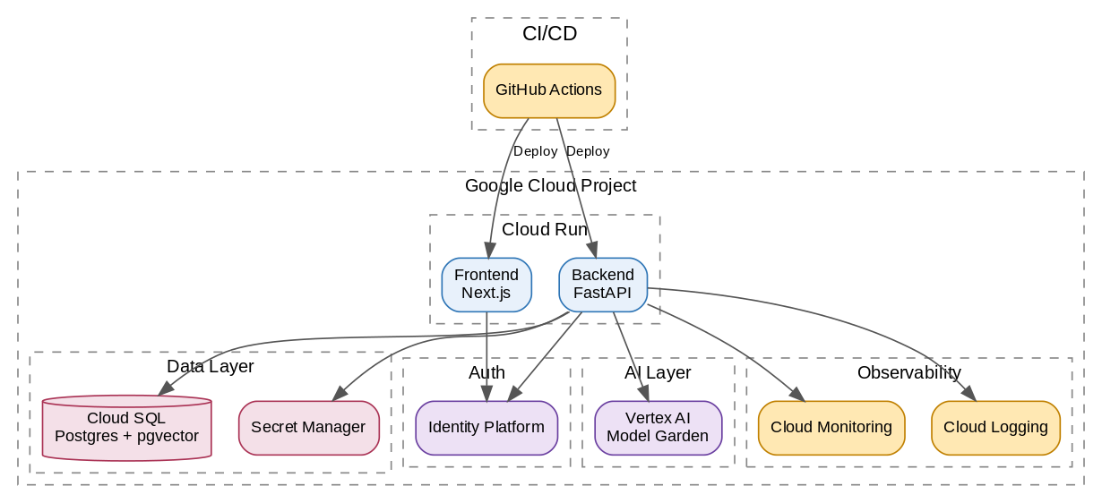
Diagram 6 — Deployment
Environments: - Local — dev machine + docker-compose Postgres + real Vertex (sandbox project) - Staging — separate GCP project, Cloud Run + Cloud SQL + real Vertex - Production — separate GCP project for isolation (pilot runs here)

8. Safety, Privacy, Observability Principles
Privacy: - Vertex enterprise contract: no data used for model training - Explicit consent gate before session start - Data retention: 90 days for the pilot (MVP); production TBD per GDPR baseline - Delete-on-request endpoint - No candidate PII in TurnTrace (only candidate_id pseudonym)
Safety: - Prompt-injection defense: scope guard in the system prompt + input normalization - Rate limiting per candidate token - All secrets accessed via Secret Manager only - Strict JSON schema validation on every agent output
Observability commitments: - 100% TurnTrace capture — a hard requirement, enforced by alert - Cost per session / per agent / per model — first-class metric - Agent p95 latency — first-class metric - Error rate alert > 5% - prompt_version label on every TurnTrace (for post-hoc A/B)

9. MVP Constraints and Voice-Readiness
MVP constraints: - Text-only interaction - Only 2 stacks (C#, React) - No advanced anti-cheating - No candidate account (magic-link only) - No RAG feature-on - Configs-as-Code only (no rubric admin UI) - Internal-only (SSO-restricted)
Voice-ready guardrails (enforced from W1): 1. WebSocket-first transport (not HTTP polling) 2. Async assessment (does not block the next turn) 3. Streaming token output from the Interviewer 4. Latency budget as a first-class metric 5. Transport-agnostic core (the orchestrator is unaware of text vs voice) 6. Full transcript preserved (once voice is added, text remains the source of truth) 7. Interruption-friendly turn structure (short turns, explicit stop tokens)

10. Glossary
Terms are used consistently across all documents. See MVP Scope Document, section 12.

