Table of Contents

Data Model Reference
Version: 0.1 (draft) Status: Draft for review Audience: Engineers writing backend, migrations, or analytics Last updated: 2026-04-18

1. Purpose
This document is the single source of truth for the TechScreen database schema: tables, columns, foreign keys, invariants, versioning, append-only semantics, and indexing.
The intended reader is an engineer about to write backend code, a migration, or an analytics query. The level of detail is enough to start writing SQL safely without breaking invariants.

2. Cross-cutting decisions
- Engine: PostgreSQL 15 on Cloud SQL.
- Extensions: pgvector (embedding search, feature-off in MVP), pgcrypto (UUID helpers).
- Primary keys: UUID v7 (time-ordered) for every table — not auto-increment. Better for distributed inserts and time-ordered sorting.
- Timestamps: created_at TIMESTAMPTZ NOT NULL DEFAULT NOW() everywhere. updated_at only where we actually mutate.
- Soft delete: not used. Where lifecycle matters, we use an explicit archived_at column.
- JSONB: for snapshot-style data (rubric_snapshot, plan_json, agent outputs). Strict JSON schema validation happens on the backend, not at the DB level, so schema evolution does not require migrations.
- Enums: Postgres ENUM for stable domains (session_status, assessment_correctness); TEXT + CHECK for domains that grow often (recommendation_category).

3. Logical groups
The schema splits into five logical groups:
- Identity & access — users, candidates, magic tokens.
- Rubric & positions — rubric tree, position templates, interview plans.
- Interview data — messages, turns, turn traces, assessments.
- Review & audit — annotations, corrections, decisions, audit log.
- Embeddings (feature-off in MVP) — annotated_turn_embedding.

4. Identity & Access

users
Internal users (recruiter, reviewer, admin). Authenticated via Identity Platform.
field | type | nullable | note
id | UUID | no | PK
email | TEXT | no | unique, Google Workspace
role | ENUM(recruiter, reviewer, admin) | no
created_at | TIMESTAMPTZ | no
archived_at | TIMESTAMPTZ | yes | soft archive
Invariant: email is unique. Role is assigned on the backend — no self-service role changes.

candidates
Minimal record per candidate. PII is deliberately minimised (see Safety principles).
field | type | nullable | note
id | UUID | no | PK
candidate_pseudonym | TEXT | no | unique, hash-based
display_name | TEXT | yes | visible to reviewer only
email_hash | TEXT | yes | used for dedup on invitations
created_at | TIMESTAMPTZ | no
Invariant: TurnTrace and Message use candidate_pseudonym, never display_name or email. No PII flows into logs or traces.

magic_tokens
Single-use invitation links for candidates.
field | type | nullable | note
id | UUID | no | PK
session_id | UUID | no | FK → interview_session
token_hash | TEXT | no | unique, SHA-256 of the token
expires_at | TIMESTAMPTZ | no | 24 h default
used_at | TIMESTAMPTZ | yes | null until first successful verification
Invariant: used_at IS NULL at creation; set atomically on first successful verification. Re-use is rejected.

5. Rubric & Positions

rubric_tree_version
A version of the rubric tree as a whole (not per-node).
field | type | nullable | note
id | UUID | no | PK
version_label | TEXT | no | unique, semantic (2026.04.01-v3)
created_at | TIMESTAMPTZ | no
source_commit_sha | TEXT | no | git commit SHA of the import source

rubric_node
A single table holds every level of the tree. The level is distinguished by kind.
field | type | nullable | note
id | UUID | no | PK
version_id | UUID | no | FK → rubric_tree_version
parent_id | UUID | yes | FK → rubric_node (null for stacks)
kind | ENUM(stack, competency_block, competency, topic, level) | no
slug | TEXT | no | stable ID inside version_id
label | TEXT | no | human-readable
level_number | SMALLINT | yes | 1..5, only for kind=level
reference_answer | TEXT | yes | only for kind=level
metadata_json | JSONB | yes | weights, tags, aliases
Invariants:
- kind=stack → parent_id IS NULL.
- Every other kind must have a parent_id whose kind matches the allowed parent (enforced on the backend, not at the DB level).
- (version_id, parent_id, slug) is unique.
- kind=level → level_number and reference_answer are required.
Indexes: (version_id, kind, slug), (parent_id).

position_template
A role definition (for example “Backend Python Middle”). Points to a specific rubric_tree_version.
field | type | nullable | note
id | UUID | no | PK
code | TEXT | no | unique (be-python-middle)
title | TEXT | no
stack_slug | TEXT | no | points into the stack node
rubric_version_id | UUID | no | FK → rubric_tree_version
hiring_target_json | JSONB | no | core / secondary + target level
time_budget_min | INT | no | session duration
status | ENUM(draft, active, archived) | no
created_by | UUID | no | FK → users
created_at | TIMESTAMPTZ | no

interview_plan
The hybrid scaffold generated by the PreInterviewPlanner for a specific session.
field | type | nullable | note
id | UUID | no | PK
session_id | UUID | no | FK → interview_session, unique
plan_json | JSONB | no | blocks, goals, topics, time budget
status | ENUM(draft, approved, frozen) | no | frozen once the session starts
generated_by_model | TEXT | no | gemini-2.5-pro@...
generated_at | TIMESTAMPTZ | no
approved_by | UUID | yes | FK → users
approved_at | TIMESTAMPTZ | yes
Invariant: status=frozen → plan_json is immutable. Any change produces a new plan row with a new id. In practice, frozen means read-only.

6. Interview data

interview_session
The core entity — one interview.
field | type | nullable | note
id | UUID | no | PK
candidate_id | UUID | no | FK → candidates
position_id | UUID | no | FK → position_template
rubric_snapshot | JSONB | no | immutable copy of the rubric subtree at session start
status | ENUM(scheduled, in_progress, completed, expired, annotated, signed_off) | no
started_at | TIMESTAMPTZ | yes
completed_at | TIMESTAMPTZ | yes
recommendation | ENUM(strong_hire, hire, borderline, no_hire, insufficient_data) | yes | computed after completion
final_decision | TEXT | yes | free-form category written by the reviewer at sign-off
created_by | UUID | no | FK → users
created_at | TIMESTAMPTZ | no
Invariants:
- rubric_snapshot is immutable. It is set when status transitions to in_progress.
- Valid status flow: scheduled → in_progress → completed → annotated → signed_off (or scheduled → expired).
- recommendation is set only after completed.
- final_decision is set only at signed_off.
Indexes: (candidate_id), (position_id, status), (status, created_at).

message
Every message in a session, from candidate, interviewer, or system.
field | type | nullable | note
id | UUID | no | PK
session_id | UUID | no | FK → interview_session
turn_id | UUID | yes | FK → turn (null for system-intro)
sender | ENUM(candidate, interviewer, system) | no
text | TEXT | no
created_at | TIMESTAMPTZ | no
Index: (session_id, created_at).

turn
A logical interview unit = Interviewer question + candidate answer + Assessor score. A turn may contain multiple messages (probe back-and-forth), but it produces a single score.
field | type | nullable | note
id | UUID | no | PK
session_id | UUID | no | FK → interview_session
topic_node_id | UUID | no | FK → rubric_node (kind=topic)
competency_node_id | UUID | no | FK → rubric_node (kind=competency) — denormalised for rollup
sequence_no | INT | no | ordinal inside the session
turn_kind | ENUM(intro, question, probe, close) | no
started_at | TIMESTAMPTZ | no
closed_at | TIMESTAMPTZ | yes | when the Assessor finished scoring or when the turn timed out
excluded_from_rollup | BOOLEAN | no | default false; reviewer may flip to true
Invariants:
- sequence_no is unique within a session.
- competency_node_id must be the parent of topic_node_id in the rubric tree.
Indexes: (session_id, sequence_no), (competency_node_id).

turn_trace
Full audit record of every agent call. Critical for debugging and calibration.
field | type | nullable | note
id | UUID | no | PK
turn_id | UUID | no | FK → turn
agent | ENUM(interviewer, assessor, planner) | no
model | TEXT | no | gemini-2.5-flash@...
prompt_version | TEXT | no | stable slug from prompts/
prompt_text | TEXT | no | full rendered prompt
response_raw | TEXT | no | full raw model output
response_parsed | JSONB | yes | parsed / validated
tokens_input | INT | no
tokens_output | INT | no
latency_ms | INT | no
cost_usd | NUMERIC(8,4) | no
created_at | TIMESTAMPTZ | no
Invariant: append-only. Never updated, only inserted.
Indexes: (turn_id, agent), (created_at) for analytics.

assessment
Score for a single turn from a single agent. There may be multiple per turn (primary Assessor + a future Verifier).
field | type | nullable | note
id | UUID | no | PK
turn_id | UUID | no | FK → turn
trace_id | UUID | no | FK → turn_trace
assessor_kind | ENUM(primary, verifier) | no | MVP: primary only
level_awarded | NUMERIC(2,1) | no | 1.0..5.0 in 0.5 steps
correctness | ENUM(correct, partially_correct, incorrect, refused) | no
confidence | NUMERIC(3,2) | no | 0.00..1.00
depth_signals | JSONB | no | array of strings
missing_signals | JSONB | no | array of strings
rationale | TEXT | no
probe_suggestion | TEXT | yes
created_at | TIMESTAMPTZ | no
Invariant: append-only. Changing a score writes an assessment_correction — the assessment row itself is never updated.
Indexes: (turn_id), unique (turn_id, assessor_kind).

7. Review & Audit

turn_annotation
Free-text reviewer note on a turn.
field | type | nullable | note
id | UUID | no | PK
turn_id | UUID | no | FK → turn
reviewer_id | UUID | no | FK → users
text | TEXT | no
tags | TEXT[] | yes | bad_question, ambiguous, great_probe
created_at | TIMESTAMPTZ | no
Invariant: append-only. A new annotation always produces a new row.

assessment_correction
A reviewer override of level_awarded or correctness.
field | type | nullable | note
id | UUID | no | PK
assessment_id | UUID | no | FK → assessment
reviewer_id | UUID | no | FK → users
new_level_awarded | NUMERIC(2,1) | yes | null if the correction is correctness-only
new_correctness | TEXT | yes
reason | TEXT | no
created_at | TIMESTAMPTZ | no
Invariant: append-only. Effective score reads the latest correction for an assessment_id, but the assessment row itself never changes.
Index: (assessment_id, created_at DESC) for fast look-up of the latest correction.

session_decision
The reviewer’s final sign-off on a session.
field | type | nullable | note
id | UUID | no | PK
session_id | UUID | no | FK → interview_session
reviewer_id | UUID | no | FK → users
decision | ENUM(hire, no_hire, next_round, hold) | no
reason | TEXT | no
created_at | TIMESTAMPTZ | no
Invariant: one session_decision per session in MVP. Changing the decision is a full replacement without history — we can switch to append-only post-MVP if needed.

audit_log
field | type | nullable | note
id | UUID | no | PK
actor_id | UUID | yes | FK → users (null for system actors)
action | TEXT | no | session.create, plan.approve, assessment.correct, …
entity_type | TEXT | no | interview_session, assessment, …
entity_id | UUID | no
diff_json | JSONB | yes | before/after for sensitive changes
ip | INET | yes
created_at | TIMESTAMPTZ | no
Invariant: append-only, read-only except for insert.

8. Embeddings (feature-off in MVP)

annotated_turn_embedding
Populated only after a session is signed off. Supports future RAG.
field | type | nullable | note
id | UUID | no | PK
turn_id | UUID | no | FK → turn, unique
topic_node_id | UUID | no | FK → rubric_node
embedding | VECTOR(768) | no | pgvector
indexed_at | TIMESTAMPTZ | no
Index: ivfflat (embedding vector_cosine_ops) — added once the table has enough rows to make it pay off.

9. Entity-relationship overview
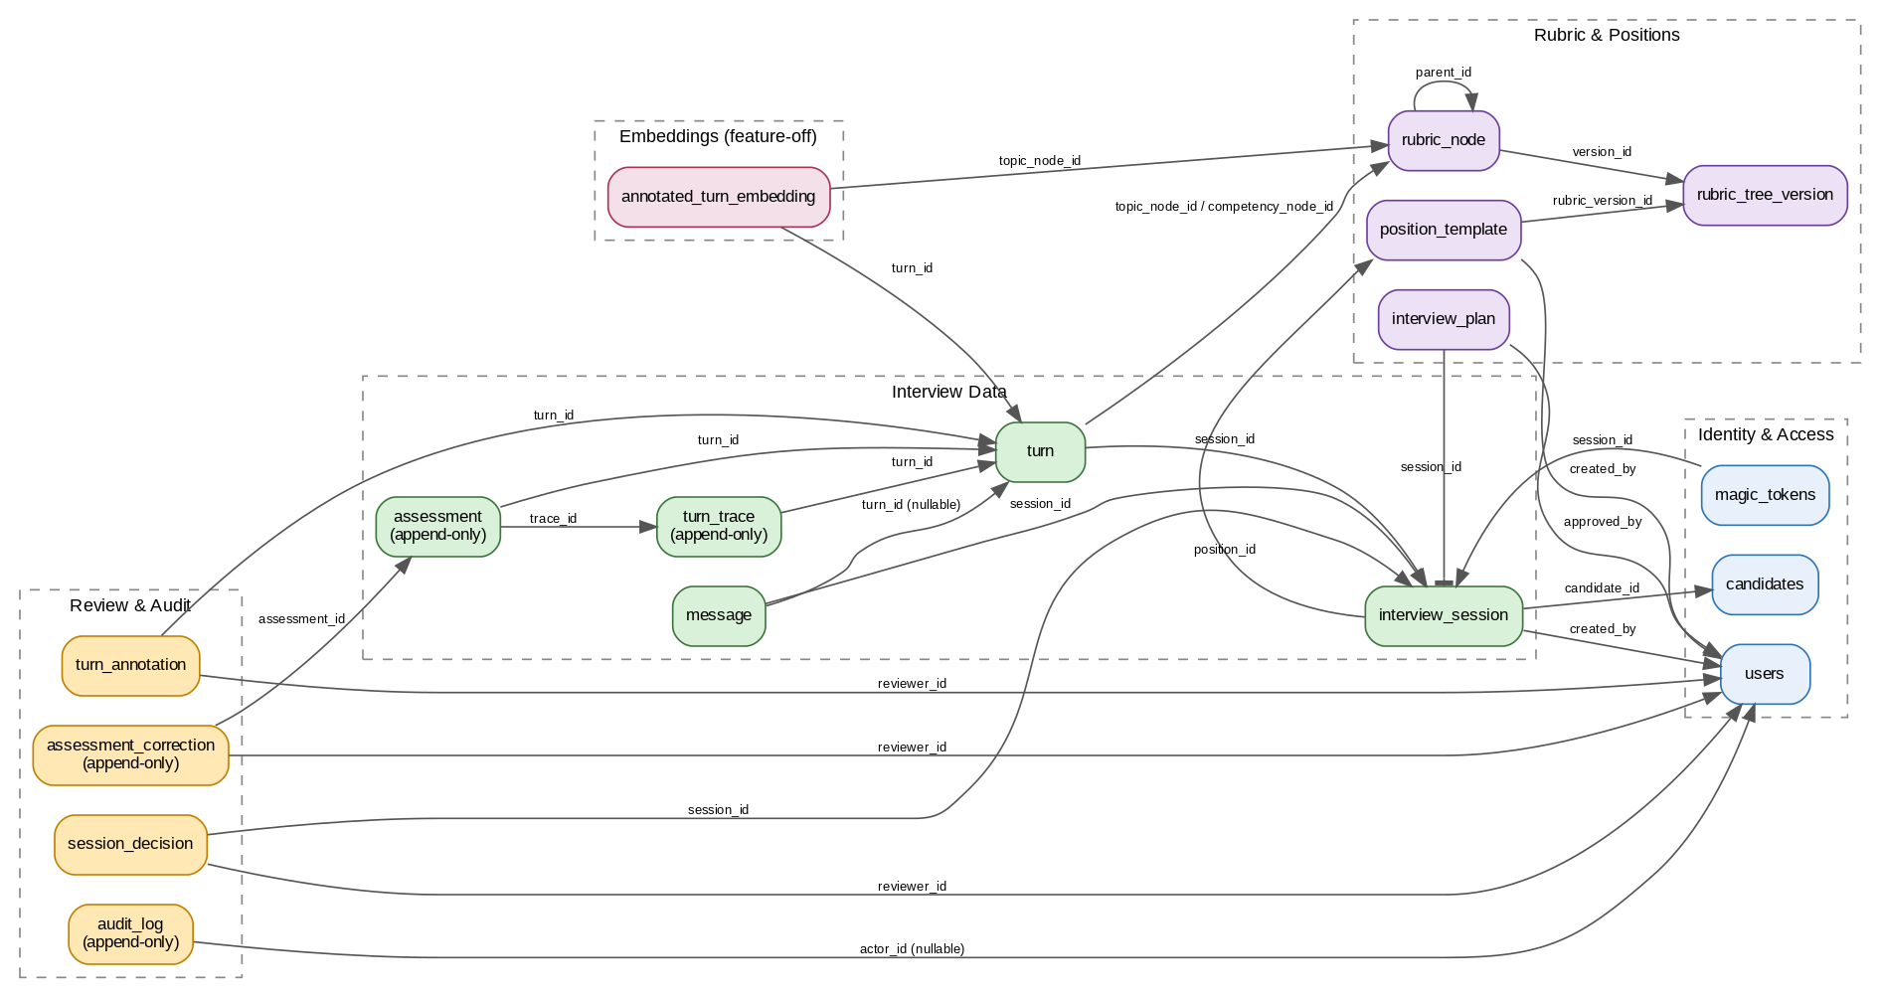
Diagram 7 — Data Model Overview

10. Key invariants (summary)
- Immutable snapshots: rubric_snapshot and plan_json (once frozen) are never rewritten.
- Append-only audit trail: turn_trace, assessment, turn_annotation, assessment_correction, audit_log — insert-only.
- Effective score is derived from the latest assessment_correction for a given assessment, not by mutating the assessment row.
- PII containment: traces and embeddings never contain emails or real names — only candidate_pseudonym.
- Rubric versioning via rubric_tree_version: changes to the live rubric never affect sessions already in progress or completed.

11. Default indexing rules
- Every foreign key gets an explicit CREATE INDEX (Postgres does not create these automatically).
- (session_id, created_at) on everything that belongs to a session.
- (turn_id) on assessment, turn_annotation, assessment_correction.
- Full-text / GIN indexes are deferred to when we add search.

12. Migrations
- Tool: Alembic (SQLAlchemy-style). One migration per file, named with a timestamp prefix.
- Forward-only in MVP — rollbacks are rare; we prefer a follow-up forward migration.
- Zero-downtime hardened for:
  - adding a column without NOT NULL,
  - creating an index → CREATE INDEX CONCURRENTLY,
  - dropping a column → two-step (stop writing, then drop).

13. Open questions
- Store the full prompt_text in turn_trace (can grow large), or a reference prompt_version plus the rendered args? MVP currently stores the full text for fast debugging.
- Add table partitioning on turn_trace (monthly) from day one, or defer until the table approaches ~1 M rows?
- Keep session_decision single-row (as designed) or go append-only from the start?

14. Glossary
- Rubric snapshot — an immutable JSONB copy of the rubric subtree stored on interview_session at session start.
- Effective score — the latest assessment_correction value for an assessment, falling back to the original assessment row.
- Append-only table — insert-only; corrections / updates are modelled as new rows.
- Hybrid scaffold — the form of plan_json: high-level blocks, not a fully scripted question list.

