Assignment #3
Rename this file to include your full name and answer all questions in this document. Handwritten answers will not be accepted. Total points: 100.

- Inheritance (20 points)
To solve this problem, you may use an object-oriented language of your choice (e.g., Java, C#, C++). In order to receive full credits, your code must have no bugs.

- Write a pair of classes, Square1 and Rectangle1. Define Square1 as a subclass of Rectangle1. Two instance variables in Rectangle1 are height and width. Square1 should not introduce any new instance variable. In addition to setters and getters, provide such methods as computeArea and computePerimeter. Write at least one test for each class.
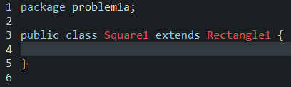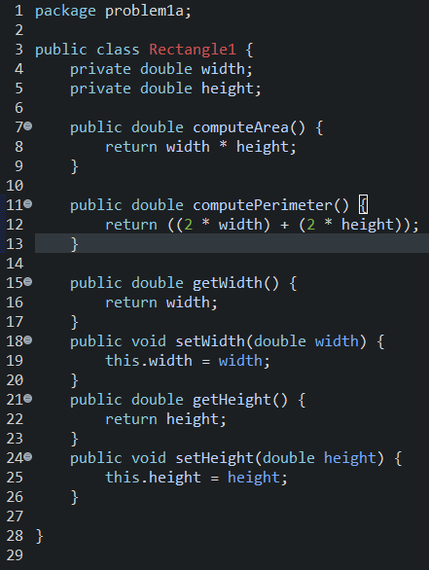
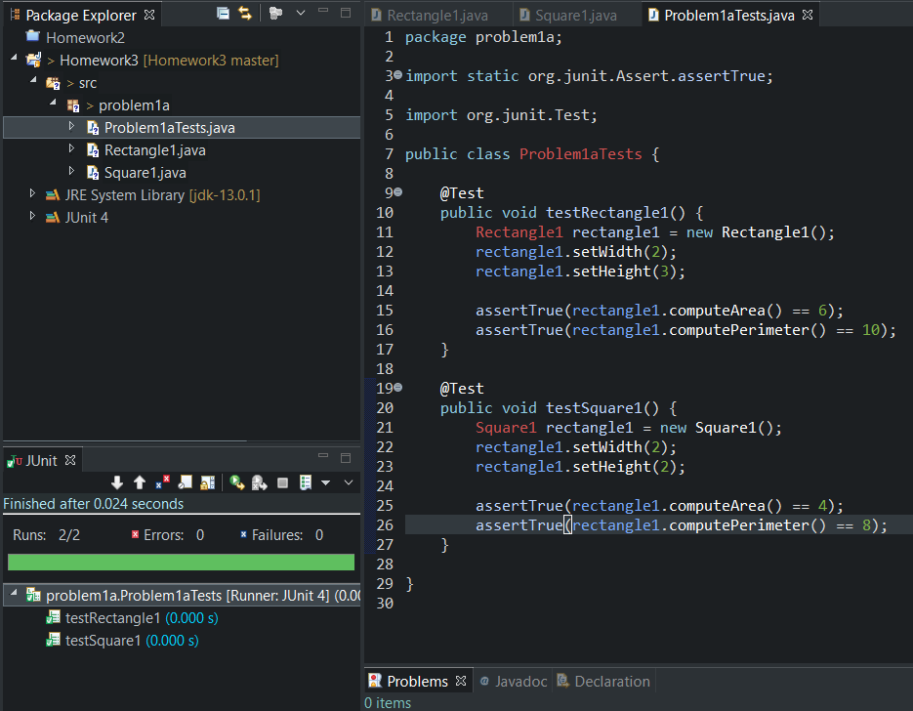

- Write a pair of classes, Square2 and Rectangle2. Define Rectangle2 as a subclass of Square2. The only instance variable in Square2 is height. Rectangle2 inherits height from Square2, and introduces a new instance variable width. In addition to setters and getters, provide such methods as computeArea and computePerimeter. Write at least one test for each class.
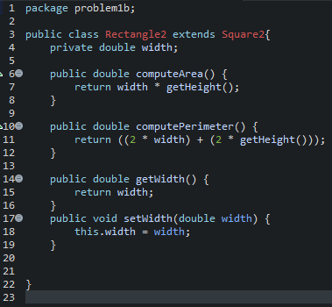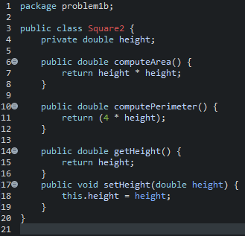
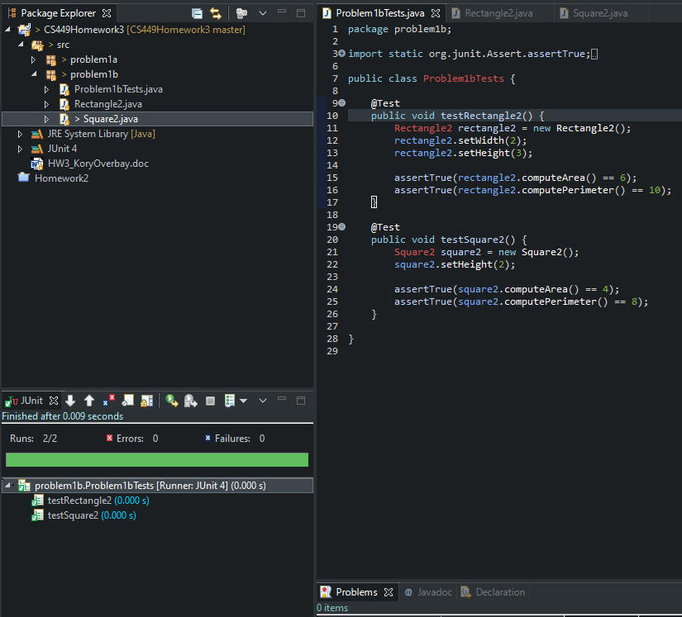
- Compare (a) and (b) and describe their pros and cons. (6 points)

 | Pros | Cons
(a) | One set of functions for finding area and perimeter | Square class doesn’t have much purpose
(b) | Each class has specific uses | Each class needs to override the area and perimeter functions

Problems 2-6 are based on the source code of the given ATM project. To test the ATM program, you may locate and run ATMMain.java in the main package. There is no need to review every class unless they are relevant to the following problems. Important: for each problem, you must provide a detailed justification of your answer (i.e., why or why not).

- Class Design (10 points for each)
- Review all the public methods of ATM, Money, and Card. Does each of these classes have a good class abstraction?
- Consider the following variables and related operations in class SimulatedBank in the simulation package: ACCOUNT_NUMBER, WITHDRAWALS_TODAY, DAILY_WINTHDRAWAL _LIMIT, and BALANCE[]. How can you improve the design?

Answers:

- Command-Query Separation Principle (10 points)
List all the public and private methods in the ATM class and determine whether or not each method has violated the command-query separation principle.

Answers:

- Design by Contract (10 points for each)
Consider the precondition of method subtract in class Money:
public void subtract(Money amountToSubtract)
- Is this.cents - amountToSubtract.cents>=0 a demanding precondition of subtract? Does it violate the reasonable precondition principle or the precondition availability principle?
- List all calls of the subtract method and describe whether or not each call violates the precondition amountToSubtract.cents>=0?

Answers:

- Class Invariant (10 points for each)
- For any object of class ATM, is it possible that switchOn is false and state=SERVING_CUSTOMER_STATE is true?
- For any object of Money class, is it possible that this.cents<0?

Answers:

- Inheritance (10 points)
Is the class hierarchy of Transaction, Withdrawal, Transfer, Deposit, and Inquiry a good application of inheritance?

Answers:

