HomeVPN
Technical Design Document
  - Architecture, VPN connectivity, deployment and security
Version 0.1 | Status: Design baseline | Language: English
Scope: ASP.NET Core management API, planned Blazor interface, Docker-hosted WireGuard service, and private home-network access.

1. Executive summary
HomeVPN is a self-hosted remote-access VPN solution designed to provide secure connectivity from authorized remote devices to selected resources on a home network. The design separates the VPN data plane (WireGuard) from the management plane (ASP.NET Core API and future Blazor UI). The initial target is a Linux mini-PC running Docker Compose.
Implementation status: the Visual Studio solution and project structure have been prepared. Networking, authentication, peer provisioning and production deployment are design targets, not verified implemented features.

2. System context and network topology
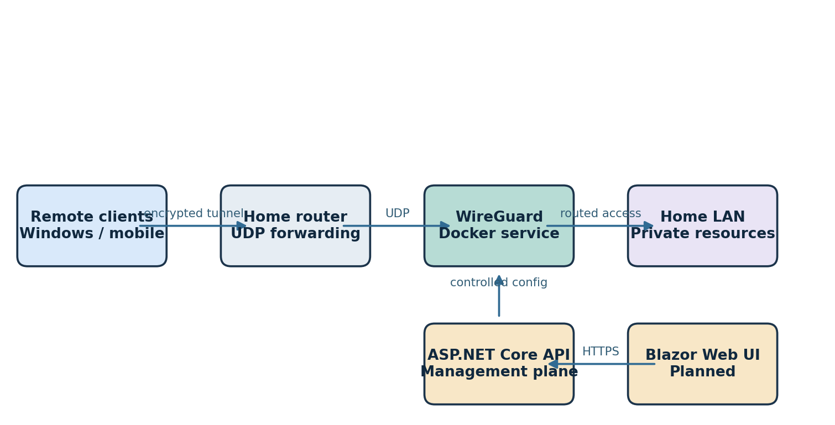
Figure 1. Proposed network topology and management-plane separation.
Remote clients connect to the public endpoint of the home router. The router forwards the selected UDP port to the WireGuard container host. After tunnel authentication, routing and firewall rules permit access only to approved home-LAN destinations. The web UI communicates with the API over HTTPS; it does not carry VPN traffic.

3. Solution architecture
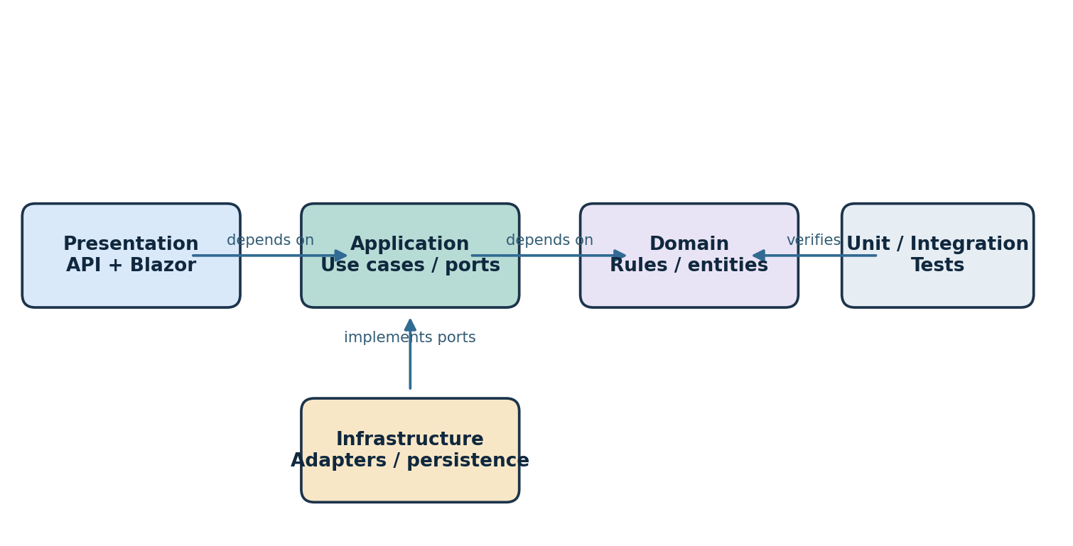
Figure 2. Clean Architecture dependency direction (conceptual).

Domain
VPN server, client/peer, address allocation and configuration rules. No dependency on web frameworks or infrastructure.

Application
Use cases such as register peer, revoke peer, retrieve server status and validate configuration; interfaces for persistence and VPN control.

Infrastructure
Concrete implementations for storage, WireGuard configuration integration and operating-system boundaries.

Presentation
ASP.NET Core Web API and a planned Blazor management UI. API authentication and authorization are required before administrative operations.

Tests
Unit tests for domain rules and application use cases; integration tests for persistence, API behavior and VPN adapter boundaries.

4. Peer provisioning workflow
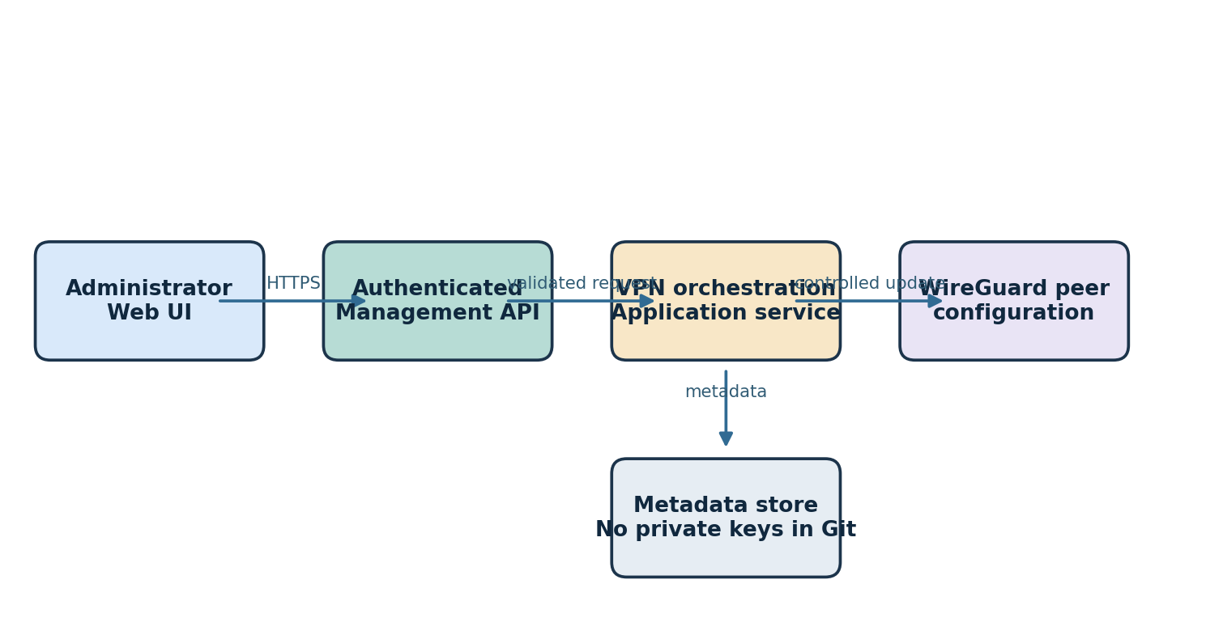
Figure 3. Planned administrative peer-management flow.
An authenticated administrator requests peer creation. The API validates input and authorization, invokes an application use case, allocates an address without conflict, persists non-sensitive peer metadata, and requests a controlled WireGuard configuration update. Private keys should be generated and handled with strict lifecycle controls; they must never be committed to the repository.

5. Component inventory
Component | Responsibility | Status
HomeVPN.Domain | Entities, invariants, value objects | Project scaffold
HomeVPN.Application | Use cases and interfaces | Project scaffold
HomeVPN.Infrastructure | Adapters and persistence | Project scaffold
HomeVPN.API | Administrative HTTP endpoints | Project scaffold
HomeVPN.Web | Blazor management interface | Project scaffold
HomeVPN.UnitTests / IntegrationTests | Automated verification | Project scaffold
WireGuard container | Encrypted VPN data plane | Planned
Docker Compose | Service deployment and networks | Planned

6. Security requirements
- Use WireGuard public-key authentication for VPN peers and strong administrator authentication for management endpoints.
- Apply least privilege to Docker containers, volumes, host mounts and API operations.
- Do not store private keys, passwords, .env files, or production VPN configuration in Git.
- Restrict forwarding and firewall rules to approved destinations; avoid unrestricted LAN exposure by default.
- Protect management traffic with HTTPS; log administrative actions without logging secrets.
- Document key rotation, device revocation, backups and recovery procedures.

7. Deployment design
Target host: Linux mini-PC with Docker Engine and Docker Compose. Deploy WireGuard and the management API as separate services, with explicit networks, persistent data locations, restart policies and health checks. Expose only the required VPN UDP port to the internet. The management interface should be reachable only through a trusted network path or explicitly secured reverse proxy.

8. Validation strategy
- Unit: address allocation, input validation, duplicate peer detection, access rules.
- Integration: API authorization, repository behavior and adapter error handling.
- Network: handshake, split-tunnel routing, DNS behavior and LAN reachability.
- Security: unauthorized requests, revoked peers, firewall isolation and secret leakage checks.
- Operations: container restart, configuration persistence, backup and restore.

9. Open design decisions
- Choose the WireGuard container image and safe configuration-update mechanism.
- Define address ranges, home-LAN CIDR and DNS strategy without overlapping client networks.
- Decide on API authentication, administrator roles and management UI exposure.
- Select persistence mechanism and key custody approach.
- Define whether IPv6 is supported and how firewall policy applies.

10. Repository placement
Recommended path: docs/documents/HomeVPN_Technical_Design_v0.1.docx. Keep detailed, frequently edited source documentation in Markdown; maintain this Word document as a versioned design snapshot.

