SERVIR GRP prototype reviewer manual

Phaya Thai District example
Prototype version: 0.1.9-prototype
Live prototype: http://18.139.74.142/
Local fallback: http://localhost:8080
Audience: Product, planning, data, method and platform reviewers
Recommended review time: 20–30 minutes

1. Purpose of this manual
This manual guides a reviewer through the current first-phase evacuation-preparedness prototype using Phaya Thai District, Bangkok as the worked example.
The review should determine whether the prototype clearly helps a Planner:
- compare five candidate locations;
- understand nearby aggregated vulnerable-population zones and movement-support needs;
- inspect illustrative shelter-proximity and population gaps;
- build a preparedness investment brief; and
- access the H/M/L risk map as supporting information.
The first phase intentionally does not contain analyst-validation status, approval states, candidate suitability scores or capacity decisions.

2. Important prototype boundaries
Before reviewing, keep these interpretation rules in mind:
- Phaya Thai District is a real administrative name.
- AOI boundaries, flood geometry, candidate locations, population values, vulnerability values, proximity results and risk points are illustrative.
- Candidate locations are not confirmed safe, suitable, approved or operational.
- Suitability and capacity are not assessed in this first phase.
- Vulnerable-population zones are aggregated and do not represent individual people or households.
- Vulnerability categories may overlap and must not be summed.
- Straight-line proximity is not walking distance, travel time or a safe route.
- “Within a threshold” does not mean people are served because capacity and accessibility are not included.
- RP20, RP50 and RP100 are static planning scenarios—not forecasts or current warnings.
- Low/green risk does not mean safe.
Do not enter personal information, operationally sensitive records or confidential facility information into the HTTP prototype.

3. Open the prototype
- Open http://18.139.74.142/ in a current desktop version of Chrome, Edge or Firefox.
- If the previous interface appears, use Ctrl+F5 to hard-refresh.
- Confirm the header says Evacuation preparedness planning.
- Confirm the starting actions include Build preparedness investment case and Review preparedness.
- Use the + button beside the assessment title to reset the demonstration at any time.
For local review:
cd prototype
python -m http.server 8080
Open http://localhost:8080.

4. Screen orientation

Left panel — planning assistant
The assistant records the selected purpose, AOI and scenario and explains the current result. Reviewers can also ask questions in natural language.

Right panel — map workspace
The map workspace contains:
- AOI selector;
- static RP scenario information;
- illustrative flood extent;
- candidate-location markers C1–C5;
- vulnerable-population zones V1–V4;
- result panel with candidate and vulnerable-people views;
- supporting risk-map view; and
- evidence/download controls.

Hide and restore information
Select × on the planning-information panel to expand the map. Select Show planning information to restore the same active view. The candidate or vulnerable-people tab should remain selected.

5. Recommended Phaya Thai review path

Step 1 — frame the purpose
Select Review preparedness.
Expected response:
- the assistant confirms the preparedness focus;
- the AOI selector opens; and
- no undefined text appears.
Reviewer questions
- Are the starting choices understandable?
- Is “Review preparedness” the right neutral entry point?
- Does the first-phase scope appear early enough?

Step 2 — select Phaya Thai District
Select Phaya Thai District, Bangkok.
Expected result:
- AOI level: District;
- real-name/mock-data warning remains visible;
- RP100 is selected by default; and
- the assistant asks the reviewer to confirm the static flood scenario.
Reviewer questions
- Is the distinction between real AOI name and mocked geometry clear?
- Is “district or sub-district” the preferred terminology?
- What authoritative AOI identifier and boundary source should production use?

Step 3 — understand RP100
Keep RP100 and select Confirm scenario & run assessment.
RP100 means a 100-year return-period flood scenario with a 1% annual exceedance probability. It does not mean the event occurs exactly once every 100 years.
Expected RP100 demonstration values:
Indicator | Illustrative value
People within displayed flood extent | 18,640
Candidate locations | 5
Vulnerable-population zones | 4
Vulnerability indicators | 4
Reviewer questions
- Is the RP100/1% AEP explanation understandable?
- Should the interface say “1% chance of being exceeded in any year” more prominently?
- Which approved return-period products and versions should production use?

Step 4 — review five candidate locations
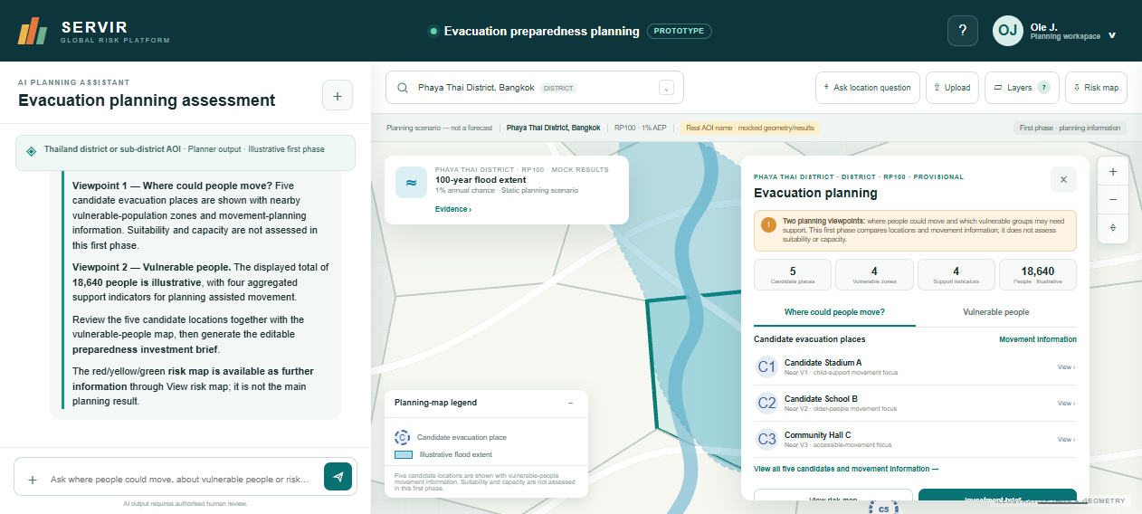
Candidate-location view for Phaya Thai District.
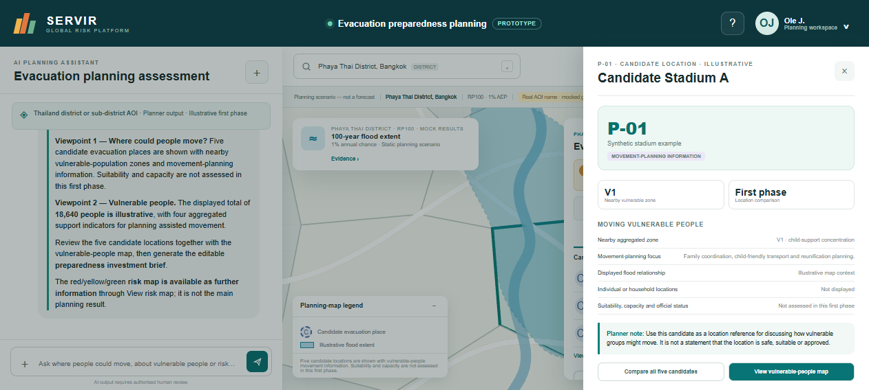
Candidate C1 movement-information drawer; no validation status or suitability score.
Open Where could people move?.
The current candidate-location relationships are:
Candidate | Nearby illustrative zone | Movement-planning focus
C1 Candidate Stadium A | V1 child-support concentration | Family coordination, child-friendly transport and reunification
C2 Candidate School B | V2 older-people concentration | Mobility assistance, medication continuity and accessible transport
C3 Community Hall C | V3 disability-support concentration | Accessible vehicles, communication support and assistance teams
C4 Government Facility D | V4 low-mobility concentration | Pickup points, assisted movement and transport coordination
C5 Open Assembly Area E | V1 + V4 mixed focus | Family movement, staging and low-mobility transport
Select C1 and inspect the drawer.
Expected content:
- candidate ID and illustrative facility type;
- nearby aggregated vulnerable zone;
- movement-planning focus;
- no individual/household locations; and
- suitability, capacity and official status explicitly outside this first phase.
Reviewer questions
- Does each candidate provide enough first-phase information?
- Is the relationship between candidate location and vulnerable group clear?
- Is any wording still incorrectly suggesting safety, capacity or approval?
- What additional movement-planning field should be introduced next?

Step 5 — review the vulnerable-people map
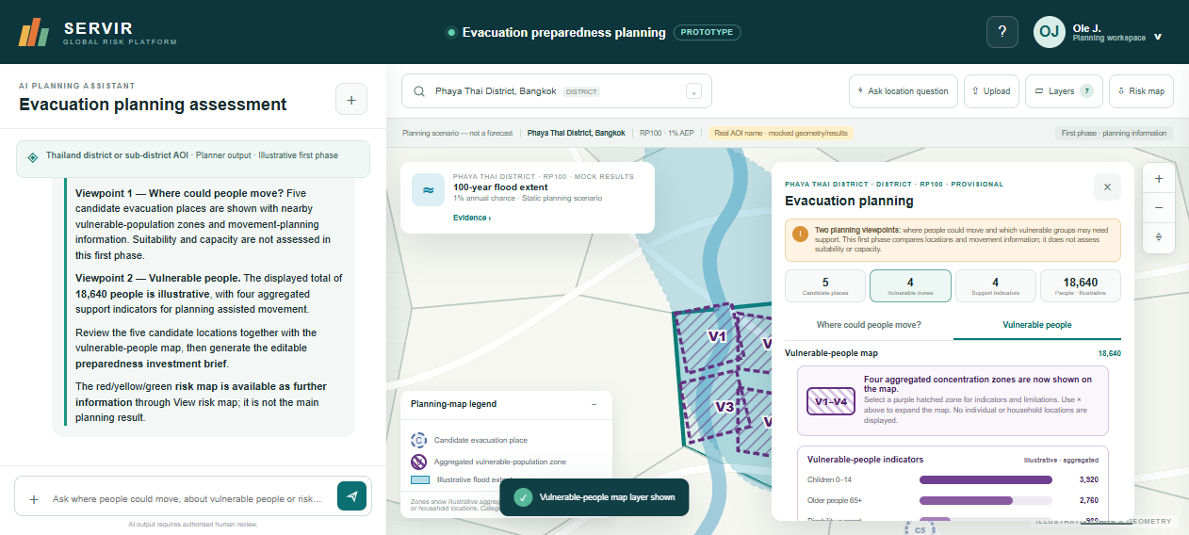
V1–V4 aggregated vulnerable-population zones and indicator chart.
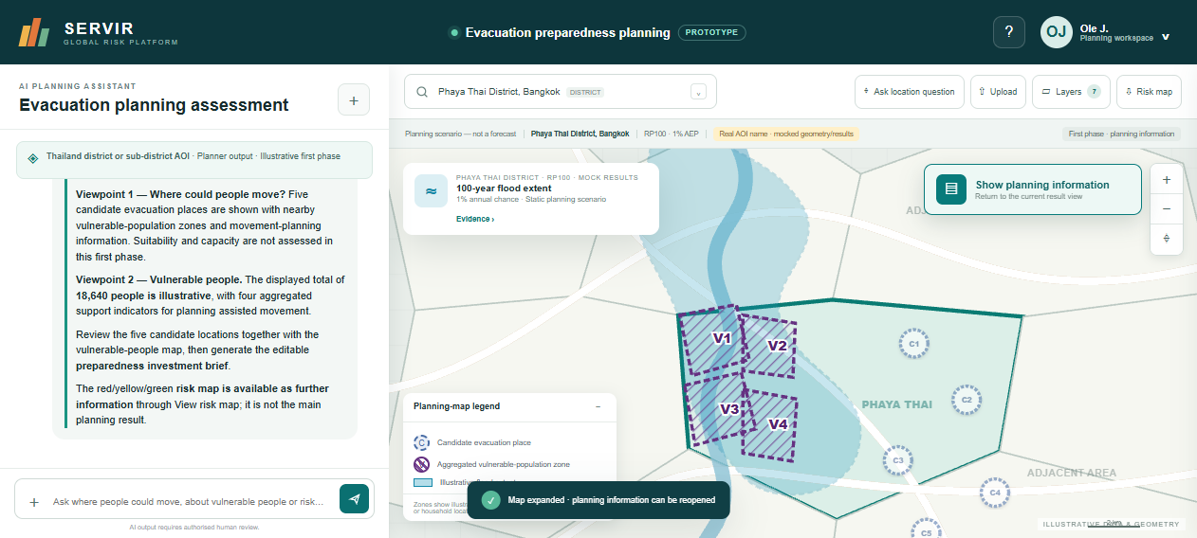
Expanded vulnerable-people map with reversible Show planning information control.
Close the candidate drawer and select Vulnerable people.
Expected map behaviour:
- four purple hatched aggregated zones V1–V4 appear;
- candidate markers remain visible but secondary;
- the legend explains the vulnerable-population layer;
- the flood layer remains supporting context; and
- no individual or household point is shown.
Select a purple zone to inspect its information. Use × on the planning panel to expand the map, then use Show planning information to return.
Reviewer questions
- Are V1–V4 visible and understandable without relying only on colour?
- Is the aggregation/privacy warning clear?
- Are four zones sufficient for the discussion?
- What spatial aggregation level should production use?

Step 6 — review the vulnerability bar chart
In the Vulnerable people view, review the horizontal bar chart.
Expected RP100 values:
Indicator | Illustrative value | Unit
Children aged 0–14 | 3,920 | People estimate
Older people aged 65+ | 2,760 | People estimate
Disability-related support needs | 930 | People estimate
Low-mobility households | 1,480 | Household estimate
The chart labels every bar and does not rely on colour alone. It states that categories may overlap and that the low-mobility measure uses a different unit.
Change to RP20 and RP50 if time permits. The chart and cards should update consistently.
Reviewer questions
- Are the labels and units clear?
- Should households and people appear in one chart or separate charts?
- Which vulnerability indicators and definitions are approved?
- What privacy and minimum-aggregation rules are required?

Step 7 — review shelter proximity and population gaps
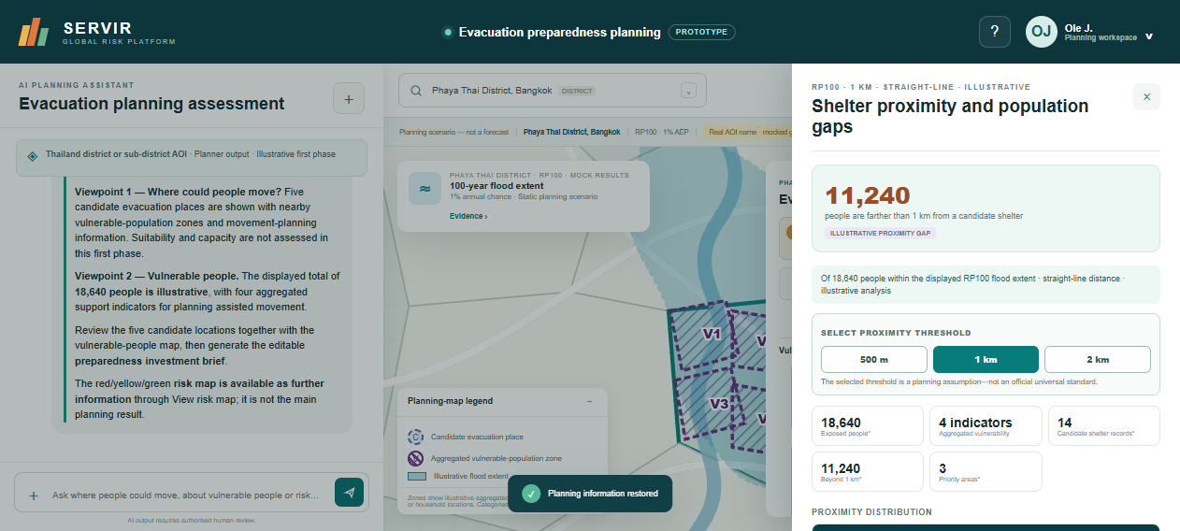
Shelter-proximity headline, selectable threshold and distance-band results.
Select Shelter proximity and population gaps below the vulnerability indicators.
Expected default headline:
11,240 people are farther than 1 km from a candidate shelter.
Expected RP100 distance bands:
Distance to nearest candidate shelter | People | Percentage
Within 500 m | 1,980 | 10.6%
500 m–1 km | 5,420 | 29.1%
1–2 km | 7,090 | 38.0%
More than 2 km | 4,150 | 22.3%
Test each threshold:
Selected threshold | People beyond threshold | Priority areas
500 m | 16,660 | 4
1 km | 11,240 | 3
2 km | 4,150 | 1
The interface must state that the threshold is a planning assumption, not an official universal standard.
Reviewer questions
- Is people beyond the threshold the correct headline?
- Which threshold is meaningful in Thailand and in what context?
- Should production use straight-line distance, network distance or travel time?
- Should the next increment add population cells and proximity radii to the map?

Step 8 — build the preparedness investment brief
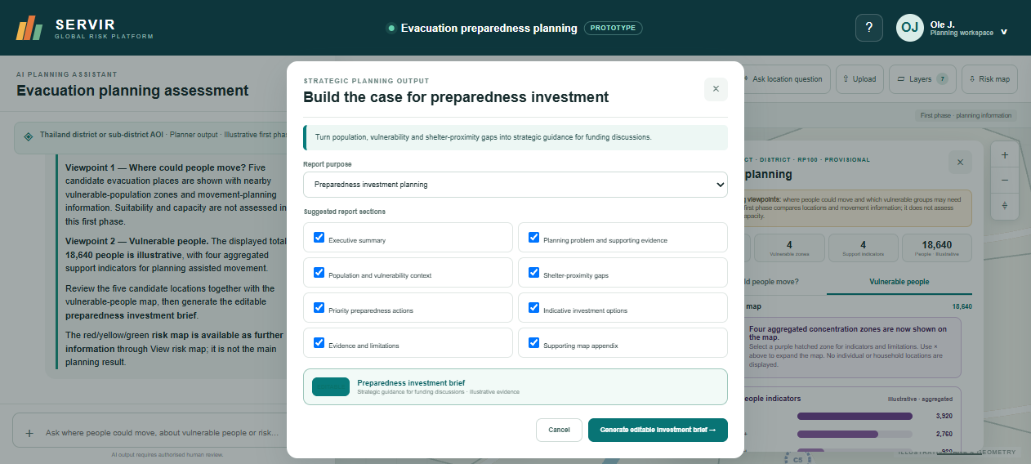
Preparedness investment brief purpose and eight suggested sections.
Close the proximity drawer and select Investment brief.
Expected title:
Build the case for preparedness investment
Expected supporting text:
Turn population, vulnerability and shelter-proximity gaps into strategic guidance for funding discussions.
Confirm the purpose is Preparedness investment planning and review the eight sections:
- Executive summary;
- Planning problem and supporting evidence;
- Population and vulnerability context;
- Shelter-proximity gaps;
- Priority preparedness actions;
- Indicative investment options;
- Evidence and limitations; and
- Supporting map appendix.
Select Generate editable investment brief. The browser should download:
Phaya_Thai_District_RP100_Preparedness_Investment_Brief.doc
The brief supports an investment discussion. It is not an automated funding decision, cost estimate or formal approval.
Reviewer questions
- Are the section names suitable for funding discussions?
- Which standard template and investment categories should be used?
- What costing, ownership and prioritisation fields belong in the next phase?
- Is the boundary between strategic guidance and formal funding approval clear?

Step 9 — inspect the supporting H/M/L risk map
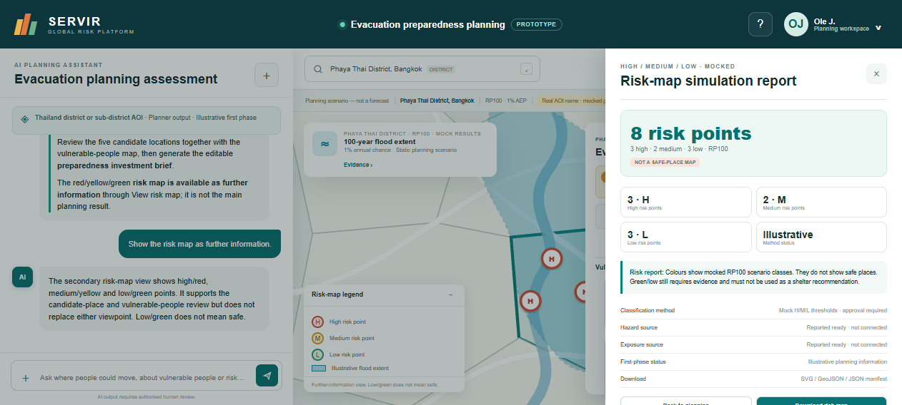
Supporting H/M/L risk-map view; low/green does not mean safe.
Select Risk map or View risk map.
Expected behaviour:
- H/red, M/yellow and L/green use both colour and letter labels;
- the map is presented as further information; and
- low/green explicitly does not mean safe.
Available prototype downloads include SVG, GeoJSON and JSON evidence. PNG and GeoTIFF remain future production-renderer outputs.
Reviewer questions
- Is the risk map correctly secondary to candidate and vulnerable-people views?
- Are the H/M/L semantics clear?
- What approved method, thresholds and provenance should production use?

Step 10 — inspect upload guidance
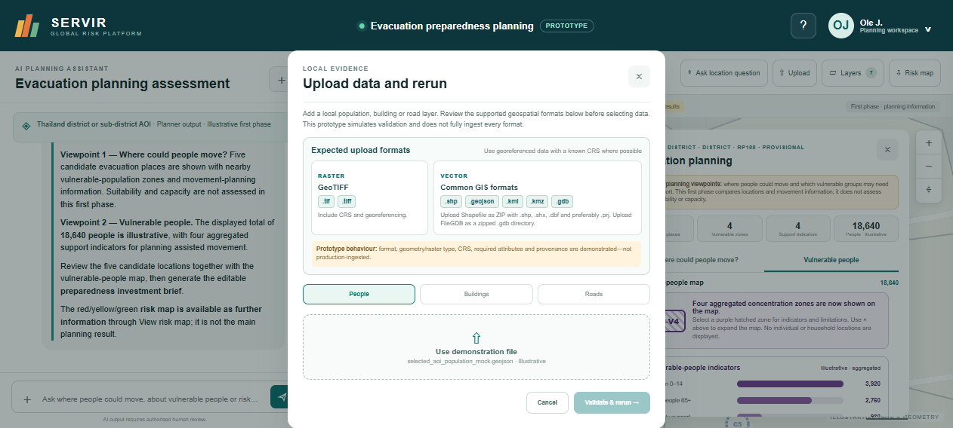
Raster and vector upload-format guidance.
Select Upload.
Expected guidance:
Raster
- .tif and .tiff GeoTIFF, preferably with CRS and georeferencing.
Vector
- zipped Shapefile containing .shp, .shx, .dbf and preferably .prj;
- .geojson;
- .kml;
- .kmz; and
- zipped .gdb File Geodatabase directory.
The prototype only simulates ingestion and schema checks.
Reviewer questions
- Which formats must Release 1 genuinely process?
- What schemas, CRS rules, size limits and required attributes apply?
- What provenance, source, licence and date must users provide?

6. Natural-language review tests
After running the Phaya Thai assessment, test:
- “Where could people move?”
- “Where are vulnerable people?”
- “Show children and older people.”
- “Show the shelter-proximity gaps.”
- “Build a preparedness investment brief.”
- “Show the risk map.”
- “Which candidate shelter is safe?”
Expected safe-place response: the assistant must not certify any candidate as safe, suitable or approved.

7. Reviewer comment method
When reviewing through Google Slides, Google Docs or an issue tracker, use these prefixes:
- [UX] workflow, labels, comprehension or accessibility;
- [DATA] source, identifier, vintage, licence or coverage;
- [METHOD] scenario, aggregation, proximity or classification method;
- [PRIVACY] vulnerable-population protection and aggregation;
- [INVESTMENT] strategic guidance, action or funding category;
- [PLATFORM] runtime, integration, deployment or shared service;
- [DECISION] explicit choice required;
- [QUESTION] clarification required.
A useful comment includes:
- prototype step or screen;
- expected behaviour;
- observed behaviour;
- recommended change;
- Release 1 impact;
- proposed owner or source, if known.
Example:
[METHOD] Shelter proximity: 1 km is currently a selectable planning assumption. Please identify the policy or study supporting the production threshold and whether urban/rural thresholds should differ. Release 1 blocker: yes. Proposed owner: method lead.

8. Reviewer completion checklist
- ☐ I opened the current prototype and confirmed the first-phase label.
- ☐ I selected Phaya Thai District.
- ☐ I ran RP100 and understood 1% AEP.
- ☐ I reviewed all five candidate locations.
- ☐ I opened at least one candidate movement-information drawer.
- ☐ I reviewed V1–V4 on the vulnerable-people map.
- ☐ I reviewed the vulnerability bar chart and unit warning.
- ☐ I tested hide/show planning information.
- ☐ I tested 500 m, 1 km and 2 km proximity thresholds.
- ☐ I generated the preparedness investment brief.
- ☐ I opened the supporting H/M/L risk map.
- ☐ I reviewed upload-format guidance.
- ☐ I tested at least two natural-language questions.
- ☐ I recorded blockers, decisions, proposed owners and sources.

9. Known limitations
- Static frontend with no authentication or persistent database.
- Refreshing resets the session.
- No production AOI, hazard, population, vulnerability or shelter service is connected.
- No individual-level information is accepted or displayed.
- Candidate suitability, capacity and official status are not assessed.
- Proximity values are mocked and use a straight-line concept.
- No road routing, travel time, accessibility or route safety.
- No production costing or formal investment approval workflow.
- H/M/L methods are not approved for production.
- The live IP currently uses HTTP rather than an HTTPS domain.

10. Troubleshooting

Old interface or wording appears
Use Ctrl+F5. If needed, clear site data and reopen the page.

The information panel hides the map
Select × to expand the map. Select Show planning information to restore it.

A download does not appear
Allow downloads for the site and check the browser Downloads folder.

A result does not appear
Reset, select Review preparedness, choose Phaya Thai District, keep RP100 and run the assessment.

Values disappear after changing scenario
Hard-refresh and confirm the prototype version is 0.1.9 or later.

