Health Care System

DataBase project

2014

Leonid Dubovyi, Valerii Doroshenko, Nadine Kovalenko

Vanier College™

13.06.2014

System Planning: Business Case:

Project glossary

HCS – Health Care System

Medical staff – doctors, nurses, medical assistants

Laboratory staff – technicians, laboratory assistants

System – Health Care System

Medical institutions – hospitals, clinics and so forth

SSN – social security number

Patient – person, who needs medical treatment

Medical history – information about previous visits and previous diagnoses

EHR - electronic health record

EMR - electronic medical record

PHR - personal health record

Objectives of the project

Current Health Care situation in Quebec and the whole Canada requires some changes to allow numerous patients use this Health System more effectively. Every city in Quebec, especially big ones like Montreal, requires reducing the waiting time for patients and fastening the access to medical services. Thus, increasing in the efficiency of supporting medical staff will lead to solve this issue. Moreover, it will lead to increasing in the efficiency of the work of general staff in hospitals or other health care institutions. In most cases the waiting time depends on the time spent on filling up necessary forms, the time spent on gathering the necessary information about a patient, time spent on checking the availability of doctors or nurses at the time of a patient visit, time spent on making the primary anamnesis and etc. Almost most of that time can be reduced by implementing the proposed project.

Finally, this project allows medical staff and patients to receive and send all necessary information in on-line mode. It will allow patients to fill in on-line forms, to schedule and reschedule an appointment, medical staff and laboratories exchange the information in on-line mode and so on. Those actions are usually performed by the phone or at the patients’ presence in hospitals manually. Proposed system can be very useful in case of a planned visit, and when people do not have any urgent cases. However, even in such case, process of filling up electronic forms is much more easily for medical staff then filling up the paperback forms.

All information mentioned above, it is only a tip of an iceberg.

Description the system

The main purpose of proposed project is to allow the medical staff, the laboratory staff and patients to be always connected through this system in the real-time mode. Achieving this goal allows all sides involved in using this project to reach the side back targets which are not considered to be minor at the same time. For example: to decrease waiting time in the medical institutions during the first and following visits; to reduce the possibilities of medical errors; to lower administrative costs, to reduce communication time within the medical institutions.

All mentioned above should be built by dividing the whole system on five subsystems. In spite of this division, all information circulating in the system should be stored in the same database. The first subsystem belongs to the medical assistance and allows entering primary information about patient. This subsystem should not let medical assistants enter the information which belongs to doctors, nurses and laboratory staff. The second subsystem belongs to nurses and allows entering primary medical information such as medical history, results of primary examinations, lists of medication and allergies, and immunization status. This subsystem should also allow nurses making prescriptions which they are authorized to do. The third subsystem belongs to doctors and allows entering all information about health status, health treatment, prescriptions, referrals to necessary tests and so forth. The fourth subsystem belongs to the laboratory staff and allows entering information about tests’ results. The fifth subsystem belongs to patients and allows entering information about desirable appointments and retrieving information about medical prescriptions, diagnoses and further appointments. In addition, system allows to patients makes initial evaluation prescribed medications.

So now we can see some benefits of the proposed project:

1. Health Care System (HCS) reduces the possibility of medical errors
2. Features, such as integrated drug databases, symptom checks, and drug interaction verification, help physicians prescribe correct medications and right dosages.
3. HCS improves patient care and treatment, lower administrative costs, and improve billings and collections.
4. Increasing the number of patient visits per day is taken into account in order not to reduce the quality of care.
5. Duplicating of tests and clinical assessments is reduced
6. According to “The Health Level Seven International. Introduction to HL7 Standards” gathering of information is used according to the standards.
7. HCS increases physician efficiency, reduces costs and promotes standardization of treatment and patient care. Physicians find themselves with more time to focus on patient care as they eliminate paperwork, speed up medical charting, receive lab test results electronically, and make prescriptions electronically.
8. HCS provides the good level of privacy, which is executed according to the right of privacy for all Canadian citizens who interact with health professionals.
9. As physicians and support staff spend less time conducting and tracking paperwork, they are able to see more patients. HCS also allows physicians to complete and to document patient encounters more quickly, thus increasing their ability to provide more qualified care and take care of more patients.
10. One of the top benefits of electronic health records is serving more patients which naturally increases the flow of patients served as well as statistical information. Electronic patient records provide physicians with the necessary documentation to support claims sent to insurance companies, Medicare, and Medicaid.
11. HCS can also provide prompts to physicians based on inputs of patient major complaints and/or risky demographic factors.

Project alternatives

There are some current alternatives (EMR and EHR):

1. **Epic®.** Is presented in two variants of software: for hospitals and for laboratories. This system mostly belongs to the EHR – systems, because it communicates with different medical institutions within medical network.
2. **Cerner®.** Presents only one variant of software. This software mostly belongs to the EMR – systems, because this system was developed mostly for gathering information about patients within the same hospital, clinic or other medical institution.
3. **MEDITECH®.** This is complete EHR-system. The main point of this system is the workflow documentation between medical institutions.

All mentioned above systems are mainly concentrated on only one type of medical systems. As a matter of fact, our project is able to take the niche of medical software market, providing the combination of systems, and becoming the basis of further project’s development. According to the most recent research[1] only 6% from 21,202 respondents said they plan to remain without an EHR. And adding some very useful features as working directly with patients, connecting all three systems in one and so on is very valuable competitive advantage for the whole system.

Implementation plan

We are planning to develop the system which combines all three systems simultaneously from the beginning. This project is going to be based on desktop-technology with further involvement Web-technology (i.e. one relational database, access to the information through Internet, involving SaaS-technology and cloud-technology in the future). We have chosen this approach because at the end, it is much more affordable for small clinics and hospitals, which face budget limits. Moreover, even it allows big clinics and hospitals use existing staff eliminating the need for the additional personal for dealing with hardware and server issues.

According to the recent research, mentioned above, "easy to learn" and "easy to implement" were among the most important factors that respondents consider the most important, because these factors are marked their introduction in both the EHR and EMR systems. Users appreciated EHRs that are based on more "intuitive" work because they allow them to figure out aspects of operation more easily when instructions and constant technical support are not available.

A key factor is appearance a useful end product. Both EHR and EMR systems ultimately need to present information in a way that is easy to understand, easy to work with, and is user-friendly. Interactivity with other office systems is also critical. When the EHR operates with other systems, these office functions can be made more efficient.

Taking all these into account we are trying to develop “easy to understand” interface, including help system and to divide the system on small parts, which are very simple to use and operate with.

Executive Summary

Goal:

* developing Health Care System which connects three categories of systems, already existing in the market;

Advantage:

* reducing the possibility of medical errors;
* improving patient care and treatment, lowering administrative costs;
* increasing staff work’s efficiency;
* increasing access to information from multiple venues of the health system;
* reducing communication time between medical institutions, within the institution between staff as well as between a medical institution and a patient;

Expenses:

* supplying the computer systems if needs;
* startup budget for implementing this system

System Planning: SWOT Analysis

***Strengths:***

* User friendly interface with minimum time for training
* The data is stored and systemized
* Access to data is fast, easy and made in different paper, electronic forms
* It doesn’t need extra software
* The System satisfies demands of the doctors, medical assistants , nurses, laboratory  
   staff and patients
* Increases the productivity of all the participants in patient treatment
* Program is going to be developed for using through Web-access (Web – application)
* Reduces the waiting time for clients due to the decrease of the paperwork level

***Weaknesses:***

* Increases budget spending on developing and implementing this project
* Might need the modernization of equipment
* Needs improving some basic software components if the old ones are in use
* Might cause conflicts with current using software of the company and demands extra efforts to get over them
* Might cause patients issues if this program is going to be implemented in other software

***Opportunities:***

* Can be supported, updated or implemented in other projects
* All the data, including particular company cases, can be covered with this program
* In the next step, information can be accessed elsewhere, even in other countries and during the vacations abroad.

***Threats:***

* Changing the demands to the performance of future Web application in Web Browsers can invoke non-displaying pages and improper functioning of the system
* The program highly depends on the Internet connection
* Appearance of the competitive software could impact the distribution of the program
* In general, it can be widely used within the hospitals all over the country, but application has to be approved by government institutions.

System Planning: Constraints

The main constraint of this system is stable network connection with database, because all information is directly storing and retrieving from database. In the best case, a medical institution should have a reserved channel to database. In the worst case, a medical institution should have a back-up server with the local database with the information, which is updated every day. This case can lead to the lost of daily information, that is especially critical at the end of the day. The only way out is to synchronize these two databases in the nearest future.

The next constraint is the number of connection at the same time. Although Oracle has possibility to establish 2047 connection simultaneously, this constraint can lead to the increasing of waiting time in a query if the number of connection exceeds 2047.

System Planning: Preliminary Investigation Overview

Step1: Understanding the Problem or Opportunity

Many hospitals and clinics are required to adopt the use of a computer system that allows sharing information with other health care institutions, such as laboratories and independent specialists. It allows patients to retrieve medical information about their current state, to replace the paperback information with its digital copy.

So far current health care electronic systems are divided on three categories:

- an electronic health record (EHR);

- an electronic medical record (EMR);

- a personal health record (PHR)

An electronic health record (EHR) is built to share information with other health care institutions, such as laboratories and independent specialists. An EHR contains information about all clinicians involved in patient care. Moreover, authorized clinicians can access the information they need, to provide better treatment to a patient.

An electronic medical record (EMR) is a digital version of paper charts in a doctor’s office. An EMR contains notes and information collected by and available to clinicians in that office. A fully implemented EMR system allows electronic storage, retrieval, and modification of patient information. It is the chance for departments within the health organization to collaborate providing patients’ care. In hospitals and clinics, these federally backed EMR systems will replace hundreds of different applications used by physicians, radiology personnel, and even hospital administration.

A personal health record (PHR) contains the same types of information as an electronic health record - diagnosis, medications, immunizations, family medical history, and contact information for health care workers, but it is designed to be set up and accessed by patients themselves.

With impact of information technology, the proposed project will join all three variants of the current systems into a unified one.

Fishbone Diagram:

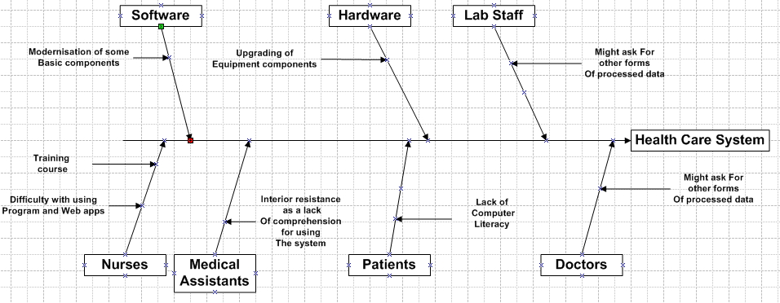

Step2: Defining the project scope and constraints

In the common case health records will be made available via large clinical systems in hospitals and health care institutions. Moreover, the goal of health record projects is to make personal health information accessible and transportable, which is beneficial to both consumers and health care workers. Hereafter, there is just an example, what kind of information can be gathered through this system:

*Data in an electronic medical record*

* patient demographics
* medical history, results of examinations and progress of reports of health state and diseases
* medication and allergy lists, and immunization status
* laboratory test results
* radiology images, x-rays, computer topographies’ or CTs, MRIs, etc
* photographs, from endoscopy or laparoscopy or clinical photographs
* medication information, including side-effects and interactions
* evidence-based recommendations for specific medical conditions
* records of appointments and other reminders
* billing records
* eligibility
* advanced directives, living wills, and health power of attorney

Step 3: Perform Fact-Finding

For detailed overview on the project and finding out the complete picture of the future system the following survey has been determined, carried out and analyzed.

**People to be interviewed**

1. GPs
2. Nurses
3. Medical Assistants
4. Lab Staff
5. Patients

Organization chart:

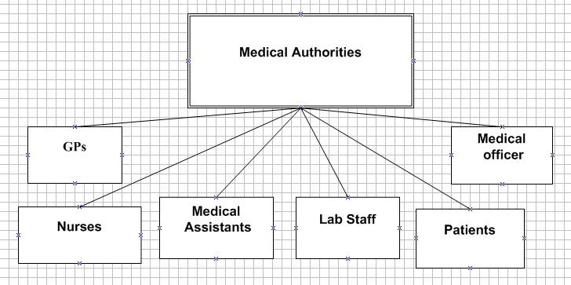

Questionnaire for a Nurse:

**Multiple choices.**

1. How do you determine your level of computer literacy?
2. Advance.
3. Intermediate.
4. Beginner.
5. Starter.
6. Which of the following programs do you use the most?
7. Word
8. Outlook
9. Excel
10. Access
11. Other specify ________________________
12. How long does it take you to learn something new?
13. 1-3 days
14. 3-5 days
15. a week
16. more than a week
17. How do you collect the patient’s information?
18. Personally by questioning her/him

(If chosen provide a sample, please)

1. Patient fills in a form (If chosen provide a sample, please)
2. Other specify _________________________________________

_________________________________________

1. How do you track the patients’ tests?
2. Receive them with a courier in paper form

(If chosen provide a sample, please)

1. Receive electronically
2. Patients collect them and hand them in personally
3. Other ways Specify______________________
4. How do you collect information about patient state during his/her visit?
5. Paper-based form (If chosen provide a sample, please)
6. Questionnaire (If chosen provide a sample, please)
7. Paper-based description in a free form
8. Any other Specify_________________
9. How long does it take you to find out the patient case according to records in her/his file?
10. Just a glimpse
11. Less than 5 min
12. More than 10 min
13. Other specify
14. Are the patients’ files organized just as you like them to be?
15. Yes
16. No

**Open-ended questions.**

1. Haw many patients use your services daily___________?
2. Haw many patients use your services weekly___________?
3. How many appointments are scheduled for you a day?
4. How does the missed appointment influence on your day schedule?
5. How long does a patient’s visit last?
6. How long does it take to full fill the patient’s file after a visit?
7. How long does it take you to make notes about patient condition during her/his visit?
8. How do you determine what hospital or what special doctor the patient has to be sent to?
9. How do you track the patient’s schedule of treatment, tests and vaccination?
10. What medications do you have a right to prescribe to a patient? Provide a list, please.
11. Who provides you with the list of medications?
12. How would you like a patient’s file to be organized?

Describe in detail, if possible provide any forms.

Questionnaire for a GP:

**Multiple choices.**

1. How do you determine your level of computer literacy?
2. Advance.
3. Intermediate.
4. Beginner.
5. Starter.
6. Which of the following programs do you use the most?
7. Word
8. Outlook
9. Excel
10. Access
11. Other specify ________________
12. How long does it take you to learn something new?
13. 1-3 days
14. 3-5 days
15. a week
16. more than a week
17. How do you collect information about patient state during his/her visit?
18. Paper-based form (If chosen provide a sample, please)
19. Questionnaire (If chosen provide a sample, please)
20. Paper-based description in free form
21. Any other Specify_________________
22. How do you track the patients’ tests?
23. Receive them with a courier in paper form
24. Receive electronically
25. Patients collect them and hand them in personally
26. Other ways Specify______________________
27. How long does it take you to find out the patient case according to records in her/his file?
28. Just a glimpse
29. Less than 5 min
30. More than 10 min
31. Other specify
32. Are the patients’ files organized just as you like them to be?
33. Yes
34. No

**Open-ended questions.**

1. Haw many patients use your services daily___________?
2. Haw many patients use your services weekly___________?
3. How many appointments are scheduled for you a day?
4. How does the missed appointment influence on your day schedule?
5. How long does a patient’s visit last?
6. How long does it take to full fill the patient’s file after a visit?
7. How do you determine what hospital or what special doctor the patient has to be sent to?
8. How would you like a patient’s file to be organized?

Describe in detail, if possible provide forms if any.

Questionnaire for a Medical Assistant:

**Multiple choices.**

1. How do you determine your level of computer literacy?
   1. Advance.
   2. Intermediate.
   3. Beginner.
   4. Starter.
2. Which of the following programs do you use the most?
3. Word
4. Outlook
5. Excel
6. Access
7. Other specify ________________
8. How long does it take you to learn something new?
9. 1-3 days
10. 3-5 days
11. a week
12. more than a week
13. How do you collect the patient information?
14. Personally (If chosen provide a sample, please)
15. Patient fills in a form (If chosen provide a sample, please)
16. Other  
    Specify_________________________________________  
     _________________________________________
17. How does a patient receive notifications about an appointment?
18. Phone call from an assistant
19. E-mail
20. Text-message
21. They don’t receive any notifications
22. How do you determine patients to a doctor or a nurse within your hospital/clinic?
23. Live line
24. According to their condition
25. Any doctor who is free takes the patient
26. Other   
    Specify_________________________________________  
     _________________________________________
27. How do you collect general information about a patient during his/her visit?
28. Paper-based form (If chosen provide a sample, please)
29. Questionnaire (If chosen provide a sample, please)
30. Paper-based description in free form
31. Any other   
    Specify_________________________________________  
     _________________________________________
32. Are the patients’ files organized just as you like them to be?
33. Yes
34. No

**Open-ended questions.**

1. How many patients use your services daily___________?
2. How many patients use your services weekly___________?
3. How many appointments do you have to schedule a day?
4. How long does it take you to schedule an appointment?
5. How many appointments do you have to reschedule a day?
6. How long does it take you to reschedule an appointment?
7. Do patient miss their appointments?
8. How often does it happen?
9. What is the main reason of missing?
10. How would you like a patient’s file to be organized?

Describe in detail, if possible provide forms if any.

1. What information does any patient file consist of? If it is possible provide a form of it.
2. How do you determine what hospital or what doctor the patient has to be sent to?

Questionnaire for a Lab Staff:

**Multiple choices.**

1. How do you determine your level of computer literacy?
   1. Advance.
   2. Intermediate.
   3. Beginner.
   4. Starter.
2. Which of the following programs do you use the most?
3. Word
4. Outlook
5. Excel
6. Access
7. Other   
   Specify_________________________________________  
    _________________________________________
8. How long does it take you to learn something new?
9. 1-3 days
10. 3-5 days
11. a week
12. more than a week
13. How many tests do you generally deal with during the day?
14. Less than 1000
15. More than 1000
16. If possible provide with a precise number___________
17. How do you write down the results of the tests?
18. Fill in a form (if checked provide a form, please)
19. Write in a free form
20. Other specify____________

**Open-ended questions.**

1. How do you receive the tests prescribed and sent them back?
2. How much time do you usually need to write down the results of a test?

Questionnaire for a Patient:

**Multiple choices.**

1. How do you determine your level of computer literacy?
2. Advance.
3. Intermediate.
4. Beginner.
5. Starter.
6. Which of the following programs do you use the most?
7. Word
8. Outlook
9. Excel
10. Access
11. Other   
    Specify_________________________________________  
     _________________________________________
12. How long does it take you to learn something new?
13. 1-3 days
14. 3-5 days
15. a week
16. more than a week
17. How would you like to receive notifications about your appointment?
18. Phone call from an assistant
19. E-mail
20. Text-message
21. Other   
    Specify_________________________________________  
     _________________________________________
22. How do you determine patients to a doctor or a nurse within your hospital/clinic?
23. Live line
24. According to their condition
25. Any doctor who is free takes the patient
26. Other   
    Specify_________________________________________  
     _________________________________________

**Open-ended questions.**

1. Have you ever missed an appointment?
2. If yes, how many times did it happen?
3. What was the main reason of missing?
4. How often do you visit a GP?
5. How long do you usually wait for the appointment?
6. Have you ever lost, asked for a copy of a prescription?
7. How long does it take you to find the prescribed medication?

Nurses’ Answers

|  |  |
| --- | --- |
| *Question 1:*  How many patients use your services daily? | *Answer:*  Over 15-30(250-500), it depends on the season  Observation: |
| *Question 2:*  Haw many patients use your services weekly | *Answer:*  Over 70-150 (1000-3000) people a day  Observation: |
| *Question 3:*  How many appointments are scheduled for you a day? | *Answer:*  One third is scheduled and the rest are urgent cases.  Observation: |
| *Question 4:*  How does the missed appointment influence on your day schedule? | *Answer:*  I prefer it doesn’t happen because even 5-10 minutes delay shift all day work and I have to continue to suppress all my work. It is a very stressful side of my work.  Observation: |
| *Question 5:*  How long does a patient’s visit last? | *Answer:*  From 15 up to 40 minutes. It depends on the case and a patient.  Observation: |
| *Question 6:*  How long does it take to full fill the patient’s file after a visit? | *Answer:*  Never less than 5-10 minutes. Sometimes more, again it depends on the case.  Observation: |
| *Question 7:*  How long does it take you to make notes about patient condition during her/his visit? | *Answer:*  Usually I don’t have enough time to finish them. During the visit just several notes or short comments, that don’t let me to forget the full picture of the case.  Observation: |
| *Question8:*  How do you determine what hospital or what special doctor the patient has to be sent to? | *Answer:*  Firstly, it is the condition and complains. Secondly, I track the doctor’s availability and check the alternatives and only after that the decision is taken.  Observation: |
| *Question 9:*  How do you track the patient’s schedule of treatment, tests and vaccination? | *Answer:*  Usually it is parents’ job to check if all the vaccines have been done. But as a matter of fact they don’t know the calendar of vaccination, so I check it during the visit and inform in advance what has to be done and approximately at what time.  Observation: |
| *Question 10:*  What medications do you have a right to prescribe to a patient? | *Answer:*  Generally, they are the medication which could be bought without prescription; any pharmacist can do the same.  Observation: |
| *Question 11:*  Who provides you with the list of medications? | *Answer:*  Any person can check this list it is available in the Internet, as well as any pharmacist knows it and can inform you. <https://www.canadadrugs.com/otc>  Observation: |
| *Question 12:*  How would you like a patient’s file to be organized? | *Answer:*  It would be perfect to see it just as the form I fill in every day in is organized.  Observation: |

Doctors’ Answers

|  |  |
| --- | --- |
| *Question 1:*  How many patients use your services daily? | *Answer:*  Over 16-25 people a week.  Observation: |
| *Question 2:*  How many patients use your services weekly? | *Answer:*  Over 80-125 people a week.  Observation: |
| *Question 3:*  How many appointments are scheduled for you a day? | *Answer:*  Over 16-20 appointments a day.  Observation: |
| *Question 4:*  How does the missed appointment influence on your day schedule? | *Answer:*  Most patients have little understanding of the intricacies of how a medicine practice operates. They have minimal knowledge of the challenge of balancing the office appointment schedule with a physician’s many other daily commitments and responsibilities. So any delay causes a disastrous influence on all day long schedule.  Observation: |
| *Question 5:*  How long does a patient’s visit last? | *Answer:*  Every appointment is scheduled from 15 to 30 minutes, but it is never less than 20. The time is determined according to the case and a patient’s reason for coming.  Observation: |
| *Question 6:*  How long does it take to full fill the patient’s file after a visit? | *Answer:*  I don’t really have time to write something in a file. Just a couple of notes to a nurse, she does the general work.  Observation: |
| *Question 7:*  How do you determine what hospital or what special doctor the patient has to be sent to? | *Answer:*  When a patient needs a consultation of a specialist, I already know the hospitals where they operate, if not I can easily find it out in a paper based guide.  Observation: |
| *Question 8:*  How would you like a patient’s file to be organized? | *Answer:*  Oh! It is an easy and the most difficult question. Firstly, it should be logically organized with the minimum time need to find the necessary information. Secondly, it shouldn’t be too complicated.    Observation: |

Medical Assistant Answers

|  |  |
| --- | --- |
| *Question 1:*  How many patients use your services daily? | *Answer:*  Over 250-500, it depends on the season  Observation: |
| *Question 2:*  How many patients use your services weekly? | *Answer:*  Over 70-150 (1000-3000) people a day  Observation: |
| *Question 3:*  How many appointments do you have to schedule a day? | *Answer:*  Over 1600-2000 appointments a day.  Observation: |
| *Question 4:*  How long does it take you to schedule an appointment? | *Answer:*  Generally it takes 3-5 minutes. In some cases when a patient has a time limit it can take more than 5 minutes.  Observation: |
| *Question 5:*  How many appointments do you have to reschedule a day? | *Answer:*  Generally 10-30 appointments a day. Sometimes less, it depends on the season. If it is a time of holidays or vacations it happens more often.  Observation: |
| *Question 6:*  How long does it take you to reschedule an appointment? | *Answer:*  Usually it is the same time as to schedule an appointment. 3-5 minutes.  Observation: |
| *Question 7:*  Do patient miss their appointments? | *Answer:*  Yes, of course.  Observation: |
| *Question 8:*  How often does it happen? | *Answer:*  Almost every day. You know, we don’t have a possibility to remind our patient about upcoming appointment. If it was taken long ago, patents tend to forget about their appointments.  Observation: |
| *Question 9:*  What is the main reason of missing? | *Answer:*  Usually they forget about it, or confuse the time.  Observation: |
| *Question 10:*  How would you like a patient’s file to be organized? | *Answer:*  Easy to find the information and to enter the new one.  Observation: |
| *Question 11:*  What information does any patient file consist of? | *Answer:*  General information about a patient such as: Full Name, address, medical insurance, and of course his health care information such as: diagnosis, anamnesis, prescription. As well as the doctor’s and nurse’s name. You can find it in the general form.  Observation: |
| *Question 12:*  How do you determine what hospital or what doctor the patient has to be sent to? | *Answer:*  We have a list of hospitals and specialist. And according to the needs of the patient we determine the hospital.  Observation: |

Questionnaire for a Lab Staff:

|  |  |
| --- | --- |
| *Question 1:*  How do you receive the tests prescribed and sent them back? | *Answer:*  We receive the tests with a currier and when the test is ready we send them back as well with a currier.  Observation: |
| *Question 2:*  How much time do you usually need to write down the results of a test? | *Answer:*  If it is a complex test it takes up to 5-7 minutes. Usually We have only to choose the options which are already defined and write some short comments which consist of just numbers. If it is a complex test we have to make complete description.  Observation: |

Questionnaire for a Patient:

|  |  |
| --- | --- |
| *Question1:*  Have you ever missed an appointment? | *Answer:*  Yes. You know, it is difficult to keep in mind long distant dates. Why don’t they notify us about upcoming appointment?  Observation: |
| *Question2:*  If yes, how many times did it happen? | *Answer:*  Twice of thrice. Not more.  Observation: |
| *Question3:*  What was the main reason of missing? | *Answer:*  I have just forgotten and once I confused the time and arrived an hour later. It would be nice to have a written notification two days before the appointment.  Observation: |
| *Question4:*  How often do you visit a GP? | *Answer:*  Twice or thrice a year.  Observation: |
| *Question5:*  How long do you usually wait for the appointment? | *Answer:*  If it a GP only a couple of days, sometimes a week. If it is a specialist than much longer. Once I waited for half a year.  Observation: |
| *Question6:*  Have you ever lost, asked for a copy of a prescription? | *Answer:*  Oh, Yes.  Observation: |
| *Question7:*  How long does it take you to find the prescribed medication? | *Answer:*  I usually go to the nearest drug store. Just another half an hour to do that.  Observation: |

The survey has shown that the determined plan for creating this medical system has the right general direction. Moreover, different paper based forms have been analyzed and together with the additional information received through the conducting these interviews, helped to determine the details of data and preferences of the users for interfaces. On the bases of the analysis the prototyping was designed.

Step 4: Analyze Project Usability, Cost, benefit and Schedule Data.

*Cost of the project consists of spending on:*

* In-house development of the program itself(negotiable)
* Indirect spending on worker’s hours, which is going to be used for surveys, observation, testing and training system(less than 5% of month total salary)
* Possible upgrades if necessary of both software and hardware(no more than 20% of total system price)

*Benefits:*

* Increase the number of scheduled appointments
* Decrease the number of missed or delayed appointments
* Increase the speed of file processing
* Decrease the waiting time for both patients and medical staff
* Redirecting labor forces to execute other tasks(increasing of productivity)
* Creating more value of the medical services

*Usability:*

* User-friendly entire interface
* Only the necessary buttons
* Clear descriptions of the buttons
* Submenu options appeared only after authorization

*Schedule date:*

* System planning: 27 days
* System planning-Fact-finding: 2 days
* System-analyzing-Modeling: 19 day
* System Design prototyping: 6 days
* System Design coding: 27 days
* System Design-Adaptation of the program to found demands: 3 days
* System Implementation-Testing: 19 day
* System Implementation -Debugging: 3 day
* System-support-Training courses: 1 day

Step 5: Evaluate feasibility

Step 6: Results and Recommendations to Management

System Planning: Feasibility

Operational Feasibility

This program will be mostly developed in-house and require minimum spending on implementation (adopting to obtain fact-finding data). It needs less than half a day for training workers. The using of this program can lead to redirecting of workers to execute other tasks or to concentrate on their professional duties.

Technical Feasibility

It can be installed on the base of Windows, MC OS or Linux. The program needs internet connection and server with Oracle database. It requires Net Beans, Java Development Kit and Java Runtime Environment. It doesn’t need extra hardware resources.

Database limits and defaults

| **Description** | **32-bit Value** | **64-bit Value** |
| --- | --- | --- |
| Maximum number of subscriber databases in a replication scheme that is not an active standby pair. | 128 | 128 |
| Minimum database size (bytes). Size includes both the permanent and temporary space required to perform operations on the database. | 32 MB | 32 MB |
| Maximum length for a fixed-length column (bytes). | 8,300 | 8,300 |
| Maximum number of columns in a table. | 1,000 | 1,000 |
| Maximum number of concurrent connections to a database (including system connections). | 2047 | 2047 |
| Maximum number of prepared PL/SQL statements per connection. | 5000 | 5000 |
| Maximum number of recently-used PL/SQL blocks that can be cached per session. | 5000 | 5000 |

Server Requirements for an Oracle-database[2]

|  |  |
| --- | --- |
| **Hardware** | |
| Processor | 4 cores; 2 GHz or greater |
| System memory | 4 GB or greater |
| Physical storage | 100 MB for program files |
| Network connection | 10 MB connection capable of communicating via HTTP(S) and TCP/IP  Connection utilized for communication between the development server and the database server. Increased bandwidth typically improves performance. |
| **Software** | |
| Operating system | Microsoft Windows 2003 Server 32-bit SP2 or 64-bit SP2  Microsoft Windows 2008 Server 32-bit or 64-bit SP2  Microsoft Windows 2008 Server 64-bit R2 or R2 SP1 |
| Web server | Microsoft Internet Information Services is required |
| Software framework | Microsoft .NET Framework 4.0 |
| **Database** | |
| Database | Oracle Database v10.2, v11.1, or v11.2 –OR– Oracle 11gR2 –OR– Microsoft SQL Server 2005 (SP3 or SP4) –OR– SQL Server 2008 (R2, SP2, R2 SP1) |
| Physical storage | 500 MB for initial installation; additional storage possibly required depending on amount of content created. |

Requirements for an end-user system

|  |  |
| --- | --- |
| **Hardware** | |
| Processor | 2 cores; 2 GHz or greater |
| System memory | 2 GB or greater |
| Physical storage | 1.3 GB (700 MB for program files; 600 MB for locally stored content) |
| Network connection | 10 MB connection capable of communicating via HTTP(S) and TCP/IP  Connection utilized for communication between the development server and the database server. Increased bandwidth typically improves performance. |
| **Software** | |
| Operating system | Microsoft Windows XP Professional 32-bit (SP3)  Microsoft Windows 7 32-bit (RTM or SP1)  Microsoft Windows 7 64-bit (RTM or SP1) |
| DPI setting | 96 DPI Fonts |
| Browser | Required: Microsoft Internet Explorer 8.0, or 9.0  Optional: Mozilla Firefox 10 or Apple Safari 5.0 or 5.1 |
| Recommended minimum screen resolution | 1280 × 1024 pixels |
| Java Runtime Environment (JRE) | Version 6 or greater |

Economic Feasibility

Being in-house developed application it requires only time spending on working hours of workers for surveys, interviews, presenting demands and half a day training course for medical staff, the training has to be organized separately as the interface and functions differ a lot.

Schedule feasibility

It is under the developer control completely. The project can’t be accelerated as it is a small project and depends only on medical institution’s specific needs. It needs a qualified project manager, whose role can be easily conducted by the head programmer.

System Planning: Project management

Project Planning

Project Scheduling

Gnatt Chart

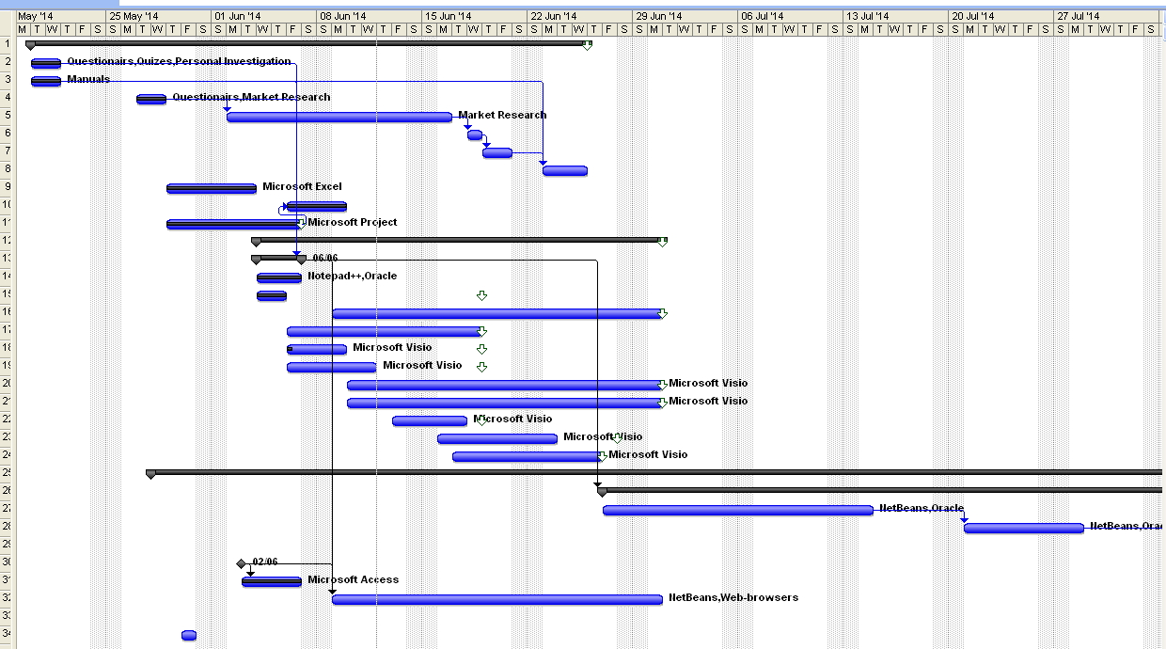

PERT/CPM/NETWORK

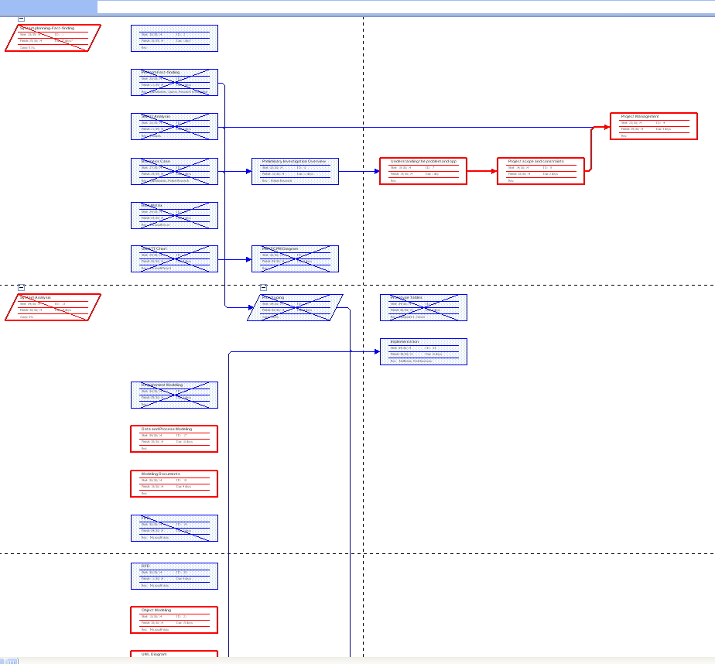

Risk Management Plan

Project can be issued with the following factors:

* Project scope
* Budget issues
* Business issues
* Scheduling
* Technical issues
* Human challenges
* Software issues

There are several organization units, which are responsible for the named factors:

* financial department
* HR department
* software Developer Company (in form of different departments)
* suppliers of software and hardware
* Principle client

All mentioned above challenges will be solved in the ways of:

* increasing financial support
* employing extra workers or evolving other departments to solve the problem
* Extra-hours working or external resources involved in project.

Identifications and analyzing of risks

**Key-risks:**

* Project’s scope risk.
* The change of demands to the application during the implementation and support-security phases, which might effect on the cost and the schedule deadlines of the project. It can be reasoned by the Principal client; the users of the application, as well as poorly realized preliminary-investigation phase of the project can impacted its realization. It leads to increasing the project‘s cost and deadlines scheduled for its completion.
* Technical risks.
* Development and implementation this application in a lot of Health Care Organization can get a problem in terms of old hardware and software, which conflicts with developed application and needs to be updated. It leads to increasing of the project’s cost.
* Access to the Internet has to be available and reliable for all devices, where current application will be installed, as the new releases of the current project can be provided through the Internet. In future as a Web-application, it can’t function without the Internet, otherwise the system won’t launch at all.

**Medium-occur-risks:**

* Software risk.
* During the developing of the project, the similar applications might be produced by other companies. Thus, the project might be cancelled or abandoned.

**Low-occur-risks:**

* Budget issues.
* Project can be under-estimated within the system planning phase. It might lead to decreasing of project’s functionality, cutting its possibilities, delaying some of the realization stages of the project or of the whole project.
* Human issues.
* Project might meet issues taking into account the needs of people in different levels. The end-user, the manager and other participants of the project won’t agree to collaborate with the developer team, or the developer team won’t survey, explain the project’s aims clearly or involve improperly people in development of the project. It leads to problems with extra modeling, prototyping and implementation, thus extra budgeting and scheduling are spent.

Risk response plan:

* Project’s scope risk. Responsible-preliminary investigation team of Software Developer Company. It has to use different approaches in their work, as well as different, simple and clear questionnaires, personal meetings and observing the procedures and tools that take place nowadays in medical institutions. If it occurs, the team has to organize fast and short extra investigations to correlate the project.
* Technical risks. Responsible - preliminary investigation team of Software Developer Company. It has to check all possible devices and software throughout the units, where Application will be installed with technical conclusion of the computers (quantity, price, and upgrade time). The team has to calculate this spending with reserved fund, if there is a need in modernization.
* Technical support team of Software Developer Company checks all the Internet connection within future Database Network and supplies preliminary investigation team with their conclusion. Support team also has to supply alternative possibilities.
* Software risk. Responsible- marketing department of Software Developer Company. It monitors the competitors, their projects, and the possibility of similar upcoming products. Marketing department has to find several available projects in realization in order to replace current ones in case of cancelation.
* Budget issues. Responsible-budget departments both of Software Developer Company and Principal Clients. They calculate, analyze, summarize spending, control financing of the whole project. They are responsible for sharing the reserved fund money to support different phases of the project in case of emergency situations (risk occasions).
* Human issues. Responsible- preliminary investigation team of Software Developer Company, HR Department of the client side. They organize meetings, interviews, surveys, in-person observations and training courses. If there is no possibility to consult the necessary people, they find and organize collaboration with other equivalent participants.

Monitor Risk:

During developing of the project, the regular meetings of all the departments will be organized. Within these meetings, the terms of realizations, (possible) issues, financing and development procedure will be discussed, negotiated and corrected. The new possible risk will be contoured and processed.

Risk Matrix:

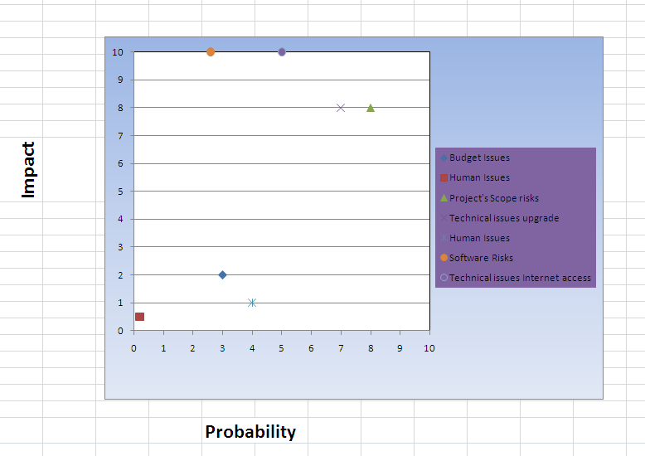

System Analysis: Client and business domain summaries, questionnaire

System Analysis: Requirements Modeling

Description the system

The main purpose of proposed project is to allow the medical staff, the laboratory staff and patients to be always connected through this system in the real-time mode. Achieving this goal allows all sides involved in using this project to reach the side back targets which are not considered to be minor at the same time. For example: to decrease waiting time in the medical institutions during the first and following visits; to reduce the possibilities of medical errors; to lower administrative costs, to reduce communication time within the medical institutions.

All mentioned above should be built by dividing the whole system on five subsystems. In spite of this division, all information circulating in the system should be stored in the same database. The first subsystem belongs to the medical assistance and allows entering primary information about patient. This subsystem should not let medical assistants enter the information which belongs to doctors, nurses and laboratory staff. The second subsystem belongs to nurses and allows entering primary medical information such as medical history, results of primary examinations, lists of medication and allergies, and immunization status. This subsystem should also allow nurses making prescriptions which they are authorized to do. The third subsystem belongs to doctors and allows entering all information about health status, health treatment, prescriptions, referrals to necessary tests and so forth. The fourth subsystem belongs to the laboratory staff and allows entering information about tests’ results. The fifth subsystem belongs to patients and allows entering information about desirable appointments and retrieving information about medical prescriptions, diagnoses and further appointments. Also system allows to patients makes initial evaluation prescribed medications.

Scope

The HCS is a desktop application which helps medical staff, the laboratory staff and patients to be connected in the real-time mode. Moreover, in further additions this system will connect patients and medical institutions through the Web-technology. The application should be distributed within medical network in order to connect medical institutions, patients, drugstores and laboratories.

All system information is maintained in a database, which is located on an Oracle-server. In the best case, the using of the system within medical institutions allover Canada, information about medical staff can be provided by professional orders and filled in by administrators of the main database automatically. Moreover, the information about drugs can be provided by drugstore network. In the worst case, information can be used within the same medical institution and be connected with couple of drugstores through database.

Thus, the software needs direct or Internet connection to the database to fetch, store and display results of different queries. The application also has the capability to represent both summary and detailed information about the patients’ health state and treatment. The system is able to estimated the cost of prescribed drugs.

Product perspective

The system consists of one main part which can be divided into two or three parts if necessary. Firstly, the biggest part belongs to hospitals and is divided into three subsystems with different users’ roles. It is doctors’ subsystem, nurses’ subsystem and medical assistants’ subsystem. The second part belongs to laboratory staff and can be used as the forth subsystem (in case when laboratory belongs to the hospital) or as the second part of system (in case of independent laboratory).The third part belongs to patients and can be use as the fifth subsystem (in case the system is used at reception desk by patients) or as an independent part if patients use this system on their own remotely. There is the administration subsystem for medical officers, but this subsystem will not be involved in the everyday situations. Mostly this subsystem is used when a new doctor is hired or can be used for retrieving current statistical information.

Since this project has common data for all subsystems this information should be stored somewhere. For this purpose a database will be used. It’s strongly recommended to use Oracle-database. Among any other advantages of this database, it allows to establish 2047 connections simultaneously[3]. We consider it to be more than enough for the functioning of system. Basing on what has been mentioned in requirement modeling part we predict that the system will work at least with 500 users in the same time. Some more information about database specifications is mentioned below, as well as server and end-user hardware and software specifications.

Raw requirement

System must do following:

* Add and retrieve information about patients.
* Close patient data file for some reason (death, moving etc.)
* Retrieve information about estimated cost of drugs. And their availability in the drugstores.
* Look through medical history, tests’ results and so forth.
* Schedule and reschedule appointments.
* Provide communication between medical institutions and within the same medical institution.

System mustn’t do following:

* Delete information about patients.
* Allow to duplicate the appointment time of different patients to the same staff.
* Allow to duplicate the appointment time of the same patient to different staff.
* Allow to duplicate tests to different medical institutions simultaneously.

It would be nice for the system to do following:

* Connect to the drugstore system, in order to estimate the best cost of drugs and to calculate the cost of drugs for a chosen drugstore.
* Book prescribed drugs online.
* Allow to inform a patient about appointment via e-mail, phone message, call by robot
* Allow a patient to mode appointment’s date with desired doctors without confirmation in the real-time. In this case system shows patient all possible dates and time.
* Voice recognizing system for nurses and doctors for filling in patient files

Functional requirements

Input:

* General information about patients
  + First name
  + Second name
  + Date of birth
  + SSN
  + Insurance information
  + Contact information (address, phone, e-mail)
* Medical information about patients
  + Primary information (illnesses, allergies etc.)
  + Results of the initial examination
  + Anamnesis
  + Diagnosis
  + Prescriptions
  + Tests’ results
  + Referrals to necessary tests
* Related information
  + Date of appointment
  + Tests’ date arrival and departure

Output:

* Display general and medical information about patients (see below)
* Display name of drugstores where drugs can be purchased
* Display estimated cost of prescribed drugs
* Display patient’s medical history and tests’ history
* Display related information (appointment dates, test date)
* Display test results

Process:

* Find information about patients
* Find information about availability of prescribed drugs in drugstores
* Calculate estimated cost of drugs
* Store entered data in database
* Retrieve necessary information from database

Non-functional requirements

Performance:

* System must allow at least 500 users to work simultaneously.
* System is capable to update information in short time interval.
* Work on any computer architecture (Mac, PC)
* Provide the everyday back-up information
* System gets primary information according to some rules (name cannot contain numbers; SSN must have exactly 9 digits etc.)
* System must provide strict checking of entering information.
* Any run-time error during system’s execution is not allowed.

Security:

* Appearing of any subsystem types depends on user’s role in the system (login and password)
* All the queries to the database should be developed with prevention of the sql-injection
* Upper level staff can see information of lower level staff. Otherwise not allowed.
* System should avoid malicious behaviour

Requirement associations

* Upper level subsystems cannot be developed before lower level subsystems.
* Medical information about patients cannot be entered before general information
* Test referrals and test results cannot be entered before either general information or medical information
* Estimated cost of drugs cannot be calculate without prescription

Product functions

The system allows to retrieve and to manipulate information about patients. The type of information depends on who uses the system, in other words it depends on the role of a user in the system. The difference between the information and the user’s role is described in the next section.

Besides the retrieving and storing information system allows to manipulate data of patient‘s file such as to open or close the file for some reason. All patients’ files have to be stored permanently; hence the system doesn’t allow deleting user file.

Also system searches information about patient according to the different criteria. The results of this search could be viewed as general information about patient, dates of appointments, test results, medical history and so forth. The criteria are different for different users as well as for retrieving information.!!!!!!

The patient’s subsystem also will estimate the cost of prescribed drugs and in the next versions could allow booking prescribed drugs on-line in the chosen drugstore. Also this subsystem will provide possibilities to schedule and reschedule appointment without appeal to medical institution.

HCS system at every moment checks the date of appointment, when demanded, and won’t allow duplicating the appointment time of different patients to the same staff, same patient to the different staff and tests to different medical institutions simultaneously.

The system could output some statistical information which concerned the doctors or medical officers. Moreover administrate subsystem allows to medical officers add new information about hired doctors, nurses and medical assistants in different hospitals. This subsystems will use for adding information about approved drugs and drugstores.

User characteristics

There are six types of users that interact with systems: patient, doctor, medical assistance, nurse, medical officer, and laboratory staff. Each of these five types of users has different use of the system so each of them has their own requirements.

Patients can only use the systems to check the appointment date and check prescribed medicaments. This means that the patient have to be able to make demand about changing appointment date and estimate the cost of prescribed drugs. Some part of general information can be shown to patient, but not allowed to change by him. All changes in the general information have to be provided only through medical staff.

Doctor has full access to the information connected with medical treatment. But not able to change test result and general information. Also doctor can make notice to the medical assistant about the next appointment. Doctor can make additional demand to the laboratory for detail test if necessary. The system allows to doctor to see such reports as: list of patient for the current date or chosen date, list of threatened patients during the chosen period, list of prescribed drugs for each patient and so forth.

Medical assistant has access to the general patient’s information and appointment’s date as well. Moreover medical assistant is able to open the patient file, fill up the general information during the first visit, close the patient file and manage appointment’s date for different doctors in different medical institutions and in the same medical institution as well.

Nurse has access to general information and can fill out the anamnesis information and information about past treatment, illnesses and vaccinations. After all the nurse can make some allowed prescription to the patient. But the list of allowed drugs for prescriptions smaller than for doctors. Also nurse can choose available doctor for visit and can see the current queue for chosen doctor, if nurse decides during the first visit, that the other doctor is more suitable for patient.

Medical officer mostly communicate with database and will use statistically information, such as how many doctors or nurses are working in the hospital, how many drugs was prescribed during chosen date and so on. Also medical officer will be allowed to add new medical staff within the hospital or in the different hospitals as well; adding approved list of drugs and drugstores and so forth.

Laboratory staff has access only to referred test for current patient, part of general information about patient and the name of hospital which referred the patient. After getting tests’ results laboratory staff can enter those results in the system and send it to the database.

Assumptions and dependencies

One assumption about the product is that it will work on the computer which has preinstalled Java Virtual Machine (JVM). Otherwise the JVM has to be installed.

Another assumption is that requirements to the gathered information for any medical institutions the same. If the some of the medical institutions has different or additional requirements, those requirements should be adjusted to adding this functionality in the whole system, if survey will show it necessary for all institutions or adaptation the new functionalities to the chosen institute. The last choice is less appropriated and undesirable.

Main dependency of the system is the general patient information. All following medical information cannot be entered without the general information about the patient.

Next dependency is that test referrals and test results cannot be entered before medical information and test referrals accordingly. Also cost of prescribed drugs cannot be calculated without prescriptions. And drugs themselves can be chosen only from the previously approved list.

Specific requirements

This section contains all of the functional and quality requirements of the system. It gives a detailed description of the system and all its features.

User Interface

At the beginning every user should see the log-in panel in the main window. Appearing the next panels depends of the role of the logged user. If it is the new patient (it means this is the first visit to the hospital) then he/she has to make the demand to the medical assistant to open file for new patient.

Next step is filling out the necessary general information. Patients can do that their own. But approving this information and making first appointment should be done by medical assistant.

System Design: Data Design

Data Structure

The data structures of this system consist of various tables that interact with each other in the main database of a medical institution and further after the development of the system within the greater database which connects all medical institutions within one city, province or country. Each table contains data about functioning of the medical institution and patients.

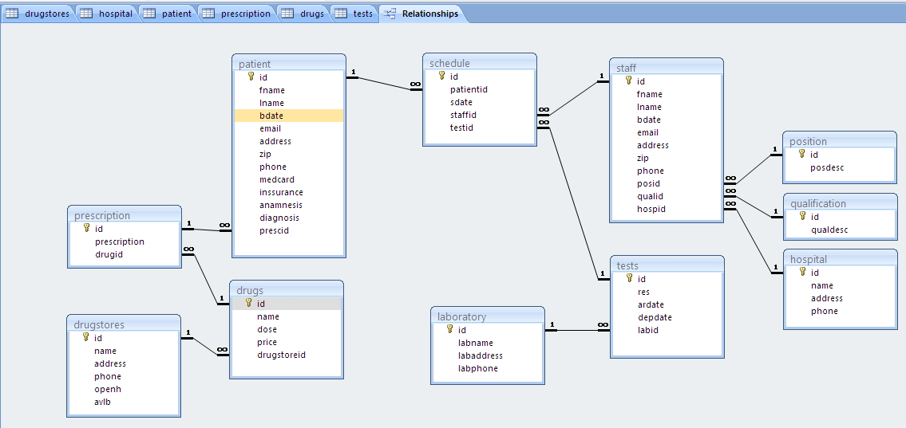

File System

ERD

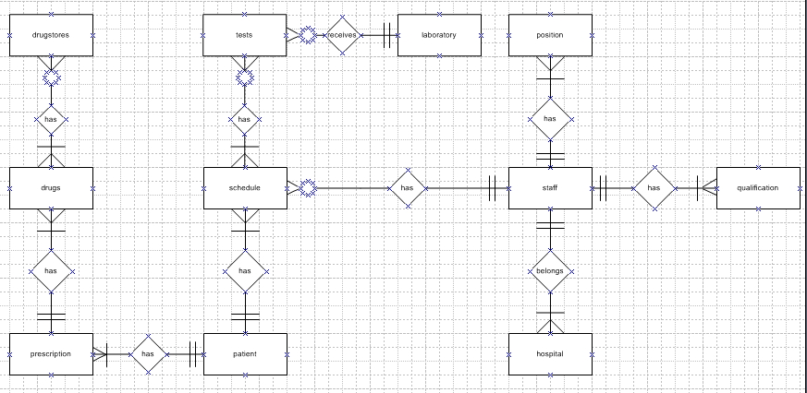

System Design: Normalization Form and Entity Relationship Model

**One-to-one relationship (1:1)**

The system doesn’t contain any relationship of this kind.

**One-to-many relationship (1:M)**

















**Many-to-many relationship (M:N)**





Norm forms

1. **First Normal Form (1NF).**

**Functional dependency**

**Functional dependency**

**Functional dependency**

**Full dependency**

|  |  |  |  |  |  |  |  |  |  |  |  |  |  |  |  |  |  |  |  |  |  |  |  |  |  |  |  |  |  |  |  |  |  |  |  |  |  |  |  |  |  |  |  |  |  |  |  |
| --- | --- | --- | --- | --- | --- | --- | --- | --- | --- | --- | --- | --- | --- | --- | --- | --- | --- | --- | --- | --- | --- | --- | --- | --- | --- | --- | --- | --- | --- | --- | --- | --- | --- | --- | --- | --- | --- | --- | --- | --- | --- | --- | --- | --- | --- | --- | --- |
| positionid | positiondesc | qualifid | qualifdesc | testid | testresult | drugid | drugname | drugdosage | drug price | Availability | Patientid | PFname | PLname | PdateBirth | Pemail | Paddress | Zip | Pphone | Pmedcard | Pinssurance | Prescription | Anamnesis | Diagnosis | Staffid | StaffFname | StaffLname | StaffdateB | Staffemail | Staffaddress | Zip | Staffphone | DStoreid | DSname | DSaddress | DSphone | DSopenhour | Hospitalid | Hname | Haddress | Hphone | Labid | testarrivetime | testdeptime | Sheduleid | AppNextdate | AppLastdate | AppHistory |

**Partial dependency**

**Transitive dependency**

**Transitive dependency**

**Partial dependency**

**Partial dependency**

**Partial dependency**

**Transitive dependency**

**Transitive dependency**

**Transitive dependency**

**Transitive dependency**

**nonkey columns**

**nonkey columns**

**nonkey columns**

**nonkey columns**

**nonkey columns**

**nonkey columns**

**nonkey columns**

**2: Tables in 2NF (No partial dependency)**

**Functional dependency**

|  |  |  |  |  |  |  |  |  |  |  |  |  |  |  |  |  |  |  |  |  |  |  |  |  |  |  |  |
| --- | --- | --- | --- | --- | --- | --- | --- | --- | --- | --- | --- | --- | --- | --- | --- | --- | --- | --- | --- | --- | --- | --- | --- | --- | --- | --- | --- |
| **Patientid** | PFname | PLname | PdateBirth | Pemail | Paddress | Zip | Pphone | Pmedcard | Pinssurance | Prescription | Anamnesis | Diagnosis | testid | testresult | Labid | testarrivetime | testdeptime | drugid | drugname | drugdosage | drug price | Availability | DStoreid | DSname | DSaddress | DSphone | DSopenhour |

**Transitive dependency**

**Transitive dependency**

**Transitive dependency**

**Transitive dependency**

**Transitive dependency**

**Functional dependency**

|  |  |  |  |  |  |  |  |  |  |  |  |
| --- | --- | --- | --- | --- | --- | --- | --- | --- | --- | --- | --- |
| **Staffid** | StaffFname | StaffLname | StaffdateB | Staffemail | Staffaddress | Zip | Staffphone | positionid | positiondesc | qualifid | qualifdesc |

**Transitive dependency**

**Transitive dependency**

|  |  |  |  |
| --- | --- | --- | --- |
| **Hospitalid** | Hname | Haddress | Hphone |

|  |  |  |  |
| --- | --- | --- | --- |
| **Sheduleid** | AppNextdate | AppLastdate | AppHistory |

**3: Tables in 3NF (No transitive dependency)**

Position

|  |  |
| --- | --- |
| **positionid** | positiondesc |

Qualification

|  |  |
| --- | --- |
| **qualifid** | qualifdesc |

Tests

|  |  |
| --- | --- |
| **testid** | testresult |

Drugs

|  |  |  |  |
| --- | --- | --- | --- |
| **drugid** | drugname | drugdosage | drug price |

Patient General Information

|  |  |  |  |  |  |  |  |  |  |
| --- | --- | --- | --- | --- | --- | --- | --- | --- | --- |
| **Patientid** | PFname | PLname | PdateBirth | Pemail | Paddress | Zip | Pphone | Pmedcard | Pinssurance |

Staff Information

|  |  |  |  |  |  |  |  |  |  |
| --- | --- | --- | --- | --- | --- | --- | --- | --- | --- |
| **Staffid** | StaffFname | StaffLname | StaffdateB | Staffemail | Staffaddress | Zip | Staffphone | **positionid** | **qualifid** |

Drug Stores Information

|  |  |  |  |  |  |
| --- | --- | --- | --- | --- | --- |
| **DStoreid** | DSname | DSaddress | DSphone | DSopenhour | **drugid** |

Hospital Information

|  |  |  |  |  |
| --- | --- | --- | --- | --- |
| **Hospitalid** | Hname | Haddress | Hphone | **Staffid** |

Laboratory

|  |  |  |  |  |  |  |
| --- | --- | --- | --- | --- | --- | --- |
| **Labid** | testarrivetime | testdeptime | **Hospitalid** | **Patientid** | **Staffid** | **testid** |

Schedule

|  |  |  |  |  |  |
| --- | --- | --- | --- | --- | --- |
| **Sheduleid** | AppNextdate | AppLastdate | AppHistory | **Patientid** | **Staffid** |

Patient Treatment

|  |  |  |  |  |  |  |  |
| --- | --- | --- | --- | --- | --- | --- | --- |
| **Sheduleid** | **Patientid** | Prescription | Anamnesis | Diagnosis | **Hospitalid** | **Staffid** | **testid** |

Availability

|  |  |  |
| --- | --- | --- |
| **DStoreid** | **drugid** | availability |

**Entity: Position.** This table contains information about the position of the staff and its description.

|  |  |  |  |  |  |  |  |
| --- | --- | --- | --- | --- | --- | --- | --- |
| **Field Name** | **Description** | **Type** | **Specification** | **Default** | **Required** | **Unique** | **Key(s)** |
| **id** | Number generated automatically | integer | 7 numeric characters |  | Yes | Yes | PK |
| **posdesc** | Description of the position(post) | character | 30 alpha-numeric characters |  | Yes | No |  |

**Entity: Qualification.**  This table contains information about the qualification of the staff and its description.

|  |  |  |  |  |  |  |  |
| --- | --- | --- | --- | --- | --- | --- | --- |
| **Field Name** | **Description** | **Type** | **Specification** | **Default** | **Required** | **Unique** | **Key(s)** |
| **id** | Number generated automatically | integer | 7 numeric characters |  | Yes | Yes | PK |
| **qualdesc** | Description of the qualification.(Qualification title) | character | 30 alpha-numeric characters |  | Yes | No |  |

**Entity: Laboratory.**  This table contains information about the tests processing at a laboratory.

|  |  |  |  |  |  |  |  |
| --- | --- | --- | --- | --- | --- | --- | --- |
| **Field Name** | **Description** | **Type** | **Specification** | **Default** | **Required** | **Unique** | **Key(s)** |
| **id** | Number generated automatically | integer | 5 numeric characters |  | Yes | Yes | PK |
| **labname** | The name of the laboratiry | character | 30 alpha-numeric characters |  | Yes | No |  |
| **labaddress** | The address of the laboratory | character | 30 alpha-numeric characters |  | Yes | No |  |
| **labphone** | The phone number of the laboratory | character | 17 alpha-numeric characters |  | Yes | Yes |  |

**Entity: Tests.**  This table contains information about the tests results.

|  |  |  |  |  |  |  |  |
| --- | --- | --- | --- | --- | --- | --- | --- |
| **Field Name** | **Description** | **Type** | **Specification** | **Default** | **Required** | **Unique** | **Key(s)** |
| **id** | Number generated automatically | integer | 20 numeric characters |  | Yes | Yes | PK |
| **res** | Description of the results of the test | character | 1000 alpha-numeric characters |  | Yes | No |  |
| **ardate** | The date, when the test was delivered | Date | “MM/DD/YYYY”  format |  | Yes | No |  |
| **depdate** | The date, when the test was sent back | Date | “MM/DD/YYYY”  format |  | Yes | No |  |
| **labtid** | Laboratory information (as an id from laboratory entity) | integer | 5 numeric characters |  | Yes | No | FK |

**Entity: Drugstores.**  This table contains information about the drugstores.

|  |  |  |  |  |  |  |  |
| --- | --- | --- | --- | --- | --- | --- | --- |
| **Field Name** | **Description** | **Type** | **Specification** | **Default** | **Required** | **Unique** | **Key(s)** |
| **id** | Number generated automatically | integer | 5 numeric characters |  | Yes | Yes | PK |
| **name** | Name of the drugstore | character | 30 alpha-numeric characters |  | Yes | No |  |
| **address** | Address of the drug store | character | 30 alpha-numeric characters |  | Yes | No |  |
| **phone** | Phone of the drug store | character | 17 alpha-numeric characters |  | Yes | Yes |  |
| **openh** | Open hours of the store | character | 10 alpha-numeric characters |  | Yes | No |  |
| **avlb** | A letter showing the availability of a drug | character | 1 character (‘N’/’Y’) format | ‘N’ | Yes | No |  |

**Entity: Drugs.**  This table contains information about the drugs name, dosage and the price.

|  |  |  |  |  |  |  |  |
| --- | --- | --- | --- | --- | --- | --- | --- |
| **Field Name** | **Description** | **Type** | **Specification** | **Default** | **Required** | **Unique** | **Key(s)** |
| **id** | Number generated automatically | integer | 5 numeric characters |  | Yes | Yes | Composite PK |
| **name** | Name of the drug | character | 30 alpha-numeric characters |  | Yes | No |  |
| **dose** | Dosage and format of the drug | character | 30 alpha-numeric characters |  | Yes | No |  |
| **price** | Number | double | (6.2) floating-point number with 6 whole parts and 2 fractional parts |  | Yes | No |  |
| **storeid** | Number | integer | 5 numeric characters |  | Yes | No | Composite PK |

**Entity: Prescription.**  This table contains information about the patients’ prescriptions.

|  |  |  |  |  |  |  |  |
| --- | --- | --- | --- | --- | --- | --- | --- |
| **Field Name** | **Description** | **Type** | **Specification** | **Default** | **Required** | **Unique** | **Key(s)** |
| **id** | Number generated automatically | integer | 10 numeric characters |  | Yes | Yes | PK |
| **prescription** | Information about prescriptions made for a patient | character | 1000 alpha-numeric characters |  | No | No |  |
| **drugid** | Number generated automatically | integer | 5 numeric characters |  | Yes | No | FK |

**Entity: Patient.**  This table contains general information about the patient.

|  |  |  |  |  |  |  |  |
| --- | --- | --- | --- | --- | --- | --- | --- |
| **Field Name** | **Description** | **Type** | **Specification** | **Default** | **Required** | **Unique** | **Key(s)** |
| **id** | Number generated automatically | integer | 11 numeric characters |  | Yes | Yes | PK |
| **fname** | Patient’s first name | character | 30 alpha-numeric characters |  | Yes | No |  |
| **lname** | Patient’s last name | character | 30 alpha-numeric characters |  | Yes | No |  |
| **bdate** | Patient’s date of birth | Date | “MM/DD/YYYY”  format |  | Yes | No |  |
| **email** | Patient’s e-mail | character | 30 alpha-numeric characters |  | No | Yes |  |
| **address** | Patient’s address | character | 30 alpha-numeric characters |  | Yes | No |  |
| **zip** | Patient’s ZIP code | character | 7 alpha-numeric characters |  | Yes | No |  |
| **phone** | Phone of the drug store | character | 17 alpha-numeric characters |  | Yes | Yes |  |
| **medcard** | Patient’s medical card number | character | 15 alpha-numeric characters |  | Yes | Yes |  |
| **inssurance** | Patient’s insurance number | character | 300 alpha-numeric characters |  | No | Yes |  |
| **anamnesis** | Description of patient’s anamnesis | character | 3000 alpha-numeric characters |  | Yes | No |  |
| **diagnosis** | Information about patien’s diagnosis | character | 100 alpha-numeric characters |  | No | No |  |
| **prescid** | Information about prescription(as an id from prescription entity) | integer | 10 numeric characters |  | Yes | No | FK |

**Entity: staff.**  This table contains information about the staff.

|  |  |  |  |  |  |  |  |
| --- | --- | --- | --- | --- | --- | --- | --- |
| **Field Name** | **Description** | **Type** | **Specification** | **Default** | **Required** | **Unique** | **Key(s)** |
| **id** | Number generated automatically | integer | 7 numeric characters |  | Yes | Yes | PK |
| **fname** | Employee’s first name | character | 30 alpha-numeric characters |  | Yes | No |  |
| **lname** | Employee’s last name | character | 30 alpha-numeric characters |  | Yes | No |  |
| **bdate** | Employee’s date of birth | Date | “MM/DD/YYYY”  format |  | Yes | No |  |
| **email** | Employee’s email address | character | 30 alpha-numeric characters |  | No | Yes |  |
| **address** | Employee’s address | character | 30 alpha-numeric characters |  | Yes | No |  |
| **zip** | Employee’s ZIP code | character | 7 alpha-numeric characters |  | Yes | No |  |
| **phone** | Employee’s phone | character | 17 alpha-numeric characters |  | Yes | Yes |  |
| **SSN** | Employee’s SSN | character | 13 alpha-numeric characters |  | Yes | Yes |  |
| **posid** | Employee’s position (as an id from the position entity) | character | 7 alpha-numeric characters |  | Yes | No | FK |
| **qualid** | Employee’s qualification (as an id from the qualification entity) | character | 7 alpha-numeric characters |  | Yes | Yes | FK |
| **hospid** | Information about hospital(as an id from hospital entity) | integer | 5 numeric characters |  | Yes | No | FK |

**Entity: hospital.**  This table contains information about the hospital.

|  |  |  |  |  |  |  |  |
| --- | --- | --- | --- | --- | --- | --- | --- |
| **Field Name** | **Description** | **Type** | **Specification** | **Default** | **Required** | **Unique** | **Key(s)** |
| **id** | Number generated automatically | integer | 5 numeric characters |  | Yes | Yes | PK |
| **name** | Name of the drugstore | character | 30 alpha-numeric characters |  | Yes | No |  |
| **address** | Address of the drug store | character | 30 alpha-numeric characters |  | Yes | No |  |
| **phone** | Phone of the drug store | character | 17 alpha-numeric characters |  | Yes | Yes |  |

**Entity: schedule.**  This table contains information about schedule of appointments of a certain patient to a certain medical staff.

|  |  |  |  |  |  |  |  |
| --- | --- | --- | --- | --- | --- | --- | --- |
| **Field Name** | **Description** | **Type** | **Specification** | **Default** | **Required** | **Unique** | **Key(s)** |
| **id** | Number generated automatically | integer | 7 numeric characters |  | Yes | Yes | Composite PK |
| **patientid** | Information about patient (as an id from patient entity) | integer | 11 numeric characters |  | Yes | No | Composite PK |
| **sdate** | The date, when the next appointment is scheduled | Date | “MM/DD/YYYY”  format |  | Yes | No |  |
| **staffid** | Staff information (as an id from staff entity) | integer | 7 numeric characters |  | Yes | No | FK |
| **testid** | test information (as an id from tests entity) | integer | 20 numeric characters |  | Yes | No | FK |

1. Medscape EHR Report 2012: Physicians Rank Top EHRs between 21,202 respondents across 25 specialties.
2. Oracle Standard Technical Specifications. VERSION 11.1
3. Oracle® TimesTen In-Memory Database Reference 11g Release 2 (11.2.2)