 **FACULTY OF COMPUTER SCIENCE AND ENGINEERING**

**Time: 1.5 hr CS221 Lab Marks: 10**

**Lab No: 01 Dated: 03/03/2021**

**Lab Activity 1:**

Learning objective: How to access and operate arrays through pointers

In C/C++ language, arrays work on memory addresses so as pointers and hence they are strongly related. Design a C program which take an array of 6 elements from the user and do the following:

1. Declare the pointer and refernce it with the array address
2. Display every element of an array by using the pointer
3. Find the maximum value in array using pointer

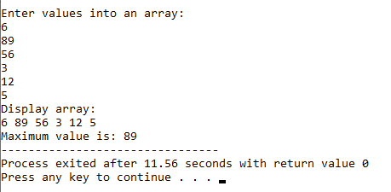

**Lab Activity 2:**

Learning Objective: Pointers in function call

In this activity you will have to use pointers to perform the following tasks on randomly generated 1D array of type **int** having size of 20.

1. Write a function **int smallest = smallest_value(int *temp, int size)**, which receives an array as pointer and find out smallest value using pointer to array.
2. Write a function **void traversal_back(int *temp, int sizeofarry)**, which receives an array as pointer and traverse array from last index to first index and print its value with its address as well.

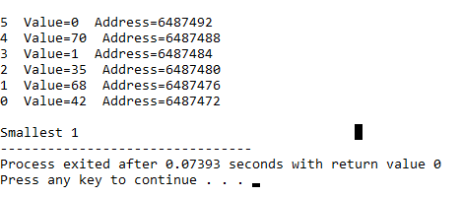

**Lab Activity 3:**

Learning Objectives: Operations on dynamic arrays

When we pass pointers to some function, the addresses of actual arguments in the calling function are copied into the arguments of the called function.

Design a C program in which we declare a dynamic array of n elements in separate user defined function (not in the main) and initialize it with some random values. You have to sort all the array elements in ascending order by sending the array to a user defined function i.e. SORTING. The prototype for the function SORTING is as under:

**Void sorting (int * ,int );**

Display the unsorted and sorted array as a result.

**Hint:** you may build more than one functions to complete the task and main function basically just have the function calls.

**Expected Output:**

