APACHE AIRLINE: TO THE SKIES AND BEYOND
Module Code : FC723
Class/Group: Group A
Module Title: Programming Theory
Assessment Title: Portfolio Project 1
Tutor Name: ellen/ sophie norman
Student GUID Number: 3184574
Date of Submission: Sunday 22nd march, 2026

“I confirm that this assignment is my own work.
Where I/we have referred to academic sources, I have provided in-text citations and included the sources in the final reference list. “

The Apache airline booking system(APABS) is an advanced command line seat reservation software, commissioned by Apache Airlines and built by KDA enterprises. Made entirely with python’s OOP principles and practices, APABS(Apache airline booking system) was created to provide an easy yet efficient booking experience for all users alike. But what can APABS(Apache airline booking system) really do? What is it capable of? And how far can it soar?

To answer the age long question, I present to you the schematics of the APABS.
Graph 1: class diagram 1
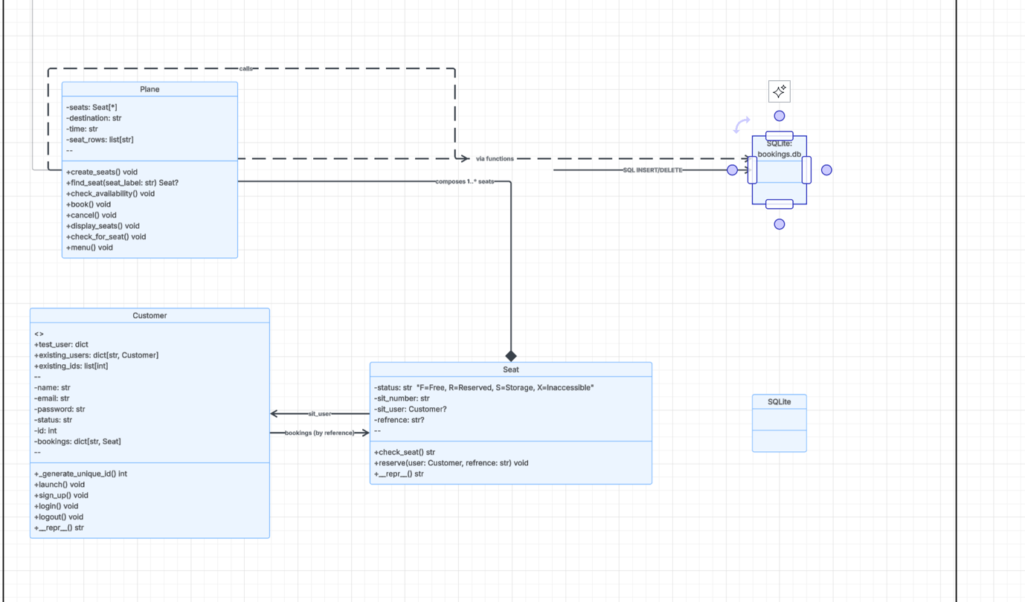
Graph 2: class diagram 2
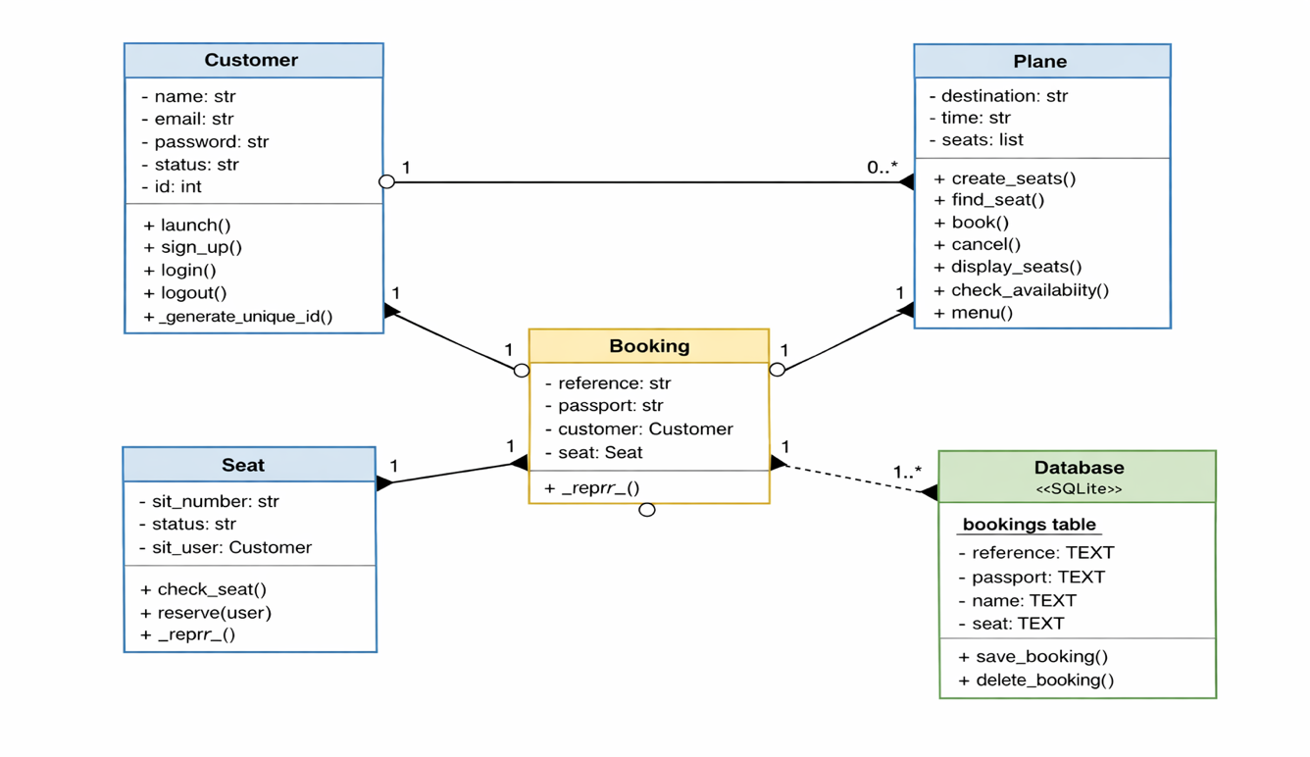
Graph 3: use case diagram
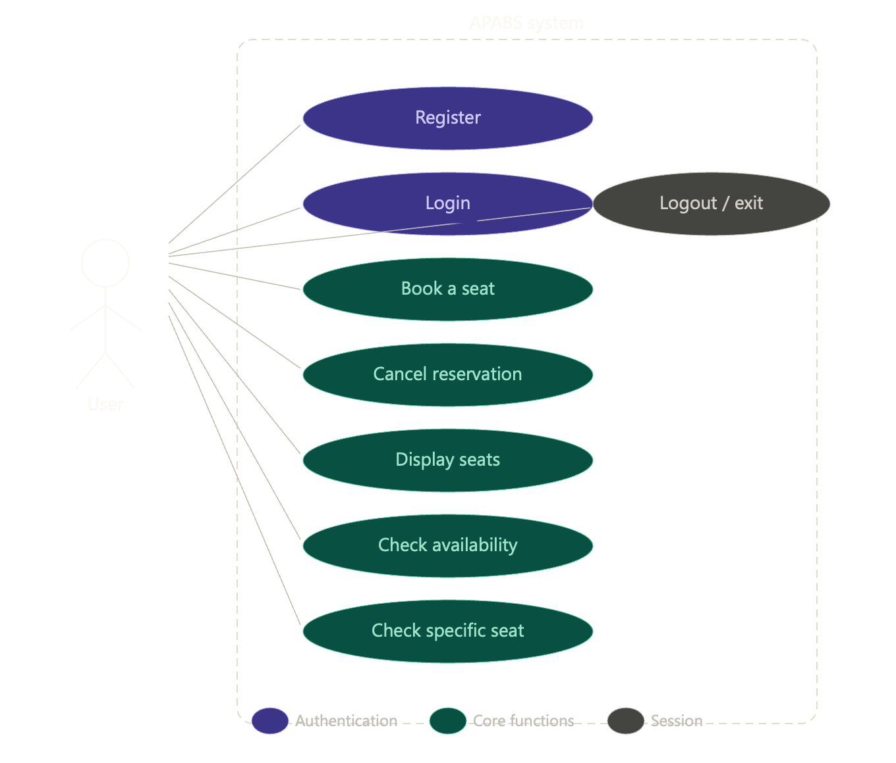
Graph 4: Activity diagram
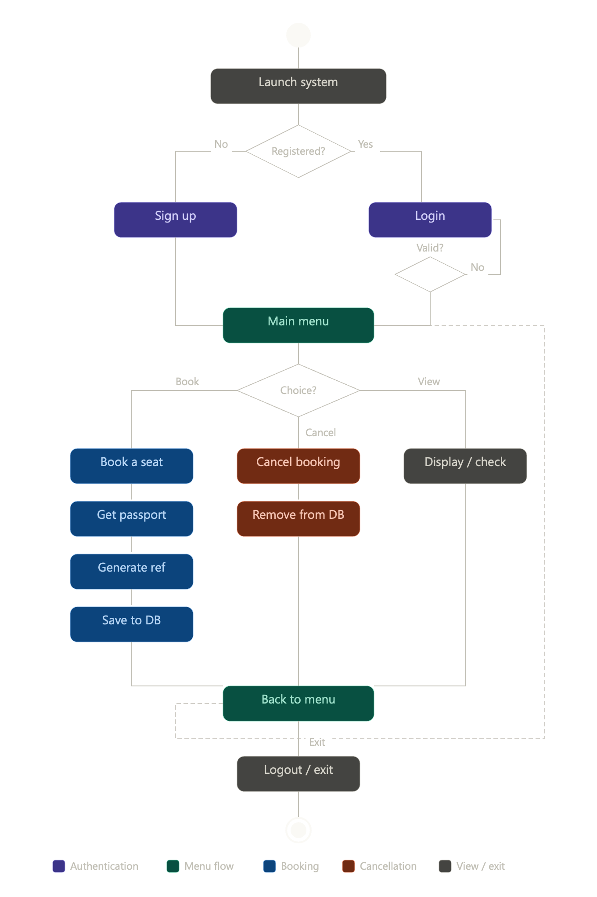
Now how does it work? Well, as illustrated by Figure 4, the activity Diagram, APABS offers two points of entry for any user: registration for new users, and login for returning ones. Once authenticated, the user is granted access to the main menu slot, which serves as the command center of the entire program. From here, the user can perform seven key operations: booking a seat, cancelling a reservation, displaying all seats, checking only for available seats, inspecting the status of a specific seat, logging out, or exiting the system entirely. Each of these operations all return to a similar origin, the menu, meaning the user is always returned to the menu after successfully completing any of the 7-action available, keeping them in full control all through the code

What is in the APABS anyway? What keeps it running? in Figure 2, the Class Diagram, APABS is seen built around three important classes, each with their own unique duties and responsibility within the system but none the less support one another very effectively.
The three are, namely: The Customer class. The Customer class is the representative of all user-related operations. “They are basically the user” ~ authors words. As the user, it is in charge of storing key information such as the user's name, email, password, status and a uniquely generated ID, while also partaking in the login, sign up and logout processes of the system.
The seat class. The Seat class represents each individual seat on the aircraft; it represents each individual seat as an object within the plane class. As the seat, it is responsible for tracking/maintaining its current status, whether it is Free, Reserved, Storage or Inaccessible as long as it is a seat it tracks this information, as well as stores the user’s name and booking reference once reserved.
Finally, The Plane class. the Plane class acts as the main body of the entire system, managing the full booking grid of over 500 seats while housing all the core booking operations available on the menu. It is one, if not, the most important part of the APABS system

As a user what part do you play in this and What is APABS really capable of? In Figure 4, the Activity Diagram, displays the full journey of a user from the moment they started up the system to the moment they exited the software. Starting off, The user is first met with a choice to make, are they a new user or a returning one? A new user is directed to the sign-up processes, whilst a returning user is taken through login, where their credentials are verified before being granted access to the main code. Once inside, the user is transported to the main menu function, where they are free to select any of the seven available actions they seek to accomplish. Does the user want to book a seat? the system request them for a seat number of choice of which the user would like to book, checks its availability and status, collects their passport number, generates a unique eight character alphanumeric booking reference(this part was a bit tricky given I couldn’t just generate random integer else it won’t fulfil the “alpha numeric” side of thing), and saves all details to the SQLite3 database. Should they cancel, the system locates the booking, removes it from the database and the object, and frees the seat for the next user to book. Every action ultimately loops back to the menu, keeping the user in the loop until they choose to exit which breaks apart from the loop, ending the program.
Another thing people often overlook when exploring the depths of the APABS is the SQLite3 database system, slaving away in the background to ensure the user’s data is not lost, the SQLite3 database is the secret backbone of the program that doesn’t get enough credit, but what is SQLite3 and why SQLite3? Why not CSV or something else? Well, SQLite3 is an effective file-based database system that is built directly into Python meaning it requires no external installation or configuration for it to function properly, making it a natural and efficient choice for a system like APABS. Ok then why not csv? CSV or Comma-Separated Values is an equally good option when making the database for the APABS but there is just one problem. It is not a true database. What do you mean? Well CSV isn’t a database but rather a text file used to store tabular data. AND?! So, it can’t perform functions native to databases, they may act and look alike but one would require tens of lines to perform a task(csv) while the other will do the same task in a line (SQLite3) making data base the more effective choice for the APABS
How far it will soar? Only time will tell, but as of right now, APABS is an effective, fully functional, fully Python OOP, airline booking system built for you and I, to make soaring the skies much easier, this is your captain speaking and remember the sky is not the limit.

