**Mandatory hands-on**

**React Exercises**

**Exercise 9: Create a React Application named “cricketapp”**

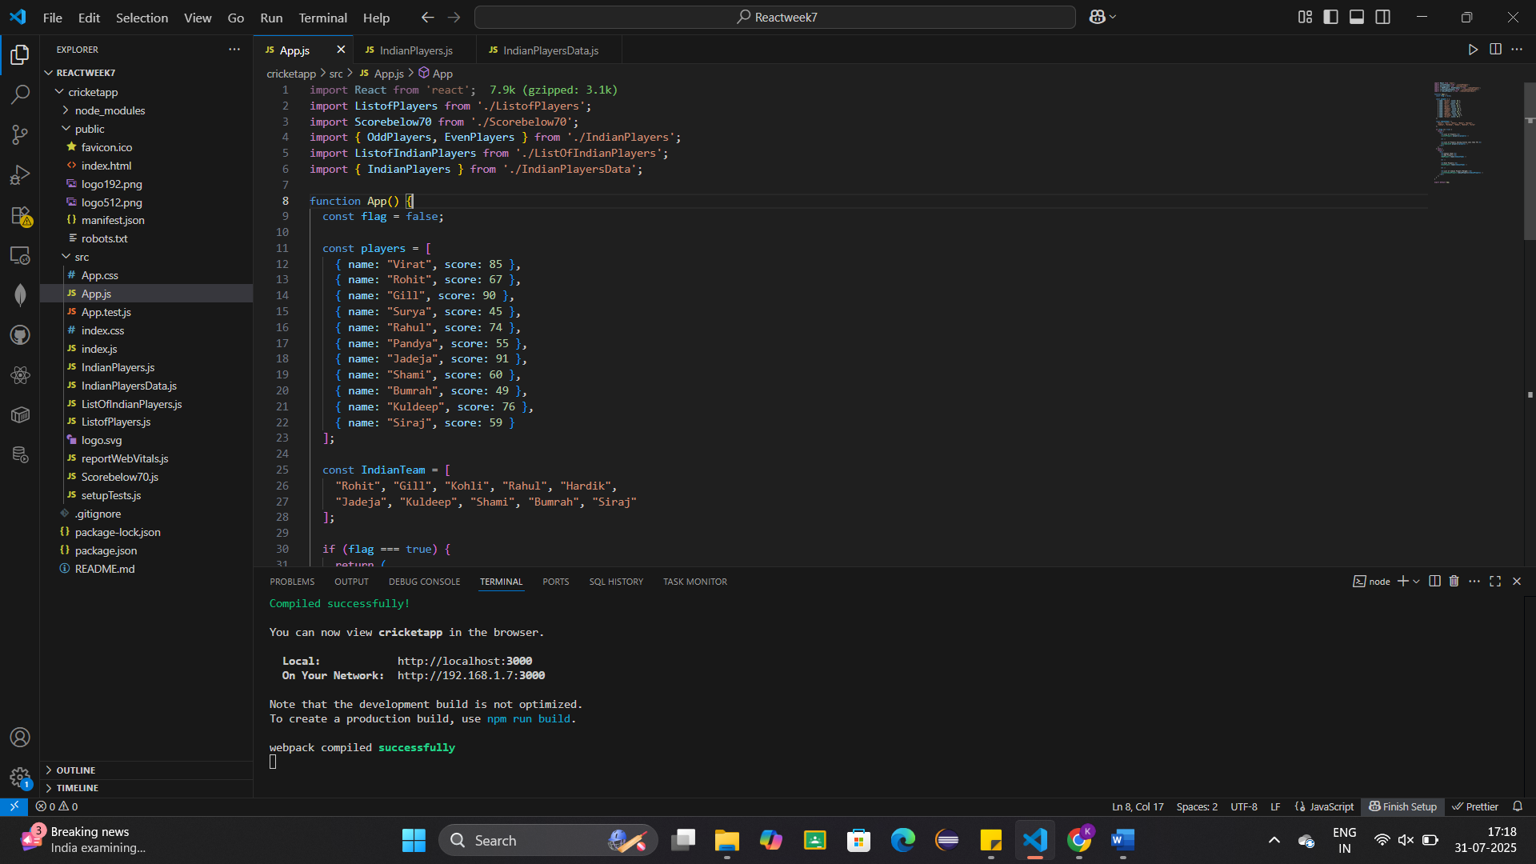

When flag=True

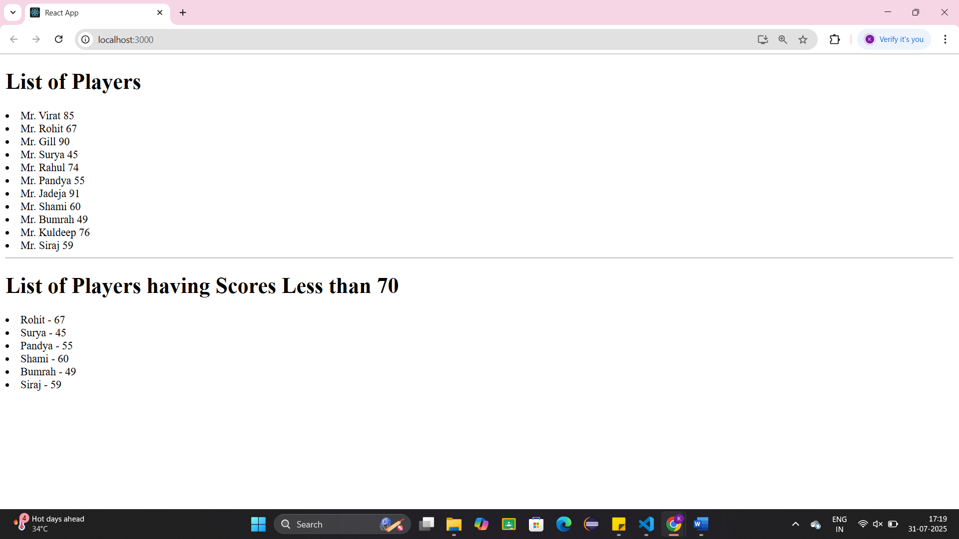

When flag=False

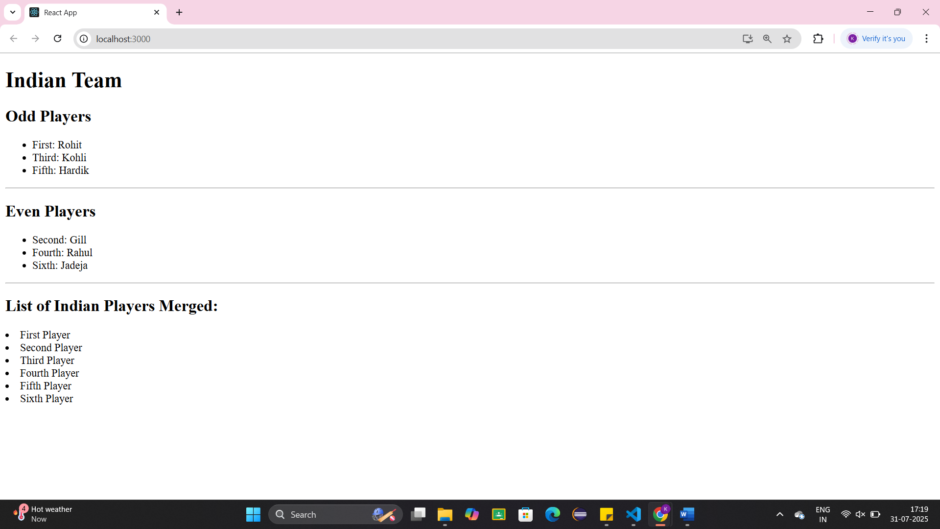

**Exercise 10: Create a React Application named “officespacerentalapp” which uses React JSX to create elements, attributes and renders DOM to display the page.**

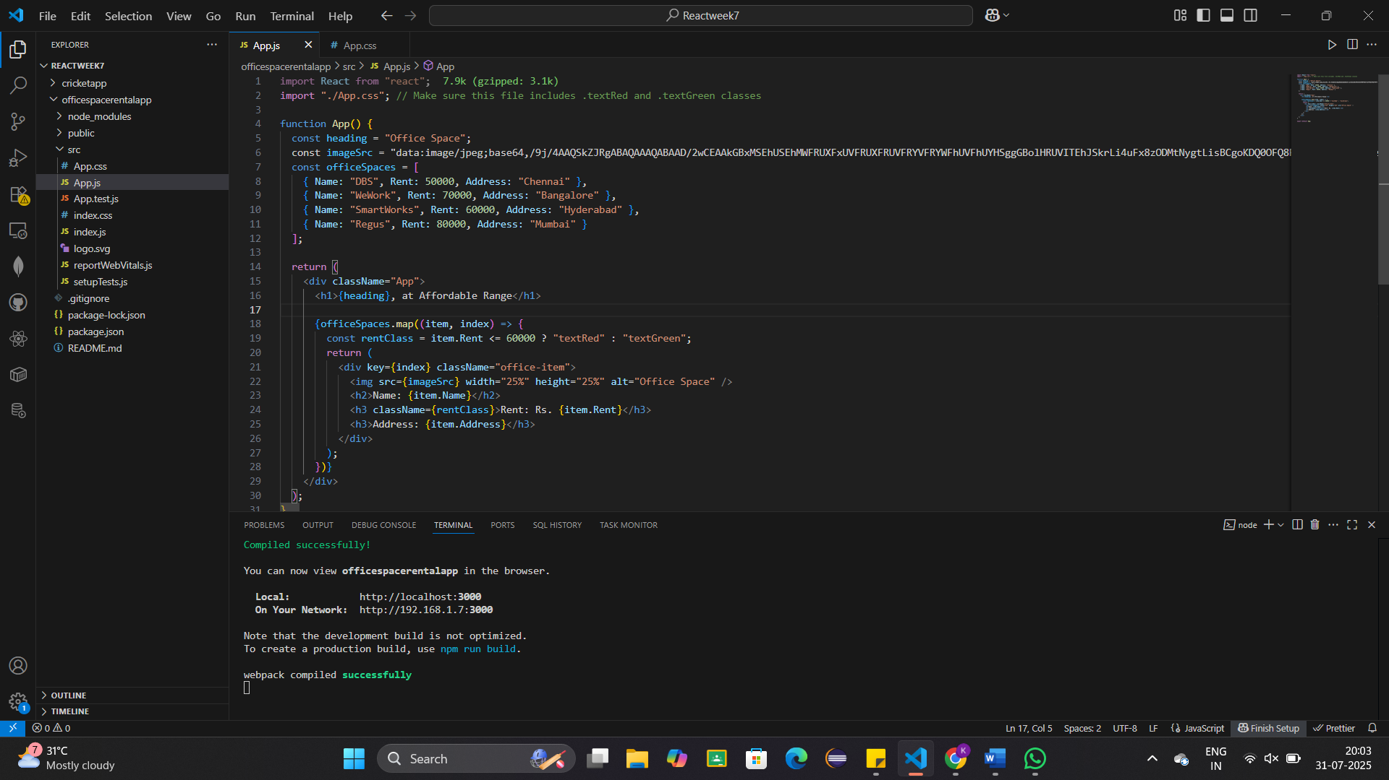

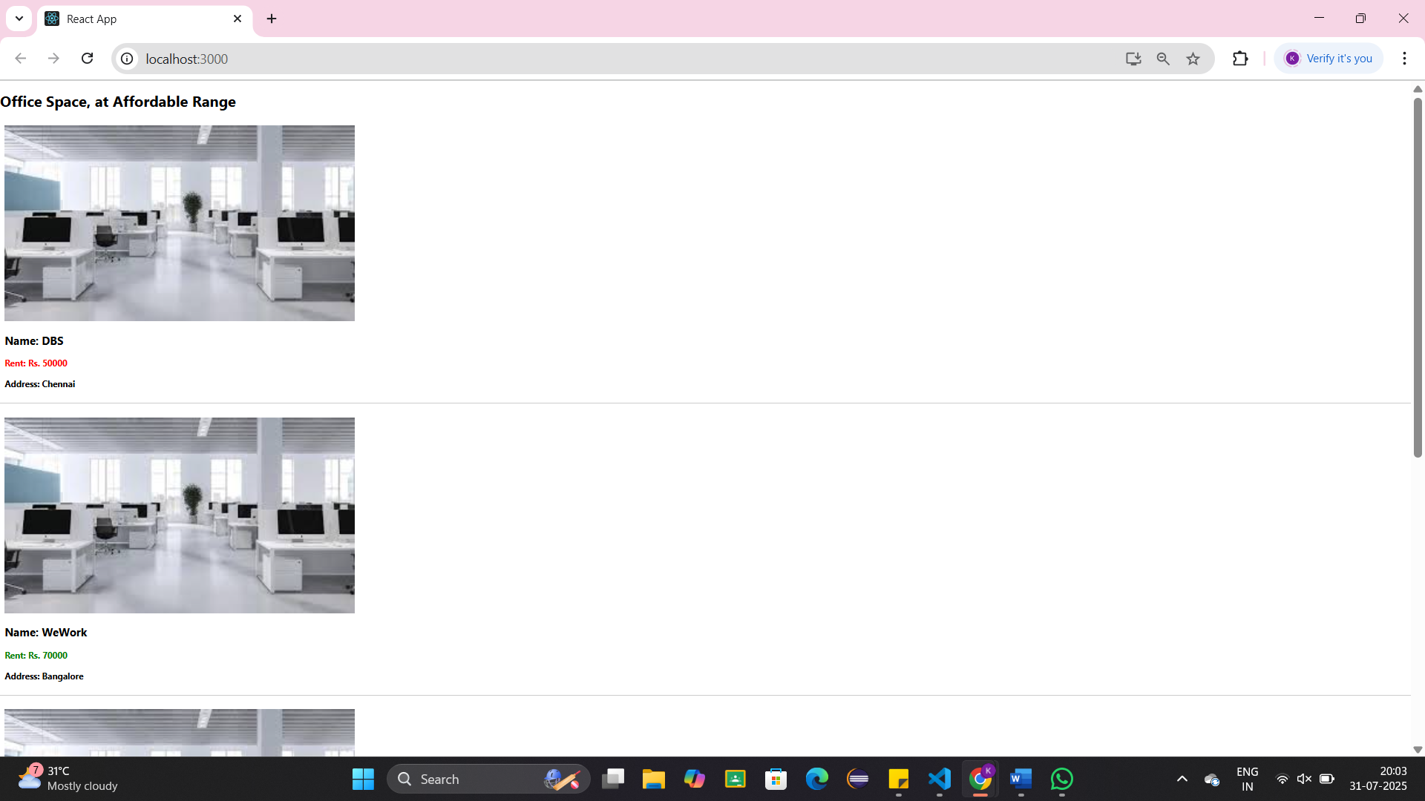

**Exercise 11: Create a React Application “eventexamplesapp” to handle various events of the form elements in HTML.**

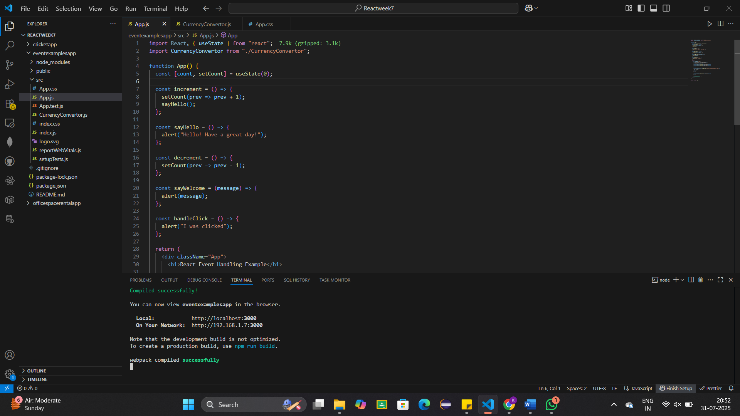

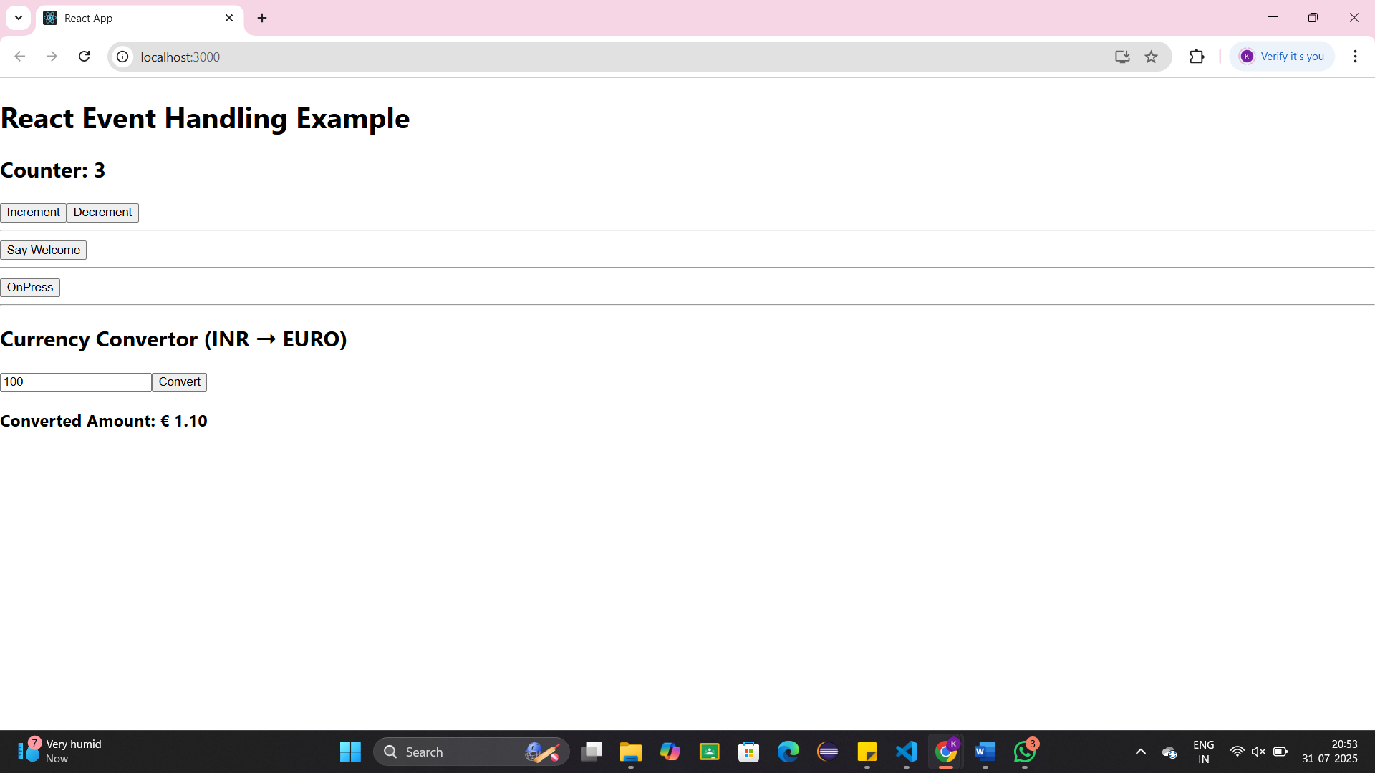

**Exercise 12: Create a React Application named “ticketbookingapp” where the guest user can browse the page where the flight details are displayed whereas the logged in user only can book tickets.**

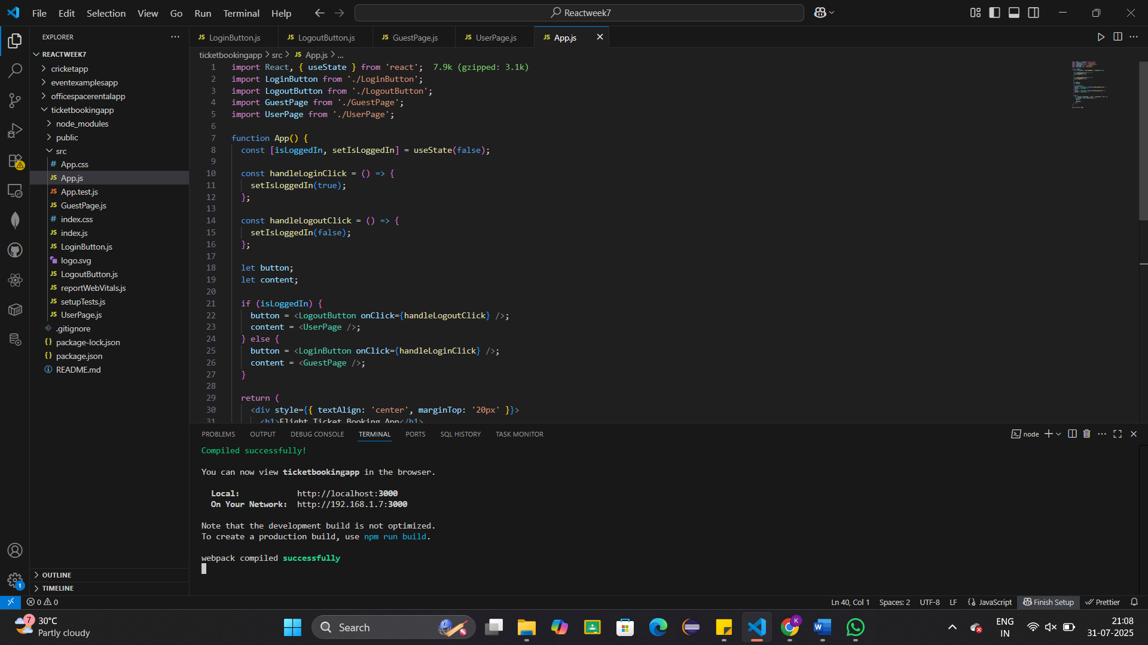

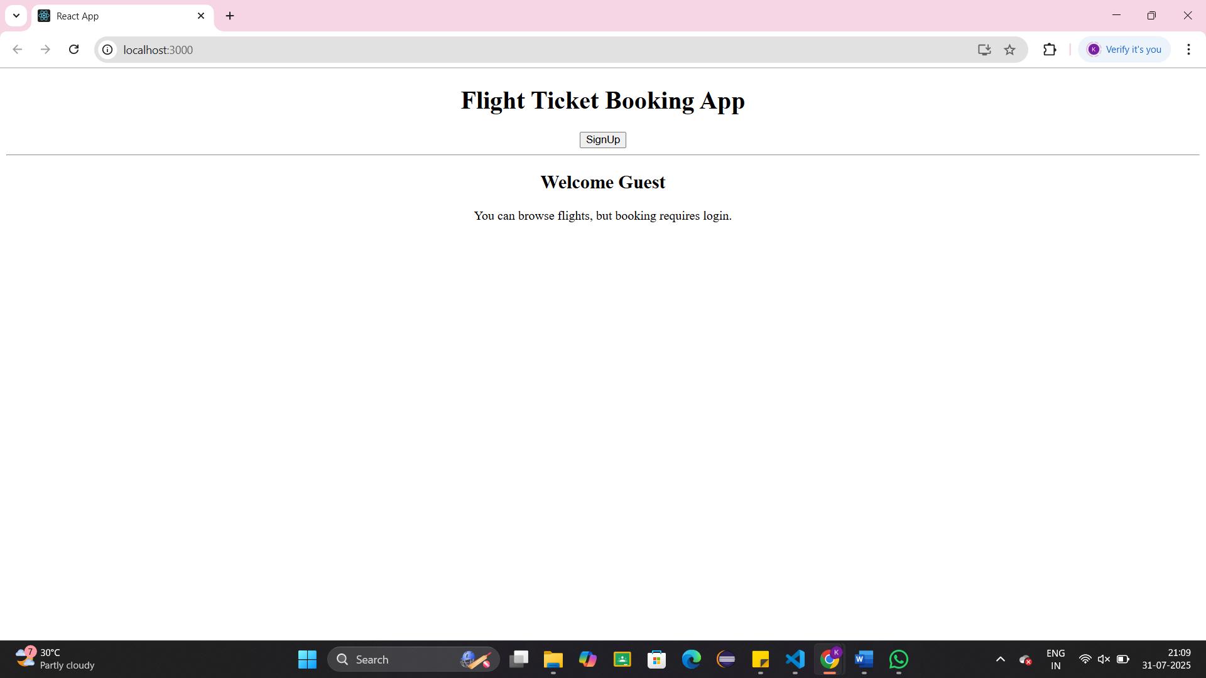

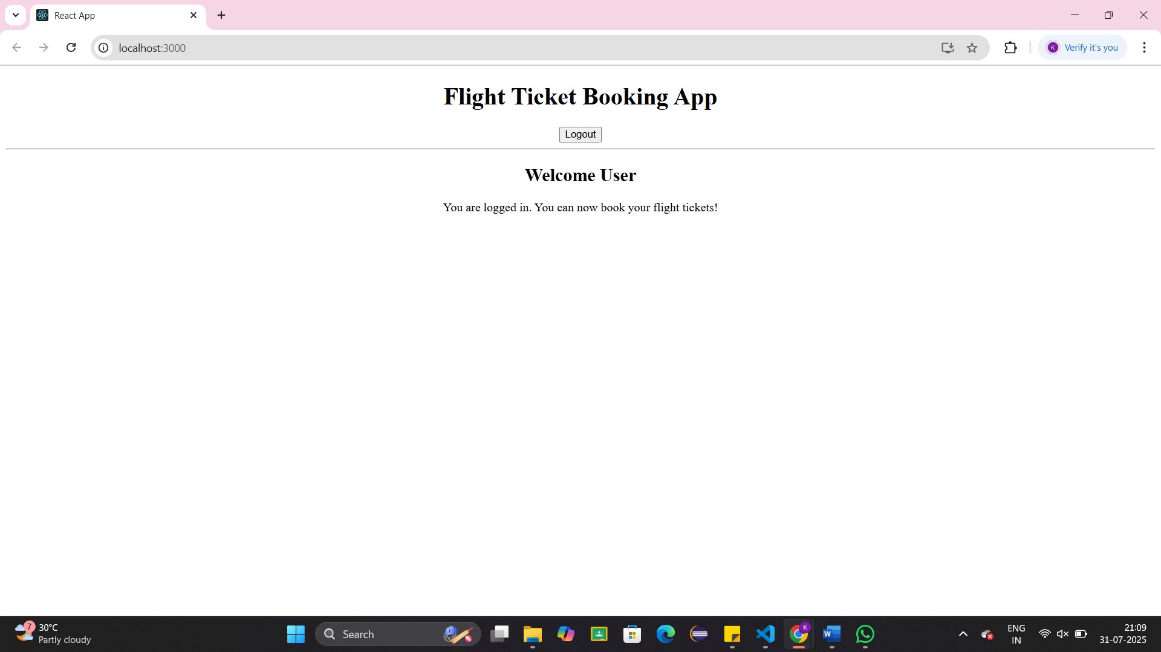

**Exercise 13: Create a React App named “bloggerapp” in with 3 components.**

1. **Book Details**
2. **Blog Details**
3. **Course Details**

**Implement this with as many ways possible of Conditional Rendering.**

