PRADEEPKUMAR.B

[pradeepkumarbkpk@gmail.com](mailto:pradeepkumarbkpk@gmail.com)

+91 90806 36900

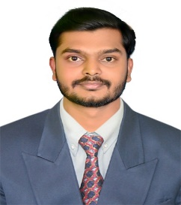

# CAREER OBJECTIVE

To secure a challenging role where I can apply my technical skills and knowledge to achieve the organization objective

# EDUCATIONAL QUALIFICATION

* Completed B.E Civil Engineering at Arul Murugan college of Engineering and Technology, Karur and secured CGPA of about 7.62 in April- 2019
* Completed DIPLAMO (Civil) at Government Polytechnic College, Coimbatore and secured 81 % in March-2016
* Completed SSLC at Government Higher Secondary School, Mulanur and secured 82% in March-2013

**SOFTWARE SKILL SET**

* Revit Architecture 2017
* STAAD Pro V8i
* 3ds MAX 2015
* Primavera P6
* Auto CAD

**ROLES AND RESPONSIBILITIES**

* Planning, design and day-to-day running of construction projects undertaken by the company
* Ensure timely delivery of projects according to schedule
* Updating and Maintain of project records for reporting purposes and submission of reports
* Availability to perform construction site visits outside of business hours, when relevant.
* Great leadership, project management, decision-making, and problem-solving skills and Smart Working.

**AREA OF INTREST**

* Site Engineering
* Designing and Estimation
* Planning

**WORK EXPERIENCE**

Maars Construction, Coimbatore : Residential Project, Dindugal

Srinithi Construction, Coimbatore: RKG Ghee Factory, Kangeyam

Deccan Construction, Chennai : CPWD Work

**HOBBIES**

* Playing Games
* Listening Music

**PERSONAL PROFILE**

Date of Birth : 29 July 1998

Father’s Name : Mr.S.Balathandapani

Mother’s Name : Mrs.B.Kowsalya

Languages Known : English, Tamil, Hindi

Present Address : 68/Thiruneelakandapuram,

Mulanur- 638106

**Place:** Mulanur **[PRADEEPKUMAR.B]**

# Date :