# Salary Survey Analysis for 2021

## Introduction

This project involves analyzing salary survey data for the year 2021. The objective was to clean, process, and analyze the dataset to derive actionable insights and provide meaningful recommendations based on the findings.

## Data Cleaning and Preprocessing

1. Handled missing values in the dataset to ensure consistency and reliability.  
2. Addressed inconsistent data values and standardized data types for seamless analysis.

**Raw Data**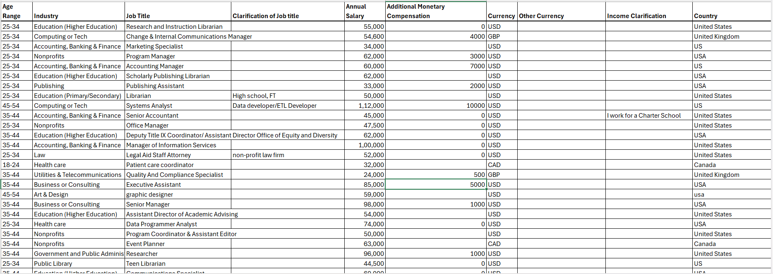

**Cleaned Data**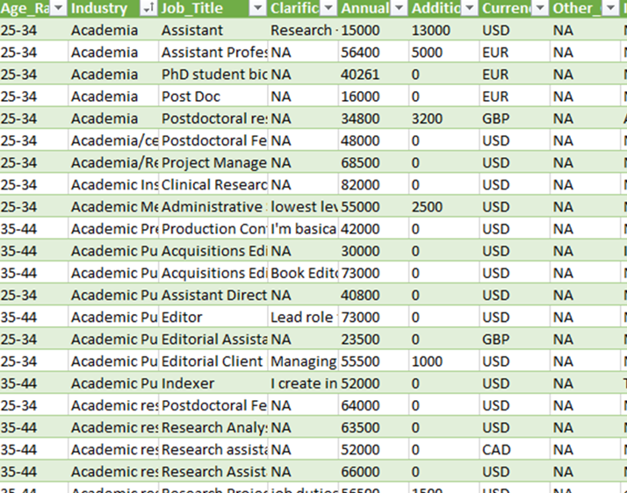

## Analysis Techniques

1. Created Pivot Tables and Charts to summarize and visualize the data effectively.  
2. Added slicers to enhance interactivity in the data analysis process.  
3. Implemented Key Performance Indicators (KPIs) to measure critical aspects of the data.

**Dashboard**

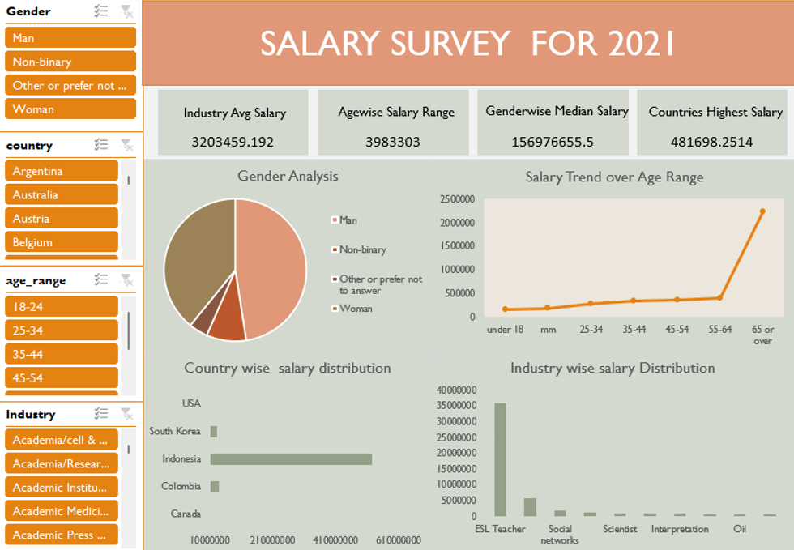

## Insights

The analysis yielded the following key insights:  
- PhD scholars fall within the highest salary range.  
- More years of experience correlate with higher salaries.  
- The 'Computing or Tech' sector employs the highest number of individuals.  
- Experienced men earn higher salaries compared to women in the same category.  
- 'Investment Banking Analysts' command the highest salaries.  
- Seoul ranks at the top for ESL Teachers in terms of salaries.

## Conclusion and Recommendations

Based on the analysis, the following recommendations are proposed:  
- Focus on recruiting talent irrespective of gender to address salary disparities.  
- Promote gender equality, especially in experienced roles where disparities are significant.  
- Other industries should strive for growth and development to remain competitive.  
- Encourage initiatives to attract younger generations, where women already dominate.

## Acknowledgment

This project was completed as part of a comprehensive analysis of salary trends. It highlights the significance of data-driven decision-making in understanding workforce dynamics.