KAMBAN COLLEGE OF ARTS AND SCIENCE FOR WOMEN
(Permanently Affiliated to Thiruvalluvar University)
(Accredited by NAAC & An ISO 9001:2015 Certified Institution)
Mathur , Thiruvannamalai
The project work submitted to the Thiruvalluvar University,Vellore in
partial fulfillment of the requirements for the award of p
Degree of
BACHELOR OF COMPUTER APPLICATION
BY
JUWAIRIYA S | (REG.NO.20624U09039)
KANCHANA DEVI K | (REG.NO.20624U09040)
KEERTHIKA V | (REG.NO.20624U09041)
KOWSALYA B | (REG.NO.20624U09042)

On the topic
“CRICKET PLAYER PERFORMANCE TRACKING APPLICATION”

User Story:
As a Salesforce Administrator, I want to build a complete cricket performance management application in Salesforce that records and evaluates player information for every match. The solution will use custom objects such as Player and Match Performance, supported by clearly defined fields and relationships for organized and reliable data. Master-detail and lookup relationships will connect related records, allowing individual and team statistics to be monitored, reports and dashboards to be produced, and player information to be managed efficiently for planning and development.

S. No. | CONTENTS | PAGE NO.
1 | INTRODUCTION | 01
2 | IDEATION PHASE | 03
3 | REQUIREMENT ANALYSIS PHASE | 08
4 | PROJECT DESIGN PHASE | 15
5 | PROJECT PLANNING & SCHEDULING | 19
6 | PROJECT DEVELOPMENT PHASE | 22
7 | FUNCTIONAL & PERFORMANCE TESTING | 25
8 | ADVANTAGES & DISADVANTAGES | 45
9 | CONCLUSION | 48
10 | FUTURE SCOPE | 50
11 | APPENDIX | 52

1. INTRODUCTION

1.1 PROJECT OVERVIEW :

CRICKSTATS is a Salesforce application developed to record, organize, and evaluate cricket player performance for each match. It combines custom objects, record relationships, dashboards, and automation features to turn match data into structured performance information.

The platform allows coaches, analysts, and administrators to maintain player statistics, prepare reports, and use performance information when planning teams and making decisions.

1.2 PURPOSE :

The project is mainly intended to:

Convert traditional player records into digital form

Make cricket statistics more accurate, organized, and easily accessible

Offer timely performance analysis through reports and dashboards

Assist player improvement and team-selection planning

Reduce manual data handling by using Salesforce automation

2.IDEATION PHASE

2.1 Problem Definition (Customer Problem Statement Template)

Problem Statement (PS) | I am (Customer) | I’m trying to | But | Because | Which makes me feel
PS-1 | A cricket coach | Monitor player results over multiple matches | Accurate statistics are difficult to obtain quickly | Information is spread across separate files and formats | Finds team-selection decisions difficult
PS-2 | A cricket team manager | Keep comprehensive player records | Updating and checking records requires considerable time | Most information is entered and maintained by hand | Experiences delays and inefficiency
PS-3 | A cricket performance analyst | Study player trends and prepare performance reports | Comparing player results is not straightforward | Performance information is not maintained in one analytics system | Has difficulty obtaining clear comparisons

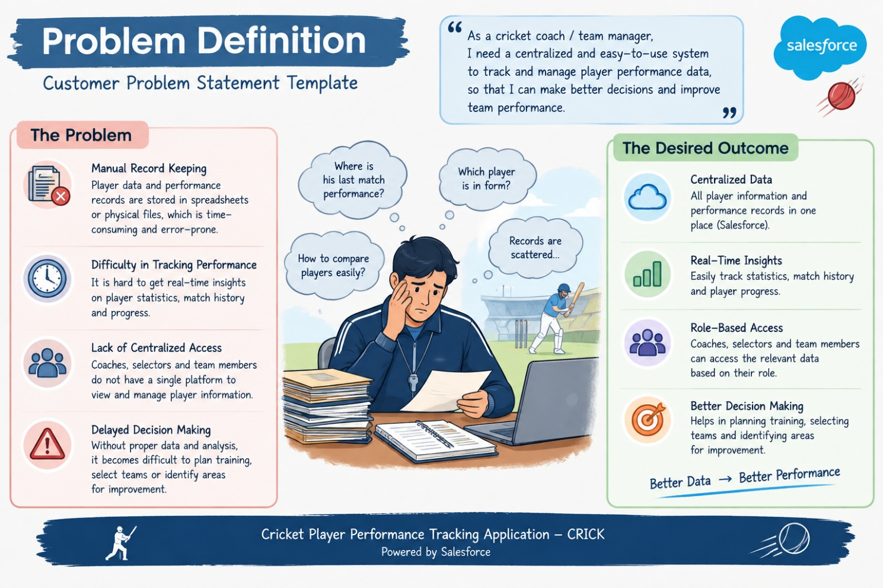

2.2 Empathy Map Analysis
Target Users
- Team Managers
- Coaches
- Analysts
- Salesforce Admins
User Perspective Analysis
Aspect Description
- Think & Feel: Want reliable statistics and meaningful insights
- Hear: Suggestions and expectations from team management
- See: Information spread across several sources
- Say & Do: Record and maintain statistics manually
- Pain: Inaccurate entries and delayed updates
- Gain: Quicker decisions and less manual effort
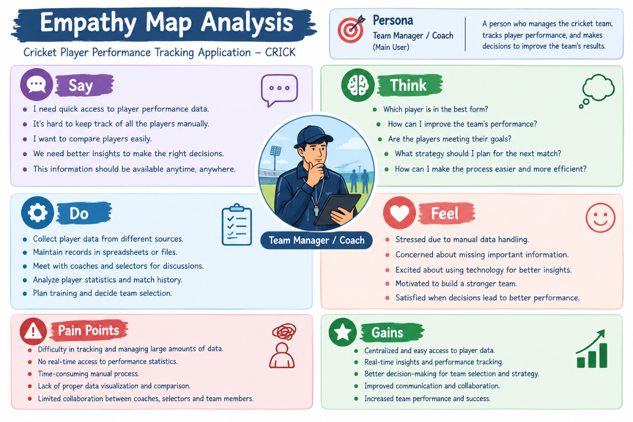

2.3 Idea Generation
Possible Ideas Considered
- Browser-based cricket player management portal
- Mobile application for recording match statistics
- CRM solution integrated with Salesforce
- AI-assisted prediction of player performance
- Interactive dashboard for performance analysis

Chosen Idea: CRICKSTATS — a Salesforce-powered cricket performance management platform

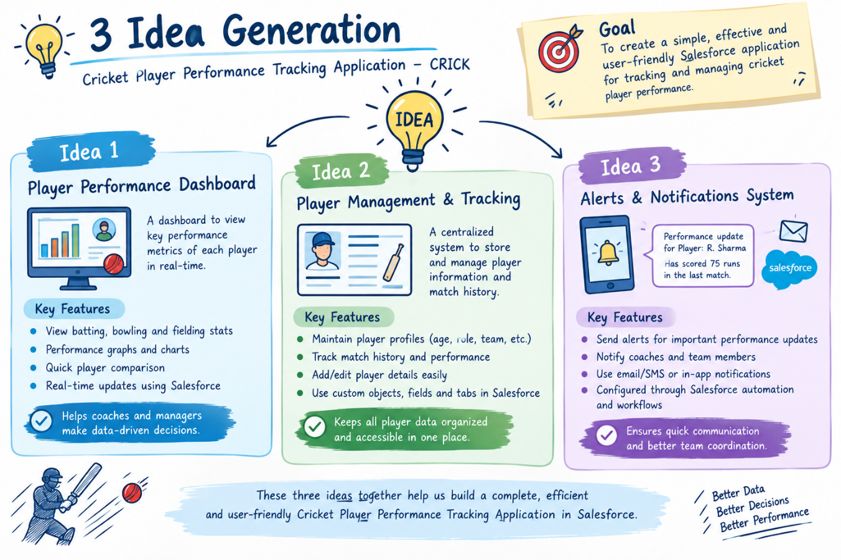

3. REQUIREMENT ANALYSIS PHASE

3.1 USER JOURNEY MAP
Main Journey Stages:
- Sign in to the application
- Add player information
- Capture match-wise performance
- Produce reports and summaries
- Review performance results
- Use insights for team decisions

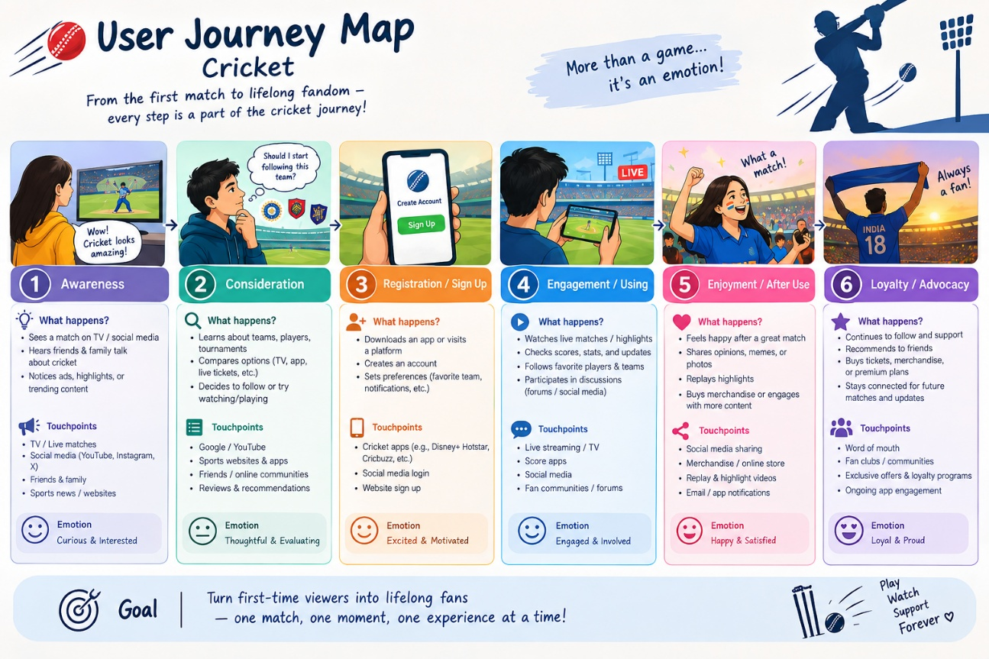

3.2 SYSTEM REQUIREMENTS
Functional Requirements

FR No | Requirement
FR-1 | Player Registration
FR-2 | Match Performance Entry
FR-3 | Dashboard Generation
FR-4 | Report Creation
FR-5 | Flow Automation

Non-Functional Requirements (NFRs) – CRICKSTATS

NFR-1: Usability
The system should be easy to understand and use by coaches, managers, analysts, and
admins without requiring technical training.
Requirements
- Simple and user-friendly interface
- Well-organized navigation options
- Readable and clearly arranged dashboards
- Little time required to learn the system
Examples:
- For example, a newly assigned coach should be able to:
- Sign in
- Record match information
- Open player performance reports
- within a short time without special instruction.
Example: Salesforce Lightning supports interactive dashboards and straightforward data-entry screens.

NFR-2: Security
The application must prevent unauthorized users from accessing confidential player information.
Requirements
- Access permissions based on user roles
- Protected user authentication
- Securely protected stored information
- Scheduled backup procedures
.
Examples:
- Coaches may view player statistics
- Managers may update permitted records
- Analysts may create performance reports
- System configuration changes are restricted to administrators
Example: Salesforce Profiles and Permission Sets can be configured to control access to sensitive records.

NFR-3: Reliability
The system should operate consistently and preserve entered information correctly.
Requirements
- Prevent loss of stored data
- Use automatic backup mechanisms
- Provide suitable error handling
- Maintain stable operation
Example:
If a manager is entering match statistics when the network is interrupted, the system should support safe recovery or saving after connectivity is restored.
Salesforce cloud services provide mechanisms that help recover information after system problems.

NFR-4: Performance
The application should deliver quick responses while processing increasing amounts of cricket data efficiently.
Requirements
- Quick page loading
- Fast report generation
- Responsive dashboard display
- Low system response time
Example:
For example, a report covering more than 100 players should be generated with minimal delay.
Efficient Salesforce queries and suitable caching can improve application responsiveness.

NFR-5: Availability
The platform should remain available whenever authorized users require access.
Requirements
- Continuous system availability
- Very limited service interruption
- Access through cloud infrastructure
- Recovery support for service failures
Example:
Authorized coaches should be able to use CRICKSTATS during matches, evenings, weekends, and other working periods.
Salesforce cloud hosting is designed to provide high service availability.

NFR-6: Scalability
The application should accommodate growth in users, teams, players, and stored records.
Requirements
- Support expanding datasets
- Allow additional teams and competitions
- Increase storage as data grows
- Preserve acceptable performance as usage increases
Example:
If the application grows from a single team to many teams, it should continue to operate effectively.
Salesforce cloud infrastructure can scale resources to support larger workloads.

3.3 DATA FLOW REPRESENTATION
Data Flow
User → Salesforce Interface → Player Records → Match Records → Reports → Dashboard

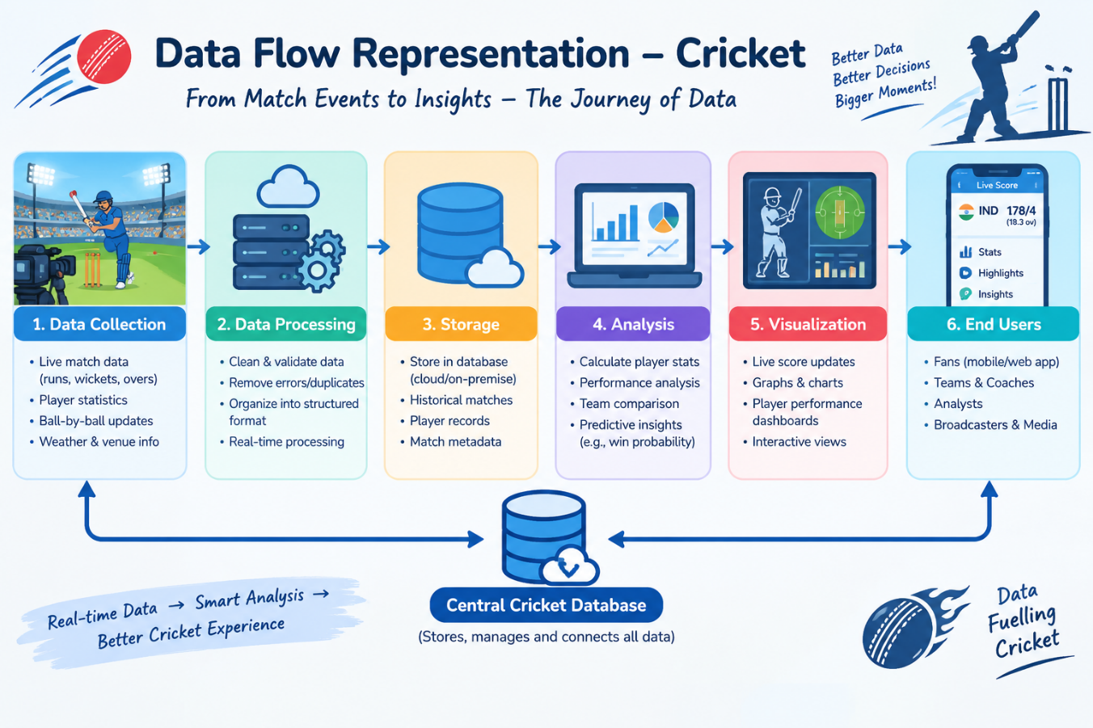

3.4 Technology Stack
Layer | Technology
Frontend | Salesforce Lightning
Analytics | Reports & Dashboards
Automation | Salesforce Flows
Backend | Salesforce Objects
Database | Salesforce Cloud

4. PROJECT DESIGN PHASE

4.1 Alignment of Problem and Solution
CRICKSTATS is designed to solve several difficulties found in conventional cricket performance management. Manual maintenance of player and match information often consumes time and can introduce entry errors. The Salesforce implementation replaces much of this manual work with structured digital records and automated processing. Concerns about misplaced information and inadequate backup are reduced through secure cloud-based storage and easier record retrieval. Since performance information is organized in related objects and displayed through dashboards, coaches and analysts can compare results more clearly. Reporting is also streamlined, reducing the time needed to obtain current statistics. In this way, CRICKSTATS connects common performance-management challenges with a centralized Salesforce solution.

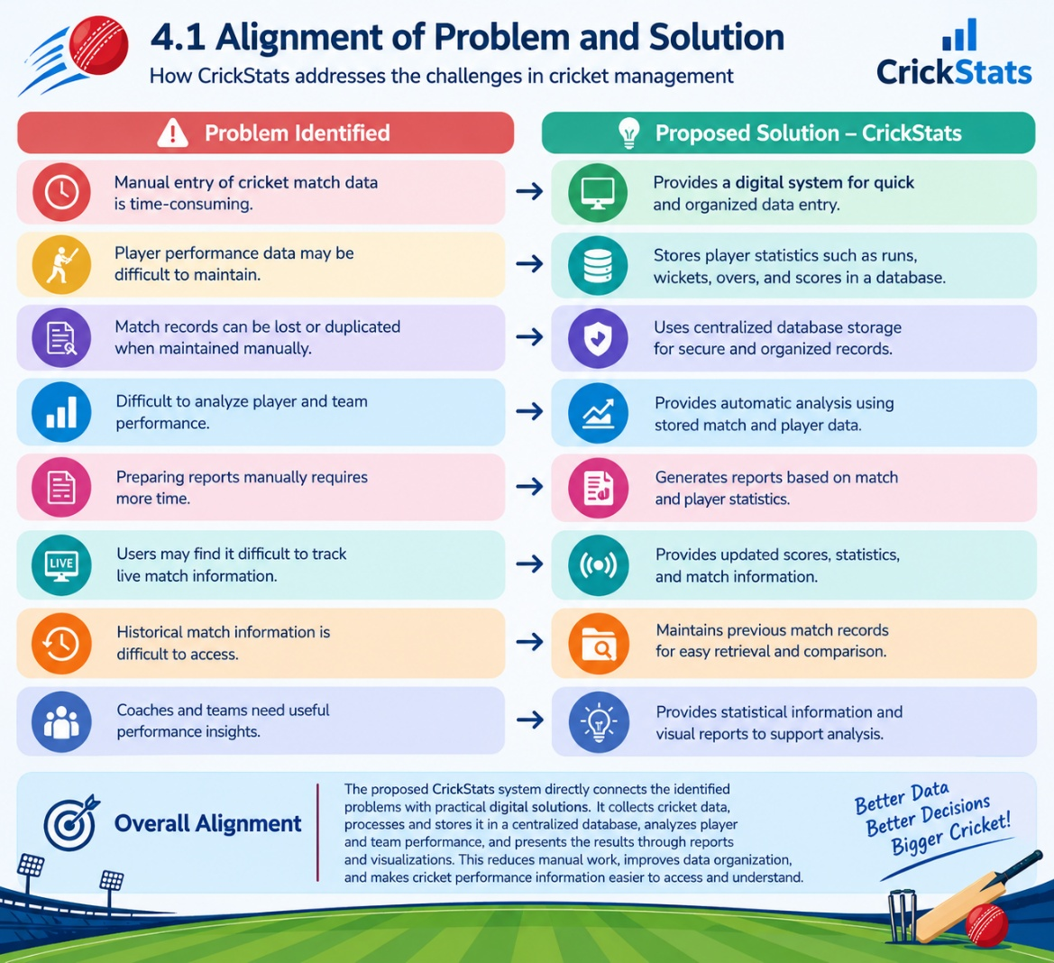

4.2 Proposed System
Overview
The CRICKSTATS solution includes:
- Custom objects for Player and Match Performance
- Master-detail record relationships
- Roll-up summary calculations
- A dedicated Lightning application
- Automated Salesforce flows
- Interactive performance dashboards

Major Features

Centralized record storage

Up-to-date statistics

Controlled and secure access

Expandable system structure

Simplified report generation

4.3 System Architecture
System Layers
- Presentation Layer (Salesforce Lightning UI)
- Application Layer (Flows and business logic)
- Data Layer (Salesforce Objects)
- Analytics Layer (Reports and Dashboards)
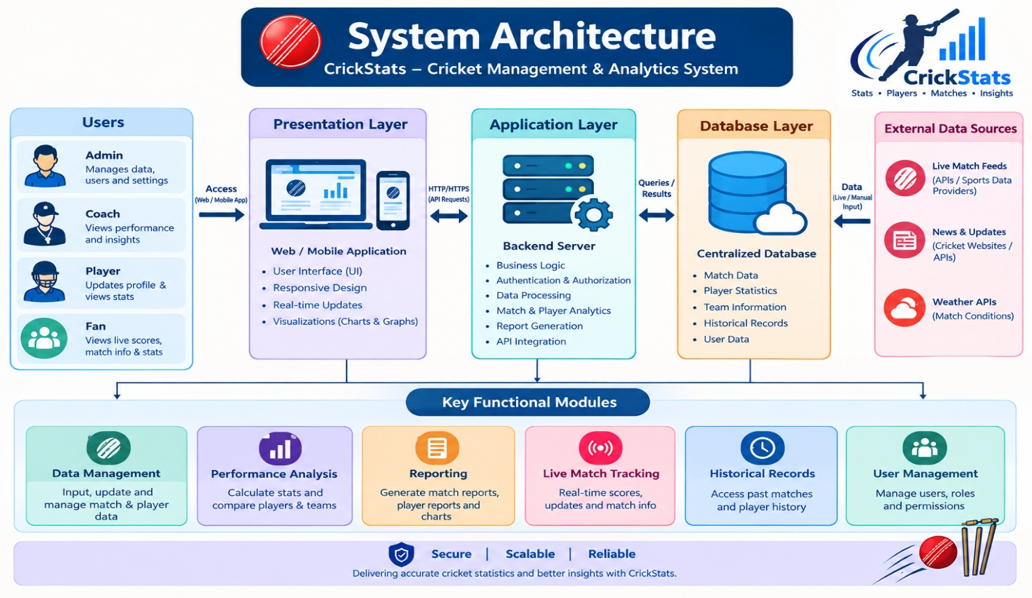

5. PROJECT PLANNING & SCHEDULING

5.1 Project Planning
- Development following an Agile approach
- Object setup → automation → reporting
- Development organized into sprints
Product Backlog, Sprint Schedule, and Estimation (4 Marks)
Use the below template to create product backlog and sprint schedule
Sprint | Functional Requirement (Epic) | User Story Number | User Story / Task | Story Points | Priority | Team Members
Sprint-1 | Developer Setup | USN-1 | As an admin, I want to create a Salesforce developer account so that I can configure and deploy the CRICKSTATS system. | 1 | High | Member1
Sprint-1 | Data Modeling | USN-2 | As an admin, I want to create Player and Match Performance objects so that player and match data can be stored systematically. | 3 | High | Member2
Sprint-2 | Navigation | USN-3 | As a user, I want separate tabs for each object so that I can easily navigate and manage records within the application. | 3 | High | Member3
Sprint-2 | UI Design | USN-4 | As a coach, I want a dedicated Lightning App so that all performance tracking features are accessible from one dashboard. | 3 | High | Member4
Sprint-2 | Data Structure | USN-5 | As an admin, I want to create player and match fields so that complete performance details can be captured accurately. | 5 | Medium | Member1
Sprint-2 | Data Structure | USN-6 | As a user, I want customized page layouts so that only relevant fields are displayed during data entry. | 5 | High | Member2
Sprint-2 | Automation | USN-7 | As a system, I want to validate player and match inputs so that incorrect data entries are prevented. | 3 | High | Member4
Sprint-3 | Automation | USN-8 | As a system, I want automated flows to update player statistics so that performance data remains accurate. | 5 | High | Member1

Sprint | Total Story Points | Duration | Sprint Start Date | Sprint End Date (Planned) | Story Points Completed (as on Planned End Date) | Sprint Release Date (Actual)
Sprint-1 | 20 | 6 Days | 24 Oct 2022 | 29 Oct 2022 | 20 | 29 Oct 2022
Sprint-2 | 20 | 6 Days | 31 Oct 2022 | 05 Nov 2022
Sprint-3 | 20 | 6 Days | 07 Nov 2022 | 12 Nov 2022
Sprint-4 | 20 | 6 Days | 14 Nov 2022 | 19 Nov 2022

6. Project Development Phase

Project Flow

Milestone 1 : Creation of developer account
Milestone 2 : Object Creation
Milestone 3 : Tabs
Milestone 4 : The Lightning App
Milestone 5 : Fields & Relationships
Milestone 6 : Roll-up Summary
Milestone 7 : Flows

Implementation

Milestone 1 - Salesforce developer account creation :

Activity 1: Creating Developer Account:

Creating a developer org in salesforce.
- Go to https://developer.salesforce.com/signup
- On the sign up form, enter the following details :

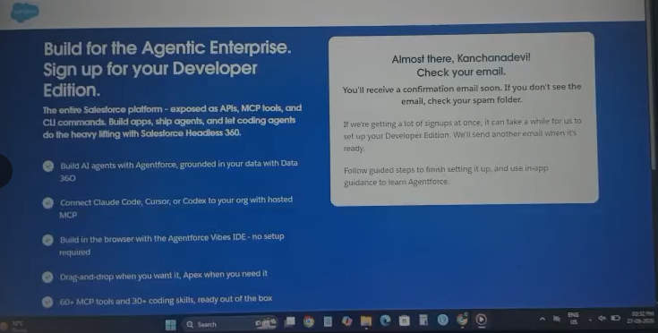

- First name & Last name
- Email
- Role : Developer
- Company : College or Company Name
- County : India
- Postal Code : pin code
- Username : should be a combination of your name and company
This need not be an actual email id, you can give anything in that format : username@organization.com
Choose sign me up after filling these.

Activity 2: Account Activation :

- Go to the inbox of the email that you used while signing up. Choose the verify account to activate your account. The email may take 5-10mins.

- Choose Verify Account.
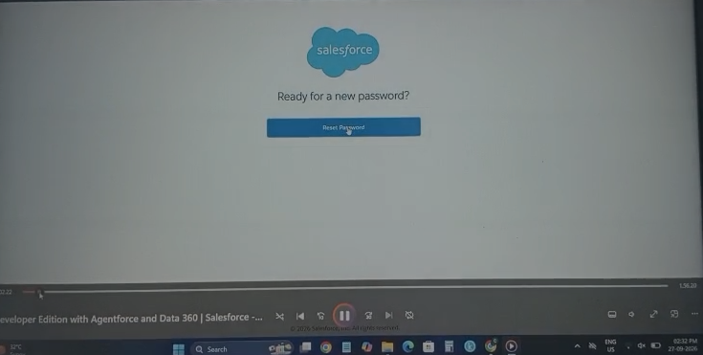

- Give a password and answer a security question and select change password.
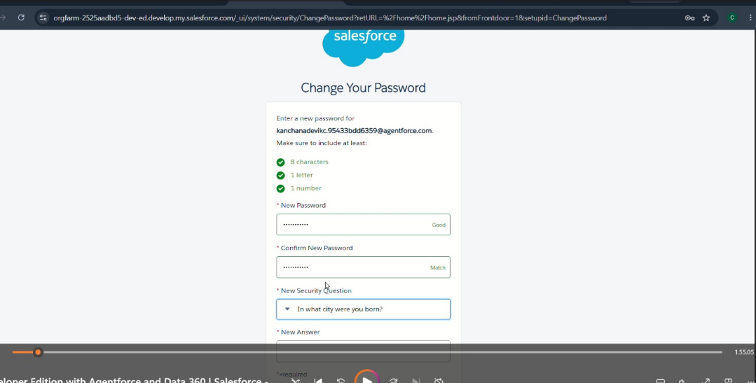

- Then you will redirect to your salesforce setup page.

Milestone 2 - Object Creation

Activity 1 : Player Object

- In your Salesforce org, click gear icon on the top left and select Setup to open Setup.
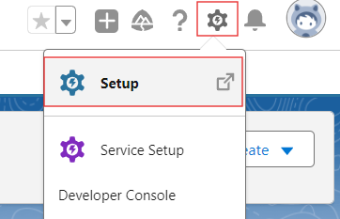

- Click the Object Manager tab. If you don’t see it, enter Object Manager in the Quick Find box.
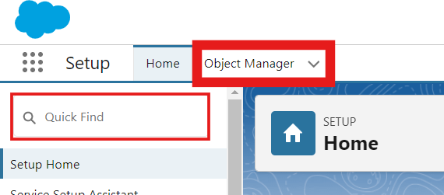

- On the Object Manager page, click Create | Custom Object.


- From the setup page → Click on Object Manager → Click on Create → Click on Custom Object.
- Label : Player
- Plural Label : Players
- Provide Record Name Label and Format
Record Name : Player Name
Data Type : Text
- In Optional features : check the boxes for Allow Reports | Allow Activities | Track Field History.
- Search Status : check the box for Allow Search.
- Save

Activity 2 : Match Performance Object

- From the setup page → Click on Object Manager → Click on Create → Click on Custom Object.
- Label : Match Performance
- Plural Label : Match Performances
- Provide Record Name Label and Format
Record Name : Customer Account Name
Data Type : Text
- In Optional features : check the boxes for Allow Reports | Allow Activities | Track Field History.
- Search Status : check the box for Allow Search.
- Save the configuration.

Milestone 3 - Tabs

Activity 1 : Custom tabs creation

- Go to setup page → type Tabs in Quick Find bar → click on tabs → New (under custom object tab)
- Select Object(Player) → Select the tab style → Next (Add to profiles page) keep it as default → Next (Add to Custom App) uncheck the include tab .
- Make sure that the Append tab to users' existing personal customizations is checked.
- Choose save.
- Repeat the same steps for Match Performances
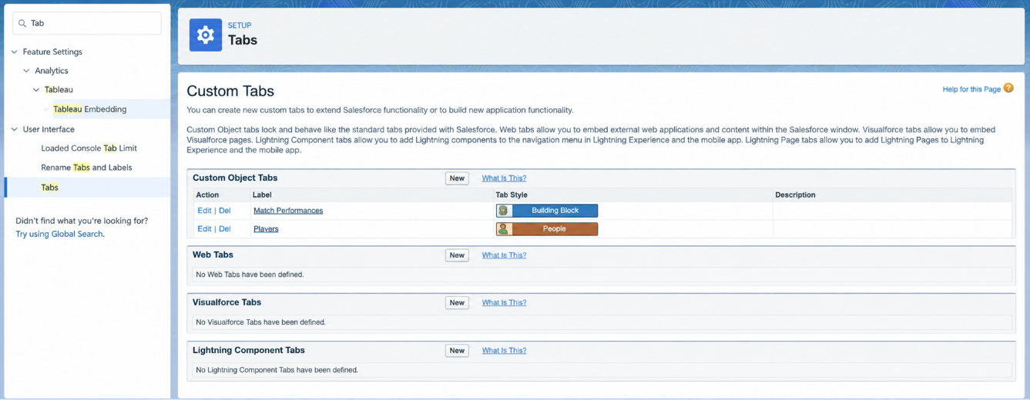

Milestone 4 - The Lightning App

Activity 1 : Create a lightning app

- Go to setup page → search “app manager” in quick find → select “app manager” → click on New lightning App.

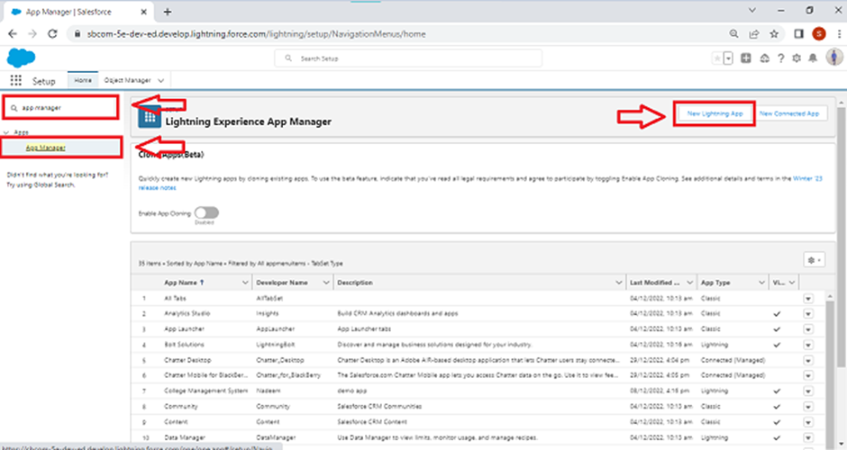

- Fill the app name in app details and branding as follow
App Name : CRICKSTATS
Developer Name : Auto Populates
Add image optional (if you want to give any image you can otherwise not mandatory) - Add Primary color Hex or leave it to default.
Then select Next.

- In App options
Navigation style : Standard navigation
Setup experience : setup
Supporters form factors : Desktop and phone
Then select Next

- In Utility items
Utility Bar alignment : Default
Then select Next.

- Navigation items
Choose the created Custom Objects and required standard objects
- Players
Match Performances
Reports
Dashboards

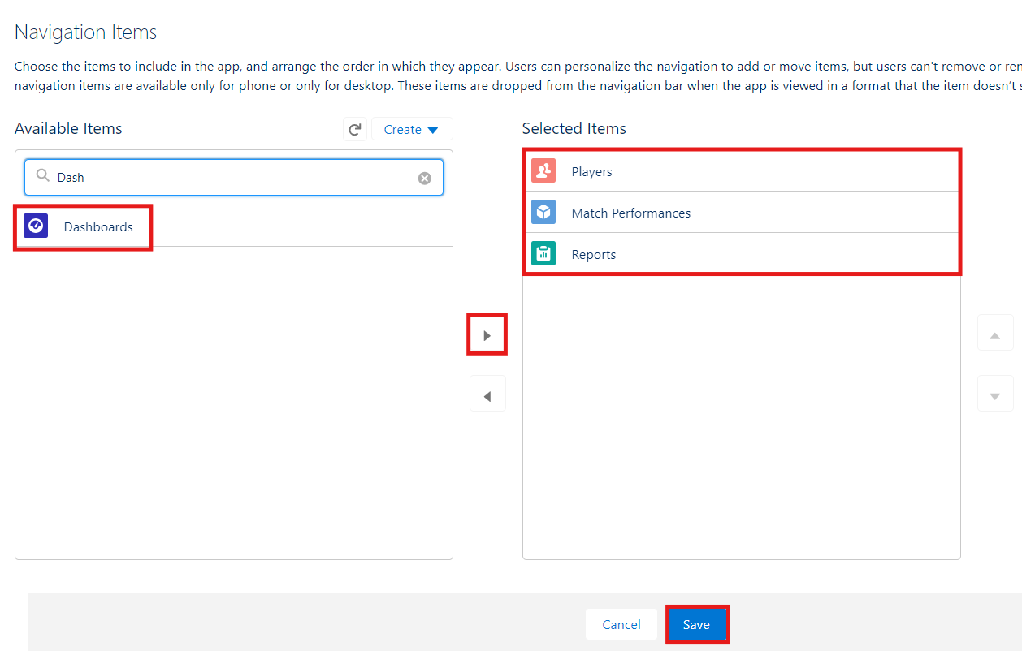
- To Add User Profiles : System Administrator
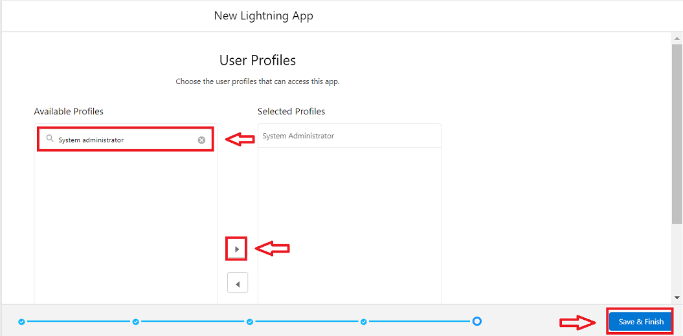
- Click Save & Finish.

Milestone 5 : Fields & Relationships

Activity 1 : Create Custom fields for Player object

- In your Salesforce org, click gear icon on the top left and select Setup to open Setup.
- Click the Object Manager tab. If you don’t see it, enter Object Manager in the Quick Find box.
- From the object manager page, In the Quick Find box, Search for the custom object you just created : Player
- From the sidebar, click Fields & Relationships. Notice that there are already some fields there. Those are the standard fields.
- Click New to create a custom field. Tip: Before creating a new field, do a quick search to make sure a similar one doesn’t already exist.
- Next, choose a data type as Text. Choosing a data type helps you format the field input.

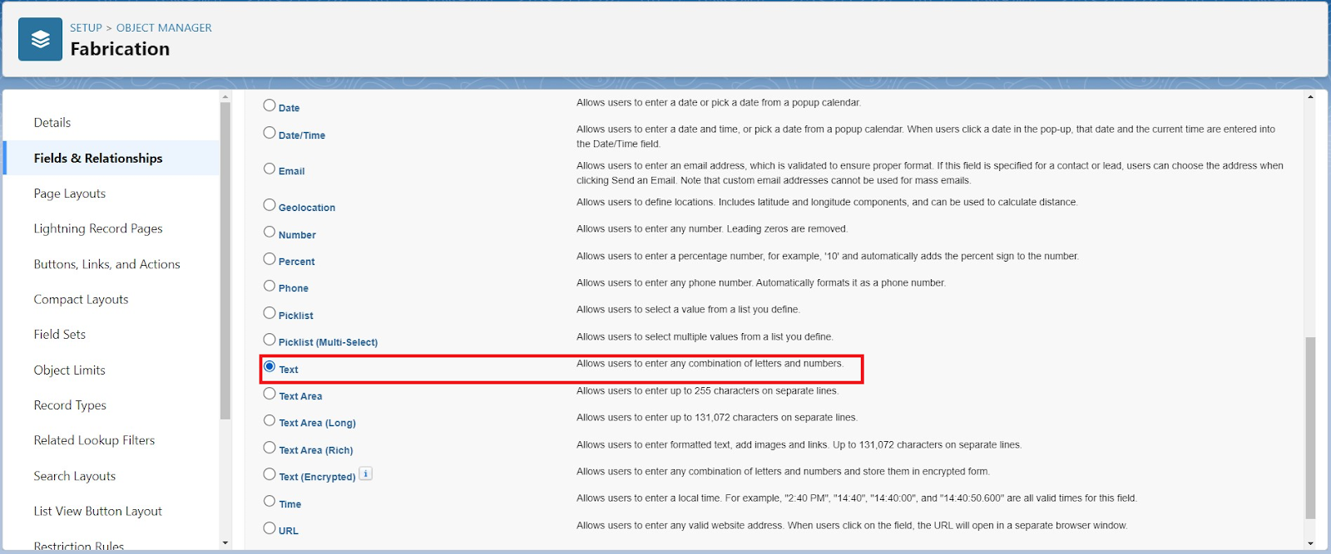

- Choose next.

- Data Type : Text
Field Label: Player Name
Field Name : Auto Populates
Length : 50
Click on Next → Next → Save and new.

- Repeat the Same steps for remaining fields

- Data Type : Text
Field Label: Player Number
Field Name : Auto Populates
Length : 3
Click on Next → Next → Save and new.

- Data Type : Rich Text Area
Field Label : Profile Picture
Field Name : Auto Populates
Click on Next → Next → Save and new.

- Data Type : Date
Field Label : Date of Birth
Field Name : Auto Populates
Click on Next → Next → Save and new.

- Data Type : Picklist
Field Label : Role
Field Name : Auto Populates
Value : Enter value, with each value separated by a new line.
Batsman
Bowler
Batsman & Wicket Keeper
All Rounder

- Data Type : Picklist
Field Label : Batting Style
Field Name : Auto Populates
Value : Enter value, with each value separated by a new line.
Right- Handed
Left - Handed
Click on Next → Next → Save and new.

- Data Type : Picklist
Field Label : Bowling Style
Field Name : Auto Populates
Value : Enter value, with each value separated by a new line.
Right-Arm Fast
Left-Arm Fast
Right-Arm Medium
Left-Arm Medium
Right-Arm Spin
Left-Arm Spin
Click on Next → Next → Save and new.

- Data Type : Picklist
Field Label : Nationality
Field Name : Auto Populates
Value : Enter value, with each value separated by a new line.
Australia
Bangladesh
England
India
New Zealand
Pakistan
South Africa
Sri Lanka
West Indies
Afghanistan
Zimbabwe
Ireland
Scotland
Netherlands
United Arab Emirates
Nepal
United States of America
Click on Next → Next → Save and new.

- Data Type : Picklist
Field Label : Team
Field Name : Auto Populates
Value : Enter value, with each value separated by a new line
Chennai Super Kings (CSK)
Delhi Capitals (DC)
Kolkata Knight Riders (KKR)
Mumbai Indians (MI)
Punjab Kings (PBKS)
Rajasthan Royals (RR)
Royal Challengers Bangalore (RCB)
Sunrisers Hyderabad (SRH)
Gujarat Titans (GT)
Lucknow SuperGiants (LSG)
- Data Type : Formula
Field Label : AVG Score
Field Name : Auto Populates
Formula Return : Number
Formula : IF(
Matches_Played__c > 0,
Total_Runs__c / Matches_Played__c ,
0
)
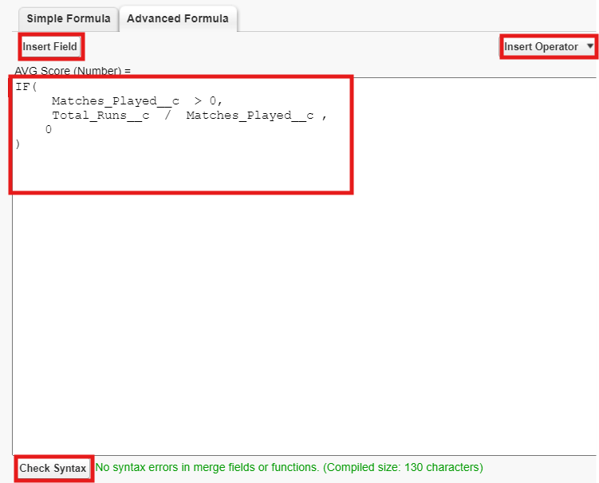
Click on Next → Next → Save & New.

- Data Type : Lookup Relationship
Related To : Match Performance
Field Label : Match Performance
Field Name : Auto Populates
Click on Next → Next → Save.

Activity 2 : Create Custom fields for Match Performance object.

- Data Type : Text
Field Label: Match Performance Name
Field Name : Auto Populates
Length : 80
Click on Next → Next → Save and new.

- Data Type : Checkbox
Field Label: Player of the Match
Field Name : Auto Populates
Click on Next → Next → Save and new.

- Data Type : Picklist
Field Label: Match Result
Field Name : Auto Populates
Value : Enter value, with each value separated by a new line
WON
LOST
DRAW
Click on Next → Next → Save and new.

- Data Type : Number
Field Label: Runs Scored
Field Name : Auto Populates
Click on Next → Next → Save and new.

- Data Type : Number
Field Label: Balls Faced
Field Name : Auto Populates
Click on Next → Next → Save and new.

- Data Type : Number
Field Label: Fours
Field Name : Auto Populates
Click on Next → Next → Save and new.

- Data Type : Number
Field Label: Sixes
Field Name : Auto Populates
Click on Next → Next → Save and new.

- Data Type : Number
Field Label: Overs Bowled
Field Name : Auto Populates
Click on Next → Next → Save and new.

- Data Type : Number
Field Label: Wickets Taken
Field Name : Auto Populates
Click on Next → Next → Save and new.

- Data Type : Number
Field Label: Runs Conceded
Field Name : Auto Populates
Click on Next → Next → Save and new.

- Data Type : Number
Field Label: Maiden Overs
Field Name : Auto Populates
Click on Next → Next → Save and new.

- Data Type : Number
Field Label: Stumpings
Field Name : Auto Populates
Click on Next → Next → Save and new

- Data Type : Number
Field Label: Catches
Field Name : Auto Populates
Click on Next → Next → Save and new.

- Data Type : Master - Detail Relationship
Related To : Player
Field Label : Player
Field Name : Auto Populates
Click on Next → Next → Save.

Milestone 6 : Roll-up Summary

Activity 1 : Create Roll-up Summary for Player object.

Note :- Roll-up Summary can only be created on parent object in Master- Detail Relationship.

- In your Salesforce org, click gear icon on the top left and select Setup to open Setup.
- Click the Object Manager tab. If you don’t see it, enter Object Manager in the Quick Find box.
- From the object manager page, In the Quick Find box, Search for the custom object you just created : Player
- From the sidebar, click Fields & Relationships. Notice that there are already some fields there. Those are the standard fields.
- Click New to create a custom field. Tip: Before creating a new field, do a quick search to make sure a similar one doesn’t already exist. Click Next,
- Choose a data type as Roll-up Summary. Choose Next.
Field Label: Matches Played
Field Name : Auto Populates
Summarized Object : Match Performances
Select Roll-up Type : COUNT

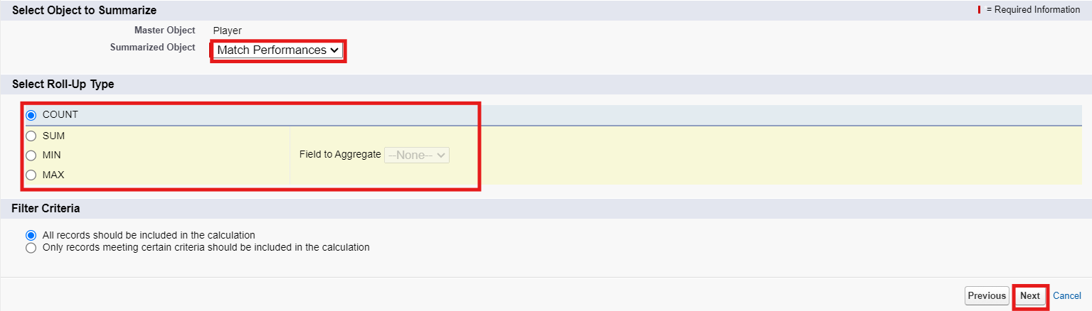

Filter Criteria : All records should be included in the calculation.
Click on Next → Next → Save and new.

- Data Type : Roll-up Summary
Field Label: Number of 50’s
Field Name : Auto Populates
Summarized Object : Match Performances
Select Roll-up Type : COUNT
Filter Criteria : Only records meeting certain criteria should be included in the calculation.
Click on Next → Next → Save and new.
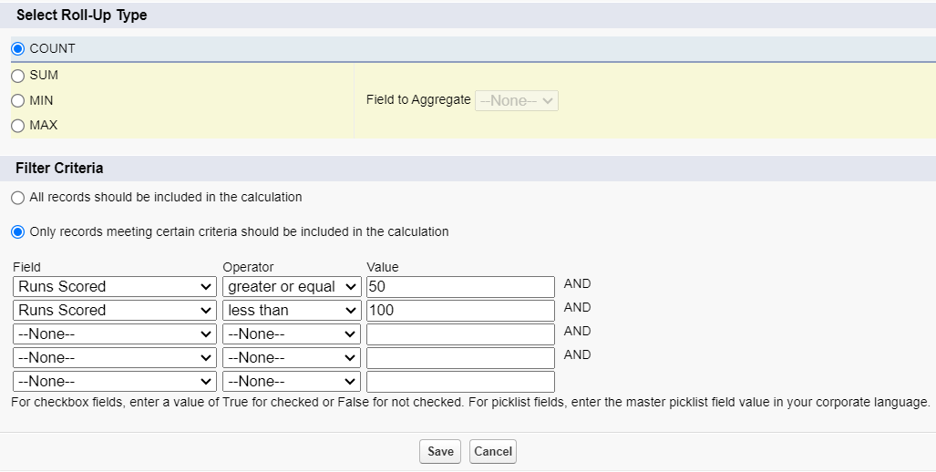

- Data Type : Roll-up Summary
Field Label: Number of 100’s
Field Name : Auto Populates
Summarized Object : Match Performances
Select Roll-up Type : COUNT
Filter Criteria : Only records meeting certain criteria should be included in the calculation.
Click on Next → Next → Save and new.

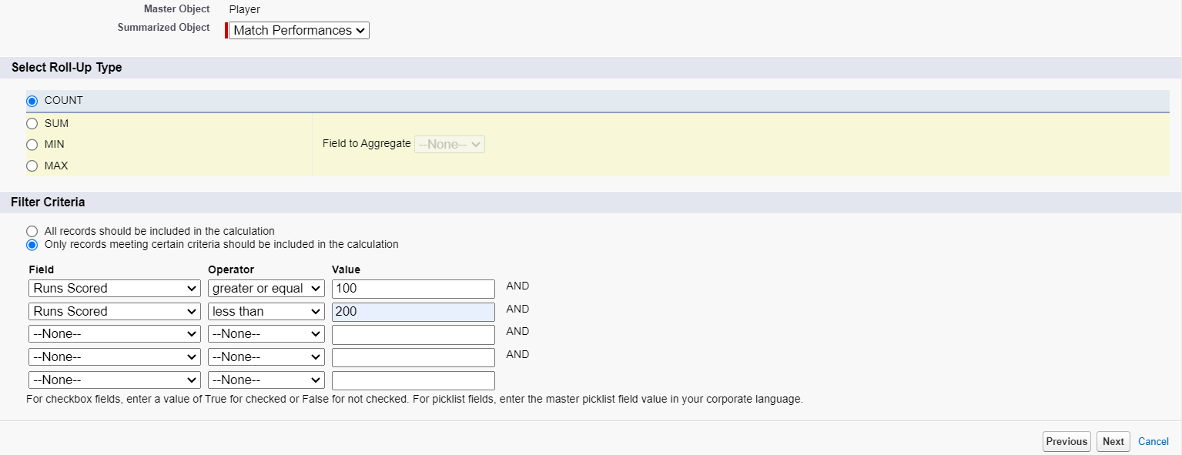

- Data Type : Roll-up Summary
Field Label: Total 4’s
Field Name : Auto Populates
Summarized Object : Match Performances
Select Roll-up Type : SUM
Field To Aggregate : Fours
Filter Criteria : All records should be included in the calculation.
Click on Next → Next → Save and new.

- Data Type : Roll-up Summary
Field Label: Total 6’s
Field Name : Auto Populates
Summarized Object : Match Performances
Select Roll-up Type : SUM
Field To Aggregate : Sixes
Filter Criteria : All records should be included in the calculation.
Click on Next → Next → Save and new.

- Data Type : Roll-up Summary
Field Label: Total Runs
Field Name : Auto Populates
Summarized Object : Match Performances
Select Roll-up Type : SUM
Field To Aggregate : Runs Scored
Filter Criteria : All records should be included in the calculation.
Click on Next → Next → Save and new.

- Data Type : Roll-up Summary
Field Label: Total Overs
Field Name : Auto Populates
Summarized Object : Match Performances
Select Roll-up Type : SUM
Field To Aggregate : Overs Bowled
Filter Criteria : All records should be included in the calculation.
Click on Next → Next → Save and new.

- Data Type : Roll-up Summary
Field Label: Total Wickets
Field Name : Auto Populates
Summarized Object : Match Performances
Select Roll-up Type : SUM
Field To Aggregate : Wickets Taken
Filter Criteria : All records should be included in the calculation.
Click on Next → Next → Save and new.

- Data Type : Roll-up Summary
Field Label: Total Stumpings
Field Name : Auto Populates
Summarized Object : Match Performances
Select Roll-up Type : SUM
Field To Aggregate : Stumpings
Filter Criteria : All records should be included in the calculation.
Click on Next → Next → Save and new.

- Data Type : Roll-up Summary
Field Label: Total Catches
Field Name : Auto Populates
Summarized Object : Match Performances
Select Roll-up Type : SUM
Field To Aggregate : Catches
Filter Criteria : All records should be included in the calculation.
Click on Next → Next → Save and new.

Milestone 7 : Flows

Activity 1 : Screen Flow

- Go to setup, Type Flow in quick find box → Click on the Flow and Select the New Flow.



- Choose Screen Flow and select Create.
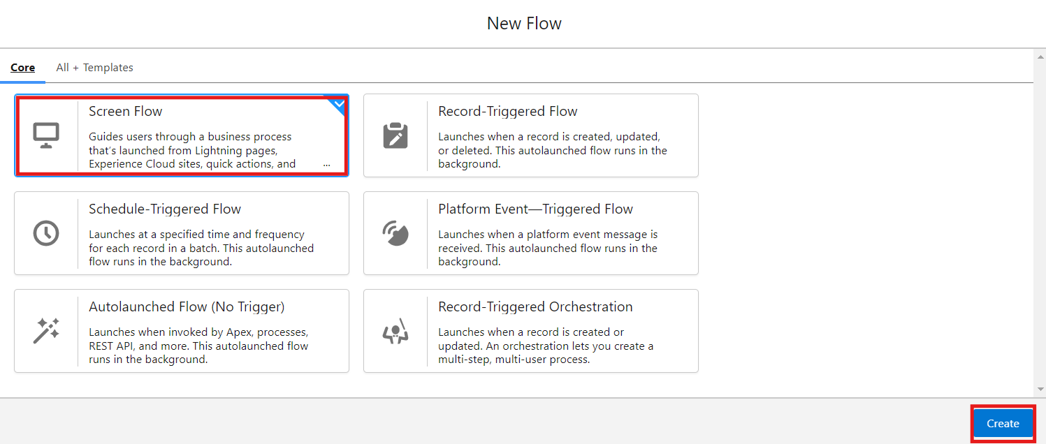

- Click (+) Icon on the flow builder and Select Screen Component.
Label : Players screen
API : Players_screen
Choose the Picklist component and place it on the screen.
Label : Team
API : Team
From Component Pane on the left side select Component Type : Picklist
Data Type : Text
Choice : Click New Choice Resources
Resource Type : Picklist Choice Set

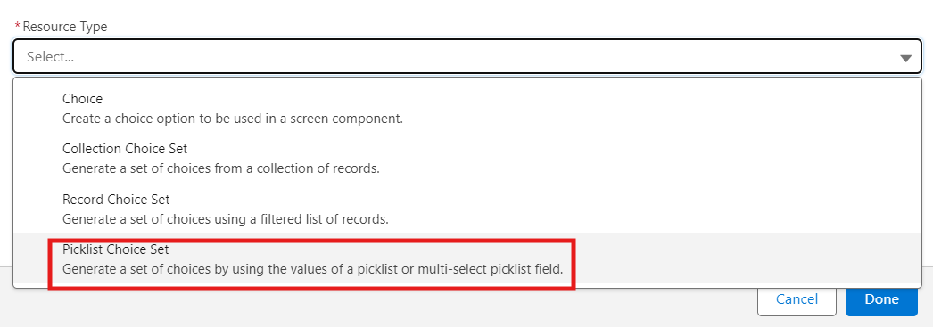

API Name : Team
Object : Player
Data Type : Picklist
Field : Team
Choose Done.
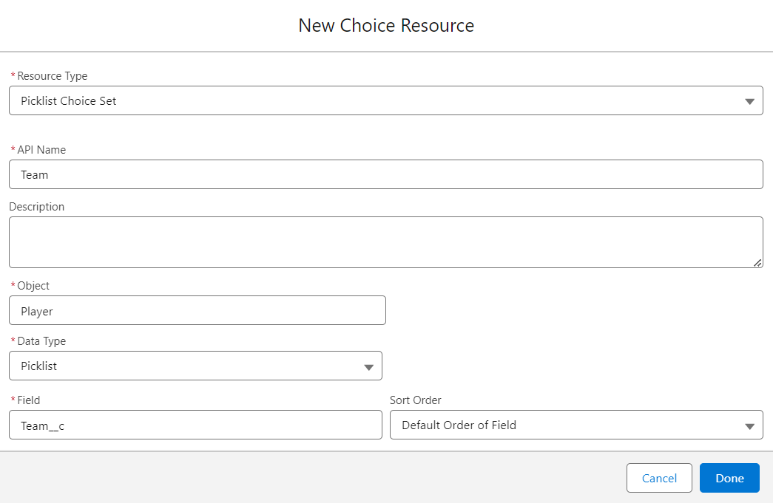

- Click (+) Icon on the flow builder and Select Get Records Component.
Label : Players
API Name : Players
Object : Player
Filter player records :
Field : Team
Operator : Equals
Value : Click New Resource
Resource Type : Variable
API Name : Dynamic
Data Type : Text
Default Value : Screen component : Team (Picklist)

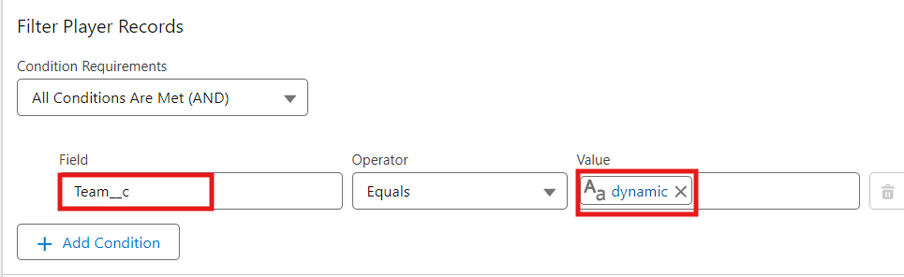

- Click (+) Icon on the flow builder and Select Screen Component.
Label : Player_info
API Name : Player_info
From Component Pane on the left side select Component Type : Data table
API Name : Player_info_table
Label : Data Table
Configure Data Source : Source Collection : Players from players (Player__c)

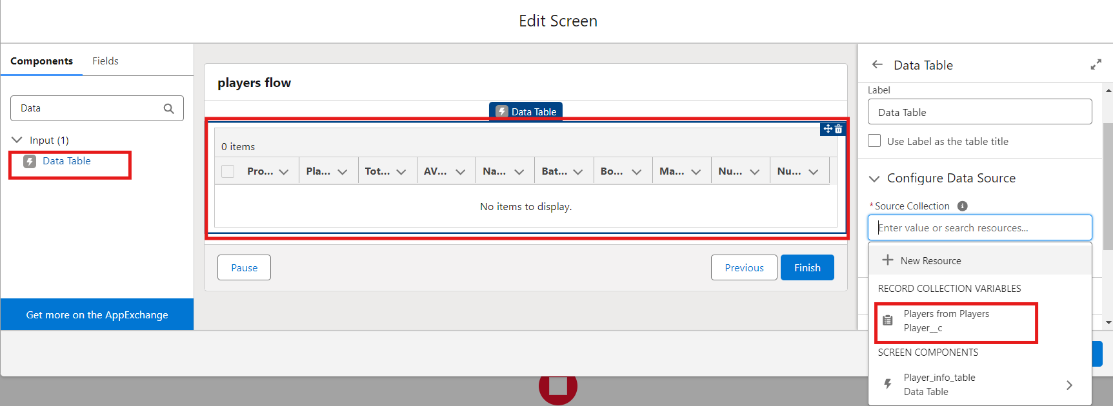

In Configure Columns : Add all the required Columns
Profile Picture | Player Name | Total Runs | AVG Score | Batting Style | Bowling Style | Matches Played | Number of 50’s | Number of 100’s
Choose Done.

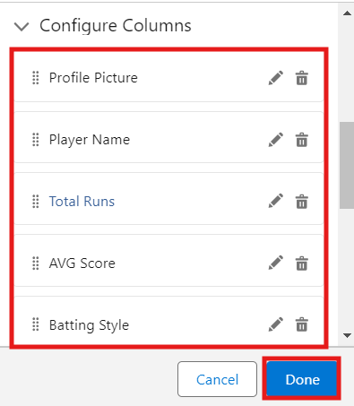
Click Save.
Flow Label : Player Flow
Flow API Name : Player_Flow
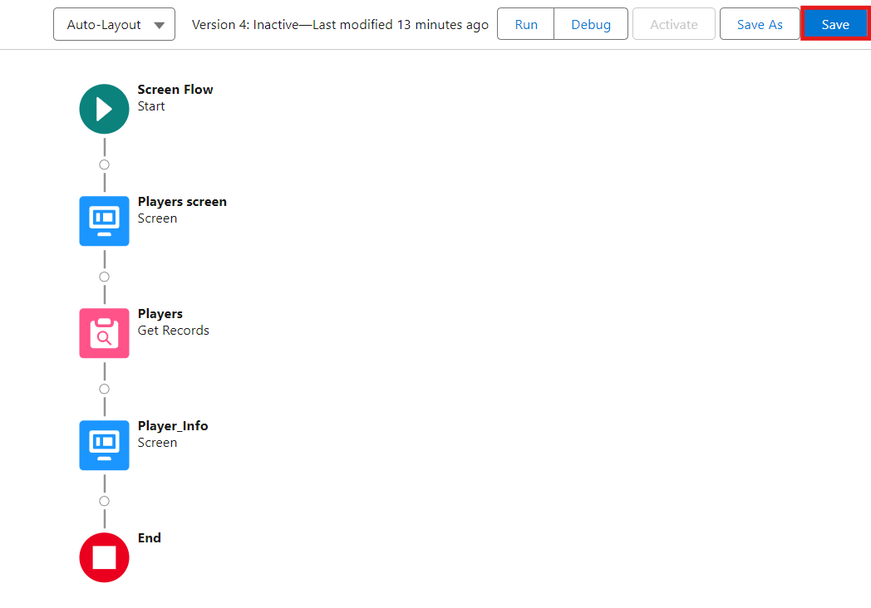
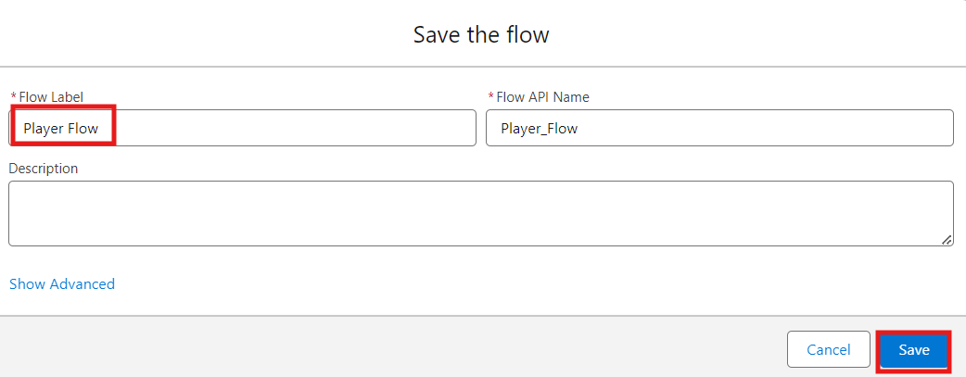

Activity 2 : Flow on Home Page

- On your CRICKSTATS Application on the top right of the Navigation Bar click on Personalize your nav bar icon (Pencil Icon) and Add Home Page and click Save.

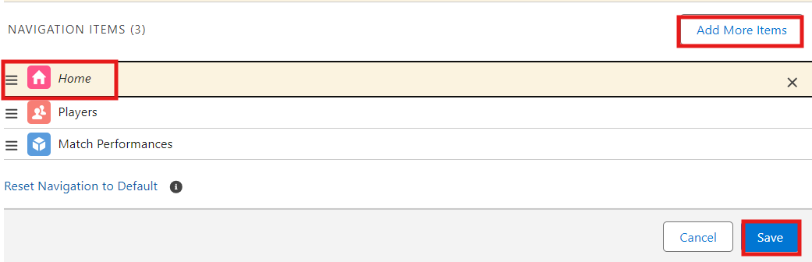

- Remove all other components and Add FLOW component from the standard components on the left side.
- Flow : Players Flow

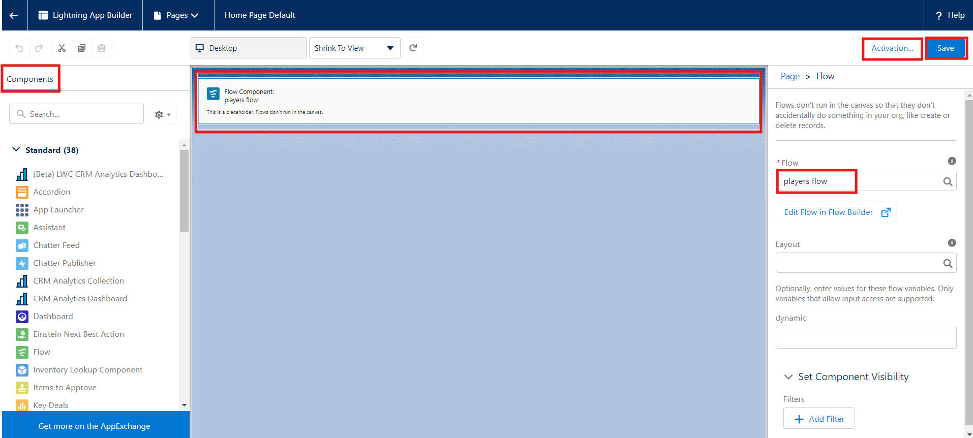

- Choose Save and Activation.
- Choose App Default and select Assign to Apps.

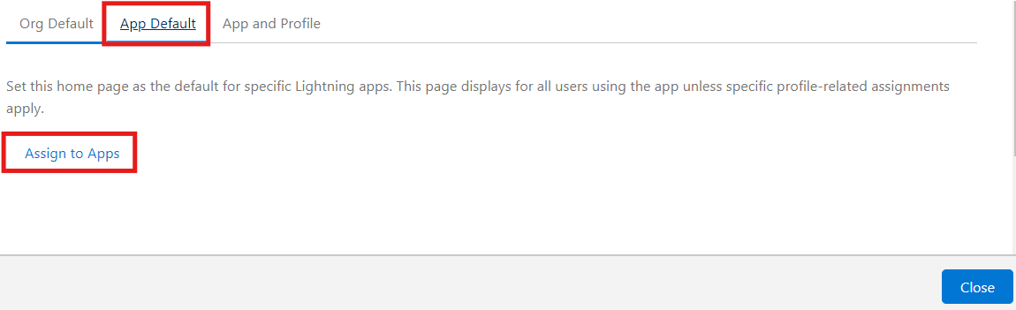
- Choose CRICKSTAS App and Choose Next and then select Save the configuration.

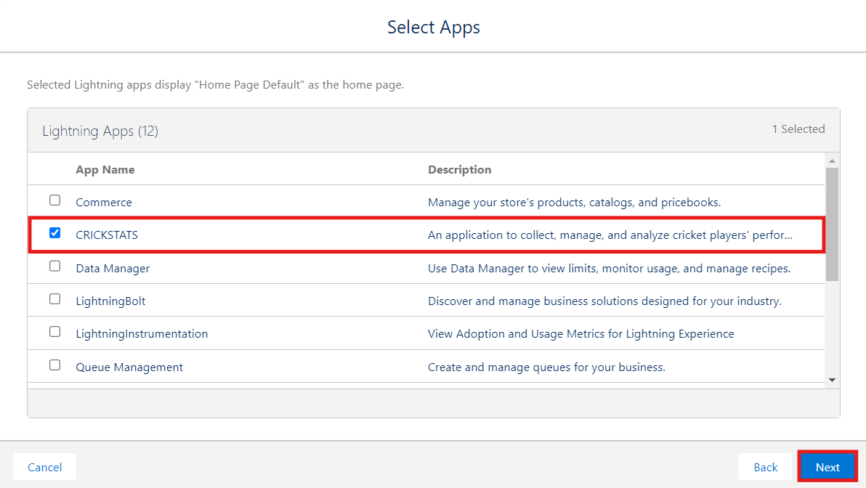

7. FUNCTIONAL & PERFORMANCE TESTING

During validation, screenshots from the Salesforce Lightning interface were used to confirm that the implemented CRICKSTATS features behaved as expected. Testing covered creation of Player and Match Performance records, required-field checks, score and input validation, record-type behavior for different match categories, and flow execution for updating player statistics. Roll-up summary fields were also checked to confirm that runs, wickets, averages, and other performance measures were calculated correctly.

System responsiveness was also observed during record entry, report creation, and dashboard loading. Multiple user actions were performed to check stability and identify unnecessary delays. Generated reports and interactive dashboards were captured as evidence of correct visualization, timely updates, and dependable performance tracking. These validation activities were intended to confirm that CRICKSTATS satisfied its functional and performance objectives before deployment.
- Choose one Team from the Picklist and Choose Next.

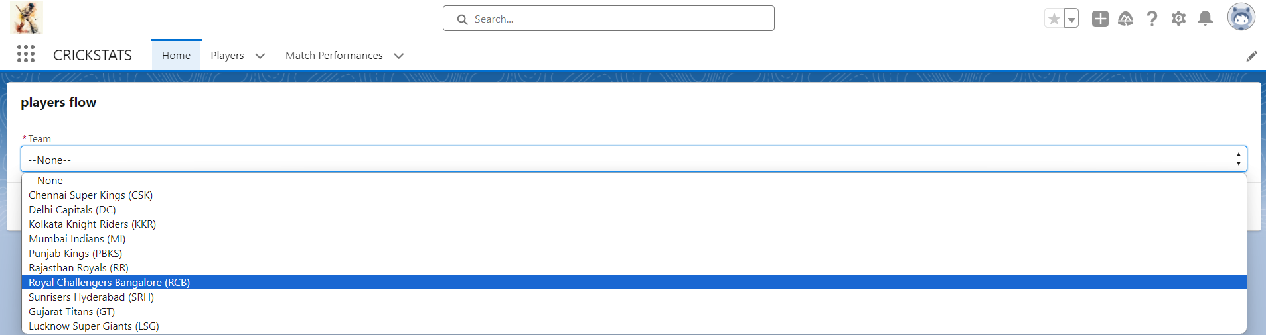

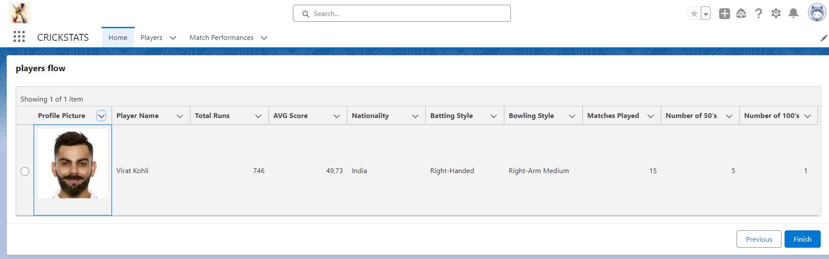
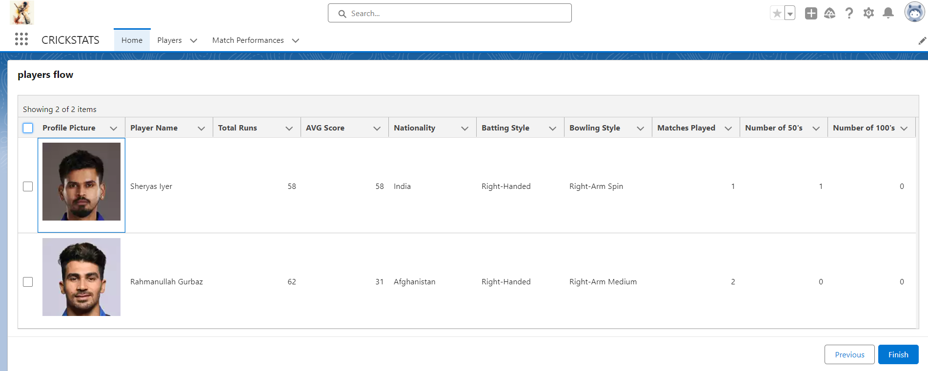

8. ADVANTAGES & LIMITATIONS

Benefits
- Unified data management
- Timely performance analytics
- Controlled-access platform
- Expandable system structure
- Less repetitive manual entry

Limitations
- Depends on an appropriate Salesforce license
- Requires network connectivity
- Offline functionality is restricted

9. Conclusion:

CRICKSTATS successfully implements a cloud-based cricket performance tracking system using Salesforce. The system automates data management, improves reporting accuracy, and supports informed decision-making.
The implementation also illustrates the practical use of SDLC activities, Agile planning, and CRM-oriented application development.

10.FUTURE ENHANCEMENTS

- Integration with a dedicated mobile application
- AI-assisted prediction of player performance
- Support for video-based match analysis
- Automated player ranking and comparison
- A public-facing statistics portal
- Support for multiple leagues and competitions

11.APPENDIX

- Salesforce Objects and Field Definitions
- Reference for manual match statistics
- Flow Configurations

Thank You

