Calculator

Assumptions:
    - The input arithmetic expression is of valid format
    - The integers used in the expression is between Integer.MIN_VALUE and Integer.MAX_VALUE
    - The arithmetic functions are spelled as add, sub, mult, div, let.

Solution:

The calculator program is designed to handle 4 arithmetic operation viz, addition,subtraction,multiplication,division and 1 assignment operation. Each of these operations are designed as individual class to let the classes implement the operation logic. Left operand class and right operand class are used to represent left ad right operands in an operation. Each operand could contain static (simple integers)or dynamic value(expression) . Factory design pattern are used to design the classes to ensure high cohesion and low coupling.

The integers in the expression are stored as BigInteger to avoid over flow or under flow of integers. The result of the arithmetic expression is also in BigInteger. Custom exception is used to throw specific error message.

Logging mechanism is implemented using Log4j library .Default log4j.properties file is used to configure the logging mechanism. However, it can also be configured by specifying new properties file from command-line.

The algorithm for the calculator and the class diagram are available as follows:

Flow chart – Calculator algorithm

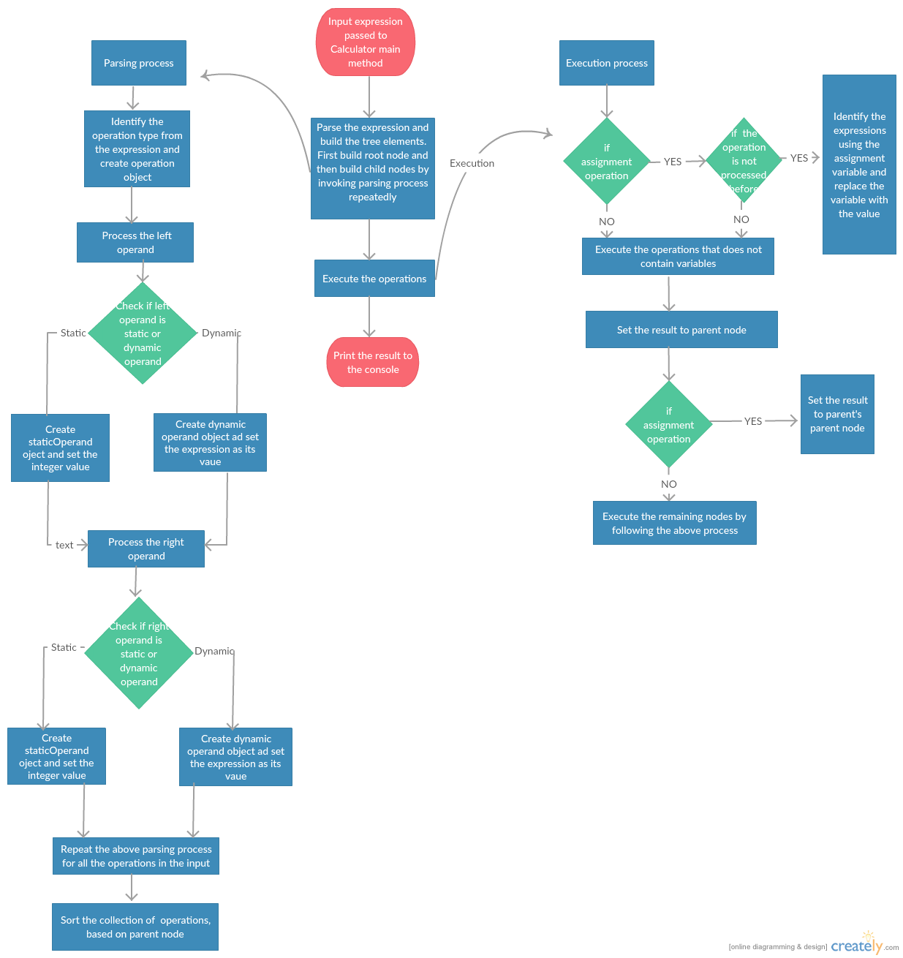

Class diagram

