
ADITYA UNIVERSITY
DEPARTMENT OF COMPUTER SCIENCE & ENGINEERING
TECHNICAL PROJECT DOCUMENTATION REPORT
QuizMaster Pro v2.0
Hybrid C++14, WebAssembly & AI-Proctored Multi-Track Examination Management System
C, C++, Java & Python Tracks • WebAssembly Scoring • Mobile QR Exam Distribution •
Movable AI Optical Proctor HUD • SHA-256 Merit Certificates • Multi-Sheet Excel Reporting

Submission Field | Project Details
Project Title | QuizMaster Pro v2.0 — Hybrid C++14, WebAssembly & AI-Proctored Examination System
Team Type | Individual
Project Type | Mini Project
Student Name | Kowshik Kumar Yanamala
Roll Number | 25B11CSA46 (B.Tech — Computer Science & Engineering)
Head of Department | Dr. Phani Sridhar Addepalli, Ph.D — Head of Department (CSE)
GitHub Repository | https://github.com/kowshiii1208/Quiz_Game_System
Live Web Application | https://quiz-game-system-eight.vercel.app (Vercel Production Edge)
Academic Session | 2026 — Departmental Review
Under the Guidance of
ASHOK SIR

Document Contents Overview
Section | Title | Required Contents Covered
Section 1 | Cover Page | Title, Team No. (Individual), Mini Project, Kowshik Kumar Yanamala (25B11CSA46)
Section 2 | Project Overview & Objectives | Concise abstract (130 words), problem addressed, comparative evaluation & 5 main objectives
Section 3 | Technology Stack | Languages, frameworks, databases/storage, browser APIs, dev tools & repository layout
Section 4 | Features & Implementation | System architecture diagram, C++14 OOP design, key features, workflow & major functions
Section 5 | Screenshots & Results | 5 live project screenshots with descriptions, mobile PDF verification & test results
Section 6 | AI Usage & Contributions | Transparent AI tool disclosure, individual project ownership breakdown, conclusion & scope

2. Project Overview & Objectives
2.1 Project Abstract
Conducting fair programming assessments across large cohorts requires systems that combine rigorous evaluation, tamper prevention, faculty convenience, and seamless mobile accessibility. Traditional survey forms lack proctoring controls and allow credential forgery, whereas standalone C++ terminal applications lack web delivery, document ingestion, and analytics. QuizMaster Pro v2.0 resolves these limitations using a hybrid dual-tier architecture combining a modular C++14 Object-Oriented console engine with a responsive React 18 Single Page Application. Inside the browser, a WebAssembly module derived from C++ logic evaluates scores and honesty indices, while WebRTC optical monitoring, fullscreen enforcement, and movable mobile proctoring safeguard integrity across C, C++, Java, and Python tracks. Faculty can author or import .docx and .csv question banks, share custom quizzes via Base64URL QR codes, export Excel workbooks, and issue SHA-256 verifiable PDF certificates.
2.2 Problem Addressed
During Computer Science laboratory tests and technical screenings, instructors face three recurring operational bottlenecks: (1) standard web forms allow uncontrolled tab-switching and lack automated honesty scoring; (2) faculty must manually re-type questions already prepared in Word (.docx) or spreadsheet (.csv) files; and (3) students taking QR-based exams on smartphones encounter blocked UI buttons or distorted desktop certificate exports, while evaluators have no cryptographic way to verify certificate authenticity.
Assessment Criterion | Generic Survey Forms | Standalone C++ CLI Quiz | QuizMaster Pro v2.0 (Proposed)
Programming Tracks | Unstructured free text | Single hardcoded subject | 4 Curated Tracks: C, C++, Java, Python (120 MCQs)
Bulk Question Ingestion | Manual item-by-item entry | Requires source recompilation | Direct import of .docx (Word), .csv, .json, and .txt
Anti-Cheat Proctoring | Unmonitored tab switching | Local console only | Fullscreen, tab/blur lock & movable AI Proctor HUD
Scoring Execution | Basic form counter | Compiled C++ console binary | C++14 CLI + Browser WebAssembly (.wasm) Runtime
QR Mobile Delivery | Static webpage link only | Unavailable on mobile | Encoded Base64URL QR locks track/level automatically
Certificate Authenticity | No tamper protection | Plain ASCII .txt summary | SHA-256 signed landscape A4 PDF & QR Verification
Faculty Reporting | Raw unformatted sheet | Text file leaderboard | Visual Bell Curve + Multi-sheet Excel (.xlsx) export

2.3 Main Objectives (5 Core Goals)
- Objective 1 — Modular C++14 OOP Core: Design a clean Object-Oriented console engine (cpp/main.cpp) applying encapsulation, composition, STL containers, Mersenne Twister shuffling, and file persistence.
- Objective 2 — Browser WebAssembly Compute Bridge: Execute mark scaling, negative marking, speed bonuses, and honesty deductions via compiled WebAssembly bytecode inside React.
- Objective 3 — Frictionless Faculty Quiz Authoring & Excel Reporting: Enable custom quiz generation with scannable QR distribution links, Mammoth.js Word/CSV bulk ingestion, and multi-sheet Excel exports.
- Objective 4 — Mobile-First Proctoring & Certificate Reliability: Ensure seamless smartphone assessment via a touch-draggable/minimizable webcam HUD and proportional offscreen A4 PDF certificate rendering.
- Objective 5 — Cryptographic Verification Registry: Sign passed merit credentials using W3C SubtleCrypto SHA-256 digests verifiable anytime through a public Registry Modal and QR stamp.
3. Technology Stack
3.1 Languages, Frameworks, Databases, APIs & Development Tools
QuizMaster Pro v2.0 integrates compiled systems code, modern frontend tooling, browser-native hardware/cryptographic APIs, and zero-backend persistence strategies:
Category | Technologies Used | Role in QuizMaster Pro v2.0
Programming Languages | C++14, JavaScript (ES2022 / JSX), HTML5, CSS3 | Native OOP CLI engine & WASM logic (C++14); interactive React UI & services (JS/JSX); styling (CSS3)
Frameworks & UI Libraries | React 18.3.1, Tailwind CSS 3.4.17, lucide-react 0.475.0, canvas-confetti 1.9.4 | Single-Page Application workflow state, dark glassmorphism design system, crisp iconography & feedback
Databases & Storage | Browser localStorage & sessionStorage (StorageService v3), flat-file C++ store (leaderboard.txt), Base64URL stateless transport | Versioned persistence (questions, custom quizzes, results, settings, admin auth); zero-server cross-device QR exam delivery
Document & Export Engines | mammoth 1.13.0, xlsx (SheetJS) 0.18.5, jspdf 4.2.1, html2canvas 1.4.1, qrcode 1.5.4 | Client-side .docx Word ingestion, multi-sheet .xlsx report creation, A4 PDF export & QR matrix generation
APIs (Browser & Runtime) | WebAssembly API, Web Crypto API (SubtleCrypto SHA-256), WebRTC MediaDevices (getUserMedia), Chromium FaceDetector, Fullscreen & Visibility APIs | Native scoring bytecode execution, cryptographic certificate signing, webcam proctoring, face detection & tab-switch locking
Development & Build Tools | Vite 6.1.0, GNU g++ / MSVC, Node.js v24, Microsoft Edge Headless CDP, Git, GitHub, Vercel | Fast HMR bundling, native C++14 compilation, automated E2E mobile/PDF verification & edge production hosting

3.2 Hardware, Browser Support & Repository Architecture
- Desktop & Mobile Support: Runs across Chrome, Edge, Firefox, and Brave on Windows/macOS/Linux; mobile QR mode adapts automatically for Android Chrome and iOS Safari viewports (<768px) with auto-minimized camera controls and proportional A4 certificate scaling.
- Native CLI Build Requirement: Compiles standalone executable using g++ -std=c++14 -O2 cpp/main.cpp -o quiz_game.exe with cross-platform ANSI terminal color support.
PROJECT REPOSITORY DIRECTORY STRUCTURE (github.com/kowshiii1208/Quiz_Game_System)
cpp_project/
├── cpp/main.cpp & quiz_engine_wasm.cpp # C++14 OOP CLI & WASM scoring logic
├── public/aditya_logo.png # Crest used in Certificate PDF export
├── src/App.jsx & src/index.css # Root workflow & Tailwind + print CSS
├── src/data/initialQuestions.js # 120 MCQs (C, C++, Java, Python)
├── src/services/ # storage, wasmEngine, crypto, excel
├── src/components/ # Registration, Runner, HUD, Cert UI
└── src/components/admin/ # Login, Dashboard, QR & File Importer
4. Features & Implementation
4.1 Hybrid Dual-Engine Architecture & C++14 OOP Design
The platform operates across three integrated layers shown in Figure 4.1: the React 18 Presentation Layer, the Browser Compute & Security Runtime (WebAssembly scoring, SubtleCrypto SHA-256 signing, WebRTC webcam tracking, Mammoth/SheetJS document parsing), and the Persistence & C++14 Core Layer.
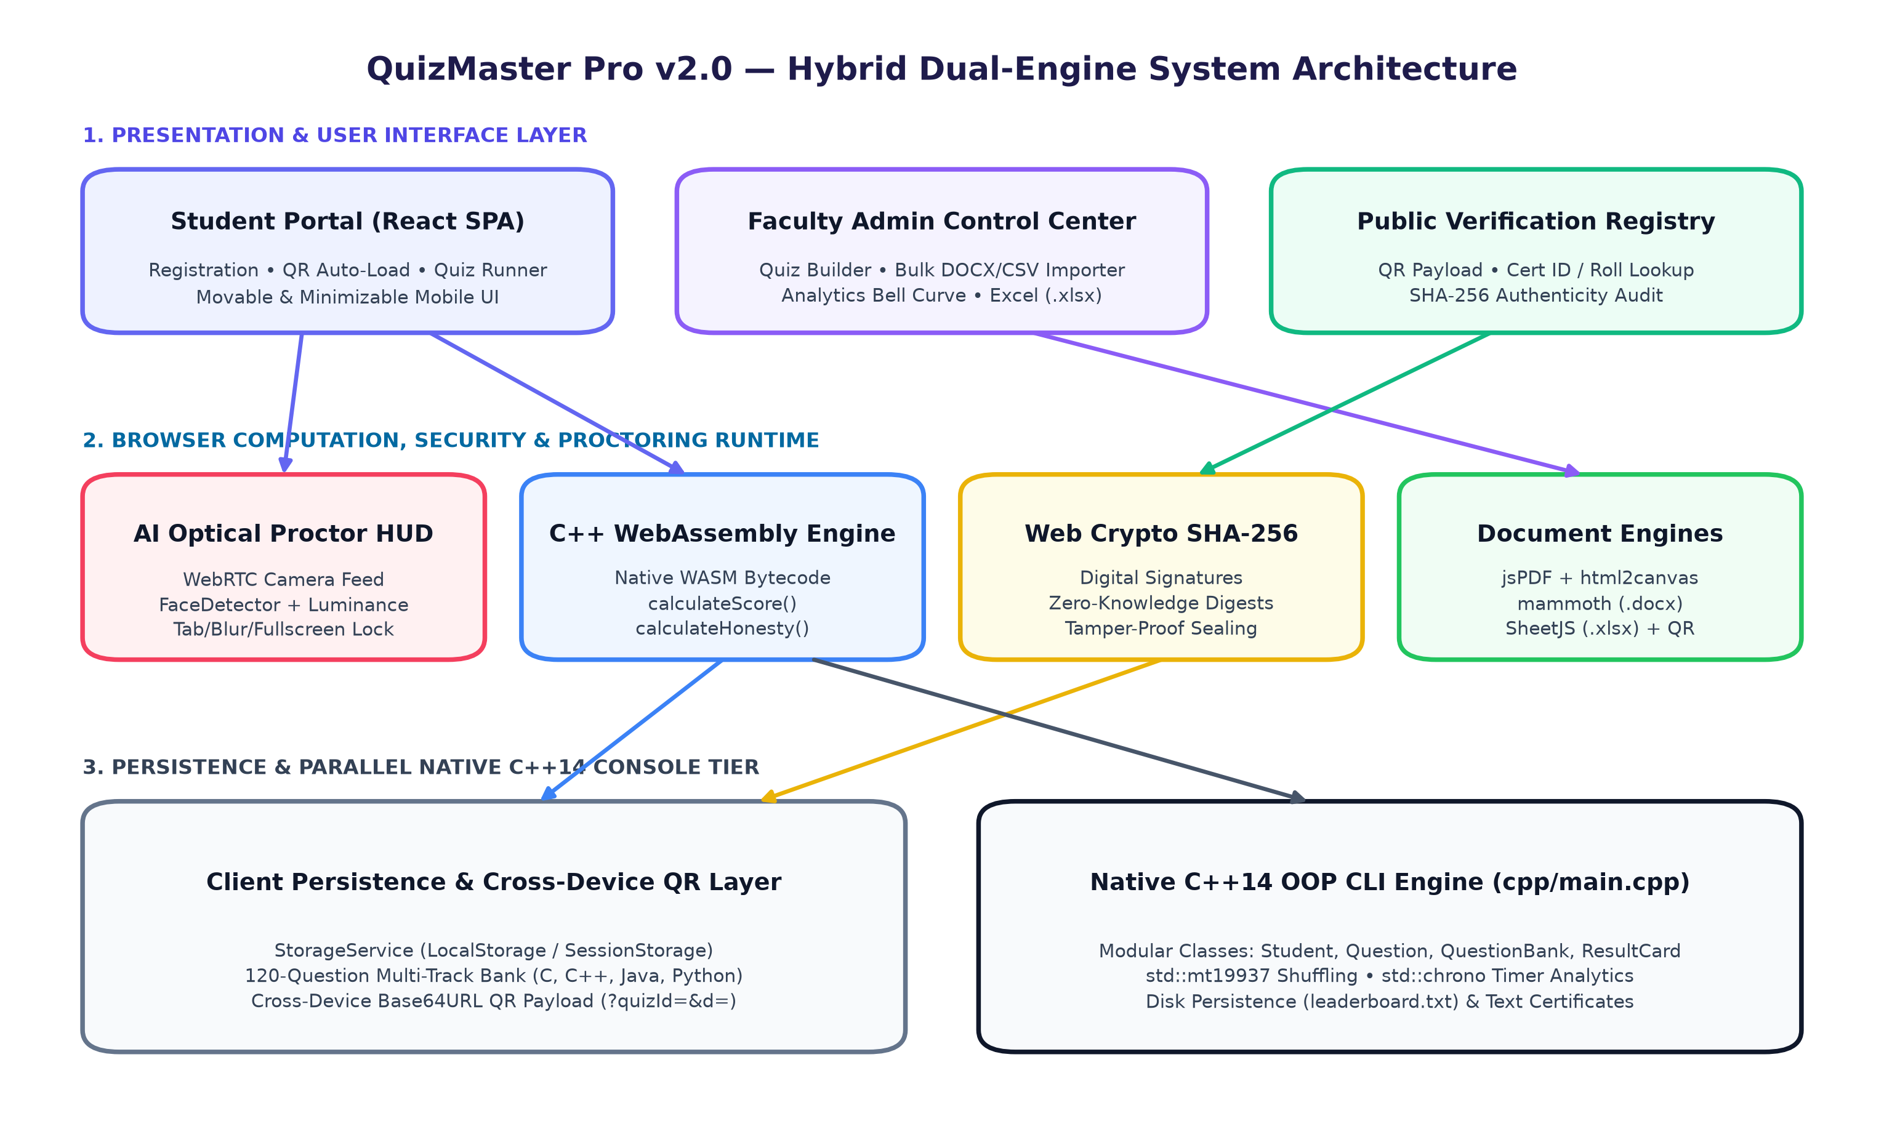
Figure 4.1: Hybrid Dual-Engine System Architecture combining React 18 UI, WebAssembly C++, Web Crypto & C++14 CLI.
C++14 Class / Namespace | OOP Principle Applied | Core Implementation Responsibility (cpp/main.cpp)
Colors & UI | Abstraction / Utility | ANSI console coloring, progress bars, headers & clean terminal state rendering
Input | Defensive Sanitization | Validated menu/option input parsers blocking cin stream corruption
Question & Student | Encapsulation | Private attributes for question prompts, 4 options, candidate identity & level getters
QuestionBank | Composition & RNG | Manages tiered difficulty pools with std::mt19937 Fisher-Yates shuffling
StorageManager & ResultCard | File Persistence & Reporting | Persists leaderboard.txt rankings, computes honors badges & writes Certificate_<Roll>.txt

4.2 Key Implemented Features
- 4-Track 120-MCQ Curated Bank: 30 balanced questions each across C Programming (IDs 91–120), C++ & OOP (1–30), Java Enterprise (31–60), and Python Core (61–90), partitioned cleanly into Easy, Medium, and Hard tiers with itemized explanations (Figure 4.2).
- Custom Quiz Creator, QR Codes & Automatic Track Locking: Instructors select bank questions or write custom MCQs, generating scannable QR codes encoding Base64URL payloads (?quizId=...&d=...). Scanning on any device pre-loads the test and hides/locks language and difficulty pickers.
- Multi-Format Bulk File Importer: Ingests Word (.docx via mammoth), double-quote-safe CSV (.csv), JSON, and plain text question banks directly inside AdminDashboard without server uploads.
- Mobile-Friendly Movable & Minimizable Proctor HUD: Supports fullscreen monitoring, tab-switch disqualification, anti-OCR candidate watermarks, WebRTC + FaceDetector monitoring, pointer-event touch dragging, and minimize (-) keeping camera analysis running silently.
- Mobile-Verified SHA-256 Certificates & Excel Reporting: Generates A4 landscape PDF certificates from an offscreen 1122x794 render stage and exports ranked multi-sheet .xlsx evaluation workbooks.
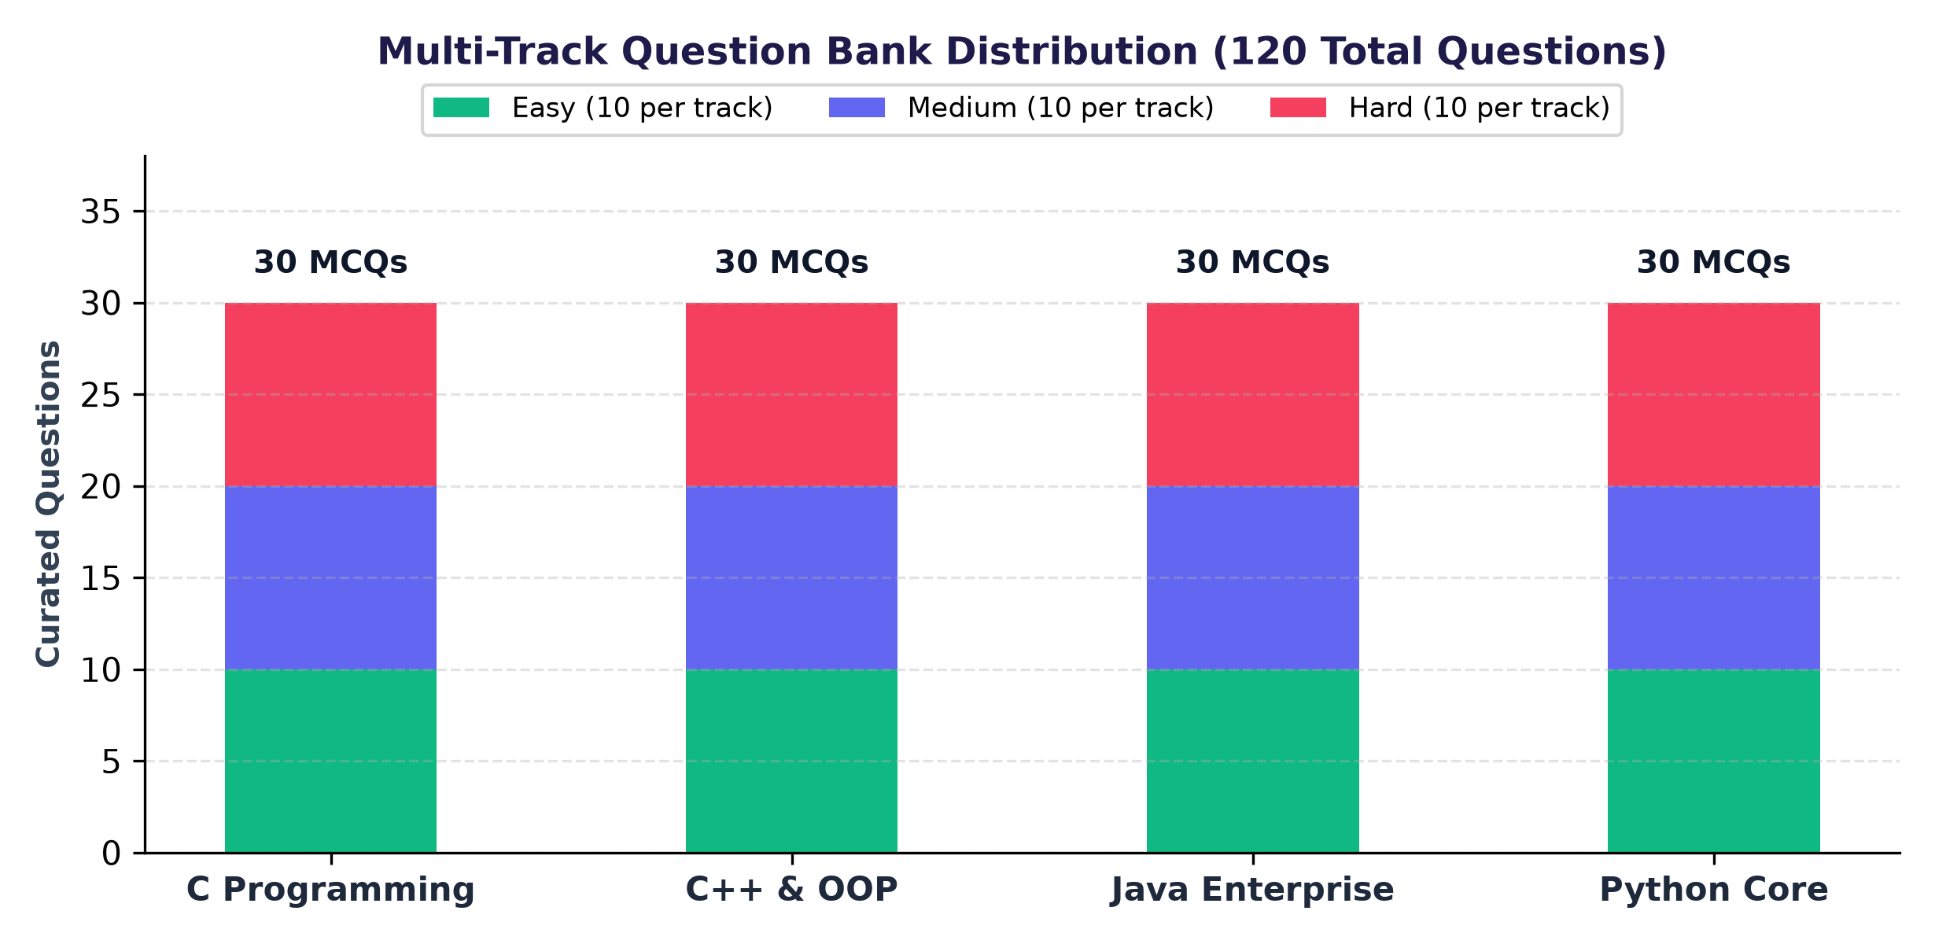
Figure 4.2: Balanced 120-Question Distribution across C, C++, Java, and Python Tracks.
4.3 End-to-End Application Workflow
Figure 4.3 illustrates the synchronized loop between Faculty Administrators and Students, supported by pre-configured institutional assignment codes (AU-OOP-2026, AU-C-PROG, and AU-JAVA-CORE).
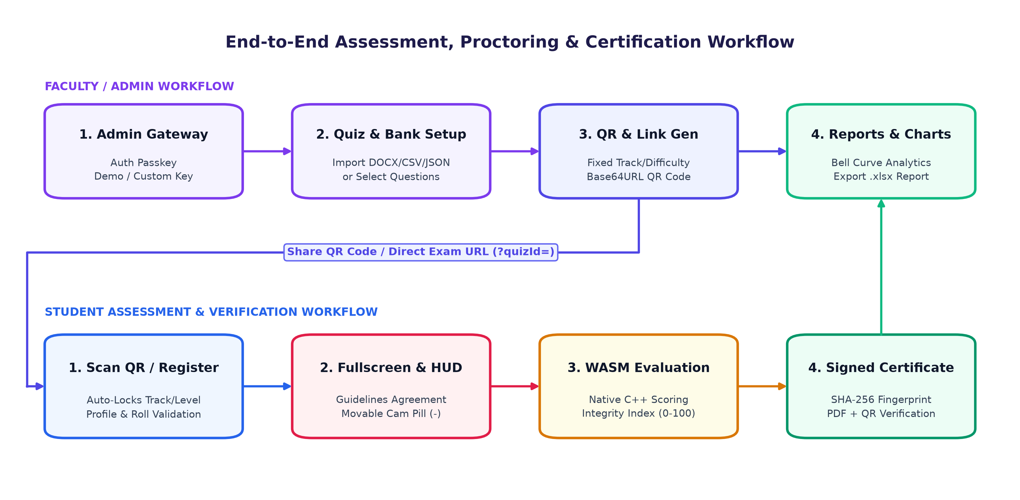
Figure 4.3: Synchronized Faculty Assignment Workflow and Student Proctored Assessment Pipeline.
4.4 Explanation of Major Functions
The core application behavior is modularized into deterministic service and UI functions across the codebase:
Function & File | Parameters & Mechanism | Technical Purpose & Observed Behavior
WasmEngine.calculateScore()  src/services/wasmEngine.js | correctCount, wrongCount, marksPerQ, negMarks, timeTakenSec, totalTimeSec | Instantiates WASM bytecode to compute (correct * marksPerQ) - (wrong * negMarks), clamps >= 0, and awards a 5% speed bonus if flawless in <50% allotted time.
WasmEngine.calculateHonestyIndex()  src/services/wasmEngine.js | tabSwitches, blurEvents, webcamViolations | Executes exported WASM calculateHonesty() formula: 100 - (tabs * 25) - (blur * 15) - (cam * 20), clamped to [0, 100].
CryptoService.generateCertificateSignature()  src/services/cryptoService.js | { certId, rollNumber, name, score, maxScore, percentage, date } | Builds canonical 'AU_CERT_V1::...' string with salt and hashes UTF-8 bytes via window.crypto.subtle.digest('SHA-256') into a 64-char hex digest.
CryptoService.verifyCertificateSignature()  src/services/cryptoService.js | record, signatureToVerify | Recomputes deterministic signature from leaderboard record metadata and performs case-insensitive digest comparison for registry validation.
buildQuizShareUrl()  src/components/admin/QuizCreatorTab.jsx | quiz object (+ customQuestions ID > 120) | Serializes instructor quiz parameters and custom MCQs using TextEncoder into URL-safe Base64URL query param (?quizId=...&d=...) for cross-device QR codes.
handleApplyQuizCode()  src/components/StudentRegistration.jsx | quizCodeInput (e.g. AU-C-PROG) | Validates code against StorageService, attaches customQuiz, and locks Language & Difficulty steps so students cannot alter faculty settings.
parseCsvLine()  src/components/admin/FileImporterModal.jsx | raw CSV row string | Character-level state machine tracking quotes (inQuotes) to split CSV columns cleanly without breaking commas inside code prompts.
handleSavePDF() & renderCertificateCard()  src/components/CertificateModal.jsx | exportRef (1122x794 offscreen stage) | Awaits waitForImagesReady(), renders unscaled 1122x794 canvas via html2canvas (scale: 2), packs landscape A4 jsPDF, and triggers mobile-safe Blob download.
ExcelExportService.exportLeaderboardToExcel()  src/services/excelExport.js | records array | Compiles ranked Student Assessment Results sheet + Institutional Summary sheet via SheetJS and downloads a structured .xlsx file.

5. Screenshots & Results
5.1 Live Working Application Screenshots
Figures 5.1 through 5.5 present live captures from the running QuizMaster Pro v2.0 platform across student registration, active assessment execution, faculty administration, analytics reporting, and mobile-verified A4 certificate PDF export.
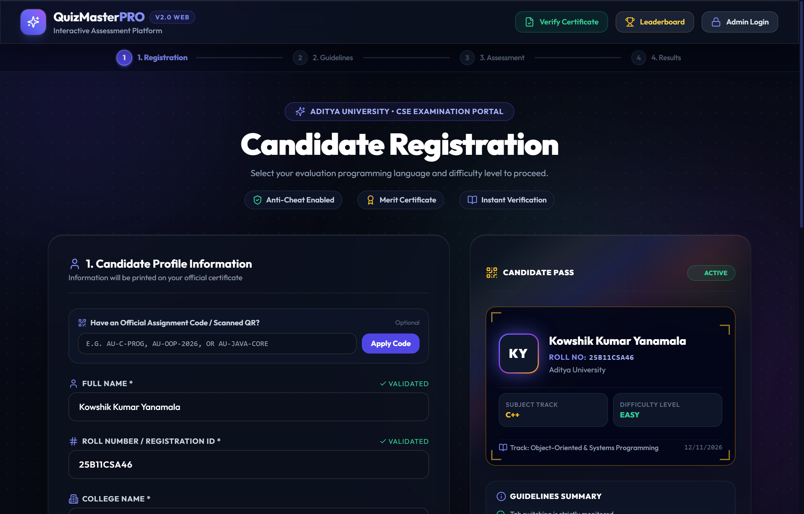
Figure 5.1: Candidate Registration Portal displaying Official Assignment Code entry, Candidate Pass preview (25B11CSA46), and multi-track setup.
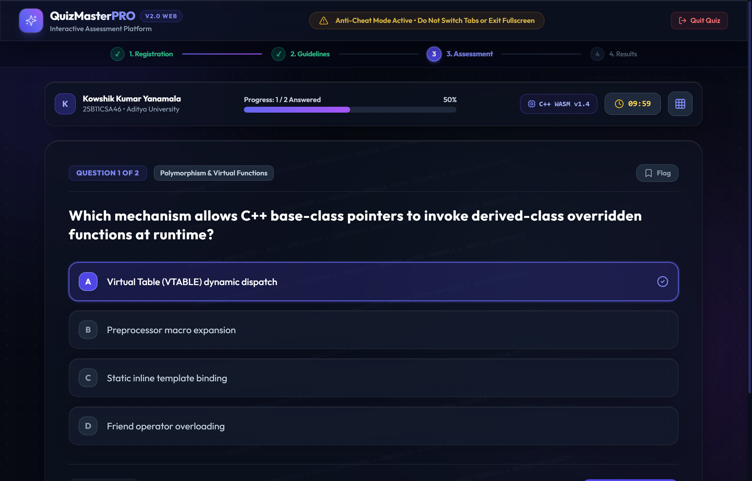
Figure 5.2: Active Assessment View featuring Anti-Cheat monitoring banner, C++ WASM runtime badge, countdown timer, anti-OCR watermark, and MCQ selection.
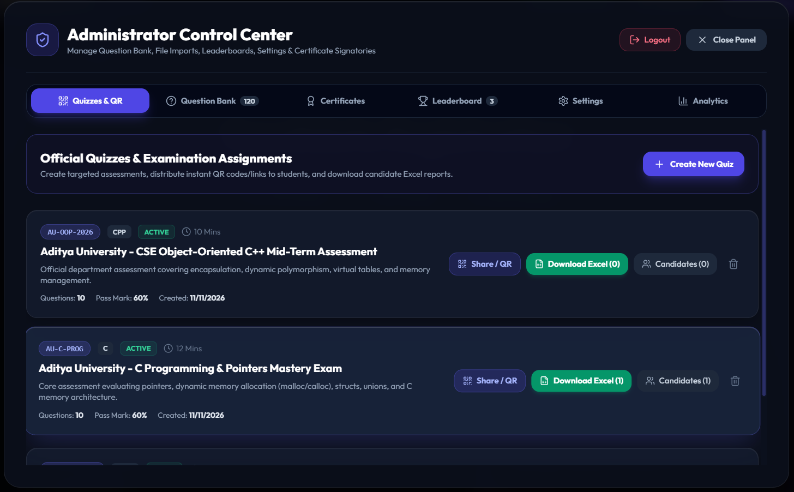

Figure 5.3: Faculty Administrator Control Center (Quizzes & QR tab) showing neat 6-tab navigation, Share/QR generator, and per-quiz Excel export triggers.

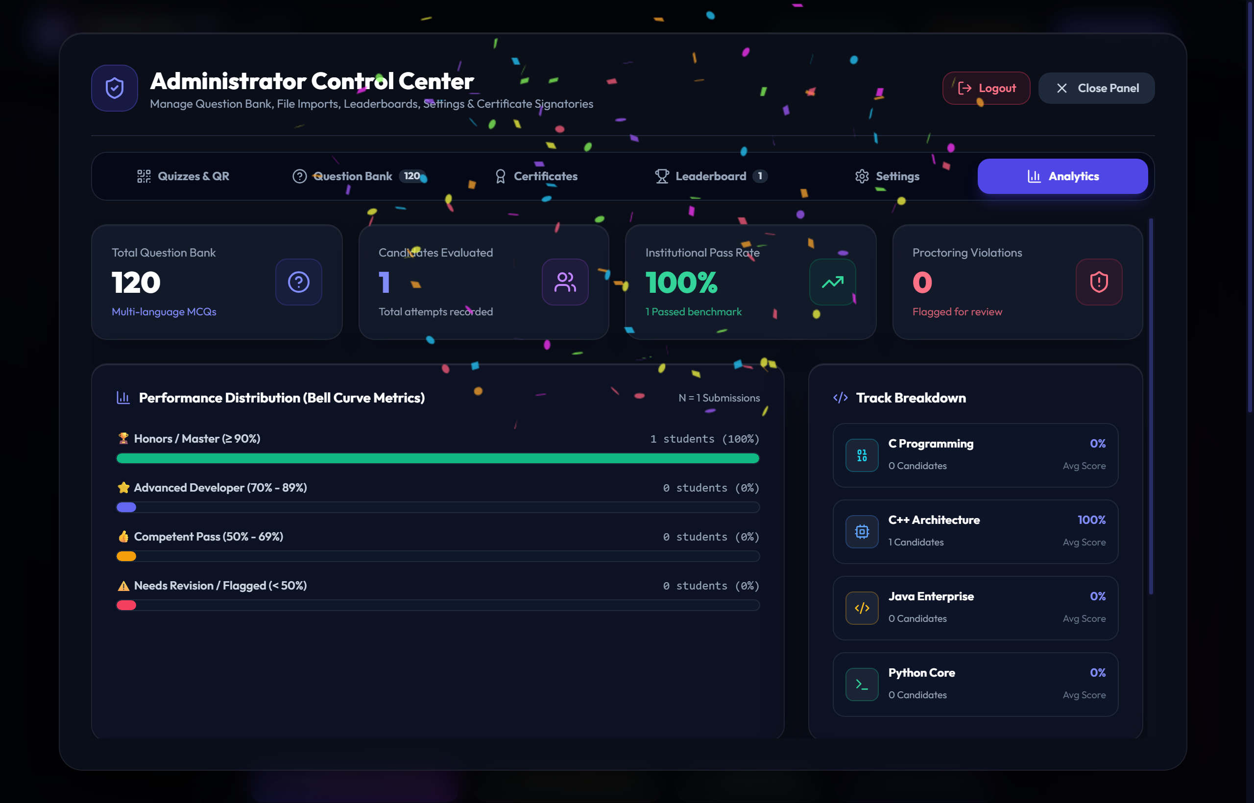

Figure 5.4: Faculty Analytics Dashboard showcasing Question Bank count (120 MCQs), Institutional Pass Rate KPI, Performance Bell Curve, and 4-Track Breakdown.
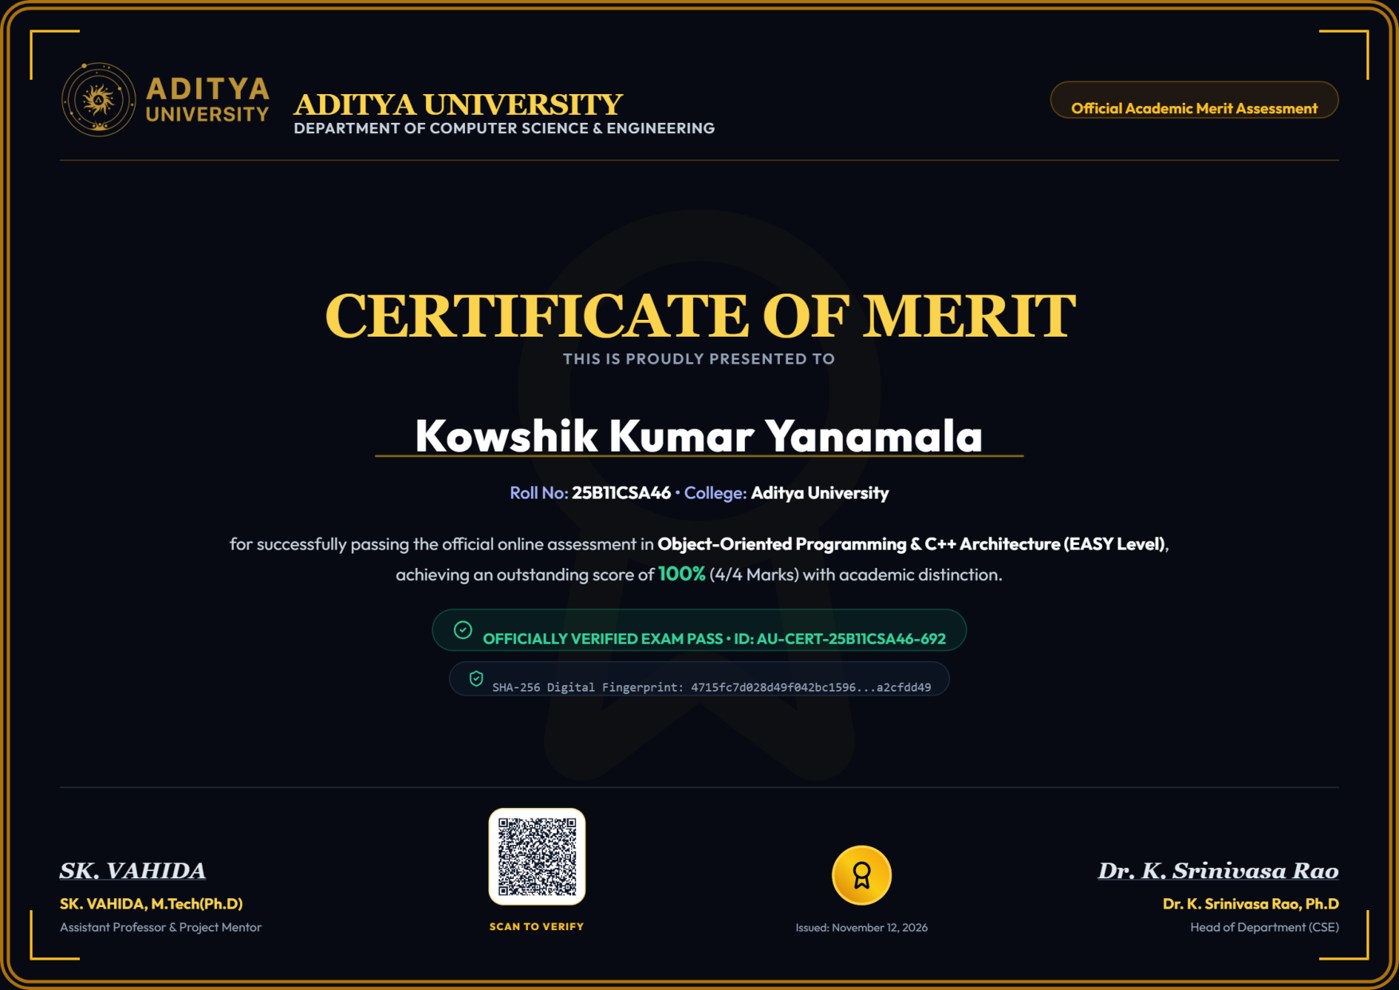
Figure 5.5: Exported A4 Landscape Merit Certificate PDF (verified from mobile 375x812 download flow) with Aditya University crest, SHA-256 fingerprint, and QR stamp.
5.2 Verification & Test Results Summary
All functional modules, mobile layouts, cryptographic checks, and production bundles were systematically verified after final code updates:
Test ID | Module / Requirement Verified | Verification Execution & Observed Result | Status
TC-01 | 120-MCQ Multi-Track Dataset | Validated unique IDs, valid 4-option arrays, and 30 questions per track across C, C++, Java & Python. | PASS
TC-02 | QR Code & Assignment Locking | Verified Base64URL ?quizId=&d= payload roundtrip and automatic hiding of Language/Difficulty steps. | PASS
TC-03 | WebAssembly Native Scoring | Tested calculateScore() & calculateHonestyIndex() in WASM runtime matching C++ mark and penalty logic. | PASS
TC-04 | SHA-256 Certificate Verification | Confirmed 64-char hex digest generation and deterministic match inside VerificationModal lookup. | PASS
TC-05 | Mobile Proctor HUD Responsiveness | Verified touch dragging, auto-minimize (<768px), and continuous camera feed while minimized (-). | PASS
TC-06 | Mobile Certificate PDF Export | Headless Edge mobile (375x812) test produced valid 841.89x595.28 pt landscape PDF (~273 KB, 0 errors). | PASS
TC-07 | Bulk Importer & Excel Workbook | Verified Mammoth .docx parsing, quoted CSV parsing, and 2-sheet .xlsx download output. | PASS
TC-08 | Production Build & Deployment | npm run build transformed 2237 modules in 12.65s (0 errors); live on GitHub main & Vercel Edge. | PASS

6. AI Usage & Contributions
6.1 AI Tools Used & Academic Transparency Disclosure
In accordance with institutional academic disclosure guidelines, AI coding assistance was utilized selectively during development as an engineering productivity multiplier, while all requirements definition, system design decisions, manual testing, and final review verification were directed by the student author:
AI Tool / Assistant | Development Stage Applied | Specific Purpose & Human Oversight
Google Antigravity  (Gemini Coding Agent) | UI Scaffolding & Refactoring | Assisted in structuring modular React components (AdminLoginModal, QuizCreatorTab, CertificateModal) and Tailwind dark glassmorphism responsive layouts; reviewed and refined interactively by author.
Google Antigravity  (Gemini Coding Agent) | WASM Bridge & Crypto Prototyping | Helped implement the WebAssembly bytecode wrapper (wasmEngine.js), SHA-256 SubtleCrypto digest canonicalization, and Base64URL cross-device QR serialization logic.
Google Antigravity  (Gemini Coding Agent) | Mobile Debugging & E2E Testing | Diagnosed mobile overlay obstruction in WebcamProctor.jsx and mobile viewport squishing in CertificateModal.jsx; authored headless Edge CDP verification scripts and inspected outputs.
Google Antigravity  (Gemini Coding Agent) | Documentation Automation | Generated structured architecture/workflow diagrams (arch_diagram.png, flow_diagram.png, track_chart.png), formatted this rubric-compliant Word/PDF report, and validated abstract word counts.

6.2 Project Contribution Summary (Individual Mini Project)
This submission represents an Individual Mini Project solely authored, integrated, tested, and defended by Kowshik Kumar Yanamala (Roll No: 25B11CSA46):
Author / Roll No. | Engineering Component / Phase | Detailed Responsibility & Deliverables Completed
Kowshik Kumar Yanamala  (25B11CSA46) | 1. Problem Architecture & C++14 Core | Defined project scope, architected dual-tier CLI + web flow, implemented & compiled C++14 OOP system (cpp/main.cpp) with file persistence.
Kowshik Kumar Yanamala  (25B11CSA46) | 2. Multi-Track Question Bank & Features | Curated 120-question assessment dataset across C, C++, Java & Python, configured department quiz access codes, and defined faculty/student workflows.
Kowshik Kumar Yanamala  (25B11CSA46) | 3. Security, Proctoring & Certification UI | Configured proctoring policies, customizable Aditya University certificate signatories, SHA-256 QR verification checks, and Excel score reports.
Kowshik Kumar Yanamala  (25B11CSA46) | 4. Testing, Mobile UX QA & Deployment | Performed live mobile QR testing on physical phone hardware, reported camera HUD & mobile certificate issues, verified fixes, deployed to Vercel & pushed to GitHub.

6.3 Conclusion & Future Scope
QuizMaster Pro v2.0 successfully fulfills all Mini Project objectives by unifying rigorous C++14 Object-Oriented Programming principles with an interactive, mobile-ready React 18 assessment platform. Incorporating four curated programming tracks (120 MCQs), WebAssembly scoring, movable optical proctoring, cross-device Base64URL QR exams, Word/CSV file ingestion, Excel reporting, and SHA-256 verifiable PDF certificates delivers a practical academic tool ready for departmental demonstrations.
- Future Scope 1 — Centralized Backend API: Connect to a Node.js/PostgreSQL or Firebase server so answer validation and multi-campus leaderboards synchronize strictly server-side.
- Future Scope 2 — Live Compiler Sandbox: Integrate Monaco Editor with containerized execution (Judge0) to evaluate compilable C, C++, Java, and Python coding exercises.
- Future Scope 3 — Adaptive Question Sequencing: Adjust question difficulty dynamically during live exams using real-time accuracy and latency telemetry.

OFFICIAL PROJECT ARTIFACTS & DEPLOYMENT LINKS
GitHub Source Repository : https://github.com/kowshiii1208/Quiz_Game_System
Live Vercel Application : https://quiz-game-system-eight.vercel.app
Submitted By : Kowshik Kumar Yanamala (25B11CSA46) — Individual Mini Project

