

DEPARTMENT OF COMPUTER SCIENCE AND ENGINEERING

SQL PROJECT
on

RAILWAY SYSTEM DATABASE

Submitted in partial fulfillment of the requirement for the award of COMPUTER SCIENCE AND ENGINEERING
Submitted by

M. Yamuna

23FE1A4336(CAI)

ABSTRACT
Project Title: Railway System Database

The Railway System Database is a structured MySQL-based project designed to streamline and automate railway reservation processes. It handles core operations such as train scheduling, ticket booking, seat management, passenger records, and cancellation tracking through a relational database model.

The system is built using key tables:
- Trains: Stores train details including name, source, destination, and timings.
- Passengers: Maintains personal details like name, email, and phone.
- Tickets: Links passengers to trains with fields like booking date, seat number, and ticket status.
Foreign key relationships ensure referential integrity and prevent issues like double booking or invalid references.

To improve functionality and automate workflows, the project uses:
- Triggers: To block duplicate seat bookings and auto-log cancellations.
- Stored Procedures: For booking (book_ticket), cancellation (cancel_ticket), and booking history queries.
- Views: To simplify common reports like
→ train_schedules_by_date,
→ active_passenger_bookings, and
→ seat_occupancy_per_train.

The system also enables advanced data analysis, including:
- Ranking most-booked trains
- Identifying frequent passengers
- Viewing recent cancellations and refunds
These capabilities are enabled through optimized SQL queries using JOINs, aggregations, window functions, and filtering.

Key Highlights
- Clean, normalized table structure
- Use of Triggers and Procedures for automation
- Real-time insights via dynamic Views and Queries
- Scalable design ready for future extensions
In summary, this project reflects real-world database design principles with emphasis on automation, reliability, and query efficiency—making it suitable as the backend for a modern railway reservation system.

INTRODUCTION TO PROJECT
RAILWAY SYSTEM DATABASE

Brief description

- The mini-project titled “Railway System Database” is developed as part of the second-year DBMS project, fulfilling the academic requirements of the B.Tech. (Computer Science) program.
- This project focuses on designing and implementing a database to manage various aspects of a railway reservation system, including trains, passengers, tickets, and booking operations.
- It allows users to search train schedules, book and cancel tickets, and view booking history, while ensuring data consistency through the use of SQL constraints, triggers, stored procedures, and views.

Objectives
The main objective of the Railway System Database project is to design and implement a structured database that manages key railway operations efficiently. Specifically, the goals are:
- To create and maintain a database for trains, passengers, and ticketing information.
- To store and retrieve train details including source, destination, departure, and arrival times.
- To ensure proper tracking of seat availability for each train.
- To manage the process of booking tickets with unique seat allocation.
- To enable cancellation of booked tickets .
- To use SQL features such as views, triggers, and stored procedures for smooth and automated data handling.

Scope
Scope of the Railway System Database Project
Comprehensive Train Data Management
The system maintains detailed information about all trains including train name, source and destination stations, departure and arrival times. This allows easy querying and scheduling for users and administrators.

- Passenger and Ticket Information Handling
It stores personal and contact details of passengers and links them with booked tickets. This helps in maintaining a full travel history for each user, enabling features like booking history and repeated user identification.
- Booking and Cancellation Operations
The database supports robust ticket booking and cancellation functionalities. It includes automatic seat availability checks, and status updates using triggers and stored procedures.
- Accurate and Secure Transactions
Through triggers and constraints, the system prevents issues such as duplicate seat bookings, invalid passenger IDs, and overlapping reservations. This ensures data integrity and improves trust in the system.
- Scalability for Integration and Reporting
The database is structured to support future integration with a web interface or mobile app. It also includes multiple views and SQL reports such as top booked trains, active passenger bookings, and seat occupancy per train for administrative analysis and decision-making.

Analysis
Railway system database is an offline backend project designed to manage train schedules, ticket bookings, passenger details, and cancellations. This system is mainly created to fulfill the following requirements, and it includes the following features:
- A central database to store complete details of trains, passengers, tickets, and cancellations.
- SQL queries and procedures to track train availability, booking status, and schedule timings.
- Each passenger is assigned a unique ID and can view their booking records anytime.
- The system maintains data integrity through constraints, triggers, and relational keys.

Table description

CREATING TABLES
These SQL statements create three tables for a railway system: Trains, Passengers, and Tickets, with primary keys and relevant fields to store train details, passenger information, and ticket bookings respectively.

Trains
- CREATE TABLE Trains (
train_id INT PRIMARY KEY AUTO_INCREMENT, name VARCHAR(100) NOT NULL,
source VARCHAR(100) NOT NULL,
destination VARCHAR(100) NOT NULL, departure_time DATETIME NOT NULL, arrival_time DATETIME NOT NULL

);
Output: Table Created.
- CREATE TABLE Passengers (
passenger_id INT PRIMARY KEY AUTO_INCREMENT, name VARCHAR(100) NOT NULL,
email VARCHAR(100) UNIQUE NOT NULL, phone VARCHAR(15) NOT NULL
);
Output: Table Created.
- CREATE TABLE Tickets (
ticket_id INT PRIMARY KEY AUTO_INCREMENT,
passenger_id INT NOT NULL, train_id INT NOT NULL, booking_date DATE NOT NULL,
seat_number VARCHAR(10) NOT NULL,
status ENUM('Booked', 'Cancelled') DEFAULT 'Booked',
FOREIGN KEY (passenger_id) REFERENCES Passengers(passenger_id), FOREIGN KEY (train_id) REFERENCES Trains(train_id)
);
Output: Table Created.
The Tickets table includes foreign keys to link each ticket with a specific train and passenger, enforcing relational integrity.

- TRAINS TABLE
Trains table stores information about each train, including a unique ID, name, source and destination stations, and departure/arrival times.
Each record represents one train's schedule in the system.
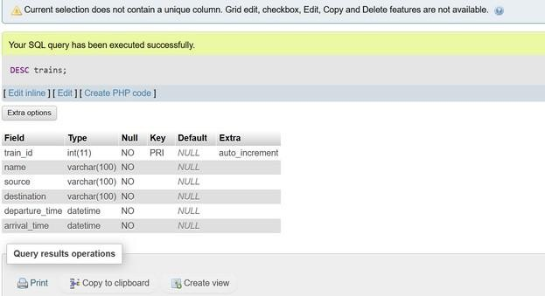

TABLE : STRUCTURE OF TRAINS TABLE

- PASSENGERS TABLE
Passengers Table holds personal details of passengers such as a unique ID, name, email, and phone number.
Each entry represents a registered individual who can book tickets
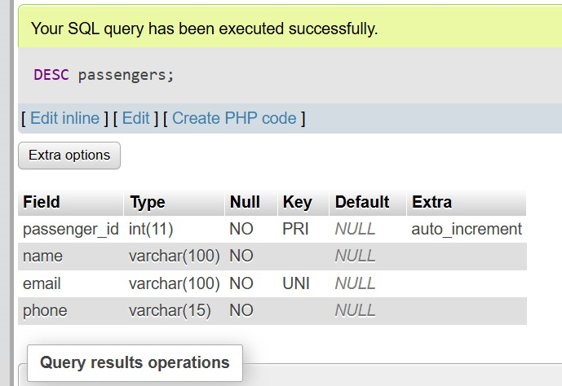

TABLE : STRUCTURE OF PASSENGERS TABLE

- TICKETS TABLE
Tickets table Records ticket bookings with a unique ticket ID, references to the passenger and train, booking date, seat number, and booking status.
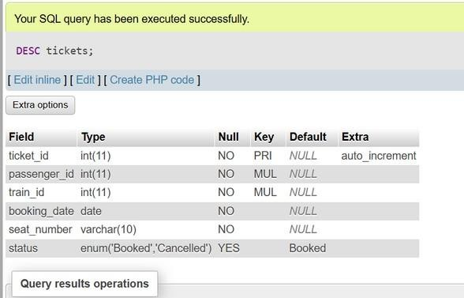
It maintains the relationship between passengers and their booked or cancelled train journeys.

TABLE : STRUCTURE OF TICKETS TABLE

TABLE : STRUCTURE OF TICKETS TABLE

Insertion of Data
These SQL INSERT statements add sample data into the Trains, Passengers, and Tickets tables. They represent two trains (Shatabdi and Duronto), two passengers (Aryan and Meera), and their corresponding ticket bookings with one booked and one cancelled status.

-- sample Insertion into trains:

INSERT INTO Trains VALUES
(6044, 'TVC Chennai egmore special', 'secundrabad', 'villupuram', '2025-07-08 20:39:08', '2025-07-09
14:39:08');
Output:1 row inserted.
INSERT INTO Trains VALUES
(7201, 'guntur jn secundrabad', 'guntur', 'secundrabad jn', '2025-07-01 06:25:48', '2025-07-02
13:55:48');
Output:1 row inserted.

-- sample Insertion into passengers:
INSERT INTO Passengers VALUES
(1, ‘YAMUNA’, ‘yamuna@gmail.com’, ‘6300112771’);
Output:1 row inserted.
INSERT INTO Passengers VALUES
(2, ‘bhavya’, ‘bhavya@gmail.com’, ‘1234567891’);
Output:1 row inserted.

--sample Insertion into tickets:
INSERT INTO Tickets VALUES
(1, 1, 6059, '2025-06-27', 'A1', 'Cancelled');
Output:1 row inserted.
INSERT INTO Tickets VALUES
(2, 15, 6059, '2025-06-26', 'A3', 'Booked');
Output:1 row inserted.

- ROWS IN TRAINS
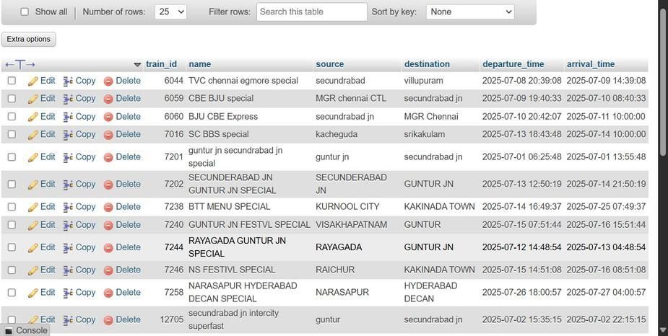

Structure of Trains table after Insertion
- ROWS IN PASSENGERS
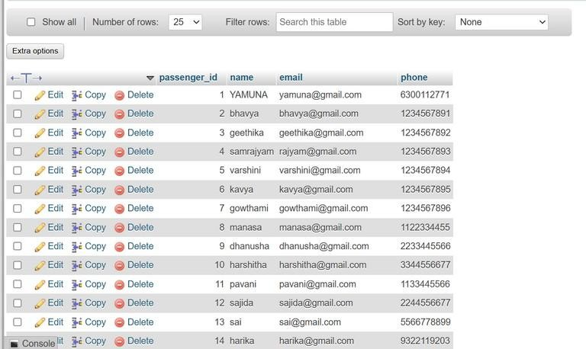

Structure of Passengers table after Insertion

- ROWS IN TICKETS

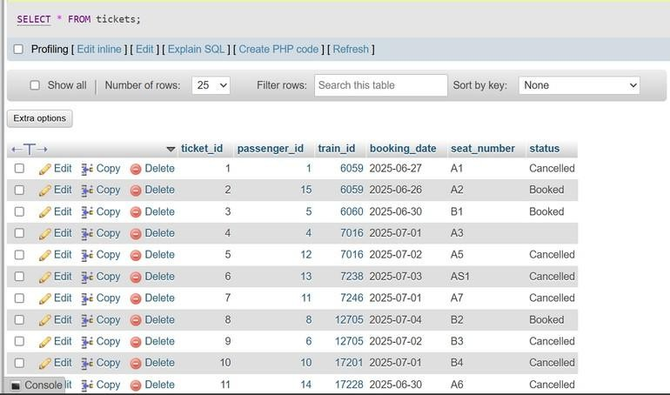
Structure of Tickets table after Insertion

Cancellation log :
The cancellation_log table stores records of cancelled tickets, including the associated ticket_id, passenger_id, time of cancellation, and refund amount.
It ensures each entry is uniquely identified by log_id and uses CURRENT_TIMESTAMP to automatically log when
the cancellation occurs.
Table creation:
- CREATE TABLE IF NOT EXISTS cancellation_log (
log_id INT AUTO_INCREMENT PRIMARY KEY,
ticket_id INT, passenger_id INT,
cancellation_time TIMESTAMP DEFAULT CURRENT_TIMESTAMP, refund_amount DECIMAL(10,2)
);
Table created.
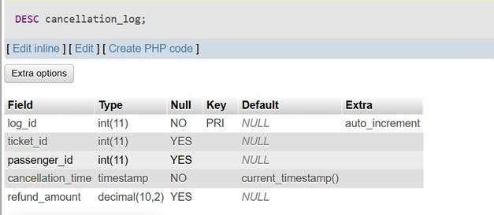
TABLE : STRUCTURE OF CONFRIMATION_LOG TABLE

-- sample Insertion into cancellation_log: INSERT INTO cancellation_log VALUES (101, 4, 4, '2025-07-13 22:55:24', ' ');
Output:1 row inserted.

- ROWS IN CANCELLATION_LOG
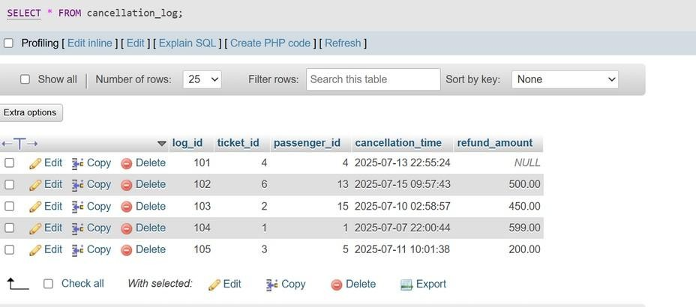
Structure of Cancellation_log table after Insertion

Confrimation log :
  - CREATE TABLE IF NOT EXISTS confirmation_log ( log_id INT AUTO_INCREMENT PRIMARY KEY,
ticket_id INT NOT NULL, passenger_id INT NOT NULL,
confirmation_time TIMESTAMP DEFAULT CURRENT_TIMESTAMP, FOREIGN KEY (ticket_id) REFERENCES Tickets(ticket_id),
FOREIGN KEY (passenger_id) REFERENCES Passengers(passenger_id)
);
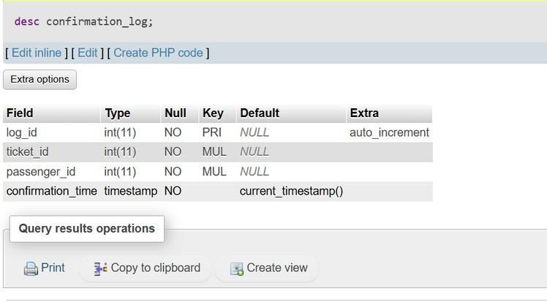
TABLE : STRUCTURE OF CONFRIMATION_LOG TABLE

-- sample Insertion into confrimation_log:
INSERT INTO confrimation_log VALUES (202, 4, 4, '2025-07-13 20:23:48');
Output:1 row inserted.
- ROWS IN CONFRIMATION_LOG
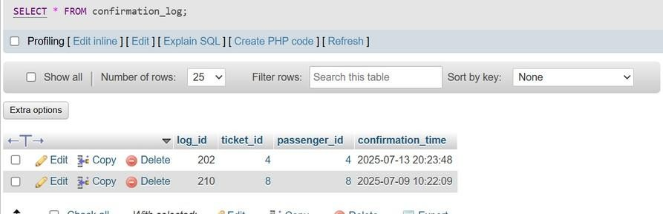
Structure of Confrimation_log table after Insertion

Triggers:
A trigger in SQL is a stored procedure that automatically executes (fires) in response to certain events on a particular table or view, such as INSERT, UPDATE, or DELETE. Triggers are used to enforce business
rules, maintain data integrity, and automate system tasks within the database Triggers: A trigger in SQL is a stored procedure that automatically executes (fires) in response to certain events on a particular table or view, such as INSERT, UPDATE, or DELETE. Triggers are used to enforce business rules, maintain data integrity, and automate system tasks within the database
- CHECK SEAT AVAILABILITY BEFORE BOOKING
This SQL trigger check_seat_availability ensures no double-booking of seats on a train. Before inserting a new ticket, it checks if the seat is already booked for that train; if so, it raises an error and prevents the insertion.
Trigger to Check Seat Availability Before Booking-
  - DELIMITER //
CREATE TRIGGER check_seat_availability BEFORE INSERT ON Tickets
FOR EACH ROW BEGIN
DECLARE seat_taken INT;

SELECT COUNT(*) INTO seat_taken FROM Tickets
WHERE train_id = NEW.train_id
AND seat_number = NEW.seat_number

AND status = 'Booked';
IF seat_taken > 0 THEN SIGNAL SQLSTATE '45000'
SET MESSAGE_TEXT = 'Seat already booked. Please choose another seat.'; END IF;
END // DELIMITER ;
Output: Trigger created

SENDING CONFIRMATION UPON TICKET BOOKING
The send_booking_confirmation trigger runs after a new ticket is inserted into the Tickets table.
It logs a confirmation message into the confirmation_log table with ticket and passenger details.
Trigger to Send Confirmation Upon Booking-
- DELIMITER //
CREATE TRIGGER send_booking_confirmation AFTER INSERT ON Tickets
FOR EACH ROW BEGIN
INSERT INTO confirmation_log (ticket_id, passenger_id) VALUES (NEW.ticket_id, NEW.passenger_id);
END // DELIMITER ;
Output: Trigger created
- LOG TICKET CANCELLATION
The log_ticket_cancellation trigger executes after a ticket’s status changes from 'Booked' to 'Cancelled'.
It calculates the time left before departure, decides the refund (80% or 50%), and logs the cancellation details into the cancellation_log table.
Trigger to log ticket cancellation-
DELIMITER //
CREATE TRIGGER log_ticket_cancellation AFTER UPDATE ON Tickets
FOR EACH ROW BEGIN
DECLARE hours_before_departure INT;1 DECLARE refund DECIMAL(10,2);
IF OLD.status = 'Booked' AND NEW.status = 'Cancelled' THEN
-- Calculate hours before departure
SELECT TIMESTAMPDIFF(HOUR, NOW(), departure_time) INTO hours_before_departure FROM Trains
WHERE train_id = NEW.train_id;

-- Calculate refund
IF hours_before_departure > 24 THEN SET refund = 80.00; -- 80% refund ELSE
SET refund = 50.00; -- 50% refund END IF;
-- Log the cancellation
INSERT INTO cancellation_log (ticket_id, passenger_id, refund_amount) VALUES (NEW.ticket_id, NEW.passenger_id, refund);
END IF;
END // DELIMITER ;
Output: Trigger created

Checking Triggers :-
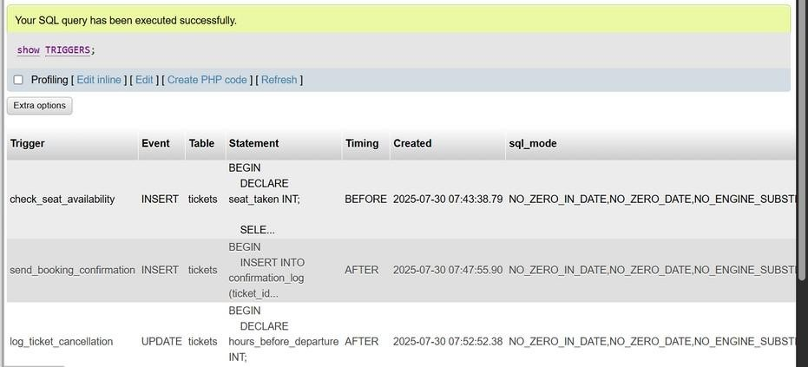

Stored Procedures:
- BOOK A NEW TICKET

The book_ticket procedure first checks if the requested seat on a train is already booked.
If available, it inserts a new ticket with the next ticket ID; otherwise, it raises an error message.

  - DELIMITER //
CREATE PROCEDURE book_ticket( IN p_passenger_id INT,
IN p_train_id INT,
IN p_seat_number VARCHAR(10), OUT p_ticket_id INT
) BEGIN
DECLARE seat_available INT DEFAULT 0;
-- Check if seat is available
SELECT COUNT(*) INTO seat_available FROM Tickets
WHERE train_id = p_train_id

AND seat_number = p_seat_number AND status = 'Booked';
IF seat_available > 0 THEN SIGNAL SQLSTATE '45000'
SET MESSAGE_TEXT = 'Seat already booked. Please choose another seat.'; ELSE
-- Get next ticket_id
SELECT IFNULL(MAX(ticket_id), 0) + 1 INTO p_ticket_id FROM Tickets;

status)
-- Insert the ticket
INSERT INTO Tickets (ticket_id, passenger_id, train_id, booking_date, seat_number,

VALUES (p_ticket_id, p_passenger_id, p_train_id, CURDATE(), p_seat_number, 'Booked'); END IF;
END // DELIMITER ;

Output: procedure created

VIEW PASSENGER BOOKING HISTORY
The passenger_booking_history procedure retrieves all ticket bookings made by a specific passenger. It displays ticket details along with train information, ordered
by the most recent booking date

  - DELIMITER //

CREATE PROCEDURE passenger_booking_history(IN p_passenger_id INT) BEGIN
SELECT
t.ticket_id,
tr.name AS train_name, tr.source, tr.destination, tr.departure_time, tr.arrival_time, t.booking_date, t.seat_number,
t.status
FROM Tickets t
JOIN Trains tr ON t.train_id = tr.train_id WHERE t.passenger_id = p_passenger_id ORDER BY t.booking_date DESC;
END // DELIMITER ;
Output: procedure created

CANCEL A TICKET AND UPDATE SEAT STATUS
The cancel_ticket procedure checks the current status of a ticket by its ID.
If the ticket exists and is not already cancelled, it updates the status to 'Cancelled' and confirms the action.

  - DELIMITER //
CREATE PROCEDURE cancel_ticket(IN p_ticket_id INT) BEGIN
DECLARE current_status VARCHAR(20);

-- Get current status
SELECT status INTO current_status FROM Tickets WHERE ticket_id = p_ticket_id;

IF current_status IS NULL THEN SIGNAL SQLSTATE '45000'
SET MESSAGE_TEXT = 'Ticket not found.'; ELSEIF current_status = 'Cancelled' THEN SIGNAL SQLSTATE '45000'
SET MESSAGE_TEXT = 'Ticket is already cancelled.'; ELSE

UPDATE Tickets
SET status = 'Cancelled' WHERE ticket_id = p_ticket_id;

SELECT 'Ticket cancelled successfully.' AS message; END IF;
END // DELIMITER ;

Output: procedure created

Checking Stored Procedures :-
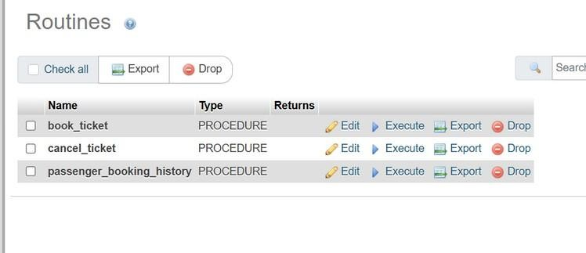

Views:
- TRAIN SCHEDULES BY DATE
The train_schedules_by_date view organizes train schedule details by extracting and displaying the date and time of departures and arrivals.
It helps users quickly view all train schedules sorted by travel date and departure time.
  - CREATE VIEW train_schedules_by_date AS SELECT
train_id,
name AS train_name, source,
destination,
DATE(departure_time) AS travel_date,

TIME(departure_time) AS departure_time, TIME(arrival_time) AS arrival_time
FROM Trains
ORDER BY travel_date, departure_time;

Output:
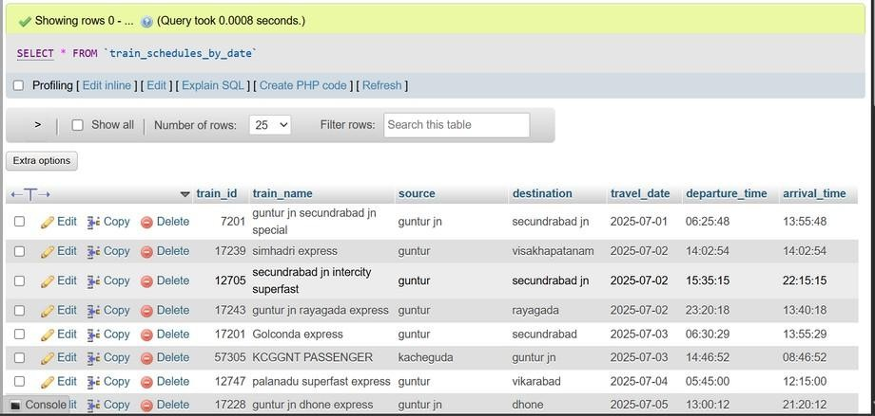

- ACTIVE BOOKINGS OF PASSENGERS
The active_passenger_bookings view displays details of all passengers with currently booked tickets, including their contact info and train details.
It filters only 'Booked' tickets and sorts the output by passenger name and train departure time.

  - CREATE VIEW active_passenger_bookings AS SELECT
p.passenger_id,
p.name AS passenger_name, p.email,
p.phone, t.ticket_id,
tr.name AS train_name, tr.source, tr.destination, tr.departure_time, tr.arrival_time, t.booking_date, t.seat_number
FROM Passengers p
JOIN Tickets t ON p.passenger_id = t.passenger_id JOIN Trains tr ON t.train_id = tr.train_id
WHERE t.status = 'Booked'
ORDER BY p.name, tr.departure_time;

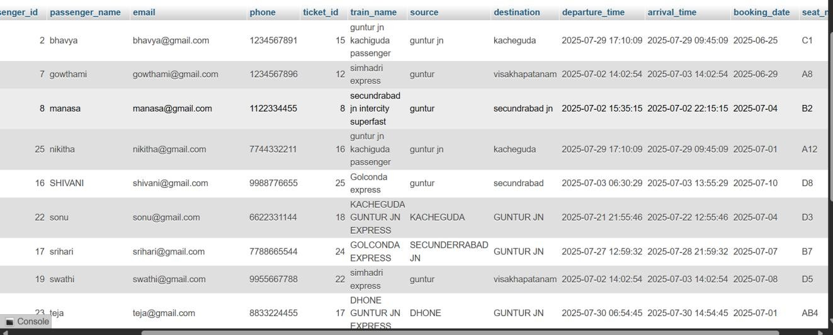
output:

- ​
- ​
- ​
- ​
- ​
- ​
- ​
- ​
- ​
- ​
- ​
- ​

- SEAT OCCUPANCY PER TRAIN
The seat_occupancy_per_train view summarizes ticket status for each train, showing how many seats are booked, cancelled, and the total issued.
It groups data by train and helps monitor seat occupancy trends across all trains.

  - CREATE VIEW seat_occupancy_per_train AS SELECT
t.train_id,
tr.name AS train_name, tr.source, tr.destination,
COUNT(CASE WHEN t.status = 'Booked' THEN 1 END) AS booked_seats, COUNT(CASE WHEN t.status = 'Cancelled' THEN 1 END) AS cancelled_seats, COUNT(*) AS total_tickets
FROM Tickets t
JOIN Trains tr ON t.train_id = tr.train_id
GROUP BY t.train_id, tr.name, tr.source, tr.destination;

output:
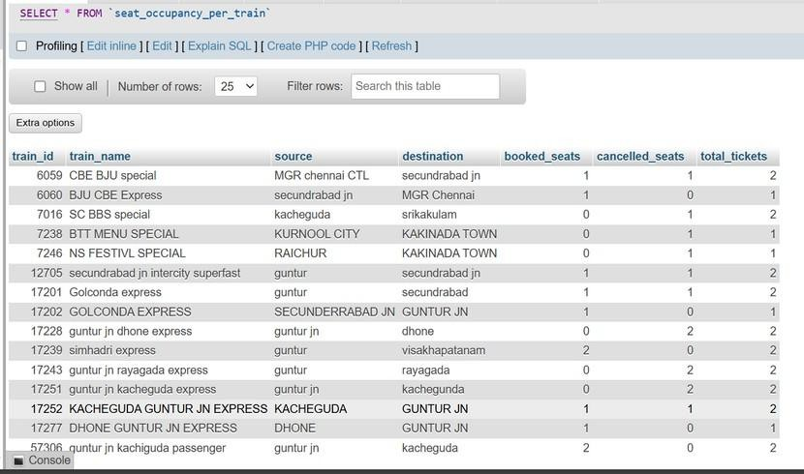

Nested Queries:
- TRAINS WITH MAXIMUM TICKETS BOOKED

This query identifies the train(s) with the highest number of currently booked tickets. It uses the RANK() window function to rank trains by ticket count and filters only those with the top rank (rank_val = 1).

  - SELECT train_id,name AS train_name, source, destination, ticket_count FROM (SELECT t.train_id,tr.name, tr.source,tr.destination COUNT(*) AS ticket_count, RANK() OVER (ORDER BY COUNT(*) DESC) AS rank_val FROM Tickets t JOIN Trains tr ON t.train_id = tr.train_id
WHERE t.status = 'Booked'
GROUP BY t.train_id, tr.name, tr.source, tr.destination
) AS ranked_trains WHERE rank_val = 1;

OUTPUT:
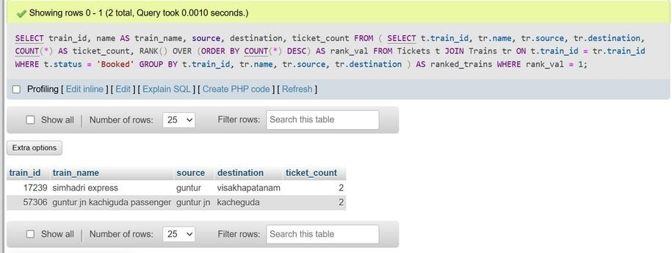

- PASSENGERS WITH MORE THAN 3 BOOKINGS
This SQL query retrieves the details of passengers who have more than 3 active (Booked) tickets.
It joins the Passengers table with a subquery that counts bookings per passenger and filters for those with a count greater than 3.

SELECT
p.passenger_id,p.name AS passenger_name,p.email,booking_count FROM Passengers p JOIN (
SELECT passenger_id, COUNT(*) AS booking_count FROM Tickets
WHERE status = 'Booked' GROUP BY passenger_id HAVING COUNT(*) > 3
) AS passenger_bookings ON p.passenger_id = passenger_bookings.passenger_id;

OUTPUT:
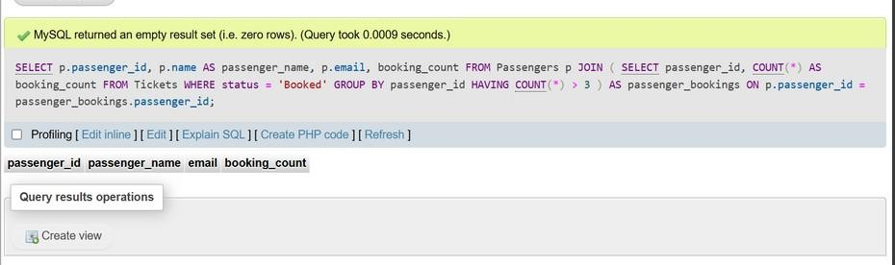
OUTPUT: NO PASSENGER WITH MORE THAN 3 BOOKING

- TICKETS CANCELLED IN THE LAST MONTH
This SQL query retrieves all tickets that were cancelled in the last 1 month, showing ticket details, passenger and train names, booking and cancellation dates, seat numbers, and refund amounts. It joins the Tickets, Passengers, Trains, and cancellation_log tables and filters based on recent cancellation time and ticket status.
  - SELECT t.ticket_id,p.name AS passenger_name,tr.name AS train_name,t.booking_date, t.seat_number,cl.cancellation_time, cl.refund_amount
FROM Tickets t
JOIN Passengers p ON t.passenger_id = p.passenger_id JOIN Trains tr ON t.train_id = tr.train_id
JOIN cancellation_log cl ON t.ticket_id = cl.ticket_id WHERE t.status = 'Cancelled' AND cl.cancellation_time >= DATE_SUB(CURRENT_DATE(), INTERVAL 1 MONTH);

OUTPUT:
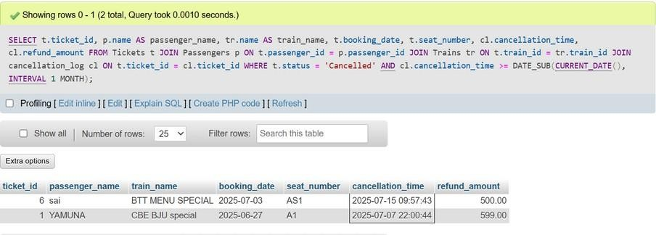

Join-Based Queries:
- TICKET DETAILS WITH PASSENGER AND TRAIN INFO

This SQL query retrieves a complete list of ticket bookings, combining ticket, passenger, and train details such as passenger name, contact, train info, seat number, and booking status. It joins the Tickets, Passengers, and Trains tables and orders the results by the most recent booking dates first.
  - SELECT t.ticket_id,p.name AS passenger_name,p.email,p.phone,
tr.name AS train_name,tr.source,tr.destination,tr.departure_time,tr.arrival_time, t.booking_date,t.seat_number,t.status
FROM Tickets t
JOIN Passengers p ON t.passenger_id = p.passenger_id JOIN Trains tr ON t.train_id = tr.train_id
ORDER BY t.booking_date DESC;
output:

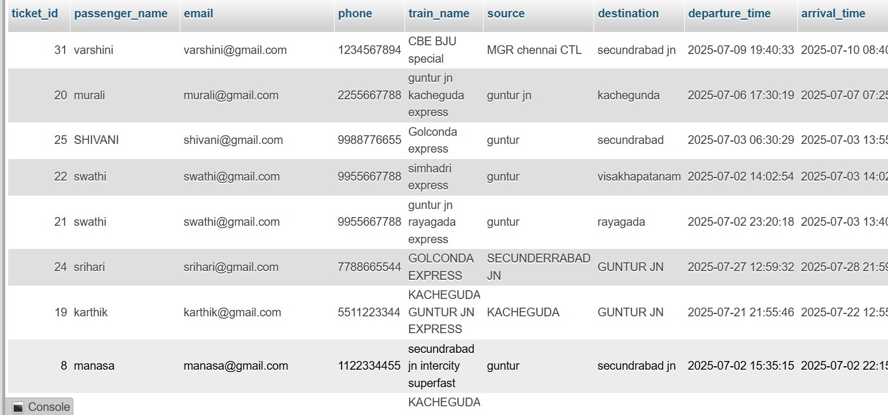
▪
▪
▪
▪
▪
▪
▪
▪
▪
▪
▪

- TRAINS DEPARTING FROM A SPECIFIC STATION

This SQL query retrieves details of all trains departing from Delhi, including their name, source, destination, and timing.
The results are ordered by the departure time, showing the earliest trains first.

  - SELECT train_id,name AS train_name,source,destination,departure_time,arrival_time FROM Trains
WHERE source = 'Delhi' -- Replace with parameter if needed ORDER BY departure_time;
output:
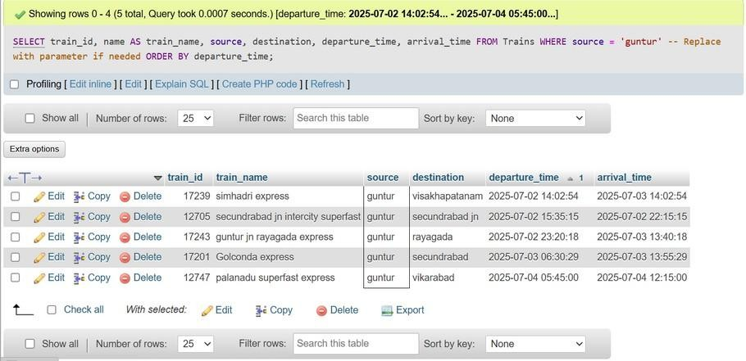

- BOOKED TICKETS FOR A SPECIFIC PASSENGER
This SQL query retrieves all booked tickets for a specific passenger (with passenger_id
= 5).
It displays ticket details along with corresponding train information, sorted by the train's departure time.
- SELECT t.ticket_id,tr.name AS train_name,tr.source,tr.destination,tr.departure_time, tr.arrival_time,t.booking_date,t.seat_number FROM Tickets t JOIN Trains tr ON t.train_id = tr.train_id WHERE t.passenger_id = 5 AND t.status = 'Booked' ORDER BY tr.departure_time;

output:
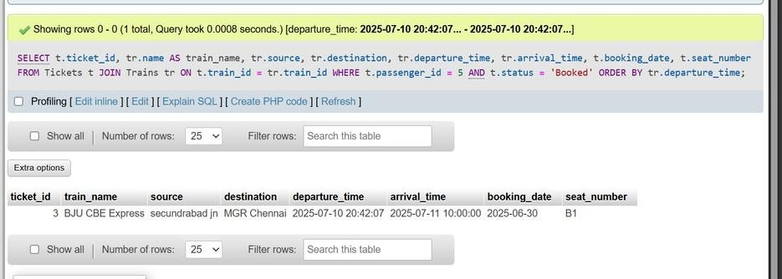

DESIGN

ER Diagram
An entity–relationship model describes inter-related things of interest in a specific domain of knowledge. An ER model is composed of entity types and specifies relationships that can exist between instances of those entity types.

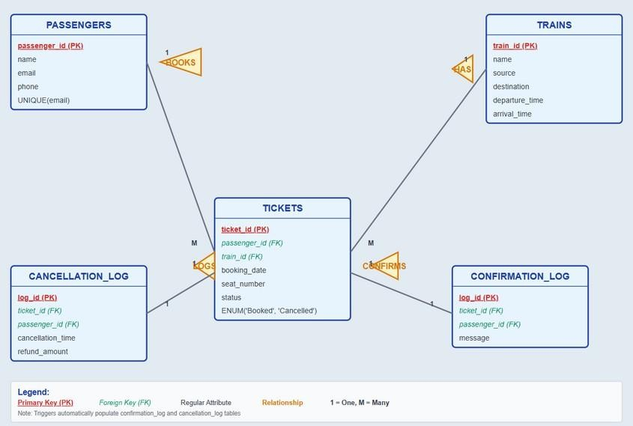

Figure . E R Diagram

This ER Diagram gives a brief idea about the relations existing between the tables and tells about the primary and the foreign keys being used in this Database.

SCHEMA DIAGRAM
A database schema can be represented in a visual diagram, which shows the database object and their relationship which represents the logical view of the database and how the relationships among them are represented.
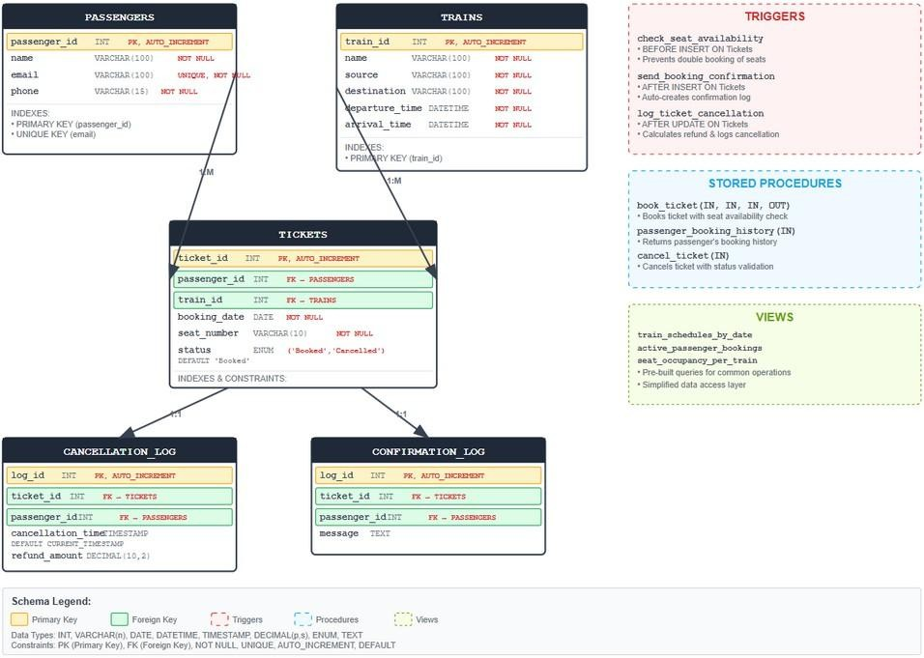
Figure :SCHEMA DIAGRAM
This Schema Diagram in Fig represents different tables used

TESTING QUERIES:
  - SELECT * FROM Trains LIMIT 5;

Output:

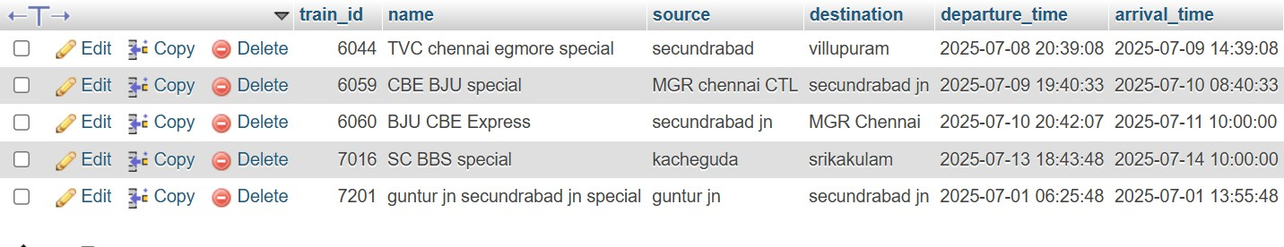

  - SELECT * FROM seat_occupancy_per_train;
Output:
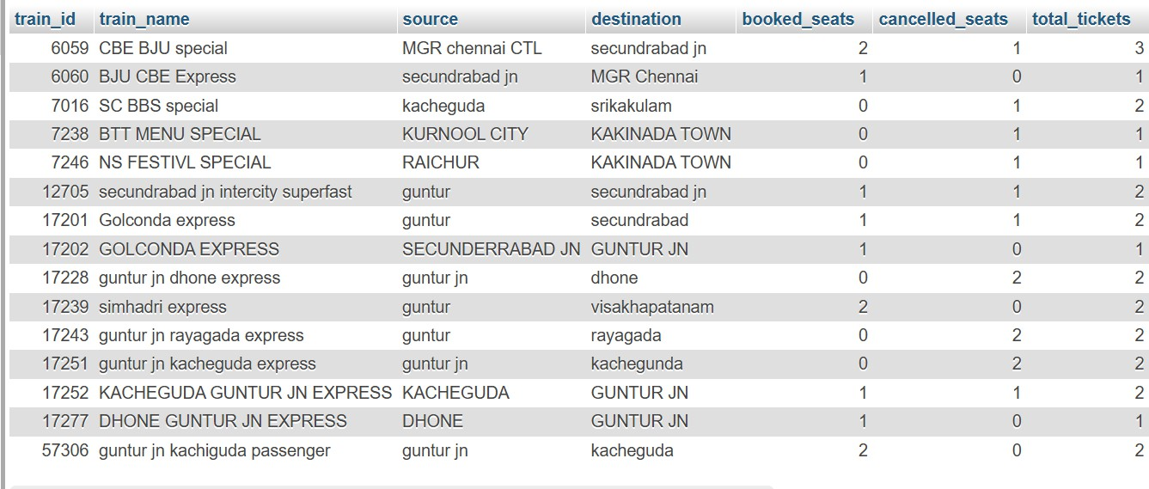

  - insert in to tickets values(null,5,6059,’2025-07-15’,’A2’,’Booked’);
Output:
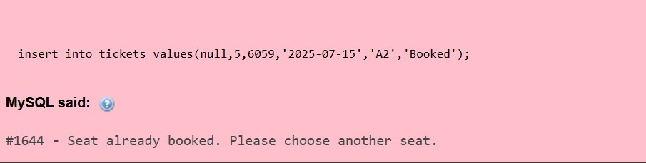

  - CALL passenger_booking_history(5);
Output:
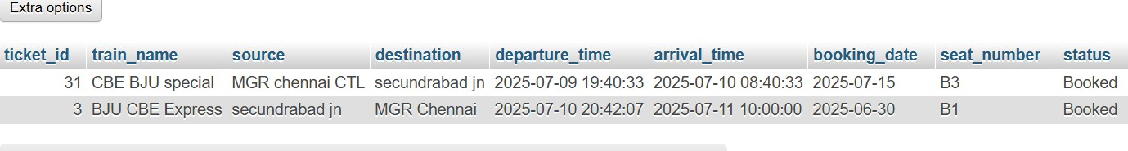

  - CALL cancel_ticket(3);
Output:

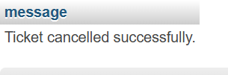

  - EXPLAIN select * from tickets where status=’booking’ and booking_date >’2025-07-01’;
Output:
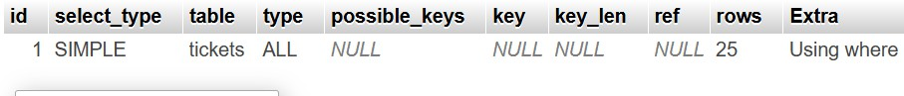

CONCLUSION
The Railway System Database project demonstrates how a structured relational database can effectively support a real-world railway reservation and management system. Key highlights of the project include:
- Efficient Data Organization: Core operations like managing train schedules, passenger information, and ticket bookings are handled using well-designed relational tables such as Trains, Passengers, and Tickets. Data is normalized to eliminate redundancy.
- Dynamic Features via SQL: The use of advanced SQL features such as triggers, views, and stored procedures makes the system automated and responsive. For example:
Triggers ensure booking constraints and log events like cancellations. Views provide summarized insights such as occupancy reports.
Stored procedures streamline tasks like booking or cancelling a ticket.
- Analytical Capability: The system includes analytical queries and reports to monitor:
    - Frequently traveled routes
    - High-volume passengers
    - Ticket booking trends and availability
- Data Integrity and Optimization: Proper use of foreign keys, constraints, and ENUMs ensures data accuracy. Indexing and optimized query design enhance performance and scalability.
- User-Centric Design: The database supports real-time tracking of bookings and cancellations. The inclusion of cancellation logs and refund policies makes the system practical and user-friendly.
- Future Ready: This backend database forms a robust foundation for future extensions, including:
    - Front-end web or mobile interfaces
    - Integration of payment gateways
    - Real-time train status and tracking
This project showcases the power of SQL in building smart, scalable, and maintainable reservation systems.

