EX 1 : Construct a java program to find the IP address of a given website using InetAddress.
import java.net.*;
class ex1
{
public static void main(String args[]) throws Exception
{
InetAddress address = InetAddress.getByName("www.google.com");
System.out.println("IP Address : "+address.getHostAddress());
}
}
OUTPUT
IP Address : 142.251.43.196

EX 2 : Create a Java program to scan open ports on a specific IP address.
import java.net.*;
class ex2 {
public static void main(String[] args) {
String ip = "127.0.0.1";
System.out.println("Scanning open ports : "+ip);
for(int port=1;port<=1024;port++) {
try {
Socket sc = new Socket(ip,port);
System.out.println("Port" +port+ " is open");
}
catch(Exception e) {
}
}
System.out.println("Scan complete");
}
}
OUTPUT
Scanning open ports : 127.0.0.1
Port135 is open
Port445 is open
Scan complete

EX 3 : Construct a Java program to get the local machine's IP address and hostname.
import java.net.*;
class ex3
{
public static void main(String args[]) throws Exception
{
InetAddress address = InetAddress.getLocalHost();
System.out.println("IP Address : "+address.getHostAddress());
System.out.println("Host Name : "+address.getHostName());
}
}
OUTPUT
IP Address : 192.168.29.23
Host Name : harsathacm

EX 4 : Constructa program to use InetAddress class and its factory methods.
import java.net.*;
class ex4
{
public static void main(String args[]) throws Exception
{
InetAddress local = InetAddress.getLocalHost();
System.out.println(" IP Address : "+local.getHostAddress());
System.out.println(" Host Name : "+local.getHostName());
InetAddress address = InetAddress.getByName("www.google.com");
System.out.println(" IP Address : "+address.getHostAddress());
System.out.println(" Host Name : "+address.getHostName());
}
}
OUTPUT
IP Address : 192.168.29.23
Host Name : harsathacm
IP Address : 142.250.192.100
Host Name : www.google.com

EX 5 : Build a Java networking program that downloads content from a URL.
import java.net.http.*;
import java.net.URI;
public class rose {
public static void main(String[] args) throws Exception {
var client = HttpClient.newHttpClient();
var request = HttpRequest.newBuilder(URI.create("https://www.example.com")).build();
var response = client.send(request, HttpResponse.BodyHandlers.ofString());
System.out.println(response.body());
}
}
OUTPUT
<!doctype html><html itemscope="" itemtype="http://schema.org/WebPage" lang="en-IN"><head><meta content="text/html; charset=UTF-8" http-equiv="Content-Type"><meta content="/images/branding/googleg/1x/googleg_standard_color_128dp.png" itemprop="image"><title>Google</title><script.nonce="k8AwSJNdFIiEMWlDhOeCLg">(function(){var_g={kEI:'x5OkaLfkIJbs1e8PnpW_kQY',kEXPI:'0,18168,184686,2,3497443,650,435,Search\x22},\x22ovr\x22:{},\x22pq\x22:\x22\x22,\x22rfs\x22:[],\x22stok\x22:\x22kP8tHsXOZ3cx8IshmWFckky_BM0\x22}}';google.pmc=JSON.parse(pmc);})();</script></body></html>

EX 6 : Build a Program to demonstrate the use of DataGramSocket and DataGram Packet.
(***RUN CLIENT PROGRAM 1ST FOLLOWED BY SERVER PROGRAM***)
SERVER PROGRAM
import java.net.*;
public class UDPReceiver {
public static void main(String[] a) throws Exception {
DatagramSocket ds = new DatagramSocket(1234);
byte[] buf = new byte[1024];
DatagramPacket dp = new DatagramPacket(buf, buf.length);
ds.receive(dp);
System.out.println("Received: " + new String(dp.getData(), 0, dp.getLength()));
ds.close();
}
}
CLIENT PROGRAM
import java.net.*;
public class UDPSender {
public static void main(String[] a) throws Exception {
DatagramSocket ds = new DatagramSocket();
byte[] b = "Hello World".getBytes();
DatagramPacket dp = new DatagramPacket(b, b.length, InetAddress.getByName("localhost"), 1234);
ds.send(dp);
ds.close();
}
}
OUTPUT:
Received : Hello World

EX 7 : Construct a simple chat application using two-way TCP/IP protocols.
(***RUN CLIENT PROGRAM 1ST FOLLOWED BY SERVER PROGRAM***)
SERVER PROGRAM
import java.io.;
import java.net.;
public class ChatServer
{
public static void main(String[] a) throws Exception
{
Socket s = new ServerSocket(1234).accept();
BufferedReader in=new BufferedReader(new InputStreamReader(s.getInputStream()));
PrintWriter out=new PrintWriter(s.getOutputStream(),true);
BufferedReader kb=new BufferedReader(new InputStreamReader(System.in));
while(true){
System.out.println("Client: "+in.readLine());
System.out.println(kb.readLine());
}
}
}
CLIENT PROGRAM
import java.io.;
import java.net.;
public class ChatClient
{
public static void main(String[] a) throws Exception
{
Socket s=new Socket("localhost",1234);
BufferedReader in=new BufferedReader(new InputStreamReader(s.getInputStream()));
PrintWriter out=new PrintWriter(s.getOutputStream(),true);
BufferedReader kb=new BufferedReader(new InputStreamReader(System.in));
while(true){
System.out.println(kb.readLine());
System.out.println("Server: "+in.readLine());
}
}
}
OUTPUT (CLIENT):
Hi
Server: Hello
OUTPUT (SERVER):
Client: Hi
Hello

EX 8 : Construct a TCP File Transfer program using networking.
(***RUN CLIENT PROGRAM 1ST FOLLOWED BY SERVER PROGRAM***)
CLIENT PROGRAM
import java.net.;
import java.io.;
public class ftp1
{
public static void main(String args[]) throws Exception ServerSocket ss =new ServerSocket (5001);
{
System. out printin ("waiting");
Socket s =ss.accept();
System. out println("connected");
FileInputstream fis = new FileInputstream("Sendfile.txt");
OutputStream os = S.getOutputStream();
byte[] b = new byte[1024];
int r;
while((r=fis. read(b))>0)os write(b,0,r);
System. out. println("sent"); tis. close();
S. Close();
ss. Close;
}
}
SERVER PROGRAM
import java.net.;
import java.io.;
public class ftp2
{
public static void main(String args[]) throws Exception
{
Socket s =new Socket ("127.0.0.1", 5001);
System. out. println("connected");
Inputstream is =s. getInputstream;
FileOutputstream fos = new FileOutputstream("received.txt");
byte[] b = new byte[1024];
int r;
while (r=is.read (b))>0)fos.write(b, 0,r);
System. out. printin("received"); fos. close();
s. close();
}
}
OUTPUT (CLIENT):
Connected
received
OUTPUT (SERVER):
Waiting
Connected
sent

EX 9: Construct a UDP Echo Server program using networking
Server Program
import java.net.*;
public class UDPEchoServer {
public static void main(String[] args) throws Exception {
DatagramSocket socket = new DatagramSocket(9876);
byte[] buffer = new byte[1024];
System.out.println("Server running...");
while (true) {
DatagramPacket packet = new DatagramPacket(buffer, buffer.length);
socket.receive(packet);
socket.send(packet);
}
}
}
Client Program
import java.net.*;
import java.util.Scanner;
public class UDPEchoClient {
public static void main(String[] args) throws Exception {
DatagramSocket socket = new DatagramSocket();
Scanner sc = new Scanner(System.in);
System.out.print("Enter message: ");
String msg = sc.nextLine();
byte[] data = msg.getBytes();
InetAddress ip = InetAddress.getByName("localhost");
DatagramPacket packet = new DatagramPacket(data, data.length, ip, 9876);
socket.send(packet);
byte[] buffer = new byte[1024];
DatagramPacket reply = new DatagramPacket(buffer, buffer.length);
socket.receive(reply);
System.out.println("Server echoed: " +
new String(reply.getData(), 0, reply.getLength()));
socket.close();
sc.close();
}
}

EX 10 : Create a Java Swing program to create a basic JFrame with a button and label.
import javax.swing.*;
class ex10
{
public static void main (String[] args)
{
JFrame frame = new JFrame ("Swing Demo");
JLabel label = new JLabel("Hello");
JButton button= new JButton("Click Me");
button.setBounds (100,100,100,30);
label.setBounds(100,50,150,30) ;
button.addActionListener(e ->label.setText("Button Clicked!"));
frame.add(button);
frame.add(label);
frame.setSize(300,200);
frame.setLayout(null);
frame.setVisible(true);
frame.setDefaultCloseOperation(JFrame.EXIT_ON_CLOSE);
}
}
OUTPUT
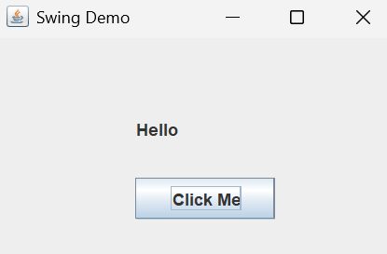
EX 11 : Create a form using labels, textboxes and button controls in a Swing application.
import javax.swing.*;
public class ex11 {
public static void main(String[] args)
{
JFrame frame = new JFrame("Form Example");
JLabel label = new JLabel("Enter Name:");
JTextField text = new JTextField(15);
JButton button = new JButton("Submit");
button.addActionListener(e ->label.setText("Name Saved!"));
JPanel panel = new JPanel();
button.setBounds (100,100,100,30);
label.setBounds(100,50,150,30) ;
panel.add(label);
panel.add(text);
panel.add(button);
frame.add(panel);
frame.setSize(300, 150);
frame.setDefaultCloseOperation(JFrame.EXIT_ON_CLOSE);
frame.setVisible(true);
frame.setLayout(null);
}
}
OUTPUT:
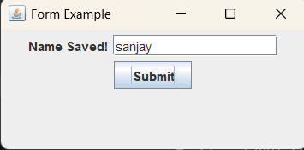

Ex 12 : Create a Swing application using JMenu and JMenuItem.
import javax.swing.*;
import java.awt.event.*;
public class SimpleMenu {
public static void main(String[] args) {
JFrame f = new JFrame("Menu Example");
JMenuBar mb = new JMenuBar();
JMenu menu = new JMenu("File");
JMenuItem i1 = new JMenuItem("Open");
JMenuItem i2 = new JMenuItem("Exit");
i2.addActionListener(e -> System.exit(0));
menu.add(i1);
menu.add(i2);
mb.add(menu);
f.setJMenuBar(mb);
f.setSize(300, 200);
f.setDefaultCloseOperation(JFrame.EXIT_ON_CLOSE);
f.setVisible(true);
}
}
Output :
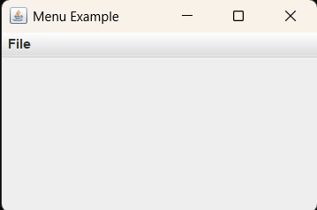
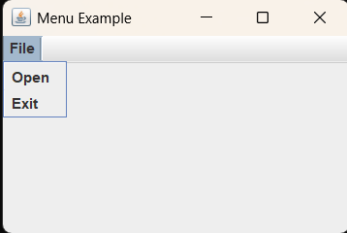
Ex 13 : Construct a Program to create a JTree.
import javax.swing.*;
public class SimpleTree {
public static void main(String[] args) {
JFrame f = new JFrame("JTree Example");
JTree tree = new JTree();
f.add(tree);
f.setSize(300, 200);
f.setDefaultCloseOperation(JFrame.EXIT_ON_CLOSE);
f.setVisible(true);
}
}
Output :
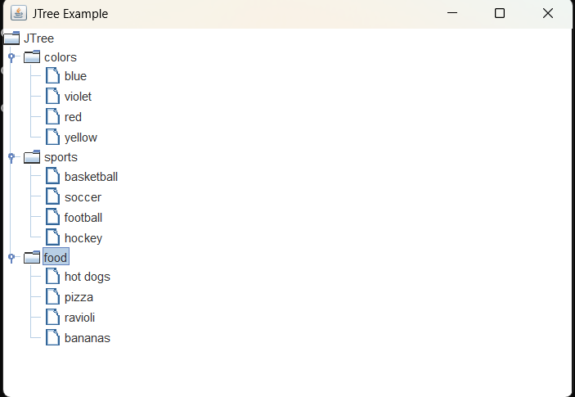
Ex 14: Build a program to create a JTable using Swings.
import javax.swing.*;
public class SimpleTable {
public static void main(String[] args) {
JFrame f = new JFrame("JTable Example");
String[][] data = {
{"1", "Alice", "23"},
{"2", "Bob", "27"},
{"3", "Charlie", "22"}
};
String[] column = {"ID", "Name", "Age"};
JTable table = new JTable(data, column);
f.add(new JScrollPane(table));
f.setSize(300, 200);
f.setDefaultCloseOperation(JFrame.EXIT_ON_CLOSE);
f.setVisible(true);
}
}
Output :
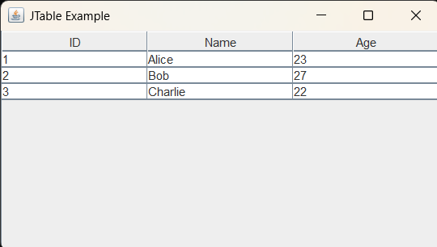

Ex 15: Build a JFileChooser Program using Swings.
import javax.swing.*;
import java.awt.event.*;
public class SimpleFileChooser {
public static void main(String[] args) {
JFrame f = new JFrame("JFileChooser Example");
JButton b = new JButton("Open File");
b.addActionListener(new ActionListener() {
public void actionPerformed(ActionEvent e) {
JFileChooser fc = new JFileChooser();
int i = fc.showOpenDialog(f);
if (i == JFileChooser.APPROVE_OPTION) {
JOptionPane.showMessageDialog(f, "Selected: " + fc.getSelectedFile().getPath());
}
}
});
f.add(b);
f.setSize(300, 150);
f.setLayout(null);
b.setBounds(90, 40, 120, 30);
f.setDefaultCloseOperation(JFrame.EXIT_ON_CLOSE);
f.setVisible(true);
}
}
Output :
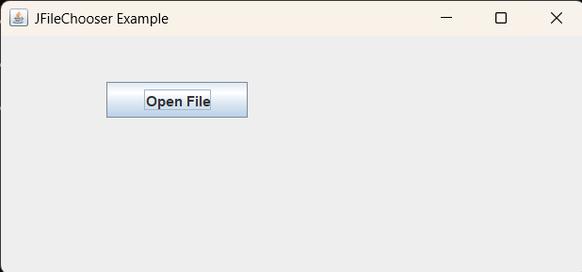

Ex 16 : Construct a Notepad Clone using Swings.
import javax.swing.*;
import java.awt.event.*;
import java.io.*;
public class SimpleNotepad extends JFrame implements ActionListener {
JTextArea area;
JMenuItem open, save, exit;
SimpleNotepad() {
area = new JTextArea();
add(new JScrollPane(area));
JMenuBar mb = new JMenuBar();
JMenu file = new JMenu("File");
open = new JMenuItem("Open");
save = new JMenuItem("Save");
exit = new JMenuItem("Exit");
file.add(open); file.add(save); file.add(exit);
mb.add(file);
setJMenuBar(mb);
open.addActionListener(this);
save.addActionListener(this);
exit.addActionListener(this);
setTitle("Simple Notepad");
setSize(500, 400);
setDefaultCloseOperation(EXIT_ON_CLOSE);
setVisible(true);
}
public void actionPerformed(ActionEvent e) {
try {
if (e.getSource() == open) {
JFileChooser fc = new JFileChooser();
if (fc.showOpenDialog(this) == JFileChooser.APPROVE_OPTION) {
BufferedReader br = new BufferedReader(new FileReader(fc.getSelectedFile()));
area.read(br, null);
br.close();
}
} else if (e.getSource() == save) {
JFileChooser fc = new JFileChooser();
if (fc.showSaveDialog(this) == JFileChooser.APPROVE_OPTION) {
BufferedWriter bw = new BufferedWriter(new FileWriter(fc.getSelectedFile()));
area.write(bw);
bw.close();
}
} else if (e.getSource() == exit) {
System.exit(0);
}
} catch (Exception ex) {
JOptionPane.showMessageDialog(this, ex.getMessage());
}
}
public static void main(String[] args) {
new SimpleNotepad();
}
}
Output:
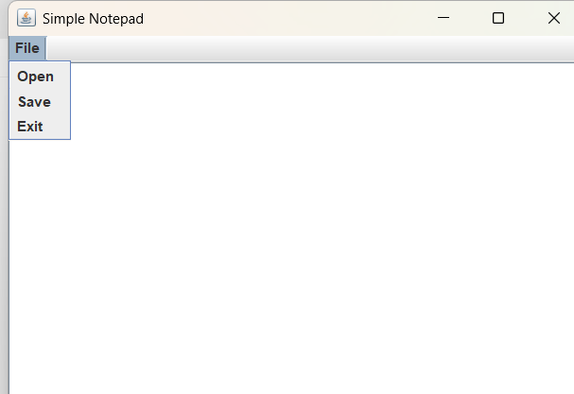

Ex 17: Create a JDBC application using JDBC driver.
import java.sql.*;
public class App {
public static void main(String[] args) {
try{
Class.forName("com.mysql.jdbc.Driver");
Connection con=DriverManager.getConnection("jdbc:mysql://localhost:3306/DB1","root","Mysql@123");
Statement stmt=con.createStatement();
ResultSet rs=stmt.executeQuery("SELECT * FROM STUDENT");
while(rs.next()){
System.out.println(rs.getInt("id") + " | " + rs.getString("name"));
}
}
catch(Exception e){
System.out.println(e.toString());
}
}
}
MySQL Code :
Open = MySQL -u root -p
CREATE DATABASE IF NOT EXISTS testdb;
USE testdb;
CREATE TABLE IF NOT EXISTS users ( id INT, name VARCHAR(50), age INT );
INSERT INTO users (name, age) VALUES('Alice', 23),('Bob', 27),('Charlie', 22);
Run : javac -cp .:source\mysql-connector-j-9.4.0.jar.jdbc2.java
java -cp .:source\mysql-connector-j-9.4.0.jar.jdbc2
Output :
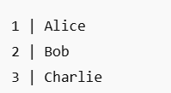

Ex 18 : Create a program to insert and retrieve the data from database using JDBC.
import java.sql.*;
public class app1 {
public static void main(String args[]){
try {
Class.forName("com.mysql.jdbc.Driver");
Connection con=DriverManager.getConnection("jdbc:mysql://localhost:3306/DB1","root","Mysql@123");
Statement stmt=con.createStatement();
System.out.println("Inserting record");
String sql="INSERT INTO STUDENT(ID,NAME,AGE) VALUE(6,'JACK',20)";
stmt.executeUpdate(sql);
} catch (Exception e) {
System.out.println(e);
}
}
}
Same MySQL code here
[run] SELECT * FROM table_name;

Ex 19: Build a program to update and delete a record from a database table.
import java.sql.*;
public class app2 {
public static void main(String[] args) {
try {
Class.forName("com.mysql.jdbc.Driver");
Connection con = DriverManager.getConnection("jdbc:mysql://localhost:3306/DB1", "root", "Mysql@123");
Statement stmt = con.createStatement();
// Update record
String updateQuery = "UPDATE STUDENT SET name='David',age=20 WHERE id=2";
int updated = stmt.executeUpdate(updateQuery);
System.out.println("Rows updated: " + updated);
// Delete record
String deleteQuery = "DELETE FROM STUDENT WHERE id=3";
int deleted = stmt.executeUpdate(deleteQuery);
System.out.println("Rows deleted: " + deleted);
} catch (Exception e) {
System.out.println(e);
}
}
}

MySQL Code : [run]
SELECT * FROM table_name;

Ex 20: Build a web application using JSP custom tags.
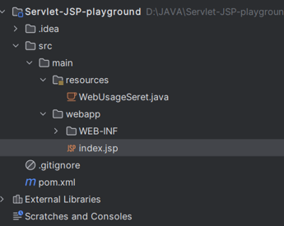
index.jsp
<%@ page contentType="text/html; charset=UTF-8" %>
<html>
<head>
<title>Login</title>
</head>
<body style="font-family:Arial; background:#f2f2f2; text-align:center; padding-top:100px;">
<h2>Login Page</h2>
<form action="loginProcess.jsp" method="post">
<div style="display:inline-block; background:#fff; padding:20px; border:1px solid #ccc;">
<p><input type="text" name="username" placeholder="Username" required></p>
<p><input type="password" name="password" placeholder="Password" required></p>
<p><input type="submit" value="Login"></p>
</div>
</form>
</body>
</html>
loginProcess.jsp
<%@ page contentType="text/html; charset=UTF-8" %>
<html>
<head>
<title>Login</title>
</head>
<body style="font-family:Arial; background:#f2f2f2; text-align:center; padding-top:100px;">
<h2>Login Page</h2>
<form action="loginProcess.jsp" method="post">
<div style="display:inline-block; background:#fff; padding:20px; border:1px solid #ccc;">
<p><input type="text" name="username" placeholder="Username" required></p>
<p><input type="password" name="password" placeholder="Password" required></p>
<p><input type="submit" value="Login"></p>
</div>
</form>
</body>
</html>

Ex 21: Create a Spring application.
Pom.xml
<project xmlns="http://maven.apache.org/POM/4.0.0"
xmlns:xsi="http://www.w3.org/2001/XMLSchema-instance"
xsi:schemaLocation="http://maven.apache.org/POM/4.0.0
http://maven.apache.org/xsd/maven-4.0.0.xsd">
<modelVersion>4.0.0</modelVersion>
<groupId>com.example</groupId>
<artifactId>SimpleSpringApp</artifactId>
<version>1.0</version>
<parent>
<groupId>org.springframework.boot</groupId>
<artifactId>spring-boot-starter-parent</artifactId>
<version>3.3.2</version>
</parent>
Create Main Class: DemoController.java
package com.example.demo;
import org.springframework.web.bind.annotation.RequestMapping;
import org.springframework.web.bind.annotation.RestController;
@RestController
public class DemoController {
@RequestMapping("/hello")
public String hello(){
return "Hello World!";
}
}
Run the Application : Open Terminal of VS Code
Run: mvn spring-boot:run
Open browser: http://localhost:8080/hello

