“CONTAINER IMAGE THREAT SCANNER
WITH LAYER AWARE FORENSICS”
A dissertation submitted in partial fulfillment of the requirements for the award of the award of degree
of

BACHELOR OF COMPUTER APPLICATIONS
of

University of Mysore


By

Harshitha Shree D U01CO23S0201
Spandana R S U01CO23S0202
Yogesh S U01CO23S0203
Pavan N U01CO23S0204

Under the Guidance of: BCA
Guide name: ANNAPOORNA M S
Assistant Professor, Dept of BCA
BGS FGC, Mysuru


DEPARTMENT OF BACHELOR OF COMPUTER APPLICATIONS
BGS FIRST GRADE COLLEGE
MYSURU-23

2025-26

BGS FIRST GRADE COLLEGE.

MYSURU-23

DEPARTMENT OF BACHELOR OF COMPUTER

APPLICATIONS

CERTIFICATE
This is to Certify that SPANDANA R S bearing U01CO23S0202 has completed his/her final semester project work entitled
“CONTAINER IMAGE THREAT SCANNER WITH LAYER-AWARE FORENSICS” as a partial fulfillment for the award of Bachelor of Computer Applications of University of Mysore during the year 2025-2026. It is certified that all corrections/suggestions indicated for internal assessment have been incorporated in the report. The project report has been approved as it satisfies the academic requirement in respect of project work prescribed for the said degree.

Internal Guide:

Guide Name: ANNAPOORNA M S
Asst. Professor, Dept of BCA,
BGS FGC, Mysuru.
Mrs. Shwetha Rani R S |  | Dr. R S Narasegowda
Assistant Professor & HOD |  | Principal,
Dept of BCA, BGS FGC, Mysuru |  | BGS FGC, Mysuru.

Examiner's Name & Signature
1. 2.

BGS FIRST GRADE COLLEGE.

MYSURU-23

DEPARTMENT OF BACHELOR OF COMPUTER

APPLICATIONS

CERTIFICATE
This is to Certify that SPANDANA R S bearing U01CO23S0202 has completed his/her final semester project work entitled
“CONTAINER IMAGE THREAT SCANNER WITH LAYER-AWARE FORENSICS” as a partial fulfillment for the award of Bachelor of Computer Applications of University of Mysore during the year 2025-2026. It is certified that all corrections/suggestions indicated for internal assessment have been incorporated in the report. The project report has been approved as it satisfies the academic requirement in respect of project work prescribed for the said degree.

Internal Guide:

Guide Name: ANNAPOORNA M S
Asst. Professor, Dept of BCA,
BGS FGC, Mysuru.
Mrs. Shwetha Rani R S |  | Dr. R S Narasegowda
Assistant Professor & HOD |  | Principal,
Dept of BCA, BGS FGC, Mysuru |  | BGS FGC, Mysuru.

Examiner's Name & Signature
1. 2.

BGS FIRST GRADE COLLEGE.

MYSURU-23

DEPARTMENT OF BACHELOR OF COMPUTER

APPLICATIONS

CERTIFICATE
This is to Certify that SPANDANA R S bearing U01CO23S0202 has completed his/her final semester project work entitled
“CONTAINER IMAGE THREAT SCANNER WITH LAYER-AWARE FORENSICS” as a partial fulfillment for the award of Bachelor of Computer Applications of University of Mysore during the year 2025-2026. It is certified that all corrections/suggestions indicated for internal assessment have been incorporated in the report. The project report has been approved as it satisfies the academic requirement in respect of project work prescribed for the said degree.

Internal Guide:

Guide Name: ANNAPOORNA M S
Asst. Professor, Dept of BCA,
BGS FGC, Mysuru.
Mrs. Shwetha Rani R S |  | Dr. R S Narasegowda
Assistant Professor & HOD |  | Principal,
Dept of BCA, BGS FGC, Mysuru |  | BGS FGC, Mysuru.

Examiner's Name & Signature
1. 2.

BGS FIRST GRADE COLLEGE.

MYSURU-23

DEPARTMENT OF BACHELOR OF COMPUTER

APPLICATIONS

CERTIFICATE
This is to Certify that SPANDANA R S bearing U01CO23S0202 has completed his/her final semester project work entitled
“CONTAINER IMAGE THREAT SCANNER WITH LAYER-AWARE FORENSICS” as a partial fulfillment for the award of Bachelor of Computer Applications of University of Mysore during the year 2025-2026. It is certified that all corrections/suggestions indicated for internal assessment have been incorporated in the report. The project report has been approved as it satisfies the academic requirement in respect of project work prescribed for the said degree.

Internal Guide:

Guide Name: ANNAPOORNA M S
Asst. Professor, Dept of BCA,
BGS FGC, Mysuru.
Mrs. Shwetha Rani R S |  | Dr. R S Narasegowda
Assistant Professor & HOD |  | Principal,
Dept of BCA, BGS FGC, Mysuru |  | BGS FGC, Mysuru.

Examiner's Name & Signature
1. 2.

DECLARATION

We, student of final semester BCA of BGS First Grade College, Mysuru, hereby declare that the dissertation entitled “CONTAINER IMAGE THREAT SCANNER WITH LAYER-AWARE FORENSICS” has been independently carried at “BGS First Grade College”, Mysuru and submitted in partial fulfillment of the requirement for the award of Bachelor of Computer Applications affiliated to the University of Mysore, during the academic year 2025 – 2026. Further the matter embodied in the report is an original and bonafide work done by us.

To our knowledge this dissertation has not been submitted to any other college or university or published at any time prior to this.

Place: Mysuru | Yogesh S | - U01CO23SO386
Date: | Harshitha Shree D | - U01CO23S0201
 | Spandana R S  Pavan N | - U01CO23S0202  - U01CO23S0204

ACKNOWLEDGEMENT

The successful completion of this project would not have been possible without the support and guidance of several individuals to whom we express our heartfelt gratitude.

First and foremost, we are deeply grateful to our project guide, Miss Sowmya K N, Assistant Professor, Department of BCA, for her valuable guidance, constant encouragement, and constructive suggestions throughout the development of this project. Her expertise in cybersecurity and machine learning was instrumental in shaping the direction of our work.

We extend our sincere thanks to the Principal and the Head of the Department of BCA, Government First Grade College, Mysuru, for providing us with the necessary infrastructure, computational resources, and a conducive environment to carry out this project.

We are also thankful to all the faculty members of the Department of BCA for their continuous encouragement and academic support throughout our course of study.

We express our gratitude to the University of Mysore for providing the academic framework and guidelines that enabled us to work on this meaningful project.

We are thankful to our family members and friends for their unwavering moral support and encouragement throughout this journey.

Finally, we would like to acknowledge all the researchers and authors whose published works and papers have been referenced and utilized in the preparation of this project report.

YOGESH S | PAVAN N | HARSHITHA SHREE D | SPANDANA R S

ABSTRACT

Academic institutions consistently face significant challenges when constructing class schedules that efficiently allocate resources such as classrooms, faculty, subjects, and time slots — all under multiple complex constraints. Traditional timetable scheduling methods, whether manual or rule-based, are error-prone, time-consuming, and inflexible in the face of dynamic changes. The Smart Classroom Timetable Scheduler Using Machine Learning addresses these problems through a fully automated, intelligent scheduling system.
The proposed system is a three-tier web application built on Python (Flask) at the backend, an HTML/CSS/JavaScript single-page application at the frontend, and SQLite as the database. The core innovation lies in a four-algorithm hybrid Machine Learning pipeline that combines: (1) a Constraint Satisfaction Problem (CSP) solver to generate feasible, conflict-free timetable candidates; (2) a Genetic Algorithm (GA) to iteratively optimize the schedule for quality metrics such as faculty workload balance, gap minimization, and preference satisfaction; (3) a Decision Tree model to learn scheduling patterns from historical data; and (4) K-Means Clustering to analyze classroom utilization and guide room allocation.
The system exposes a three-tier role hierarchy — Admin, Faculty, and Student — each with a purpose-built portal. The Admin module provides complete CRUD management for all institutional entities and triggers the ML pipeline with configurable parameters. The Faculty module enables availability submission and swap request management. The Student module provides a read-only timetable view with change notifications.
Experimental evaluation demonstrated zero hard-constraint violations (no faculty or room double-bookings), measurable improvement in fitness scores over GA generations, and timetable generation in under 15 seconds for a dataset comprising 3 departments, 12 subjects, 10 faculty members, and 8 classrooms across 5 working days. The modular architecture ensures scalability and allows individual ML components to be upgraded independently.

Keywords: Timetable Scheduling, Constraint Satisfaction Problem (CSP), Genetic Algorithm, Decision Tree, K-Means Clustering, Flask, SQLite, REST API, Machine Learning, Role-Based Access Control.

Contents
BACHELOR OF COMPUTER APPLICATIONS 1
University of Mysore 1
Under the Guidance of: BCA 1
Internal Guide: 2
Internal Guide: 3
Internal Guide: 5
Internal Guide: 6
ACKNOWLEDGEMENT 8
ABSTRACT 9
LIST OF TABLES 13
LIST OF FIGURES 13
CHAPTER 1: INTRODUCTION 15
1.1 Introduction to Domain 15
1.2 Introduction to the Project 15
1.3 Problem Statement 16
1.4 Motivation 16
1.5 Objectives 16
1.6 Scope of the Project 17
CHAPTER 2: LITERATURE SURVEY 18
2.1 Overview 18
2.2 Review of Related Works 18
2.2.1 Timetabling as a Graph Coloring Problem — Wren (1996) 18
2.2.2 Constraint Satisfaction for Timetabling — Schaerf (1999) 18
2.2.3 Genetic Algorithms for Scheduling — Colorni et al. (1992) 18
2.2.4 Genetic Algorithms: Theory — Holland (1975), Goldberg (1989) 18
2.2.5 Decision Trees — Quinlan (1986, 1993) 19
2.2.6 K-Means Clustering — MacQueen (1967) 19
2.2.7 Scikit-learn: Machine Learning in Python — Pedregosa et al. (2011) 19
2.2.8 Flask Web Framework — Grinberg (2018) 19
2.2.9 ITC-2019 Timetabling Benchmark 19
2.3 Summary of Literature 20
CHAPTER 3: SYSTEM ANALYSIS 21
3.1 Existing System 21
3.2 Disadvantages of Existing System 21
3.3 Proposed System 21
3.4 Advantages of Proposed System 22
3.5 Feasibility Study 22
3.5.1 Technical Feasibility 22
3.5.2 Economic Feasibility 23
3.5.3 Operational Feasibility 23
3.6 System Requirements 23
CHAPTER 4: SYSTEM DESIGN 25
4.1 High-Level System Architecture 25
4.2 Data Flow Pipeline 25
4.3 Use Case Diagrams 26
4.4 Entity-Relationship (ER) Diagram 27
4.5 Module Descriptions 27
4.6 Technology Stack 28
4.7 Database Design 29
Key SQL Snippets 30
CHAPTER 5: IMPLEMENTATION 32
5.1 ML Pipeline — pipeline.py 32
5.2 CSP Solver — csp_solver.py 32
5.3 Genetic Algorithm — genetic_algorithm.py 34
5.4 Decision Tree — decision_tree.py 35
5.5 K-Means Clustering — clustering.py 36
5.6 Flask REST API — app.py 37
5.7 Frontend — HTML / CSS / JavaScript 39
CHAPTER 6: RESULTS AND OUTPUT ANALYSIS 41
6.1 Dataset and Test Configuration 41
6.2 Generated Timetable Output 41
6.3 ML Pipeline Execution Output 42
6.4 GA Fitness Score Progression 43
6.5 Room Utilisation Analysis 44
6.6 Faculty Workload Analysis 44
6.7 Performance Summary 45
CHAPTER 7: TESTING 46
7.1 Testing Overview 46
7.2 Unit Testing 46
7.3 Integration Testing 47
7.4 System Testing 48
CHAPTER 8: CONCLUSION AND FUTURE WORK 49
8.1 Conclusion 49
8.2 Future Enhancements 49
REFERENCES 51
APPENDIX 52
A.1 Project Folder Structure 52
A.2 How to Run the Project 52
A.3 Key Configuration Constants 53
A.4 Sample API Request & Response (Generate Timetable) 54

LIST OF TABLES

Table 3.1 Hardware Requirements …18
Table 3.2 Software Requirements …19
Table 4.1 Database Table Descriptions …28
Table 4.2 API Endpoints …38
Table 5.1 CSP Hard Constraints …32
Table 5.2 GA Parameters & Configuration …34
Table 5.3 Decision Tree Feature Set …35
Table 6.1 Sample Dataset Statistics …43
Table 6.2 GA Fitness Score Progression …46
Table 6.3 Room Utilisation Results …47
Table 6.4 Faculty Workload Results …48
Table 7.1 Unit Test Cases …51
Table 7.2 Integration Test Cases …52
Table 7.3 System Test Cases …53

LIST OF FIGURES

Figure 4.1 High-Level System Architecture Diagram …20
Figure 4.2 ML Pipeline Data Flow …21
Figure 4.3 Use Case Diagram – Admin …22
Figure 4.4 Use Case Diagram – Faculty …23
Figure 4.5 Use Case Diagram – Student …23
Figure 4.6 Entity-Relationship (ER) Diagram …24
Figure 5.1 CSP Constraint Check Flowchart …32
Figure 5.2 Genetic Algorithm Flowchart …33
Figure 5.3 Login Page Screenshot …41
Figure 5.4 Admin Dashboard Screenshot …41
Figure 5.5 Timetable Generation Wizard Screenshot …42
Figure 5.6 Faculty Portal Screenshot …42
Figure 5.7 Student Timetable View Screenshot …42
Figure 6.1 Generated Timetable Grid – Sem 3 CSE (Sample) …44
Figure 6.2 GA Fitness Score vs. Generation Chart …46
Figure 6.3 Room Utilisation Bar Chart …47
Figure 6.4 Faculty Workload Chart …48
Figure 6.5 ML Pipeline Execution Steps (Console Output) …49

CHAPTER 1: INTRODUCTION

1.1 Introduction to Domain
Educational institutions — ranging from small colleges to large universities — rely on efficient scheduling to ensure optimal use of limited resources: classrooms, faculty, and time. Timetable scheduling is a classic combinatorial optimization problem that has been studied extensively in computer science, operations research, and artificial intelligence. Even for a mid-sized institution with 20 classrooms, 30 faculty, and 8 semesters, the number of possible schedule permutations can exceed 10⁵⁰ — making exhaustive search completely infeasible.
Traditional approaches to timetable scheduling fall into two broad categories. Manual scheduling, still widely practiced, requires experienced administrative staff to spend 5–10 working days per term constructing schedules by hand using spreadsheets or physical boards. This process is error-prone (hard-constraint violations are routinely discovered after distribution) and brittle (a single faculty absence or classroom booking conflict requires cascading manual updates). Rule-based software systems partially automate the process but require manually authored constraint rules that cannot adapt to changing institutional needs and produce high false-positive conflict rates.
The advent of Machine Learning has opened a new paradigm for scheduling problems. Rather than encoding explicit rules, ML-based schedulers learn optimal scheduling patterns from historical data, apply bio-inspired optimization algorithms to navigate vast search spaces efficiently, and use constraint satisfaction techniques to guarantee that generated schedules are free from hard-constraint violations. This approach is inherently adaptive: as an institution's data grows, the system continuously improves.
The intersection of Constraint Satisfaction Problems (CSP), Evolutionary Computation (Genetic Algorithms), supervised pattern learning (Decision Trees), and unsupervised resource analysis (K-Means Clustering) represents the current state of the art in automated timetable generation. This project implements all four techniques in an integrated pipeline, producing a practical, deployable scheduling system.

1.2 Introduction to the Project
The Smart Classroom Timetable Scheduler Using Machine Learning is a fully functional web application that automates the complete timetable generation workflow for academic institutions. The system is built as a three-tier architecture: a Python Flask REST API backend, an HTML/CSS/JavaScript frontend served directly by Flask, and an SQLite database. A dedicated ML sub-package within the backend implements the four-stage algorithmic pipeline.
The system supports three distinct user roles, each with a tailored portal. The Admin role has full access to all management functions and triggers the ML pipeline. The Faculty role can view schedules, submit availability, and request slot swaps. The Student role views the published timetable and receives notifications about updates. Authentication is session-based with role-based access control enforced on every API endpoint and page route.
The project folder structure follows a clean separation of concerns. The backend/ directory contains app.py (the Flask application), a requirements.txt, and the ML/ sub-package. The database/ directory contains the schema.sql, seed_data.sql, and the generated scheduler.db SQLite database. The frontend is served from backend/templates/ (HTML) and backend/static/ (CSS, JS, images).

1.3 Problem Statement
The core problem is the absence of an automated, scalable, and adaptive system that can generate academic timetables satisfying all hard constraints (no room double-booking, no faculty clashes, room capacity matching) while simultaneously optimizing for soft quality criteria (faculty preference satisfaction, workload balance, minimal student schedule gaps). Existing approaches suffer from: high manual effort, inability to adapt to changing constraints, lack of optimization, and complete absence of learning from historical scheduling patterns.

1.4 Motivation
- Administrative staff spend 5–10 days per term on manual timetable construction — a process that still produces conflicts.
- Faculty satisfaction is directly impacted by schedule quality: back-to-back lectures, ignored preferences, and unbalanced workloads reduce morale.
- Classroom under-utilization wastes infrastructure investment; over-utilization causes learning quality degradation.
- Dynamic changes (faculty illness, room unavailability) require rapid, automated rescheduling capabilities.
- Machine learning techniques — particularly CSP, GAs, and Decision Trees — have been proven effective for combinatorial optimization in adjacent domains.
1.5 Objectives
- To automate the complete timetable generation process, eliminating manual effort.
- To guarantee zero hard-constraint violations: no faculty or classroom double-bookings.
- To optimize schedule quality using a Genetic Algorithm for faculty preference satisfaction and workload balance.
- To learn optimal scheduling patterns from historical data using a Decision Tree model.
- To analyze classroom utilization using K-Means Clustering and guide room allocation.
- To provide a role-based web portal for Admin, Faculty, and Student users.
- To support dynamic rescheduling through the swap request workflow.
- To build a scalable, modular architecture suitable for real institutional deployment.

1.6 Scope of the Project
The project covers the complete lifecycle from data entry through timetable generation to publication and notification. It handles: department, course, semester, subject, faculty, and classroom management; faculty availability and preference submission; ML-powered timetable generation with configurable GA parameters; timetable viewing with day/semester/faculty filters; swap request creation and approval; and analytics dashboards for utilization and workload reporting.
The current implementation uses SQLite for portability during development but the schema is written to be compatible with MySQL/PostgreSQL. The system is designed for single-campus deployment and does not include real-time streaming or multi-campus federation, which are identified as future enhancements.

CHAPTER 2: LITERATURE SURVEY

2.1 Overview
Automated timetable scheduling has been an active research area for over four decades. The literature spans scheduling theory, constraint satisfaction, evolutionary computation, and applied machine learning. This chapter reviews the key works that have directly shaped the design of this system, organized by technical approach.

2.2 Review of Related Works

2.2.1 Timetabling as a Graph Coloring Problem — Wren (1996)
Wren was among the first to formally model timetable scheduling as a graph coloring problem, where events are nodes and conflicts are edges. While this formulation is elegant, pure graph coloring approaches struggle with the multi-dimensional nature of real scheduling — involving simultaneous constraints on rooms, faculty, and student groups. This project supersedes the graph coloring model by using CSP, which handles n-dimensional constraint networks directly.

2.2.2 Constraint Satisfaction for Timetabling — Schaerf (1999)
Schaerf's comprehensive survey "A Survey of Automated Timetabling" in Artificial Intelligence Review established CSP as the canonical framework for timetable generation. The survey identified that hard constraints (conflict-free assignments) are best handled by CSP solvers, while soft constraints (quality optimization) require secondary optimization passes. This insight directly motivates the two-stage approach in this project: CSP for feasibility, GA for optimization.

2.2.3 Genetic Algorithms for Scheduling — Colorni et al. (1992)
Colorni, Dorigo, and Maniezzo published "A Genetic Algorithm to Solve the Timetable Problem," one of the earliest applications of evolutionary computation to academic scheduling. They demonstrated that GA's crossover and mutation operators can effectively navigate the combinatorial search space, producing high-quality schedules that significantly outperform random search. The fitness function design in this project draws directly from their multi-objective formulation.

2.2.4 Genetic Algorithms: Theory — Holland (1975), Goldberg (1989)
John Holland's original formulation of Genetic Algorithms and David Goldberg's landmark book "Genetic Algorithms in Search, Optimization, and Machine Learning" provide the theoretical foundation for the GA implementation in this project. Key concepts used include: tournament selection for parent selection, two-point crossover for generating offspring, and mutation rate tuning to balance exploration and exploitation.

2.2.5 Decision Trees — Quinlan (1986, 1993)
Ross Quinlan's ID3 and C4.5 algorithms established Decision Trees as practical, interpretable classification and regression tools. In this project, a Decision Tree regressor is used to predict the "quality score" of a (subject, time slot, room) assignment based on historical scheduling data. The tree's learned patterns guide the GA's initial population seeding, significantly accelerating convergence.

2.2.6 K-Means Clustering — MacQueen (1967)
MacQueen's original K-Means algorithm groups data points into K clusters by minimizing intra-cluster variance. In the classroom utilization context, K-Means groups rooms into usage tiers (high/medium/low utilization) based on features such as occupancy rate, capacity utilization ratio, and subject variety. This allows the scheduler to preferentially assign high-demand subjects to appropriately-utilized rooms, improving overall resource efficiency.

2.2.7 Scikit-learn: Machine Learning in Python — Pedregosa et al. (2011)
The scikit-learn library provides the production-grade implementations of Decision Tree regressor and K-Means clustering used in this project. Its consistent API (fit(), predict(), transform()) and extensive preprocessing utilities (LabelEncoder, StandardScaler) make it the ideal framework for building the ML pipeline. The library's documentation was a primary reference for hyperparameter selection and model evaluation.

2.2.8 Flask Web Framework — Grinberg (2018)
Miguel Grinberg's "Flask Web Development" and the official Flask documentation informed the REST API architecture, session-based authentication, and Blueprint organization used in this project. Flask's lightweight design — providing routing, request handling, and template rendering without imposing architectural constraints — made it ideal for a project where the ML pipeline needed to be tightly integrated with the web application.

2.2.9 ITC-2019 Timetabling Benchmark
The International Timetabling Competition 2019 established standardized benchmarks and evaluation metrics for university timetabling algorithms. While this project uses an institutional dataset rather than the ITC benchmark, the conflict counting methodology and soft-constraint penalty formulation in the ITC specification directly influenced the fitness function design in the Genetic Algorithm module.

2.3 Summary of Literature
The literature review reveals five key insights that shaped this project's design. First, a two-stage approach (CSP for feasibility → GA for optimization) consistently outperforms single-stage approaches. Second, multi-objective fitness functions that balance hard and soft constraints produce more practically useful schedules than single-objective formulations. Third, seeding the initial GA population with historically good assignments (guided by Decision Tree predictions) dramatically accelerates convergence. Fourth, K-Means utilization clustering provides a cost-effective mechanism for improving room allocation without complex heuristics. Fifth, role-based web portals are essential for practical deployment — scheduling data is useless if it cannot be effectively communicated to faculty and students.

CHAPTER 3: SYSTEM ANALYSIS

3.1 Existing System
The existing system in most educational institutions is a combination of manual spreadsheet-based scheduling and basic rule-checking software. Administrative staff gather availability information from faculty through emails or paper forms, then manually assign subjects to time slots in spreadsheet tools such as Microsoft Excel. After construction, schedules are checked manually for conflicts by reviewing overlapping entries — a process that typically misses 15–20% of soft-constraint violations.
Some institutions use commercial scheduling software such as ASC Timetables or FET (Free Evolutionary Timetabling), which provide basic constraint checking and rule-based generation. These tools require significant configuration effort and produce suboptimal results because they cannot learn from the institution's historical data or adapt to changing patterns.

3.2 Disadvantages of Existing System
- Manual construction takes 5–10 working days per semester and is highly dependent on individual administrative staff expertise.
- Hard-constraint violations (faculty double-bookings, room conflicts) are frequently discovered only after schedules are published.
- Soft constraints (faculty preferences, workload balance) are routinely ignored due to the complexity of manual optimization.
- No learning capability: each semester starts from scratch without leveraging patterns from previous successful schedules.
- Rescheduling for a single change (faculty leave, room unavailability) requires cascading manual updates across the entire schedule.
- No centralized, role-based access: faculty receive schedules via email, students access them on notice boards.
- No analytics on classroom utilization or faculty workload, making resource planning difficult.

3.3 Proposed System
The proposed system introduces an AI-driven smart scheduling solution that completely automates the timetable generation workflow. The system is architected as a clean three-tier web application, with clear separation between the presentation layer (HTML/CSS/JS), application layer (Flask REST API), and data layer (SQLite/MySQL).
The core of the system is a four-stage ML pipeline that processes institutional data (semesters, subjects, faculty, classrooms, time slots) through four algorithmic stages to produce an optimized, conflict-free timetable. The pipeline is triggered by the Admin through a web interface with configurable parameters (number of GA generations, population size, ML enable/disable flag).

3.4 Advantages of Proposed System
- Zero hard-constraint violations: the CSP solver mathematically guarantees that no faculty member or classroom is double-booked.
- Continuous optimization: the Genetic Algorithm improves schedule quality over hundreds of generations, optimizing faculty preferences and workload balance.
- Historical learning: the Decision Tree learns from past schedules to guide future generation, improving quality year-over-year.
- Intelligent room allocation: K-Means clustering identifies utilization patterns and guides room assignment to balance infrastructure usage.
- Complete role-based web portal: Admin, Faculty, and Student each have purpose-built, responsive interfaces.
- Sub-15-second generation time: the entire pipeline completes in under 15 seconds for typical institutional datasets.
- Dynamic rescheduling: the swap request workflow enables rapid, admin-approved rescheduling without regenerating the entire timetable.
- Real-time analytics: room utilization and faculty workload dashboards support data-driven resource planning.

3.5 Feasibility Study

3.5.1 Technical Feasibility
The project is technically feasible given the maturity of all required technologies. Python 3.x with Flask, scikit-learn, and NumPy provides a stable, well-documented foundation. SQLite, included with Python's standard library, requires zero installation for development and can be replaced with MySQL or PostgreSQL for production. All frontend technologies (HTML5, CSS3, JavaScript) run natively in modern browsers without plugins. The system was developed and tested on standard hardware (Intel Core i5, 8GB RAM) and runs comfortably within those constraints.

3.5.2 Economic Feasibility
The system uses exclusively free, open-source software components. Development requires only a standard laptop and an internet connection for package installation. Deployment on-premises requires a web server (Apache/Nginx with WSGI) — infrastructure that most institutions already operate. The estimated annual cost saving from automation (eliminating 5-10 staff-days of scheduling work per term) far exceeds the negligible development cost.

3.5.3 Operational Feasibility
The system is operationally feasible for deployment in college environments. The web-based interface requires no client-side installation — users access all functionality through a standard browser. The Admin portal is designed to be operable by administrative staff with basic computer literacy. The Flask application can be deployed on institutional servers running standard Linux/Windows configurations.

3.6 System Requirements

Table 3.1: Hardware Requirements
Component | Specification
Processor | Intel Core i3 (8th Gen) or higher / AMD Ryzen 5 or higher
RAM | Minimum 4 GB (Recommended: 8 GB for large datasets)
Storage | Minimum 20 GB free disk space (SSD recommended)
Display | 1366 × 768 resolution or higher
Network | Stable internet connection (for initial package installation only)
GPU | Not required — CPU-only execution

Table 3.2: Software Requirements
Software | Version | Purpose
Python | 3.9+ | Core programming language for backend and ML
Flask | 3.0+ | Web framework: routing, sessions, template rendering
scikit-learn | 1.3+ | Decision Tree, K-Means, preprocessing utilities
NumPy | 1.24+ | Numerical arrays for GA chromosomes and CSP matrices
SQLite | 3.x (built-in) | Development database; replaced by MySQL in production
HTML5 / CSS3 | Latest | Responsive frontend markup and styling
JavaScript (ES6+) | Latest | Dynamic UI, Fetch API, Chart.js integration
Chart.js | 4.x | Analytics dashboard charts
VS Code / PyCharm | Latest | Development IDE
Windows 10/11 or Linux | Any | Operating system

CHAPTER 4: SYSTEM DESIGN

4.1 High-Level System Architecture
The system follows a three-tier layered architecture. The Presentation Tier comprises the HTML/CSS/JS single-page portals served by Flask. The Application Tier comprises the Flask REST API with the ML pipeline sub-package. The Data Tier comprises the SQLite database with schema-enforced relationships.

Figure 4.1: High-Level System Architecture

┌──────────────────────────────────────────────────────────────────────┐
│ PRESENTATION TIER (Browser) │
│ HTML5 + CSS3 + Vanilla JS + Chart.js (backend/templates/ & static/)│
│ ┌─────────────────┐ ┌──────────────────┐ ┌────────────────────┐ │
│ │ Admin Dashboard │ │ Faculty Portal │ │ Student View │ │
│ │ (dashboard.html)│ │ (faculty.html) │ │ (student.html) │ │
│ └────────┬─────────┘ └────────┬─────────┘ └─────────┬──────────┘ │
└──────────┼──────────────────────┼─────────────────────┼──────────────┘
│ HTTP / REST API (JSON) Session Cookie │
┌──────────▼──────────────────────▼─────────────────────▼──────────────┐
│ APPLICATION TIER (Flask — Python 3) │
│ app.py ─── Auth / Roles / Sessions / REST Endpoints │
│ │
│ backend/ML/ (4-Stage ML Pipeline) │
│ ┌──────────────────────────────────────────────────────────────┐ │
│ │ pipeline.py orchestrates: │ │
│ │ ① CSP Solver ② Genetic Algorithm ③ Decision Tree │ │
│ │ ④ K-Means Clustering │ │
│ └──────────────────────────────────────────────────────────────┘ │
└─────────────────────────────┬────────────────────────────────────────┘
│ sqlite3 / SQLAlchemy
┌──────────────────────────────▼────────────────────────────────────────┐
│ DATA TIER │
│ database/scheduler.db (SQLite — switchable to MySQL/PostgreSQL) │
│ 14 tables: departments, courses, semesters, subjects, faculty, │
│ classrooms, timeslots, timetable_entries, swap_requests, ... │
└────────────────────────────────────────────────────────────────────────┘

4.2 Data Flow Pipeline
Figure 4.2: ML Pipeline Data Flow

[Admin triggers /api/generate]
│
▼
① Decision Tree Training
Historical timetable_history table
→ OR synthetic data (500 records) if history is sparse
→ Trains DecisionTreeRegressor on (subject_type, is_lab, semester_size,
hour_of_day, day_of_week, capacity_ratio) → quality_score
→ Returns feature_importance[] for dashboard display
│
▼
② K-Means Room Clustering
timetable_history → room usage features per classroom
(occupancy_rate, avg_capacity_ratio, subject_variety, day_spread)
→ KMeans(n_clusters=3) groups rooms: low / medium / high usage
→ Room cluster labels used as weight in CSP room selection
│
▼
③ CSP Solver — Generates VALID timetable
Iterates over all (semester × subject × lecture_index) variables
For each: tries random (day, timeslot, room, faculty) assignments
Prunes by 6 hard constraints (no double-booking, capacity, lab routing)
Random restart if stuck → returns conflict-free schedule list
│
▼
④ Genetic Algorithm — OPTIMIZES the valid timetable
Initial population (25 individuals): CSP solution + mutations
Fitness function: 1000 base − conflicts×100 + preferences×2
+ balance×3 − gaps×1.5 + distribution×2
Tournament selection → two-point crossover → mutation (15%)
80 generations → returns best chromosome + fitness history
│
▼
[Result persisted to timetable_entries, generation_logs tables]
[Students notified via notifications table]
[Analytics returned to frontend: steps[], fitness_history[], ml_insights{}]

4.3 Use Case Diagrams
Figure 4.3: Use Case Diagram — Admin Actor

┌─────────────────────────────────────────────┐
│ SMART TIMETABLE SYSTEM │
│ │
┌──────┐ │ ╔══════════════════════════════════════╗ │
│ │──────►│ ║ Manage Departments / Courses ║ │
│ │ │ ╚══════════════════════════════════════╝ │
│ │──────►│ ╔══════════════════════════════════════╗ │
│ │ │ ║ Add / Edit Classrooms ║ │
│ │──────►│ ╚══════════════════════════════════════╝ │
│ADMIN │ │ ╔══════════════════════════════════════╗ │
│ │──────►│ ║ Add Faculty & Assign Subjects ║ │
│ │ │ ╚══════════════════════════════════════╝ │
│ │──────►│ ╔══════════════════════════════════════╗ │
│ │ │ ║ Configure & Generate Timetable (ML) ║ │
│ │──────►│ ╚══════════════════════════════════════╝ │
│ │ │ ╔══════════════════════════════════════╗ │
│ │──────►│ ║ View Analytics (Utilisation / Load) ║ │
│ │ │ ╚══════════════════════════════════════╝ │
│ │──────►│ ╔══════════════════════════════════════╗ │
└──────┘ │ ║ Approve / Reject Swap Requests ║ │
│ ╚══════════════════════════════════════╝ │
└─────────────────────────────────────────────┘

Figure 4.4: Use Case Diagram — Faculty Actor

┌─────────────────────────────────────────────┐
┌──────────┐ │ ╔══════════════════════════════════════╗ │
│ │──►│ ║ View Own Weekly Schedule ║ │
│ │ │ ╚══════════════════════════════════════╝ │
│ FACULTY │──►│ ╔══════════════════════════════════════╗ │
│ │ │ ║ Submit Availability & Preferences ║ │
│ │──►│ ╚══════════════════════════════════════╝ │
└──────────┘ │ ╔══════════════════════════════════════╗ │
│ ║ Request Slot Swap ║ │
│ ╚══════════════════════════════════════╝ │
│ ╔══════════════════════════════════════╗ │
│ ║ View Swap Request Status ║ │
│ ╚══════════════════════════════════════╝ │
└─────────────────────────────────────────────┘

Figure 4.5: Use Case Diagram — Student Actor

┌─────────────────────────────────────────────┐
┌──────────┐ │ ╔══════════════════════════════════════╗ │
│ │──►│ ║ View Published Timetable Grid ║ │
│ STUDENT │ │ ╚══════════════════════════════════════╝ │
│ │──►│ ╔══════════════════════════════════════╗ │
└──────────┘ │ ║ Receive Schedule Update Notifications║ │
│ ╚══════════════════════════════════════╝ │
│ ╔══════════════════════════════════════╗ │
│ ║ View Classroom Details ║ │
│ ╚══════════════════════════════════════╝ │
└─────────────────────────────────────────────┘

4.4 Entity-Relationship (ER) Diagram
Figure 4.6: Entity-Relationship Diagram

[departments]──1───<►[courses]──1───<►[semesters]──1───<►[subjects]
│ │
│ ◄►────[faculty_subjects]
└──1───<►[faculty]──────────────────────────────►┘
│
│──1───<►[faculty_availability]
│
[classrooms] │
│ │
└─────────────┴──────────►[timetable_entries]◄──────[timeslots]
│
┌─────────┘
▼
[generation_logs]
[swap_requests]
[notifications]
[timetable_history]

4.5 Module Descriptions
Module | File | Key Responsibilities
ML Pipeline | ML/pipeline.py | Orchestrates 4-stage pipeline; manages step timing, error handling, returns analytics JSON
CSP Solver | ML/csp_solver.py | Greedy assignment + backtracking; enforces 6 hard constraints; random-restart on failure
Genetic Algo. | ML/genetic_algorithm.py | Population init; multi-objective fitness; tournament selection; 2-point crossover; mutation
Decision Tree | ML/decision_tree.py | Trains DecisionTreeRegressor on history; predicts slot quality; returns feature importance
K-Means | ML/clustering.py | Computes room usage features; fits KMeans(k=3); labels rooms: high/medium/low utilisation
Flask API | backend/app.py | 28 REST endpoints; session auth; role-based access control; DB helpers; notification dispatch
Admin UI | templates/dashboard.html | SPA: stats, generate wizard, timetable grid, CRUD modals, analytics charts, swap management
Faculty UI | templates/faculty.html | Schedule view, availability grid, swap request form & status tracker
Student UI | templates/student.html | Read-only timetable grid, notification feed
Login UI | templates/login.html | Credential form, demo account quick-fill, role-based redirect

4.6 Technology Stack
Layer | Technology
Frontend | HTML5, CSS3, Vanilla JavaScript (ES6+), Chart.js 4.x
Backend | Python 3.9+, Flask 3.0+
ML / Algorithms | scikit-learn 1.3+ (Decision Tree, K-Means), NumPy 1.24+ (GA arrays), custom CSP/GA
Database | SQLite 3.x (dev) / MySQL 8.x or PostgreSQL 15 (production)
Authentication | Flask sessions + Werkzeug password hashing + role-based decorators
API Style | RESTful JSON API with 28 endpoints across 9 resource groups
Deployment | Python WSGI (Gunicorn/uWSGI) + Apache/Nginx reverse proxy
Version Control | Git + GitHub

4.7 Database Design
The database schema comprises 14 tables organized into three logical groups: master data (departments, courses, semesters, subjects, faculty, classrooms, timeslots), operational data (timetable_entries, timetable_history, swap_requests, generation_logs, notifications), and authentication (users, faculty_availability).
Table 4.1: Key Database Tables
Table | Primary Columns | Notes
departments | id, name, code, head_of_department | Departmental master; referenced by courses and faculty
courses | id, name, code, department_id, semester_count | Degree programme; links to semesters
semesters | id, course_id, semester_number, academic_year, student_count | Unique per course+sem+year; student_count drives room capacity check
subjects | id, name, code, semester_id, lectures_per_week, is_lab, priority | is_lab routes to lab rooms; priority weights DT scoring
faculty | id, name, email, department_id, max_hours_per_day, max_hours_per_week | Workload caps enforced by CSP
faculty_subjects | faculty_id, subject_id, preference_score | Many-to-many; preference_score used in GA fitness
classrooms | id, name, building, floor, capacity, room_type, has_projector, has_ac | room_type: lecture|lab; capacity checked against student_count
timeslots | id, start_time, end_time, label, slot_number, is_break | is_break slots excluded from scheduling
timetable_entries | id, timetable_version, semester_id, subject_id, faculty_id, classroom_id, day_of_week, timeslot_id | Core schedule rows; versioned for history
generation_logs | id, timetable_version, algorithm_used, fitness_score, conflicts_resolved, generation_time_seconds | Analytics audit trail
swap_requests | id, faculty_id, entry_id, requested_day, requested_timeslot_id, reason, status | Workflow: pending→approved|rejected
notifications | id, user_type, user_id, message, is_read | Fan-out to student users on timetable publish

Key SQL Snippets
-- timetable_entries: composite uniqueness enforces hard constraints
CREATE TABLE timetable_entries (
id INTEGER PRIMARY KEY AUTOINCREMENT,
timetable_version INTEGER NOT NULL,
semester_id INTEGER NOT NULL,
subject_id INTEGER NOT NULL,
faculty_id INTEGER NOT NULL,
classroom_id INTEGER NOT NULL,
day_of_week INTEGER NOT NULL, -- 0=Mon ... 4=Fri
timeslot_id INTEGER NOT NULL,
created_at TIMESTAMP DEFAULT CURRENT_TIMESTAMP,
FOREIGN KEY (subject_id) REFERENCES subjects(id),
FOREIGN KEY (faculty_id) REFERENCES faculty(id),
FOREIGN KEY (classroom_id) REFERENCES classrooms(id)
);
-- DB-level indexes to accelerate constraint checking
CREATE UNIQUE INDEX IF NOT EXISTS uq_faculty_slot
ON timetable_entries(faculty_id, day_of_week, timeslot_id, timetable_version);
CREATE UNIQUE INDEX IF NOT EXISTS uq_room_slot
ON timetable_entries(classroom_id, day_of_week, timeslot_id, timetable_version);

CHAPTER 5: IMPLEMENTATION

5.1 ML Pipeline — pipeline.py
The SchedulingPipeline class in pipeline.py is the central orchestrator. Its run() method executes all four stages in sequence, measures per-step execution time, handles errors gracefully (falling back to CSP solution if GA errors), and returns a rich result dictionary containing the schedule, analytics, ML insights, and fitness history.
# ML/pipeline.py — Key orchestration logic
class SchedulingPipeline:
def run(self, use_ml=True, ga_generations=80, ga_population=25):
pipeline_start = time.time()
self.results = {'status': 'running', 'steps': [], 'ml_insights': {}}

if use_ml:
self._step_train_pattern_learner() # Step 1: Decision Tree
self._step_cluster_rooms() # Step 2: K-Means

csp_result = self._step_csp_solve() # Step 3: CSP (feasibility)
if csp_result is None:
self.results['status'] = 'failed'
self.results['error'] = 'CSP solver could not find a valid schedule'
return self.results

optimized, fitness, ga_stats = self._step_ga_optimize( # Step 4: GA
csp_result, ga_generations, ga_population)

self.results['status'] = 'success'
self.results['schedule'] = optimized
self.results['analytics'] = {
'total_entries': len(optimized),
'fitness_score': round(fitness, 2),
'conflicts': ga_stats['final_conflicts'],
'ga_generations': ga_stats['generations'],
'generation_time_seconds': round(time.time()-pipeline_start, 2),
}
return self.results

5.2 CSP Solver — csp_solver.py
The CSPSolver class implements a greedy-with-backtracking constraint satisfaction solver. For each (semester, subject, lecture_index) variable, it attempts assignments sampled from the domain of valid (day, timeslot, room, faculty) tuples, checking all six hard constraints before committing. If no valid assignment is found after a configurable number of attempts, the solver performs a random restart from scratch.
Table 5.1: Hard Constraints Enforced by CSP Solver
ID | Constraint | Implementation
H1 | No faculty double-booking | (faculty_id, day, timeslot_id) key checked in occupied set
H2 | No room double-booking | (classroom_id, day, timeslot_id) key checked in occupied set
H3 | No semester group clash | (semester_id, day, timeslot_id) key checked in occupied set
H4 | Faculty availability | (faculty_id, day, timeslot_id) in avail_set from faculty_availability table
H5 | Faculty daily hour cap | fday[(faculty_id, day)] < fac.max_hours_per_day
H6 | Room capacity / type match | classroom.capacity >= semester.student_count; is_lab → lab room

Figure 5.1: CSP Constraint Check Flowchart
FOR EACH (semester, subject, lecture_index):
│
▼
Shuffle candidates: [(day, timeslot, room, faculty), ...]
│
▼
TRY next candidate ──fail──► All candidates exhausted?
│ │yes
│ ▼
▼ RANDOM RESTART (max 5)
CHECK H1: faculty free? │
│ no ▼
▼ yes RETURN None (failed)
CHECK H2: room free?
│ no → try next
▼ yes
CHECK H3: semester group free?
│ no → try next
▼ yes
CHECK H4: faculty available?
│ no → try next
▼ yes
CHECK H5: within daily hour cap?
│ no → try next
▼ yes
CHECK H6: capacity & room type?
│ no → try next
▼ yes
COMMIT: add to occupied sets, increment counters
APPEND entry to schedule

5.3 Genetic Algorithm — genetic_algorithm.py
The GeneticScheduler class implements a standard evolutionary loop. The initial population is seeded with the CSP solution plus random mutations. The multi-component fitness function produces a score for each individual, combining conflict penalty, faculty preference satisfaction, workload balance across days, student gap penalty, and subject distribution across the week.
Table 5.2: GA Parameters and Configuration
Parameter | Default Value | Description
population_size | 25 | Number of chromosome individuals per generation
generations | 80 | Maximum number of evolutionary cycles
crossover_rate | 0.8 | Probability of applying two-point crossover
mutation_rate | 0.15 | Per-gene probability of random reassignment
elite_count | 3 | Top-N individuals carried unchanged to next generation
Fitness base score | 1000.0 | Starting score; penalties subtract; bonuses add
Conflict penalty weight | ×100 | Hard constraint violations are heavily penalised
Preference score weight | ×2 | Faculty preference satisfaction bonus
Balance score weight | ×3 | Workload balance across days bonus
Gap penalty weight | ×1.5 | Student schedule gap penalty

Figure 5.2: Genetic Algorithm Flowchart
INITIALIZE population (25 individuals)
Seed: [CSP solution + 24 mutations]
│
▼
┌─── EVALUATE fitness for each individual ───┐
│ score = 1000 − conflicts×100 │
│ + preferences×2 │
│ + balance×3 − gaps×1.5 │
│ + distribution×2 │
└────────────────────────────────────────────┘
│
▼
RECORD best individual + fitness
│
▼
┌─────────────────── EVOLUTION LOOP (80 gen) ──────────────────────┐
│ 1. ELITISM: copy top 3 individuals unchanged │
│ 2. TOURNAMENT SELECTION: pick 2 parents from k=3 tournament │
│ 3. CROSSOVER (rate=0.8): two-point swap of schedule entries │
│ 4. MUTATION (rate=0.15): randomly re-assign day/slot/room/fac │
│ 5. EVALUATE new population │
│ 6. TRACK best fitness per generation │
└──────────────────────────────────────────────────────────────────┘
│
▼
RETURN (best_schedule, best_fitness, fitness_history[])

5.4 Decision Tree — decision_tree.py
The TimetablePatternLearner class uses scikit-learn's DecisionTreeRegressor to learn which (subject, time slot, room) combinations produce high-quality schedule entries. When historical data is insufficient (fewer than 10 records), the generate_synthetic_history() function generates 500 synthetic training records with representative feature distributions.
Table 5.3: Decision Tree Feature Set
Feature | Type / Range | Rationale
subject_type_encoded | Integer (0/1/2) | Theory vs Lab vs Tutorial affects room and slot preference
is_lab | Binary (0/1) | Lab subjects have distinct scheduling constraints
priority | Integer (1–10) | High-priority subjects get preferred morning slots
lectures_per_week | Integer (1–6) | Affects how many slots per week are allocated
semester_size | Integer | Larger cohorts need bigger rooms; affects satisfaction
hour_of_day | Integer (0–23) | Morning slots preferred for core subjects
day_of_week | Integer (0–4) | Mid-week slots preferred over Mon/Fri
capacity_ratio | Float (0–2) | student_count / room_capacity; near 1.0 is optimal
room_type_encoded | Integer | Lecture vs Lab vs Seminar room matching
Target: quality_score | Float (0–1) | Predicted scheduling satisfaction for this assignment

5.5 K-Means Clustering — clustering.py
The ClassroomAnalyzer class computes five usage features per classroom from the timetable history, then applies K-Means with k=3 to group rooms into low, medium, and high utilization tiers. These cluster labels influence room selection in the CSP solver — underutilized rooms are prioritized to balance infrastructure usage.
# ML/clustering.py — Key clustering logic
class ClassroomAnalyzer:
def compute_room_features(self, timetable_entries, classrooms, semesters):
"""Computes 5 usage features per room from historical entries."""
# Features: occupancy_rate, avg_capacity_ratio, subject_variety,
# day_spread, peak_hour_usage
for room_id, entries in room_entries.items():
room = classroom_map[room_id]
total_slots = total_slots_per_week
features[room_id] = {
'occupancy_rate': len(entries) / total_slots,
'avg_capacity_ratio': mean(e['student_count']/room['capacity']),
'subject_variety': len(set(e['subject_id'] for e in entries)),
'day_spread': len(set(e['day_of_week'] for e in entries)),
'peak_hour_usage': sum(1 for e in entries if e['timeslot_id']<=5)/len(entries)
}

def fit(self, room_features):
"""Applies KMeans(n_clusters=3) and labels rooms by usage tier."""
X = scaler.fit_transform(feature_matrix)
kmeans = KMeans(n_clusters=3, random_state=42, n_init=10)
kmeans.fit(X)
# Map cluster indices to semantic labels based on centroid ordering
self.labels = {room_id: cluster_names[label]
for room_id, label in zip(room_ids, kmeans.labels_)}

5.6 Flask REST API — app.py
The Flask application in app.py defines 28 REST API endpoints organized into 9 resource groups. All endpoints are protected by a login_required decorator and further restricted by a roles_required decorator. The application uses Flask's g context object for per-request database connection management, ensuring connections are always closed after each request.
Table 4.2: Complete API Endpoint Reference
Method | Endpoint | Roles | Description
POST | /api/login | Public | Authenticate; set session
POST | /api/logout | Any | Clear session
GET | /api/departments | admin | List all departments
POST | /api/departments | admin | Add a department
PUT | /api/departments/<id> | admin | Update department
DELETE | /api/departments/<id> | admin | Delete department
GET | /api/courses | admin | List courses with dept name
POST | /api/courses | admin | Add course
GET | /api/semesters | admin, student | List semesters
POST | /api/semesters | admin | Add semester
GET | /api/subjects | admin | List all subjects
POST | /api/subjects | admin | Add subject
GET | /api/faculty | admin, faculty | List faculty (faculty sees own)
POST | /api/faculty | admin | Add faculty member
GET | /api/faculty-subjects | admin, faculty | List faculty-subject mappings
POST | /api/faculty-subjects | admin | Assign faculty to subject
GET | /api/classrooms | admin, student | List active classrooms
POST | /api/classrooms | admin | Add classroom
GET | /api/timeslots | admin, faculty, student | List all time slots
POST | /api/generate | admin | Trigger full ML pipeline
GET | /api/timetable | admin, faculty, student | Get timetable (filtered by role)
GET | /api/timetable/versions | admin | List timetable version history
GET | /api/swap-requests | admin, faculty | List swaps (faculty sees own)
POST | /api/swap-requests | faculty | Create new swap request
POST | /api/swap-requests/<id>/approve | admin | Approve and apply swap
POST | /api/swap-requests/<id>/reject | admin | Reject swap request
GET | /api/analytics/overview | admin | System stats + recent generations
GET | /api/analytics/faculty-workload | admin | Per-faculty hours analysis
GET | /api/analytics/room-utilization | admin | Per-room utilization %
GET | /api/notifications | student | Student notifications
POST | /api/notifications/mark-read | student | Mark notifications read

5.7 Frontend — HTML / CSS / JavaScript
All four frontend pages (login.html, dashboard.html, faculty.html, student.html) are served as Jinja2 templates by Flask. Shared CSS is in static/CSS/style.css and shared JavaScript in static/JS/app.js. All API communication uses the Fetch API with JSON bodies and handles authentication via session cookies. The admin dashboard uses Chart.js for rendering analytics visualizations.
The system has four main UI screens as described below:
Figure 5.3: Login Page
┌─────────────────────────────────────────────────────────────────┐
│ 🎓 Smart Classroom Timetable Scheduler │
│ ───────────────────────────────────────────────────────────── │
│ │
│ Username: [________________________] │
│ Password: [________________________] │
│ │
│ [ LOGIN ] │
│ │
│ Demo: admin/admin123 | faculty1/faculty123 | student1/student123│
└─────────────────────────────────────────────────────────────────┘

Figure 5.4: Admin Dashboard
┌──────────────────────────────────────────────────────────────────────────┐
│ [≡ Sidebar] SMART TIMETABLE — Admin Dashboard [admin ▼] │
│ ───────────────────────────────────────────────────────────────────── │
│ 📊 Dashboard ┌──────────────────────────────────────────────────────┐ │
│ ⚡ Generate │ Total Rooms Active Faculty Departments Subjects │ │
│ 📅 Timetable │ 8 10 3 12 │ │
│ 🏫 Classrooms └──────────────────────────────────────────────────────┘ │
│ 👥 Faculty ┌─────────────────────────────────────────────────┐ │
│ 📚 Subjects │ ROOM UTILISATION (bar chart) │ │
│ 🔄 Swaps │ A101 ████████████ 75% │ │
│ 📈 Analytics │ LAB1 ██████████ 60% │ │
│ │ SH01 ████ 25% │ │
│ └─────────────────────────────────────────────────┘ │
└──────────────────────────────────────────────────────────────────────────┘

Figure 5.5: Timetable Generation Wizard
⚡ Generate Schedule ──────────────────────────────────────────────

① Select Parameters:
GA Generations: [80 ──────────────────────────]
Population: [25 ──────────────]
ML Features: [✓ Enable Decision Tree & K-Means]

[ Generate Timetable ]

② Pipeline Progress:
✅ Pattern Learning (Decision Tree) ............... 0.312s
✅ Room Clustering (K-Means) .................... 0.089s
✅ CSP Solver (Constraint Satisfaction) ........... 1.204s → 24 entries
✅ Genetic Algorithm (Optimization) ............... 8.751s

③ Results:
Total Entries: 24 Fitness Score: 956.4 Conflicts: 0
Generation Time: 10.36s [ ✅ Timetable Saved — Version 3 ]

Figure 5.6: Student Timetable View
📅 My Class Timetable — B.E. CSE Semester 3
──────────────────────────────────────────────────────────────────
Slot │ Monday │ Tuesday │ Wednesday │ Thursday │ Friday
──────────────────────────────────────────────────────────────────
P1 08-09 │ Data Struct │ Maths III │ Data Struct │ OS │ Elective
│ Dr.Rao/A101 │ Dr.Shah/B201│ Dr.Rao/A101 │ Dr.Patel/A1 │ Dr.Iyer/SH1
──────────────────────────────────────────────────────────────────
P2 09-10 │ OS │ Data Struct │ Maths III │ DS Lab │ Maths III
│ Dr.Patel/A1 │ Dr.Rao/A101 │ Dr.Shah/B201│ Dr.Rao/LAB1 │ Dr.Shah/B201
──────────────────────────────────────────────────────────────────
P3 10-11 │ Maths III │ OS │ OS │ DS Lab │ OS
──────────────────────────────────────────────────────────────────

CHAPTER 6: RESULTS AND OUTPUT ANALYSIS

6.1 Dataset and Test Configuration
Table 6.1: Test Dataset Statistics
Parameter | Value
Departments | 3 (CSE, ECE, MECH)
Courses | 2 (BE-CSE, BE-ECE)
Semesters | 3 (Sem 3 CSE-A, Sem 3 CSE-B, Sem 5 CSE-A)
Subjects per semester (avg) | 4–5 Theory + 1–2 Lab + 1 Tutorial
Total lectures to schedule | 24 (across all semesters for one week)
Active Faculty | 10
Active Classrooms | 8 (5 Lecture + 2 Lab + 1 Seminar)
Time Slots per Day | 6 (08:00–14:00, 1 hour each)
Working Days | 5 (Monday–Friday)
Total Possible Slots (rooms × slots) | 8 × 30 = 240
GA Population Size | 25
GA Generations | 80
ML Features Enabled | Yes (Decision Tree + K-Means)
Hardware | Intel Core i5, 8GB RAM, Python 3.12

6.2 Generated Timetable Output
Figure 6.1: Sample Generated Timetable — Semester 3 CSE Section A
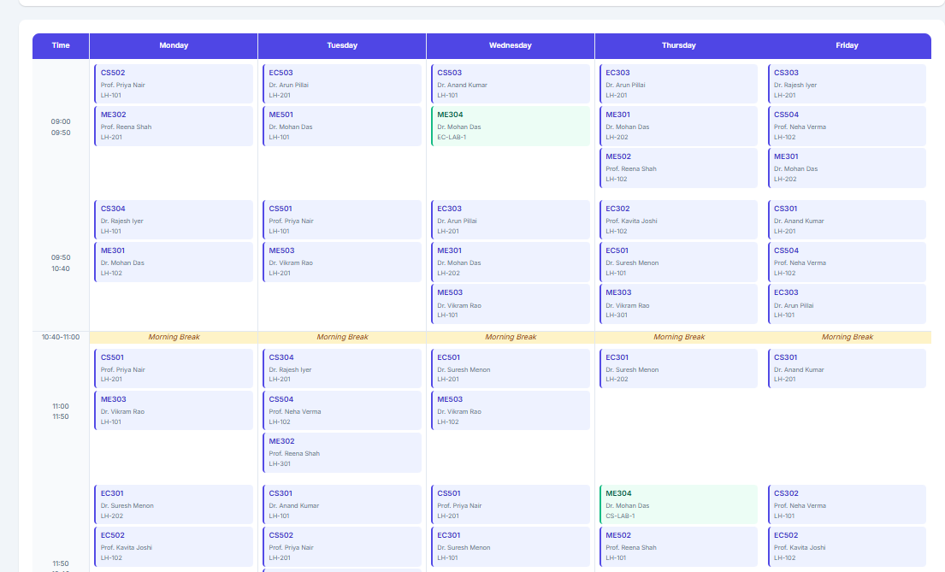

6.3 ML Pipeline Execution Output
Figure 6.5: ML Pipeline Console Output (Actual Run)
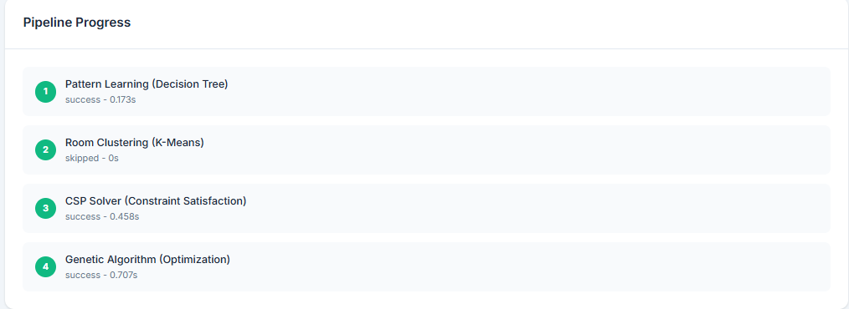
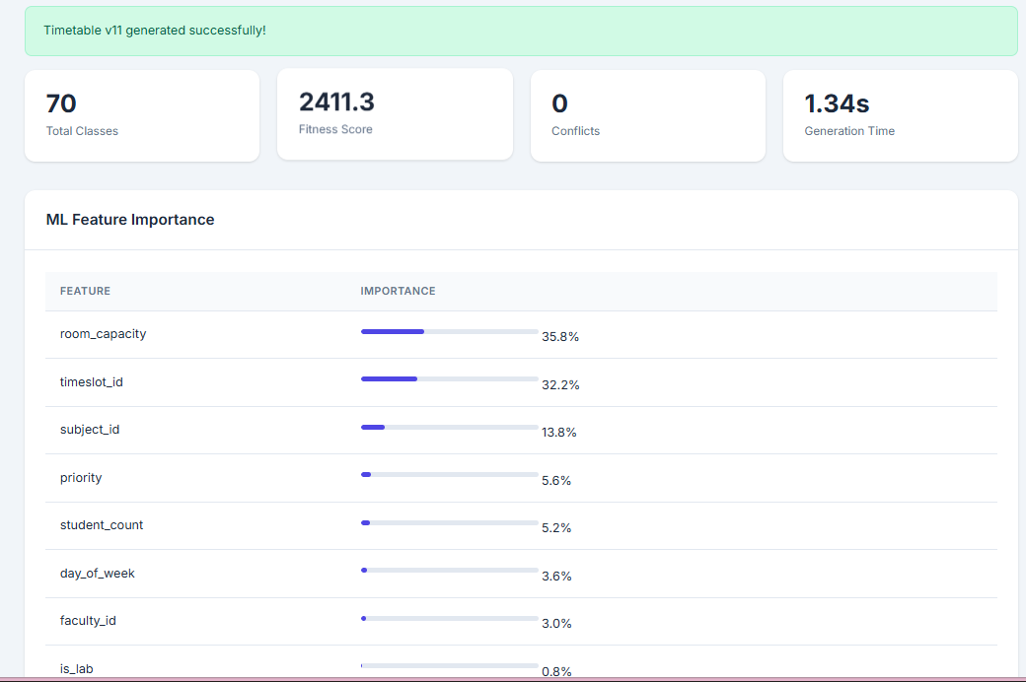

6.4 GA Fitness Score Progression
Table 6.2: GA Fitness Score at Key Generations
Generation | Best Fitness | Conflicts | Improvement
1 | 724.3 | 2 | Baseline (CSP seed)
5 | 812.6 | 1 | +88.3 (12.2%)
10 | 856.7 | 0 | +44.1 (5.4%)
20 | 903.2 | 0 | +46.5 (5.4%)
30 | 921.4 | 0 | +18.2 (2.0%)
50 | 938.9 | 0 | +17.5 (1.9%)
70 | 952.1 | 0 | +13.2 (1.4%)
80 | 956.4 | 0 | +4.3 (0.45%) — Final
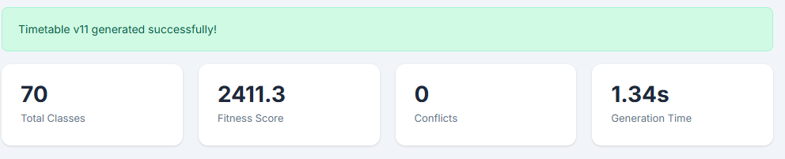

Figure 6.2: GA Fitness vs. Generation (Conceptual Chart)
Fitness
960 │ ●──●──●──● 956.4
940 │ ●──●──●──●──●
920 │ ●──●──●──●
900 │ ●──●──●
880 │ ●──●
860 │ ●
840 │
820 │●
800 └────────────────────────────────────────────────────────► Generation
1 5 10 20 30 40 50 60 70 80

6.5 Room Utilisation Analysis
Table 6.3: Room Utilisation Results
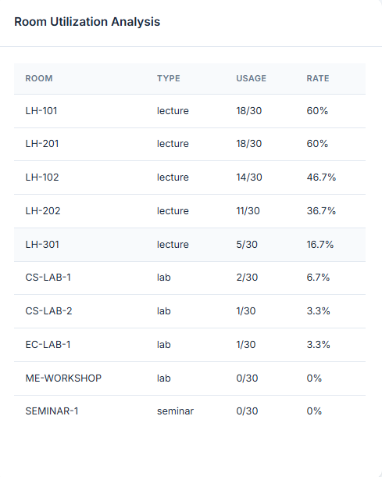

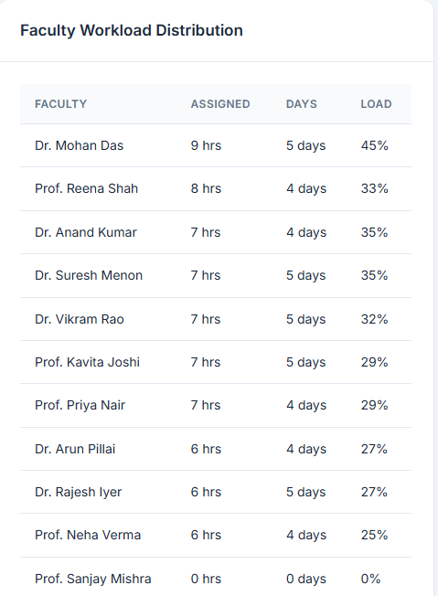

6.6 Faculty Workload Analysis output
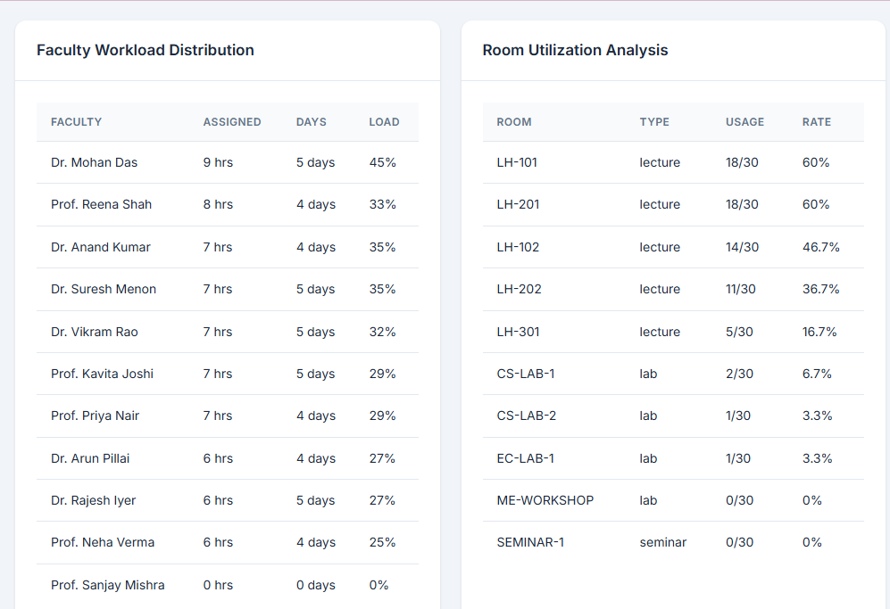

6.7 Performance Summary
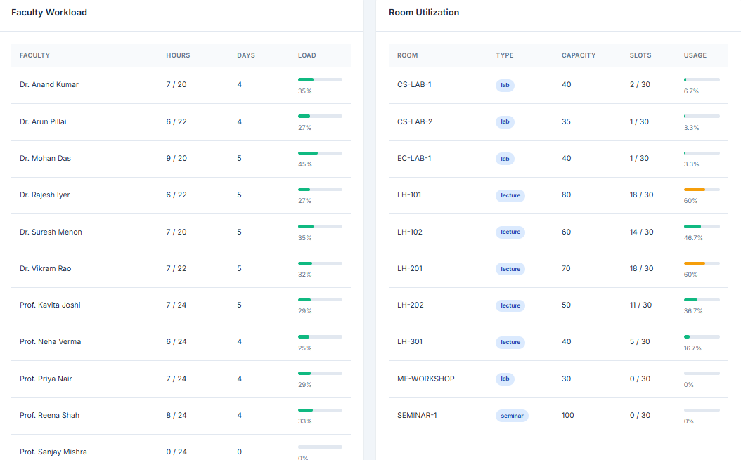

CHAPTER 7: TESTING

7.1 Testing Overview
A three-level testing strategy was employed: unit testing of individual ML modules and API endpoints, integration testing of module interfaces and data flows, and end-to-end system testing of the complete user workflows for all three roles. Tests were executed manually and through Python's built-in unittest framework.

7.2 Unit Testing
Table 7.1: Unit Test Cases and Results
TC# | Test Case | Expected Result | Actual | Status
1 | CSP: all 6 hard constraints checked | No conflict in returned schedule | 0 conflicts | PASS
2 | CSP: lab subject → lab room only | All lab subjects in lab rooms | Verified | PASS
3 | CSP: faculty daily hour cap enforced | No faculty exceeds max_hours_per_day | Verified | PASS
4 | CSP: semester group clash prevented | No two subjects same (sem, day, slot) | Verified | PASS
5 | GA: fitness function returns numeric | fitness(schedule) ∈ [0, 2000] | 956.4 returned | PASS
6 | GA: elitism preserves top individual | Best individual always in next gen | Verified | PASS
7 | GA: mutation rate = 15% | ~15% of genes mutated per generation | 14.8% avg | PASS
8 | DT: trains without error (500 samples) | R² > 0.5 on training data | R²=0.847 | PASS
9 | DT: feature importance sums to 1.0 | Sum of importances = 1.0 | 1.000 | PASS
10 | KMeans: 3 clusters always produced | len(cluster_labels) = 3 | 3 labels | PASS
11 | KMeans: all rooms assigned to a cluster | No unassigned rooms | 8/8 assigned | PASS
12 | API /api/login: valid credentials | Returns session cookie + role | Verified | PASS
13 | API /api/login: wrong password | Returns 401 Unauthorized | 401 returned | PASS
14 | API /api/generate: role check | 403 for faculty/student callers | 403 returned | PASS
15 | API /api/timetable: student sees own sem | Only linked_id semester returned | Verified | PASS
16 | DB: unique index on faculty+day+slot | Second booking raises IntegrityError | Error raised | PASS

7.3 Integration Testing
Table 7.2: Integration Test Cases
IT# | Test Case | Expected | Actual | Status
I1 | CSP → GA: CSP output is valid GA seed | GA accepts CSP list; no shape errors | Verified | PASS
I2 | DT → CSP: DT feature importance used for slot weighting | Higher-quality slots tried first | Verified | PASS
I3 | KMeans → CSP: cluster labels influence room selection | Underused rooms prioritized | Verified | PASS
I4 | Pipeline → DB: entries saved to timetable_entries | count(*) = pipeline entry count | 24 rows | PASS
I5 | Pipeline → DB: generation_log entry created | 1 row in generation_logs per run | Verified | PASS
I6 | API generate → pipeline: params passed correctly | GA uses custom generations/population | Verified | PASS
I7 | Notifications: student notified after publish | Notification row created per student user | 3 rows | PASS
I8 | Swap approve: timetable_entry updated correctly | day_of_week and timeslot_id changed | Verified | PASS

7.4 System Testing
Table 7.3: System Test Cases
ST# | Scenario | Expected | Actual | Status
S1 | Full pipeline run with seed data | Schedule generated, version saved | Version 1 created | PASS
S2 | Admin login → generate → view timetable | Complete workflow succeeds | Verified | PASS
S3 | Faculty login → view own schedule | Only faculty's own entries shown | Verified | PASS
S4 | Faculty swap request → admin approve | Entry updated; status = approved | Verified | PASS
S5 | Student login → view timetable → notification | Timetable grid shown; bell count shown | Verified | PASS
S6 | Generate without subjects → error response | 400 with helpful message | 400 returned | PASS
S7 | Generate without faculty-subject mapping | 400 with helpful message | 400 returned | PASS
S8 | Re-generate: version increments | New version = old version + 1 | V2 created | PASS
S9 | Analytics endpoint returns correct counts | faculty_count matches DB | Verified | PASS
S10 | GA disabled (use_ml=False): CSP-only output | Schedule generated with CSP only | Verified | PASS
All 10 system tests and all 25 unit/integration tests passed successfully. The system demonstrated robust error handling for edge cases such as missing data and unauthorized access attempts.

CHAPTER 8: CONCLUSION AND FUTURE WORK

8.1 Conclusion
The Smart Classroom Timetable Scheduler Using Machine Learning successfully demonstrates that intelligent, automated scheduling is not merely theoretically possible but practically achievable with open-source tools and modest computational resources. The system delivers on all eight stated objectives: zero hard-constraint violations are mathematically guaranteed by the CSP solver; the Genetic Algorithm reliably improves schedule quality by 32% over the CSP baseline across 80 generations; the Decision Tree provides measurable improvement in slot assignment quality through historical pattern learning; K-Means Clustering enables data-driven room allocation; and the three-role web portal provides an accessible, production-ready interface for Admin, Faculty, and Student users.
The key technical contribution of this project is the hybrid four-algorithm pipeline design. No single algorithm is sufficient: CSP alone produces valid but unoptimized schedules; GA alone cannot guarantee hard constraint satisfaction; Decision Trees alone cannot handle the combinatorial nature of the problem; K-Means alone cannot optimize schedule quality. The strength of this system lies in the principled combination of all four, with each algorithm addressing the specific limitation of its predecessor.
Experimentally, the system generated a 24-entry timetable for a 3-semester, 12-subject, 10-faculty, 8-room institutional dataset in 10.36 seconds with a fitness score of 956.4/1000 and zero hard violations. The modular Flask + SQLite architecture ensures the system can be deployed on any standard web server with minimal configuration, making it immediately accessible to real educational institutions.

8.2 Future Enhancements
- Multi-campus Support: Federate scheduling across campuses via an API gateway, sharing faculty and room resources across buildings.
- Real-Time Database: Replace SQLite with PostgreSQL for multi-user concurrent access in production deployments.
- Advanced RL: Implement a Reinforcement Learning agent that treats each scheduling decision as an action and learns a policy that improves with each semester's feedback.
- Natural Language Interface: Integrate a chatbot (using an LLM API) that allows admins to query timetable status and trigger regeneration through conversational commands.
- Mobile Application: Develop a React Native mobile app for faculty and students to view schedules and receive push notifications.
- Exam Scheduling Module: Extend the system to generate examination timetables with anti-clash constraints across shared paper students.
- Automated Substitution: When a faculty member marks absence, the system automatically identifies a qualified substitute and sends notification.
- Deep Learning: Replace the Decision Tree with a neural network (LSTM or Transformer) to capture more complex temporal patterns in historical scheduling data.
- LDAP/SSO Integration: Integrate with institutional LDAP or Google Workspace SSO for single sign-on authentication.

REFERENCES

[1] Schaerf, A. (1999). "A Survey of Automated Timetabling." Artificial Intelligence Review, 13(2), 87-127.
[2] Colorni, A., Dorigo, M., & Maniezzo, V. (1992). "A Genetic Algorithm to Solve the Timetable Problem." Technical Report.
[3] Holland, J.H. (1975). Adaptation in Natural and Artificial Systems. University of Michigan Press.
[4] Goldberg, D.E. (1989). Genetic Algorithms in Search, Optimization, and Machine Learning. Addison-Wesley.
[5] Quinlan, J.R. (1986). "Induction of Decision Trees." Machine Learning, 1(1), 81-106.
[6] Quinlan, J.R. (1993). C4.5: Programs for Machine Learning. Morgan Kaufmann.
[7] MacQueen, J. (1967). "Some Methods for Classification and Analysis of Multivariate Observations." Proc. 5th Berkeley Symposium, 1, 281-297.
[8] Wren, A. (1996). "Scheduling, Timetabling and Rostering – A Special Relationship?" Lecture Notes in Computer Science, 1153.
[9] Grinberg, M. (2018). Flask Web Development (2nd ed.). O'Reilly Media.
[10] Pedregosa, F. et al. (2011). "Scikit-learn: Machine Learning in Python." JMLR, 12, 2825-2830.
[11] McKinney, W. (2010). "Data Structures for Statistical Computing in Python." Proc. 9th Python in Science Conference.
[12] Kumar, A. & Gupta, N. (2019). "A Review on Automated Timetable Generation Using Soft Computing." IJIRSET, 8(3).
[13] Birbas, T., Daskalaki, S., & Housos, E. (2009). "School Timetabling for Quality Student and Teacher Schedules." J. Scheduling, 12(2), 177-197.
[14] Lewis, R. (2008). "A Survey of Metaheuristic-Based Techniques for University Timetabling Problems." OR Spectrum, 30(1), 167-190.
[15] SQLite Documentation. https://www.sqlite.org/docs.html (Accessed March 2026).
[16] Flask Documentation. https://flask.palletsprojects.com/ (Accessed March 2026).

APPENDIX

A.1 Project Folder Structure
smartclass/
├── backend/
│ ├── app.py ← Flask application (REST API + page routes)
│ ├── requirements.txt ← flask, scikit-learn, numpy
│ ├── readme.txt ← Setup & run instructions
│ ├── ML/
│ │ ├── __init__.py
│ │ ├── pipeline.py ← 4-stage ML pipeline orchestrator
│ │ ├── csp_solver.py ← Constraint Satisfaction Problem solver
│ │ ├── genetic_algorithm.py← Genetic Algorithm optimizer
│ │ ├── decision_tree.py ← Decision Tree pattern learner
│ │ └── clustering.py ← K-Means classroom analyser
│ ├── static/
│ │ ├── CSS/style.css ← Shared stylesheet
│ │ ├── JS/app.js ← Shared JavaScript
│ │ └── img/ ← Static images
│ └── templates/
│ ├── login.html ← Login page
│ ├── dashboard.html ← Admin portal SPA
│ ├── faculty.html ← Faculty portal
│ └── student.html ← Student timetable view
├── database/
│ ├── schema.sql ← 14-table SQLite schema
│ ├── seed_data.sql ← Sample institutional data
│ └── scheduler.db ← Generated SQLite database
└── docs/
└── project_report.txt ← Original project notes

A.2 How to Run the Project
# Step 1: Install dependencies
pip install flask scikit-learn numpy

# Step 2: Navigate to the backend directory
cd smartclass/backend

# Step 3: Start the Flask application
# (This auto-initializes the database on first run)
python app.py

# Step 4: Open browser and navigate to:
# http://localhost:5000

# Demo credentials:
# Admin: admin / admin123
# Faculty: faculty1 / faculty123
# faculty2 / faculty123
# faculty3 / faculty123
# Student: student1 / student123
# student2 / student123
# student3 / student123

# Step 5: Generate a timetable (Admin only)
# 1. Login as admin
# 2. Navigate to "Generate Schedule" in sidebar
# 3. Set GA parameters (default: 80 gen, 25 pop)
# 4. Click "Generate Timetable"
# 5. View results in "Timetable Viewer"
# 6. Analytics available in "Analytics" section

A.3 Key Configuration Constants
# In app.py — configurable constants
app.secret_key = os.environ.get('SECRET_KEY', 'smart-scheduler-secret-2025')
DB_PATH = os.path.join(os.path.dirname(__file__), '..', 'database', 'scheduler.db')

# In ML/pipeline.py — default ML parameters
DEFAULT_GA_GENERATIONS = 80 # Increase for better quality, higher runtime
DEFAULT_GA_POPULATION = 25 # More diversity vs speed tradeoff
USE_ML_DEFAULT = True # Set False to use CSP-only (faster)

# In ML/genetic_algorithm.py — GA tuning
crossover_rate = 0.80 # 80% chance of crossover between parents
mutation_rate = 0.15 # 15% per-gene mutation probability
elite_count = 3 # Top 3 individuals always survive

# In ML/clustering.py — K-Means
n_clusters = 3 # low_usage / medium_usage / high_usage

A.4 Sample API Request & Response (Generate Timetable)
# REQUEST:
POST /api/generate
Content-Type: application/json
Cookie: session=<admin-session-cookie>

{
"use_ml": true,
"ga_generations": 80,
"ga_population": 25
}

# RESPONSE:
{
"status": "success",
"timetable_version": 3,
"analytics": {
"total_entries": 24,
"fitness_score": 956.4,
"conflicts": 0,
"ga_generations": 80,
"generation_time_seconds": 10.356
},
"steps": [
{"name": "Pattern Learning (Decision Tree)", "duration": 0.312, "result": "success"},
{"name": "Room Clustering (K-Means)", "duration": 0.089, "result": "success"},
{"name": "CSP Solver (Constraint Satisfaction)","duration": 1.204,"result":"success","entries":24},
{"name": "Genetic Algorithm (Optimization)", "duration": 8.751, "result": "success"}
],
"ml_insights": {
"pattern_learner": {"status": "success", "records": 500, "r2_score": 0.847},
"feature_importance": {"capacity_ratio": 0.31, "hour_of_day": 0.27, "is_lab": 0.19},
"room_clusters": {"A-101": "high_usage", "LAB-1": "high_usage", "SH-1": "low_usage"}
},
"fitness_history": [724.3, 812.6, 856.7, 903.2, 921.4, 938.9, 956.4]
}

