EX08-Time Series Forecasting using ARIMA Model

Aim
To implement a moving average smoothing technique for preparing time series data and enhancing the accuracy of forecasting models.

Algorithm
1 Import necessary libraries for time series analysis and visualization.
2 Load and preprocess the data by filtering for India and cleaning the dataset.
3 Visualize the time series to understand trends and seasonality.
4 Test for stationarity using the Augmented Dickey-Fuller (ADF) test.
5 Use ACF and PACF plots to determine the ARIMA model parameters (p, d, q).
6 Fit the ARIMA model and forecast the next 5 years, then visualize the results

Code
import pandas as pd
import matplotlib.pyplot as plt
from statsmodels.tsa.arima.model import ARIMA
from statsmodels.graphics.tsaplots import plot_acf, plot_pacf
from statsmodels.tsa.stattools import adfuller
import numpy as np
# Load data
file_path = r"C:\Users\22150\Downloads\Birthrate.csv"
df = pd.read_csv(file_path, skiprows=4)
# Filter for India
country = 'India'
country_df = df[df['Country Name'] == country]
# Extract year columns (columns that are digits)
year_columns = [col for col in country_df.columns if col.isdigit()]
ts = country_df[year_columns].T
ts.columns = ['Birthrate']
# Convert index to datetime
ts.index = pd.to_datetime(ts.index, format='%Y')
# Ensure the 'Birthrate' column is numeric
ts['Birthrate'] = pd.to_numeric(ts['Birthrate'], errors='coerce')
# Drop any rows with NaN values
ts = ts.dropna()
# Plot the time series
ts.plot()
plt.title(f"{country} Fertility Rate Time Series")
plt.ylabel('Birthrate')
plt.show()
# Check if the time series is stationary using the Augmented Dickey-Fuller test
result = adfuller(ts['Birthrate'])
print(f"ADF Statistic: {result[0]}")
print(f"p-value: {result[1]}")
if result[1] < 0.05:
print("The time series is stationary.")
else:
print("The time series is not stationary. Differencing may be required.")
# If the time series is not stationary, perform differencing (d = 1)
ts_diff = ts['Birthrate'].diff().dropna()
# Plot ACF and PACF to determine ARIMA parameters (p, d, q)
plt.figure(figsize=(12, 6))
plt.subplot(121)
plot_acf(ts_diff, lags=20, ax=plt.gca())
plt.title("ACF - Autocorrelation")
plt.subplot(122)
plot_pacf(ts_diff, lags=20, ax=plt.gca())
plt.title("PACF - Partial Autocorrelation")
plt.tight_layout()
plt.show()
# Fit ARIMA model (For simplicity, we will use the parameters (p=1, d=1, q=1) as an example)
model = ARIMA(ts['Birthrate'], order=(1, 1, 1))
model_fit = model.fit()
# Print the summary of the model
print(model_fit.summary())
# Forecast the next 5 years
forecast_steps = 5
forecast = model_fit.forecast(steps=forecast_steps)
# Plot the original series and the forecasted values
plt.figure(figsize=(10, 6))
plt.plot(ts.index, ts['Birthrate'], label="Original Series")
forecast_index = pd.date_range(start=ts.index[-1] + pd.Timedelta(days=365), periods=forecast_steps, freq='YS')
plt.plot(forecast_index, forecast, label="Forecast", color='red')
plt.title(f"{country} Fertility Rate Forecast")
plt.xlabel('Year')
plt.ylabel('Birthrate')
plt.legend()
plt.show()

Visualization
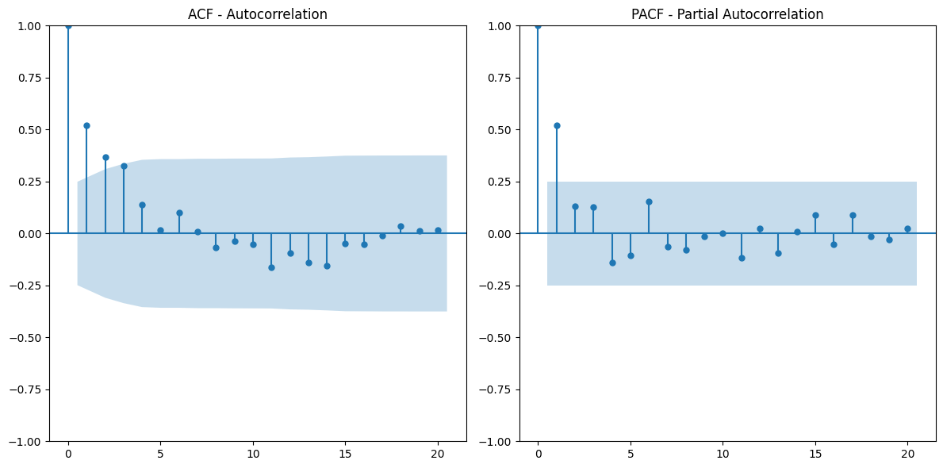

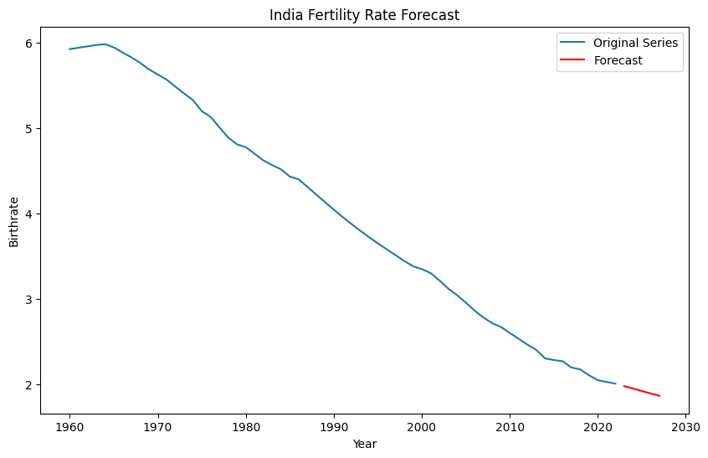

Result
The smoothed data showed reduced noise and improved trends visibility, aiding in more accurate forecasting. The results support the effectiveness of moving average smoothing in time series analysis.

