Bootstrap Tutorial for Beginners

Bootstrap was created at Twitter in mid-2010 by **Mark Otto** and **Jacob Thornton**. Prior to being an open-sourced framework, Bootstrap was known as **Twitter Blueprint**. A few months into development, Twitter held its first Hack Week and the project exploded as developers of all skill levels jumped in without any external guidance. It served as the style guide for internal tools development at the company for over a year before its public release, and continues to do so today.

What is Hackathon..?

* A hackathon is an event in computer programmers ,web and graphic developer
* few months into development, Twitter held its first hackathon Week and the project exploded as developers .
* It was renamed from **Twitter Blueprint** to **Bootstrap**

Features

* **Easy to use**

Anybody with just basic knowledge of HTML and CSS can start using Bootstrap.

* **Responsive features**

Bootstrap's responsive CSS adjusts to phones, tablets, and desktops.

* **Mobile-first approach**

In Bootstrap 3, mobile-first styles are part of the core framework.

Bootstrap is compatible with all modern browsers (Chrome, Firefox, Internet Explorer, Edge, Safari, and Opera).

Development of Bootstrap

* Bootstrap is released on August 19, 2011.
* Its free and Open source..
* Front-end frame work
* It has continued to be maintained by Mark Otto, Jacob Thornton

Bootstrap Versions

* Bootstrap 2
* Bootstrap 3
* Bootstrap 4
* Bootstrap 5

Bootstrap 2

On January 31, 2012, Bootstrap 2 was released, which added built-in support for Glyphicons, several new components, as well as changes to many of the existing components. This version supports responsive web design, meaning the layout of web pages adjusts dynamically, taking into account the characteristics of the device used (whether desktop, tablet, or mobile phone).

Features

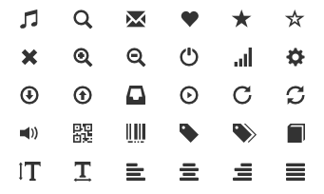

* Added a twelve-column division style.
* Responsive grid layout system.
* Inbuilt support for Glyphicons.
* Several new components.
* Prepared monochromatic icons and symbol.
* Created with an emphasis to simplicity and easy orientation.



Bootstrap 3

On August 19, 2013, Bootstrap 3, was released. It redesigned components to use flat design and a mobile first approach. Bootstrap 3 features new plugin system with name spaced events. Bootstrap 3 dropped Internet Explorer 7 and Firefox 3.6 support, but there is an optional polyfil for these browsers.

Features

* Redesigned components to use flat design, and a mobile first approach.
* In this release, Bootstrap follows the **mobile-first approach** and makes your site**always responsive**by default.
* The new grid is significantly simplified and combined into one single grid system.
* JavaScript plugins are rewritten and all events are now namespaced to prevent any conflicts that may occur.
* Now the customizer can save your customizations to an anonymous Gist for easy reuse, sharing, and modifications.

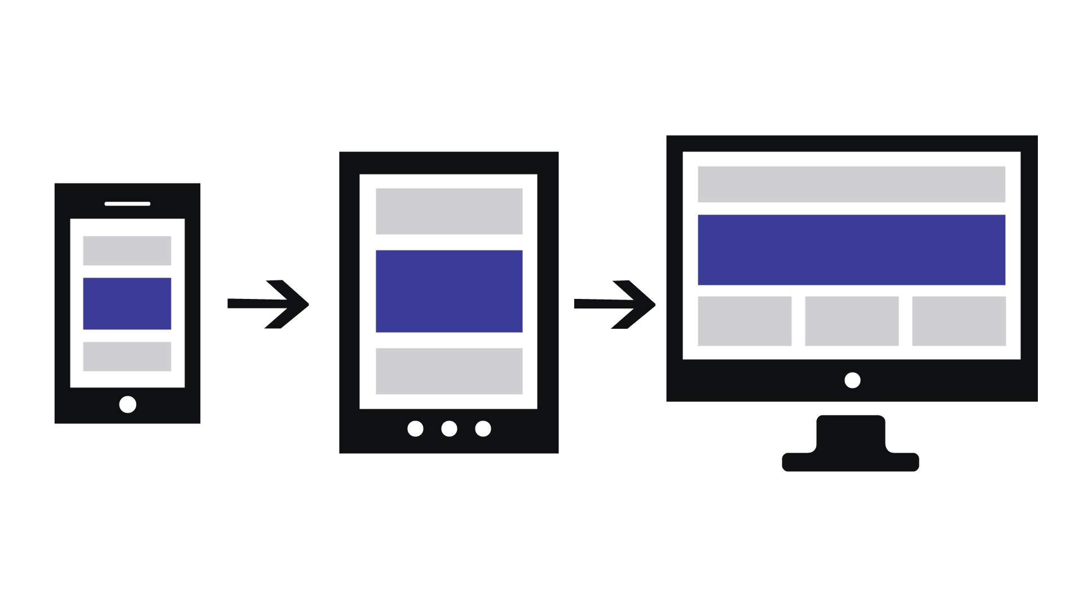

* Smallest file size. With the changes made in this release a reduction of over 20% is achieved in the minified CSS file.



Bootstrap 4

Mark Otto announced Bootstrap 4 on October 29, 2014. The first alpha version of Bootstrap 4 was released on August 19, 2015. The first beta version was released on August 10, 2017. Mark suspended work on Bootstrap 3 on September 6, 2016, to free up time to work on Bootstrap 4. Bootstrap 4 was finalized on January 18, 2018.



Features

* Grid System Improvements.
* Flexbox ships lot of amazing features which makes the bootstrap a powerful framework.
* Improved Form Support.
* SASS Flexible Performance.
* Introduced New Card Components.
* Responsive Spacing Utilities.

Bootstrap 5

Bootstrap 5 was officially released on May 5, 2021.

Features

* Added a twelve-column division style.
* Responsive grid layout system.
* Inbuilt support for Glyphicons.
* Several new components.
* Prepared monochromatic icons and symbol.
* Created with an emphasis to simplicity and easy orientation.

### Get Bootstrap

Bootstrap allows two ways to start using Bootstrap on your own web site.

* Download Bootstrap from getbootstrap.com
* Using Bootstrap CDN ( **C**ontent **D**elivery **N**etwork )

### Bootstrap CDN

If you don't want to download and host Bootstrap yourself, you can include it from a CDN.

#### **CSS**

<!-- Latest compiled and minified CSS -->

<**link** rel="stylesheet" href="https://maxcdn.bootstrapcdn.com/bootstrap/3.4.1/css/bootstrap.min.css">

#### **JQuery**

<!-- jQuery library -->

<**script** src="https://ajax.googleapis.com/ajax/libs/jquery/3.5.1/jquery.min.js"></**script**>

<!-- Latest compiled JavaScript -->

<**script** src="https://maxcdn.bootstrapcdn.com/bootstrap/3.4.1/js/bootstrap.min.js"></**script**>

### Create First Web Page With Bootstrap

* Add the HTML5 doctype
* Bootstrap 3 is mobile-first

#### DOCTYPE html

Bootstrap uses HTML elements and CSS properties that require the HTML5 **doctype**.

<!DOCTYPE html>

<**html** lang="en">

<**head**>

<**meta** charset="utf-8">

</**head**>

</**html**>

#### Mobile-first

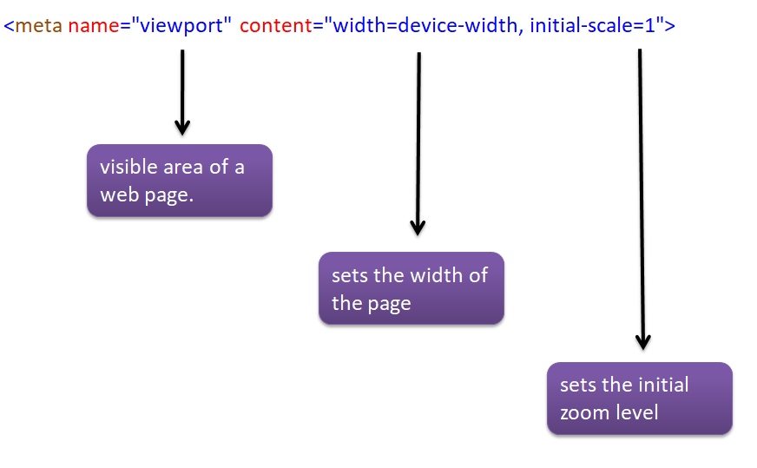

* To ensure proper rendering and touch zooming, add the following **< meta >** tag inside the **< head >** element.
* **width=device-width** - follow the screen-width of the device.
* **initial-scale=1** - Initial zoom level when the page is first loaded by the browser.

#### Source Code

<!DOCTYPE html>

<**html** lang="en">

<**head**>

<**meta** charset="UTF-8">

<**meta** http-equiv="X-UA-Compatible" content="IE=edge">

<**meta** name="viewport" content="width=device-width, initial-scale=1.0">

<**title**>Tutor Joes</**title**>

<**link** rel="stylesheet" href="https://maxcdn.bootstrapcdn.com/bootstrap/3.4.1/css/bootstrap.min.css">

<!--<link rel="stylesheet" href="css/bootstrap.min.css">-->

</**head**>

<**body**>

<**h1**>Tutor Joes Computer Education</**h1**>

<**script** src="https://ajax.googleapis.com/ajax/libs/jquery/3.5.1/jquery.min.js"></**script**>

<**script** src="https://maxcdn.bootstrapcdn.com/bootstrap/3.4.1/js/bootstrap.min.js"></**script**>

<!--<script src="js/jquery.min.js"></script>-->

<!--<script src="js/bootstrap.min.js"></script>-->

</**body**>

</**html**>

### Containers

Containers are used to pad the content inside of them. Their are two classes available in Bootstrap

* The **.container** class provides a responsive fixed width container.
* The **.container-fluid** class provides a full width container.

### Well

1. Adds a
   * rounded border
   * gray background color
   * some padding
2. Change the size of the well by adding some following class name .
   * well-sm
   * well-lg

### Jumbotron

Indicates a big box for calling extra attention to some special content. Adds a

* Displayed as a grey box
* Rounded corners.
* It also enlarges the font sizes of the text inside it.

#### **Source Code**

<!DOCTYPE html>

<**html** lang="en">

<**head**>

<**meta** charset="UTF-8">

<**meta** http-equiv="X-UA-Compatible" content="IE=edge">

<**meta** name="viewport" content="width=device-width, initial-scale=1.0">

<**title**>Tutor Joes</**title**>

<**link** rel="stylesheet" href="https://maxcdn.bootstrapcdn.com/bootstrap/3.4.1/css/bootstrap.min.css">

<!--<link rel="stylesheet" href="css/bootstrap.min.css">-->

</**head**>

<**body**>

<**div** class="container well">

<**h1**>Tutor Joes Computer Education ( Well )</**h1**>

</**div**>

<**div** class="container well well-sm">

<**h1**>Tutor Joes Computer Education ( well-sm )</**h1**>

</**div**>

<**div** class="container well well-lg">

<**h1**>Tutor Joes Computer Education ( well-lg )</**h1**>

</**div**>

<**div** class="container-fluid well">

<**h1**>Tutor Joes Computer Education</**h1**>

</**div**>

<**div** class="container jumbotron">

<**h1**>Tutor Joes Computer Education</**h1**>

</**div**>

<**script** src="https://ajax.googleapis.com/ajax/libs/jquery/3.5.1/jquery.min.js"></**script**>

<**script** src="https://maxcdn.bootstrapcdn.com/bootstrap/3.4.1/js/bootstrap.min.js"></**script**>

<!--<script src="js/jquery.min.js"></script>-->

<!--<script src="js/bootstrap.min.js"></script>-->

</**body**>

</**html**>

### Grid System

Bootstrap's grid system allows up to 12 columns across the page. If you do not want to use all 12 column individually, you can group the columns together to create wider columns.

Bootstrap's grid system is responsive, and the columns will re-arrange depending on the screen size

**The Bootstrap grid system has four classes**

* **lg** screens equal to or greater than 1200px wide
* **md** screens equal to or greater than 992px wide
* **sm** screens equal to or greater than 768px wide
* **xs** screens less than 768px wide

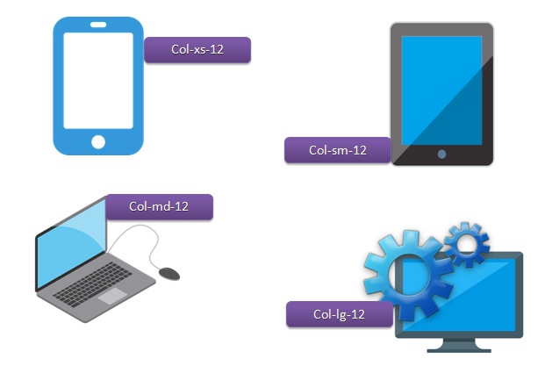

#### **Source Code**

<!DOCTYPE html>

<**html** lang="en">

<**head**>

<**meta** charset="UTF-8">

<**meta** http-equiv="X-UA-Compatible" content="IE=edge">

<**meta** name="viewport" content="width=device-width, initial-scale=1.0">

<**title**>Tutor Joes</**title**>

<**link** rel="stylesheet" href="https://maxcdn.bootstrapcdn.com/bootstrap/3.4.1/css/bootstrap.min.css">

<!--<link rel="stylesheet" href="css/bootstrap.min.css">-->

</**head**>

<**body**>

<**div** class="container-fluid">

<**h3**>Grid System</**h3**>

<**div** class="row">

<**div** class="col-md-12 well">Box-12</**div**>

<**div** class="col-md-6 well">Box-1</**div**>

<**div** class="col-md-6 well">Box-2</**div**>

<**div** class="col-md-4 well">Box-3</**div**>

<**div** class="col-md-4 well">Box-4</**div**>

<**div** class="col-md-4 well">Box-5</**div**>

</**div**>

</**div**>

<**script** src="https://ajax.googleapis.com/ajax/libs/jquery/3.5.1/jquery.min.js"></**script**>

<**script** src="https://maxcdn.bootstrapcdn.com/bootstrap/3.4.1/js/bootstrap.min.js"></**script**>

<!--<script src="js/jquery.min.js"></script>-->

<!--<script src="js/bootstrap.min.js"></script>-->

</**body**>

</**html**>

### Typography

Typography is a feature of Bootstrap for styling and formatting the text content. It is used to create customized headings, inline subheadings, lists, paragraphs, aligning, adding more design-oriented font styles and much more.

**Some classes and Tags to implement typography feature of bootstrap**

| **Class Name** | **Used for** |
| --- | --- |
| lead | to make a paragraph stand out i.e. Tutor joes. |
| small | to create secondary subheadings. |
| text-center | to align the text to center. |
| text-right | to align the text to right. |
| text-left | to align the text to left. |
| text-justify | to align the text to left and right. |
| list-inline | to make the element of list inline. |
| text-uppercase | to transform text to uppercase. |
| text-lowercase | to transform text to lowercase. |
| text-capitalize | to transform text to capitalize first letter of each word leaving other letters in lowercase. |

Typography is a feature of Bootstrap for styling and formatting the text content. It is used to create customized headings, inline subheadings, lists, paragraphs, aligning, adding more design-oriented font styles and much more.

#### **Colors / Backgrounds**

Convey meaning through color with a handful of color utility classes.

**Text Colors Classes**

* text-primary
* text-success
* text-info
* text-danger
* text-warning

**Background Classes**

* bg-primary
* bg-success
* bg-info
* bg-danger
* bg-warning

#### **Source Code**

<!DOCTYPE html>

<**html** lang="en">

<**head**>

<**meta** charset="UTF-8">

<**meta** http-equiv="X-UA-Compatible" content="IE=edge">

<**meta** name="viewport" content="width=device-width, initial-scale=1.0">

<**title**>Tutor Joes</**title**>

<**link** rel="stylesheet" href="https://maxcdn.bootstrapcdn.com/bootstrap/3.4.1/css/bootstrap.min.css">

<!--<link rel="stylesheet" href="css/bootstrap.min.css">-->

</**head**>

<**body**>

<**div** class="container">

<**h3**>Text Properties</**h3**>

<**p** class="text-primary">Lorem ipsum dolor sit amet consectetur, adipisicing elit. Quaerat voluptates numquam quod amet repellendus veritatis unde nulla mollitia quam nostrum!</**p**>

<**p** class="text-success">Lorem ipsum dolor sit amet consectetur, adipisicing elit. Quaerat voluptates numquam quod amet repellendus veritatis unde nulla mollitia quam nostrum!</**p**>

<**p** class="text-info">Lorem ipsum dolor sit amet consectetur, adipisicing elit. Quaerat voluptates numquam quod amet repellendus veritatis unde nulla mollitia quam nostrum!</**p**>

<**p** class="text-warning">Lorem ipsum dolor sit amet consectetur, adipisicing elit. Quaerat voluptates numquam quod amet repellendus veritatis unde nulla mollitia quam nostrum!</**p**>

<**p** class="text-danger">Lorem ipsum dolor sit amet consectetur, adipisicing elit. Quaerat voluptates numquam quod amet repellendus veritatis unde nulla mollitia quam nostrum!</**p**>

<**p** class="bg-primary">Lorem ipsum dolor sit amet consectetur, adipisicing elit. Quaerat voluptates numquam quod amet repellendus veritatis unde nulla mollitia quam nostrum!</**p**>

<**p** class="bg-success">Lorem ipsum dolor sit amet consectetur, adipisicing elit. Quaerat voluptates numquam quod amet repellendus veritatis unde nulla mollitia quam nostrum!</**p**>

<**p** class="bg-info">Lorem ipsum dolor sit amet consectetur, adipisicing elit. Quaerat voluptates numquam quod amet repellendus veritatis unde nulla mollitia quam nostrum!</**p**>

<**p** class="bg-warning">Lorem ipsum dolor sit amet consectetur, adipisicing elit. Quaerat voluptates numquam quod amet repellendus veritatis unde nulla mollitia quam nostrum!</**p**>

<**p** class="bg-danger">Lorem ipsum dolor sit amet consectetur, adipisicing elit. Quaerat voluptates numquam quod amet repellendus veritatis unde nulla mollitia quam nostrum!</**p**>

<**p**>Tutor <**i** class='lead'>Joes</**i**></**p**>

<**p**>Tutor <**i** class='small'>Joes</**i**></**p**>

<**p** class="text-left">Lorem ipsum dolor sit amet consectetur, adipisicing elit. Quaerat voluptates numquam quod amet repellendus veritatis unde nulla mollitia quam nostrum!</**p**>

<**p** class="text-right">Lorem ipsum dolor sit amet consectetur, adipisicing elit. Quaerat voluptates numquam quod amet repellendus veritatis unde nulla mollitia quam nostrum!</**p**>

<**p** class="text-center">Lorem ipsum dolor sit amet consectetur, adipisicing elit. Quaerat voluptates numquam quod amet repellendus veritatis unde nulla mollitia quam nostrum!</**p**>

<**p** class="text-justify">Lorem ipsum dolor sit amet consectetur, adipisicing elit. Quaerat voluptates numquam quod amet repellendus veritatis unde nulla mollitia quam nostrum!</**p**>

<**p** class="text-lowercase">Lorem ipsum dolor sit amet consectetur, adipisicing elit. Quaerat voluptates numquam quod amet repellendus veritatis unde nulla mollitia quam nostrum!</**p**>

<**p** class="text-uppercase">Lorem ipsum dolor sit amet consectetur, adipisicing elit. Quaerat voluptates numquam quod amet repellendus veritatis unde nulla mollitia quam nostrum!</**p**>

<**p** class="text-capitalize">Lorem ipsum dolor sit amet consectetur, adipisicing elit. Quaerat voluptates numquam quod amet repellendus veritatis unde nulla mollitia quam nostrum!</**p**>

<**ul** class="list-unstyled">

<**li**>Item</**li**>

<**li**>Item</**li**>

<**li**>Item</**li**>

<**li**>Item</**li**>

<**li**>Item</**li**>

<**li**>Item</**li**>

</**ul**>

<**ul** class="list-inline">

<**li**>Item</**li**>

<**li**>Item</**li**>

<**li**>Item</**li**>

<**li**>Item</**li**>

<**li**>Item</**li**>

<**li**>Item</**li**>

</**ul**>

</**div**>

<**script** src="https://ajax.googleapis.com/ajax/libs/jquery/3.5.1/jquery.min.js"></**script**>

<**script** src="https://maxcdn.bootstrapcdn.com/bootstrap/3.4.1/js/bootstrap.min.js"></**script**>

<!--<script src="js/jquery.min.js"></script>-->

<!--<script src="js/bootstrap.min.js"></script>-->

</**body**>

</**html**>

### Tables

| **Class Name** | **Used for** |
| --- | --- |
| table | A basic Bootstrap table has a light padding and only horizontal dividers. |
| table-bordered | adds borders on all sides of the table and cells |
| table-striped | adds zebra-stripes to a table |
| table-hover | adds a hover effect (grey background color) on table rows. |
| table-condensed | makes a table more compact by cutting cell padding. |
| Contextual Classes | used to color table rows or cells. |
| table-responsive | the table will then scroll horizontally on small devices |

#### **Source Code**

<!DOCTYPE html>

<**html** lang="en">

<**head**>

<**meta** charset="UTF-8">

<**meta** http-equiv="X-UA-Compatible" content="IE=edge">

<**meta** name="viewport" content="width=device-width, initial-scale=1.0">

<**title**>Tutor Joes</**title**>

<**link** rel="stylesheet" href="https://maxcdn.bootstrapcdn.com/bootstrap/3.4.1/css/bootstrap.min.css">

<!--<link rel="stylesheet" href="css/bootstrap.min.css">-->

</**head**>

<**body**>

<**div** class="container">

<**h3**>Bootstrap Tables</**h3**>

<**table** class="table">

<**tr**>

<**th**>Sno</**th**>

<**th**>Name</**th**>

<**th**>Age</**th**>

<**th**>Email</**th**>

<**th**>Contact</**th**>

</**tr**>

<**tr**>

<**td**>1</**td**>

<**td**>Sam</**td**>

<**td**>25</**td**>

<**td**>sam@gmail.com</**td**>

<**td**>95858585853</**td**>

</**tr**>

<**tr**>

<**td**>2</**td**>

<**td**>Ram</**td**>

<**td**>25</**td**>

<**td**>ram@gmail.com</**td**>

<**td**>69588338552</**td**>

</**tr**>

<**tr**>

<**td**>3</**td**>

<**td**>Ravi</**td**>

<**td**>22</**td**>

<**td**>Ravi@gmail.com</**td**>

<**td**>85957585855</**td**>

</**tr**>

<**tr**>

<**td**>4</**td**>

<**td**>Kumar</**td**>

<**td**>20</**td**>

<**td**>kumar@gmail.com</**td**>

<**td**>32585858858</**td**>

</**tr**>

<**tr**>

<**td**>5</**td**>

<**td**>Sundar</**td**>

<**td**>20</**td**>

<**td**>sundar@gmail.com</**td**>

<**td**>95825858258</**td**>

</**tr**>

</**table**>

<**table** class="table table-striped">

<**tr**>

<**th**>Sno</**th**>

<**th**>Name</**th**>

<**th**>Age</**th**>

<**th**>Email</**th**>

<**th**>Contact</**th**>

</**tr**>

<**tr**>

<**td**>1</**td**>

<**td**>Sam</**td**>

<**td**>25</**td**>

<**td**>sam@gmail.com</**td**>

<**td**>95858585853</**td**>

</**tr**>

<**tr**>

<**td**>2</**td**>

<**td**>Ram</**td**>

<**td**>25</**td**>

<**td**>ram@gmail.com</**td**>

<**td**>69588338552</**td**>

</**tr**>

<**tr**>

<**td**>3</**td**>

<**td**>Ravi</**td**>

<**td**>22</**td**>

<**td**>Ravi@gmail.com</**td**>

<**td**>85957585855</**td**>

</**tr**>

<**tr**>

<**td**>4</**td**>

<**td**>Kumar</**td**>

<**td**>20</**td**>

<**td**>kumar@gmail.com</**td**>

<**td**>32585858858</**td**>

</**tr**>

<**tr**>

<**td**>5</**td**>

<**td**>Sundar</**td**>

<**td**>20</**td**>

<**td**>sundar@gmail.com</**td**>

<**td**>95825858258</**td**>

</**tr**>

</**table**>

<**table** class="table table-bordered table-hover">

<**tr**>

<**th**>Sno</**th**>

<**th**>Name</**th**>

<**th**>Age</**th**>

<**th**>Email</**th**>

<**th**>Contact</**th**>

</**tr**>

<**tr**>

<**td**>1</**td**>

<**td**>Sam</**td**>

<**td**>25</**td**>

<**td**>sam@gmail.com</**td**>

<**td**>95858585853</**td**>

</**tr**>

<**tr**>

<**td**>2</**td**>

<**td**>Ram</**td**>

<**td**>25</**td**>

<**td**>ram@gmail.com</**td**>

<**td**>69588338552</**td**>

</**tr**>

<**tr**>

<**td**>3</**td**>

<**td**>Ravi</**td**>

<**td**>22</**td**>

<**td**>Ravi@gmail.com</**td**>

<**td**>85957585855</**td**>

</**tr**>

<**tr**>

<**td**>4</**td**>

<**td**>Kumar</**td**>

<**td**>20</**td**>

<**td**>kumar@gmail.com</**td**>

<**td**>32585858858</**td**>

</**tr**>

<**tr**>

<**td**>5</**td**>

<**td**>Sundar</**td**>

<**td**>20</**td**>

<**td**>sundar@gmail.com</**td**>

<**td**>95825858258</**td**>

</**tr**>

</**table**>

<**table** class="table table-condensed">

<**tr**>

<**th**>Sno</**th**>

<**th**>Name</**th**>

<**th**>Age</**th**>

<**th**>Email</**th**>

<**th**>Contact</**th**>

</**tr**>

<**tr**>

<**td**>1</**td**>

<**td**>Sam</**td**>

<**td**>25</**td**>

<**td**>sam@gmail.com</**td**>

<**td**>95858585853</**td**>

</**tr**>

<**tr**>

<**td**>2</**td**>

<**td**>Ram</**td**>

<**td**>25</**td**>

<**td**>ram@gmail.com</**td**>

<**td**>69588338552</**td**>

</**tr**>

<**tr**>

<**td**>3</**td**>

<**td**>Ravi</**td**>

<**td**>22</**td**>

<**td**>Ravi@gmail.com</**td**>

<**td**>85957585855</**td**>

</**tr**>

<**tr**>

<**td**>4</**td**>

<**td**>Kumar</**td**>

<**td**>20</**td**>

<**td**>kumar@gmail.com</**td**>

<**td**>32585858858</**td**>

</**tr**>

<**tr**>

<**td**>5</**td**>

<**td**>Sundar</**td**>

<**td**>20</**td**>

<**td**>sundar@gmail.com</**td**>

<**td**>95825858258</**td**>

</**tr**>

</**table**>

<**div** class="table-responsive">

<**table** class="table table-bordered table-hover">

<**tr**>

<**th**>Sno</**th**>

<**th**>Name</**th**>

<**th**>Age</**th**>

<**th**>Email</**th**>

<**th**>Contact</**th**>

</**tr**>

<**tr**>

<**td**>1</**td**>

<**td**>Sam</**td**>

<**td**>25</**td**>

<**td**>sam@gmail.com</**td**>

<**td**>95858585853</**td**>

</**tr**>

<**tr**>

<**td**>2</**td**>

<**td**>Ram</**td**>

<**td**>25</**td**>

<**td**>ram@gmail.com</**td**>

<**td**>69588338552</**td**>

</**tr**>

<**tr**>

<**td**>3</**td**>

<**td**>Ravi</**td**>

<**td**>22</**td**>

<**td**>Ravi@gmail.com</**td**>

<**td**>85957585855</**td**>

</**tr**>

<**tr**>

<**td**>4</**td**>

<**td**>Kumar</**td**>

<**td**>20</**td**>

<**td**>kumar@gmail.com</**td**>

<**td**>32585858858</**td**>

</**tr**>

<**tr**>

<**td**>5</**td**>

<**td**>Sundar</**td**>

<**td**>20</**td**>

<**td**>sundar@gmail.com</**td**>

<**td**>95825858258</**td**>

</**tr**>

</**table**>

</**div**>

</**div**>

<**script** src="https://ajax.googleapis.com/ajax/libs/jquery/3.5.1/jquery.min.js"></**script**>

<**script** src="https://maxcdn.bootstrapcdn.com/bootstrap/3.4.1/js/bootstrap.min.js"></**script**>

<!--<script src="js/jquery.min.js"></script>-->

<!--<script src="js/bootstrap.min.js"></script>-->

</**body**>

</**html**>

### Images

Bootstrap provides classes that can be used when working with the <img> element. Specifically, there are classes for responsive images, and classes for image shapes.

**Image Classes**

* img-responsive     - images automatically adjust to fit the size of the screen.
* img-rounded          - adds rounded corners to an image
* img-circle                - Adds the image to a circle
* img-thumbnail      - Adds the image to a white frame border.

#### **Source Code**

<!DOCTYPE html>

<**html** lang="en">

<**head**>

<**meta** charset="UTF-8">

<**meta** http-equiv="X-UA-Compatible" content="IE=edge">

<**meta** name="viewport" content="width=device-width, initial-scale=1.0">

<**title**>Tutor Joes</**title**>

<**link** rel="stylesheet" href="https://maxcdn.bootstrapcdn.com/bootstrap/3.4.1/css/bootstrap.min.css">

<!--<link rel="stylesheet" href="css/bootstrap.min.css">-->

<**style**>

**body** {

**background-color**: brown;

**color**: wheat;

}

**img** {

**margin**: 15px;

}

</**style**>

</**head**>

<**body**>

<**div** class="container">

<**h3**>Bootstrap Images</**h3**>

<**div** class="row">

<**div** class="col-md-6">

<**img** class="img-responsive" src="dog.jpg" alt="Dog image">

<**img** class="img-responsive img-rounded" src="dog.jpg" alt="Dog image">

<**img** class="img-responsive img-circle" src="dog.jpg" alt="Dog image">

<**img** class="img-responsive img-thumbnail" src="dog.jpg" alt="Dog image">

</**div**>

</**div**>

</**div**>

<**script** src="https://ajax.googleapis.com/ajax/libs/jquery/3.5.1/jquery.min.js"></**script**>

<**script** src="https://maxcdn.bootstrapcdn.com/bootstrap/3.4.1/js/bootstrap.min.js"></**script**>

<!--<script src="js/jquery.min.js"></script>-->

<!--<script src="js/bootstrap.min.js"></script>-->

</**body**>

</**html**>

### Buttons

Bootstrap provides different styles of buttons.

**Button Classes**

* btn
* btn-primary
* btn-success
* btn-info
* btn-warning
* btn-danger

**Button Size Classes**

* btn-lg
* btn-sm
* btn-xs
* btn-block

A button can be set to an active (appear pressed) or a disabled (unclickable) state.

* active
* disabled

#### **Source Code**

<!DOCTYPE html>

<**html** lang="en">

<**head**>

<**meta** charset="UTF-8">

<**meta** http-equiv="X-UA-Compatible" content="IE=edge">

<**meta** name="viewport" content="width=device-width, initial-scale=1.0">

<**title**>Tutor Joes</**title**>

<**link** rel="stylesheet" href="https://maxcdn.bootstrapcdn.com/bootstrap/3.4.1/css/bootstrap.min.css">

<!--<link rel="stylesheet" href="css/bootstrap.min.css">-->

</**head**>

<**body**>

<**div** class="container">

<**h3**>Bootstrap Buttons</**h3**>

<**div** class="row">

<**div** class="col-md-6">

<**button** type="button" class="btn">Basic</**button**>

<**button** type="button" class="btn btn-default">Default</**button**>

<**button** type="button" class="btn btn-primary">primary</**button**>

<**button** type="button" class="btn btn-success">success</**button**>

<**button** type="button" class="btn btn-info">info</**button**>

<**button** type="button" class="btn btn-danger">danger</**button**>

<**button** type="button" class="btn btn-warning">warning</**button**>

</**div**>

<**div** class="col-md-6">

<**button** type="button" class="btn btn-success btn-xs">Extra Small</**button**>

<**button** type="button" class="btn btn-success btn-sm">Small</**button**>

<**button** type="button" class="btn btn-success btn-lg">Large</**button**>

<**button** type="button" class="btn btn-success">Normal</**button**>

<**button** type="button" class="btn btn-success btn-block">Normal</**button**>

</**div**>

<**div** class="col-md-6">

<**button** type="button" class="btn btn-success active">Active</**button**>

<**button** type="button" class="btn btn-success disabled">Disable</**button**>

</**div**>

<**div** class="col-md-6">

<**a** href="#" class="btn btn-danger">Anchor Button</**a**>

<**button** type="button" class="btn btn-success">Button</**button**>

<**input** type="submit" class="btn btn-danger" value="submit">

</**div**>

</**div**>

</**div**>

<**script** src="https://ajax.googleapis.com/ajax/libs/jquery/3.5.1/jquery.min.js"></**script**>

<**script** src="https://maxcdn.bootstrapcdn.com/bootstrap/3.4.1/js/bootstrap.min.js"></**script**>

<!--<script src="js/jquery.min.js"></script>-->

<!--<script src="js/bootstrap.min.js"></script>-->

</**body**>

</**html**>

### Button Group

Group a series of buttons together on a single line with the button group.

**Button Group Classes**

* btn-group
* btn-group-vertical
* btn-group-justified

#### **Source Code**

<!DOCTYPE html>

<**html** lang="en">

<**head**>

<**meta** charset="UTF-8">

<**meta** http-equiv="X-UA-Compatible" content="IE=edge">

<**meta** name="viewport" content="width=device-width, initial-scale=1.0">

<**title**>Tutor Joes</**title**>

<**link** rel="stylesheet" href="https://maxcdn.bootstrapcdn.com/bootstrap/3.4.1/css/bootstrap.min.css">

<!--<link rel="stylesheet" href="css/bootstrap.min.css">-->

<**style**>

**hr** {

**margin-top**: 15px;

**margin-bottom**: 15px;

**display**: block;

}

</**style**>

</**head**>

<**body**>

<**div** class="container">

<**h3**>Bootstrap Button Group</**h3**>

<**div** class="row">

<**div** class="col-md-6">

<**div** class="btn-group">

<**button** type="button" class="btn btn-primary">Home</**button**>

<**button** type="button" class="btn btn-info">Contact</**button**>

<**button** type="button" class="btn btn-danger">Product</**button**>

<**button** type="button" class="btn btn-success">Download</**button**>

</**div**>

<**hr**>

<**div** class="btn-group btn-group-lg">

<**button** type="button" class="btn btn-primary">Home</**button**>

<**button** type="button" class="btn btn-info">Contact</**button**>

<**button** type="button" class="btn btn-danger">Product</**button**>

<**button** type="button" class="btn btn-success">Download</**button**>

</**div**>

<**hr**>

<**div** class="btn-group btn-group-sm">

<**button** type="button" class="btn btn-primary">Home</**button**>

<**button** type="button" class="btn btn-info">Contact</**button**>

<**button** type="button" class="btn btn-danger">Product</**button**>

<**button** type="button" class="btn btn-success">Download</**button**>

</**div**>

<**hr**>

<**div** class="btn-group btn-group-xs">

<**button** type="button" class="btn btn-primary">Home</**button**>

<**button** type="button" class="btn btn-info">Contact</**button**>

<**button** type="button" class="btn btn-danger">Product</**button**>

<**button** type="button" class="btn btn-success">Download</**button**>

</**div**>

<**hr**>

<**div** class="btn-group-vertical">

<**button** type="button" class="btn btn-danger">Home</**button**>

<**button** type="button" class="btn btn-danger">Contact</**button**>

<**button** type="button" class="btn btn-danger">Product</**button**>

<**button** type="button" class="btn btn-danger">Download</**button**>

</**div**>

<**hr**>

<**div** class="btn-group">

<**a** href="#" class="btn btn-primary">Home</**a**>

<**a** href="#" class="btn btn-primary">Contact</**a**>

<**a** href="#" class="btn btn-primary">Product</**a**>

<**a** href="#" class="btn btn-primary">Download</**a**>

</**div**>

<**hr**>

<**div** class="btn-group btn-group-justified">

<**a** href="#" class="btn btn-primary">Home</**a**>

<**a** href="#" class="btn btn-primary">Contact</**a**>

<**a** href="#" class="btn btn-primary">Product</**a**>

<**a** href="#" class="btn btn-primary">Download</**a**>

</**div**>

<**hr**>

<**div** class="btn-group btn-group-justified">

<**div** class="btn-group">

<**button** type="button" class="btn btn-danger">Home</**button**>

</**div**>

<**div** class="btn-group">

<**button** type="button" class="btn btn-danger">Contact</**button**>

</**div**>

<**div** class="btn-group">

<**button** type="button" class="btn btn-danger">Product</**button**>

</**div**>

<**div** class="btn-group">

<**button** type="button" class="btn btn-danger">Download</**button**>

</**div**>

</**div**>

<**hr**>

</**div**>

</**div**>

</**div**>

<**script** src="https://ajax.googleapis.com/ajax/libs/jquery/3.5.1/jquery.min.js"></**script**>

<**script** src="https://maxcdn.bootstrapcdn.com/bootstrap/3.4.1/js/bootstrap.min.js"></**script**>

<!--<script src="js/jquery.min.js"></script>-->

<!--<script src="js/bootstrap.min.js"></script>-->

</**body**>

</**html**>

### Button Group with Dropdown

Place a .btn-group within another .btn-group when you want dropdown menus mixed with a series of buttons.

#### **Source Code**

<!DOCTYPE html>

<**html** lang="en">

<**head**>

<**meta** charset="UTF-8">

<**meta** http-equiv="X-UA-Compatible" content="IE=edge">

<**meta** name="viewport" content="width=device-width, initial-scale=1.0">

<**title**>Tutor Joes</**title**>

<**link** rel="stylesheet" href="https://maxcdn.bootstrapcdn.com/bootstrap/3.4.1/css/bootstrap.min.css">

<!--<link rel="stylesheet" href="css/bootstrap.min.css">-->

<**style**>

**hr** {

**margin-top**: 15px;

**margin-bottom**: 15px;

**display**: block;

}

</**style**>

</**head**>

<**body**>

<**div** class="container">

<**h3**>Bootstrap Button Group With Dropdown</**h3**>

<**div** class="row">

<**div** class="col-md-6">

<**div** class="btn-group">

<**button** class="btn btn-primary">Courses</**button**>

<**button** class="btn btn-primary dropdown-toggle" data-toggle="dropdown">

<**span** class="caret"></**span**>

</**button**>

<**ul** class="dropdown-menu" role="menu">

<**li**><**a** href="#">C</**a**></**li**>

<**li**><**a** href="#">C++</**a**></**li**>

<**li**><**a** href="#">Java</**a**></**li**>

<**li**><**a** href="#">C#.Net</**a**></**li**>

</**ul**>

</**div**>

<**hr**>

<**div** class="btn-group">

<**button** class="btn btn-primary">Home</**button**>

<**button** class="btn btn-primary">Downloads</**button**>

<**div** class="btn-group">

<**button** class="btn btn-primary">Courses</**button**>

<**button** class="btn btn-primary dropdown-toggle" data-toggle="dropdown">

<**span** class="caret"></**span**>

</**button**>

<**ul** class="dropdown-menu" role="menu">

<**li**><**a** href="#">C</**a**></**li**>

<**li**><**a** href="#">C++</**a**></**li**>

<**li**><**a** href="#">Java</**a**></**li**>

<**li**><**a** href="#">C#.Net</**a**></**li**>

</**ul**>

</**div**>

</**div**>

</**div**>

</**div**>

</**div**>

<**script** src="https://ajax.googleapis.com/ajax/libs/jquery/3.5.1/jquery.min.js"></**script**>

<**script** src="https://maxcdn.bootstrapcdn.com/bootstrap/3.4.1/js/bootstrap.min.js"></**script**>

<!--<script src="js/jquery.min.js"></script>-->

<!--<script src="js/bootstrap.min.js"></script>-->

</**body**>

</**html**>

### Glyphicons

Includes over 250 glyphs in font format from the Glyphicon Halflings set. Glyphicons Halflings are normally not available for free, but their creator has made them available for Bootstrap free of cost.

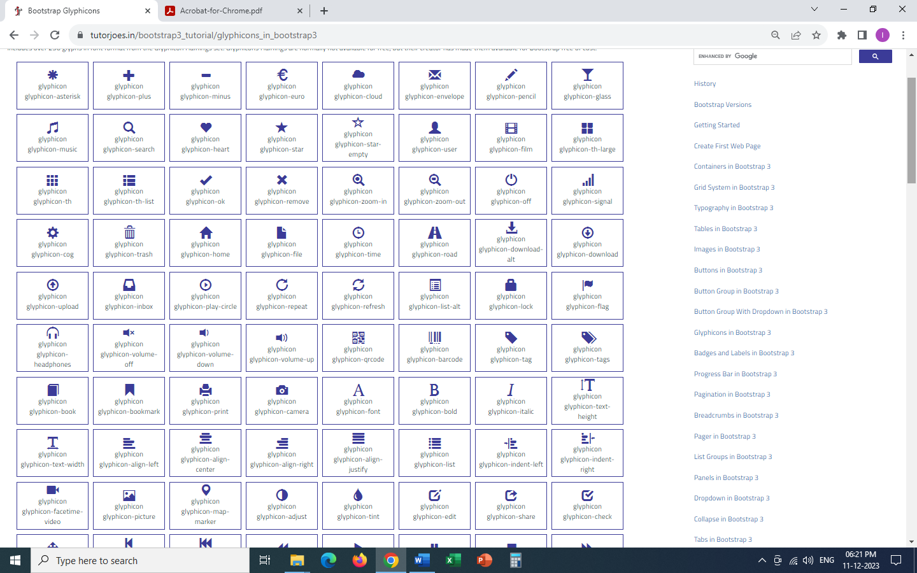

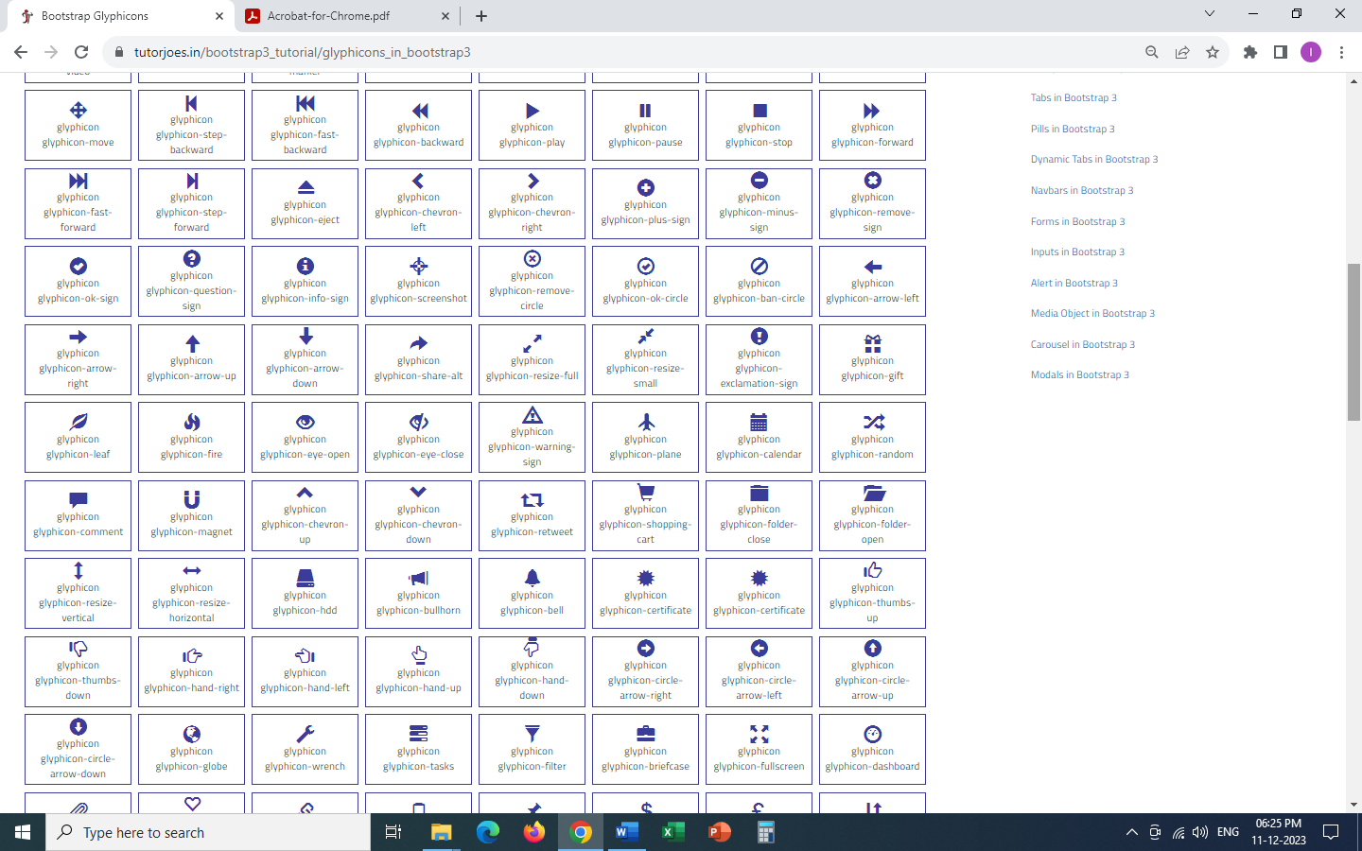

#### 

#### **Source Code**

<!DOCTYPE html>

<**html** lang="en">

<**head**>

<**meta** charset="UTF-8">

<**meta** http-equiv="X-UA-Compatible" content="IE=edge">

<**meta** name="viewport" content="width=device-width, initial-scale=1.0">

<**title**>Tutor Joes</**title**>

<**link** rel="stylesheet" href="https://maxcdn.bootstrapcdn.com/bootstrap/3.4.1/css/bootstrap.min.css">

<!--<link rel="stylesheet" href="css/bootstrap.min.css">-->

<**style**>

**hr** {

**margin-top**: 15px;

**margin-bottom**: 15px;

**display**: block;

}

</**style**>

</**head**>

<**body**>

<**div** class="container">

<**h3**>Bootstrap Glyphicons</**h3**>

<**div** class="row">

<**div** class="col-md-6">

<**i** class="glyphicon glyphicon-user" style="**color**: red;"></**i**>

<**button** class="btn btn-primary"><**i** class="glyphicon glyphicon-user"></**i**> Save</**button**>

</**div**>

</**div**>

</**div**>

<**script** src="https://ajax.googleapis.com/ajax/libs/jquery/3.5.1/jquery.min.js"></**script**>

<**script** src="https://maxcdn.bootstrapcdn.com/bootstrap/3.4.1/js/bootstrap.min.js"></**script**>

<!--<script src="js/jquery.min.js"></script>-->

<!--<script src="js/bootstrap.min.js"></script>-->

</**body**>

</**html**>

### Badges and Labels

Bootstrap **Badges** are numerical indicators used to show that how many items are associated with the specific link. Badges are used to highlight new or unread items.

Bootstrap **labels** are used to specify the additional information about something like offering counts, tips, or other makeup for pages.

**contextual label classes**

* label-default
* label-primary
* label-success
* label-info
* label-warning
* label-danger

**Hint :**To create a label within a <span> element.

#### **Source Code**

<!DOCTYPE html>

<**html** lang="en">

<**head**>

<**meta** charset="UTF-8">

<**meta** http-equiv="X-UA-Compatible" content="IE=edge">

<**meta** name="viewport" content="width=device-width, initial-scale=1.0">

<**title**>Tutor Joes</**title**>

<**link** rel="stylesheet" href="https://maxcdn.bootstrapcdn.com/bootstrap/3.4.1/css/bootstrap.min.css">

<!--<link rel="stylesheet" href="css/bootstrap.min.css">-->

<**style**>

**hr** {

**margin-top**: 15px;

**margin-bottom**: 15px;

**display**: block;

}

</**style**>

</**head**>

<**body**>

<**div** class="container">

<**h3**>Bootstrap Badges and Labels</**h3**>

<**div** class="row">

<**div** class="col-md-6">

<**a** href="#">Inbox <**span** class="badge">10</**span**></**a**> <**br**>

<**a** href="#">Outbox <**span** class="badge">2</**span**></**a**> <**br**>

<**a** href="#">Spam <**span** class="badge">5</**span**></**a**> <**br**>

<**a** href="#">Social <**span** class="badge">50</**span**></**a**> <**br**>

<**hr**>

<**button** class="btn btn-danger">Inbox<**span** class="badge">10</**span**></**button**>

<**hr**>

<**span** class="label label-default">Default</**span**>

<**span** class="label label-primary">primary</**span**>

<**span** class="label label-success">success</**span**>

<**span** class="label label-danger">danger</**span**>

<**span** class="label label-info">info</**span**>

<**span** class="label label-warning">warning</**span**>

<**hr**>

</**div**>

</**div**>

</**div**>

<**script** src="https://ajax.googleapis.com/ajax/libs/jquery/3.5.1/jquery.min.js"></**script**>

<**script** src="https://maxcdn.bootstrapcdn.com/bootstrap/3.4.1/js/bootstrap.min.js"></**script**>

<!--<script src="js/jquery.min.js"></script>-->

<!--<script src="js/bootstrap.min.js"></script>-->

</**body**>

</**html**>

### Progress Bar

Progress components are built with two HTML elements, some CSS to set the width, and a few attributes.

**Bootstrap provides several types of progress bars.**

* progress-bar (default)
* progress-bar-striped

Add class **active** to animate the progress bar

**Colored Progress Bars**

* progress-bar-default
* progress-bar-primary
* progress-bar-success
* progress-bar-info
* progress-bar-warning
* progress-bar-danger

Progress bars can also be stacked.

#### **Source Code**

<!DOCTYPE html>

<**html** lang="en">

<**head**>

<**meta** charset="UTF-8">

<**meta** http-equiv="X-UA-Compatible" content="IE=edge">

<**meta** name="viewport" content="width=device-width, initial-scale=1.0">

<**title**>Tutor Joes</**title**>

<**link** rel="stylesheet" href="https://maxcdn.bootstrapcdn.com/bootstrap/3.4.1/css/bootstrap.min.css">

<!--<link rel="stylesheet" href="css/bootstrap.min.css">-->

<**style**>

**hr** {

**margin-top**: 15px;

**margin-bottom**: 15px;

**display**: block;

}

</**style**>

</**head**>

<**body**>

<**div** class="container">

<**div** class="row">

<**div** class="col-md-6">

<**h3**>Progress Bar</**h3**>

<**div** class="progress">

<**div** class="progress-bar" style="**width**: 60%;">60%</**div**>

</**div**>

<**hr**>

<**div** class="progress">

<**div** class="progress-bar progress-bar-success" role="progressbar" aria-valuemin="0" aria-valuemax="100" aria-valuenow="40" style="**width**: 50%;">50%</**div**>

</**div**>

<**hr**>

<**div** class="progress">

<**div** class="progress-bar progress-bar-danger" style="**width**: 60%;">60%</**div**>

</**div**>

<**hr**>

<**div** class="progress">

<**div** class="progress-bar progress-bar-warning" style="**width**: 60%;">60%</**div**>

</**div**>

<**hr**>

<**div** class="progress">

<**div** class="progress-bar progress-bar-info" style="**width**: 60%;">60%</**div**>

</**div**>

<**hr**>

<**div** class="progress">

<**div** class="progress-bar progress-bar-danger progress-bar-striped" style="**width**: 60%;">60%</**div**>

</**div**>

<**hr**>

<**div** class="progress">

<**div** class="progress-bar progress-bar-danger progress-bar-striped active" style="**width**: 60%;">60%</**div**>

</**div**>

<**hr**>

<**div** class="progress">

<**div** class="progress-bar progress-bar-success" style="**width**: 40%;">40%</**div**>

<**div** class="progress-bar progress-bar-warning" style="**width**: 30%;">30%</**div**>

<**div** class="progress-bar progress-bar-danger" style="**width**: 20%;">20%</**div**>

</**div**>

<**hr**>

</**div**>

</**div**>

</**div**>

<**script** src="https://ajax.googleapis.com/ajax/libs/jquery/3.5.1/jquery.min.js"></**script**>

<**script** src="https://maxcdn.bootstrapcdn.com/bootstrap/3.4.1/js/bootstrap.min.js"></**script**>

<!--<script src="js/jquery.min.js"></script>-->

<!--<script src="js/bootstrap.min.js"></script>-->

</**body**>

</**html**>

### Pagination

If you have a web site with lots of pages, you may wish to add some sort of pagination to each page.

**Pagination size**

Pagination blocks can also be sized to a larger size or a smaller size.

* pagination-lg
* pagination-sm

#### **Source Code**

<!DOCTYPE html>

<**html** lang="en">

<**head**>

<**meta** charset="UTF-8">

<**meta** http-equiv="X-UA-Compatible" content="IE=edge">

<**meta** name="viewport" content="width=device-width, initial-scale=1.0">

<**title**>Tutor Joes</**title**>

<**link** rel="stylesheet" href="https://maxcdn.bootstrapcdn.com/bootstrap/3.4.1/css/bootstrap.min.css">

<!--<link rel="stylesheet" href="css/bootstrap.min.css">-->

<**style**>

**hr** {

**margin-top**: 15px;

**margin-bottom**: 15px;

**display**: block;

}

</**style**>

</**head**>

<**body**>

<**div** class="container">

<**div** class="row">

<**div** class="col-md-6">

<**ul** class="pagination">

<**li**><**a** href="#">1</**a**></**li**>

<**li**><**a** href="#">2</**a**></**li**>

<**li**><**a** href="#">3</**a**></**li**>

<**li**><**a** href="#">4</**a**></**li**>

<**li**><**a** href="#">5</**a**></**li**>

</**ul**>

<**hr**>

<**ul** class="pagination">

<**li**><**a** href="#">1</**a**></**li**>

<**li**><**a** href="#">2</**a**></**li**>

<**li** class="active"><**a** href="#">3</**a**></**li**>

<**li**><**a** href="#">4</**a**></**li**>

<**li** class="disabled"><**a** href="#">5</**a**></**li**>

</**ul**>

<**hr**>

<**ul** class="pagination">

<**li**><**a** href="#">1</**a**></**li**>

<**li**><**a** href="#">2</**a**></**li**>

<**li**><**a** href="#">3</**a**></**li**>

<**li**><**a** href="#">4</**a**></**li**>

<**li**><**a** href="#">5</**a**></**li**>

</**ul**>

<**ul** class="pagination pagination-lg">

<**li**><**a** href="#">1</**a**></**li**>

<**li**><**a** href="#">2</**a**></**li**>

<**li**><**a** href="#">3</**a**></**li**>

<**li**><**a** href="#">4</**a**></**li**>

<**li**><**a** href="#">5</**a**></**li**>

</**ul**>

<**ul** class="pagination pagination-sm">

<**li**><**a** href="#">1</**a**></**li**>

<**li**><**a** href="#">2</**a**></**li**>

<**li**><**a** href="#">3</**a**></**li**>

<**li**><**a** href="#">4</**a**></**li**>

<**li**><**a** href="#">5</**a**></**li**>

</**ul**>

<**hr**>

</**div**>

</**div**>

</**div**>

<**script** src="https://ajax.googleapis.com/ajax/libs/jquery/3.5.1/jquery.min.js"></**script**>

<**script** src="https://maxcdn.bootstrapcdn.com/bootstrap/3.4.1/js/bootstrap.min.js"></**script**>

<!--<script src="js/jquery.min.js"></script>-->

<!--<script src="js/bootstrap.min.js"></script>-->

</**body**>

</**html**>

### Breadcrumbs

Indicate the current page's location within a navigational hierarchy that automatically adds separators via CSS.

#### **Source Code**

<!DOCTYPE html>

<**html** lang="en">

<**head**>

<**meta** charset="UTF-8">

<**meta** http-equiv="X-UA-Compatible" content="IE=edge">

<**meta** name="viewport" content="width=device-width, initial-scale=1.0">

<**title**>Tutor Joes</**title**>

<**link** rel="stylesheet" href="https://maxcdn.bootstrapcdn.com/bootstrap/3.4.1/css/bootstrap.min.css">

<!--<link rel="stylesheet" href="css/bootstrap.min.css">-->

<**style**>

**hr** {

**margin-top**: 15px;

**margin-bottom**: 15px;

**display**: block;

}

</**style**>

</**head**>

<**body**>

<**div** class="container">

<**div** class="row">

<**div** class="col-md-6">

<**ul** class="breadcrumb">

<**li**><**a** href="#">menu-1</**a**></**li**>

<**li**><**a** href="#">menu-2</**a**></**li**>

<**li**><**a** href="#">menu-3</**a**></**li**>

<**li** class="active">menu-4</**li**>

</**ul**>

</**div**>

</**div**>

</**div**>

<**script** src="https://ajax.googleapis.com/ajax/libs/jquery/3.5.1/jquery.min.js"></**script**>

<**script** src="https://maxcdn.bootstrapcdn.com/bootstrap/3.4.1/js/bootstrap.min.js"></**script**>

<!--<script src="js/jquery.min.js"></script>-->

<!--<script src="js/bootstrap.min.js"></script>-->

</**body**>

</**html**>

### Pager

Pager is also a form of pagination. Pager provides previous and next buttons (links)

#### **Source Code**

<!DOCTYPE html>

<**html** lang="en">

<**head**>

<**meta** charset="UTF-8">

<**meta** http-equiv="X-UA-Compatible" content="IE=edge">

<**meta** name="viewport" content="width=device-width, initial-scale=1.0">

<**title**>Tutor Joes</**title**>

<**link** rel="stylesheet" href="https://maxcdn.bootstrapcdn.com/bootstrap/3.4.1/css/bootstrap.min.css">

<!--<link rel="stylesheet" href="css/bootstrap.min.css">-->

<**style**>

**hr** {

**margin-top**: 15px;

**margin-bottom**: 15px;

**display**: block;

}

</**style**>

</**head**>

<**body**>

<**div** class="container">

<**div** class="row">

<**div** class="col-md-12">

<**p**>Lorem ipsum dolor sit amet consectetur adipisicing elit. Quam laborum quidem nostrum provident atque unde, natus neque cupiditate consectetur voluptas sunt similique, assumenda asperiores non? Mollitia dicta reprehenderit atque qui itaque

non deleniti soluta nihil eos. Beatae, a perspiciatis dolorem sequi cumque eveniet, velit maxime laborum dolore, quas odit. Consectetur, voluptate? Nemo natus et dolorem ut nobis qui reprehenderit magnam vitae. A, sunt assumenda dicta,

unde aperiam vel distinctio eum adipisci necessitatibus similique itaque iusto neque ex libero quia nesciunt blanditiis labore harum totam eaque veniam repellat. Magni mollitia odio inventore nostrum! Quibusdam alias dignissimos, ad

tempore rerum nemo, adipisci modi sint, voluptatibus quae animi officiis ea unde recusandae dolore eos dolor sapiente! Possimus hic iure aspernatur, id ab natus doloremque facere, deleniti eligendi ipsam architecto odit molestiae non

cum in vel dolorum quam? Culpa praesentium officia odit adipisci, pariatur, laborum impedit nihil distinctio corrupti ullam debitis perferendis! Facilis est vel earum quaerat reiciendis deserunt ullam iste magnam dicta sed officia

expedita blanditiis doloremque impedit aliquid possimus laborum at animi voluptates, asperiores voluptate officiis, temporibus consequatur. Fugit dicta facere voluptas nesciunt! Velit voluptatum, voluptate debitis officiis, quibusdam

eius itaque quae amet, possimus ipsam magnam eligendi doloribus dicta commodi quisquam delectus?</**p**>

<**ul** class="pager">

<**li**><**a** href="#">Previous</**a**></**li**>

<**li**><**a** href="#">Next</**a**></**li**>

</**ul**>

<**ul** class="pager">

<**li** class="previous"><**a** href="#">Previous</**a**></**li**>

<**li** class="next"><**a** href="#">Next</**a**></**li**>

</**ul**>

</**div**>

</**div**>

</**div**>

<**script** src="https://ajax.googleapis.com/ajax/libs/jquery/3.5.1/jquery.min.js"></**script**>

<**script** src="https://maxcdn.bootstrapcdn.com/bootstrap/3.4.1/js/bootstrap.min.js"></**script**>

<!--<script src="js/jquery.min.js"></script>-->

<!--<script src="js/bootstrap.min.js"></script>-->

</**body**>

</**html**>

### List Groups

List groups are a flexible and powerful component for displaying a series of content. Modify and extend them to support just about any content within.

#### **Source Code**

<!DOCTYPE html>

<**html** lang="en">

<**head**>

<**meta** charset="UTF-8">

<**meta** http-equiv="X-UA-Compatible" content="IE=edge">

<**meta** name="viewport" content="width=device-width, initial-scale=1.0">

<**title**>Tutor Joes</**title**>

<**link** rel="stylesheet" href="https://maxcdn.bootstrapcdn.com/bootstrap/3.4.1/css/bootstrap.min.css">

<!--<link rel="stylesheet" href="css/bootstrap.min.css">-->

<**style**>

**hr** {

**margin-top**: 15px;

**margin-bottom**: 15px;

**display**: block;

}

</**style**>

</**head**>

<**body**>

<**div** class="container">

<**div** class="row">

<**div** class="col-md-6">

<**ul** class="list-group">

<**li** class="list-group-item">Item-1</**li**>

<**li** class="list-group-item">Item-2</**li**>

<**li** class="list-group-item">Item-3</**li**>

</**ul**>

<**hr**>

<**ul** class="list-group">

<**li** class="list-group-item">Inbox <**span** class="badge">10</**span**></**li**>

<**li** class="list-group-item">Sent <**span** class="badge">5</**span**></**li**>

<**li** class="list-group-item">Outbox <**span** class="badge">0</**span**></**li**>

</**ul**>

<**hr**>

<**div** class="list-group">

<**a** href="#" class="list-group-item">Item-1</**a**>

<**a** href="#" class="list-group-item">Item-2</**a**>

<**a** href="#" class="list-group-item active">Item-3</**a**>

<**a** href="#" class="list-group-item">Item-4</**a**>

<**a** href="#" class="list-group-item disabled">Item-5</**a**>

</**div**>

</**div**>

</**div**>

</**div**>

<**script** src="https://ajax.googleapis.com/ajax/libs/jquery/3.5.1/jquery.min.js"></**script**>

<**script** src="https://maxcdn.bootstrapcdn.com/bootstrap/3.4.1/js/bootstrap.min.js"></**script**>

<!--<script src="js/jquery.min.js"></script>-->

<!--<script src="js/bootstrap.min.js"></script>-->

</**body**>

</**html**>

### Panels

A panel in bootstrap is a bordered box with some padding around its content.

#### **Source Code**

<!DOCTYPE html>

<**html** lang="en">

<**head**>

<**meta** charset="UTF-8">

<**meta** http-equiv="X-UA-Compatible" content="IE=edge">

<**meta** name="viewport" content="width=device-width, initial-scale=1.0">

<**title**>Tutor Joes</**title**>

<**link** rel="stylesheet" href="https://maxcdn.bootstrapcdn.com/bootstrap/3.4.1/css/bootstrap.min.css">

<!--<link rel="stylesheet" href="css/bootstrap.min.css">-->

<**style**>

**hr** {

**margin-top**: 15px;

**margin-bottom**: 15px;

**display**: block;

}

</**style**>

</**head**>

<**body**>

<**div** class="container">

<**div** class="row">

<**div** class="col-md-8">

<**div** class="panel panel-default">

<**div** class="panel-heading">Heading</**div**>

<**div** class="panel-body">Lorem ipsum, dolor sit amet consectetur adipisicing elit. Ex, adipisci?</**div**>

<**div** class="panel-footer">Footer</**div**>

</**div**>

<**div** class="panel panel-primary">

<**div** class="panel-heading">Heading</**div**>

<**div** class="panel-body">Lorem ipsum, dolor sit amet consectetur adipisicing elit. Ex, adipisci?</**div**>

<**div** class="panel-footer">Footer</**div**>

</**div**>

<**div** class="panel panel-danger">

<**div** class="panel-heading">Heading</**div**>

<**div** class="panel-body">Lorem ipsum, dolor sit amet consectetur adipisicing elit. Ex, adipisci?</**div**>

<**div** class="panel-footer">Footer</**div**>

</**div**>

</**div**>

</**div**>

</**div**>

<**script** src="https://ajax.googleapis.com/ajax/libs/jquery/3.5.1/jquery.min.js"></**script**>

<**script** src="https://maxcdn.bootstrapcdn.com/bootstrap/3.4.1/js/bootstrap.min.js"></**script**>

<!--<script src="js/jquery.min.js"></script>-->

<!--<script src="js/bootstrap.min.js"></script>-->

</**body**>

</**html**>

### Dropdown

A dropdown menu is a toggleable menu that allows the user to choose one value from a predefined list.

| **Class Name** | **Description** |
| --- | --- |
| dropdown | indicates a dropdown menu. |
| dropdown-toggle | To open the dropdown menu. |
| dropdown-menu | a <ul> element to actually build the dropdown menu. |
| divider | used to separate links inside the dropdown menu with a thin horizontal border. |

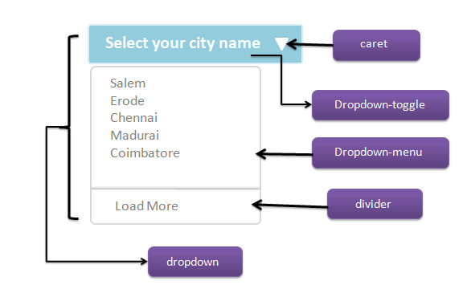

#### **Source Code**

<!DOCTYPE html>

<**html** lang="en">

<**head**>

<**meta** charset="UTF-8">

<**meta** http-equiv="X-UA-Compatible" content="IE=edge">

<**meta** name="viewport" content="width=device-width, initial-scale=1.0">

<**title**>Tutor Joes</**title**>

<**link** rel="stylesheet" href="https://maxcdn.bootstrapcdn.com/bootstrap/3.4.1/css/bootstrap.min.css">

<!--<link rel="stylesheet" href="css/bootstrap.min.css">-->

<**style**>

**hr** {

**margin-top**: 15px;

**margin-bottom**: 15px;

**display**: block;

}

</**style**>

</**head**>

<**body**>

<**div** class="container">

<**div** class="row">

<**div** class="col-md-12">

<**h4**>Dropdowns</**h4**>

<**div** class="dropdown">

<**button** class="btn btn-danger dropdown-toggle" data-toggle="dropdown">

Courses

<**span** class="caret"></**span**>

</**button**>

<**ul** class="dropdown-menu">

<**li**><**a** href="#">C</**a**></**li**>

<**li**><**a** href="#">C++</**a**></**li**>

<**li**><**a** href="#">Java</**a**></**li**>

<**li** class="divider"></**li**>

<**li**><**a** href="#">HTML</**a**></**li**>

<**li**><**a** href="#">CSS</**a**></**li**>

<**li**><**a** href="#">Js</**a**></**li**>

</**ul**>

</**div**>

<**hr**>

<**div** class="dropdown">

<**button** class="btn btn-danger dropdown-toggle" data-toggle="dropdown">Courses <**span** class="caret"></**span**></**button**>

<**ul** class="dropdown-menu">

<**li** class="dropdown-header">Programming Courses</**li**>

<**li** class="active"><**a** href="#">C</**a**></**li**>

<**li**><**a** href="#">C++</**a**></**li**>

<**li** class="disabled"><**a** href="#">Java</**a**></**li**>

<**li** class="divider"></**li**>

<**li** class="dropdown-header">Web Design Courses</**li**>

<**li**><**a** href="#">HTML</**a**></**li**>

<**li**><**a** href="#">CSS</**a**></**li**>

<**li**><**a** href="#">Js</**a**></**li**>

</**ul**>

</**div**>

<**hr**>

<**div** class="dropdown">

<**button** class="btn btn-danger dropdown-toggle" data-toggle="dropdown">Courses <**span** class="caret"></**span**></**button**>

<**ul** class="dropdown-menu dropdown-menu-right">

<**li** class="dropdown-header">Programming Courses</**li**>

<**li** class="active"><**a** href="#">C</**a**></**li**>

<**li**><**a** href="#">C++</**a**></**li**>

<**li** class="disabled"><**a** href="#">Java</**a**></**li**>

<**li** class="divider"></**li**>

<**li** class="dropdown-header">Web Design Courses</**li**>

<**li**><**a** href="#">HTML</**a**></**li**>

<**li**><**a** href="#">CSS</**a**></**li**>

<**li**><**a** href="#">Js</**a**></**li**>

</**ul**>

</**div**>

<**hr**>

<**div** class="dropup">

<**button** class="btn btn-danger dropdown-toggle" data-toggle="dropdown">Courses <**span** class="caret"></**span**></**button**>

<**ul** class="dropdown-menu">

<**li** class="dropdown-header">Programming Courses</**li**>

<**li** class="active"><**a** href="#">C</**a**></**li**>

<**li**><**a** href="#">C++</**a**></**li**>

<**li** class="disabled"><**a** href="#">Java</**a**></**li**>

<**li** class="divider"></**li**>

<**li** class="dropdown-header">Web Design Courses</**li**>

<**li**><**a** href="#">HTML</**a**></**li**>

<**li**><**a** href="#">CSS</**a**></**li**>

<**li**><**a** href="#">Js</**a**></**li**>

</**ul**>

</**div**>

</**div**>

</**div**>

</**div**>

<**script** src="https://ajax.googleapis.com/ajax/libs/jquery/3.5.1/jquery.min.js"></**script**>

<**script** src="https://maxcdn.bootstrapcdn.com/bootstrap/3.4.1/js/bootstrap.min.js"></**script**>

<!--<script src="js/jquery.min.js"></script>-->

<!--<script src="js/bootstrap.min.js"></script>-->

</**body**>

</**html**>

### Collapse

Collapsible are useful when you want to hide and show large amount of content.

* **collapse** - indicates a collapsible (content that will be shown or hidden ) element
* ( Attribute ) **data-toggle="collapse"** - To control (show/hide) the collapsible content

#### **Source Code**

<!DOCTYPE html>

<**html** lang="en">

<**head**>

<**meta** charset="UTF-8">

<**meta** http-equiv="X-UA-Compatible" content="IE=edge">

<**meta** name="viewport" content="width=device-width, initial-scale=1.0">

<**title**>Tutor Joes</**title**>

<**link** rel="stylesheet" href="https://maxcdn.bootstrapcdn.com/bootstrap/3.4.1/css/bootstrap.min.css">

<!--<link rel="stylesheet" href="css/bootstrap.min.css">-->

<**style**>

**hr** {

**margin-top**: 15px;

**margin-bottom**: 15px;

**display**: block;

}

</**style**>

</**head**>

<**body**>

<**div** class="container">

<**div** class="row">

<**div** class="col-md-6">

<**h4**>Collapse</**h4**>

<**button** class="btn btn-success" data-toggle="collapse" data-target="#box">Click Me</**button**>

<**div** id="box" class="collapse" style="**background-color**: teal;**color**:white;**padding**: 5px;">

<**p**>

Lorem ipsum dolor sit amet, consectetur adipisicing elit. Cupiditate delectus unde modi reprehenderit voluptatem nobis non ipsa fuga eligendi natus tenetur, assumenda cumque omnis officiis architecto debitis nisi ullam aspernatur, eum voluptates mollitia

dolores saepe ipsam inventore. Reprehenderit inventore iure hic laboriosam ipsam quae, perspiciatis soluta cupiditate officia cumque rem. Aut saepe necessitatibus soluta perferendis nisi voluptate optio maiores voluptas? Facilis

corporis totam tempora, qui tempore neque ipsam cumque velit? Ipsam, minus quam. Velit dolore unde repudiandae, similique recusandae at vitae quaerat omnis aperiam! Nihil placeat quam odit rerum totam dolor officiis repellendus

quo, sequi voluptate eligendi? Reprehenderit quod quos voluptate velit quia ex sit dolore reiciendis maxime architecto cumque quidem nesciunt laudantium veritatis, quasi hic. Mollitia molestiae voluptatibus quam incidunt accusamus

assumenda ea nesciunt nobis, alias, voluptate odit ex natus rerum. Similique laborum corporis eius dignissimos qui, voluptate esse quaerat dolores blanditiis a, at itaque inventore delectus cum laudantium illum nemo dolorum accusamus.

Cupiditate vitae aspernatur totam, delectus magni adipisci neque fugiat ex dolor obcaecati omnis, aliquid repellat explicabo harum minus! Voluptatum omnis hic eaque perferendis a cumque molestiae. Voluptate, sed. Totam quo atque

fugit impedit laborum ipsam! Et cumque excepturi quis perferendis vitae. Temporibus facilis harum minus impedit?

</**p**>

</**div**>

<**hr**>

<**div** class="panel panel-default">

<**div** class="panel-heading">

<**a** href="#box2" data-toggle="collapse">Heading</**a**>

</**div**>

<**div** id="box2" class="panel-collapse collapse">

<**div** class="panel-body">Lorem ipsum, dolor sit amet consectetur adipisicing elit. Ex, adipisci?</**div**>

<**div** class="panel-footer">Footer</**div**>

</**div**>

</**div**>

</**div**>

</**div**>

</**div**>

<**script** src="https://ajax.googleapis.com/ajax/libs/jquery/3.5.1/jquery.min.js"></**script**>

<**script** src="https://maxcdn.bootstrapcdn.com/bootstrap/3.4.1/js/bootstrap.min.js"></**script**>

<!--<script src="js/jquery.min.js"></script>-->

<!--<script src="js/bootstrap.min.js"></script>-->

</**body**>

</**html**>

### Tabs

Tabs are used to separate content into different panes where each pane is viewable one at a time.

#### **Source Code**

<!DOCTYPE html>

<**html** lang="en">

<**head**>

<**meta** charset="UTF-8">

<**meta** http-equiv="X-UA-Compatible" content="IE=edge">

<**meta** name="viewport" content="width=device-width, initial-scale=1.0">

<**title**>Tutor Joes</**title**>

<**link** rel="stylesheet" href="https://maxcdn.bootstrapcdn.com/bootstrap/3.4.1/css/bootstrap.min.css">

<!--<link rel="stylesheet" href="css/bootstrap.min.css">-->

<**style**>

**hr** {

**margin-top**: 15px;

**margin-bottom**: 15px;

**display**: block;

}

</**style**>

</**head**>

<**body**>

<**div** class="container">

<**div** class="row">

<**div** class="col-md-12">

<**h4**>Tabs</**h4**>

<**hr**>

<**ul** class="nav nav-tabs">

<**li**><**a** href="#">menu-1</**a**></**li**>

<**li** class="active"><**a** href="#">menu-2</**a**></**li**>

<**li**><**a** href="#">menu-3</**a**></**li**>

<**li**><**a** href="#">menu-4</**a**></**li**>

<**li**><**a** href="#">menu-5</**a**></**li**>

</**ul**>

<**hr**>

<**ul** class="nav nav-tabs">

<**li**><**a** href="#">menu-1</**a**></**li**>

<**li** class="active"><**a** href="#">menu-2</**a**></**li**>

<**li** class="dropdown">

<**a** href="#" class="dropdown-toggle" data-toggle="dropdown">

menu-3<**span** class="caret"></**span**>

</**a**>

<**ul** class="dropdown-menu">

<**li**><**a** href="#">Menu</**a**></**li**>

<**li**><**a** href="#">Menu</**a**></**li**>

<**li**><**a** href="#">Menu</**a**></**li**>

</**ul**>

</**li**>

<**li**><**a** href="#">menu-4</**a**></**li**>

<**li**><**a** href="#">menu-5</**a**></**li**>

</**ul**>

</**div**>

</**div**>

</**div**>

<**script** src="https://ajax.googleapis.com/ajax/libs/jquery/3.5.1/jquery.min.js"></**script**>

<**script** src="https://maxcdn.bootstrapcdn.com/bootstrap/3.4.1/js/bootstrap.min.js"></**script**>

<!--<script src="js/jquery.min.js"></script>-->

<!--<script src="js/bootstrap.min.js"></script>-->

</**body**>

</**html**>

### Pills

Tabs are used to separate content into different panes where each pane is viewable one at a time.

To center/justify the tabs and pills, use the**.nav - justified**class.

#### **Source Code**

<!DOCTYPE html>

<**html** lang="en">

<**head**>

<**meta** charset="UTF-8">

<**meta** http-equiv="X-UA-Compatible" content="IE=edge">

<**meta** name="viewport" content="width=device-width, initial-scale=1.0">

<**title**>Tutor Joes</**title**>

<**link** rel="stylesheet" href="https://maxcdn.bootstrapcdn.com/bootstrap/3.4.1/css/bootstrap.min.css">

<!--<link rel="stylesheet" href="css/bootstrap.min.css">-->

<**style**>

**hr** {

**margin-top**: 15px;

**margin-bottom**: 15px;

**display**: block;

}

</**style**>

</**head**>

<**body**>

<**div** class="container">

<**div** class="row">

<**div** class="col-md-12">

<**h4**>Pills</**h4**>

<**hr**>

<**ul** class="nav nav-pills">

<**li** class="active"><**a** href="#">menu-1</**a**></**li**>

<**li**><**a** href="#">menu-2</**a**></**li**>

<**li**><**a** href="#">menu-3</**a**></**li**>

<**li**><**a** href="#">menu-4</**a**></**li**>

<**li**><**a** href="#">menu-5</**a**></**li**>

</**ul**>

<**hr**>

<**div** class="col-md-3">

<**ul** class="nav nav-pills nav-stacked">

<**li** class="active"><**a** href="#">menu-1</**a**></**li**>

<**li**><**a** href="#">menu-2</**a**></**li**>

<**li**><**a** href="#">menu-3</**a**></**li**>

<**li**><**a** href="#">menu-4</**a**></**li**>

<**li**><**a** href="#">menu-5</**a**></**li**>

</**ul**>

</**div**>

</**div**>

</**div**>

</**div**>

<**script** src="https://ajax.googleapis.com/ajax/libs/jquery/3.5.1/jquery.min.js"></**script**>

<**script** src="https://maxcdn.bootstrapcdn.com/bootstrap/3.4.1/js/bootstrap.min.js"></**script**>

<!--<script src="js/jquery.min.js"></script>-->

<!--<script src="js/bootstrap.min.js"></script>-->

</**body**>

</**html**>

### Dynamic Tabs

Tabs are used to separate content into different panes where each pane is viewable one at a time.

* **data-toggle="tab"**   - To make the tabs toggleable.
* **.tab-pane** - To specifies unique tab.
* **.tab-content**- To specifies tab content.
* **.fade**- Tabs to fade in and out when clicking on it.

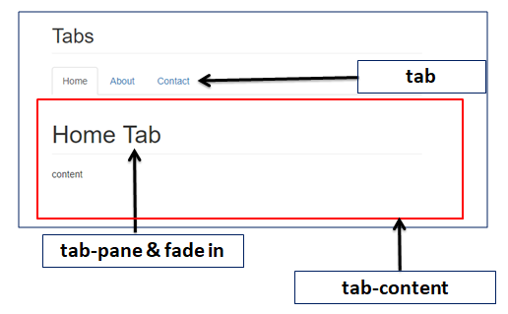

#### **Source Code**

<!DOCTYPE html>

<**html** lang="en">

<**head**>

<**meta** charset="UTF-8">

<**meta** http-equiv="X-UA-Compatible" content="IE=edge">

<**meta** name="viewport" content="width=device-width, initial-scale=1.0">

<**title**>Tutor Joes</**title**>

<**link** rel="stylesheet" href="https://maxcdn.bootstrapcdn.com/bootstrap/3.4.1/css/bootstrap.min.css">

<!--<link rel="stylesheet" href="css/bootstrap.min.css">-->

<**style**>

**hr** {

**margin-top**: 15px;

**margin-bottom**: 15px;

**display**: block;

}

</**style**>

</**head**>

<**body**>

<**div** class="container">

<**div** class="row">

<**div** class="col-md-12">

<**ul** class="nav nav-tabs">

<**li**><**a** data-toggle="tab" href="#menu1">menu-1</**a**></**li**>

<**li** class="active"><**a** data-toggle="tab" href="#menu2">menu-2</**a**></**li**>

<**li**><**a** data-toggle="tab" href="#menu3">menu-3</**a**></**li**>

<**li**><**a** data-toggle="tab" href="#menu4">menu-4</**a**></**li**>

</**ul**>

<**div** class="tab-content">

<**div** id="menu1" class="tab-pane fade">

<**h3**>Menu-1</**h3**>

<**p**>Lorem ipsum dolor sit amet consectetur adipisicing elit. Dignissimos dolorem eius ipsum tempore perspiciatis nemo totam beatae. Pariatur, vitae deleniti.</**p**>

</**div**>

<**div** id="menu2" class="tab-pane fade in active">

<**h3**>Menu-2</**h3**>

<**p**>Lorem ipsum dolor sit amet consectetur adipisicing elit. Dignissimos dolorem eius ipsum tempore perspiciatis nemo totam beatae. Pariatur, vitae deleniti.</**p**>

</**div**>

<**div** id="menu3" class="tab-pane fade">

<**h3**>Menu-3</**h3**>

<**p**>Lorem ipsum dolor sit amet consectetur adipisicing elit. Dignissimos dolorem eius ipsum tempore perspiciatis nemo totam beatae. Pariatur, vitae deleniti.</**p**>

</**div**>

<**div** id="menu4" class="tab-pane fade">

<**h3**>Menu-4</**h3**>

<**p**>Lorem ipsum dolor sit amet consectetur adipisicing elit. Dignissimos dolorem eius ipsum tempore perspiciatis nemo totam beatae. Pariatur, vitae deleniti.</**p**>

</**div**>

</**div**>

</**div**>

</**div**>

</**div**>

<**script** src="https://ajax.googleapis.com/ajax/libs/jquery/3.5.1/jquery.min.js"></**script**>

<**script** src="https://maxcdn.bootstrapcdn.com/bootstrap/3.4.1/js/bootstrap.min.js"></**script**>

<!--<script src="js/jquery.min.js"></script>-->

<!--<script src="js/bootstrap.min.js"></script>-->

</**body**>

</**html**>

### Navigation Bar

navigation bar is a navigation header that is mostly placed at the top of the page. The navigation bar often takes up too much space on a small screen. We should hide the navigation bar; and only show it when it is needed. So using the collapse classes.

| **CLASS NAME** | **USED FOR** |
| --- | --- |
| navbar-brand | used to mark our company or site name. |
| navbar-nav | full-height and lightweight navigation . |
| navbar-fixed-top | makes the navigation bar fixed at the top. |
| navbar-fixed-bottom | makes the navigation bar stay at the bottom. |
| navbar-right | right-align navigation bar menus. |
| navbar-btn | to add buttons inside the navbar. |
| collapse & navbar-collapse | for grouping and hiding navbar contents by a parent breakpoint. |

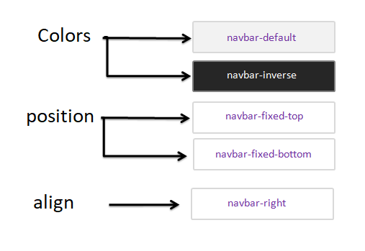

### Fixed top Navigation Bar

<**nav** class="navbar navbar-default navbar-fixed-top">

<**div** class="container-fluid">

<**div** class="navbar-header">

<**a** class="navbar-brand" href="#">Fixed top Navigation</**a**>

</**div**>

</**div**>

</**nav**>

### Fixed Bottom Navigation Bar

<**nav** class="navbar navbar-default navbar-fixed-bottom">

<**div** class="container-fluid">

<**div** class="navbar-header">

<**a** class="navbar-brand" href="#">Fixed top Navigation</**a**>

</**div**>

</**div**>

</**nav**>

### Default Navigation Bar

<**nav** class="navbar navbar-default">

<**div** class="container-fluid">

<**div** class="navbar-header">

<**a** class="navbar-brand" href="#">Fixed top Navigation</**a**>

</**div**>

</**div**>

</**nav**>

### Inverse Colored Navigation Bar

<**nav** class="navbar navbar-inverse">

<**div** class="container-fluid">

<**div** class="navbar-header">

<**a** class="navbar-brand" href="#">Fixed top Navigation</**a**>

</**div**>

</**div**>

</**nav**>

### Responsive Navigation Bar

<**nav** class="navbar navbar-inverse">

<**div** class="container-fluid">

<**div** class="navbar-header">

<**button** type="button" class="navbar-toggle" data-toggle="collapse" data-target="#nav">

<**span** class="icon-bar"></**span**>

<**span** class="icon-bar"></**span**>

<**span** class="icon-bar"></**span**>

</**button**>

<**a** class="navbar-brand" href="#">Tutor Joe's</**a**>

</**div**>

<**div** class="collapse navbar-collapse" id="nav">

<**ul** class="nav navbar-nav navbar-right">

<**li**><**a** href="#">Home</**a**></**li**>

<**li**><**a** href="#">About</**a**></**li**>

<**li**><**a** href="#">Login</**a**></**li**>

</**ul**>

</**div**>

</**div**>

</**nav**>

#### **Source Code**

<!DOCTYPE html>

<**html** lang="en">

<**head**>

<**meta** charset="UTF-8">

<**meta** http-equiv="X-UA-Compatible" content="IE=edge">

<**meta** name="viewport" content="width=device-width, initial-scale=1.0">

<**title**>Tutor Joes</**title**>

<**link** rel="stylesheet" href="https://maxcdn.bootstrapcdn.com/bootstrap/3.4.1/css/bootstrap.min.css">

<!--<link rel="stylesheet" href="css/bootstrap.min.css">-->

<**style**>

**hr**{

**margin-top**: 15px;

**margin-bottom**: 15px;

**display**: block;

}

</**style**>

</**head**>

<**body**>

<**nav** class="navbar navbar-default navbar-fixed-top">

<**div** class="container-fluid">

<**div** class="navbar-header">

<**a** class="navbar-brand" href="#">Fixed top Navigation</**a**>

</**div**>

</**div**>

</**nav**>

<**nav** class="navbar navbar-inverse navbar-fixed-bottom">

<**div** class="container-fluid">

<**div** class="navbar-header">

<**a** href="#" class="navbar-brand">Tutor Joes</**a**>

</**div**>

<**ul** class="nav navbar-nav">

<**li** class="active"><**a** href="#">Link-1</**a**></**li**>

<**li**><**a** href="#">Link-2</**a**></**li**>

<**li**><**a** href="#">Link-3</**a**></**li**>

<**li** class="dropdown">

<**a** href="#" class="dropdown-toggle" data-toggle="dropdown">

Link-4

<**span** class="caret"></**span**>

</**a**>

<**ul** class="dropdown-menu">

<**li**><**a** href="#">link-4.1</**a**></**li**>

<**li**><**a** href="#">link-4.2</**a**></**li**>

<**li**><**a** href="#">link-4.3</**a**></**li**>

</**ul**>

</**li**>

</**ul**>

<**button** class="btn btn-danger navbar-btn">Click Me</**button**>

<**form** class="navbar-form navbar-left">

<**div** class="form-group">

<**input** type="text" class="form-control" placeholder="Search Text">

</**div**>

<**button** type="submit" class="btn btn-primary">Search Now</**button**>

</**form**>

<**ul** class="nav navbar-nav navbar-right">

<**li**><**a** href="#"><**i** class="glyphicon glyphicon-log-in"></**i**> Login</**a**></**li**>

<**li**><**a** href="#"><**i** class="glyphicon glyphicon-user"></**i**> About</**a**></**li**>

</**ul**>

</**div**>

</**nav**>

<**div** class="container" style="**margin-top**:50px;">

<**div** class="row">

<**h2** class="page-header"> Navigation Bar (Default) </**h2**>

<**nav** class="navbar navbar-default">

<**div** class="container-fluid">

<**div** class="navbar-header">

<**a** class="navbar-brand" href="#">Tutor Joe's</**a**>

</**div**>

<**div** class="collapse navbar-collapse" id="myNavbar">

<**ul** class="nav navbar-nav navbar-right">

<**li**><**a** href="#">Home</**a**></**li**>

<**li**><**a** href="#">About</**a**></**li**>

<**li**><**a** href="#">Login</**a**></**li**>

</**ul**>

</**div**>

</**div**>

</**nav**>

<**br**>

<**h2** class="page-header"> Navigation Bar (Inverse) </**h2**>

<**nav** class="navbar navbar-inverse">

<**div** class="container-fluid">

<**div** class="navbar-header">

<**a** class="navbar-brand" href="#">Tutor Joe's</**a**>

</**div**>

<**div** class="collapse navbar-collapse" id="myNavbar">

<**ul** class="nav navbar-nav navbar-right">

<**li**><**a** href="#">Home</**a**></**li**>

<**li**><**a** href="#">About</**a**></**li**>

<**li**><**a** href="#">Login</**a**></**li**>

</**ul**>

</**div**>

</**div**>

</**nav**>

<**br**><**br**>

<**h2** class="page-header">Responsive Navigation Bar (Inverse) </**h2**>

<**nav** class="navbar navbar-inverse">

<**div** class="container-fluid">

<**div** class="navbar-header">

<**button** type="button" class="navbar-toggle" data-toggle="collapse" data-target="#nav">

<**span** class="icon-bar"></**span**>

<**span** class="icon-bar"></**span**>

<**span** class="icon-bar"></**span**>

</**button**>

<**a** class="navbar-brand" href="#">Tutor Joe's</**a**>

</**div**>

<**div** class="collapse navbar-collapse" id="nav">

<**ul** class="nav navbar-nav navbar-right">

<**li**><**a** href="#">Home</**a**></**li**>

<**li**><**a** href="#">About</**a**></**li**>

<**li**><**a** href="#">Login</**a**></**li**>

</**ul**>

</**div**>

</**div**>

</**nav**>

</**div**>

</**div**>

<**div** class="container-fluid" style="**margin-top**: 50px;">

<**div** class="row">

<**div** class="col-md-12">

<**p**>Lorem, ipsum dolor sit amet consectetur adipisicing elit. Dolorum quibusdam non id quo facere iusto! Incidunt ullam minus recusandae magnam quasi esse rerum voluptatem autem libero consequatur eius, voluptates expedita illum. Alias, deleniti

vitae totam velit ullam laudantium voluptatibus quaerat ipsam id, optio porro ea blanditiis unde fugiat praesentium sunt minima, saepe vero atque labore quis voluptas enim accusantium. Asperiores, ratione! Deleniti corrupti incidunt

dolore dignissimos recusandae sequi sed facere debitis accusamus in possimus reiciendis ipsum et perspiciatis eveniet repellat ab expedita eaque minima, consequatur tempore odit maiores ullam. Deleniti inventore expedita doloremque

dicta odit, optio corrupti dolore ratione consequatur quos quaerat cumque natus neque nemo qui commodi. Minima, quo temporibus. Sit amet placeat eaque nobis, consectetur, autem soluta alias adipisci quia molestiae provident temporibus

debitis dolorem vero atque nesciunt nemo quam voluptates necessitatibus iusto. Cumque, dolore repudiandae! Quis deleniti, est consequatur incidunt dignissimos placeat vel perferendis ipsum quae porro ipsa repellendus harum libero accusantium

ex maiores error praesentium voluptas quam sint ratione quasi similique vitae facere! Aliquid incidunt vel quis, sunt corporis nostrum optio illo earum repellendus doloremque voluptate itaque assumenda dolorem soluta velit odit tenetur

maiores dolores vero rem dicta atque. Aliquid iure sequi vitae enim autem dignissimos, unde deleniti dolore optio, modi consequatur soluta nihil! Rerum facilis sint veniam, perspiciatis nostrum perferendis corporis porro soluta consequuntur,

qui asperiores in natus alias exercitationem. Fuga officiis itaque temporibus deserunt, eos molestias provident exercitationem ipsam in error ratione maiores ipsum quibusdam eligendi unde? Eum neque laborum vero expedita excepturi

recusandae blanditiis nam ea dolorum voluptate, asperiores aspernatur quam distinctio enim nostrum ipsam itaque omnis eligendi quis nesciunt maxime velit explicabo ullam sed. Sed sint dignissimos ipsum aut impedit vitae quasi fugiat

repudiandae quis labore? Omnis, enim! Commodi similique molestias fugiat corporis iure corrupti deleniti, libero ipsam error debitis eum voluptatum eveniet aperiam unde, labore, minima nemo sint animi modi veniam non optio nisi doloribus

neque. Nemo quisquam neque aliquid esse commodi ipsam? Molestias, in quis quasi quo pariatur repellendus vero autem exercitationem odio ipsam necessitatibus, modi nulla, vel possimus nobis. Quo, maiores blanditiis incidunt dolorem

sint itaque doloribus totam mollitia quis dolore, ab quia perferendis natus. Nulla dolorum possimus maxime accusantium quod ab magnam rerum vitae similique, enim, impedit, alias magni. Laborum repellat dicta accusantium laboriosam

totam doloribus nulla fugiat iure quod sunt illum dolorum aspernatur ipsa, reiciendis vero sapiente voluptas ad, rem sequi qui, officiis ullam. Porro, dignissimos ipsum ducimus eos officiis perspiciatis consequuntur earum explicabo

itaque, voluptatum quam dolorum repellendus, enim ad laborum! Obcaecati deserunt consectetur consequuntur a expedita cumque? Nulla nisi nobis magni eos in delectus mollitia, ullam unde, qui architecto temporibus aliquam expedita laborum

alias. Commodi ducimus laborum at delectus! Tenetur inventore sapiente magni dicta consequatur mollitia nesciunt reprehenderit! Ex esse voluptatum odio cupiditate dignissimos recusandae accusamus fugit officiis, fuga rerum ut veniam

nostrum eos in nesciunt quidem optio quae soluta ipsa. Quod rerum at ullam possimus pariatur deserunt velit voluptates impedit voluptas autem. Aut in aspernatur explicabo! Omnis exercitationem distinctio pariatur, rerum dolore optio

quibusdam provident error eos maiores modi aut minus fuga repellat sed deserunt necessitatibus ex doloremque? Ad natus possimus amet veniam illum eligendi totam cumque unde, dolor repellendus. Enim animi magnam earum eius provident

ut at doloremque nesciunt possimus. Id, nulla sunt? Quidem non necessitatibus quis possimus quos fugiat dolor! Earum vitae cumque pariatur quos, rem laudantium iure accusamus sequi expedita ab quod dolore asperiores fugit molestias

hic impedit veritatis est, velit, commodi veniam quia. Nobis quam natus beatae rerum adipisci ut qui, neque quia repellendus mollitia recusandae vero accusantium optio possimus illum, porro quis ratione. Quas ex odio cupiditate sint

omnis! Sunt sapiente consectetur qui iste beatae corrupti quaerat totam debitis, adipisci suscipit exercitationem provident temporibus quos eligendi commodi cumque tempora. Inventore accusantium nesciunt aliquid omnis rem quo itaque,

laboriosam quos harum doloribus ducimus consequuntur aliquam ad nam maiores non molestiae voluptate consectetur a! Impedit fugiat soluta, ex eaque doloremque, saepe aliquid est ut numquam vero ducimus assumenda placeat nesciunt molestiae

voluptates unde eveniet nulla! Saepe sapiente dolorem vel quas, officiis sunt iure voluptatem ipsa reiciendis quos eum rerum ratione tenetur quam atque error perspiciatis expedita impedit illo ab eos. Accusamus at culpa repudiandae

quae distinctio repellat doloremque eum cum suscipit. Dolorum, veniam sed repellendus alias veritatis iure facilis quaerat commodi, officiis doloremque dolore, possimus et nesciunt impedit. Tempora sed nulla aliquam ipsa ipsum ad quasi

aliquid neque ut aut odit excepturi fuga dolorum assumenda doloribus, eligendi laudantium atque, provident incidunt voluptate ipsam. Dolores velit dignissimos autem eaque, maiores, dolor ipsa iusto soluta blanditiis omnis provident

quam sit tempore voluptate magnam harum deserunt ut architecto ex quia similique assumenda? Aliquid, velit, quae voluptatum laborum laudantium, facilis sequi impedit ipsa nam ipsum mollitia consequatur fugit odit non quibusdam voluptatibus

quidem voluptatem reiciendis vitae! Qui quibusdam veritatis ducimus nemo esse nisi optio dolorum voluptatem explicabo. Repellendus nesciunt labore tempore corporis aspernatur adipisci quis praesentium nisi excepturi. Et laboriosam,

molestias magni facere repudiandae expedita iusto nesciunt voluptatibus fugiat minus aspernatur nihil modi illum culpa unde illo dignissimos, quas delectus voluptas ipsum fuga officia veniam! Aut rerum fugiat, deserunt ut numquam itaque

illum molestias quasi! Fugiat, dignissimos consequuntur itaque unde at voluptatum autem? Quisquam, commodi? Id ex placeat distinctio perferendis enim libero minus nobis voluptatibus dicta. Fugiat eius voluptatibus excepturi optio earum

soluta harum placeat nesciunt eum saepe. Sed sequi accusamus nulla ut enim adipisci numquam deleniti? Ducimus asperiores delectus fuga officiis dolore, sit qui consectetur earum tempora, perspiciatis ab modi error esse et perferendis

reiciendis? Totam atque voluptate deserunt consequatur qui, quas earum magnam vero repudiandae in necessitatibus unde aliquid accusantium nisi cum placeat voluptates inventore a minus eius, doloribus eveniet sequi praesentium! Animi,

omnis culpa laborum blanditiis neque repellat est rerum, dolorum enim recusandae, dolorem sunt. Doloribus aut harum, similique possimus natus dolor sequi hic voluptate? Eaque magni deleniti itaque possimus, delectus reiciendis suscipit

quo. Deserunt consectetur in ullam delectus saepe laborum iste, impedit possimus harum! Aut adipisci blanditiis non explicabo laboriosam veritatis porro tenetur quisquam molestiae, hic in magnam incidunt magni possimus totam atque

optio eligendi nobis fugit voluptas voluptates at sint error? At ducimus aspernatur fugit illum nostrum? Dolorum distinctio accusamus quam non minima recusandae aperiam, voluptatum ullam ducimus a repudiandae nesciunt tempora perferendis!

Nobis tempore nemo minus doloremque assumenda. Vero blanditiis ullam soluta veniam? Deserunt aperiam magnam repellat hic accusantium labore deleniti reiciendis. Porro perferendis incidunt aliquam nulla doloremque illum ipsam, facere

deleniti amet soluta doloribus corporis similique quae. Quam labore, alias porro dolore, quod iusto eligendi illo rem qui beatae blanditiis, a odit! Itaque nemo deleniti maiores dolorum aliquam exercitationem rem veritatis, doloribus

consequatur molestias, earum magni porro temporibus voluptatibus velit odit! Laudantium dolores numquam quibusdam magnam nulla est expedita quod aliquam facilis quaerat voluptatibus in sunt mollitia, nihil repellat labore sint impedit.

Id adipisci quo, nisi est inventore non saepe qui modi dolores perspiciatis fugit ducimus minus enim aperiam. Officia dolorum ipsam porro tenetur at perferendis, vitae maxime ex error ea totam ullam tempora, nulla fuga consequuntur

itaque. Molestiae, cumque omnis voluptates, labore et distinctio ipsum facere non consequuntur ad, eos nostrum necessitatibus qui! Voluptates facilis dolorem rem numquam culpa tempore sit quas sint, animi voluptatibus et blanditiis

officiis, nulla aliquam dolor a necessitatibus doloremque! Nostrum eveniet eum error quis mollitia aliquam eaque, commodi quos, sapiente sint, delectus corrupti ducimus quam id reprehenderit modi tempore iste fugiat nemo praesentium

iure dolor minus. Laboriosam minus, distinctio voluptatibus voluptatum error cum quos exercitationem officiis aspernatur corporis alias, dolor ipsa sint tempore temporibus nulla nisi repellat. In adipisci nobis fugit blanditiis. Rerum

autem maxime soluta magni rem distinctio doloremque natus nobis ea repellendus quas amet veritatis nisi qui, dolor numquam, reiciendis eligendi, ab quidem illum voluptatibus magnam error eaque! Enim id non, eaque temporibus magnam

explicabo libero corporis! Eveniet ipsum eos culpa omnis quidem assumenda reprehenderit provident, laborum fugiat magnam exercitationem hic suscipit rem at libero eaque facilis iure dolorum doloribus sunt incidunt harum ratione. Distinctio

quas minus, expedita ex nostrum rem debitis impedit voluptatum architecto dolore, fuga soluta voluptatibus iusto. Porro distinctio deserunt, eaque provident nemo minus nesciunt, cumque voluptate eum maiores reprehenderit velit impedit

iusto itaque dignissimos, quos cupiditate consectetur sit hic dolorem perspiciatis saepe! Neque deserunt perferendis nisi distinctio dolorum quisquam cumque amet! Reiciendis eos sunt deserunt sed aut excepturi nobis saepe dolore minus

ullam quidem optio ducimus et sapiente in rerum nemo, placeat recusandae animi sint molestias blanditiis obcaecati ratione? Incidunt ipsam voluptates minus quos provident blanditiis eveniet, totam deleniti! Obcaecati perspiciatis mollitia

aperiam voluptatem distinctio, repudiandae ducimus eos numquam consequuntur, cum eligendi amet blanditiis. Consequatur, blanditiis, quae delectus quo nihil aliquam illo veritatis ipsum atque eos non similique aut laboriosam. Assumenda

corporis qui sunt odit deserunt voluptates eaque ullam laudantium error ipsa quos soluta libero excepturi itaque atque, accusantium velit ratione quo doloribus. Voluptate sed quasi at nesciunt, maiores id ullam, quam odio iure quo

vitae quas facilis praesentium exercitationem laudantium mollitia accusamus, ipsa tenetur dolorem natus? Aliquam, doloremque dignissimos. Molestiae, libero quibusdam nobis porro placeat repellendus dicta velit eius ipsum pariatur quasi

iusto ad! Cupiditate adipisci blanditiis ea vitae perferendis culpa temporibus recusandae minima error sequi fugiat odit, ut numquam magni tempore exercitationem expedita nihil molestias qui? Accusamus molestias velit distinctio soluta

sed, modi repellat animi quos itaque ipsam, quam odio consectetur veritatis aut doloremque eos iusto? Labore doloribus quae, reprehenderit aperiam nulla quis provident iusto culpa eius quo obcaecati temporibus, quas voluptatum! Similique

quasi praesentium eius alias impedit nostrum, vel voluptate ab amet odio sed, tempora ullam placeat corporis maxime nisi doloribus sapiente enim dolorem excepturi facere eligendi dolores. Temporibus officiis quae voluptas similique

commodi architecto iusto, earum rerum neque unde quidem beatae nulla necessitatibus itaque assumenda voluptatibus fugiat id aliquid tempore? Laboriosam temporibus molestiae maiores reiciendis nihil modi possimus necessitatibus expedita,

vel earum nulla nam voluptas. Nulla perferendis iure mollitia tempore voluptate dignissimos atque laborum quisquam eaque. Id repellat saepe, explicabo porro facere autem necessitatibus aliquam distinctio at sint magnam alias nostrum

amet natus eius, numquam corporis? Sequi voluptatem aut blanditiis est, iste cum laboriosam placeat perferendis dolore nostrum quis reiciendis error illo, excepturi omnis numquam hic soluta nam vero deserunt incidunt mollitia aperiam

modi. Facere libero saepe consequuntur dicta animi quia quidem quae ullam quasi iure unde, expedita error nulla soluta, accusantium hic! Dolore itaque magnam dolorum ipsa, eaque tempore aperiam libero odit quae temporibus consectetur

voluptate magni necessitatibus facilis tenetur explicabo odio nostrum a consequatur molestiae amet! Eum, dolor distinctio placeat nemo molestiae ea eos repellat labore quos fugit vitae quia dolore numquam amet doloribus minus dolores!

Quis, eveniet ad dolore error quae cupiditate eaque reprehenderit iste eos quibusdam repellendus sunt veritatis sit vero nesciunt assumenda porro ullam eius reiciendis distinctio tenetur dolores, nobis corporis perferendis? Velit,

amet temporibus! Omnis eos adipisci ratione quidem voluptatibus repudiandae deleniti dicta vel, mollitia neque beatae, veritatis velit ducimus a minus aperiam soluta magnam, illo recusandae saepe. Enim voluptatem officiis commodi eveniet

beatae voluptatum numquam. Ratione accusantium numquam et quia excepturi debitis, labore illum error, aut doloremque quae laboriosam ex commodi! Sunt quasi labore blanditiis architecto non excepturi dolorum obcaecati sint, fugit dolores

accusamus magnam nobis laudantium consectetur deserunt quis quas vero quo odio pariatur. Eligendi accusamus, autem quis, labore, ipsum nulla veritatis ea voluptas provident corrupti veniam itaque sint dolore minima dicta? Reprehenderit

voluptas possimus velit fuga voluptatibus qui eius placeat repellendus. Aliquid possimus alias fuga nulla voluptas iusto corporis vitae labore omnis odit, ullam a dicta dolorum. Dolore cum libero aperiam? Perspiciatis eum excepturi

omnis, atque dignissimos repellendus, recusandae error ratione ipsam quisquam fugiat. Iure ipsa beatae quaerat animi, unde esse dolore, adipisci voluptatum quas sit sunt omnis, vero officiis iste? Illum vitae ratione incidunt? Voluptatum

minima explicabo cum temporibus. Error accusamus cumque ad nostrum quo maxime obcaecati magni cum impedit omnis voluptates nemo deserunt a quos exercitationem beatae optio, delectus illo, minima officiis sed asperiores labore quae!

Quasi, est numquam quibusdam quae itaque quidem sint ea explicabo. Porro non modi suscipit molestias unde, aperiam magnam corporis quasi est laboriosam voluptate itaque officia, architecto ipsam atque numquam eum perspiciatis expedita

aliquam. Sequi, obcaecati?</**p**>

</**div**>

</**div**>

</**div**>

<**script** src="https://ajax.googleapis.com/ajax/libs/jquery/3.5.1/jquery.min.js"></**script**>

<**script** src="https://maxcdn.bootstrapcdn.com/bootstrap/3.4.1/js/bootstrap.min.js"></**script**>

<!--<script src="js/jquery.min.js"></script>-->

<!--<script src="js/bootstrap.min.js"></script>-->

</**body**>

</**html**>

### Forms

Form controls automatically receive some global styling with Bootstrap.

**Bootstrap provides three types of form layouts**

* Vertical form (this is default)
* Horizontal form
* Inline form

### Vertical form

In an Vertical form is default method of form alignment in bootstrap, all of the elements are take new line, left-aligned format.

<**form** action="#">

<**div** class="form-group">

<**label** for="name">User Name:</**label**>

<**input** type="text" class="form-control" id="name">

</**div**>

<**div** class="form-group">

<**label** for="pass">Password:</**label**>

<**input** type="password" class="form-control" id="pass">

</**div**>

<**div** class="form-group">

<**label** >City:</**label**>

<**select** class="form-control">

<**option** value="">Select</**option**>

<**option** value="">Salem</**option**>

<**option** value="">Erode</**option**>

<**option** value="">Chennai</**option**>

</**select**>

</**div**>

<**div** class="checkbox">

<**label**><**input** type="checkbox"> Remember me</**label**>

</**div**>

<**button** type="submit" class="btn btn-primary">Submit</**button**>

</**form**>

### Horizontal form

A horizontal form means that the labels are aligned next to the input field on large and medium screens. On small screens, it will transform to a vertical form.

<**form** class="form-horizontal" action="#">

<**div** class="form-group">

<**label** class="control-label col-sm-2" for="City">City:</**label**>

<**div** class="col-sm-10">

<**input** type="text" class="form-control" id="city" placeholder="Enter City">

</**div**>

</**div**>

<**div** class="form-group">

<**label** class="control-label col-sm-2" for="pwd">Address:</**label**>

<**div** class="col-sm-10">

<**textarea** type="text" class="form-control" id="addr" placeholder="Enter Address"></**textarea**>

</**div**>

</**div**>

<**div** class="form-group">

<**div** class="col-sm-offset-2 col-sm-10">

<**button** type="submit" class="btn btn-success" >Submit</**button**>

</**div**>

</**div**>

</**form**>

### Inline form

In an inline form, all of the elements are inline, left-aligned, and the labels are alongside.

<**form** action="#" class="form-inline">

<**div** class="form-group">

<**label** for="email">Email :</**label**>

<**input** type="email" class="form-control" id="email">

</**div**>

<**div** class="form-group">

<**label** for="pno">Phone Number:</**label**>

<**input** type="password" class="form-control" id="pno">

</**div**>

<**div** class="radio">

<**label**>Gender</**label**>

<**input** type="radio" name="gen"> Male

<**input** type="radio" name="gen"> Female

</**div**>

<**div** class="form-group">

<**button** type="submit" class="btn btn-info">Submit</**button**>

</**div**>

</**form**>

#### **Source Code**

<!DOCTYPE html>

<**html** lang="en">

<**head**>

<**meta** charset="UTF-8">

<**meta** http-equiv="X-UA-Compatible" content="IE=edge">

<**meta** name="viewport" content="width=device-width, initial-scale=1.0">

<**title**>Tutor Joes</**title**>

<**link** rel="stylesheet" href="https://maxcdn.bootstrapcdn.com/bootstrap/3.4.1/css/bootstrap.min.css">

<!--<link rel="stylesheet" href="css/bootstrap.min.css">-->

<**style**>

**hr**{

**margin-top**: 15px;

**margin-bottom**: 15px;

**display**: block;

}

</**style**>

</**head**>

<**body**>

<**div** class="container" style="**margin-top**:20px;">

<**div** class="row">

<**div** class="col-md-3">

<**h2** class="page-header">Vertical form</**h2**>

<**form** action="#">

<**div** class="form-group">

<**label** for="name">User Name:</**label**>

<**input** type="text" class="form-control" id="name">

</**div**>

<**div** class="form-group">

<**label** for="pass">Password:</**label**>

<**input** type="password" class="form-control" id="pass">

</**div**>

<**div** class="form-group">

<**label** >City:</**label**>

<**select** class="form-control">

<**option** value="">Select</**option**>

<**option** value="">Salem</**option**>

<**option** value="">Erode</**option**>

<**option** value="">Chennai</**option**>

</**select**>

</**div**>

<**div** class="checkbox">

<**label**><**input** type="checkbox"> Remember me</**label**>

</**div**>

<**button** type="submit" class="btn btn-primary">Submit</**button**>

</**form**>

</**div**>

<**div** class="col-md-9">

<**h2** class="page-header">Inline form</**h2**>

<**form** action="#" class="form-inline">

<**div** class="form-group">

<**label** for="email">Email :</**label**>

<**input** type="email" class="form-control" id="email">

</**div**>

<**div** class="form-group">

<**label** for="pno">Phone Number:</**label**>

<**input** type="password" class="form-control" id="pno">

</**div**>

<**div** class="radio">

<**label**>Gender</**label**>

<**input** type="radio" name="gen"> Male

<**input** type="radio" name="gen"> Female

</**div**>

<**div** class="form-group">

<**button** type="submit" class="btn btn-info">Submit</**button**>

</**div**>

</**form**>

</**div**>

<**div** class="col-md-12">

<**h2** class="page-header">Horizontal form</**h2**>

<**form** class="form-horizontal" action="#">

<**div** class="form-group">

<**label** class="control-label col-sm-2" for="City">City:</**label**>

<**div** class="col-sm-10">

<**input** type="text" class="form-control" id="city" placeholder="Enter City">

</**div**>

</**div**>

<**div** class="form-group">

<**label** class="control-label col-sm-2" for="pwd">Address:</**label**>

<**div** class="col-sm-10">

<**textarea** type="text" class="form-control" id="addr" placeholder="Enter Address"></**textarea**>

</**div**>

</**div**>

<**div** class="form-group">

<**div** class="col-sm-offset-2 col-sm-10">

<**button** type="submit" class="btn btn-success" >Submit</**button**>

</**div**>

</**div**>

</**form**>

</**div**>

</**div**>

</**div**>

<**script** src="https://ajax.googleapis.com/ajax/libs/jquery/3.5.1/jquery.min.js"></**script**>

<**script** src="https://maxcdn.bootstrapcdn.com/bootstrap/3.4.1/js/bootstrap.min.js"></**script**>

<!--<script src="js/jquery.min.js"></script>-->

<!--<script src="js/bootstrap.min.js"></script>-->

</**body**>

</**html**>

### Inputs

Most usage Bootstrap controls

* checkbox
* radio
* input

### Checkbox

Checkboxes are used if you want the user to select any number of options from a list of preset options.

**Display Option**

* Vertical align
* Inline

#### **Vertical Checkbox**

<**form**>

<**div** class="checkbox">

<**label**><**input** type="checkbox" value="">BCA</**label**>

</**div**>

<**div** class="checkbox">

<**label**><**input** type="checkbox" value="">MCA</**label**>

</**div**>

<**div** class="checkbox">

<**label**><**input** type="checkbox" value="">BSC CS</**label**>

</**div**>

<**div** class="checkbox">

<**label**><**input** type="checkbox" value="">MSC CS</**label**>

</**div**>

</**form**>

#### **Inline Checkbox**

<**form**>

<**label** class="checkbox-inline">

<**input** type="checkbox" value="">BCA

</**label**>

<**label** class="checkbox-inline">

<**input** type="checkbox" value="">MCA

</**label**>

<**label** class="checkbox-inline">

<**input** type="checkbox" value="">BSC CS

</**label**>

<**label** class="checkbox-inline">

<**input** type="checkbox" value="">MSC CS

</**label**>

</**form**>

### Radio

Radio buttons are used if you want to limit the user to just one selection from a list of preset options.

**Display Option**

* Vertical align
* Inline

#### **Vertical Radio Button**

<**form**>

<**div** class="radio">

<**label**><**input** type="radio" name="gen">Male</**label**>

</**div**>

<**div** class="radio">

<**label**><**input** type="radio" name="gen">Female</**label**>

</**div**>

</**form**>

#### **Inline Radio Button**

<**form**>

<**label** class="radio-inline">

<**input** type="radio" name="gen">Male

</**label**>

<**label** class="radio-inline">

<**input** type="radio" name="gen">Female

</**label**>

</**form**>

### Input Groups

The **.input-group** class is a container to enhance an input by adding an icon, text or a button in front or behind it as a "help text".

* **.input-group-addon** attaches an icon
* **.input-group-btn** attaches a button next to an input

<**form**>

<**div** class="input-group">

<**span** class="input-group-addon"><**i** class="glyphicon glyphicon-user"></**i**></**span**>

<**input** id="name" type="text" class="form-control" name="name" placeholder="Name">

</**div**>

<**div** class="input-group">

<**span** class="input-group-addon"><**i** class="glyphicon glyphicon-lock"></**i**></**span**>

<**input** id="pass" type="password" class="form-control" name="pass" placeholder="Password">

</**div**>

<**br**>

<**div** class="input-group">

<**input** type="text" class="form-control" placeholder="Search">

<**div** class="input-group-btn">

<**button** class="btn btn-success" type="submit">

<**i** class="glyphicon glyphicon-search"></**i**>

</**button**>

</**div**>

</**div**>

</**form**>

### Input Control States

| **Control** | **Used** |
| --- | --- |
| focus | The outline of the input |
| Disabled | This attribute to disable an input field |
| Readonly | This attribute to an input to prevent user input |
| Validation States (.has-error or .has-success ) | This attribute to an input to prevent user input |
| .has-feedback ( Icons ) | You can add feedback icons |
| .sr-only | Non-visible labels |

<**form** class="form-horizontal">

<**div** class="form-group">

<**label** for="dis" class="col-sm-2 control-label">Disabled</**label**>

<**div** class="col-sm-10">

<**input** class="form-control" id="dis" type="text" disabled>

</**div**>

</**div**>

<**div** class="form-group has-success has-feedback">

<**label** class="col-sm-2 control-label" for="suc">

success</**label**>

<**div** class="col-sm-10">

<**input** type="text" class="form-control" id="suc">

<**span** class="glyphicon glyphicon-ok form-control-feedback"></**span**>

</**div**>

</**div**>

<**div** class="form-group has-warning has-feedback">

<**label** class="col-sm-2 control-label" for="war">

warning</**label**>

<**div** class="col-sm-10">

<**input** type="text" class="form-control" id="war">

<**span** class="glyphicon glyphicon-warning-sign form-control-feedback"></**span**>

</**div**>

</**div**>

<**div** class="form-group has-error has-feedback">

<**label** class="col-sm-2 control-label" for="err">

error</**label**>

<**div** class="col-sm-10">

<**input** type="text" class="form-control" id="err">

<**span** class="glyphicon glyphicon-remove form-control-feedback"></**span**>

</**div**>

</**div**>

</**form**>

### Input Size

Set the heights of input elements using bootstrap classes

* **input-sm**
* **input-lg**
* **input-group-lg**  - Change size all inputs and other elements inside an .input-group
* **form-group-lg** - Change size of labels and form controls within a Horizontal form

<**h2** class="page-header"> Input Size</**h2**>

<**form**>

<**div** class="form-group">

<**label**>First Name </**label**>

<**input** type="text" class="form-control input-sm" placeholder="small size">

</**div**>

<**div** class="form-group">

<**label**>Last Name </**label**>

<**input** type="text" class="form-control" placeholder="Default size">

</**div**>

<**div** class="form-group">

<**label**>Phone Number </**label**>

<**input** type="text" class="form-control input-lg" placeholder="Large size">

</**div**>

</**form**>

<**h2** class="page-header"> Group Size</**h2**>

<**form** class="form-horizontal">

<**div** class="form-group form-group-lg">

<**label** class="col-sm-2 control-label" for="lg">lg</**label**>

<**div** class="col-sm-10">

<**input** class="form-control" type="text" id="lg">

</**div**>

</**div**>

<**div** class="form-group form-group-sm">

<**label** class="col-sm-2 control-label" for="sm">sm</**label**>

<**div** class="col-sm-10">

<**input** class="form-control" type="text" id="sm">

</**div**>

</**div**>

<**div** class="input-group input-group-lg">

<**input** type="text" class="form-control" placeholder="Search">

<**div** class="input-group-btn">

<**button** class="btn btn-default" type="submit"><**i** class="glyphicon glyphicon-search"></**i**></**button**>

</**div**>

</**div**><**br**><**br**>

<**div** class="input-group input-group-sm">

<**input** type="text" class="form-control" placeholder="Search">

<**div** class="input-group-btn">

<**button** class="btn btn-default" type="submit"><**i** class="glyphicon glyphicon-search"></**i**></**button**>

</**div**>

</**div**>

</**form**>

#### **Source Code**

<!DOCTYPE html>

<**html** lang="en">

<**head**>

<**meta** charset="UTF-8">

<**meta** http-equiv="X-UA-Compatible" content="IE=edge">

<**meta** name="viewport" content="width=device-width, initial-scale=1.0">

<**title**>Tutor Joes</**title**>

<**link** rel="stylesheet" href="https://maxcdn.bootstrapcdn.com/bootstrap/3.4.1/css/bootstrap.min.css">

<!--<link rel="stylesheet" href="css/bootstrap.min.css">-->

<**style**>

**hr**{

**margin-top**: 15px;

**margin-bottom**: 15px;

**display**: block;

}

</**style**>

</**head**>

<**body**>

<**div** class="container" style="**margin-top**:20px;">

<**div** class="row">

<**div** class="col-md-6">

<**h2** class="page-header">Checkboxs</**h2**>

<**div** class="col-md-5">

<**form**>

<**div** class="checkbox">

<**label**><**input** type="checkbox" value="">BCA</**label**>

</**div**>

<**div** class="checkbox">

<**label**><**input** type="checkbox" value="">MCA</**label**>

</**div**>

<**div** class="checkbox">

<**label**><**input** type="checkbox" value="">BSC CS</**label**>

</**div**>

<**div** class="checkbox">

<**label**><**input** type="checkbox" value="">MSC CS</**label**>

</**div**>

</**form**>

</**div**>

<**div** class="col-md-7">

<**form**>

<**label** class="checkbox-inline">

<**input** type="checkbox" value="">BCA

</**label**>

<**label** class="checkbox-inline">

<**input** type="checkbox" value="">MCA

</**label**>

<**label** class="checkbox-inline">

<**input** type="checkbox" value="">BSC CS

</**label**>

<**label** class="checkbox-inline">

<**input** type="checkbox" value="">MSC CS

</**label**>

</**form**>

</**div**>

</**div**>

<**div** class="col-md-6">

<**h2** class="page-header">Radio Box</**h2**>

<**div** class="col-md-5">

<**form**>

<**div** class="radio">

<**label**><**input** type="radio" name="gen">Male</**label**>

</**div**>

<**div** class="radio">

<**label**><**input** type="radio" name="gen">Female</**label**>

</**div**>

</**form**>

</**div**>

<**div** class="col-md-7">

<**form**>

<**label** class="radio-inline">

<**input** type="radio" name="gen">Male

</**label**>

<**label** class="radio-inline">

<**input** type="radio" name="gen">Female

</**label**>

</**form**>

</**div**><**br** style="**clear**:both;">

</**div**>

</**div**>

<**div** class="col-md-6">

<**h2** class="page-header"> Input Groups</**h2**>

<**form**>

<**div** class="input-group">

<**span** class="input-group-addon"><**i** class="glyphicon glyphicon-user"></**i**></**span**>

<**input** id="name" type="text" class="form-control" name="name" placeholder="Name">

</**div**>

<**div** class="input-group">

<**span** class="input-group-addon"><**i** class="glyphicon glyphicon-lock"></**i**></**span**>

<**input** id="pass" type="password" class="form-control" name="pass" placeholder="Password">

</**div**>

<**br**>

<**div** class="input-group">

<**input** type="text" class="form-control" placeholder="Search">

<**div** class="input-group-btn">

<**button** class="btn btn-success" type="submit">

<**i** class="glyphicon glyphicon-search"></**i**>

</**button**>

</**div**>

</**div**>

</**form**>

</**div**>

<**div** class="col-md-6">

<**h2** class="page-header"> Input Control States</**h2**>

<**form** class="form-horizontal">

<**div** class="form-group">

<**label** for="dis" class="col-sm-2 control-label">Disabled</**label**>

<**div** class="col-sm-10">

<**input** class="form-control" id="dis" type="text" disabled>

</**div**>

</**div**>

<**div** class="form-group has-success has-feedback">

<**label** class="col-sm-2 control-label" for="suc">

success</**label**>

<**div** class="col-sm-10">

<**input** type="text" class="form-control" id="suc">

<**span** class="glyphicon glyphicon-ok form-control-feedback"></**span**>

</**div**>

</**div**>

<**div** class="form-group has-warning has-feedback">

<**label** class="col-sm-2 control-label" for="war">

warning</**label**>

<**div** class="col-sm-10">

<**input** type="text" class="form-control" id="war">

<**span** class="glyphicon glyphicon-warning-sign form-control-feedback"></**span**>

</**div**>

</**div**>

<**div** class="form-group has-error has-feedback">

<**label** class="col-sm-2 control-label" for="err">

error</**label**>

<**div** class="col-sm-10">

<**input** type="text" class="form-control" id="err">

<**span** class="glyphicon glyphicon-remove form-control-feedback"></**span**>

</**div**>

</**div**>

</**form**>

</**div**>

<**div** class="col-md-6">

<**h2** class="page-header"> Input Size</**h2**>

<**form**>

<**div** class="form-group">

<**label**>First Name </**label**>

<**input** type="text" class="form-control input-sm" placeholder="small size">

</**div**>

<**div** class="form-group">

<**label**>Last Name </**label**>

<**input** type="text" class="form-control" placeholder="Default size">

</**div**>

<**div** class="form-group">

<**label**>Phone Number </**label**>

<**input** type="text" class="form-control input-lg" placeholder="Large size">

</**div**>

</**form**>

</**div**>

<**div** class="col-md-6">

<**h2** class="page-header"> Group Size</**h2**>

<**form** class="form-horizontal">

<**div** class="form-group form-group-lg">

<**label** class="col-sm-2 control-label" for="lg">lg</**label**>

<**div** class="col-sm-10">

<**input** class="form-control" type="text" id="lg">

</**div**>

</**div**>

<**div** class="form-group form-group-sm">

<**label** class="col-sm-2 control-label" for="sm">sm</**label**>

<**div** class="col-sm-10">

<**input** class="form-control" type="text" id="sm">

</**div**>

</**div**>

<**div** class="input-group input-group-lg">

<**input** type="text" class="form-control" placeholder="Search">

<**div** class="input-group-btn">

<**button** class="btn btn-default" type="submit"><**i** class="glyphicon glyphicon-search"></**i**></**button**>

</**div**>

</**div**><**br**><**br**>

<**div** class="input-group input-group-sm">

<**input** type="text" class="form-control" placeholder="Search">

<**div** class="input-group-btn">

<**button** class="btn btn-default" type="submit"><**i** class="glyphicon glyphicon-search"></**i**></**button**>

</**div**>

</**div**>

</**form**>

</**div**>

</**div**>

<**script** src="https://ajax.googleapis.com/ajax/libs/jquery/3.5.1/jquery.min.js"></**script**>

<**script** src="https://maxcdn.bootstrapcdn.com/bootstrap/3.4.1/js/bootstrap.min.js"></**script**>

<!--<script src="js/jquery.min.js"></script>-->

<!--<script src="js/bootstrap.min.js"></script>-->

</**body**>

</**html**>

### Alerts

Bootstrap provides an easy way to create predefined alert messages. Alerts are available for any length of text, as well as an optional dismiss button.

Alerts are created with the **.alert** class

#### Contextual Classes

* alert-primary
* alert-success
* alert-info
* alert-warning
* alert-danger

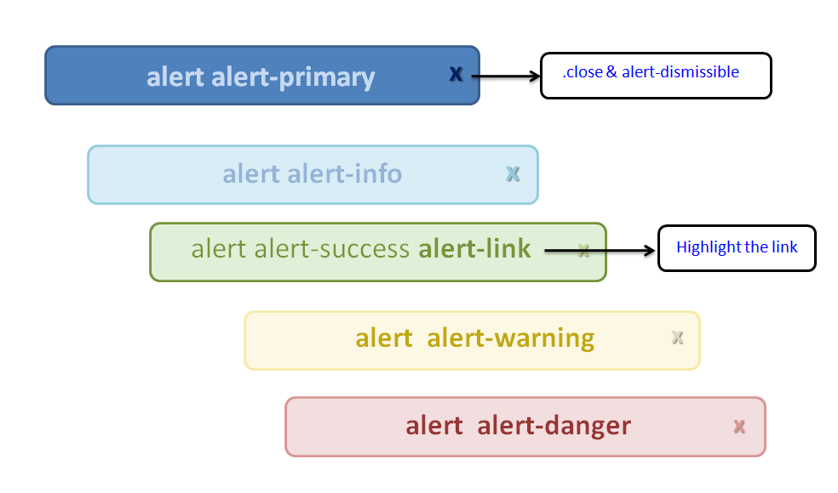

* **alert-link**- Add any links inside the alert box
* **alert-dismissible & close**- Class to the alert container.
* **fade and in** - Adds a fading effect when closing the alert

#### **Source Code**

<!DOCTYPE html>

<**html** lang="en">

<**head**>

<**meta** charset="UTF-8">

<**meta** http-equiv="X-UA-Compatible" content="IE=edge">

<**meta** name="viewport" content="width=device-width, initial-scale=1.0">

<**title**>Tutor Joes</**title**>

<**link** rel="stylesheet" href="https://maxcdn.bootstrapcdn.com/bootstrap/3.4.1/css/bootstrap.min.css">

<!--<link rel="stylesheet" href="css/bootstrap.min.css">-->

<**style**>

**hr**{

**margin-top**: 15px;

**margin-bottom**: 15px;

**display**: block;

}

</**style**>

</**head**>

<**body**>

<**div** class="container" style="**margin-top**:20px;">

<**div** class="row">

<**div** class="col-md-4">

<**div** class="alert alert-primary">

<**b**>Primary!</**b**> Default Alert

</**div**>

<**div** class="alert alert-success">

<**b**>Success!</**b**> Green Alert

</**div**>

<**div** class="alert alert-info">

<**b**>Info!</**b**> Blue Alert

</**div**>

<**div** class="alert alert-danger">

<**b**>Danger!</**b**> Red Alert

</**div**>

<**div** class="alert alert-warning">

<**b**>Warning!</**b**> Yellow Alert

</**div**>

</**div**>

<**div** class="col-md-offset-1 col-md-4">

<**div** class="alert alert-warning">

<**b**>alert-link</**b**> Any links inside the alert box to create <**a** href="#" class="alert-link">matching colored links</**a**>.

</**div**>

<**h2** class="page-header">Closing Alerts </**h2**>

<**div** class="alert alert-info alert-dismissible">

<**a** href="#" class="close" data-dismiss="alert" aria-label="close">&times;</**a**>

<**strong**>Closing Alert!</**strong**>

</**div**>

<**h2** class="page-header">Animated Alerts</**h2**>

<**div** class="alert alert-danger fade in">

<**a** href="#" class="close" data-dismiss="alert" aria-label="close">&times;</**a**>

<**strong**>Animated Alert!</**strong**>

</**div**>

</**div**>

</**div**>

</**div**>

<**script** src="https://ajax.googleapis.com/ajax/libs/jquery/3.5.1/jquery.min.js"></**script**>

<**script** src="https://maxcdn.bootstrapcdn.com/bootstrap/3.4.1/js/bootstrap.min.js"></**script**>

<!--<script src="js/jquery.min.js"></script>-->

<!--<script src="js/bootstrap.min.js"></script>-->

</**body**>

</**html**>

### Media Object

Bootstrap provides an easy way to align media objects (like images or videos) to the left or to the right of some content.

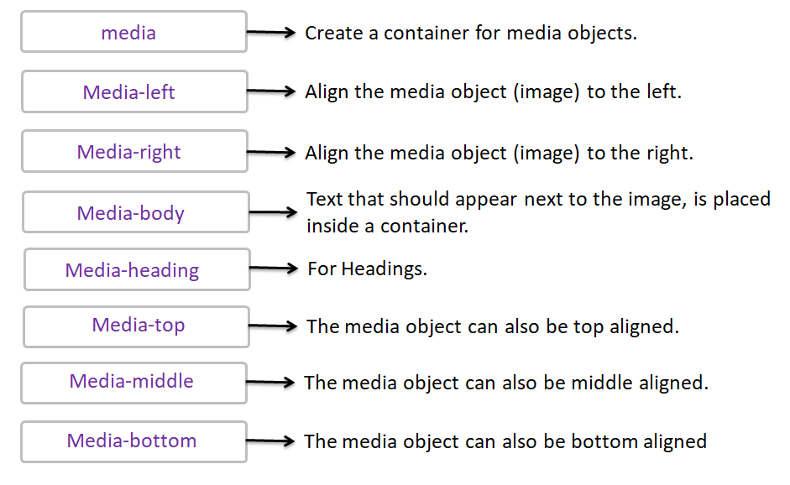

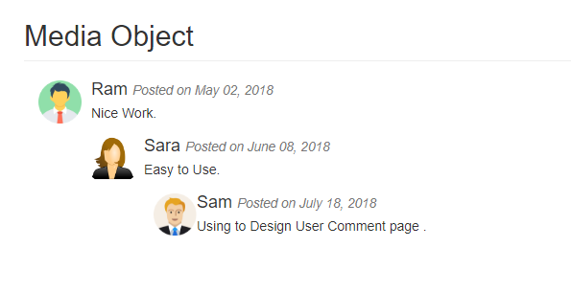

#### **Source Code**

<!DOCTYPE html>

<**html** lang="en">

<**head**>

<**meta** charset="UTF-8">

<**meta** http-equiv="X-UA-Compatible" content="IE=edge">

<**meta** name="viewport" content="width=device-width, initial-scale=1.0">

<**title**>Tutor Joes</**title**>

<**link** rel="stylesheet" href="https://maxcdn.bootstrapcdn.com/bootstrap/3.4.1/css/bootstrap.min.css">

<!--<link rel="stylesheet" href="css/bootstrap.min.css">-->

<**style**>

**hr**{

**margin-top**: 15px;

**margin-bottom**: 15px;

**display**: block;

}

</**style**>

</**head**>

<**body**>

<**div** class="container" style="**margin-top**:20px;">

<**div** class="row">

<**h2** class="page-header">Media Object</**h2**>

<**div** class="col-md-9">

<**div** class="media">

<**div** class="media-left">

<**img** src="u1.png" class="media-object" style="**width**:45px">

</**div**>

<**div** class="media-body">

<**h4** class="media-heading">Ram <**small**><**i**>Posted on May 02, 2018</**i**></**small**></**h4**>

<**p**>Nice Work.</**p**>

<!-- Nested media object -->

<**div** class="media">

<**div** class="media-left">

<**img** src="u2.png" class="media-object" style="**width**:45px">

</**div**>

<**div** class="media-body">

<**h4** class="media-heading"> Sara <**small**><**i**>Posted on June 08, 2018</**i**></**small**></**h4**>

<**p**> Easy to Use.</**p**>

<!-- Nested media object -->

<**div** class="media">

<**div** class="media-right">

<**img** src="u3.png" class="media-object" style="**width**:45px">

</**div**>

<**div** class="media-body">

<**h4** class="media-heading"> Sam <**small**><**i**>Posted on July 18, 2018</**i**></**small**></**h4**>

<**p**> Using to Design User Comment page .</**p**>

</**div**>

</**div**>

</**div**>

</**div**>

</**div**>

</**div**>

</**div**>

</**div**>

</**div**>

<**script** src="https://ajax.googleapis.com/ajax/libs/jquery/3.5.1/jquery.min.js"></**script**>

<**script** src="https://maxcdn.bootstrapcdn.com/bootstrap/3.4.1/js/bootstrap.min.js"></**script**>

<!--<script src="js/jquery.min.js"></script>-->

<!--<script src="js/bootstrap.min.js"></script>-->

</**body**>

</**html**>

### Carousel

The Carousel plugin is a component for cycling through elements, like a slideshow.

**Plugins can be included individually "carousel.js" or "bootstrap.js" or "bootstrap.min.js".**

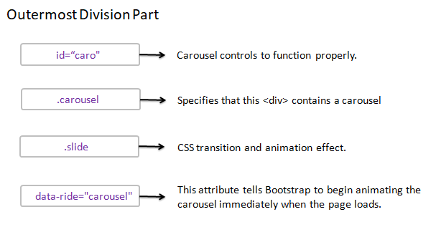

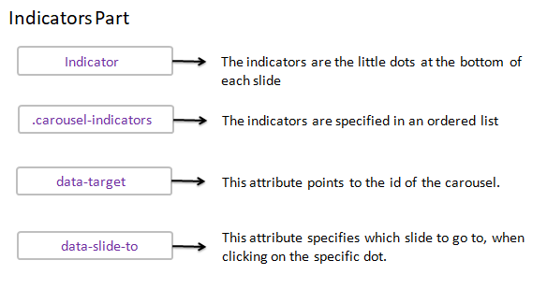

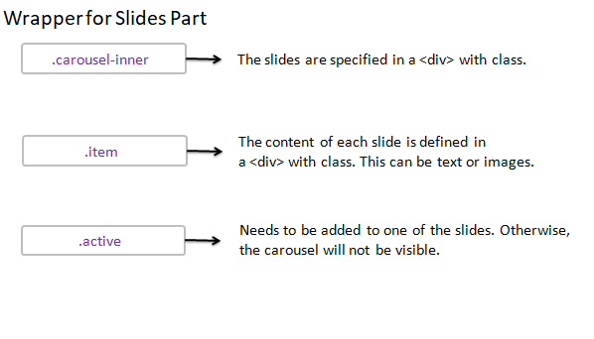

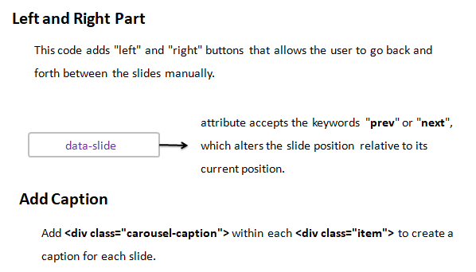

#### **Source Code**

<!DOCTYPE html>

<**html** lang="en">

<**head**>

<**meta** charset="UTF-8">

<**meta** http-equiv="X-UA-Compatible" content="IE=edge">

<**meta** name="viewport" content="width=device-width, initial-scale=1.0">

<**title**>Tutor Joes</**title**>

<**link** rel="stylesheet" href="https://maxcdn.bootstrapcdn.com/bootstrap/3.4.1/css/bootstrap.min.css">

<!--<link rel="stylesheet" href="css/bootstrap.min.css">-->

<**style**>

**hr**{

**margin-top**: 15px;

**margin-bottom**: 15px;

**display**: block;

}

</**style**>

</**head**>

<**body**>

<**div** class="container" style="**margin-top**:20px;">

<**div** class="row">

<**h2** class="page-header">Carousel</**h2**>

<**div** class="col-md-12">

<**div** id="caro" class="carousel slide" data-ride="carousel">

<!-- Indicators -->

<**ol** class="carousel-indicators">

<**li** data-target="#caro" data-slide-to="0" class="active"></**li**>

<**li** data-target="#caro" data-slide-to="1"></**li**>

<**li** data-target="#caro" data-slide-to="2"></**li**>

<**li** data-target="#caro" data-slide-to="3"></**li**>

<**li** data-target="#caro" data-slide-to="4"></**li**>

</**ol**>

<!-- Wrapper for slides -->

<**div** class="carousel-inner">

<**div** class="item active">

<**img** src="c1.jpg" alt="" style="**width**:100%;">

<**div** class="carousel-caption">

<**h3**>Slide 1</**h3**>

<**p**>Sample Text!</**p**>

</**div**>

</**div**>

<**div** class="item">

<**img** src="c2.jpg" alt="" style="**width**:100%;">

<**div** class="carousel-caption">

<**h3**>Slide 2</**h3**>

<**p**>Sample Text!</**p**>

</**div**>

</**div**>

<**div** class="item">

<**img** src="c3.jpg" alt="" style="**width**:100%;">

<**div** class="carousel-caption">

<**h3**>Slide 3</**h3**>

<**p**>Sample Text!</**p**>

</**div**>

</**div**>

<**div** class="item">

<**img** src="c4.jpg" alt="" style="**width**:100%;">

<**div** class="carousel-caption">

<**h3**>Slide 4</**h3**>

<**p**>Sample Text!</**p**>

</**div**>

</**div**>

<**div** class="item">

<**img** src="c5.jpg" alt="" style="**width**:100%;">

<**div** class="carousel-caption">

<**h3**>Slide 5</**h3**>

<**p**>Sample Text!</**p**>

</**div**>

</**div**>

</**div**>

<!-- Left and right controls -->

<**a** class="left carousel-control" href="#caro" data-slide="prev">

<**span** class="glyphicon glyphicon-chevron-left"></**span**>

<**span** class="sr-only">Previous</**span**>

</**a**>

<**a** class="right carousel-control" href="#caro" data-slide="next">

<**span** class="glyphicon glyphicon-chevron-right"></**span**>

<**span** class="sr-only">Next</**span**>

</**a**>

</**div**>

</**div**>

</**div**>

</**div**>

<**script** src="https://ajax.googleapis.com/ajax/libs/jquery/3.5.1/jquery.min.js"></**script**>

<**script** src="https://maxcdn.bootstrapcdn.com/bootstrap/3.4.1/js/bootstrap.min.js"></**script**>

<!--<script src="js/jquery.min.js"></script>-->

<!--<script src="js/bootstrap.min.js"></script>-->

</**body**>

</**html**>

### Modal

The Modal plugin is a dialog box/popup window that is displayed on top of the current page

**Plugins can be included individually "modal.js" or "bootstrap.js" or "bootstrap.min.js".**

#### Trigger Part

To trigger the modal window, you need to use a button or a link.

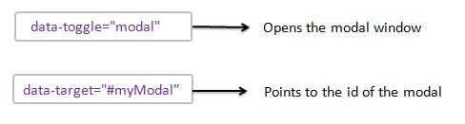

#### Modal Part

The parent <div> of the modal must have an ID that is the same as the value of the data-target attribute used to trigger the modal ("myModal").

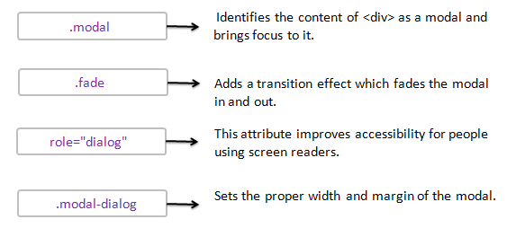

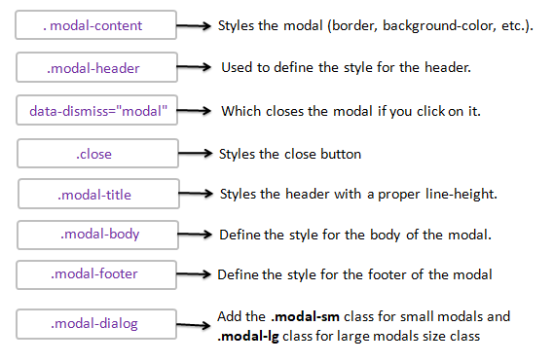

#### **Source Code**

<!DOCTYPE html>

<**html** lang="en">

<**head**>

<**meta** charset="UTF-8">

<**meta** http-equiv="X-UA-Compatible" content="IE=edge">

<**meta** name="viewport" content="width=device-width, initial-scale=1.0">

<**title**>Tutor Joes</**title**>

<**link** rel="stylesheet" href="https://maxcdn.bootstrapcdn.com/bootstrap/3.4.1/css/bootstrap.min.css">

<!--<link rel="stylesheet" href="css/bootstrap.min.css">-->

<**style**>

**hr**{

**margin-top**: 15px;

**margin-bottom**: 15px;

**display**: block;

}

</**style**>

</**head**>

<**body**>

<**div** class="container" style="**margin-top**:20px;">

<**div** class="row">

<**h2** class="page-header">Login Using Modal</**h2**>

<**div** class="col-md-12">

<**button** type="button" class="btn btn-info btn-lg" data-toggle="modal" data-target="#myModal">Click to open login form</**button**>

<!-- Modal -->

<**div** id="myModal" class="modal fade" role="dialog">

<**div** class="modal-dialog">

<!-- Modal content-->

<**div** class="modal-content">

<**div** class="modal-header">

<**button** type="button" class="close" data-dismiss="modal">&times;</**button**>

<**h4** class="modal-title">Login</**h4**>

</**div**>

<**div** class="modal-body">

<**form** action="#">

<**div** class="form-group">

<**label** for="name">User Name:</**label**>

<**input** type="text" class="form-control" id="name">

</**div**>

<**div** class="form-group">

<**label** for="pass">Password:</**label**>

<**input** type="password" class="form-control" id="pass">

</**div**>

<**button** type="submit" class="btn btn-primary">Submit</**button**>

</**form**>

</**div**>

<**div** class="modal-footer">

<**button** type="button" class="btn btn-danger" data-dismiss="modal">Close</**button**>

</**div**>

</**div**>

</**div**>

</**div**>

</**div**>

</**div**>

</**div**>

<**script** src="https://ajax.googleapis.com/ajax/libs/jquery/3.5.1/jquery.min.js"></**script**>

<**script** src="https://maxcdn.bootstrapcdn.com/bootstrap/3.4.1/js/bootstrap.min.js"></**script**>

<!--<script src="js/jquery.min.js"></script>-->

<!--<script src="js/bootstrap.min.js"></script>-->

</**body**>

</**html**>