**BIG DATA ANALYSIS WITH IBM CLOUD DATABASES**

Project Title: Big Data Analysis

**Problem Statement :**

* Dive into the world of big data analysis with IBM Cloud Databases.
* Uncover hidden insights from vast datasets, from climate trends to social patterns.
* Visualize your findings and derive valuable business intelligence.
* Embark on data-driven adventures, exploring the endless possibilities of big data.

**Problem Definition :**

* The project involves delving into big data analysis using IBM Cloud Databases.
* The objective is to extract valuable insights from extensive datasets, ranging from climate trends to social patterns.
* The project includes designing the analysis process, setting up IBM Cloud Databases, performing data analysis, and visualizing the results for business intelligence.

**METHOD OF APPROACH:**

1. **Data Exploration and Collection:**

* Begin by identifying and collecting relevant datasets, such as climate data, social media feeds, or business transaction records.
* Ensure data quality, cleaning, and pre processing to eliminate inconsistencies in the data.

**Datasets for analysis:**

1.**For Climate:**

* NASA Global Climate Change Data
* European Space Agency (ESA) Climate Data

2.**For Social Media Analysis:**

* Reddit Datasets
* Data Sharing Platforms:
* Websites like:
* Kaggle
* Data.gov provide data.

2.**IBM Cloud Databases Setup:**

* Choose the appropriate IBM Cloud Database service based on your data needs (e.g., Db2, Db2 on Cloud, or Db2 Warehouse).
* Configure the database to handle the volume and complexity of your data.

3.**Data Storage and Management:**

* Store your datasets securely within the IBM Cloud Database, ensuring proper organization and indexing.
* Utilize cloud-based data management tools to efficiently handle large datasets.

4.**Data Analysis Tools Selection:**

* Identify the right analytical tools and programming languages (e.g., Python, R, or SQL) for your specific analysis tasks.
* Leverage IBM Cloud services and integrations to streamline analysis workflows.

5.**Hypothesis Generation:**

* Formulate hypotheses based on your initial observations and domain knowledge.
* Develop clear research questions to guide your analysis.

6.**Advanced Analytics and Modelling:**

* Apply advanced analytics techniques, such as machine learning or statistical modelling, to extract valuable patterns and predictions from the data.
* Utilize IBM Cloud’s AI and machine learning services to enhance your analysis.

7.**Data Visualization:**

* Create meaningful visualizations, dashboards, and reports to communicate your findings effectively.
* Utilize IBM Watson Studio or other visualization tools for this purpose.

8.**Iterative Analysis:**

* Continuously refine your analysis based on feedback and emerging insights.
* Be open to adjusting your hypotheses and exploring new angles.

9.**Business Intelligence and Decision-Making:**

* Translate your analytical results into actionable business intelligence.
* Collaborate with stakeholders to derive strategic insights and make informed decisions.

10.**Data Governance and Security:**

* Implement robust data governance practices to ensure data security, compliance, and privacy.
* Leverage IBM Cloud’s security features and certifications.

11.**Scalability and Optimization:**

* As your analysis evolves, consider scalability options within IBM Cloud Databases to accommodate growing data volumes.
* Continuously optimize database performance and query efficiency.

12.**Documentation and Knowledge Sharing:**

* Document your analysis process, methodologies, and findings for future reference.
* Share insights with team members and stakeholders to foster data-driven decision-making.

13.**Monitoring and Maintenance:**

* Regularly monitor data sources, database performance, and analysis pipelines.
* Implement automated alerts and maintenance routines to ensure data integrity.

14.**Continuous Learning and Innovation:**

* Stay updated with the latest advancements in big data analysis and cloud technologies.
* Explore new possibilities and technologies within the IBM Cloud ecosystem.

**Required Libraries:-**

**1.Pandas:**

Pandas is a powerful data manipulation library for handling structured data. It provides data structures like Data Frames and tools for data cleaning and analysis.

1. **NumPy:**

NumPy is a fundamental library for numerical computing in Python. It’s crucial for performing mathematical and statistical operations on large datasets.

1. **Matplotlib or Seaborn:**

These libraries are used for data visualization. Matplotlib is a versatile library for creating various types of plots, while Seaborn is built on Matplotlib and simplifies creating aesthetically pleasing statistical visualizations.

1. **Hadoop Ecosystem (PySpark):**

If you are working with big data, you can use PySpark, the Python library for Apache Spark, which is a popular framework for distributed data processing. This is especially useful for large-scale data analysis.

1. **Ibm-cos-sdk:**

If you’re using IBM Cloud Object Storage, you can use the ibm-cos-sdk library to interact with your COS buckets and objects.

1. **IBM Watson SDKs:**

If you are integrating with IBM Watson services or using IBM Cloud offerings like Watson Studio, you might need the relevant Watson SDKs for Python.

1. **Datetime:**

For working with date and time data, you can use Python’s built-in datetime module.

1. **Scikit-learn:**

If your analysis includes machine learning tasks, scikit-learn provides a wide range of machine learning algorithms and tools.

1. **Ibm-watson-machine-learning:**

If you are working on machine learning projects, the ibm-watson-machine-learning Python library can help you deploy and manage models on IBM Cloud.

**10.PyArrow (for efficient data exchange):**

When working with large datasets, you may use PyArrow for efficient data exchange between different data formats and systems.

**11.IBM Cloud CLI:**

If you need to manage IBM Cloud services and resources from the command line, you’ll require the IBM Cloud Command Line Interface (CLI).

**SOLUTION:**

Certainly, building a big data analysis solution that incorporates advanced Techniques and visualizations is essential for deriving meaningful insights from Your data. Let’s continue with the process:

**Step 1:**

Download a CSV or xlsx file for upload in the DB2 database.

Example: open the web browser.

Search for the convenient topic to download database.(eg:kaggle,Data.world..)

**Step 2:**

Create a data table in IBM Cloud DB2 Database.

**Step 3:**

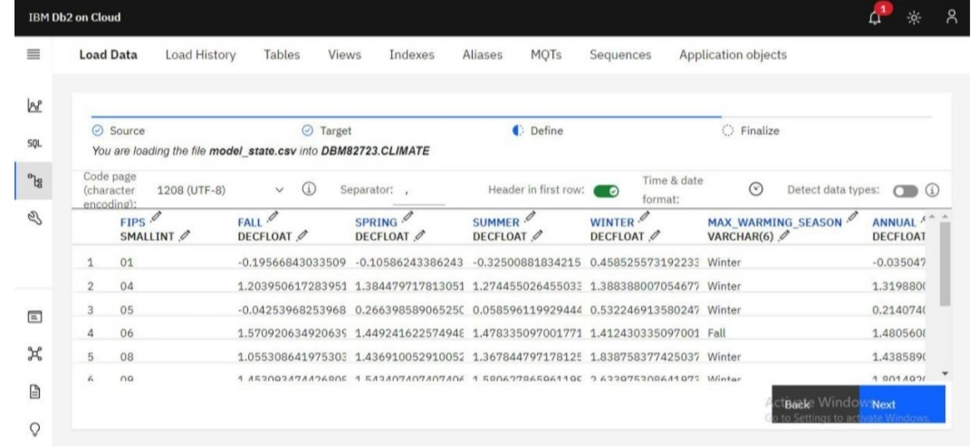Upload the downloaded CSV. File in the database.

**Step 4:**

Finalize the uploading settings.

**Step 5:**

Run the loaded data to check it is contain error or not.

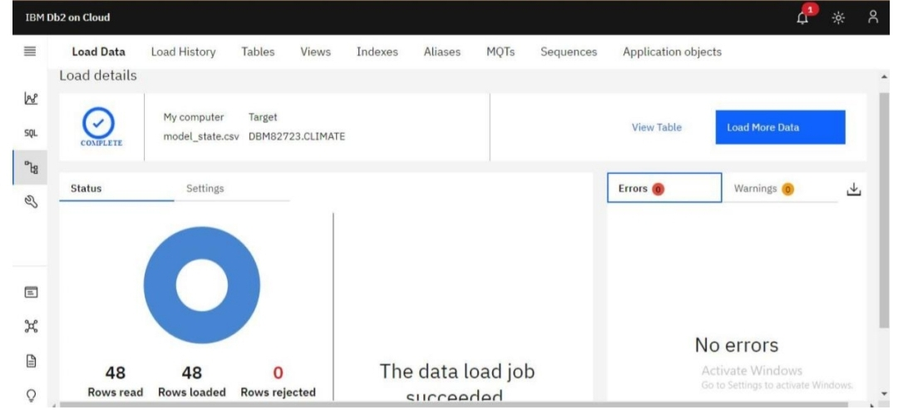

**Step 6:**

Create SQL queries to run the database table.

**Step 7:**

For development the analysis data we need to use the virtualization techniques in the datasets.

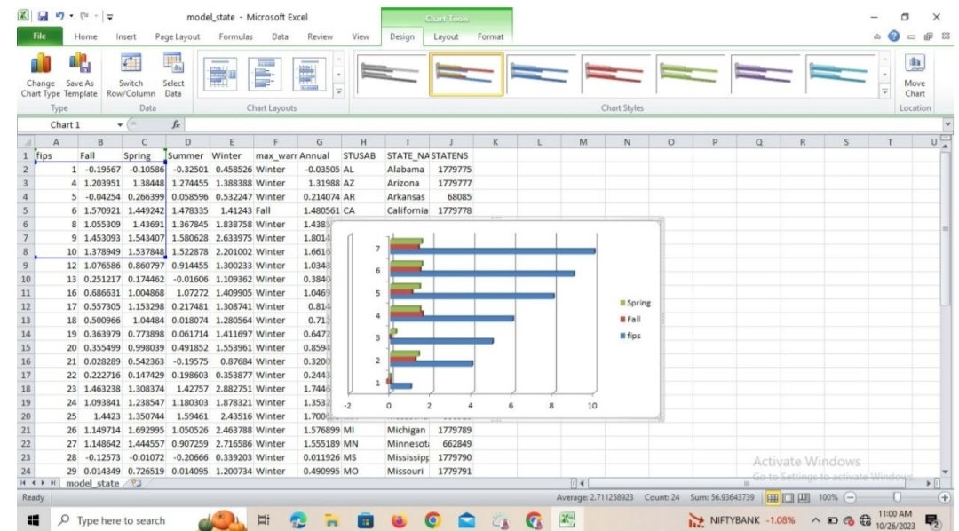

**Step 8: Using python.**

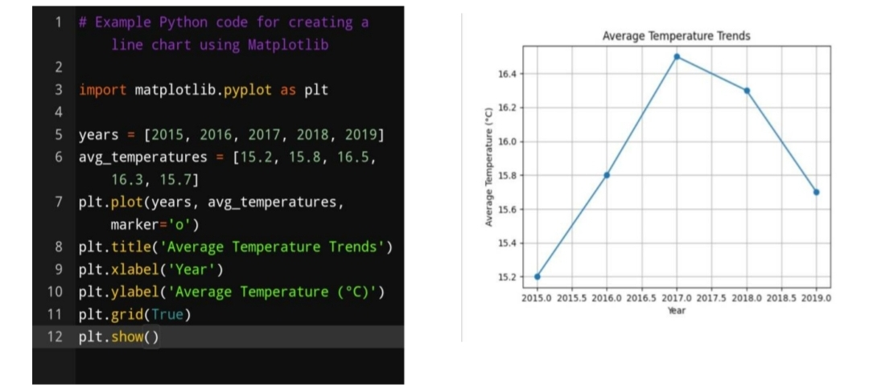

**Step 9:**

Using Machine Learning techniques.

**Select Appropriate Analysis Techniques:**

Depending on the nature of your dataset and specific objectives, consider various

**Advanced analysis techniques:**

Machine Learning Algorithms: Use supervised or unsupervised machine learning Algorithms like decision trees, random forests, support vector machines, or Clustering algorithms for predictive modeling or pattern recognition.

Time Series Analysis: If your data involves time-based data points, use time Series analysis techniques to identify trends, seasonality, and forecast future Values.

Sentiment Analysis: Apply natural language processing techniques to extract Sentiment from text data, useful for social media or customer reviews analysis.

Example:

#Example Python code for sentiment analysis using NLTK import nltk

from nltk.sentiment import SentimentIntensityAnalyzer

nltk.download(‘vader_lexicon’)

Sia = SentimentIntensityAnalyzer()

Text = “The weather is wonderful and the scenery is breathtaking.” Sentiment_score = sia.polarity_scores(text) print(sentiment_score)

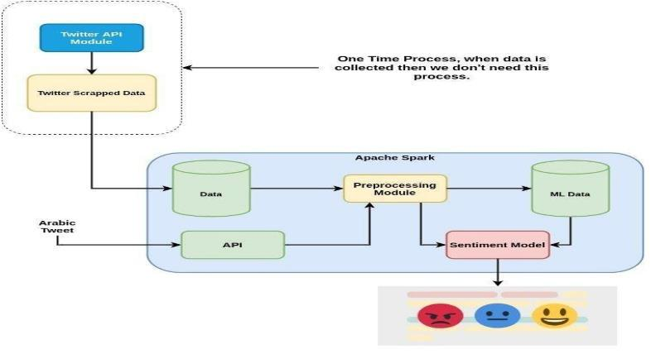

**DIFFICULTIES IN APPROACH:**

1.**Data Overload:**

Managing and making sense of the sheer volume, velocity, and variety of data can be overwhelming. Organizations need to filter out noise and focus on relevant information.

2.**Data Quality:**

Ensuring data accuracy, consistency, and reliability is a recurring issue. Inaccurate data can lead to flawed insights and decisions.

3.**Scalability:**

As data grows exponentially, traditional databases may struggle to scale efficiently. Organizations need databases that can seamlessly handle massive data loads.

4.**Real-time Insights:**

Many industries require real-time data analysis to make immediate decisions, such as in financial trading or healthcare.

5.**Security and Compliance:**

Protecting sensitive data and complying with data privacy regulations is non-negotiable.

**FLOWCHART OF EXECUTION:**

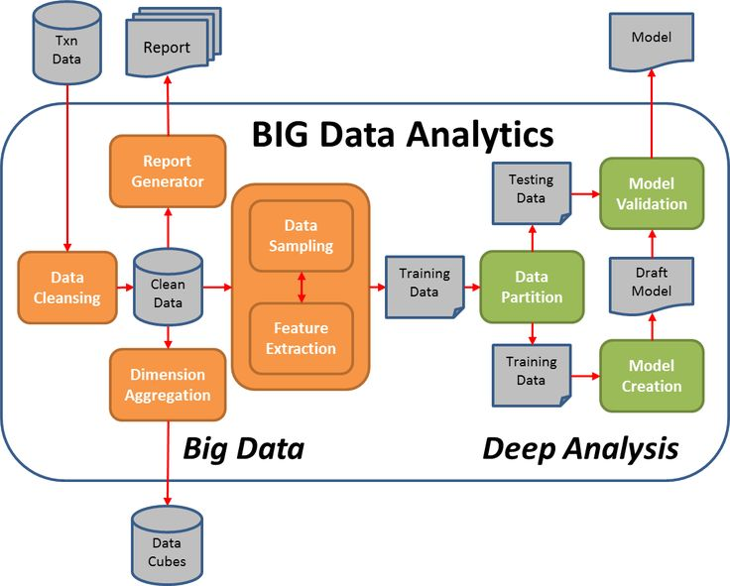

**Conclusion:**

Thus the ,Continue building the big data analysis solution by applying advanced analysis techniques And visualizing the results has been completed.