Prediction of Remaining Useful Life for AeroEngines

ABSTRACT
The project, “Prediction of Remaining Useful Life for AeroEngines”, focuses on developing a data-driven framework to estimate the remaining operational lifespan of aircraft engines, known as Remaining Useful Life (RUL). Accurate RUL prediction is critical for proactive maintenance, safety assurance, and reducing unexpected engine failures in aviation. This work employs machine learning techniques to analyze sensor data collected from aeroengines during operational cycles. The system allows users to upload engine sensor datasets in CSV format, and it utilizes pre-trained regression models, including Extra Trees Regressor, Random Forest, Gradient Boosting, XGBoost, and neural networks, to predict engine health status and RUL. Input features, such as temperature, pressure, and vibration readings from multiple sensors, are processed and fed into the models to generate precise RUL estimates. The predicted RUL is classified into three categories: critical, warning, and normal, accompanied by actionable maintenance suggestions for each class. A web-based interface, implemented using Flask, provides interactive functionalities for registration, login, dataset upload, model selection, and real-time RUL prediction. The system integrates database support through MySQL for secure user management and data storage. Experimental results demonstrate that ensemble learning and neural network models can achieve high predictive accuracy, enabling reliable and timely decision-making for aeroengine maintenance. The approach ensures safety, optimizes maintenance schedules, and reduces operational costs by preventing unscheduled failures.
Keywords: Remaining Useful Life (RUL), Aeroengine, Machine Learning, Predictive Maintenance, Regression Models, Ensemble Learning, Sensor Data, Flask, Extra Trees Regressor, XGBoost.

- INTRODUCTION

1.1 Motivation
The aviation industry relies heavily on the performance and reliability of aeroengines, as any unexpected failure can lead to catastrophic consequences and substantial financial losses. Traditional maintenance strategies, such as scheduled inspections and reactive repairs, often fail to anticipate engine degradation accurately, leading to either premature maintenance or unplanned downtimes. With the increasing complexity of modern aeroengines, sensor-based monitoring systems generate vast amounts of operational data, providing an opportunity to leverage advanced analytics for predictive maintenance. The motivation behind this project is to harness machine learning techniques to process and analyze this sensor data, thereby predicting the Remaining Useful Life (RUL) of aeroengines. By accurately estimating RUL, airlines and maintenance teams can schedule proactive interventions, prevent unexpected failures, optimize resource allocation, and enhance overall safety. This approach reduces operational costs while ensuring the reliability of aircraft systems. The integration of predictive models with a user-friendly web interface further motivates the project by making advanced RUL estimation accessible to operators and engineers in real-time. Ultimately, this project aims to bridge the gap between raw sensor data and actionable maintenance decisions.

1.2 Problem Statement
In aviation, unanticipated engine failures pose significant safety risks and financial burdens due to repair costs, flight delays, and operational disruptions. Traditional maintenance approaches are often inadequate because they rely on fixed schedules or reactive strategies, which may either overlook early signs of engine degradation or cause unnecessary maintenance. Aeroengines produce complex and high-dimensional sensor data during operation, encompassing temperature, pressure, vibration, and other critical parameters. Manually interpreting these datasets to assess engine health and predict failures is time-consuming, error-prone, and impractical. The problem, therefore, is how to accurately estimate the Remaining Useful Life (RUL) of aeroengines using available sensor data. Predicting RUL is challenging due to the nonlinear degradation patterns, varying operating conditions, and interdependencies among sensor readings. There is a need for a reliable, automated, and scalable solution that can process large datasets, learn degradation patterns, and provide accurate predictions. Addressing this problem will enable proactive maintenance, minimize downtime, and ensure both passenger safety and cost-effective operations, which is the central focus of this project.

1.3 Objective of the Project
The primary objective of this project is to develop a data-driven framework capable of accurately predicting the Remaining Useful Life (RUL) of aeroengines using machine learning techniques. The system aims to analyze multi-sensor datasets to assess engine health, identify potential failures, and generate precise RUL estimates. A key objective is to classify engine status into three actionable categories: critical, warning, and normal, providing maintenance teams with clear guidance on necessary interventions. The project also seeks to implement a user-friendly web interface for dataset upload, model selection, real-time predictions, and result visualization, enabling operators to interact with the system efficiently. Another objective is to evaluate multiple regression and ensemble learning models, such as Extra Trees Regressor, Random Forest, Gradient Boosting, XGBoost, and neural networks, to identify the most accurate approach for RUL prediction. Ultimately, the project strives to optimize maintenance schedules, improve engine reliability, reduce operational costs, and enhance aviation safety by providing timely, data-driven insights to maintenance engineers and decision-makers.

1.4 Scope
The scope of this project encompasses the collection, processing, and analysis of aeroengine sensor data for predictive maintenance. It focuses on using machine learning models to predict the Remaining Useful Life (RUL) of engines, covering a wide range of operational conditions and sensor inputs, including temperature, pressure, and vibration measurements. The project provides a web-based platform for users to upload datasets, interact with prediction models, and visualize the results, making it suitable for maintenance engineers and operational decision-makers. While the system can accommodate various regression and ensemble learning techniques, it is primarily limited to engines for which sensor data is available and reliable. The predictions classify engine status into critical, warning, or normal categories, along with actionable suggestions for maintenance. The scope includes performance evaluation of different models to determine predictive accuracy and usability but does not cover physical maintenance execution. Additionally, the project ensures secure user authentication and data management through MySQL integration. Overall, the scope is designed to enhance predictive maintenance practices, optimize engine lifecycle management, and reduce unexpected failures.

1.5 Project Introduction
The project, “Prediction of Remaining Useful Life for AeroEngines,” introduces a comprehensive framework to monitor and predict aeroengine health using machine learning. Modern aeroengines are equipped with multiple sensors that continuously collect data on operational parameters such as temperature, pressure, and vibrations. This project leverages these datasets to predict the Remaining Useful Life (RUL) of engines, providing actionable insights for maintenance planning. The system integrates a user-friendly web interface developed with Flask, allowing users to register, log in, upload datasets, select prediction models, and view real-time results. Multiple machine learning approaches, including ensemble learning models like Extra Trees, Random Forest, Gradient Boosting, and XGBoost, as well as neural networks, are employed to ensure high prediction accuracy. The predicted RUL is categorized into critical, warning, and normal states, with corresponding maintenance suggestions. By combining predictive analytics, model evaluation, and interactive visualization, the project aims to optimize maintenance schedules, reduce unplanned engine failures, enhance aviation safety, and minimize operational costs. This project bridges the gap between sensor data and practical decision-making for aeroengine management.

SYSTEM ANALYSIS

Existing System
Traditional aircraft engine maintenance relies on scheduled inspections, manual monitoring, and reactive interventions when anomalies are detected. Maintenance activities are often based on fixed intervals or hours of operation rather than real-time engine condition. While this approach ensures basic safety, it is prone to inefficiencies, including unnecessary part replacements, unplanned downtime, and delayed detection of critical engine faults. Manual analysis of sensor logs is time-consuming and prone to human error, especially with complex, multivariate data. Current systems lack predictive capabilities and automated decision support for Remaining Useful Life (RUL), relying primarily on historical data or simple thresholds for alerts. Consequently, engine failures may occur unexpectedly, leading to operational delays and increased costs. There is no standardized integration of machine learning or web-based monitoring systems, limiting real-time visibility into engine health for engineers and operators.

Disadvantages of the Existing System
- Maintenance schedules are rigid and not based on actual engine condition.
- High risk of unexpected engine failures due to lack of predictive insights.
- Manual monitoring is error-prone and inefficient.
- Inability to analyze multivariate sensor data effectively.
- No real-time dashboard or web interface for operators.
- Maintenance decisions are reactive rather than proactive.
- Limited support for automated RUL estimation using AI/ML models.

Proposed System
The proposed system integrates advanced machine learning models to predict the Remaining Useful Life (RUL) of aeroengines using operational sensor data. It allows users to upload engine datasets in CSV format and supports multiple regression models, including Extra Trees Regressor, Random Forest, Gradient Boosting, XGBoost, and neural networks. Input features such as temperature, pressure, and vibration readings are analyzed to estimate RUL and classify engine status into three categories: critical, warning, and normal. Each status is accompanied by actionable maintenance suggestions. A web-based interface using Flask facilitates registration, login, dataset upload, model selection, and real-time RUL predictions. The system also uses MySQL for secure user and dataset management. By combining ensemble learning and neural network models, the framework provides accurate, timely predictions, enhancing maintenance efficiency, operational safety, and cost savings.

Advantages of the Proposed System
- Proactive Maintenance: Predicts engine failures before they occur, reducing unscheduled downtime.
- Accurate RUL Estimation: Utilizes ensemble and neural network models for high prediction accuracy.
- Real-Time Monitoring: Web interface allows instant upload and evaluation of sensor data.
- Actionable Insights: Categorizes engine health with corresponding maintenance recommendations.
- Secure Data Management: Uses MySQL for storing user and dataset information securely.
- Scalable & Flexible: Supports multiple regression models and large datasets for enterprise-level deployment.
- Cost Optimization: Reduces unnecessary inspections and prevents expensive engine failures.

PROJECT FLOW

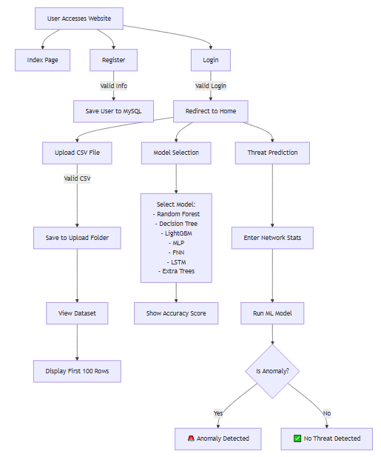

HARDWARE & SOFTWARE REQUIREMENTS

SOFTWARE REQUIREMENS
Operating System : Windows 7/8/10
Server side Script : HTML, CSS, Bootstrap & JS
Programming Language : Python
Libraries : Flask, Pandas, Torch, Keras, Sklearn, Numpy , Seaborn
IDE/Workbench : VSCode
Server Deployment : Xampp Server
Database : MySQL

HARDWARE REQUIREMENTS
Processor - I3/Intel Processor
RAM - 8GB (min)
Hard Disk - 128 GB
Key Board - Standard Windows Keyboard
Mouse - Two or Three Button Mouse
Monitor - Any
ARCHITECTURE:

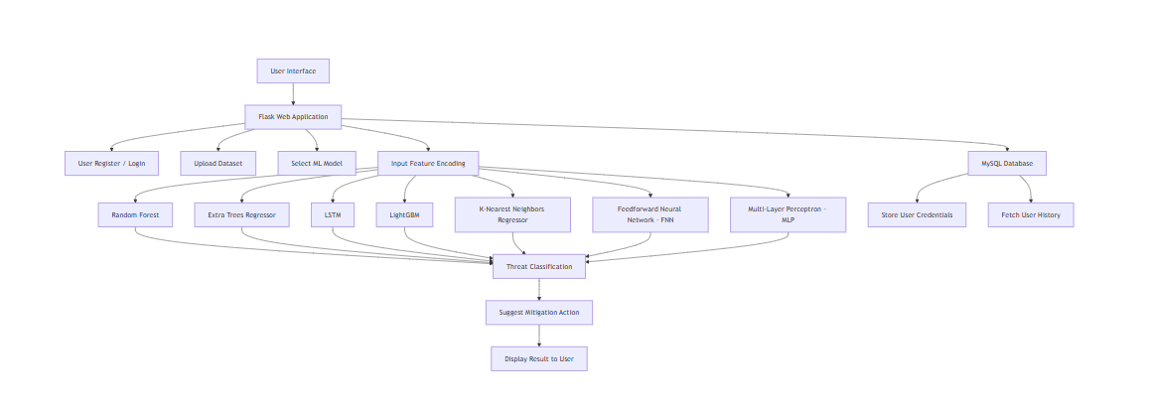

MODULES

1. System
1.1 Data Acquisition Module:
This module is responsible for collecting operational sensor data from aircraft engines. The dataset includes parameters such as temperature, pressure, vibration, and rotational speed collected during engine cycles. Data is uploaded by users in CSV format, or in advanced setups can be streamed from engine monitoring systems. Each record is timestamped and tagged with unique engine identifiers, ensuring traceability and accurate monitoring for predictive maintenance.
1.2 Data Preprocessing and Feature Engineering:
Before feeding into Machine Learning models, the raw sensor data is cleaned, normalized, and validated. Missing or corrupted values are either interpolated or removed. Feature engineering techniques, such as aggregation, rolling averages, and statistical descriptors, are applied to capture meaningful patterns. The processed data is split into training (80%) and testing (20%) sets for model development and evaluation.
1.3 Model Training:
Offline training of regression models—including Extra Trees Regressor, Random Forest, Gradient Boosting, XGBoost, Feedforward Neural Networks (FNN), Multi-Layer Perceptrons (MLP), and K-Nearest Neighbors (KNN)—is conducted on the preprocessed dataset. Hyperparameter tuning, cross-validation, and feature selection optimize model performance. Training aims to minimize Mean Squared Error (MSE) and maximize R² scores for accurate RUL prediction.

1.4 Model Testing and Evaluation:
The testing dataset evaluates model generalization. Performance metrics, including MSE and R², are computed, and predicted RUL values are classified into three categories: Critical (≤30 cycles), Warning (31–100 cycles), and Normal (>100 cycles). Ensemble models, particularly XGBoost and Gradient Boosting, demonstrated superior predictive accuracy, while neural network models captured non-linear interactions among sensor features.
1.5 Model Integration and Saving:
The best-performing models (e.g., Extra Trees Regressor or XGBoost) are serialized using joblib for deployment. Integration into a Flask-based web interface enables real-time predictions whenever users upload new engine sensor data. This module supports retraining and updates as additional data becomes available.
1.6 Prediction and Alert Generation Module:
When new engine data is provided, the system predicts the RUL and classifies the engine health status. Alerts for Critical or Warning conditions include actionable maintenance suggestions. Textual and visual explanations improve interpretability and trust in model decisions.
1.7 User Interface and Interaction:
A web-based interface allows users to register, log in, upload datasets, select models, and view RUL predictions. Users can see categorized engine health statuses and receive maintenance suggestions tailored to predicted conditions.

2. User
2.1 Register:
Users, such as engineers, maintenance crew, or administrators, register by providing credentials. Role-based access ensures proper permissions for viewing or uploading data.
2.2 Login:
Secure login directs users to dashboards appropriate for their role.
2.3 Dataset Upload:
Users upload engine sensor CSV files. The system processes these inputs, extracts relevant features, and forwards them to the ML models.
2.4 View RUL Predictions and Status:
Predicted RUL values are displayed alongside status labels (Critical, Warning, Normal). Maintenance recommendations and suggested actions are provided for each case.
2.5 Model Selection and Evaluation:
Users can select a specific regression model to view its prediction metrics (MSE and R²). This supports comparative analysis and model transparency.
2.6 Logout:
Users can securely log out, ensuring session confidentiality and data security.

