INTELLIGENT VIDEO SURVEILLANCE AND INCIDENT MONITORING SYSTEM
A Project Report Submitted in partial fulfilment of the requirement for the Award of the degree of

BACHELOR OF TECHNOLOGY IN
INFORMATION TECHNOLOGY

Submitted By

Student Name Pin. No.

DADANI VENKATA KOWSHIK REDDY - 22T91A1213
DENDULURI DEVI - 22T91A1216
GURIJALA VIJAY RAJU - 22T91A1219
MADA BATTULA SATYA ASHISH - 22T91A1222

Under the Esteemed Guidance of
Mr. M. SREENIVASU, M.Tech., (Ph.D.),
Associate Professor , HoD
Department of Information Technology


DEPARTMENT OF INFORMATION TECHNOLOGY
GIET ENGINEERING COLLEGE
(Affiliated to JNTUK, Kakinada and approved by AICTE, Accredited by NAAC A+, New Delhi) Chaitanya Knowledge City, Velugubanda, Rajamahendravaram,
Andhra Pradesh, India-522396.
2025-2026

GIET ENGINEERING COLLEGE
(Affiliated to JNTUK, Kakinada and approved by AICTE, Accredited by NAAC A+, New Delhi) Chaitanya Knowledge City, Velugubanda, Rajamahendravaram,
Andhra Pradesh, India-522396.

DEPARTMENT OF INFORMATION TECHNOLOGY
BONAFIDE CERTIFICATE

This is to certify that DADANI VENKAT KOWSHIK REDDY (22T91A1213), DENDULURI DEVI (22T91A1216), GURIJALA VIJAY RAJU (22T91A1219), MADA BATTULA SATYA ASHISH (22T91A1222) studying in IV B. Tech II Semester of INFORMATION TECHNOLOGY have submitted their project “INTELLIGENT VIDEO SURVEILLANCE AND INCIDENT MONITORING SYSTEM” during the academic year 2025-2026 in partial fulfilment of the requirements for the award of degree in Bachelor of Technology, JNTUK, Kakinada.
The result embodied in this project has not been submitted to any other University or Institute for the award of degree.

Signature of the Project Guide
Mr. M.Sreenivasu, M.Tech., (Ph.D.),
Associate Professor, HoD,
Department of Information Technology
Signature of the Head of the Department Mr. M. Sreenivasu, M.Tech., (Ph.D.),
Associate Professor, HoD,
Department of Information Technology

External Viva Voice Conducted on

INTERNAL EXAMINER EXTERNAL EXAMINER

ACKNOWLEDGEMENT

We feel immense pleasure to express our sincere thanks and profound sense of gratitude to all those people who played the valuable role for the successful completion of our project.
We would like to express our gratitude to Dr.K.V.V.SATYANARAYANA RAJU, Chairman, Chaitanya Group of Institutions, Sri K. SASI KIRAN VARMA, Vice Chairman, GIET Group of Institutions for providing necessary infrastructures.
We are thankful to Principal Dr. M. VIJAY SEKHARA BABU for permitting and encoura- ging in doing this project.
Our special thanks to Mr. M. SREENIVASU, Vice Principal, HoD for his content guidance and motivation and also for providing an excellent environment. We truly grateful for his valuable suggestion and advice.
We feeling grateful to express our deep sense of gratitude and respect towards our internal guide Mr. M. SREENIVASU, Associate Professor, whose motivation and constant encourag - ement has lead to pursue this project in the field of Deep Learning. We are very fortunate for having his gracious presence to enlightening us in all the aspects of life as well as project and transforming us to be in an individual in this field.
We are heartly thankful to our project coordinator Mrs. T. MEENAKSHI, Assistant professor, GIET ENGINEERING COLLEGE, for her moral support which was always there to comfort and solace during tough times.
Finally, we would like to thank our TEACHING AND NON-TEACHING STAFF whose blessings and encouragement were always there as a source of strength and inspiration.
We feel very much thankful to all of them and also to our PARENTS and FRIENDS for encouraging and giving us all the moral support required for making this success is possible.

DADANI VENKATA KOWSHIK REDDY - 22T91A1213
DENDULURI DEVI - 22T91A1216
GURIJALA VIJAY RAJU - 22T91A1219
MADA BATTULA SATYA ASHISH - 22T91A1222

GIET ENGINEERING COLLEGE
(Affiliated to JNTUK, Kakinada and approved by AICTE, Accredited by NAAC A+, New Delhi) Chaitanya Knowledge City, Velugubanda, Rajamahendravaram,
Andhra Pradesh, India-522396.

DEPARTMENT OF INFORMATION TECHNOLOGY
DECLARATION
We hereby declare that this project entitled “INTELLIGENT VIDEO SURVEILLANCE AND INCIDENT NONITORING SYSTEM” submitted to the Department of COMPUTER SCIENCE AND ENGINEERING, GIET ENGINEERING COLLEGE, affiliated to JNTUK, Kakinada, as partial fulfilment for the award of Bachelor of Technology degree is entirely the original work done by us and has not been submitted to any other organization.

Project Member Pin Number Signature

DADANI VENKATTA KOWSHIK REDDY 22T91A1213
DENDULURI DEVI 22T91A1216
GURIJALA VIJAY RAJU 22T91A1219
MADA BATTULA SATYA ASHISH 22T91A1222

ABSTRACT

This project presents a CNN-based violence detection system designed for smart-city surveillance using CCTV videos. Most existing violence detection approaches rely on datasets captured using handheld cameras, which limits their effectiveness in real-world CCTV environments. To address this issue, the proposed system is developed and evaluated using the Smart-City CCTV Violence Detection (SCVD) dataset, which is specifically curated for fixed-view surveillance scenarios. The dataset includes three activity classes: normal activities, violent activities, and weaponized activities, where any handheld object capable of causing harm is treated as a weapon. In this project, video segments are converted into salient super-images by combining temporally sampled frames into a single composite image. These super-images are processed using a two-dimensional convolutional neural network (CNN) to learn discriminative spatiotemporal features. The CNN model is trained using supervised learning with data augmentation techniques to improve robustness under varying lighting and environmental conditions. The performance of the system is evaluated using classification accuracy.To facilitate user interaction and practical deployment, a web-based interface is developed that allows users to upload CCTV videos and visualize classification results in an intuitive and accessible manner, making the system suitable for academic projects and real-world smart-city surveillance applications.

TABLE OF CONTENTS

S.NO CONTENT PG.NO.

BONAFIDE CERTIFICATE i
ACKNOWLEDGEMENT ii
DECLARATION iii
ABSTRACT iv
TABLE OF CONTENTS v
LIST OF FIGURES vii
LIST OF TABLES viii
LIST OF ABBREVIATIONS ix

1 INTRODUCTION 1
1.1 Introduction 1
1.2 Objective 2
1.3 Problem Statement 2
1.4 Software Requirements 2
1.5 Hardware Requirements 3

2 FEASIBILITY STUDY 4

3 SYSTEM ANALYSIS 6
3.1 Existing System 6
3.1.1 Disadvantages of Existing System 6
3.2 Proposed System 6
3.2.1 Advantages of Proposed System 7
3.3 Functional Requirements 7
3.4 Non-Functional Requirements 8

4 SYSTEM DESIGN 9
4.1 System Architecture 9
4.2 Data Flow Diagram 9
4.3 UML Diagrams 12

5 IMPLEMENTATION 19
5.1 Modules 19
5.2 Algorithms 20
5.3 Sample Code 20

6 SOFTWARE ENVIRONMENT 29

7 SYSTEM TESTING 41
7.1 Types of Testing 41
7.2 Test Cases 44
8 RESULTS 46
8.1 Performance Evaluation Tables 46
8.2 Comparison Graphs 46
8.3 Screenshots 46
9 CONCLUSION 50
9.1 Conclusion 50
9.2 Future Scope 50
10 REFERENCES 51

Figure No. Title Page No. Figure 4.1 System Architecture Diagram 9
Figure 4.2 Data Flow Diagram 11
Figure 4.3.1 Use Case Diagram 14
Figure 4.3.2 Class Diagram 15
Figure 4.3.3 Activity Diagram 16
Figure 4.3.4 Sequence Diagram 17
Figure 4.3.5 Component Diagram 18
Figure 4.3.6 Deployment Diagram 18
Figure 6.1 Difference between AI, Ml, Dl 29
Figure 6.2 Machine learning life cycle 30
Figure 7.1 Types of system Testing 42
Figure 8.1 person and weapone detection output 46
Figure 8.2 violance detection in video frames 46
Figure 8.3 System user interface for video upload 46
Figure 8.4 Normal activity detection screen1 47
Figure 8.5 Indoor violence detection 47
Figure 8.6 Violence detection 47
Figure 8.7 Weapon detection in store environment 48
Figure 8.8 Weapon detection in corridor scene 48
Figure 8.9 Multi-person and weapon detection 48
Figure 8.10 Weapon detection in outdoor environment 49
Figure 8.11 Weapon detection 49

LIST OF FIGURE
LIST OF TABLES

S.NO Table No. Title Page No.

1 Table 7.2 Test Cases 44

LIST OF ABBREVIATIONS

SDLC Software Development Life Cycle
QA Quality Assurance
SVM Support Vector Machines
SMOTE Synthetic Minority Over sampling Technique
GA Genetic Algorithm
ACO Ant Colony Optimization
PSO Particle Swarm Optimization
MLP Multi-Layer Perceptron
LightGBM Light Gradient Boosting Machine
XGBoost Extreme Gradient Boosting
BR Bayesian regularization
ML Machine Learning
NumPy Numerical Python
OOP Object-Oriented Programming
UI User Interface
HTML HyperText Markup Language
CSS Cascading Style Sheets
ROC Receiver Operating Characteristic
AUC Area Under the Curve
MDP Metrics Data Program
CCTV Closed-circuit television
SCVD Smartcity CC TV Violance Detection

CHAPTER 1

INTRODUCTION
1.1 INTRODUCTION
With the rapid growth of urbanization and smart city development, the need for efficient and intelligent surveillance systems has become increasingly important. Traditional CCTV-based monitoring systems rely heavily on human operators to observe video feeds continuously, which often leads to fatigue, delayed responses, and a higher probability of missing critical incidents. These limitations highlight the necessity for automated systems that can analyze video data in real time and detect suspicious activities without human intervention.
Recent advancements in Artificial Intelligence (AI) and Deep Learning have enabled the development of intelligent video surveillance systems capable of analyzing complex visual data. In particular, Convolutional Neural Networks (CNNs) have shown significant success in image and video analysis tasks, including activity recognition and anomaly detection. However, many existing systems are computationally expensive or designed for controlled environments, making them less suitable for real-world CCTV applications.
In this project, an intelligent video surveillance system named SentinelAI is proposed to detect violence and weapon-related activities using CCTV footage. The system utilizes a CNN-based model along with a super-image representation technique, where multiple frames are combined to capture both spatial and temporal features efficiently. The model classifies activities into three categories: normal, violent, and weaponized, enabling accurate identification of suspicious events.
Additionally, a Flask-based web interface is developed to allow users to upload videos and visualize detection results in real time. The system is designed with a modular and scalable architecture, ensuring ease of deployment and practical usability. By reducing human effort and improving response time, the proposed system contributes to enhancing public safety and security in smart surveillance environments.
1.2 OBJECTIVE
- To develop an intelligent video surveillance system for automatic detection of violence and weapon-related activities from CCTV footage.
- To implement a Convolutional Neural Network (CNN) model for accurate classification of activities into normal, violent, and weaponized categories.
- To utilize super-image representation for capturing both spatial and temporal features efficiently from video data.
- To design a user-friendly web interface using Flask for video upload and real-time visualization of results.
- To reduce human effort and improve response time in surveillance systems through automated monitoring.

1.3 PROBLEM STATEMENT
Traditional video surveillance systems rely heavily on manual monitoring, where human operators continuously observe CCTV footage to identify suspicious activities. This approach is inefficient, time-consuming, and prone to human errors such as fatigue and lack of attention, which may lead to delayed detection of critical incidents like violence or weapon usage.
Moreover, existing systems lack intelligent mechanisms to automatically analyze video data and classify activities in real time. They do not provide automated alerts, accurate activity recognition, or efficient handling of large-scale surveillance data. Therefore, there is a need to develop an AI-based intelligent surveillance system that can automatically detect and classify abnormal activities such as violence and weaponized actions, ensuring faster response and improved public safety.
1.4 SOFTWARE REQUIREMENTS
- Software: Anaconda (2023.03-1)
- Primary Language: Python (3.10.9)
- Web Framework: Flask
- Development Environment: Jupyter Notebook
- Database: Sqlite3
- Front-End Technologies: HTML, CSS, JavaScript and Bootstrap4
1.5 HARDWARE REQUIREMENTS
- Operating System: Windows 10 (Min) and Above
- Processor: i5 9th Gen and Above
- RAM: 8GB (Min) – 16 or 32 Preferable
- Hard Disk: Free space 100 GB (Min)

CHAPTER - 2
FEASIBILITY STUDY
A feasibility study—sometimes called a feasibility analysis or feasibility report—is a way to evaluate whether or not a project plan could be successful. A feasibility study evaluates the practicality of your project plan in order to judge whether or not you’re able to move forward with the project.
Types of feasibility studies:
There are five main types of feasibility studies: technical feasibility, financial feasibility, market feasibility (or market fit), operational feasibility, and legal feasibility. Most comprehensive feasibility studies will include an assessment of all five of these areas.
Technical feasibility:
A technical feasibility study reviews the technical resources available for your project. This study determines if you have the right equipment, enough equipment, and the right technical knowledge to complete your project objectives. For example, if your project plan proposes creating 50,000 products per month, but you can only produce 30,000 products per month in your factories, this project isn’t technically feasible.
Financial feasibility:
Financial feasibility describes whether or not your project is fiscally viable. A financial feasibility report includes a cost-benefit analysis of the project. It also forecasts an expected return on investment (ROI) and outlines any financial risks. The goal at the end of the financial feasibility study is to understand the economic benefits the project will drive.
Market feasibility:
The market feasibility study is an evaluation of how your team expects the project’s deliverables to perform in the market. This part of the reporbhmmmṁt includes a market analysis, a market competition breakdown, and sales projections.
Operational feasibility:
An operational feasibility study evaluates whether or not your organization is able to complete this project. This includes staffing requirements, organizational structure, and any applicable legal requirements. At the end of the operational feasibility study, your team will have a sense of whether or not you have the resources, skills, and competencies to complete this work.
Legal feasibility:
A legal feasibility analysis assesses whether the proposed project complies with all relevant legal requirements and regulations. This includes examining legal and regulatory barriers, necessary permits, licenses, or certifications, potential legal liabilities or risks, and intellectual property considerations. The legal feasibility study ensures that the project can be completed without running afoul of any laws or incurring undue legal exposure for the organization.

CHAPTER – 3
SYSTEM ANALYSIS
3.1 EXISTING SYSTEM
Traditional video surveillance systems mainly consist of CCTV cameras connected to monitoring stations where human operators continuously observe video feeds. These systems do not have the capability to automatically analyze or interpret video content. All decisions regarding suspicious activities depend on human observation, which makes the process inefficient and error-prone.
In existing systems, there is no intelligent mechanism to classify activities such as violence or weapon usage. They lack automation, real-time alert generation, and advanced analytics. As a result, critical incidents may go unnoticed or be detected too late. Additionally, these systems are not scalable and cannot efficiently handle large volumes of video data generated in modern surveillance environments.
3.1.1 Disadvantages of Existing System:
- Requires continuous human monitoring, leading to fatigue
- High probability of missing critical incidents
- No automatic detection of violence or weapon usage
- Delayed response to emergency situations
- Lack of real-time alerts and notifications
- Inefficient handling of large-scale video data
- Limited scalability for smart city applications
- No advanced analytics or activity classification
3.2 PROPOSED SYSTEM
The proposed system, SentinelAI, is an AI-based intelligent video surveillance system designed to automatically detect violence and weapon-related activities from CCTV footage. Unlike traditional systems, it uses a Convolutional Neural Network (CNN) to analyze video data and classify activities into normal, violent, and weaponized categories. The system processes input videos by extracting frames and converting them into super-images, which capture both spatial and temporal features efficiently.
The system also includes a Flask-based web interface that allows users to upload videos and view detection results in real time. It provides outputs with confidence scores and bounding box annotations, enabling easy interpretation of detected activities. The architecture is modular and scalable, ensuring efficient performance with low computational requirements. This makes the system suitable for real-time surveillance applications in smart cities and public safety environments.
3.2.1 Advantages of Proposed System:
- Automatic detection of violence and weapon-related activities
- Reduces human effort and monitoring workload
- Provides real-time alerts and faster response
- Accurate activity classification using CNN
- Efficient processing using super-image technique
- User-friendly web interface for easy interaction
- Scalable and suitable for real-world applications
- Works on standard hardware with low cost
3.3 FUNCTIONAL REQUIREMENTS
1. Real-Time Environmental Data Acquisition: The system must continuously collect soil moisture, soil temperature, air temperature, and humidity using IoT-enabled sensors, ensuring accurate, real-time environmental data for effective irrigation prediction and decision-making.
2. Irrigation Necessity Classification: The system should classify whether irrigation is required for a specific crop based on sensor inputs and environmental forecasts using the hybrid TANELU-activated artificial neural network model.
3. Optimal Watering Time Prediction: The system must determine the best time of day for irrigation by analyzing environmental parameters, crop type, and forecasted data to ensure water efficiency and prevent wastage.
4. Environmental Feature Forecasting: The system should employ regression algorithms such as Random Forest, XGBoost, AdaBoost, and hybrid ensemble models to predict future soil and atmospheric conditions, supporting accurate irrigation scheduling.
5. Web and Mobile-Based User Interface: The system must provide a Flask-based interface for farmers to upload data, view irrigation recommendations, and receive real-time alerts for both irrigation necessity and optimal watering time.
3.4 NON-FUNCTIONAL REQUIREMENTS
1. Performance and Efficiency: The system must process real-time sensor data and run hybrid ANN and regression models efficiently, ensuring low latency in irrigation predictions and delivering timely recommendations for water management without overloading computational resources.
2. Scalability: The system should support integration of additional sensors, crops, and geographic regions, enabling expansion without major architectural changes while maintaining prediction accuracy and response times for larger datasets or multiple simultaneous users.
3. Reliability and Accuracy: The system must consistently provide correct irrigation classifications and watering time predictions, ensuring robustness against sensor failures, missing data, and environmental variability to maintain trust and reduce water wastage.
4. Usability and Accessibility: The system should offer an intuitive, user-friendly web and mobile interface, allowing farmers with minimal technical knowledge to easily monitor, interpret, and act upon irrigation recommendations.
5. Security and Data Privacy: The system must ensure secure data transmission and storage, protecting sensitive agricultural and environmental information from unauthorized access, maintaining integrity, and complying with relevant data privacy standards.

CHAPTER - 4
SYSTEM DESIGN

4.1 SYSTEM ARCHITECTURE
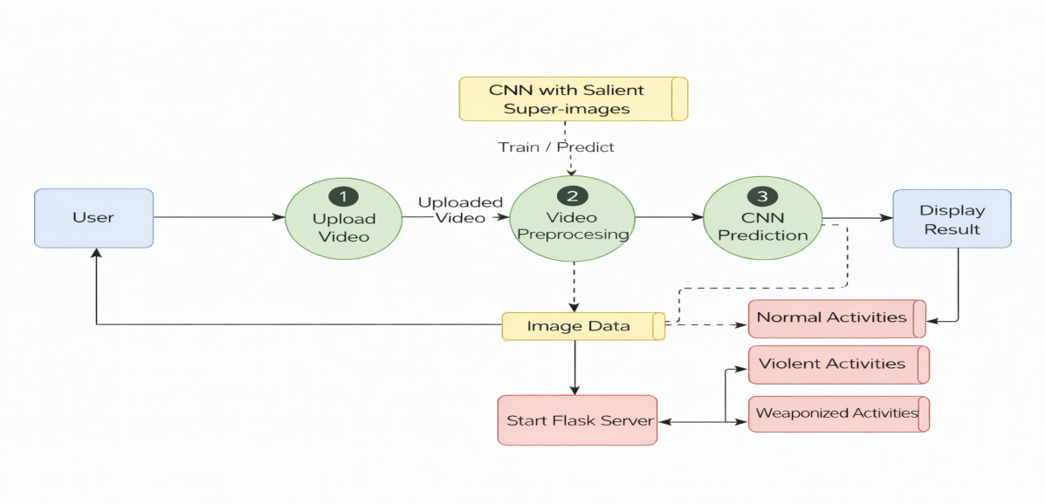
Fig.4.1 System Architecture
4.2 DATA FLOW DIAGRAM
A Data Flow Diagram (DFD) is a graphical representation that illustrates how information moves within a system, showing the flow of data between different components, processes, and external entities. It provides a clear and structured way to understand the movement, transformation, and storage of information, highlighting how input data is processed to generate meaningful output. In the context of smart irrigation systems, a DFD helps visualize how environmental information such as soil moisture, temperature, humidity, and crop type is collected, processed, and used to make irrigation decisions. It identifies the flow of real-time sensor data from monitoring devices to processing units, where decisions about irrigation necessity and optimal watering time are determined. The DFD also shows how these results are communicated to users through interfaces, enabling informed actions for water management. By mapping data flows, the DFD clarifies system functionality, interactions, and dependencies, making it easier to identify inefficiencies, potential bottlenecks, and points where data validation or transformation occurs. Overall, a DFD provides a high-level view of system operations, supporting better planning, analysis, and understanding of the irrigation process for precision water management and sustainable agriculture.
Goals of DFD:
Illustrates the flow of environmental data from IoT sensors to processing units, helping visualize how soil moisture, temperature, and humidity measurements are collected and utilized for irrigation decision-making.
Shows the transformation of raw sensor information into actionable insights, including determining irrigation necessity and predicting optimal watering times for crops.
Highlights interactions between data sources, processing modules, and user interfaces, ensuring farmers receive timely and understandable irrigation recommendations.
Identifies data storage points and pathways, allowing efficient management of historical environmental data to improve forecasting accuracy and support long-term water resource planning.Supports analysis of system efficiency and potential bottlenecks, enabling optimization of data flow, minimizing delays in irrigation predictions, and ensuring sustainable water usage across diverse agricultural conditions.

Importing the Packages
Exploring the Dataset
Visualization

Pre-processing

Normalizing

Is Data Valid?

Upload Valid Data

Split the Data to train and Test

Train

Test

Build & Train the Model

User Login

Is Process Completed?

Invalid Credentials

Predict Irrigation & Watering

Logout

YES
NO
NO
YES

Fig.4.2 Data Flow Diagram

4.3 UML DIAGRAMS
Unified Modeling Language (UML) is a standardized visual language used to describe, specify, and communicate the structure, behavior, and interactions within a system. It provides a set of graphical notations that help represent complex processes, workflows, and relationships in a clear and organized manner. In the context of a smart irrigation system, UML can be used to model how environmental information flows through the system, how decisions are made regarding irrigation necessity, and how outputs such as optimal watering schedules are delivered to users. UML diagrams, such as use case diagrams, sequence diagrams, and activity diagrams, help illustrate the dynamic and static aspects of the system, including interactions between data sources, processing units, and user interfaces. This modeling approach allows a precise understanding of how different components interact, ensuring efficient water management and timely irrigation. UML also facilitates identifying potential issues in system operations, optimizing process flows, and enhancing overall reliability. By providing a visual representation of system functionality, UML aids in planning, analyzing, and improving irrigation processes, supporting sustainable water usage, and ensuring that agricultural operations are responsive to real-time environmental conditions. It helps make complex systems more understandable and manageable for implementation and operation.
Goals of UML:
- Provides a clear visual representation of the irrigation system’s processes, showing how environmental data is collected, analyzed, and used to determine irrigation requirements and optimal watering times.
- Helps illustrate interactions between system components, including sensors, data processing modules, and user interfaces, ensuring seamless communication and timely delivery of irrigation recommendations.
- Supports modeling of dynamic system behavior, such as real-time decision-making and adaptive irrigation adjustments, enabling efficient water usage and responsive crop management under varying environmental conditions.
- Facilitates identification of inefficiencies or bottlenecks in data flow and process execution, allowing improvements in system performance and ensuring sustainable and precise irrigation scheduling.
- Enhances understanding of system functionality for monitoring and control, providing a structured overview of how information is transformed into actionable irrigation guidance for precision water management.
4.3.1 Use Case Diagram:
A use case diagram is a visual representation that shows the interactions between actors and system functionalities. Actors represent users or external entities, while use cases define system operations that achieve specific goals. Associations link actors to the use cases they participate in, illustrating responsibilities and interactions. In a smart irrigation system, actors include farmers and sensors, and use cases cover irrigation decision-making, watering time prediction, and data monitoring. The diagram helps visualize how users interact with the system and ensures clarity of functional requirements.
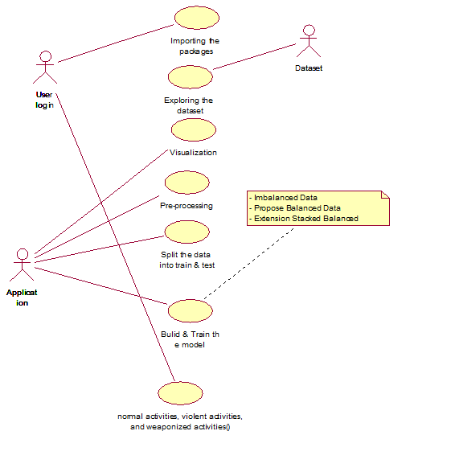
Fig.4.3.1 Use Case Diagram
4.3.2 Class Diagram:
A class diagram represents the static structure of a system by showing classes, their attributes, operations, and relationships. Attributes define data stored in the class, while operations indicate functions performed. Aggregation represents a whole-part relationship between classes. In a smart irrigation system, classes include EnvironmentalSensor, IrrigationController, and WateringScheduler. Attributes capture parameters like soil moisture or humidity, and operations perform calculations or predictions. The class diagram clarifies system organization, object relationships, and data handling.
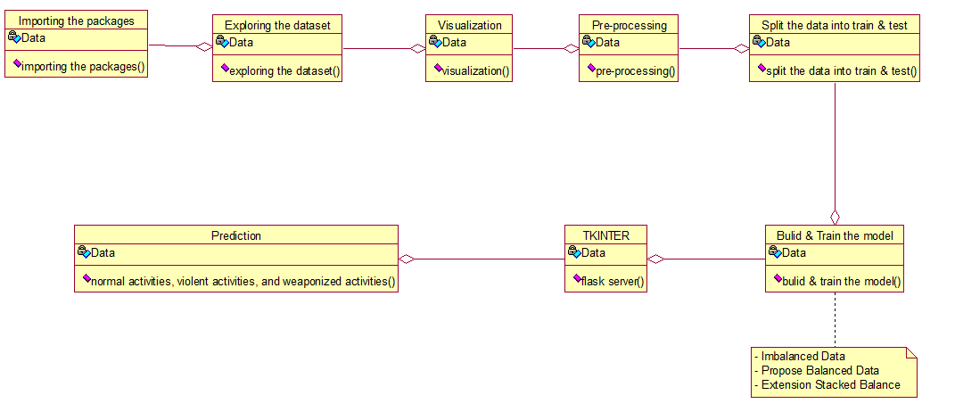
Fig. 4.3.2 Class Diagram
4.3.3 Activity Diagram:
An activity diagram illustrates the dynamic flow of actions within a system, showing the sequence of steps, decisions, and control flow. Actions represent operations performed, and decision nodes indicate branching based on conditions, while control flows depict execution order. In a smart irrigation system, actions include collecting sensor data, normalizing environmental parameters, predicting irrigation necessity, and determining optimal watering times. Decision nodes manage conditional checks, such as whether irrigation is required. The diagram helps understand system workflows and process dependencies clearly.
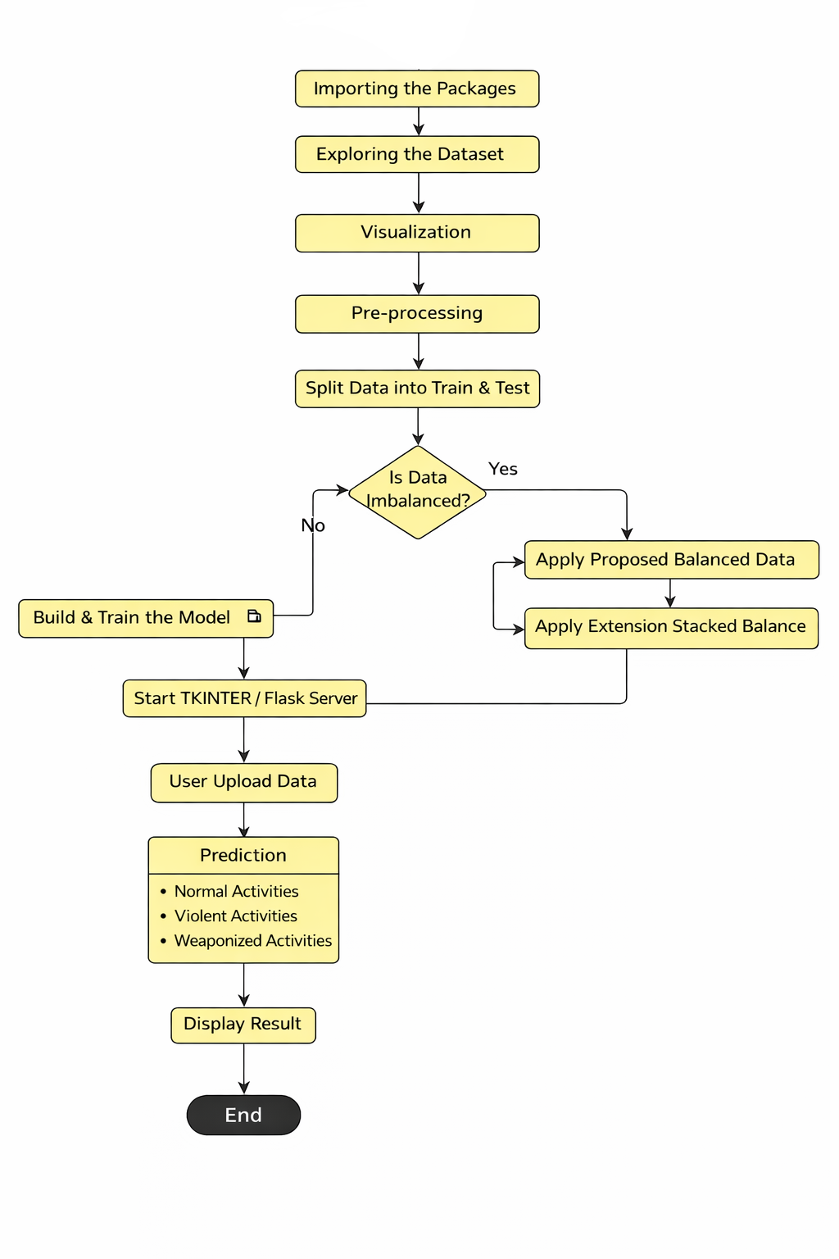
Fig. 4.3.3 Activity Diagram
4.3.4 Sequence Diagram:
A sequence diagram models the interaction between objects in chronological order, highlighting how objects communicate through messages. Objects represent entities like sensors, controllers, or user interfaces, while object messages depict the flow of information or commands between them. In a smart irrigation system, objects include SoilSensor, ANNModel, and FarmerInterface. Messages involve transmitting environmental data, performing predictions, and delivering irrigation recommendations. The diagram helps visualize temporal interactions, identify message sequences, and ensure proper data flow for real-time decision-making.
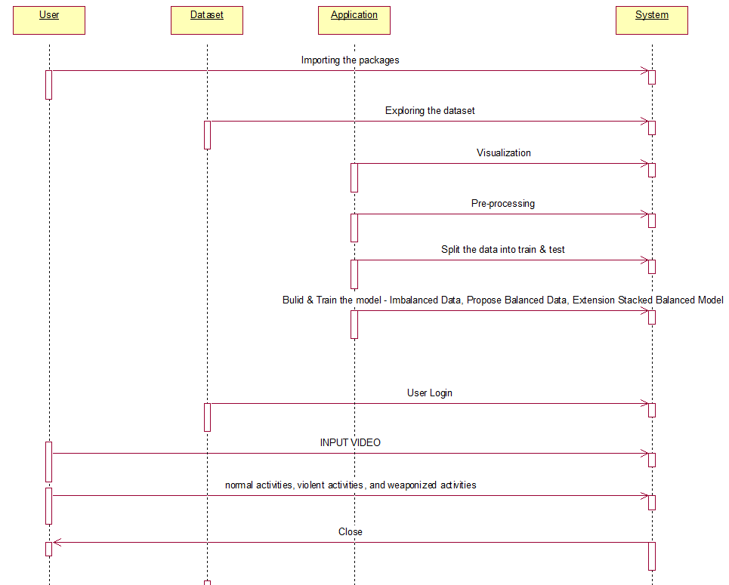
Fig.4.3.4 Sequence Diagram
4.3.5 Component Diagram:
A component diagram illustrates the organization and dependencies of system components and packages. Components represent modular parts of the system, and packages group related components. Dependencies show how components rely on each other to perform operations. In a smart irrigation system, components include SensorModule, ANNProcessingUnit, RegressionForecastingUnit, and UserInterfacePackage. The diagram highlights how modules interact, share data, and maintain system modularity. It aids in planning system implementation, understanding interdependencies, and supporting updates or replacements of individual components efficiently.
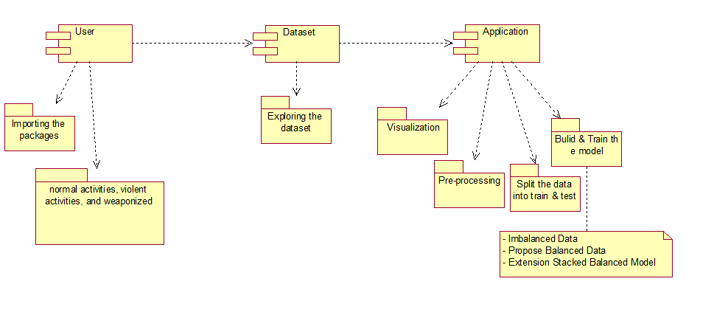
Fig.4.3.5 Component Diagram
4.3.6 Deployment Diagram:
A deployment diagram shows the physical arrangement of system nodes, the connectors between them, and attached notes. Nodes represent hardware or execution environments, while connectors indicate communication paths. Anchor notes provide additional context or specifications. In a smart irrigation system, nodes include IoT sensors, edge processing devices, and web servers. Connectors illustrate data transmission from sensors to processing units and then to user interfaces. Notes can specify sampling intervals or sensor calibration. This diagram supports understanding system deployment, network interactions, and resource allocation.
v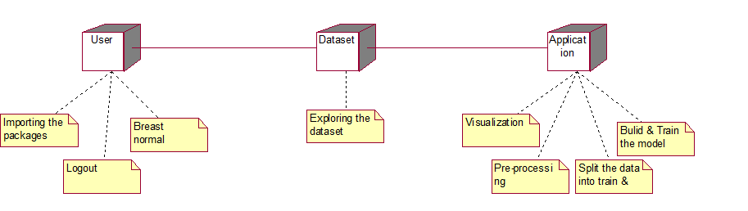
Fig.4.3.6 Deployment Diagram

CHAPTER-5
IMPLEMENTATION
5.1 MODULES
1. Dataset Preparation Module
This module is responsible for organizing and preprocessing the Smart-City CCTV Violence Detection (SCVD) dataset. It includes class labeling into normal, violent, and weaponized categories, along with frame extraction and sampling from videos. Data augmentation techniques such as flipping, rotation, and brightness adjustment are applied to improve model robustness and generalization under different environmental conditions.
2. Salient Super-Image Generation Module
In this module, input CCTV videos are converted into salient super-images by combining multiple temporally sampled frames into a single composite image. This approach efficiently captures both spatial and temporal information in a compact form. It reduces computational complexity compared to processing full video sequences while preserving motion-related features.
3. CNN-Based Classification Module
This module implements a Convolutional Neural Network (CNN) to extract deep features from the generated super-images. The CNN processes the input through convolutional, pooling, and fully connected layers to learn discriminative patterns. It classifies the input into three categories: normal activities, violent activities, and weaponized activities with corresponding confidence scores.
4. Training and Evaluation Module
The model is trained using supervised learning with labeled data from the SCVD dataset. During training, optimization techniques such as backpropagation and suitable loss functions are applied to improve accuracy. The system is evaluated using performance metrics like classification accuracy, ensuring reliable detection across different scenarios.
5. Web Interface Module
A Flask-based web interface is developed to provide user interaction with the system. It allows users to upload CCTV videos and view prediction results in real time. The interface displays outputs with labels, confidence scores, and bounding boxes, making the system easy to use and suitable for practical deployment.

5.2 ALGORITHMS
1. Convolutional Neural Network (CNN)
The CNN algorithm is used for feature extraction and classification of activities. It consists of multiple layers such as convolutional layers for feature extraction, pooling layers for dimensionality reduction, and fully connected layers for classification. The model learns discriminative patterns from super-images and classifies them into normal, violent, and weaponized categories based on learned features

5.3 SAMPLE CODE

import torch
import cv2
import numpy as np
from PIL import Image, ImageTk
import torchvision.transforms as transforms
import tkinter as tk
from tkinter import filedialog
from ultralytics import YOLO
from Scripts.salientclassifier import SalientClassifier
# ---------------- DEVICE ----------------
device = torch.device("cuda" if torch.cuda.is_available() else "cpu")
# ---------------- VIOLENCE MODEL ----------------
violence_model = SalientClassifier(
salinet_arch="salinet2m",
num_classes=3
)
violence_model.load_state_dict(
torch.load(
"weights/SalientClassifier-Salinet2m-SCVD.pth",
map_location=device
)
)
violence_model.to(device)
violence_model.eval()
class_names = {
0: "Normal",
1: "Violence",
2: "Weaponized"
}
transform = transforms.Compose([
transforms.Resize((224,224)),
transforms.ToTensor(),
transforms.Normalize(
mean=[0.485,0.456,0.406],
std=[0.229,0.224,0.225]
)
])
# ---------------- WEAPON MODEL ----------------
weapon_model = YOLO("best.pt")
# ---------------- VIOLENCE DETECTION ----------------
def process_violence(video_path):
cap = cv2.VideoCapture(video_path)
frames_buffer = []
while True:
ret, frame = cap.read()
if not ret:
break
frames_buffer.append(frame)
if len(frames_buffer) < 12:
continue
frames = [cv2.resize(f,(224,224)) for f in frames_buffer]
canvas = np.zeros((224*4,224*3,3), dtype=np.uint8)
for i,f in enumerate(frames):
r,c = divmod(i,3)
canvas[r*224:(r+1)*224, c*224:(c+1)*224] = cv2.cvtColor(
f,
cv2.COLOR_BGR2RGB
)
img = Image.fromarray(canvas)
x = transform(img).unsqueeze(0).to(device)
with torch.no_grad():
outputs = violence_model(x)
probs = torch.softmax(outputs, dim=1)
pred = probs.argmax(1).item()
confidence = probs[0,pred].item()
label = class_names[pred]
text = f"{label} ({confidence*100:.2f}%)"
cv2.putText(
canvas,
text,
(20,40),
cv2.FONT_HERSHEY_SIMPLEX,
1,(255,0,0),3
)
canvas = cv2.resize(canvas,(700,450))
img = Image.fromarray(canvas)
imgtk = ImageTk.PhotoImage(image=img)
video_label.config(image=imgtk)
video_label.image = imgtk
prediction_label.config(text="Prediction : " + text)
root.update()
frames_buffer = []
cap.release()
# ---------------- WEAPON DETECTION ----------------
def process_weapon(video_path):
cap = cv2.VideoCapture(video_path)
while True:
ret, frame = cap.read()
if not ret:
break
# YOLO detection with 50% confidence threshold
results = weapon_model(frame, conf=0.5)
for r in results:
for box in r.boxes:
x1,y1,x2,y2 = map(int,box.xyxy[0])
conf = float(box.conf[0])*100
cls = int(box.cls[0])
label = weapon_model.names[cls]
cv2.rectangle(frame,(x1,y1),(x2,y2),(0,255,0),2)
cv2.putText(
frame,
f"{label} {conf:.1f}%",
(x1,y1-10),
cv2.FONT_HERSHEY_SIMPLEX,
0.7,(0,255,0),2
)
prediction_label.config(
text=f"Prediction : {label} {conf:.1f}%"
)
frame = cv2.resize(frame,(700,450))
frame = cv2.cvtColor(frame,cv2.COLOR_BGR2RGB)
img = Image.fromarray(frame)
imgtk = ImageTk.PhotoImage(image=img)
video_label.config(image=imgtk)
video_label.image = imgtk
root.update()
cap.release()
# ---------------- FILE UPLOAD ----------------
def upload_violence():
file_paths = filedialog.askopenfilenames(
title="Select Videos",
filetypes=[("Video Files","*.mp4 *.avi *.mov")]
)
for video in file_paths:
status_label.config(text="Running Violence Detection")
root.update()
process_violence(video)
status_label.config(text="Finished")
def upload_weapon():
file_path = filedialog.askopenfilename(
title="Select Video",
filetypes=[("Video Files","*.mp4 *.avi *.mov")]
)
if file_path:
status_label.config(text="Running Weapon Detection")
root.update()
process_weapon(file_path)
status_label.config(text="Finished")

# ---------------- GUI ----------------
root = tk.Tk()

root.title("AI Video Detection System")

root.geometry("900x750")

root.configure(bg="#1c1c2e")

# HEADER
header = tk.Label(
root,
text="AI Video Detection System",
font=("Arial",22,"bold"),
bg="#7b1fa2",
fg="white",
pady=15
)

header.pack(fill="x")

# VIOLENCE BUTTON
violence_btn = tk.Button(
root,
text="Upload Videos - Violence Detection",
command=upload_violence,
font=("Arial",14,"bold"),
bg="#ff5252",
fg="white",
padx=20,
pady=10
)

violence_btn.pack(pady=10)

# WEAPON BUTTON
weapon_btn = tk.Button(
root,
text="Upload Video - Weapon Detection",
command=upload_weapon,
font=("Arial",14,"bold"),
bg="#00c853",
fg="white",
padx=20,
pady=10
)

weapon_btn.pack(pady=10)
# VIDEO DISPLAY
video_label = tk.Label(root,bg="black")
video_label.pack(pady=20)
# PREDICTION LABEL
prediction_label = tk.Label(
root,
text="Prediction : ",
font=("Arial",16,"bold"),
bg="#1c1c2e",
fg="white"
)

prediction_label.pack()
# STATUS LABEL
status_label = tk.Label(
root,
text="Status : Waiting",
font=("Arial",12),
bg="#1c1c2e",
fg="lightgreen"
)
status_label.pack(pady=10)
root.mainloop()

CHAPTER - 6
SOFTWARE ENVIRONMENT
Machine Learning:
Machine learning (ML) is a branch of artificial intelligence (AI) and computer science that focuses on the using data and algorithms to enable AI to imitate the way that humans learn, gradually improving its accuracy.
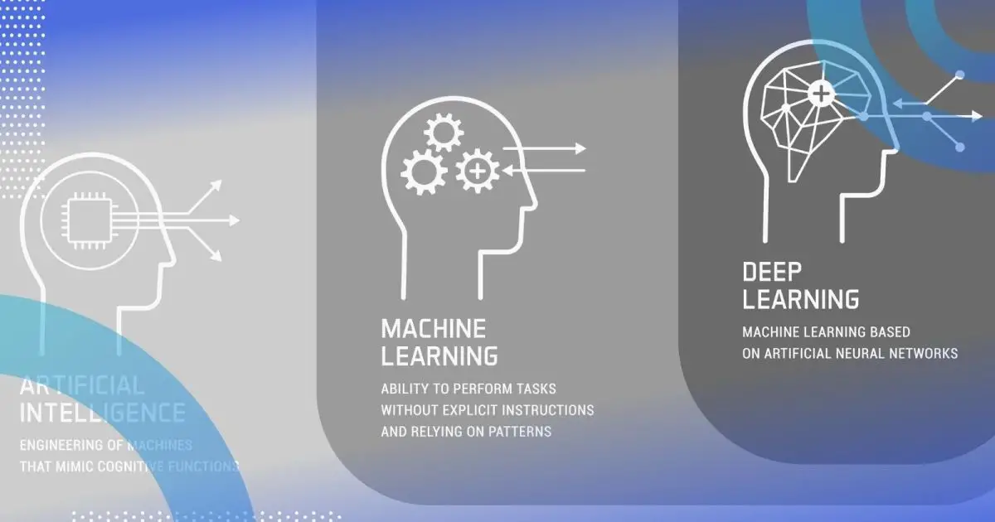

Fig.6.1 Difference between AI, ML, DL
The purpose of machine learning is to figure out how we can build computer systems that improve over time and with repeated use. This can be done by figuring out the fundamental laws that govern such learning processes.
MACHINE LEARNING LIFE CYCLE:
Machine learning has given the computer systems the abilities to automatically learn without being explicitly programmed. But how does a machine learning system work? So, it can be described using the life cycle of machine learning. Machine learning life cycle is a cyclic process to build an efficient machine learning project. The main purpose of the life cycle is to find a solution to the problem or project.
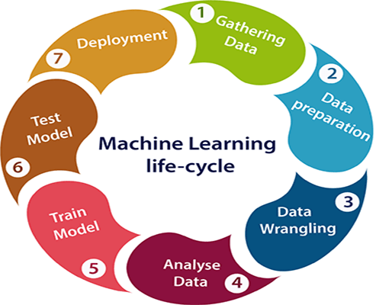

Fig.6.2 Machine learning life cycle
1. Gathering Data: In this step, we need to identify the different data sources, as data can be collected from various sources such as files, database, internet, or mobile devices. It is one of the most important steps of the life cycle. The quantity and quality of the collected data will determine the efficiency of the output. The more will be the data, the more accurate will be the prediction.
This step includes the below tasks:
- Identify various data sources
- Collect data
- Integrate the data obtained from different sources
2. Data preparation: After collecting the data, we need to prepare it for further steps. Data preparation is a step where we put our data into a suitable place and prepare it to use in our machine learning training.
In this step, first, we put all data together, and then randomize the ordering of data.
This step can be further divided into two processes:
- Data exploration:
- Data pre-processing:
3. Data Wrangling: Data wrangling is the process of cleaning and converting raw data into a useable format. It is the process of cleaning the data, selecting the variable to use, and transforming the data in a proper format to make it more suitable for analysis in the next step. It is one of the most important steps of the complete process. Cleaning of data is required to address the quality issues.
It is not necessary that data we have collected is always of our use as some of the data may not be useful. In real-world applications, collected data may have various issues, including:
- Missing Values
- Duplicate data
- Invalid data
- Noise
4. Data Analysis: Now the cleaned and prepared data is passed on to the analysis step. This step involves:
- Selection of analytical techniques
- Building models
- Review the result
The aim of this step is to build a machine learning model to analyze the data using various analytical techniques and review the outcome. It starts with the determination of the type of the problems, where we select the machine learning techniques such as Classification, Regression, Cluster analysis, Association, etc. then build the model using prepared data, and evaluate the model.
5. Train Model: Now the next step is to train the model, in this step we train our model to improve its performance for better outcome of the problem.
We use datasets to train the model using various machine learning algorithms. Training a model is required so that it can understand the various patterns, rules, and, features.
6. Test Model: Once our machine learning model has been trained on a given dataset, then we test the model. In this step, we check for the accuracy of our model by providing a test dataset to it.
Testing the model determines the percentage accuracy of the model as per the requirement of project or problem.
7. Deployment:
The last step of machine learning life cycle is deployment, where we deploy the model in the real-world system.
If the above-prepared model is producing an accurate result as per our requirement with acceptable speed, then we deploy the model in the real system. But before deploying the project, we will check whether it is improving its performance using available data or not. The deployment phase is similar to making the final report for a project.
Challenges Faced By Machine Learning:
In Machine Learning, there occurs a process of analyzing data for building or training models. There are a lot of challenges that machine learning professionals face to inculcate ML skills and create an application from scratch.
1. Poor Quality of Data: Data plays a significant role in the machine learning process. One of the significant issues that machine learning professionals face is the absence of good quality data.
2. Underfitting of Training Data
This process occurs when data is unable to establish an accurate relationship between input and output variables. It simply means trying to fit in undersized jeans. It signifies the data is too simple to establish a precise relationship. To overcome this issue:
- Maximize the training time
- Enhance the complexity of the model
- Add more features to the data
- Reduce regular parameters
- Increasing the training time of model
3. Overfitting of Training Data: Overfitting refers to a machine learning model trained with a massive amount of data that negatively affect its performance. It is like trying to fit in oversized jeans.
We can tackle this issue by:
- Analyzing the data with the utmost level of perfection
- Use data augmentation technique
- Remove outliers in the training set
- Select a model with lesser features
4. Lack of Training Data: The most important task you need to do in the machine learning process is to train the data to achieve an accurate output. Less amount training data will produce inaccurate or too biased predictions.
5. Slow Implementation: This is one of the common issues faced by machine learning professionals. The machine learning models are highly efficient in providing accurate results, but it takes a tremendous amount of time. Slow programs, data overload, and excessive requirements usually take a lot of time to provide accurate results. Further, it requires constant monitoring and maintenance to deliver the best output.

PYTHON ANACONDA INSTALLATION
1. Go to this link and download Anaconda for Windows, Mac, or Linux: – Download anaconda

You can download the installer for Python 3.7 or for Python 2.7 (at the time of writing). And you can download it for a 32-bit or 64-bit machine.
2. Click on the downloaded .exe to open it. This is the Anaconda setup. Click next.


3. Now, you’ll see the license agreement. Click on ‘I Agree’.

4. You can install it for all users or just for yourself. If you want to install it for all users, you need administrator privileges.


5. Choose where you want to install it. Here, you can see the available space and how much you need.

6. Now, you’ll get some advanced options. You can add Anaconda to your system’s PATH environment variable, and register it as the primary system Python 3.7. If you add it to PATH, it will be found before any other installation. Click on ‘Install’.


7. It will unpack some packages and extract some files on your machine. This will take a few minutes.


8. The installation is complete. Click Next.


9. This screen will inform you about PyCharm. Click Next.


10. The installation is complete. You can choose to get more information about Anaconda cloud and how to get started with Anaconda. Click Finish.


11. If you search for Anaconda now, you will see the following options:
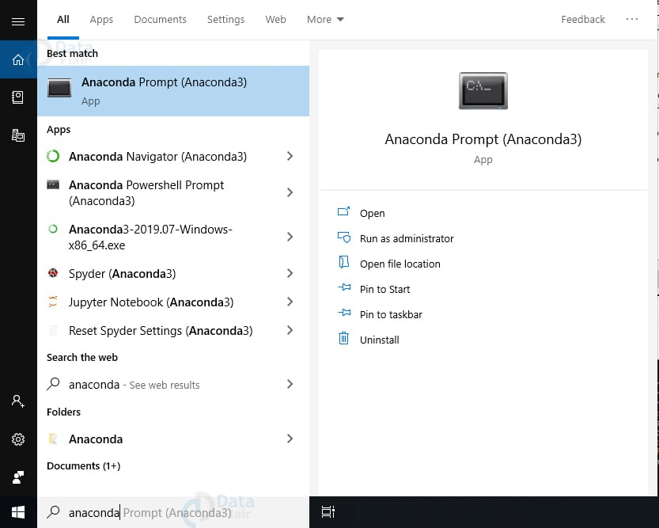
LIBRARIES/PACKAGES
1. NumPy:
Provides support for large, multi-dimensional arrays and matrices. Includes a vast collection of mathematical functions to operate on these arrays.
2. Pandas:
Offers data structures like DataFrames for efficient data manipulation and analysis. Simplifies data cleaning, preparation, and munging tasks for data science projects.
3. SciPy:
Builds on NumPy by adding a collection of algorithms for scientific and technical computing. Covers areas such as integration, optimization, interpolation, eigenvalue problems, and others.

4. Matplotlib:
Enables the creation of static, animated, and interactive visualizations in Python. Commonly used for plotting graphs and charts, making it a staple for data visualization.
5. Scikit-learn:
Provides simple and efficient tools for data mining and data analysis. Supports various machine learning algorithms, including classification, regression, and clustering.
6. TensorFlow:
An open-source library for numerical computation and large-scale machine learning. Used for building and deploying machine learning models, especially deep neural networks.
7. Keras:
A high-level neural networks API, written in Python and capable of running on top of TensorFlow. Facilitates fast experimentation with deep neural networks due to its user-friendly, modular nature.

CHAPTER - 7
7. SYSTEM TESTING
System testing, also referred to as system-level testing or system integration testing, is the process in which a quality assurance (QA) team evaluates how the various components of an application interact together in the full, integrated system or application.
System testing verifies that an application performs tasks as designed. It's a type of black box testing that focuses on the functionality of an application rather than the inner workings of a system, which white box testing is concerned with.
7.1 TYPES OF SYSTEM TESTING
With system testing, a QA team gauges if an application meets all of its technical, business and functional requirements. To accomplish this, the QA team might utilize various types of software testing techniques that determine the overall test coverage for an application and help catch critical defects that hamper an application's core functionalities before release.
The following are the common types of system testing techniques:
Performance testing: Performance testing measures the speed, average load time, stability, reliability and peak response times of the system under various conditions. It's typically coupled with stress testing and may include both hardware and software testing tools.
Usability testing: These are tests to evaluate if a system is easy to use and functional for the end user. Metrics, including user error rates, task success rates, the time it takes a user to complete a task and user satisfaction, are used during testing.
Load testing: This is testing to determine how a system or software performs under a real-life extreme load and test scenarios. Metrics, such as throughput, number of users and latency, are measured through this testing.
Regression testing: Also known as sanity testing, it ensures that all changes introduced into an application or code during system testing, recent code changes or updates haven't caused any new bugs or issues. Regression testing is responsible for the functionality of the existing features of a system or software.
Migration testing: This is conducted to ensure smooth migration of legacy systems to new systems without disruptions, data loss or downtimes.
Scalability testing: This measures an application's or system's capability to scale up or down when trying to meet the changing user requirements.
Functional88ity testing: This is conducted to validate a system's functionality against its functional and business requirements.
Recovery testing: This is a type of nonfunctional testing done to ensure that a system is capable of recovering from certain system errors, crashes and failures.
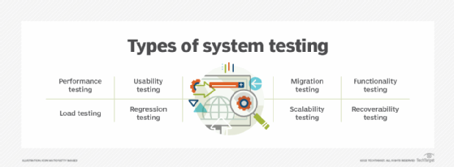
Phases of system testing
System testing examines every component of an application to make sure that they work as a complete and unified whole. A QA team typically conducts system testing after it checks individual modules with functional or user story testing and then each component through integration testing.
If a software build achieves the desired results in system testing, it gets a final check via acceptance testing before it goes to production, where users consume the software. An app dev team logs all defects and establishes what kinds and numbers of defects are tolerable.
Typically, system testing goes through the following stages:
Test environment. In this initial stage, a test server is set up for creating a testing environment, which enables a tester to run a set of predefined test cases and test scripts.
Test case. This stage generates the test case for the testing process.
Test data. At this stage, the data to be tested is generated.
Test case execution. Once the test case and test data are generated, test cases are executed.
Reporting of defects. This is the stage where defects in the system are identified.
Regression testing. This is done to see if any problems were introduced into the development process by the previous stages.
Defect logging. All the identified defects are fixed at this stage.
Retest. A test is repeated if it's unsuccessful.

7.2 TEST CASES
Test Case ID | Test Name | Type | Input | Expected Output | Actual Output | Status
TC01 | Valid Login | Positive | Username: admin, Password: admin | Login successful, dashboard displayed | Login successful, dashboard displayed | Pass
TC02 | Upload Normal Activity Video | Positive | Valid CCTV video (normal activity) | Classified as Normal Activity with confidence score | Classified as Normal Activity with confidence score | Pass
TC03 | Detect Violence Activity | Positive | Video containing fight/violence | Classified as Violent Activity with bounding boxes | Classified as Violent Activity with bounding boxes | Pass
TC04 | Detect Weapon Activity | Positive | Video with weapon (knife/gun) | Classified as Weaponized Activity | Classified as Weaponized Activity | Pass
TC05 | Display Results in UI | Positive | Processed video upload | Results displayed with labels, confidence score, bounding boxes | Results displayed with labels, confidence score, bounding boxes | Pass
TC06 | Invalid Login | Negative | Username: user, Password: 1234 | Error message “Invalid Credentials” | Error message displayed | Pass
TC07 | Unsupported File Upload | Negative | Upload .txt/.pdf file | Error “Invalid file format” | Error displayed | Pass
TC08 | Corrupted Video Upload | Negative | Damaged/empty video file | Error “File cannot be processed” | Error displayed | Pass
TC09 | Blank Video Input | Negative | Empty/black frames video | Output “Normal Activity” or “No activity detected” | Output shown as “Normal Activity” | Pass
TC10 | Large File Upload (Overload) | Negative | Very large video file | Warning or delay message | Warning/delay observed | Pass

CHAPTER-8
RESULTS

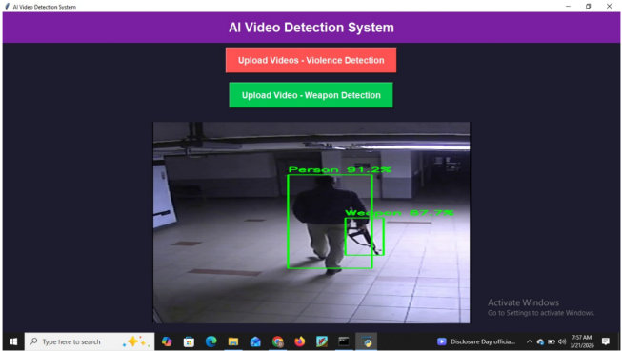

Fig.8.1: Person and Weapon Detection Output

Illustrates the system detecting a person and weapon with bounding boxes and confidence scores

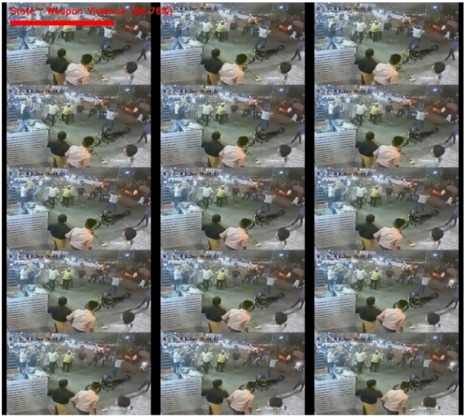

Fig.8.2: Violence Detection in Video Frames

Shows multiple frames where violent activity is identified with high confidence.

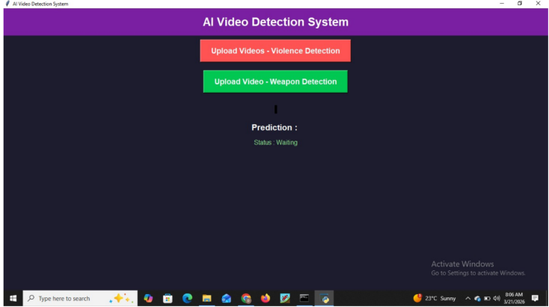
Fig.8.3: System User Interface for Video Upload

Represents the web interface where users upload videos and view prediction results.

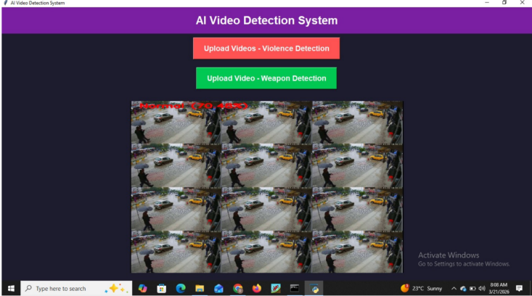

Fig.8.4: Normal Activity Detection (Scene 2)

Shows another example of normal activity correctly classified by the model.

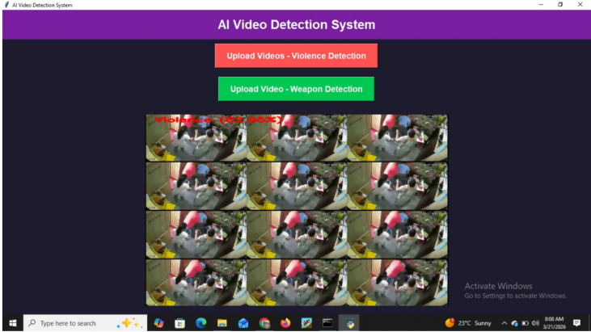

Fig.8.5: Indoor Violence Detection

Illustrates detection of violent activity in an indoor environment with high accuracy.
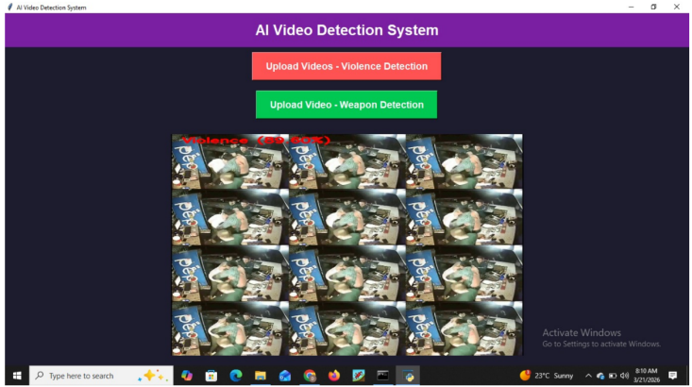

Fig.8.6: Violence Detection (Alternate Scenario)

Shows another instance of violence detection confirming model consistency.

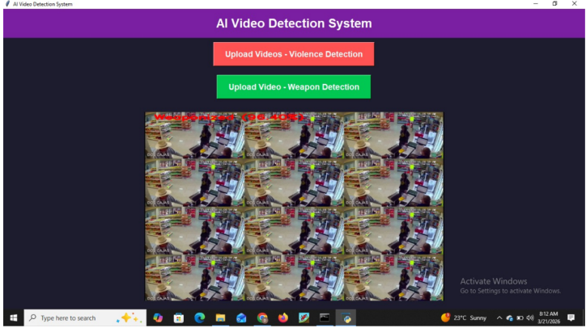

Fig.8.7: Weapon Detection in Store Environment

Represents weapon detection in a retail/store setup using bounding boxes.

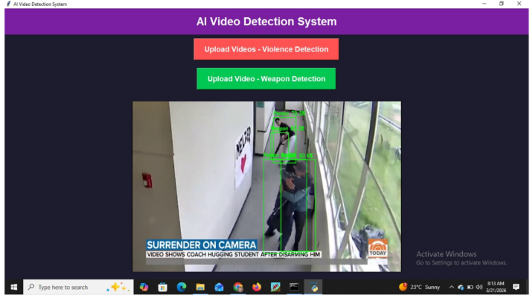

Fig.8.8: Weapon Detection in Corridor Scene

Shows detection of a weapon and person in a corridor environment.

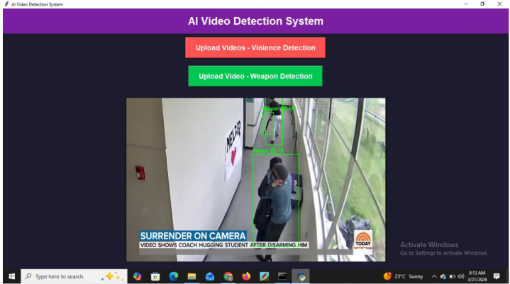

Fig.8.9: Multi-Person and Weapon Detection

Illustrates detection of multiple persons and weapons in a surveillance scenario.

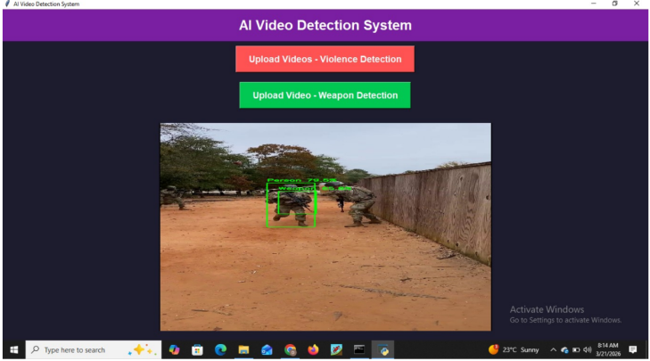

Fig.8.10: Weapon Detection in Outdoor Environment

Depicts weapon detection in an outdoor/military-like environment.

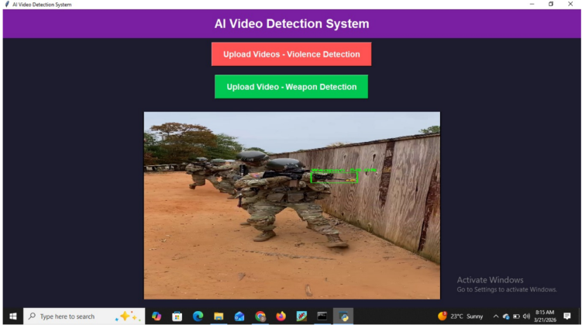

Fig.8.11: Weapon Detection (Additional Scenario)

Shows another example of weapon detection demonstrating model reliability.

CHAPTER 9
CONCLUSION AND FUTURE SCOPE
9.1 CONCLUSION
The proposed system, SentinelAI, successfully demonstrates an AI-based intelligent video surveillance solution for detecting violence and weapon-related activities in CCTV footage. By utilizing a Convolutional Neural Network (CNN) along with super-image representation, the system efficiently captures both spatial and temporal features, enabling accurate classification of activities into normal, violent, and weaponized categories.
The integration of a Flask-based web interface enhances usability by allowing real-time video upload and visualization of results with confidence scores and bounding boxes. The system reduces human effort, improves response time, and operates effectively on standard hardware with low computational requirements. Overall, the proposed approach provides a practical and scalable solution for smart surveillance applications, contributing to improved public safety and security.
9.2 FUTURE SCOPE
- Integration with live CCTV camera feeds for real-time continuous monitoring
- Implementation of advanced models such as Transformers for improved accuracy
- Addition of real-time alert systems using SMS, email, or mobile notifications
- Enhancement of detection accuracy using larger and more diverse datasets
- Deployment on cloud platforms for large-scale surveillance applications
- Optimization for edge devices to enable faster and low-latency processing
- Inclusion of facial recognition for identifying suspicious individuals
- Development of mobile applications for remote monitoring and control
CHAPTER 10
REFERENCES
[1] Sanam Narejo, Bishwajeet Pandey, Doris Esenarro Vargas, Ciro Rodriguez,
and M Rizwan Anjum. Weapon detection using yolo v3 For SmartSurveillance
System.Mathematical Problems in Engineering,2021(1):9975700, 2021

[2] Mingze Xu, Yuanjun Xiong, Hao Chen, Xiyu Li, Wei Xia, Zhuowen Tu, and
Stefano Soatto. Long short-term transformer for online action detection. Advances in Neural Information Processing Systems, 34:1086–1099, 2021.

[3] Palash Yuvraj Ingle and Young-Gab Kim. Real-time abnormal object detection for
video surveillance in smart cities. Sensors, 22(10):3862,2022

[4] Romas Vijeikis, Vidas Raudonis, and Gintaras Dervinis. Efficient violence
detection in surveillance.Sensors, 22(6):2216, 2022.

[5] James Wensel, Hayat Ullah, and Arslan Munir. Vit-ret : Vision and recurrent
transformer neural networksfor human activity recognition in videos. IEEE Access, 11:72227–72249, 2023.

[6] Waseem Ullah, Tanveer Hussain, Fath U Min Ullah, Mi Young Lee, and Sung
Wook Baik. Transcnn : Hybrid cnn and transformer mechanism for the
surveillance anomaly detection.Engineering Applications of Artificial Intelligence,
123:106173, 2023.

[7] Pablo Negre, Ricardo S Alonso, Alfonso Gonzalez - Briones, Javier Prieto, and
Sara Rodr ´ ´ıguez-Gonzalez. ´Literature review of deep- learning-based
detection of violence in video. Sensors, 24(12):4016,2024.

WEBSITES
[1] https://www.nist.gov/pqcrypto – NIST Post-Quantum Cryptography Standardization project documentation.
[2] https://www.idquantique.com – Commercial QKD hardware specifications and deployment guides.
[3] https://pycryptodome.readthedocs.io – PyCryptodome library documentation for AES and cryptographic operations.
[4] https://flask.palletsprojects.com – Flask framework documentation for RESTful API development.
[5] https://numpy.org – NumPy documentation for numerical computation used in QKD simulation.
[6] https://www.sqlite.org – SQLite documentation for lightweight database integration.

