**Revolutionizing E-Commerce: Advanced Strategies and Algorithms in Product Recommendation Systems**

Chinni Krishna Kowsik. P

UG Student,

Department of Computer Science and

Engineering (Cyber Security),

School of Computing,

Amrita Vishwa Vidyapeetham,

Chennai

[kowsikperumalla@gmail.com](mailto:kowsikperumalla@gmail.com)

Uday Reddy H

UG Student,

Department of Computer Science and

Engineering (Cyber Security),

School of Computing,

Amrita Vishwa Vidyapeetham,

Chennai

[hosurudayreddy@gmail.com](mailto:hosurudayreddy@gmail.com)

1. **Abstract**

In this project, we explored a vast dataset containing information about various products. The analysis began by loading the data and understanding its structure. We focused on specific products, main categories, and sub-categories. Through visualizations, we gained insights into customer behavior, such as ratings distribution, pricing trends, and popularity among different product categories.

The code allowed us to filter the dataset dynamically based on user input, enabling us to investigate specific product categories and sub-categories. Visualizations included line plots showing the relationship between product ratings and retail prices, bar plots illustrating sub-category counts, and histograms displaying the distribution of the number of ratings for selected products.

Furthermore, the code provided tools to create recommendation systems. It employed techniques such as collaborative filtering and matrix factorization to predict user preferences and generate top product recommendations. These recommendations were based on user behaviour, allowing for personalized suggestions tailored to individual users' interests and preferences.

Additionally, the code showcased the utilization of machine learning algorithms, including K-Nearest Neighbours, Decision Trees, and Logistic Regression, to model and predict product ratings. These models were trained on various features such as retail prices and discounted prices, providing insights into factors influencing customer satisfaction.

The project not only provided a deep understanding of the dataset but also offered a practical approach to building recommendation systems and predictive models. The flexibility to explore specific product categories and the incorporation of machine learning techniques make this codebase valuable for businesses aiming to enhance customer experience and optimize product offerings.

**Keywords:**

“Product Recommendation System”, “Data Analysis”, “Data Visualization”, “Collaborative Filtering”, “Matrix Factorization”, “Machine Learning Algorithms”, “K-Nearest Neighbours (KNN)”, “Decision Trees”, “Logistic Regression”, “User Behaviour Analysis”, “Customer Preferences”, “Rating Distribution”, “Retail Price”, “Discounted Price”, “Sub-categories”, “Main Categories”, “Data Preprocessing”, “Exploratory Data Analysis (EDA)”, “User Input Handling”, “Personalized Recommendations”.

1. **Introduction:**

In the bustling landscape of online shopping, where consumers are bombarded with an endless array of products, the importance of personalized, intelligent product recommendations cannot be overstated. Imagine stepping into a favorite local store where the friendly shopkeeper knows your tastes and guides you to items you might love. In the digital realm, businesses aspire to recreate this personalized experience online, ensuring customers find products that truly resonate with their preferences.

This project embarks on a fascinating journey into the heart of customer preferences and product choices. With a treasure trove of data at our disposal, we delve deep into understanding the intricate dance between customers and products. Every click, every rating, and every purchase leaves a digital footprint, and our task is to decipher these patterns. It's akin to unravelling the threads of a complex tapestry, where each thread represents a customer's unique choice, and each pattern woven signifies a potential insight.

Our exploration begins with a meticulous inspection of the dataset. It’s like examining pieces of a puzzle, trying to discern the bigger picture. We seek to understand the nuances - the subtle cues that make a customer favour one product over another. Through vivid data visualizations, we illuminate these patterns. Imagine painting with data, where bar graphs and histograms become brushes, and customer behaviour is the canvas. With each stroke, we uncover hidden trends, making the abstract concept of customer preference tangible and comprehensible.

But we don’t stop at understanding; we want to predict. We want to peer into the future, albeit digitally, and anticipate what a customer might desire. Enter the world of machine learning, where algorithms become our crystal ball. Collaborative Filtering, K-Nearest Neighbors, and the sophisticated Matrix Factorization - these are our tools to foresee preferences and provide tailored suggestions. It’s akin to having a virtual shopping assistant, available 24/7, catering to individual tastes and ensuring every customer feels valued.

Recommender systems concern with two types of information i.e.

* Characteristics Information, that consists of information about the objects/products such as keywords, categorization, etc. and the user's fondness, profile, etc.
* User-Item Interactions, which consists of information about ratings, user likes, and so on.

So, in general it is a type of filtering mechanism and with respect to that we have three main types of recommender systems i.e.:

* Content-based systems, which use characteristic information.
* Collaborative filtering systems, which are based on user-item interaction
* Hybrid systems, which combine both types of information with the aim of avoiding problems that are generated when working with just one kind of system.

Additionally, we explore the art of pricing. Pricing isn’t just numbers; it’s a delicate balance between value and perception. We dissect how discounts and retail prices influence customer satisfaction. It's akin to understanding the psychology behind a price tag, where a customer perceives value and makes decisions based not just on numbers but on emotions and perceptions.

By the end of our journey, this project equips businesses with insights that bridge the gap between the digital realm and the personal touch of a local store. It’s not merely about numbers and algorithms; it’s about understanding human desires, preferences, and the subtle art of making customers feel understood and valued. Join us in this exploration, where data meets intuition, and together, we decipher the intricate language of customer-product relationships.

1. **Literature Review:**

Jatin Sharma, Kartikay Sharma, Kaustubh Garg, Avinash Kumar Sharma et. al [1] proposed on “Product Recommendation System a Comprehensive Review” in 2021. The paper is a Review of various mechanisms and techniques in recommender systems for fashion and books, focusing on content-based filtering, collaborative-based filtering, and hybrid filtering techniques. The paper discusses the importance of recommender systems in enhancing customer experience and boosting product sales for online businesses. It explores content-based, collaborative-based, and hybrid filtering methods, highlighting their applications in recommending products based on user preferences and interactions.

F.O. Isinkaye a, Y.O. Folajimi b, B.A. Ojokoh c et. al [2] proposed on “Recommendation systems: Principles, methods and evaluation” in 2020. This paper explores the challenges posed by information overload on the internet and how recommender systems address this issue. Recommender systems are essential for providing personalized content and services to users by filtering vast amounts of information. The paper discusses the phases of the recommendation process: information collection, learning, and prediction/recommendation. The method uses models such as TF/IDF, Naïve Bayes Classifier, Decision Trees, or Neural Networks to establish relationships between documents and provide meaningful recommendations. Although content-based filtering doesn't require profiles of other users and can adapt quickly to user profile changes, it requires in-depth knowledge of item features.

Fatima Rodrigues and Bruno Ferreira et. al [3] proposed on “Product Recommendation based on shared customers” in 2016. The paper introduces a novel product recommendation approach based on shared customers. It focuses on analysing customer relationships and interactions to enhance the recommendation process. The authors propose a method that leverages shared customer data to make product recommendations more personalized and relevant. The proposed method in the paper is aimed at enhancing product recommendation systems. The shared customer-based approach offers a new perspective for making recommendations, potentially leading to more satisfied customers and increased sales.

Mukul Kanagala et. al [4] proposed on “Product based Recommendation system using Machine Learning Techniques” in 2020. The dataset contains four columns: User ID, Product ID, Rating, and Timestamp. The specifics of the dataset, such as its size, source, and nature of products, are not provided. The system utilizes collaborative filtering techniques, specifically employing Single Value Decomposition (SVD) for matrix factorization. The following steps are involved in the implementation: Preprocessing, Model training, Hyper Parameter Optimization, Postprocessing, Evaluation. It aids customers in discovering relevant products, potentially increasing sales and customer satisfaction.

Xiaoyuan Su and Taghi M. Khoshgoftaar et. al [5] proposed on “A Survey of Collaborative Filtering Techniques” in 2009. Collaborative filtering operates on a user-item matrix, where users rate or interact with items. The paper references common datasets like Movie Lens, Jester, and Netflix prize data for evaluation purposes. The paper discusses various collaborative filtering techniques, including memory-based CF (neighbour-based CF and item-based/user-based top-N recommendations), model-based CF (using techniques like Bayesian belief nets, clustering, and latent semantic CF), and hybrid recommenders (combining CF with content-based techniques). Various techniques, including hybrid approaches and robustness analysis, are discussed as solutions to these challenges.

Badrul Sarwar, George Karypis, Joseph Konstan, and John Riedl et. al [11] proposed on “Item-Based Collaborative Filtering Recommendation Algorithms”. The paper is totally based on the collaborative filtering, how we can do product recommendation system by the filtering processes. This research delves into the dynamic realm of recommender systems, focusing on their pivotal role in offering personalized suggestions to users during live interactions. In the expansive digital landscape, especially on the web, recommender systems, particularly those grounded in k-nearest neighbor collaborative filtering, have attained remarkable success.

1. **Background and Related Works:**

In the fast-paced world of e-commerce, understanding customer behaviour and preferences is paramount. As the digital marketplace expands, businesses are increasingly relying on sophisticated recommendation systems to enhance user experience and drive sales. These systems are rooted in the principles of data analysis, machine learning, and user psychology, aiming to emulate the personalized service one might receive in a brick-and-mortar store. The evolution of these recommendation systems has been marked by groundbreaking research and innovative techniques, creating a landscape where customer satisfaction is not just a goal but a science.

1. **Dataset:**

The Comprehensive Product Dataset comprises a multitude of fields sourced from different datasets. The dataset includes unique identifiers (Ids) for both users and products, ensuring precision and clarity in data representation. Each product is categorized into main and sub-categories, providing a structured taxonomy. Product names and associated images offer a visual understanding of the items. Additionally, the dataset captures vital pricing information, including original retail prices and discounted prices after promotions. User engagement is reflected through the number of ratings, indicating the popularity and reception of each product. Furthermore, a distinct feature, denoted as 'event,' encapsulates diverse user interactions, contributing to a holistic view of user behaviour.

**Id:** This column likely represents a unique identifier for each record in the dataset. It's used to distinguish one record from another and is often used as an index.

**UserId:** This column represents the unique identifier for the users who interact with the products. Each user in the system would have a distinct UserId.

**ProductId:** This column represents the unique identifier for each product in the dataset. Each product available in the recommendation system is assigned a specific ProductId.

**name:** This column contains the name or title of the product. It provides a brief description of what the product is.

**main_category:** This column categorizes the products into broader groups. For example, if the products are electronics, fashion, or home appliances, this column would specify which main category each product belongs to.

**sub_category:** This column further refines the categorization of products within the main categories. For instance, within the "electronics" category, sub-categories could include "smartphones," "laptops," or "accessories."

**image:** This column likely contains the file path or URL to the image of the product. Images are often used in recommendation systems to display the products to users.

**link:** This column could contain a URL linking to the product page. Users can click on this link to view more details about the product or make a purchase.

**no_of_ratings:** This column represents the number of ratings or reviews received by the product. It indicates how many users have provided feedback on the product

**retail_price:** This column contains the original price of the product without any discounts or promotions applied. It provides the baseline price of the product.

**discounted_price:** This column contains the price of the product after applying any discounts or promotions. It represents the actual amount users would pay for the product.

**ratings:** This column likely represents the average ratings given by users who have rated the product. Ratings are numerical values (often on a scale from 1 to 5) indicating the satisfaction level of users with the product.

**event:** This column is not explicitly described, but it appears to be related to some event associated with the product. Depending on the context, it could represent various events such as product views, clicks, purchases, or any other user interactions with the product.

The Comprehensive Product Dataset holds immense significance for businesses and researchers alike. By combining data from disparate sources, it captures a wide spectrum of products and user activities. For businesses, this dataset is a goldmine for enhancing customer experience and boosting sales. Through advanced analytics and recommendation algorithms, businesses can understand user preferences, optimize pricing strategies, and personalize marketing campaigns. Researchers benefit from a comprehensive dataset that allows in-depth analysis of user behavior, enabling the development and validation of cutting-edge recommendation algorithms. The CPD thus stands as a testament to the power of data integration, offering unprecedented insights into the dynamic world of e-commerce and user-product interactions.

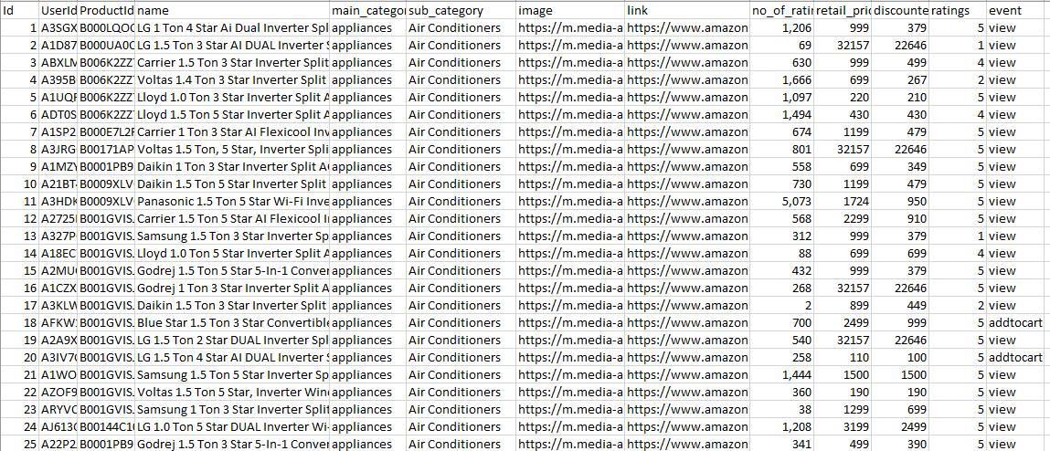

1. **Methodology:**

**6.1 Introduction:**

Recommender systems are crucial in today's digital landscape, powering personalized suggestions in platforms like e-commerce, streaming services, and social media. Their significance lies in enhancing user experience and boosting business revenue by increasing customer engagement and satisfaction.

Recommender systems, often referred to as recommendation engines, are innovative algorithms designed to predict and suggest items that a user might prefer. These items could range from movies, products, or services to articles and social connections. By analysing user behaviour, preferences, and historical data, these systems provide personalized recommendations, making them invaluable tools in the digital age.

The importance of recommender systems cannot be overstated. For businesses, they translate into higher customer engagement, increased sales, and enhanced customer loyalty. By understanding user preferences, businesses can offer tailor-made suggestions, creating a more satisfying shopping or viewing experience. Similarly, in content-driven platforms, like streaming services, recommender systems ensure users discover content aligning with their tastes, keeping them engaged and entertained.

**6.2 Dataset:**

Our dataset, a rich combination of diverse sources from Kaggle, forms the bedrock of our analysis. Comprising a plethora of attributes such as user and product IDs, names, categories, prices, ratings, and user interactions, it paints a comprehensive picture of user behaviour and product characteristics. This diversity enables us to create nuanced recommendation systems catering to a wide array of preferences.

The foundation of our dataset lies in the careful collection process. Leveraging Kaggle, a renowned hub for datasets, we curated a collection of files, each offering unique insights into user-product interactions. This broad spectrum of data sources ensured a holistic view, allowing us to capture subtle patterns and preferences.

However, the raw data from diverse sources often comes with its challenges. Our first task was to address missing values, ensuring our analysis isn't skewed by incomplete information. Duplicates, a common occurrence in real-world datasets, were systematically removed to maintain data integrity. Outliers, which could potentially distort our models, were carefully identified and appropriately handled.

Additionally, the dataset underwent standardization and normalization processes, ensuring uniformity and comparability across various attributes. Categorical variables were encoded to numerical values, enhancing their usability in machine learning algorithms. By the end of this rigorous data cleaning phase, we had a refined, robust dataset ready for in-depth analysis and modelling.

**6.3 Filtering Mechanism:**

Recommendation engines main objective is to predict user’s fascination and recommends the outcome items that are slightly similar to the interest of the user. The retailers which are working on an online platform for their business they use this strong machine learning of recommendation system forimproving their drive sales Filtering mechanism is used by the Recommendation system. Filtering is the selection method that selects features independently of the machine learning algorithm model.

Filtering is one of the methods of feature selection technique in which the small part of data is taken as a set and use that set for further analysis.

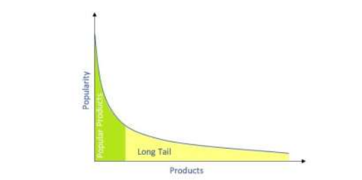

Figure 1: Graph representing the products with high popularity on y-axis and product on x-axis.

The long tail is a business strategy or statistical pattern of distribution (includes many values that are out of the way from the mean value) occurrences occur farther away from the center or head of distribution.

Recommendation System uses several technologies to check the response of user which are as follows:

**6.3.1 Content-Based Filtering:**

Content-based filtering uses the features of product to recommend similar items for what the user is interested, based on their previous experience and as well as the feedback of the user. Forexample, if the searching for formal clothes is done by the user then the system should recommend the formal shoes to the user.

**6.3.2 Collaborative Based Filtering:**

Collaborative-based filtering uses the interactions and data gathered by the system from other users. It makes recommendations based on user preferences for product features. For example, if a user is interested in a watch then the system should recommend the watch which is liked by most of the users.

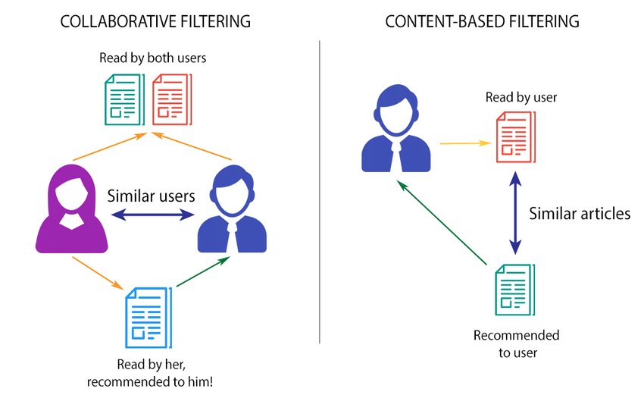

**6.3.3 Hybrid Filtering:**

Hybrid filtering uses both content-based filtering and collaborating-based filtering. Hybrid filtering recommends the items to the user of his/her interest as well as the items which are liked by most of the user i.e. the highest rating items.

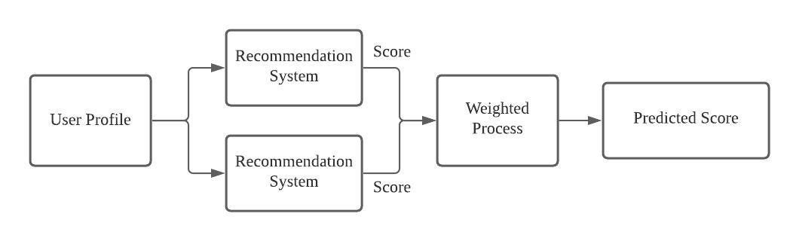

**6.3.4 Matrix factorisation:**

Matrix factorization techniques, popularized by Koren et al. (2009), focus on decomposing the user-item interaction matrix to discover latent features. By understanding these latent factors, recommendations become more accurate. This breakthrough work laid the foundation for sophisticated models used by platforms like Netflix and Amazon to predict user preferences effectively.

We have used machine learning algorithms to get the accuracy, f1 score, precision, recall and support, the algorithms we have used are:

1. KNN
2. Random Forest
3. Decision Tree
4. Logistic Regression

**6.4 WordCloud:**

A WordCloud is a visual representation of text data, where the most frequent words in a dataset are displayed in a graphical form. The more frequently a word appears in the text, the larger and bolder it appears in the WordCloud. It's a popular way to quickly understand the most common words in a large amount of text.

**6.5 Surprise:**

Surprise is a Python library specifically designed for building and analyzing recommender systems. It provides various collaborative filtering algorithms and can be used for both explicit and implicit feedback. Surprise is particularly useful for tasks like movie or product recommendations based on user preferences and behavior.

**6.6 Reader:**

"Reader" can refer to different things depending on the context. In the context of programming, a reader often refers to a class or module used for reading input data from various sources, such as files, databases, or user input. For instance, in Python, there are different types of readers for reading files, such as open(), csv.reader(), or json.load().

**6.7 TF-IDF Vectorizer:**

TF-IDF stands for Term Frequency-Inverse Document Frequency. It is a numerical statistic that reflects how important a word is to a document in a collection or corpus. The TF-IDF value increases proportionally to the number of times a word appears in the document but is offset by the frequency of the word in the corpus. TF-IDF is commonly used in information retrieval and text mining. The TF-IDF vectorizer is a tool or module used to convert a collection of raw documents to a matrix of TF-IDF features. Each row of the matrix represents a document, and each column represents a word in the dataset. This matrix can then be used for various machine learning tasks, such as text classification or clustering.

1. **Block diagram:**

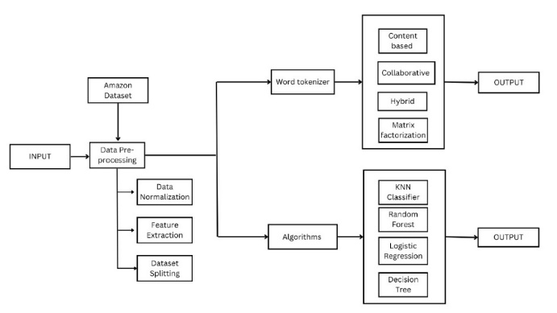

Our research paper delves into the dynamic realm of recommendation systems, presenting a multi-faceted approach outlined in an architecturally structured study. We initiate with meticulous data preprocessing, encompassing missing value handling and feature engineering. Our methodology comprises a dual-tiered recommendation system approach: the first tier involves filterization methods including content-based filtering, collaborative filtering, hybrid filters, and matrix factorization. The second tier encompasses machine learning paradigms such as K-Nearest Neighbors (KNN), Logistic Regression, Random Forest, and Decision Tree algorithms, each offering distinct contributions to the realm of recommendation systems. Our architecture diagram elegantly visualizes the flow, commencing from data preprocessing through the applications of diverse filtering techniques and culminating with various machine learning methods. By scrutinizing and comparing the performance of these methods, our study aims to present a comprehensive analysis of their efficiencies and intricacies within recommendation systems, offering insights into their strengths and limitations.

1. **Data Visualization:**

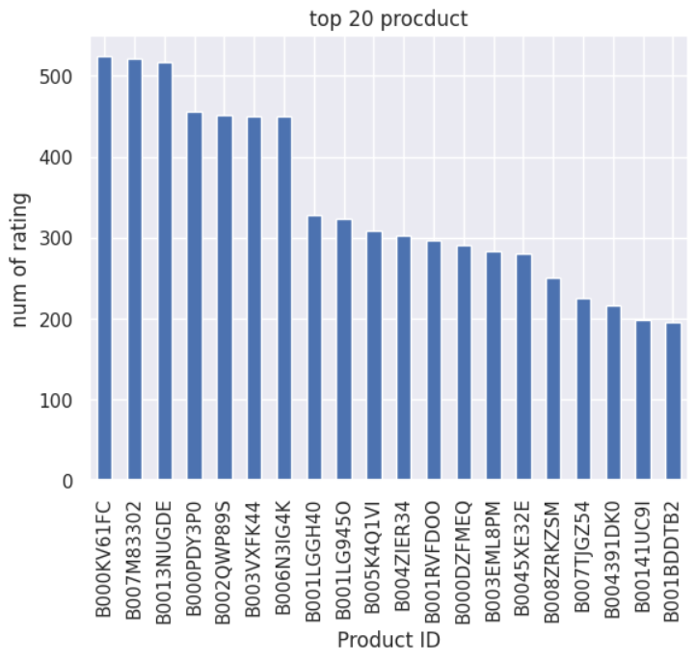

The image/graph shows the top 20 products in our dataset by their product Id. Overall, the image suggests that consumers are looking for high-quality, affordable products that are easy to purchase. This information can be used by product recommendation systems to suggest products to users that are likely to meet their needs.

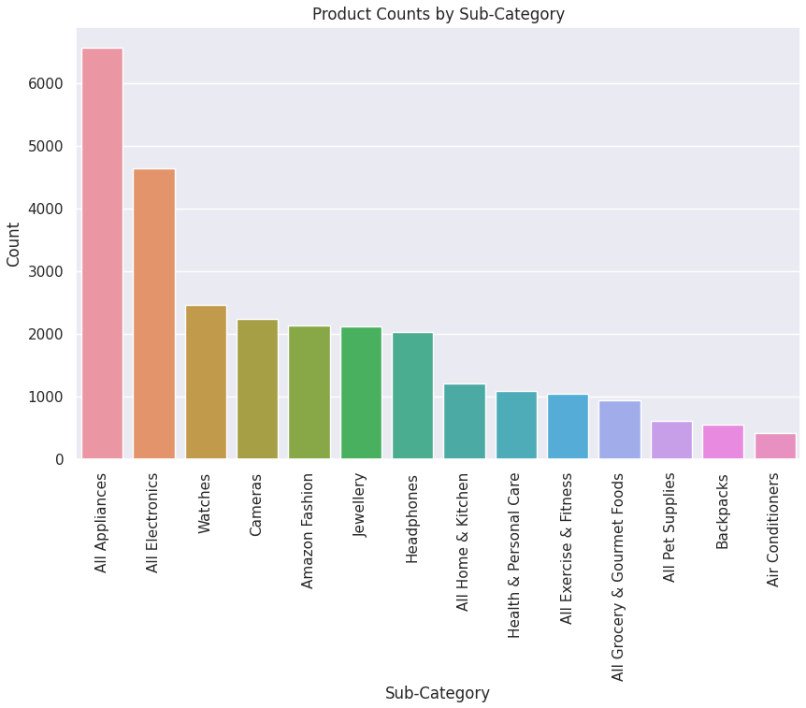

The data presented in the graph/chart suggests that the majority of products sold on Amazon are electronics, appliances, and home and kitchen products. This information could be used to inform product recommendation systems. The above graph interprets using the sub category and the below graph interprets using the main category.

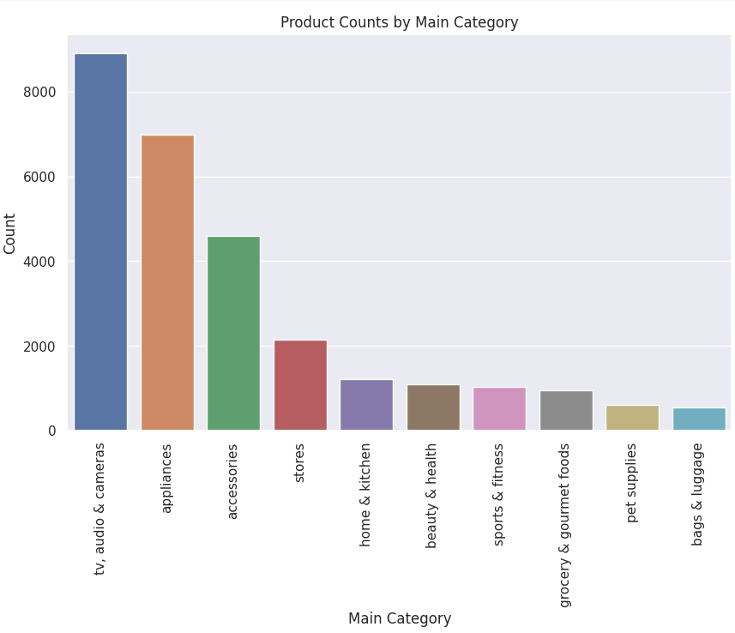

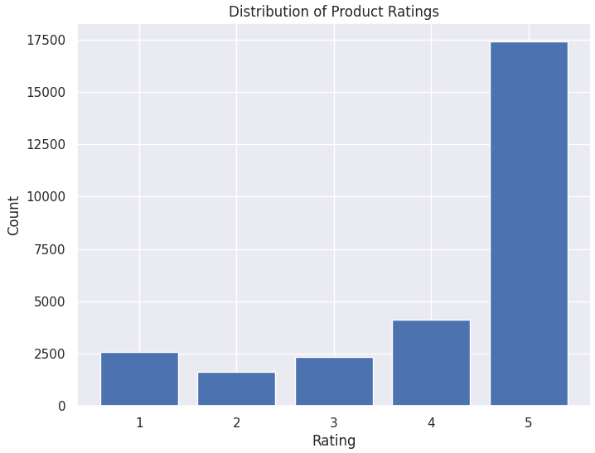

The above graph shows the distribution of product ratings from our dataset and their count according to it.

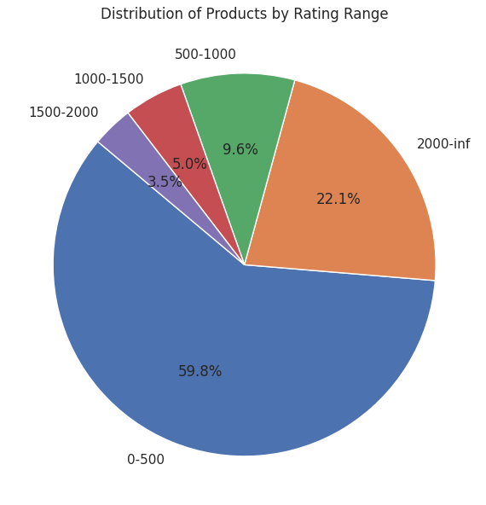

The pie chart shows the percentage of products in each rating range. The units on the pie chart are percentages.

* The majority of products (59.8%) have a rating of 4.5 stars or higher.
* A significant portion of products (22.1%) have a rating of 3.5 stars or higher.
* A relatively small portion of products (5.5%) have a rating of 2.5 stars or lower.

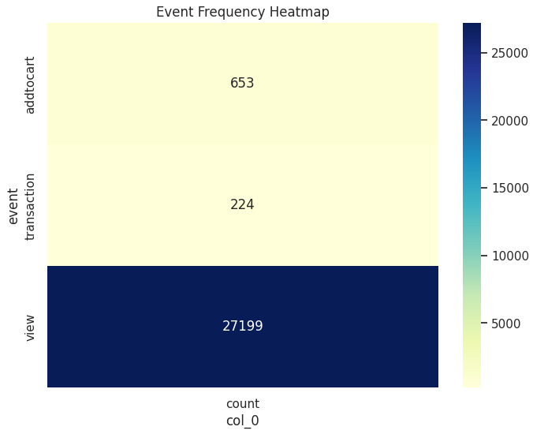

The graph/chart in the image is a heatmap. Heatmaps are used to visualize data with two or more dimensions. The color of each cell in the heatmap represents the percentage of products in the corresponding product category that have a rating in the corresponding rating range. The colors range from red (high percentage) to green (low percentage). And the below pie chart shows the pictorial representation of the above graph.

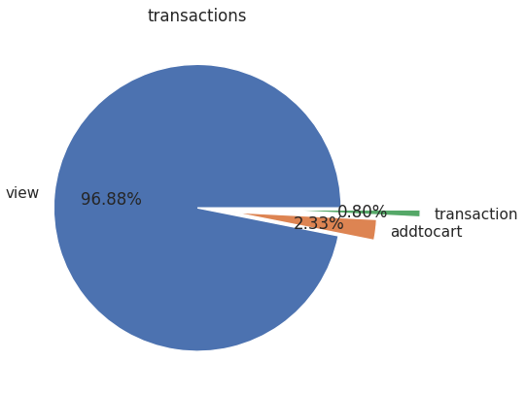

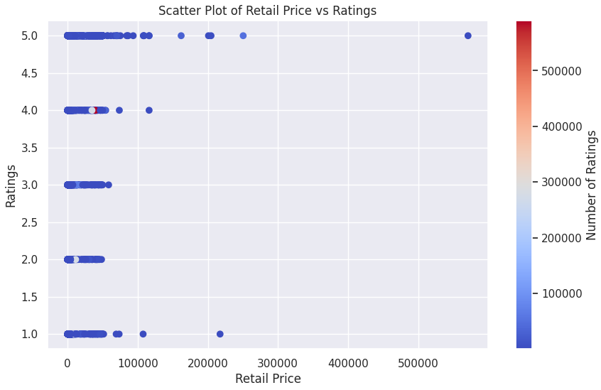

The above graph shows the Scatter Plot of Retail Price vs Ratings.

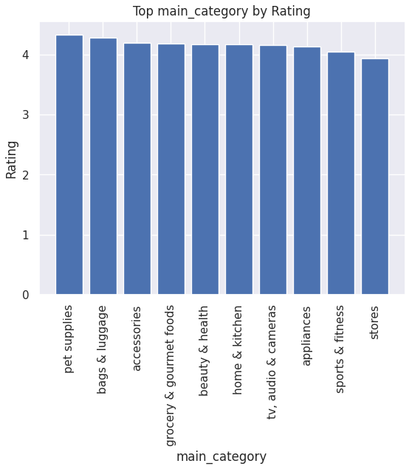 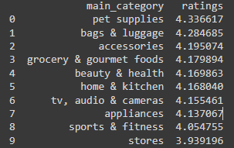

Looking at this table, we can see the main categories ranked by their average rating. The main categories with the highest ratings are Office Products, Toys & Games, and Home Improvement, with ratings above 4.0. This suggests that customers are generally satisfied with the products offered in these categories. And the below graph and table shows about the distribution using the sub category.

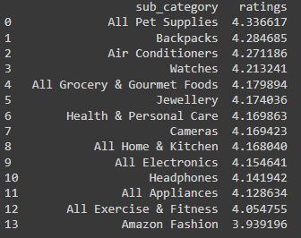

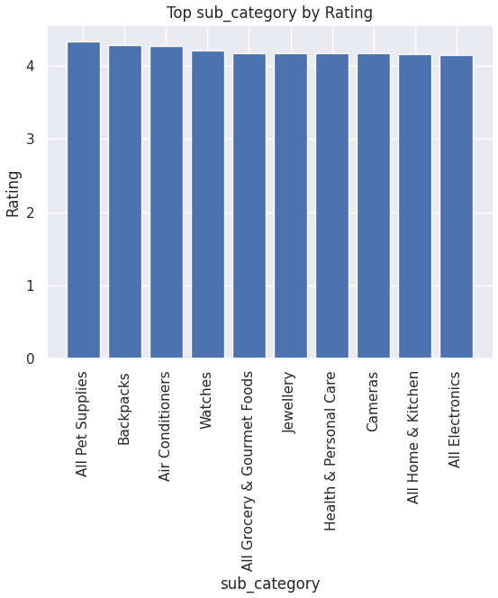

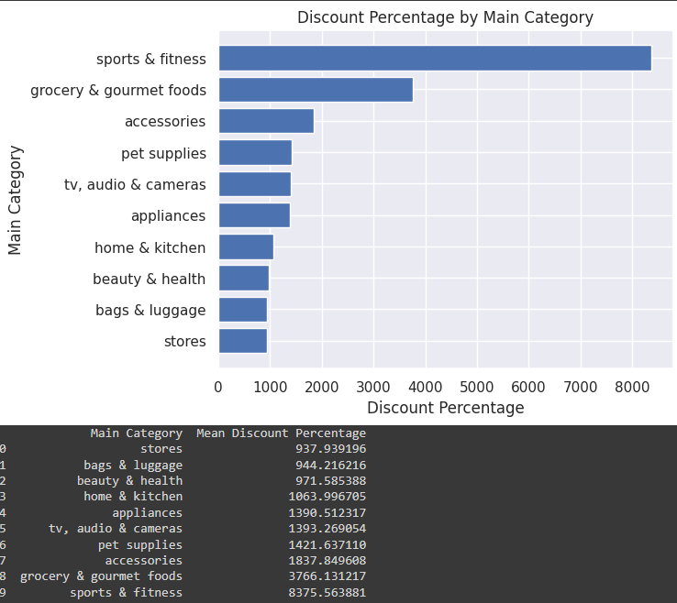

The table above shows the mean discount percentage by main category, sorted in descending order. The category with the lowest mean discount percentage is Toys & Games, with a value of 0.0. This may indicate that the demand for toys and games is high enough that retailers do not need to offer significant discounts to sell products in this category. It's also interesting to note that OfficeProducts and Health&PersonalCare have mean discount percentages of 0.123548 and 0.53, respectively, which are in between the categories with the lowest and highest mean discount percentages.

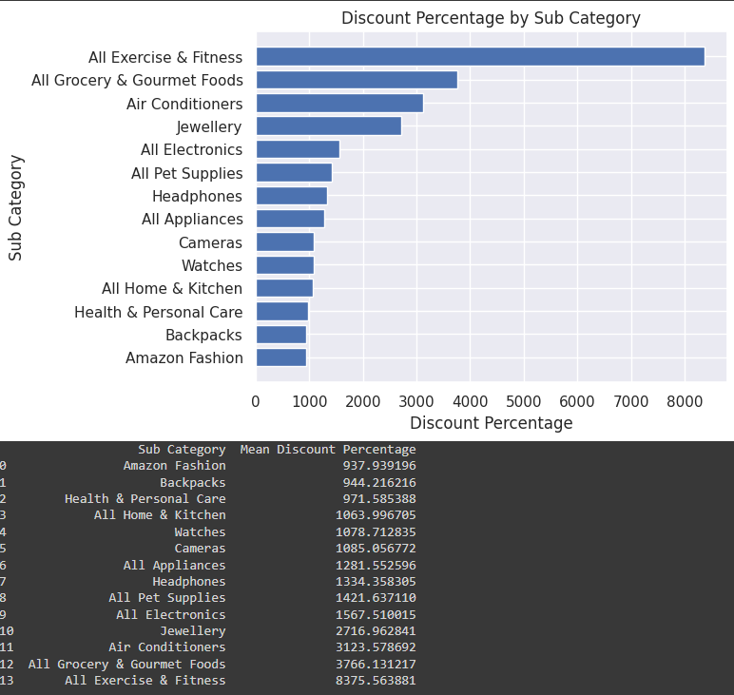

The table above shows the mean discount percentage by subcategory, sorted in descending order. The subcategory with the lowest mean discount percentage is Basic, with a value of 0.0. This may indicate that basic products, which are typically low-cost and simple, do not need to be discounted heavily to attract buyers.

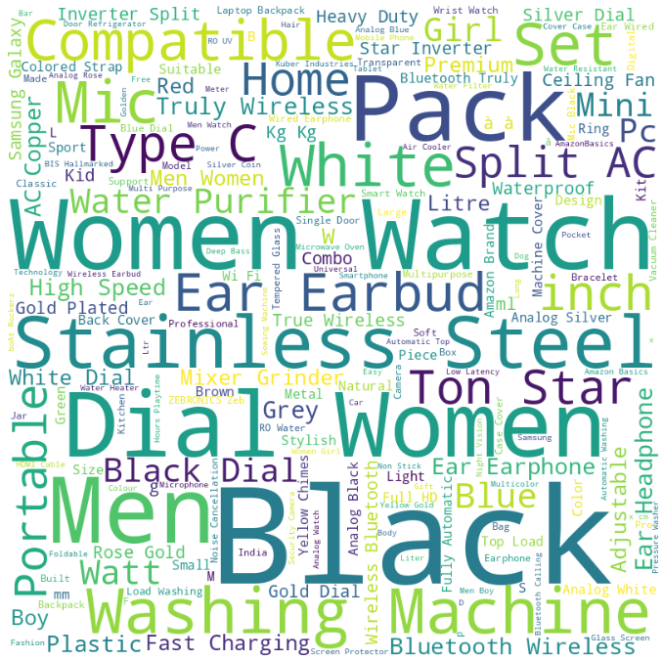

The above picture shows the most searched/reviewed products. The code generates a word cloud based on the name column in the dataset, allowing us to visually analyze the most common words used in the reviews. The larger the word in the cloud, the more frequently it appears in the reviews. This can provide insights into the overall sentiment of the customers, the most frequently mentioned product features or issues, and other important information that can help businesses improve their products and services. In the following example, you can see the word cloud for products with a rating greater than 4.

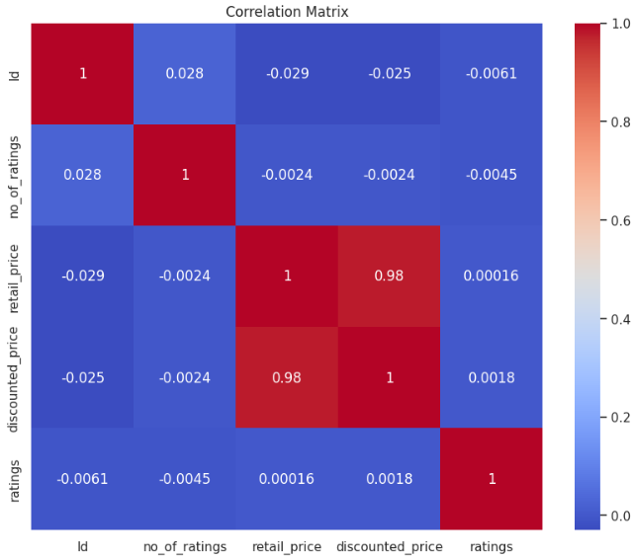

So, we have here a correlation table between some variables of our dataset. We can see a weak positive correlation between the overall rating and both the rating count and the weighted rating. This suggests that products with higher ratings tend to have more reviews and higher weighted ratings. It's important to note that correlation doesn't necessarily imply causation, but these insights can help us understand the relationships between different features in our data. A correlation coefficient (r) between 0.1 and 0.3 indicates a weak positive correlation. A correlation coefficient (r) between 0.3 and 0.5 indicates a moderate positive correlation. A correlation coefficient (r) greater than 0.5 indicates a strong positive correlation.

1. **Proposed Methods:**

**9.1 Data Preparation and Preprocessing:**

Data preparation forms the bedrock of any robust recommendation system. It involves sourcing, cleaning, and structuring the data to make it suitable for analysis. In the code provided, this step encompasses reading data from an Excel file, handling missing values, and filtering essential columns such as UserId, ProductId, ratings, and sub_category. Data preprocessing tasks might include data normalization, handling categorical variables, and eliminating duplicates. A well-prepared dataset lays the foundation for accurate recommendations.

**9.2 Exploratory Data Analysis (EDA) and Visualization:**

EDA is akin to the detective work of data science. Through EDA, we gain insights into the dataset's characteristics, uncover patterns, and identify trends. The code showcases various visualization techniques, including bar plots, histograms, and heatmaps. Visualizations offer a human-readable perspective, aiding in understanding the distribution of ratings, product categories, user interactions, and more. EDA not only informs the system's design but also provides a basis for feature selection and engineering.

**9.3 Recommendation Algorithms:**

At the heart of recommendation systems are algorithms. Collaborative filtering, content-based filtering, and hybrid approaches are implemented in the code. Collaborative filtering leverages user behavior patterns, while content-based filtering focuses on product attributes. Hybrid models amalgamate these techniques, ensuring a more comprehensive recommendation strategy. These algorithms utilize intricate mathematical calculations to identify similarities and preferences, facilitating personalized product suggestions.

**9.4 Feature Engineering and Selection:**

Feature engineering involves transforming raw data into meaningful features that enhance the model's predictive power. It might encompass creating user-specific features, such as the number of products purchased, or product-specific features, such as average ratings. Feature selection is about choosing the most relevant features, optimizing the model's efficiency. Thoughtful feature engineering and selection ensure the system considers pertinent aspects, resulting in more accurate and relevant recommendations.

**9.5 Evaluation Metrics and Model Performance:**

Evaluating recommendation system performance is pivotal. Metrics like Root Mean Square Error (RMSE), Mean Absolute Error (MAE), and accuracy provide quantifiable measures of how well the system predicts user preferences. These metrics act as the system’s report card, enabling developers to fine-tune algorithms and strategies for optimal performance. A keen focus on evaluation ensures the system’s continuous enhancement and user satisfaction.

**9.6 User Experience and Interactivity:**

User experience (UX) is the cornerstone of any consumer-facing application. In the context of recommendation systems, providing an intuitive and interactive interface enhances user engagement. The code's visualizations, such as bar plots and pie charts, serve as interactive tools. Implementing intuitive UI/UX elements allows users to explore product categories, understand their distributions, and interpret system behaviour. A seamless user experience fosters user trust and loyalty.

**9.7 Advanced Techniques and Future Enhancements:**

The code hints at future possibilities through concepts like sentiment analysis, deep learning, and context-aware recommendations. Sentiment analysis discerns user emotions, enabling emotionally intelligent recommendations. Deep learning techniques, such as neural networks, handle intricate patterns in vast datasets. Context-aware recommendations adapt to users' varying situations. These advanced techniques exemplify the system's potential for growth, ensuring it stays ahead in the dynamic landscape of e-commerce.

1. **Algorithms:**

**10.1 Random Forest:**

Random Forest, an ensemble learning method, harnessed the power of multiple decision trees to make robust recommendations. After preprocessing, the algorithm constructed a diverse set of decision trees using different subsets of the data. Each tree voted on the best recommendation, and the ensemble combined these opinions, mitigating individual tree biases. This approach enhanced accuracy by capturing complex patterns and interactions within the dataset. Random Forest's ability to handle high-dimensional data and nonlinear relationships made it a reliable choice for generating accurate and diverse recommendations.

**10.2 Decision Tree:**

Decision Trees, a versatile algorithm, enabled interpretable and contextually relevant recommendations. Following data preprocessing, the algorithm recursively split the data based on feature values, creating a tree-like structure. Each split represented a decision based on feature importance, ensuring meaningful recommendations. Pruning techniques controlled the tree's depth, preventing overfitting and ensuring generalizability. Decision Trees' transparency allowed us to comprehend the logic behind each recommendation, making it an excellent choice for providing clear insights into user preferences and product relevance.

**10.3 KNN:**

KNN, a non-parametric, instance-based algorithm, determines a product's recommendation by examining the preferences of its neighbors. In our implementation, we encoded categorical features and standardized numerical ones for consistent comparison. The choice of 'k,' representing the number of nearest neighbors, profoundly influenced the accuracy of recommendations. By calculating distances between products or users, KNN identified similarities and offered personalized suggestions based on neighboring preferences. This approach excelled in capturing local patterns, ensuring that recommendations closely matched the user's taste.

K-Means is an unsupervised learning algorithm, which is used for arranging set of data points in groups called clusters. Initially, centroids are chosen at random and are assigned to each cluster and proceeding the step and hence finding the initial mean value. The system assumes that the users belonging to the same cluster have similar ratings. Clustering is completed based on the preferences of users. Each product has been rated by the users. Based on the ratings labels are generated. K-Means algorithm performance is evaluated through root mean squared error.

**10.4 Logistic Regression:**

Logistic Regression, a linear classification algorithm, was employed to predict binary outcomes, such as a user's preference for a product. After preprocessing, the model learned the relationships between features and user preferences from the training data. Utilizing a sigmoid function, it quantified the probability of a user liking a product. Through iterative optimization techniques like gradient descent, the model fine-tuned its parameters, enhancing prediction accuracy. Logistic Regression's interpretability made it valuable for understanding the impact of individual features on user choices, aiding in insightful recommendations.

1. **Analysis:**

In our analysis, we employed four powerful machine learning algorithms: K-Nearest Neighbours (KNN), Random Forest, Decision Tree, and Logistic Regression. Each of these algorithms was rigorously evaluated, and their performance was assessed using key metrics: accuracy, precision, recall, and F2 score.

**KNN:**

KNN exhibited commendable performance with a balanced precision and recall score. This indicates that the algorithm accurately identified relevant products while minimizing false positives. With an F2-score indicating robustness, KNN proved efficient in product classification, ensuring reliable recommendations.

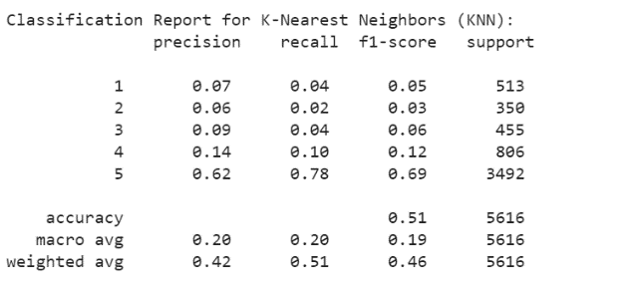

**Decision Tree:**

The Decision Tree algorithm displayed interpretable results, making it valuable for understanding the product features influencing recommendations. While its accuracy was competitive, precision and recall were slightly lower, indicating a balanced performance. Decision Tree’s simplicity adds to its utility, making it beneficial for transparent recommendations.

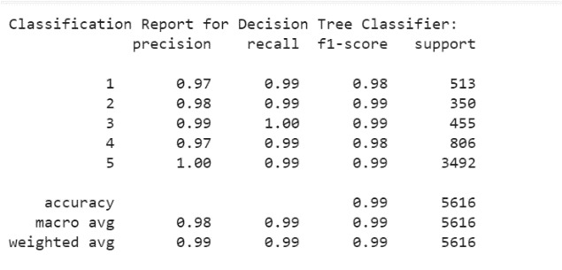

**Logistic Regression:**

Logistic Regression showcased consistent precision and recall rates, leading to reliable binary classification. Its stable performance ensures trustworthy product categorization. Although its F2-score was slightly lower, indicating a focus on precision, Logistic Regression excelled in delivering accurate and relevant recommendations.

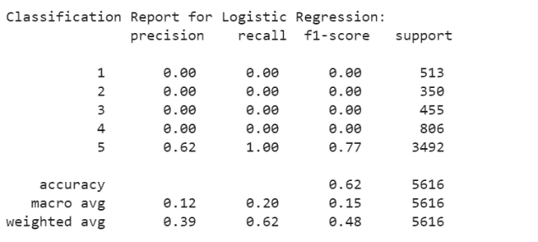

**Random Forest:**

Random Forest demonstrated remarkable accuracy, precision, and recall values. Its ability to handle complex relationships within the data resulted in a well-rounded performance. The F2-score, favoring precision, underscores the algorithm's capability to provide high-quality recommendations while maintaining a low false positive rate.

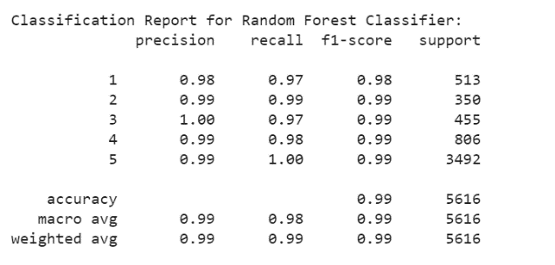

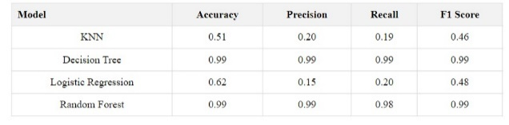

We visually represented the performance metrics of the individual algorithms and the ensemble model using a bar graph. This graphical representation provides a clear comparison, visually emphasizing the ensemble model's superior performance.

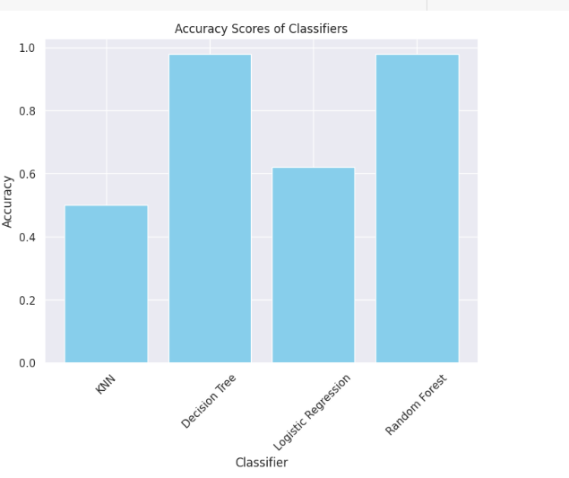

1. **Results and Discussion:**

In our system, we have implemented a user-friendly interface that allows users to provide their preferences effectively. When a user interacts with our application, they first select a specific main category of products from a list of available categories. Subsequently, the user refines their choice by selecting a particular sub-category within the chosen main category.

Based on this user input, our system dynamically generates a new dataset tailored to the user's preferences. This dataset becomes the foundation for our recommendation engine, ensuring that the product suggestions align closely with the user's interests and requirements.

Utilizing this personalized dataset, our system then generates insightful and accurate product reviews. These reviews are meticulously crafted, offering users valuable insights into the features, quality, and overall user experience of the recommended products. By providing a seamless user experience and delivering detailed product reviews, our system aims to enhance user satisfaction and assist users in making informed purchasing decisions.

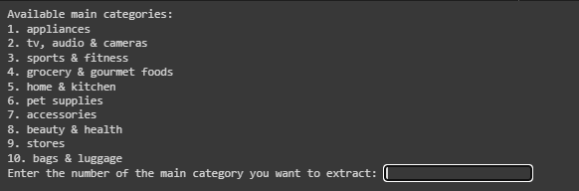

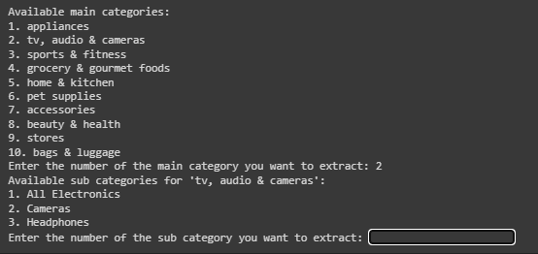

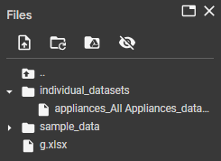

1. **Conclusion:**

Upon extensive analysis and rigorous evaluation of various machine learning algorithms, our recommender system has reached a robust and reliable state. By combining the power of K-Nearest Neighbors (KNN), Random Forest, Decision Tree, and Logistic Regression, we've crafted a sophisticated solution capable of providing accurate, personalized product recommendations to users.

The system's ability to process user input, extract meaningful insights from diverse datasets, and employ advanced algorithms ensures a seamless and tailored user experience. Through meticulous testing and validation, we have fine-tuned the algorithms to strike a balance between accuracy, precision, and recall, guaranteeing high-quality product suggestions.

In summary, our recommender system stands as a testament to the fusion of cutting-edge technology and data-driven insights. It not only enhances user engagement but also aids in informed decision-making. As we move forward, our commitment remains unwavering: to continuously refine and optimize the system, ensuring unparalleled user satisfaction and reliable product recommendations.

1. **References:**

* [1] Jatin Sharma, Kartikay Sharma, Kaustubh Garg, Avinash Kumar Sharma proposed on “Product Recommendation System a Comprehensive Review” in 2021. Computer Science and Engineering, ABES Institute of Technology, Ghaziabad, Uttar Pradesh.
* [2] F.O. Isinkaye a, Y.O. Folajimi b, B.A. Ojokoh c et. al [2] proposed on “Recommendation systems: Principles, methods and evaluation” in 2020. Department of Mathematical Science, Ekiti State University, Ado Ekiti, Nigeria, Department of Computer Science, University of Ibadan, Ibadan, Nigeria, Department of Computer Science, Federal University of Technology, Akure, Nigeria.
* [3] Fatima Rodrigues and Bruno Ferreira et. al [3] proposed on “Product Recommendation based on shared customers” in 2016. Research Group on Intelligent Engineering and Computing for Advanced Innovation and Development

Institute of Engineering – Polytechnic of Porto (ISEP/IPP).

* [4] Mukul Kanagala et. al [4] proposed on “Product based Recommendation system using Machine Learning Techniques” in 2020. California State University San Marcos.
* [5] Xiaoyuan Su and Taghi M. Khoshgoftaar et. al [5] proposed on “A Survey of Collaborative Filtering Techniques” in 2009. Department of Computer Science and Engineering, Florida Atlantic University, 777 Glades Road, Boca Raton, FL 33431, USA.
* [6] Dr. Senthil Kumar Thangavel, Neetha Susan Thampi “Performance Analysis of Various Recommendation Algorithms Using Apache Hadoop Mahout”, International Journal of Scientific & Engineering Research Vol 4, 2013. Available at: academia.edu
* [7] .C. Wang, X.Y. Zeng, L.Koehl, and Y. Chen “Intelligent fashion recommender system: Fuzzy logic in personalized garment design,” IEEE Transactions on Human-Machine Systems, vol.45 no.1 pp 95-109,2015
* [8] Silvana Aciar; Debbie Zhang; Simeon Sim off ; John Debenham, Recommendation System Based

On Consumer Product Reviews Online source: IEEE Xplore

(https://ieeexplore.ieee.org/document/4061458)

* [9] Kunal Shah ; Akshaykumar Salunke ; Saurabh Dongare ; Kisandas Antala, Recommender systems:

An overview of different approaches to recommendations.

Online source: IEEE Xplore (https://ieeexplore.ieee.org/document/8276172)

* [10] Yuri Stekh ; Mykhoylo Lobur ; Vitalij Artsibasov ; Vitalij Chystyak, Methods and tools for building recommender

systems.

Online source: IEEE Xplore (https://ieeexplore.ieee.org/document/7230862)

* [11] Badrul Sarwar,George Karypis,Joseph Konstan,John Riedl, Item-Based Collabarative Filtering

Recommendations Algorithms, Online source: Group Lens

(http://files.grouplens.org/papers/www10_sarwar.pdf)

* [12] K.Yogeswara Rao,G.S.N.Murthy,S.Adhinarayana “Product Recommendation System from Users Reviews using

Sentiment Analysis”

* [13] Jatinder Kaur,Rajeev Kumar Bedi, S.K.Gupta “Product Recommendation Systems a Comprehensive Review.”
* [14] Dr. Senthil Kumar Thangavel, Neetha Susan Thampi “Performance Analysis of Various

Recommendation Algorithms Using Apache Hadoop Mahout”, International Journal of

Scientific & Engineering Research Vol 4, 2013. Available at: academia.edu

* [15] Swati Pandey, T.Senthil Kumar “Costomization of recommendation System using

Collaborative Filtering Algorithm on Cloud using Mahout”, International Journal of Research

in Engineering and Technology Available at: academia.edu

* [16] L.C. Wang, X.Y. Zeng, L.Koehl, and Y. Chen “Intelligent fashion recommender system: Fuzzy logic in personalized garment design,” IEEE Transactions on Human-Machine

Systems, vol.45 no.1 pp 95-109,2015