OpenGL Museum Corridor Demo
ECE-433

User Manual and Future Development plans

Nikolaos Koxenoglou
Helen Veroni
Irene Tsitsopoulou

Contents:

Chapter 1: Intro

Chapter 2: Basic Usage

Chapter 3: Future Development

Chapter 1: Intro

This chapter serves to introduce the user to the main concept of this demo.

As it stands the corridor features six of the most basic shapes and actions, that the OpenGL community deems as the bare basics for someone to begin their journey in its development. These shapes transformations are taken from the lectures labs as well as other OpenGL tutorials.

This demo as many possible uses from a simple tech demo to demonstrate what OpenGL is capable of to a user with no technical know-how. As well as a quick reference to someone already knowing or learning OpenGL as it contains important snippets of code regarding the most used features in one source code.

Chapter 2: Basic Usage

As mentioned in the previous paragraph the demo is made in order to be used by a user who has no knowledge of OpenGL as well as someone well versed in the field. That is why we chose the corridor approach ass seen below.
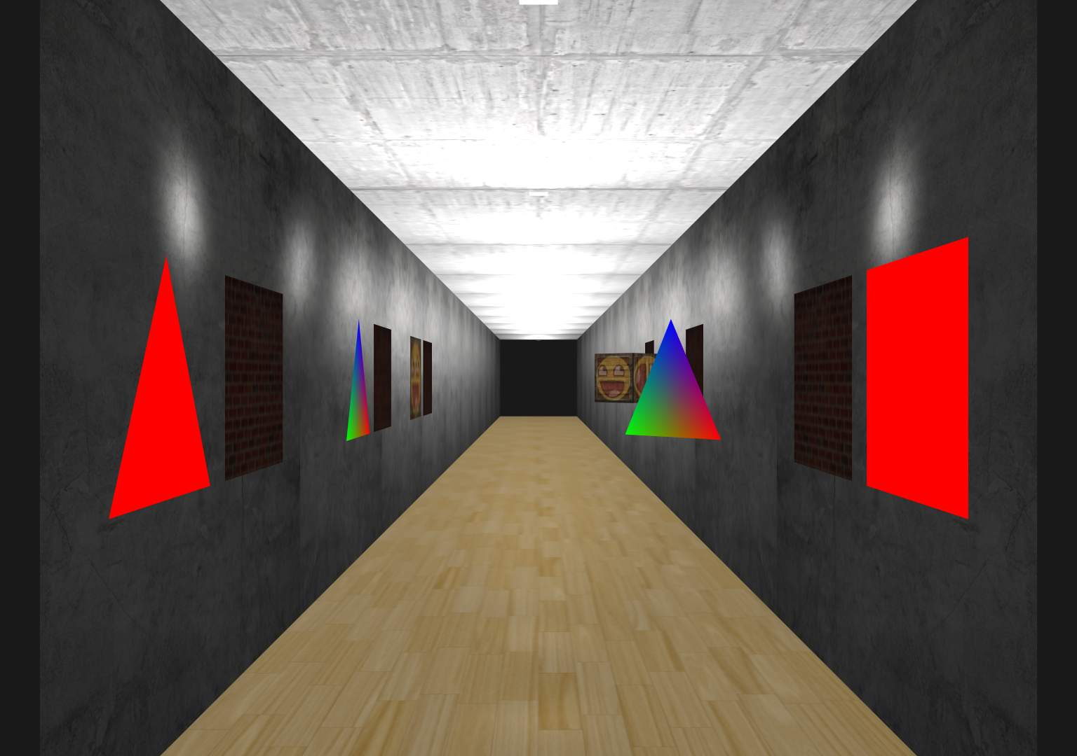
The user can simply fly in the corridor and observe in real-time the exhibits display an OpenGL function, and either go in the source code to see how each one is implemented or read the exhibit description about what everything is in a more simplistic manner.

At this point the exhibits explanations are filed with placeholder items in order to determine the correct dimensions for each explanation and exhibit placement.

From left to right and then back the exhibits display:

- The basic triangle used for almost everything

- A basic square made from two said triangles

- A basic triangle displaying colour interpolation from the primary colours (red, green, blue) on each of the corners.

- The same triangle with an applied transformations to make it rotate

- A square with a blend of two textures

- The same square with an applied transformations to make it rotate in order to demonstrate the correct depth display. As the object rotates the back side remains in the back and it doesn’t ruin the front view.

Chapter 3: Future Development

Future development plans include to make the scene look more realistic with the use of more detailed textures and a greater fine grain control of the lighting parameters.

Implementation of more exhibits showing lighting and material properties, other transformations etc.

Even more ambitiously the corridor can be extended to many rooms with more user interaction with the exhibits instead of just displaying them.

