**PRATICAL NO 2:CREATE TABLE INSERT 10 RECORD IN IT**

NAME:SONAL SHRIKANT VISPUTE ROLL NO.207

DIV:B BATCH:B7

create database student13;

CREATE TABLE student13(

stu_id VARCHAR(8),

stu_name VARCHAR(20),

stu_dep_id VARCHAR(20),

stu_age INT,

stu_roll_no INT,

stu_exam_no INT,

stu_marks INT,

stu_add VARCHAR(50),

stu_percentage INT);

INSERT INTO student13 values('g541','sonal','s2341',12,200,1565,75,'ganeshcolony',56);

INSERT INTO student13 values('g542','payal','s2342',18,201,1577,78,'ganeshcolony',77);

INSERT INTO student13 values('g543','sonal','s2343',15,202,1867,79,'ganeshcolony',98);

INSERT INTO student13 values('g544','sakshi','s2344',18,237,1967,88,'ganeshcolony',68);

INSERT INTO student13 values('g545','sai','s2345',17,204,1507,98,'ganeshcolony',76);

INSERT INTO student13 values('g546','dipak','s2346',19,207,1567,67,'ganeshcolony',48);

INSERT INTO student13 values('g547','vedant','s2347',28,205,1967,78,'ganeshcolony',68);

INSERT INTO student13 values('g548','tanvi','s2348',15,208,1587,66,'ganeshcolony',68);

INSERT INTO student13 values('g549','janvi','s2349',18,209,1567,78,'ganeshcolony',58);

INSERT INTO student13 values('g5410','priya','s23410',10,205,1967,98,'ganeshcolony',75);

select*from student13;

OUTPUT:-

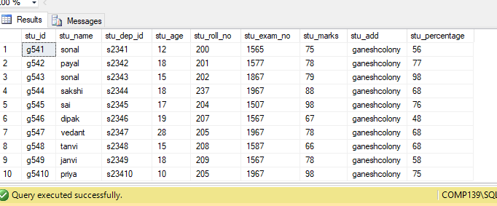

**PRATICAL NO 1:DEMONSTARTION OF CREATING DATABASE**

NAME:SONAL SHRIKANT VISPUTE ROLL NO.207

DIV:B BATCH:B7

create database student11;

OUTPUT:-

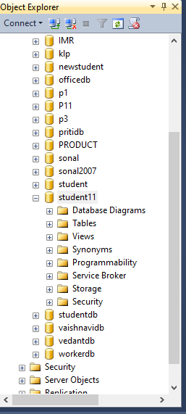

**PRATICAL NO 3:DEMONSTRATE TO INSERT, UPDATE, AND DELETE RECORDS IN TABLE**

NAME:SONAL SHRIKANT VISPUTE ROLL NO.207

DIV:B BATCH:B7

UPDATE:

use student13;

select*from dbo.hospital;

update hospital set hos_name='SANJIVNI' where hos_name='NAVJIVAN';

OUTPUT:-

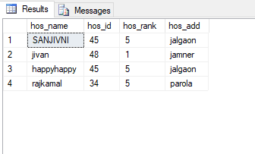

DELETE:

use student13;

select*from dbo.hospital;

update hospital set hos_name='SANJIVNI' where hos_name='NAVJIVAN';

delete from hospital where hos_id=48;

OUTPUT:-

