**Computational Complexity CSC 5173**

**Professor : Tom Altman**

**Final Report**

**PEG SOLITAIRE**

**INTRODUCTION:**

**Peg solitaire** (or **Solo Noble**) is a board game for one player involving movement of pegs on a board with holes. Some sets use marbles in a board with indentations. The standard game fills the entire board with pegs except for the central hole. The objective is, making valid moves, to empty the entire board except for a solitary peg in the central hole. It is very easy to go wrong and find you have two or three widely spaced lone pegs. Many people never manage to solve the problem. There are many different solutions to the standard problem, and one notation used to describe them assigns letters to the holes.

Mirror image notation is used, amongst other reasons, since on the European board, one set of alternative games is to start with a hole at some position and to end with a single peg in its mirrored position. On the English board the equivalent alternative games are to start with a hole and end with a peg at the same position.

There is no solution to the European board with the initial hole centrally located, if only orthogonal moves are permitted. several other configurations where a single initial hole can be reduced to a single peg. A tactic that can be used is to divide the board into packages of three and to purge (remove) them entirely using one extra peg, the catalyst, that jumps outand then jumps back again.

The origins of peg solitaire are not known for certain. However, John Beasley and John Maltby have done extensive research trying to determine the genealogy of the game . The most common legend is that it was created by a French nobleman while he was incarcerated in the Bastille during the seventeenth century . This legend would explain one of the game’s less common names, solo noble. However, there is no hard evidence to support this myth. Beasley also gives other possible origins of the game in such as American Indians playing the game with their arrows after returning from a hunt, or that it was a German nun’s game. Some even suggest the game has roots in China, Chaldaea, or ancient Rome. However, the earliest known evidence is the engraving Madame la Princesse de Soubise jo¨uant au jeu de Solitaire by Claude-Auguste Berey, which is dated 1697. The picture is of Anne de Rohan-Chabot, Princess of Soubise, who is seated with the game by her side as shown in Figure 5. It is also a legend that the game was invented by Pelisson, a French mathematician, to entertain Louis XIV . 19Figure 5: Madame la Princesse de Soubise jo¨uant au jeu de Solitaire by ClaudeAuguste Berey, 1697.

The earliest written description of the game is given in a paper by Leibniz in 1710, which is quoted in as follows: Not so very long ago there became widespread an excellent kind of game, called Solitaire, where I play on my own, but as with a friend as witness and referee to see that I play correctly. A board is filled with stones set in holes, which are removed in turn, but none (except the first, which may be chosen for removal at will) can be removed unless you are able to jump another stone across it into an adjacent empty place, when it is captured as in Draughts. He who removes all the stones right to the end according to this rule, wins; but he who is compelled to leave more than one stone still on the board, yields the palm.

Despite evidence documenting the game to the late 17th century, both Beasley and Maltby agree that similar games were played much earlier due to the simplicity of the rules. There are several variations of boards on which the game can be played. The most common is called the English board and is shown in Figure 6. The board is made of wood and has recessed impressions, called holes, which are filled with glass marbles or small stones, called pegs or “men.” The English board has thirty-three holes which are arranged symmetrically in the shape of a cross.

Despite evidence documenting the game to the late 17th century, both Beasley and Maltby agree that similar games were played much earlier due to the simplicity of the rules. There are several variations of boards on which the game can be played. The most common is called the English board and is shown in Figure 6. The board is made of wood and has recessed impressions, called holes, which are filled with glass marbles or small stones, called pegs or “men.” The English board has thirty-three holes which are arranged symmetrically in the shape of a cross.

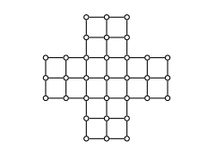

This is the board the Princess of Soubise is playing in Berey’s engraving.

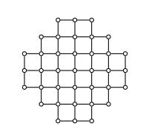

There is also the Triangular board, which consists of fifteen holes arranged in a triangular shape. This board is commonly found on the dining tables of the restaurant Cracker Barrel and is referred to as the “peg game.” Also, in this configuration, diagonal jumps are allowed, unlike the previous boards where only vertical and horizontal moves are allowed. The Triangular Board There are obviously many variations of boards on which peg solitaire can be played. Only a few of the most commonly used boards have been listed above Beasley goes into great detail on how to solve some of the boards. Beasley even explores playing the game on a three dimensional board. Another work that is certainly worth noting is Winning Ways for your Mathematical Plays, by Berlekamp, Conway, and Guy .This publication deals mainly with playing the game on traditional boards. In this work, the major idea is the use of purges to solve the boards instead of using “brute force” methods to play the game. A package is a collection of vertices which satisfy a specific configuration of pegs and holes such that a predetermined sequence of jumps will preserve the locations of certain pegs and holes and remove the remaining pegs. When a package is used to remove pegs, it is called a purge. The pegs and holes which are restored to their original locations are called the catalyst. This idea of purges will prove to be very useful in this thesis. From [11], Bruijn explains in detail the relationship of the English board and a finite field. This paper also gives another variation of the game, demanding that the remaining peg should end in the hole in the center of the board. They also define four elements, as well as addition and multiplication operators, such that the pegs and holes can be thought of as elements of a finite field. The pegs and holes are also given coordinates in the ordinary Cartesian plane, which is easily done on the English board. It is also mentions that the shape of the board plays no essential role in the consideration of each hole’s given coordinates and the game can even be considered in more than two dimensions. Operations are then performed on the elements which are analogous to making the moves on the board. The location of the final peg can be found by this method. In, Hentzel uses the same approach as Bruijn , except Hentzel plays the game on the triangular board. Also, Hentzel has to only define a commutative group and its addition operator, instead of a finite field with two operations. Hentzel then defines the parity of the game, which does not change throughout the game. This is used to classify some games as being not solvable without making any jumps. However, this does not necessarily classify a game as being solvable. Hentzel’s method can be used on any hexagonal type board, or hexagonal array.

Playing the game on the English board is approached from the artificial intelligence point of view. Variables are assigned to represent the pegs and holes, then operations are performed to simulate jumps being made and pegs being removed. Also in the variation of the game known as fool’s solitaire is explored. The method of finding the optimal number of pegs that can remain at the end of the game is done by an exhaustive computer search. The downside to this method is that it can take a very long time to calculate every possible terminal state. One way that was mentioned to reduce the number of terminal states that need to be checked is by only checking unique terminal states. Since the board is symmetrical, one terminal state can be thought of as four terminal states simply by rotating the board. Another way to ensure that an optimal solution has been found is to seek a terminal state after performing only one move. If that cannot be done, then attempt finding a terminal state after performing only two moves, and so on. This variation will also be discussed in detail in this thesis. Another interesting variation is noted , called Long-hop solitaire. It is called a hop when the same peg is moved consecutively, as if playing checkers. This is another optimization problem by attempting to perform as few hops as possible.

**Studies on peg solitaire:**

A thorough analysis of the game is provided in [Winning Ways](http://en.wikipedia.org/wiki/Winning_Ways_for_your_Mathematical_Plays) [ISBN 0-12-091102-7](http://en.wikipedia.org/wiki/Special:BookSources/0120911027) in the UK and [ISBN 1-56881-144-6](http://en.wikipedia.org/wiki/Special:BookSources/1568811446) in the US (Vol 4, 2nd edition). They0 introduced a notion called **pagoda function** which is a strong tool to show the infeasibility of a given (generalized) peg solitaire problem. A problem for finding a pagoda function (which concludes the infeasibility of a given problem) is formulated as a linear programming problem and solvable in polynomial time (see Kiyomi and Matsui 2001). Uehara and Iwata (1990) dealt with the generalized Hi-Q problems which are equivalent to the peg solitaire problems and showed their [NP-completeness](http://en.wikipedia.org/wiki/NP-completeness). Avis and Deza (1996) formulated a peg solitaire problem as a combinatorial optimization problem and discussed the properties of the feasible region called 'a solitaire cone'. Kiyomi and Matsui (2001) proposed an efficient method for solving peg solitaire problems.

An unpublished study from 1989 on a generalised version of the game on the English board showed that each possible problem in the generalised game has 29 possible distinct solutions, excluding symmetries, as the English board contains 9 distinct 3×3 sub-squares. One consequence of this analysis is to put a lower bound on the size of possible 'inverted position' problems, in which the cells initially occupied are left empty and vice versa. Any solution to such a problem must contain a minimum of 11 moves, irrespective of the exact details of the problem.

It can be proved using [abstract algebra](http://en.wikipedia.org/wiki/Abstract_algebra) that there are only 5 fixed board positions where the game can successfully end with one peg.

**A Description Of Cross Peg Solitaire:**

The board is cross shaped and contains of 35 holes. A peg might be placed in each hole. The starting configuration is a full board except for an empty place in the center.

|  |  |  |  |  |  |  |
| --- | --- | --- | --- | --- | --- | --- |
|  | | *•* | *•* | *•* |  | |
| *•* | *•* | *•* |
| *•* | *•* | *•* | *•* | *•* | *•* | *•* |
| *•* | *•* | *•* |  | *•* | *•* | *•* |
| *•* | *•* | *•* | *•* | *•* | *•* | *•* |
|  | | *•* | *•* | *•* |  | |
| *•* | *•* | *•* |

A peg is allowed to jump vertically or horizontally over an adjacent peg to an empty hole.

The peg that was jumped over is removed, decreasing the number of pegs on the board by one.



The object of the game is to invert the starting configuration, i.e. to end up with one peg in the center of the board. According to the game brochure (Milton Bradley Co., 1986), whoever succeeds in leaving the last peg in the center is a genius Anyone who leaves a single peg elsewhere is an outstanding player.

**A VARIATION OF THE GAME:OCTAGON SOLITAIRE**

**W**e can alter the game by changing the starting position, ending position or the structure of the board.The following postion of the game was sold in Israel.The board is now in the shape of octagon.

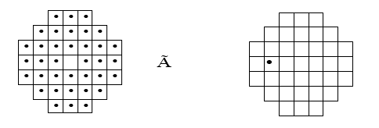

The starting configuration The winning configuration

The game’s brochure didn’t include a solution. Alternatively, the manufacturer offered a prize to anyone able to come up with one. No matter how generous the prize actually was, the manufacturer wasn’t taking any chances by offering it. The game is insolvable!

Let’s take a moment to reflect here. How can we know for sure that no matter which way we proceed we’ll never be able to end up in the winning position?

In this case we can make the following rough estimate: Any peg can move in 4 directions or less. At any given time there are no more than 38 pegs on the board. Hence, at any point of the game we have no more than 4 *·* 38 = 152 options for legal moves. Since we lose a peg with every move and we start with 38 pegs, a single game will consist of 37 moves or less. Therefore, the number of possible games is less than (152)37.

Therefore, in order to show that no solution exists all we have to do is check all possible games and verify that none of them is a winner. The problem is that (152)37 is an astronomical number and it is quite impractical to go over so many games, even with the aid of a computer. Moreover, oftentimes in Math or Physics we want to affirm the impossibility of a process or the existence of an object, and there usually the number of possibilities there is not finite, so such an approach will never work.

**The Insolvability Of Octagon Game :**

Lets “color” our board with the numbers 0 and 1 as in the figure

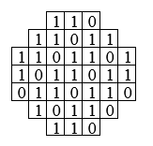

For a configuration C,let Nc be the sum of colors of the filled spaces. For example

Nc start=24 (We donot count the empty 1 in the center).

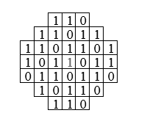

Notice that performing an elementary move might change N, or leave it unchanged as demonstrated by the following examples:

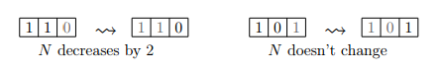

However the parity of Nc remains the same throughout,since moves either leave N un-changed or decrease it by 2.Lets take a moment to digest this: The parity of Nc ,P(Nc) is an invariant of the game, which means it remains constant(while C changes )because as we have seen no legal move can change it.

Nstart =24 which is even, and since the center is marked by 1,Nwin=1 which is odd. So we cannot get from one configuration to the other .We cannot win this game!

**Introduction To Groups :**

**W**e will now show the insolvability of the octagon game by a different method – using groups.

A group is a collection of reversible actions that we can carryout one after the other .Consider the actions you take to get dressed in the morning:

* Put a sock on the right leg
* Remove sock from the left leg
* Put on both shoes
* Put on a pair of pants

Sometimes, the order of the actions matters and sometimes it doesn’t. Putting on your right sock first and then your left one, or doing it the other way around, doesn’t really change the end result. However, putting on your underwear first and then your pants is different than putting on your pants first and then your underwear! It seems superman hasn’t realized this yet, but he is an alien after all. Here’s another example, “Don’t drink and drive” is not quite the same as “Don’t drive and drink”.

Two elements (actions) in a group are said to commute if the order in which they are carried out doesn’t matter. A group in which every two actions commute, is called commutative or abelian.

**KLEIN’S GROUP :**

Suppose we have two light bulbs, and two buttons. Pushing button *A* lights the left bulb, and another push turns it off. We denote the action of pressing *A* by *a*. Pushing button *B* lights the right bulb, another turns it off, this will be denoted *b*. *c* is pressing the two buttons at once, and *e* is not doing anything at all.

Our group ,K ,will consist of 4 elements : a,b,c and e. Doing a and then a,denoted a . a or just a2 ,is like doing nothing at all.We express this by the equation a2 = e.The same goes for b :b2 =e.Doing a and then b amounts to lighting both bulbs so a . b=c. We completed the multiplication table for the group K below(multiplying two elements just means doing one after the other from left to right).

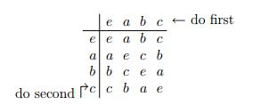

**C**learly K, is an abliean group.

**Back To Game:**

We shall now color our board with elements of K, instead of 0’s and 1’s.

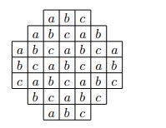

For the configuration of the board C let Mc be the product of all markings of full squares, where the multiplication follows the rules of the table above. Note that we can multiply them in any order we choose since K is abliean. So, Mstart = a12 . b12 .c12=e . Another observation is that Mc is invariant, notice that elementary moves don’t change the product !

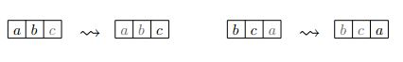

Mstart = e but none of the squares is marked e. So not only can we never win this game and get one peg in the center , but we can never reach any one peg configuration !

**Analysis Of The Cross Game Using Klien’s Group :**

Remember that according to the game’s manufacturer,whomever ends up with one peg not in the center is an outstanding player? In this section we will see that anyone who ends up with one peg,not in the center cannot qualify for the title.He is merely very very lucky.Color the board with elements of Klien’s group as below:

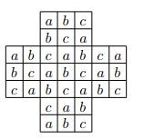

Mstart = b. Therefore ,if we end up with one peg on the board it will be marked b.But there is another obstruction. If we can reach the configuration (1) below, we can also reach its mirror image, numbered (2) – just mirror image the moves !

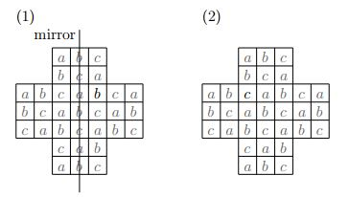

But by our previous consideration,the configuration on the right is impossible , since it is marked by C . Hence , the configuration on the left is also unattainable.We can thus rule out all one peg configuration except for the winning one and : 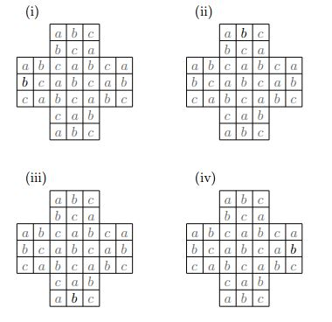

Now comes the punch line :suppose we have arrived at configuration

(i) then the previous one must have been :

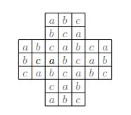

But we could have easily gone from that configuration to a winning one.Therefore ,whoever reaches configuration (i) must not have comprehended the rules of the game,hence must have been very lucky to end up.

Conclusion:

This project helps me to get practical knowledge.Most of them were online papers.This gave me the idea of computational complexity. I am glad to work with Professor Tom Altman. Fortunately I am going to take his next class too.