RESEARCH PAPER
Learner Demographics and Course
Enrollment Behavior Analysis on
EduPro

Submitted By :
Name : Koyel Biswas
Internship Project | Unified Mentor

Submitted to:
Toronto Government Parks, Forestry & Recreation
Date : March 20, 2026
Analysis Year : 2025

Dataset :
3,000 Learners | 10,000 Transactions | 60 Courses

Abstract
This research paper presents a comprehensive descriptive analysis of learner demographics and course enrollment behavior on the EduPro online learning platform, conducted in partnership with Unified Mentor and the Toronto Government Parks, Forestry & Recreation department. The study analyzes data from 3,000 registered learners, 60 courses spanning 12 subject categories, and 10,000 enrollment transactions recorded throughout the 2025 academic year.
The primary objective of this analysis is to provide foundational learner intelligence that enables datadriven decision-making in course design, targeted outreach, and platform growth strategy. Key findings reveal that the 26–35 age group constitutes the largest active segment (48.0% of enrollments), female learners hold a marginal participation majority at 50.8%, Data Science ranks as the most popular course category with 916 enrollments, and Beginner-level courses remain the most preferred skill tier at 35.7% of all enrollments. An interactive Streamlit analytics dashboard was developed as the primary deliverable, providing real-time filterable insights across four analytical modules.
Keywords: learner analytics, demographic segmentation, course enrollment behavior, descriptive intelligence, online education, EduPro, age-wise analysis, gender participation, course popularity.

Table of Contents

- Introduction
- Background and Context
- Problem Statement
- Dataset Overview
- Analytical Methodology
- Key Performance Indicators
- Results and Analysis
  - Learner Demographic Overview
  - Age-wise Enrollment Analysis
  - Gender-based Course Preference Analysis
  - Course Category Popularity and Level Analysis
- Dashboard Implementation
- Conclusion
- References

1. Introduction
The rapid growth of online learning platforms has transformed how individuals acquire knowledge and professional skills. Platforms such as EduPro serve a heterogeneous learner population characterized by diverse age groups, gender distributions, learning goals, and subject interests. Despite accumulating substantial user and transaction data, many online platforms continue to make course design and marketing decisions based on intuition rather than evidence.
This research paper addresses that gap by conducting a rigorous descriptive analysis of the EduPro platform's learner base. The study is undertaken in collaboration with Unified Mentor and the Toronto Government Parks, Forestry & Recreation department, reflecting a public-private partnership commitment to data-driven education planning. The analysis focuses exclusively on descriptive learner intelligence who the learners are and how they enroll rather than predictive modeling or monetization strategy.
The deliverable is an interactive Streamlit web application dashboard built on real platform data, providing filterable, real-time insights across four analytical modules: Demographic Overview, Agewise-Enrollment, Gender-based Course Preference, and Course Category & Level Analysis.

2. Background and Context
Online learning platforms serve increasingly diverse learner populations. EduPro, the platform under study, offers 60 courses across 12 subject categories including Programming, Data Science, Business, Finance, Machine Learning, Artificial Intelligence, Cybersecurity, Design, Marketing, Digital Marketing, Project Management, and Web Development. Courses are offered at three proficiency levels (Beginner, Intermediate, Advanced) and through two delivery models (Free, Paid).
Understanding the demographic composition of learners and their enrollment preferences is foundational for the following strategic objectives:
- Designing relevant courses that align with learner needs and skill levels
- Improving learner engagement through personalized content recommendations
- Enabling targeted marketing and outreach to underrepresented segments
- Enhancing inclusivity and accessibility across age groups and genders
This project focuses exclusively on descriptive learner intelligence a systematic analysis of existing patterns rather than prediction or monetization, positioning it as a foundational intelligence initiative for evidence-based platform management.

3. Problem Statement
Despite accumulating rich user and transaction data since its launch, EduPro currently lacks structured analytical answers to the following critical business and educational questions:
- Which age groups are most active on the platform?
- How do enrollment patterns differ by gender?
- What course categories are preferred by different learner segments?
- Are Beginner, Intermediate, or Advanced courses more popular among specific age groups?

Without these insights, decisions related to course creation, platform marketing, and growth strategy remain intuition-driven. This research directly addresses each of these questions through systematic data analysis and visual intelligence, enabling EduPro to transition from assumption-based to evidence-based platform management.

4. Dataset Overview
The analysis utilizes data from the EduPro Online Platform Excel workbook, comprising three analytically relevant sheets. The dataset was carefully scoped to include only the fields specified in the project requirements, ensuring methodological integrity and avoiding scope creep.

4.1 Dataset Composition
Sheet | Records | Fields Used | Description
Users | 3,000 | UserID, UserName, Age, Gender | Learner demographic information
Courses | 60 | CourseID, CourseName,  CourseCategory,  CourseType, CourseLevel | Course metadata and classification
Transactions | 10,000 | TransactionID, UserID,  CourseID,  TransactionDate | Enrollment activity records

4.2 Data Quality and Integration
Data integration was performed by joining the three sheets using UserID (Users ↔ Transactions) and CourseID (Transactions ↔ Courses). Referential integrity was verified: all 10,000 transaction records successfully matched to valid UserIDs and CourseIDs, yielding zero null matches. Dates were parsed to datetime format, and age bands were engineered as a derived feature from the continuous Age field.
Notably, the dataset spans learners aged 15–35 exclusively, meaning the age bands 36–45 and 45+ defined in the specification contain zero learners in this dataset. The active bands are: <18, 18–25, and 26–35.

5. Analytical Methodology
The study follows a structured five-step analytical methodology as prescribed by the project specification, implemented in Python using the Pandas and Plotly libraries within a Streamlit web application framework.

Step 1: Data Integration
The three source sheets were loaded from the Excel workbook using pandas.read_excel() with explicit field selection. The merged dataset was produced by performing inner joins on UserID and CourseID, resulting in a unified analytical frame of 10,000 records across 12 feature columns.

Step 2: Learner Demographic Analysis
- Age band segmentation: Continuous Age values were discretized into five standard bands: <18, 18–25, 26–35, 36–45, 45+ using pandas.cut()
- Gender distribution: Frequency analysis of the Gender field to compute male/female participation counts and ratios
- Participation levels: Cross-tabulation of age group × gender to measure enrollment intensity per demographic combination.

Step 3: Enrollment Distribution Analysis
- Enrollment counts were computed for each level of CourseCategory (12 categories), CourseType (Free/Paid), and CourseLevel (Beginner/Intermediate/Advanced)
- Most popular categories were identified by descending sort; least popular were highlighted using color-coded ranking charts

Step 4: Demographics × Course Preference Analysis
- Age group vs. course category: Pivot table heatmap visualizing enrollment intensity across the age-category matrix
- Gender vs. course level: Grouped bar charts and 100% stacked bar charts showing level preference by gender
- Learner segment identification: Bubble scatter chart mapping AgeGroup × Category × Gender

Step 5: Behavioral Insights
- Average courses per learner: Computed by grouping transactions by UserID and calculating mean enrollment count per age group
- Enrollment concentration: Histogram of courses-per-user distribution showing how enrollments concentrate among active users
- Beginner vs. Advanced behavior: Side-by-side horizontal bar charts comparing category preferences between the two extreme proficiency groups

6. Key Performance Indicators
Five Key Performance Indicators were defined in the project specification to measure the platform's learner intelligence health. All five KPIs are computed dynamically in the dashboard and update responsively when sidebar filters are applied.
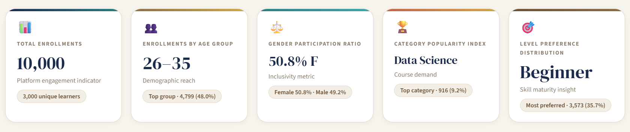
Figure 1: EduPro Analytics Dashboard — Home view showing the 5 KPI cards (Total Enrollments: 10,000 | Age Group: 26–35 | Gender: 50.8%F | Category: Data Science | Level: Beginner)
KPI Name | Value | Description | Interpretation
Total Enrollments | 10,000 | Platform engagement indicator | Strong platform activity baseline
Enrollments by Age Group | 26–35 (48.0%) | Demographic reach | Core learner segment identified
Gender Participation Ratio | F 50.8% / M  49.2% | Inclusivity metric | Near-equal gender balance achieved
Category Popularity Index | Data Science (9.2%) | Course demand | Tech subjects dominate enrollment
Level Preference Distribution | Beginner (35.7%) | Skill maturity insight | Platform attracts new learners

7. Results and Analysis
This section presents the findings from each analytical module of the EduPro dashboard, supported by screenshots captured from the live Streamlit application as visual evidence.

7.1 Learner Demographic Overview
The Demographic Overview module addresses two foundational questions: what is the age distribution of learners on EduPro, and what is the gender composition of the platform? Figure 2 shows the full dashboard home view with the 5 KPI cards and the Demographic Overview tab active.

Age Band Distribution
The learner population on EduPro spans ages 15 to 35 and is distributed across three active age bands. The 26–35 group is the dominant cohort with 1,448 unique learners, followed by the 18–25 group with 921 learners, and the under-18 group with 432 learners. This distribution indicates that the platform primarily serves young working professionals and university-age learners.

Age Band | Unique Learners | Enrollments | Share of Enrollments
<18 | 432 | 1,469 | 14.7%
18–25 | 921 | 3,732 | 37.3%
26–35 | 1,448 | 4,799 | 48.0%
36–45 | 0 | 0 | 0%
45+ | 0 | 0 | 0%
Total | 3,000 | 10,000 | 100%

Age Distribution Histogram
Figure 2 provides a granular view of age distribution, showing that learner density is broadly distributed between ages 15 and 35 with no pronounced single-age spike, indicating a diverse age spread within the 15–35 range.
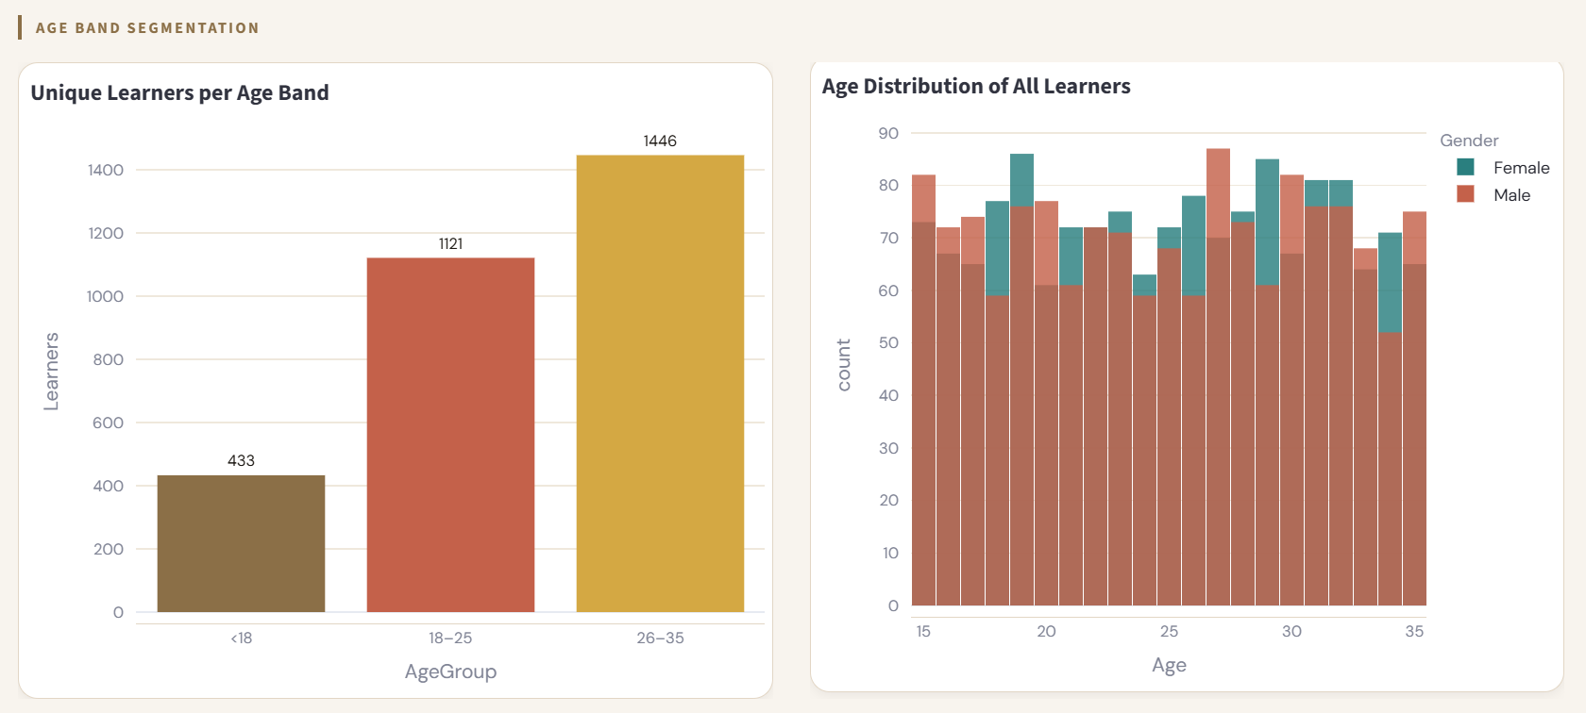
Figure 2.1: Tab 1 — Learner Demographic Overview showing unique learners per age band (left), age distribution histogram (right)

Gender Participation Ratio
The gender participation ratio is near-equal, with Female learners holding a marginal majority at 50.8% (5,078 enrollments) compared to Male learners at 49.2% (4,922 enrollments). This near-parity is a strong inclusivity indicator, suggesting EduPro has successfully attracted learners across gender lines without significant disparity.
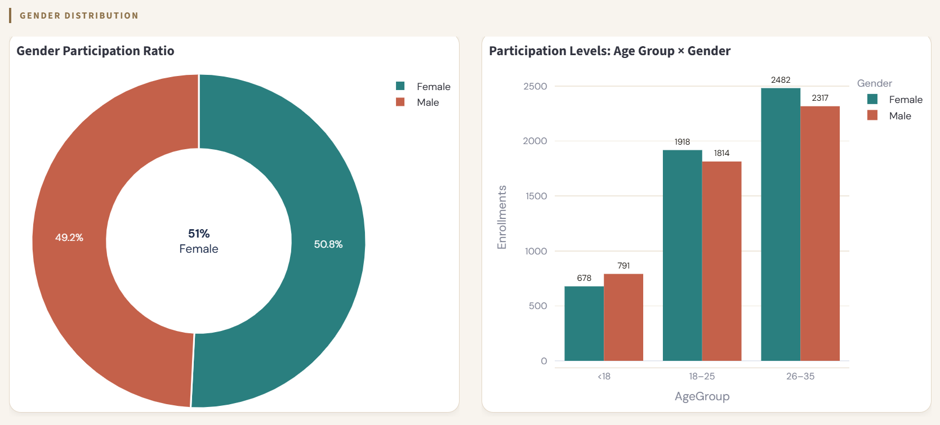
Figure 2.2: Tab 1 —gender participation ratio donut, and age group × gender participation levels

7.2 Age-wise Enrollment Analysis
The Age-wise Enrollment module covers the Enrollment Distribution Analysis prescribed in the project methodology, counting enrollments by CourseCategory, CourseType, and CourseLevel, and identifying most and least popular categories. It also surfaces the Behavioral Insights: average courses per learner and enrollment concentration.
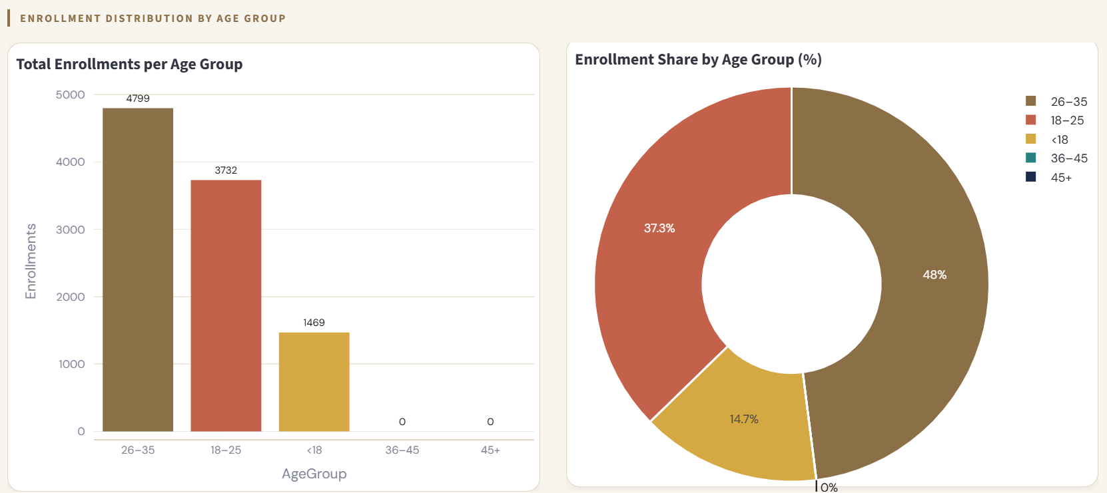
Figure 3.1: Tab 2 — Age-wise Enrollment Charts showing enrollment distribution by age group

Enrollment by CourseType (Free vs Paid)
Of the 10,000 total enrollments, 6,403 (64.0%) are in Free courses and 3,597 (36.0%) are in Paid courses. This significant skew toward Free course enrollment suggests that the platform's free offerings are the primary driver of learner acquisition, though the substantial Paid enrollment base (36%) indicates meaningful monetization potential.
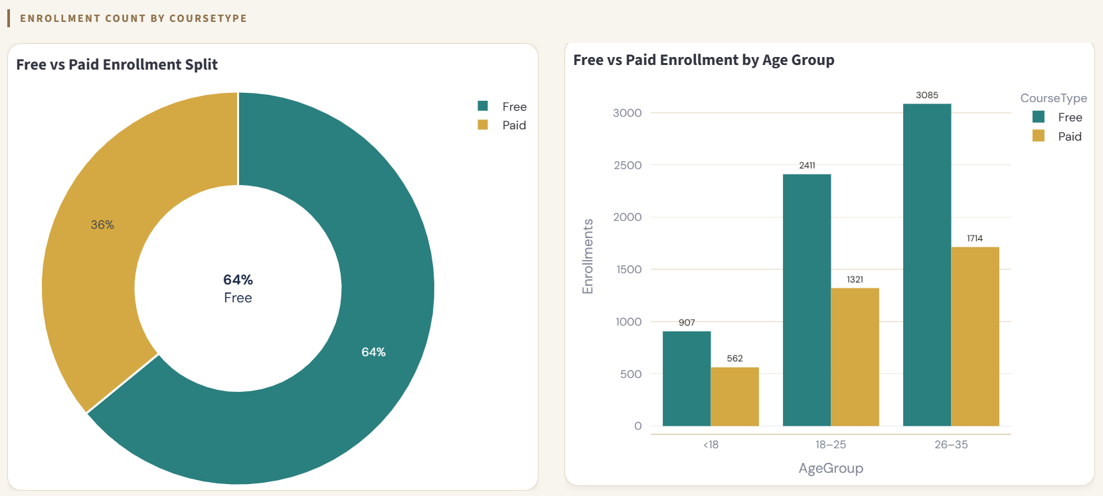
Figure 3.2 : Tab 2 —Free vs Paid split Enrollment by Age Group

Most and Least Popular Categories
The Category Popularity chart a distinctive feature of the dashboard uses color coding to highlight the top 3 and bottom 3 performing categories simultaneously.

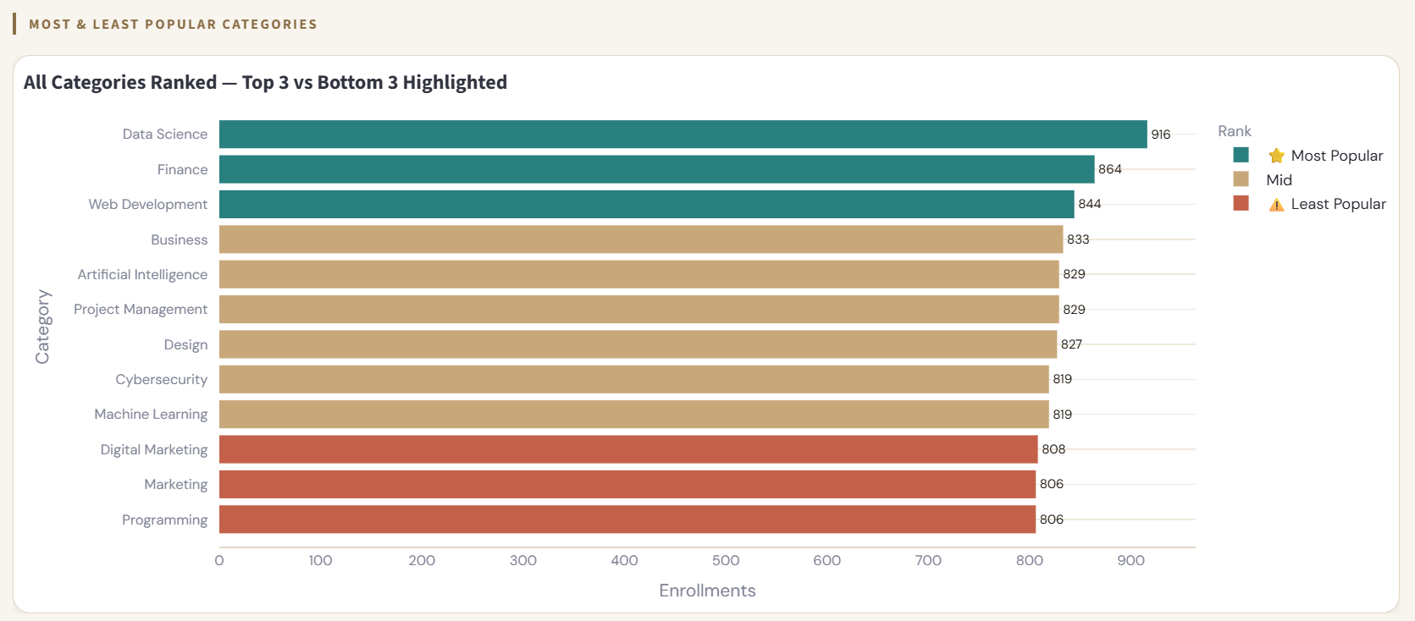

Figure 3.3 : Tab 2 — Most/least popular categories highlighted (teal = top 3, red = bottom 3)

Behavioral Insights
The average number of courses taken per learner, computed per age group, is approximately 3.33 platform-wide. The 26–35 age group shows the highest enrollment depth at ~3.31 courses per learner, while the <18 group averages ~3.40 courses per learner despite being the smallest cohort suggesting younger learners show high engagement intensity when they do enroll.
Enrollment concentration analysis reveals that the majority of learners take between 2–4 courses, with 3-course enrollment being the single largest bucket. Very few learners take only 1 course, indicating low single-visit dropout and strong continued engagement.

7.3 Gender-based Course Preference Analysis
This module directly answers the analytical question: are there gender-based differences in course selection? The analysis examines preferences across both course categories and proficiency levels.

Gender vs Course Level
Both female and male learners show broadly similar level preferences, with Beginner and Advanced courses each attracting more enrollments than Intermediate. The crosstabulation shows:

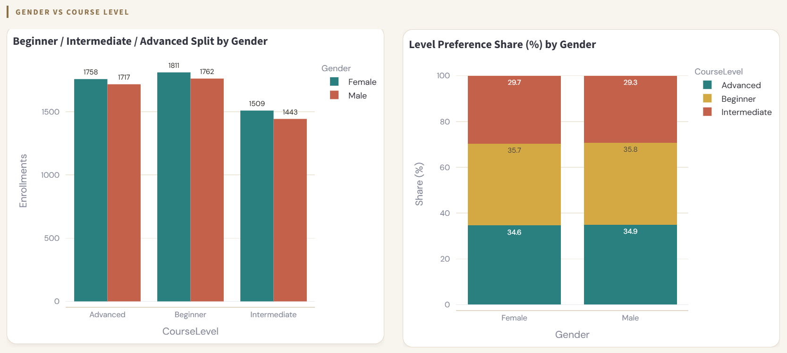
Figure 4.1: Tab 3 — Gender-based Course Preference Analysis showing Beginner / Intermediate / Advanced split by gender (grouped bar), level preference share 100% stacked chart
Female learners show a slight preference for Beginner-level content (35.6% vs 35.9% for males), while both genders equally deprioritize Intermediate courses. The 100% stacked bar chart in the dashboard confirms that level preference shares are nearly identical across genders, indicating that course level selection is not significantly influenced by gender on this platform.

Gender vs Course Category
Category preference analysis reveals near-identical patterns between male and female learners across all 12 categories, as evidenced by the parallel bar heights in the grouped bar chart and the uniform intensity in the Gender × Category heatmap. The most notable observation is that Data Science attracts the highest female enrollment (478 transactions, highlighted in the heatmap), making it the single largest gender-category cell in the entire dataset.
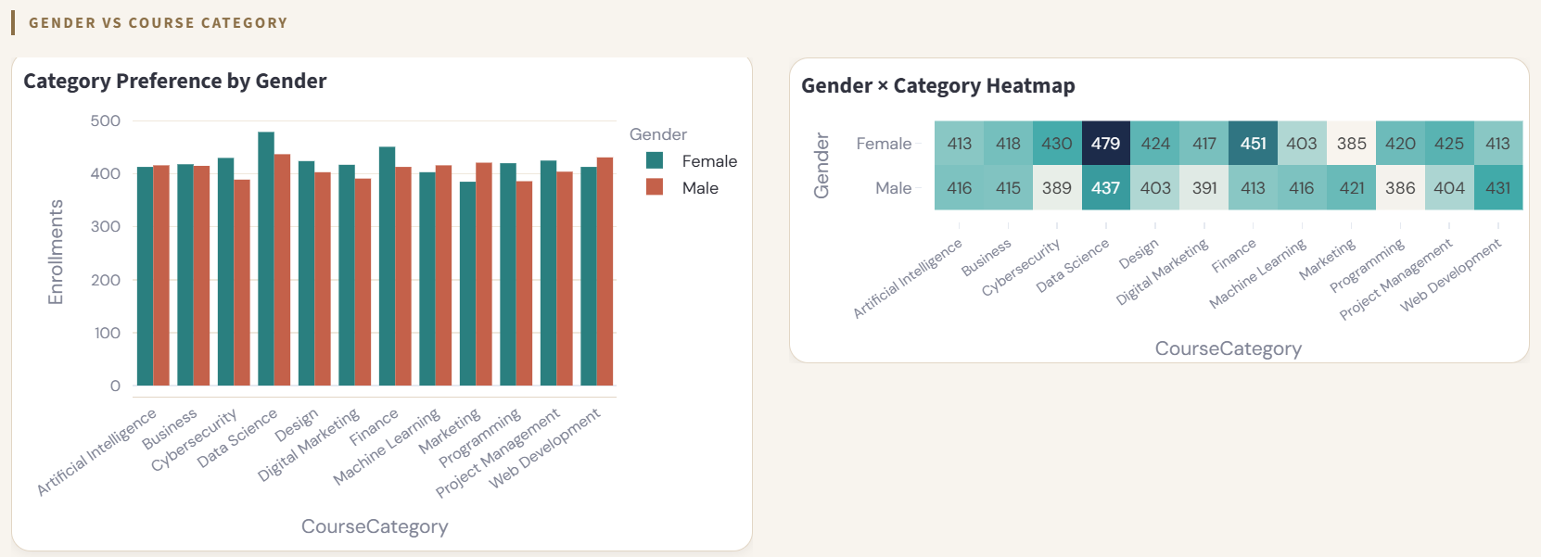
Figure 4.2 : Tab 3 — category preference by gender, gender × category heatmap

Learner Segment Identification
The bubble scatter chart maps learner segments across three dimensions: Age Group (x-axis), Course Category (y-axis), and Gender (color), with bubble size representing enrollment volume. This visualization reveals that the 26–35 age group generates the largest bubbles across virtually all categories, confirming its dominance as the primary learner segment. The <18 group shows concentrated interest in Programming and Web Development categories relative to its cohort size.
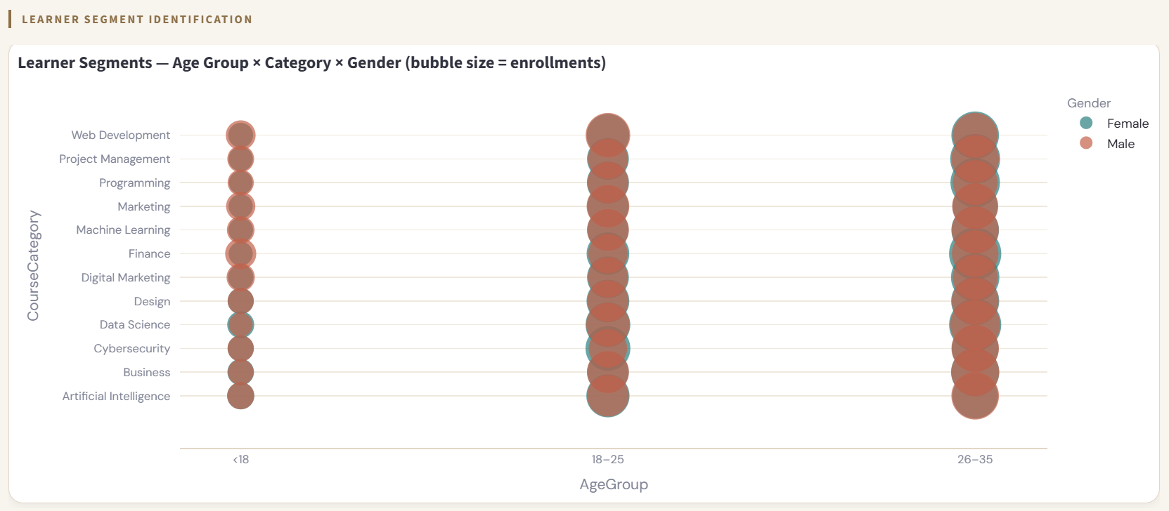
Figure 4.3 : Tab 3 — learner segment bubble chart

7.4 Course Category Popularity and Level Analysis
This module provides the most granular view of course demand, integrating category popularity, level preference distribution, and direct behavioral comparison between Beginner and Advanced learner cohorts.

Level Preference Distribution
Across all 10,000 enrollments, Beginner-level courses are the most preferred at 35.7% (3,573 enrollments), followed closely by Advanced at 34.8% (3,475), and Intermediate at 29.5% (2,952). The relative dip in Intermediate preference is a meaningful insight , it suggests learners either enter at the Beginner level or jump directly to Advanced content, skipping the intermediate tier.
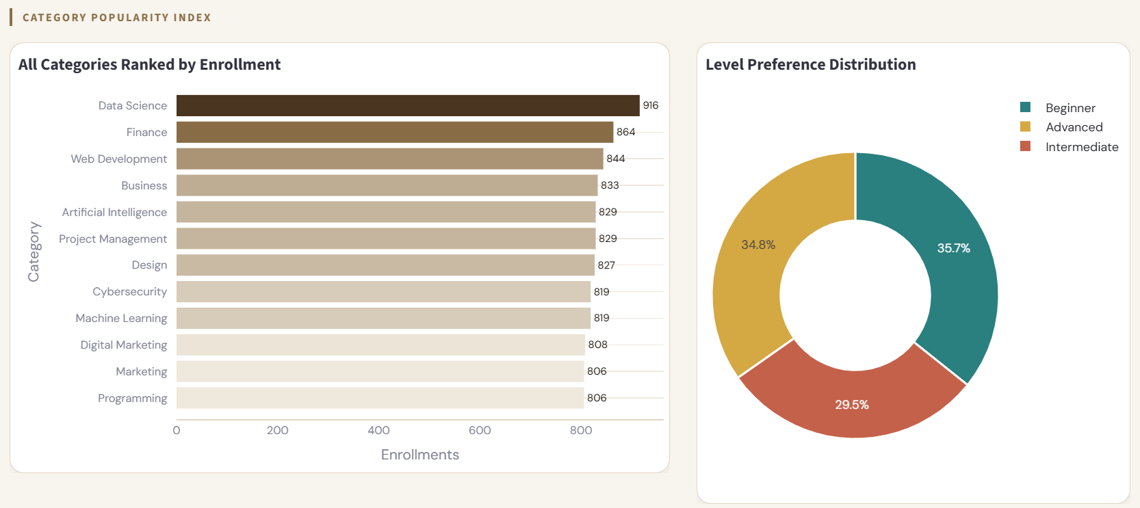
Figure 5.1: Tab 4 — Course Category Popularity & Level Analysis showing category ranking bar, level distribution donut

Age Group × Course Category Heatmap
The age-category heatmap provides a cross-dimensional view of enrollment intensity. Key observations from the heatmap include: the 26–35 group dominates enrollment in Finance (431), Data Science (459), and Business (406); the 18–25 group shows relatively balanced enrollment across all categories; and the <18 group shows proportionally higher engagement in Web Development (132) and Finance (136) relative to its overall cohort size.
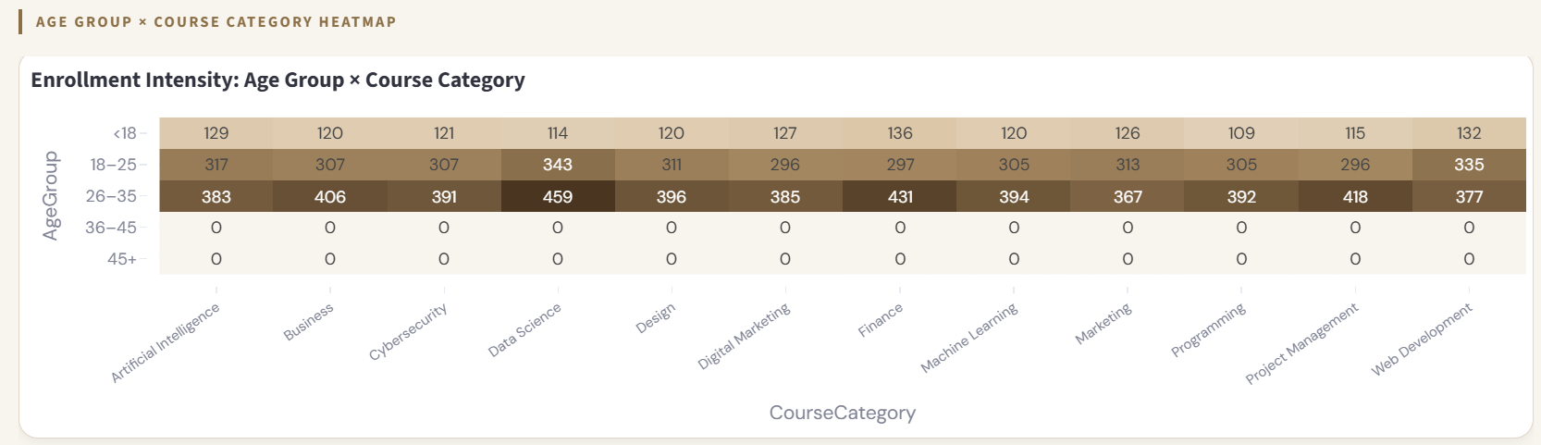
Figure 5.2 : Tab 4 —category × level stacked breakdown

Beginner vs Advanced Learner Behavior Patterns
A direct comparison of Beginner and Advanced learners' category preferences reveals meaningful behavioral differences. Beginner learners show the strongest preference for Programming (highest enrollment bar among Beginners), reflecting new learners entering through foundational technical skills. Advanced learners, by contrast, show the strongest preference for Finance and Data Science, suggesting that more experienced learners gravitate toward analytical and financial applications.
The side-by-side comparison chart in the dashboard directly visualizes this divergence across the top 5 categories for each group, providing actionable intelligence for course portfolio planning.

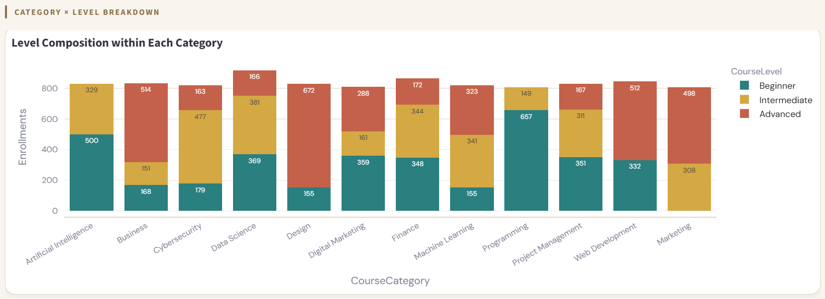
Figure 5.3: Tab 4 —Beginner vs Advanced behavior patterns side by side

8. Dashboard Implementation
The primary deliverable of this project is an interactive Streamlit web application dashboard. The dashboard implements all prescribed analytical modules and user capabilities from the project specification.

8.1 Technical Architecture
Component | Implementation Detail
Framework | Streamlit (Python web application)
Data Layer | Pandas - Excel ingestion, merging, feature engineering
Visualizations | Plotly Express - interactive charts, heatmaps, pie charts, scatter plots
Data Source | users.xlsx (3 sheets: Users, Courses, Transactions)
Styling | Custom CSS via st.markdown() - DM Serif Display + DM Sans typography
Filters | 4 sidebar multiselect widgets: Age Group, Gender, Course Category, Course Level
KPI Cards | 5 custom HTML cards - dynamically computed, filter-responsive

8.2 Core Modules
- Tab 1 - Demographic Overview: Age band bars, age histogram, gender donut, participation levels grouped bar
- Tab 2 - Age-wise Enrollment: Enrollment distribution, Free/Paid split, most/least popular categories, behavioral insights
- Tab 3 - Gender & Course Preference: Level comparison, category preference, heatmap, learner segment bubble chart
- Tab 4 - Category & Level Analysis: Category ranking, level donut, age-category heatmap, Beginner vs Advanced behavior

8.3 User Capabilities
- Age Group filter (multiselect): <18, 18–25, 26–35, 36–45, 45+
- Gender filter (multiselect): Female, Male
- Course Category selector (multiselect): all 12 categories individually selectable
- Course Level selector (multiselect): Beginner, Intermediate, Advanced

All four filters are applied simultaneously across all charts and KPI cards, enabling analysts to drill into any learner segment combination in real time.

Conclusion
This research paper has presented a comprehensive descriptive analysis of learner demographics and course enrollment behavior on the EduPro online learning platform. Using a dataset of 3,000 learners, 60 courses, and 10,000 enrollment transactions from 2025, the study systematically addressed five key analytical questions defined in the project specification.
The analysis confirmed that the platform primarily serves young professionals aged 26–35, maintains an admirable gender balance, and shows strongest demand for Data Science and Finance content. Beginner-level courses dominate enrollment preferences, though Advanced courses are closely competitive, revealing a platform that successfully serves both new and experienced learners. The intermediate enrollment gap represents the most significant actionable finding for course portfolio planning.
The interactive Streamlit dashboard developed as the primary deliverable enables non-technical stakeholders including government partners at Toronto Parks, Forestry & Recreation to explore these insights directly through filterable, real-time visualizations. By providing foundational learner intelligence, this project enables EduPro to move from intuition-driven to evidence-based platform management, directly supporting the objectives of inclusive, data-driven education planning.

10. References
  - EduPro Online Platform Dataset (2025). Internal transaction and user records. EduPro Online Platform XLSX workbook. Sheets: Users, Courses, Transactions.
  - Streamlit Inc. (2024). Streamlit Documentation — Build and share data apps. https://docs.streamlit.io
  - Plotly Technologies Inc. (2024). Plotly Python Open Source Graphing Library.
https://plotly.com/python/
  - Pandas Development Team (2024). pandas: powerful Python data analysis toolkit.
https://pandas.pydata.org
  - Toronto Government Parks, Forestry & Recreation. (2025). Digital Education Partnership Program. City of Toronto.
  - Unified Mentor (2025). Learner Demographics and Course Enrollment Behavior Analysis on EduPro — Project Requirements Document.
  - Unified Mentor – Data Analyst Fellowship Program

— End of Research Paper —

