Instagram Data Analysis Report
Author: Bhuvani Surya
Data Science Internship Project 3

Project Overview
This project analyzes Instagram user engagement data using Python, Pandas and Matplotlib. The analysis focuses on content types, filter usage, user verification status, likes, comments and hashtag trends.

Dataset Preview
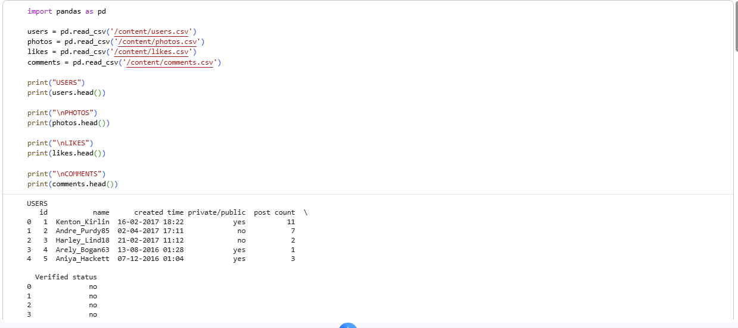

Dataset Information
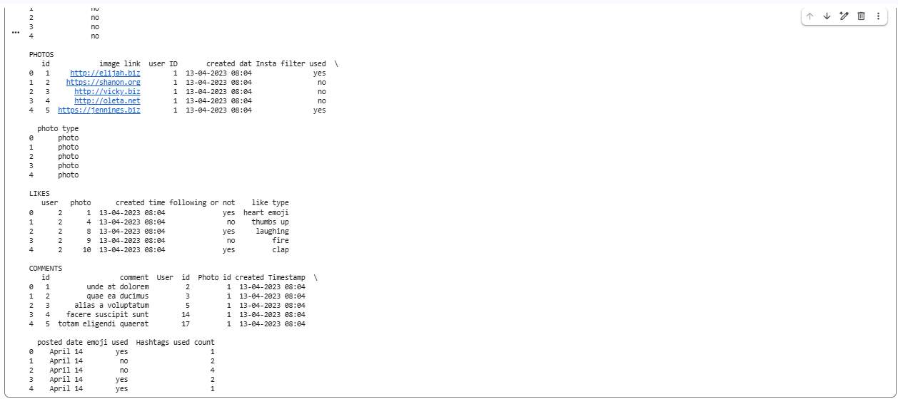

Missing Values Analysis
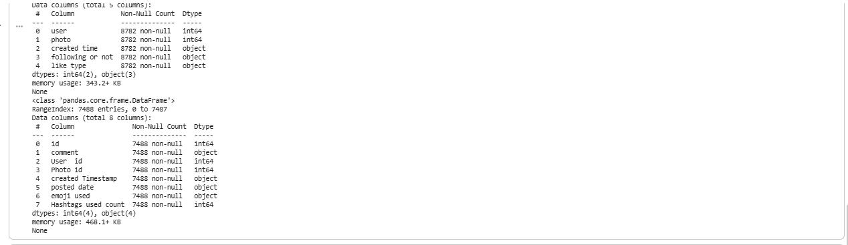

Photo Type Distribution
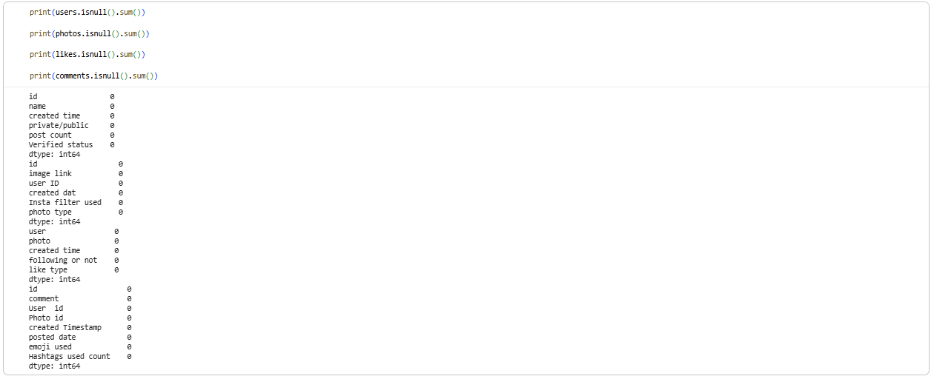

Instagram Filter Usage
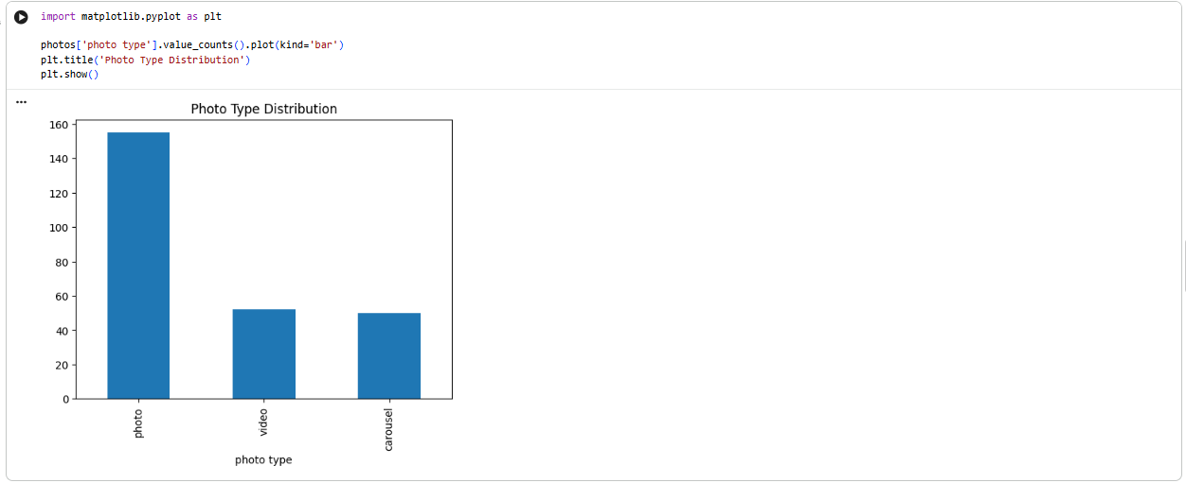

Verified vs Non-Verified Users
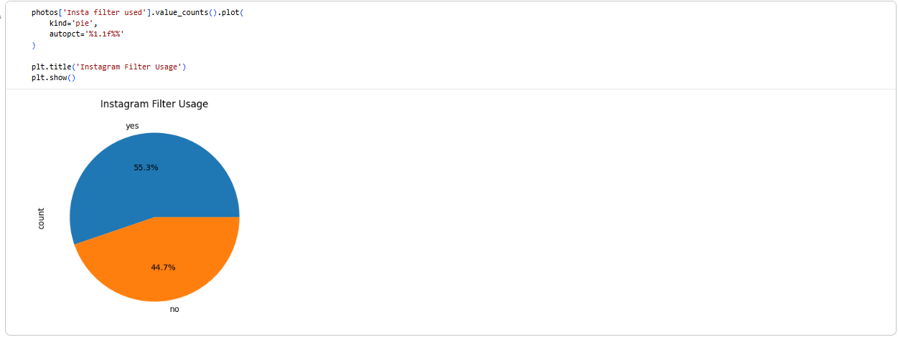

Top Like Types
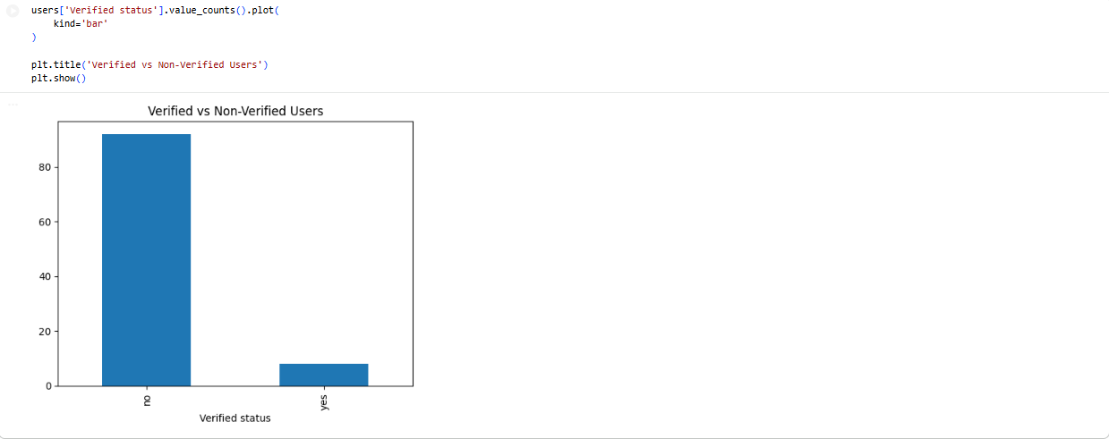

Hashtag Usage Count
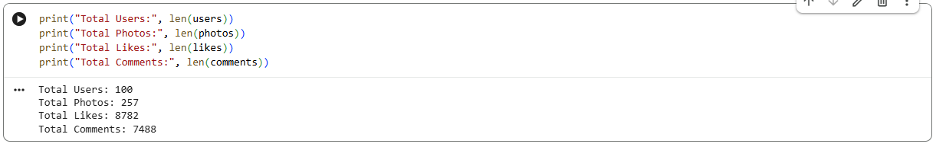

Dataset Statistics
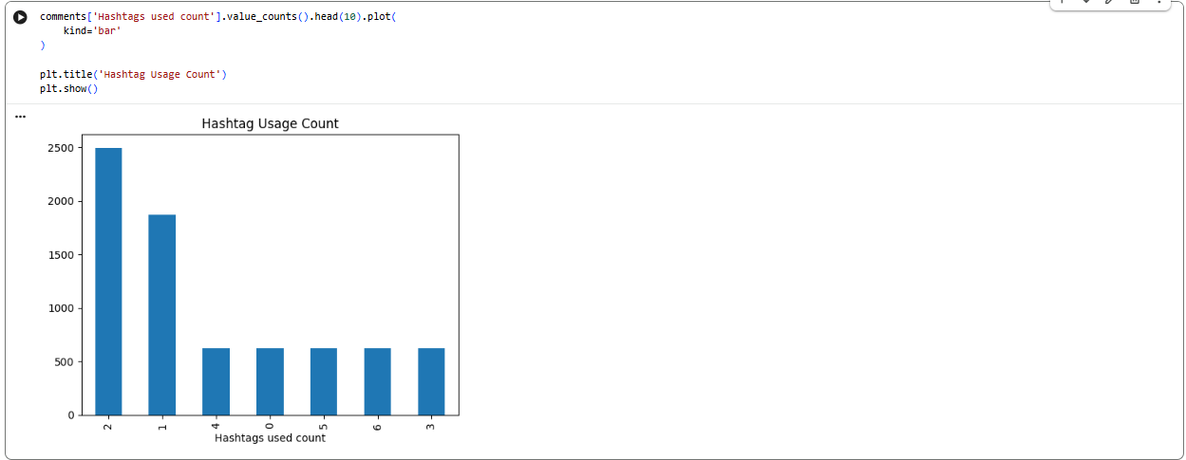

Key Findings
• Photos are the most common content type.
• 55.3% of posts use Instagram filters.
• Most users are non-verified accounts.
• Popular reactions include clap, thumbs up, heart emoji, laughing and fire.
• Posts commonly use 1–2 hashtags.
• Dataset contains 100 users, 257 photos, 8782 likes and 7488 comments.

Conclusion
The analysis demonstrates strong user engagement across Instagram content. Photos remain the dominant content format, while filter usage and hashtag strategies play an important role in engagement and visibility.

