Loan Approval Prediction - Internship Project Report
This report presents data preprocessing, missing value analysis, label encoding, train-test splitting, model training using Random Forest Classifier, evaluation metrics, and visualization of loan approval status.

Dataset Loading
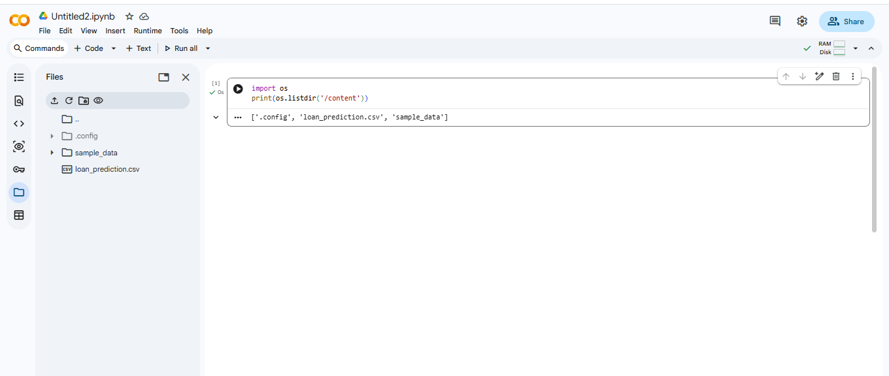
Figure: Dataset Loading

Dataset Preview
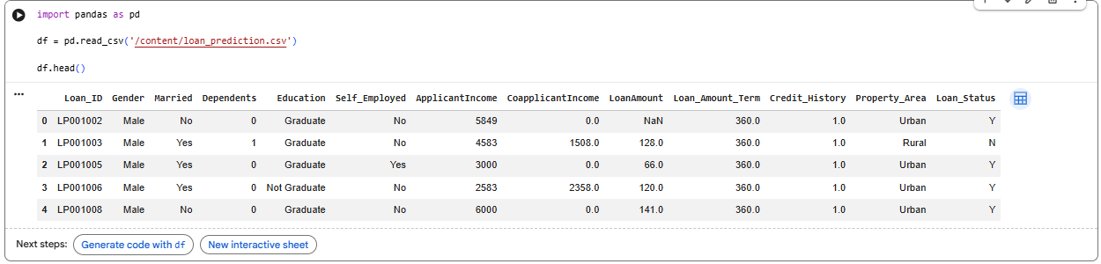
Figure: Dataset Preview

Dataset Information
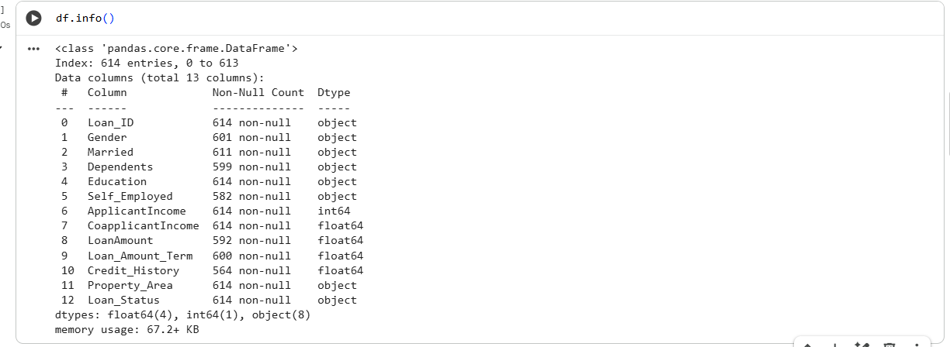
Figure: Dataset Information

Missing Values Analysis
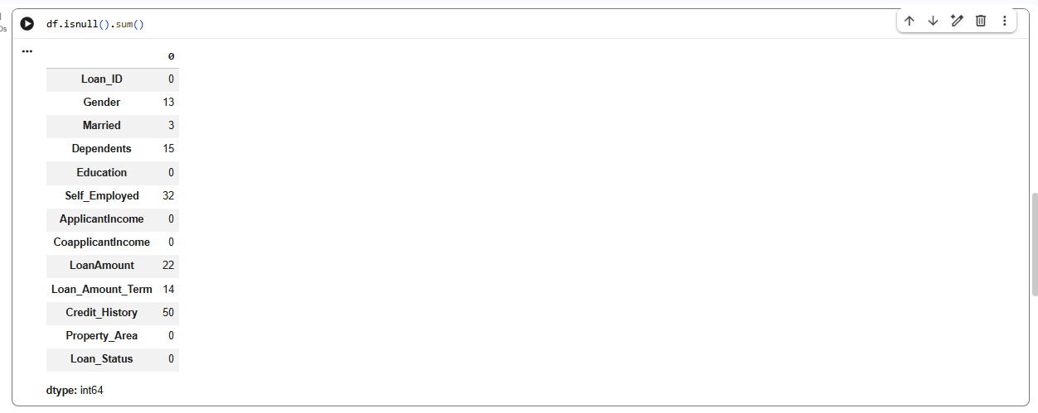
Figure: Missing Values Analysis

Data Preprocessing and Encoding
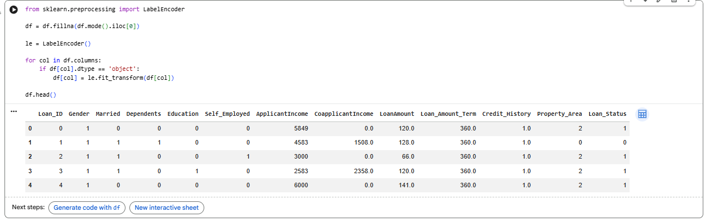
Figure: Data Preprocessing and Encoding

Train Test Split
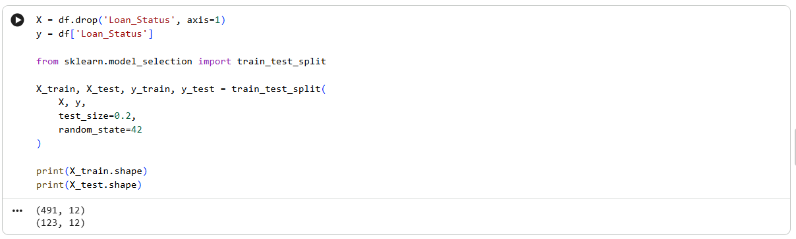
Figure: Train Test Split

Model Accuracy
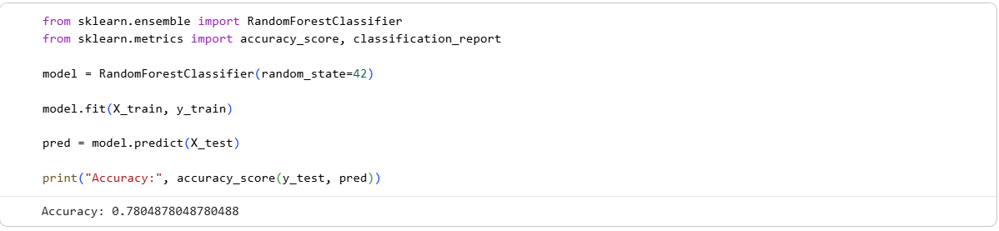
Figure: Model Accuracy

Classification Report
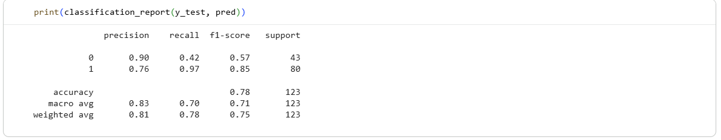
Figure: Classification Report

Loan Approval Status Visualization
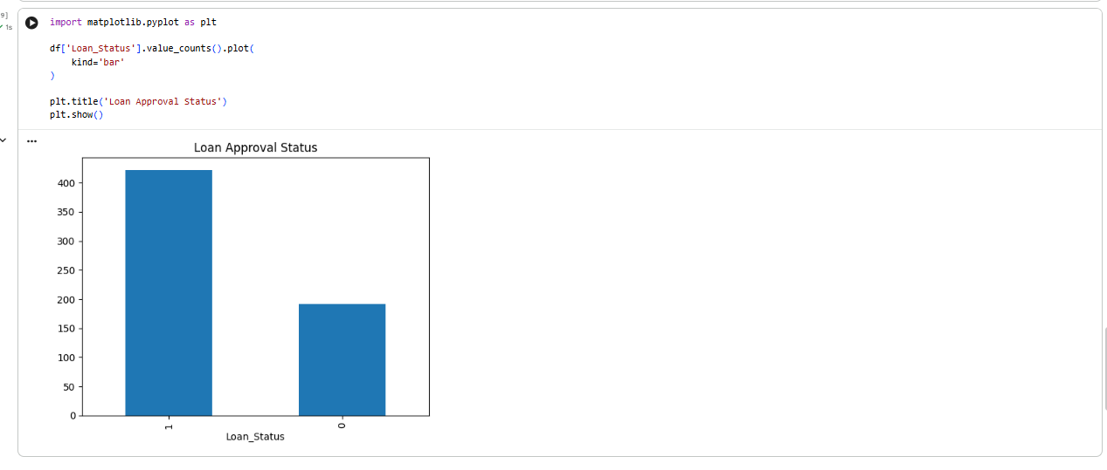
Figure: Loan Approval Status Visualization

Conclusion
A Random Forest model was trained on the loan approval dataset after handling missing values and encoding categorical features. The model achieved approximately 78% accuracy. The results indicate that the model can reasonably predict loan approval outcomes and can be further improved through hyperparameter tuning and advanced preprocessing techniques.

