Zomato Dataset Analysis

Introduction
The Zomato Dataset Analysis project aims to analyze restaurant data and identify trends related to restaurant locations, cuisines, online ordering, and restaurant types.

Dataset Overview
Total records: 56,252
Total columns: 13
Dataset contains restaurant details such as name, location, cuisine, ratings, votes, and online ordering availability.
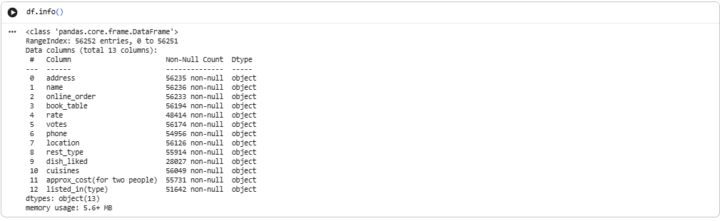
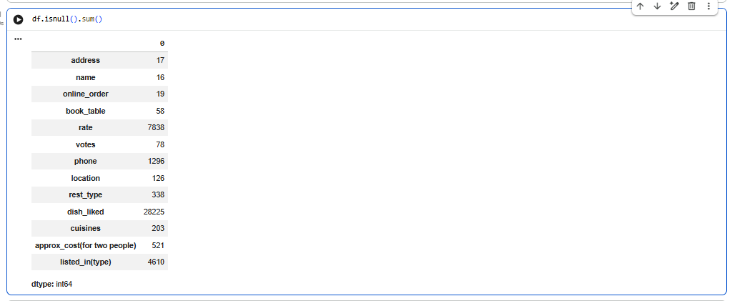
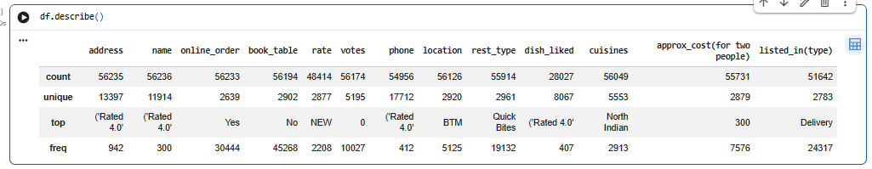

Data Cleaning
The dataset was cleaned by removing duplicate records and cleaning the rating column.

Visualization 1: Top Restaurant Locations
Observation: BTM contains the highest number of restaurants followed by Whitefield and HSR.
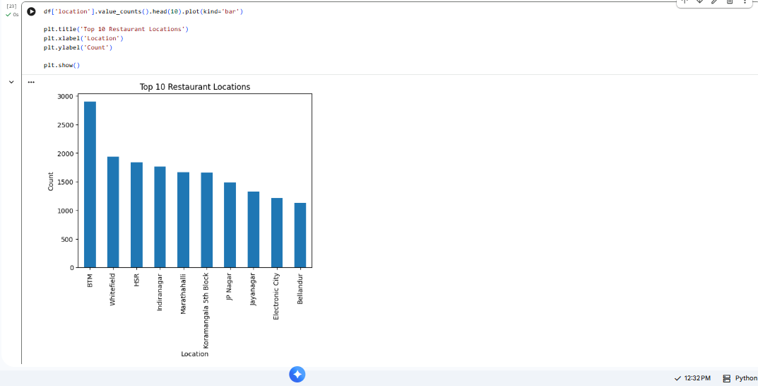

Visualization 2: Online Order Availability
Observation: Approximately 60.2% of restaurants provide online ordering while 39.8% do not.
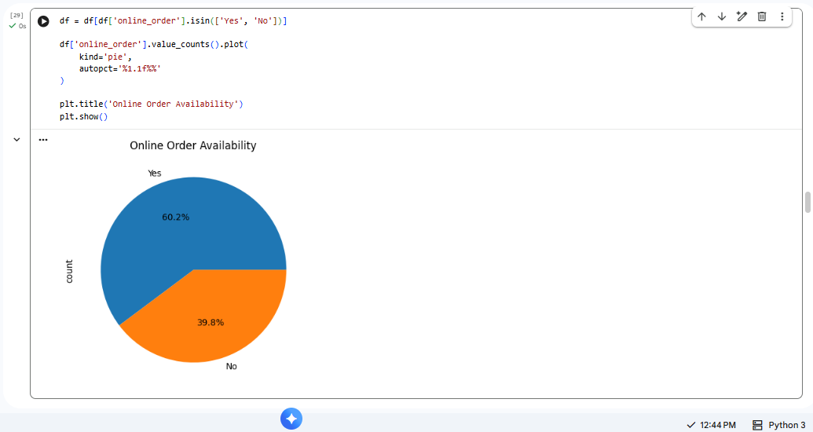

Visualization 3: Top Restaurant Types
Observation: Quick Bites and Casual Dining are the most common restaurant types.
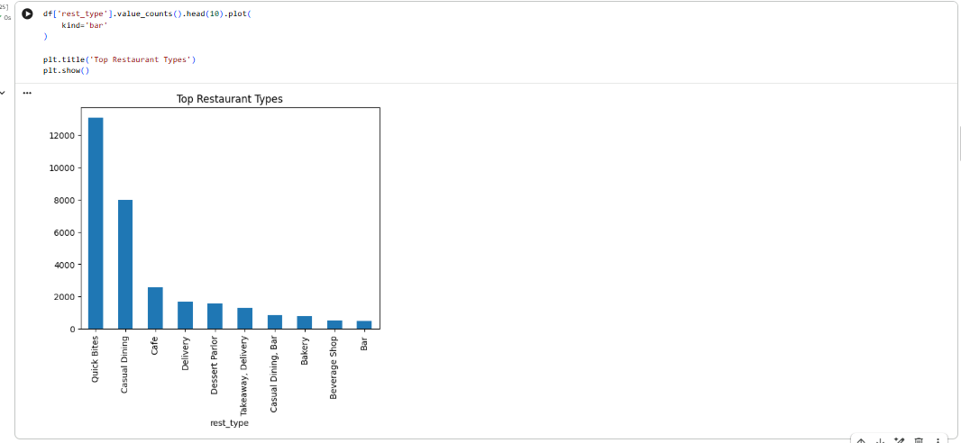

Visualization 4: Top Cuisines
Observation: North Indian cuisine is the most popular cuisine.
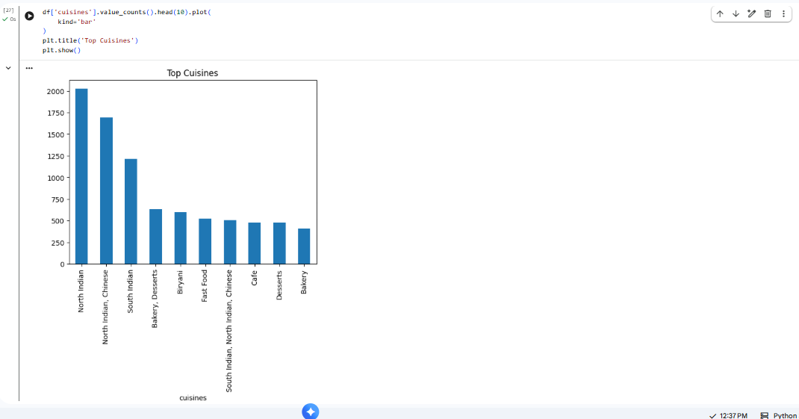

Key Findings
1. Restaurants are concentrated in major commercial areas.
2. Online ordering is widely adopted.
3. Quick Bites is the dominant restaurant category.
4. North Indian cuisine has the highest representation.
5. Restaurant distribution varies significantly across locations.

Recommendations
1. Focus promotions in high-density locations.
2. Strengthen partnerships with popular restaurant categories.
3. Promote online ordering services.
4. Build location-based recommendation systems.
5. Use customer preferences to recommend cuisines.

Conclusion
The analysis reveals significant insights regarding restaurant distribution, cuisine popularity, and online ordering trends.

