Matthew Kozak

EGRE 426, Lab 5

11/21/2019

Implementation

The program for this lab assignment was chosen to be written in C, as VHDL was recommended. The very first thing implemented was command line argument configuration in order to specify the parameters necessary to chance the cache for testing, discussed later. The program specified how many parameters it needs at runtime. Next, file intake was managed. The program will check if the address file specified by a ‘.txt.’ is actually present in the directory of the executable. If it is not, it will inform the user. To finalize the initial error checking, the code checks the associativity and the block size to confirm that both are equal to a power of 2. If either of these are not a power of 2, the program will let the user know what needs to be resolved.

The initializations of the code begin with determining the bits necessary for an offset. This is done by taking the natural logarithm of the block size input by the user, then dividing that by the natural logarithm of 2. The result of this rounded up provides an integer representation of the number of bits required to represent the offset required. The same formula is used to determine the bits for the index. However, when calculating this value, the program will also remove a number of bits based on the number of bits needed for the associativity. For example:

* For ‘addresses.txt’, there are 10000 elements, which requires 12 bits to be represented
* If an associativity of 2 is selected, this reduces the result by 1
* If an associativity of 4 is selected, this reduces the result by 2, etc.

This result (‘b_min’ in the code) is then used to produce a mask called ‘shift_temp’. This mask is used against the address read in to determine the index. After these values are calculated, the arrays to hold the tag, valid bit, count (for LRU), and the index (e.g. data for Step 1 cases) are generated, and cleared to be all zeros.

The body of the code begins with a main ‘for’ loop that is waiting until the end of the file has been reached. Each time it increments to the next line of the file using ‘fscanf’. The tag is the most significant btis, without the index and the offset, so the entire address (‘curr_addr’) is shifted right by the sum of number of bits needed for the index and the number of bits needed for the offset. The current index is the current address ANDed with the mask created, then shifted over by the number of offset bits to extract just the index. The current block address is calculated as the current address divided by the block size

Another ‘for’ loop is implemented to work through the associativity. Each time a new address is read in, the loop checks all values in that index/set to see if the tags match. If any of them produce a hit, the hit count is incremented. Additionally, if the setting is LRU and not random, the count for that element is reset to one, and the count for the other elements in the index/set are incremented by 1. If there is a miss, a flag is set and a separate method is implemented. This could have been implemented din its own function for improved clarity.

Finding a miss will first increment the miss count, then go through two different actions based on whether LRU or random placement was selected. If random was selected, the program will check the index/set and see if any elements are invalid (valid bit == 0) and set a flag if so. A while loop will then generate a random value for an element in that set that is not valid. It will set that value as valid, add the tag in, and clear the flag for the while loop.

If LRU is selected, the miss handler will increment the count of all valid elements in the index/set by 1. Then, each element in the index/set is checked and if the valid is not set, then the new tag will be placed at that location, and the count will be reset to 1 for that element. If no elements are invalid, then the program will look for the element with the highest count value and place the new tag there.

Finally, the code will print out the cache table if Step 1 in the report is currently being tested (number of elements == 16). For all cases, the code prints the cache size in KB, the number of reads, hits, misses, and the rates for the hits and misses based on the number of reads.

Testing

**NOTE:** The command line arguments for all code is as follows. For random/LRU, a ‘1’ yields LRU, a ‘0’ yields random:

<*executable file*> <*block size*> <*number of blocks*> <*associativity*> <*random/LRU*> <*address file name*>

The code was tested as specified by the assignment file using two different address files to test how the program responds to varying block sizes, associativity, and number of blocks. Step 1 specified a series of addresses to be loaded into the cache simulator. For Part A, the only hits occurred for the second 11 and the second 16, since it was a direct mapped program and these were the only repetitions of values. The final 16 was not a hit because the 48 was loaded to the same position beforehand, and the new 16 missed since the tag represented 48 instead. We were also to assume LRU was used. The output of Step 1 Part A can be found below:

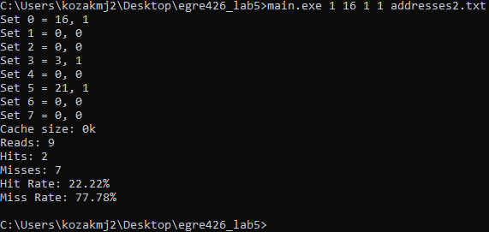

Figure : Step 1 Part A output result

In Step 1 Part B, the same setup was used but this time with an associativity of 2, allowing 2 elements to be placed in the same set/index. This produced a similar result as before, but with the second 16 still being a hit. The 48 replaced the 0 in Set 0 since the count for that was higher, and the second 16 in Set 0 never gets replaced, so the last 16 address is a hit. The output can be found below:

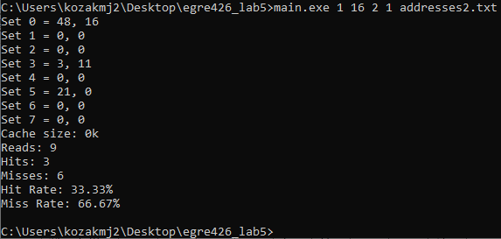

Figure : Step 1 Part B output result

For Step 2 in testing, a larger address file was used, this one having 10000 addresses to load into the cache. This tested the increase in block size and how it effects the number of hits based on the bits required for the offset. The output for Part A where a 16-word block size with 256 blocks can be found below:

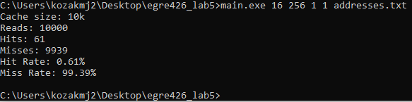

Figure :Step 2 Part A output result

For Step 2 Part B, the block size is increased from 16 to 256 with the same remaining parameters:

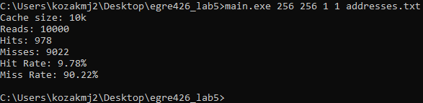

Figure : Step 2 Part B output result

Extra Credit Testing

As specified in the assignment file, implementation of random selection in addition to LRU yields 15% extra credit on the assignment. As discussed in the ‘Implementation’ section, random selection was implemented to choose one of the non-valid addresses in an index/set. If all are valid, it picks a random one to replace. A test below compares two different results (as an associativity of at least 2, which is required to demonstrate random selection) when random placement is used. Note that if LRU is used, the results would be the same. However, since random is used the results can differ with the same inputs:

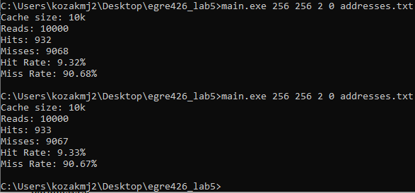

Figure : Extra Credit Testing of Random Selection