**Пункт 1**

**1 ЗАДАНИЕ**

**details**

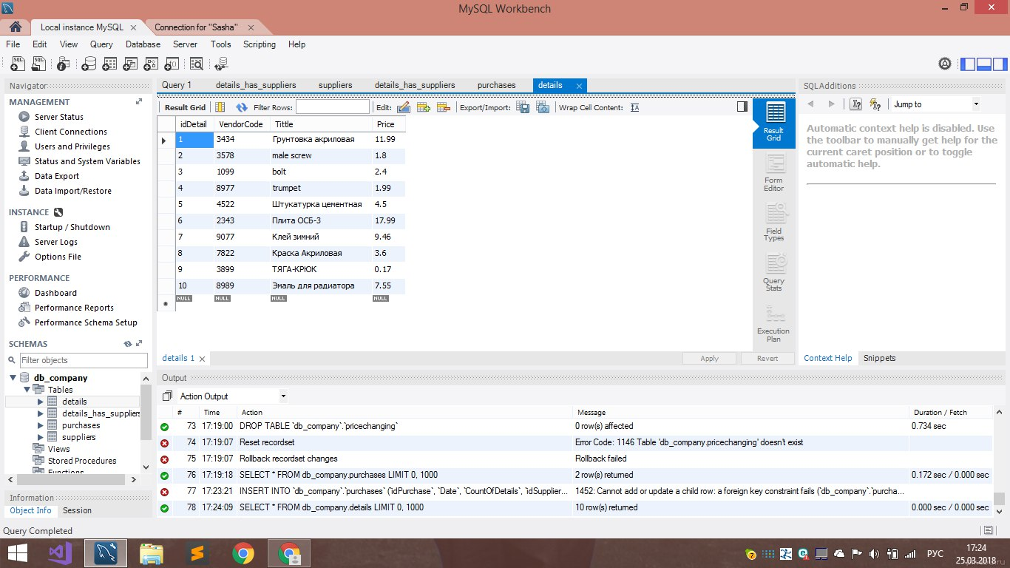

**Details has suppliers**

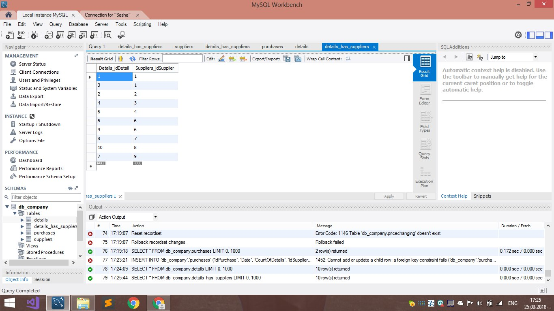

**Purchases**

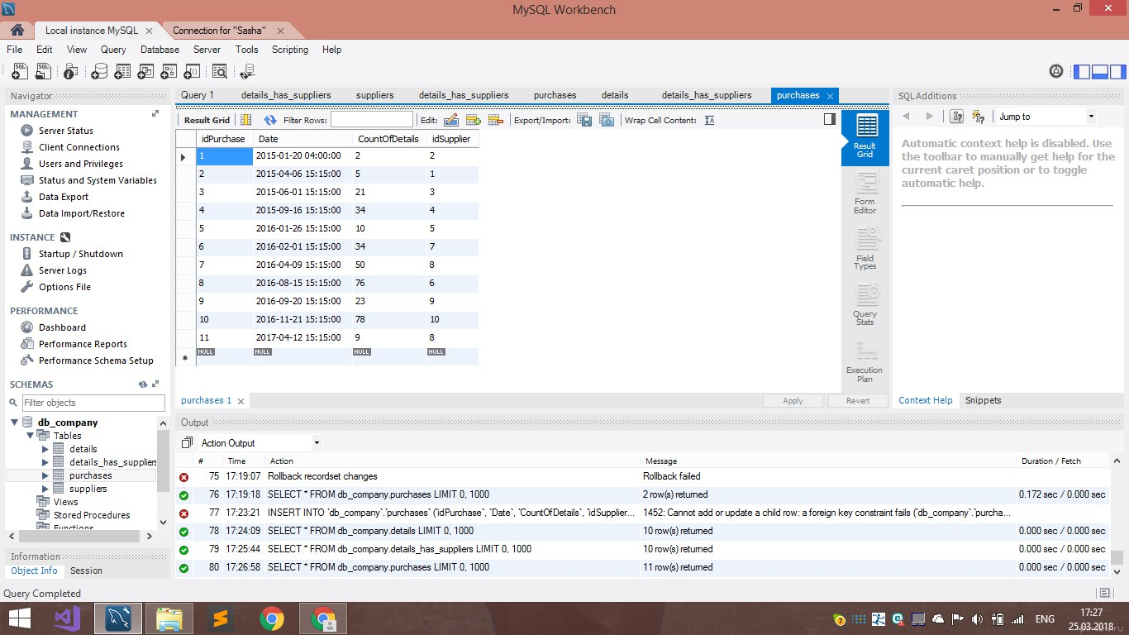

**Suppliers**

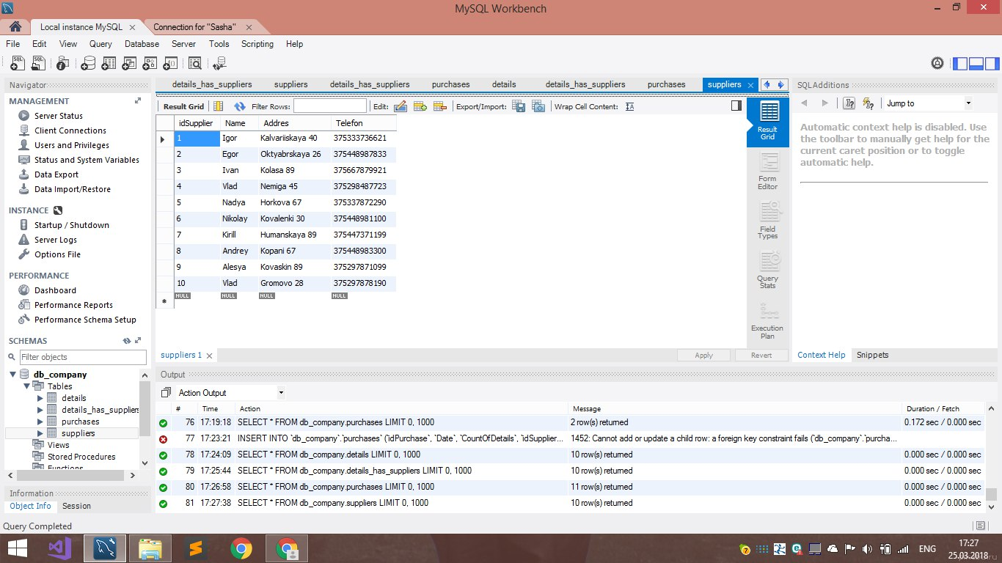

**2 ЗАДАНИЕ**

SET SQL_SAFE_UPDATES = 0;

UPDATE details SET VendorCode='7788' WHERE idDetail=1;

UPDATE purchases SET CountOfDetails=2 WHERE idSupplier=2;

UPDATE suppliers SET Addres="Kovalevskay 67" WHERE idSupplier=3;

**3 ЗАДАНИЕ**

REPLACE INTO suppliers SET idSupplier = 11, Name = "Alex",Addres="Kovaleriyskaya 99",Telefon=375446764455;

REPLACE INTO details SET idDetail = 12, VendorCode = 6737, Tittle="Супер клей", price = 1.87;

**4 ЗАДАНИЕ**

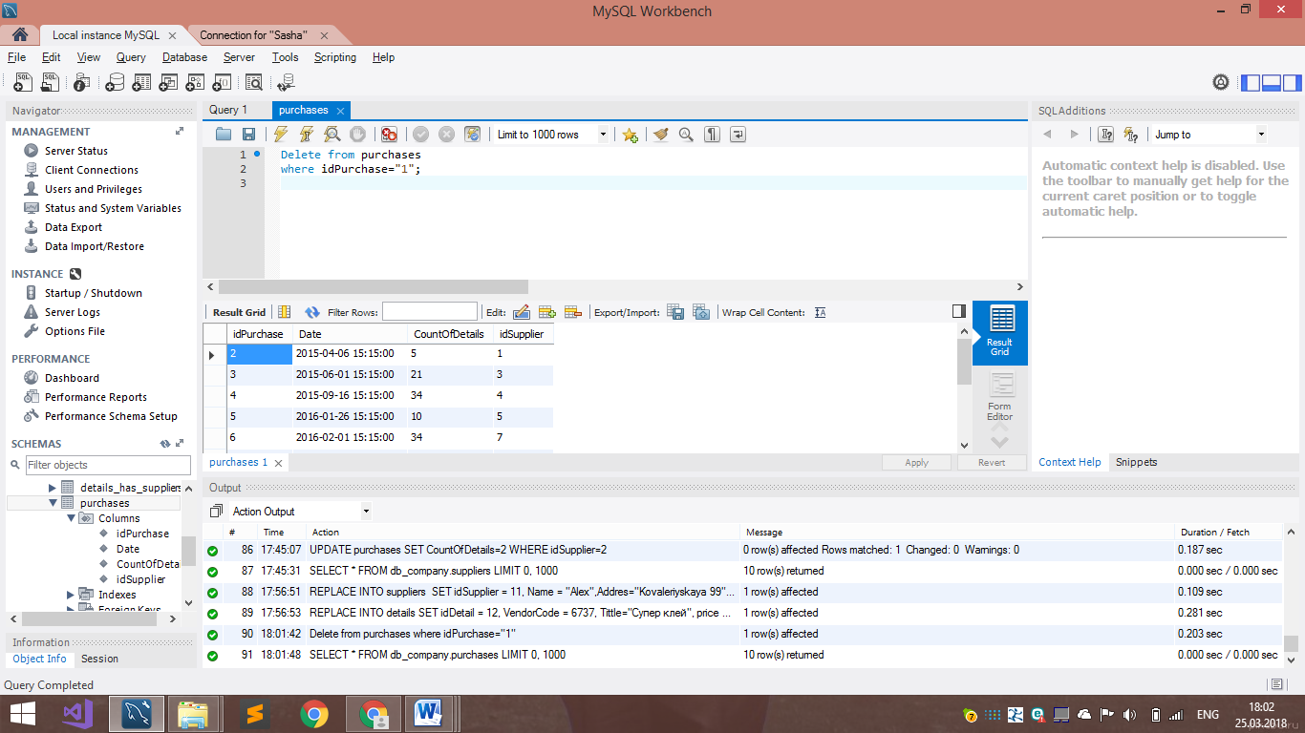

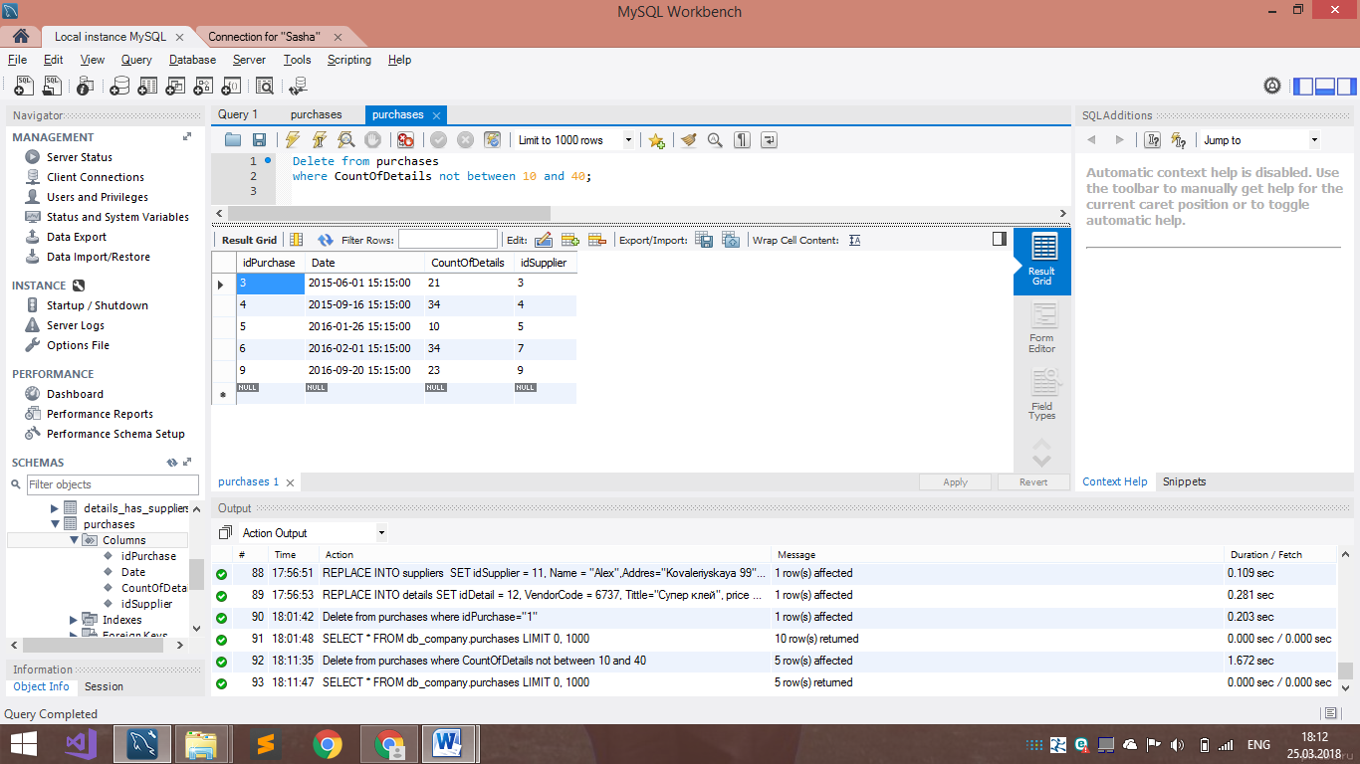

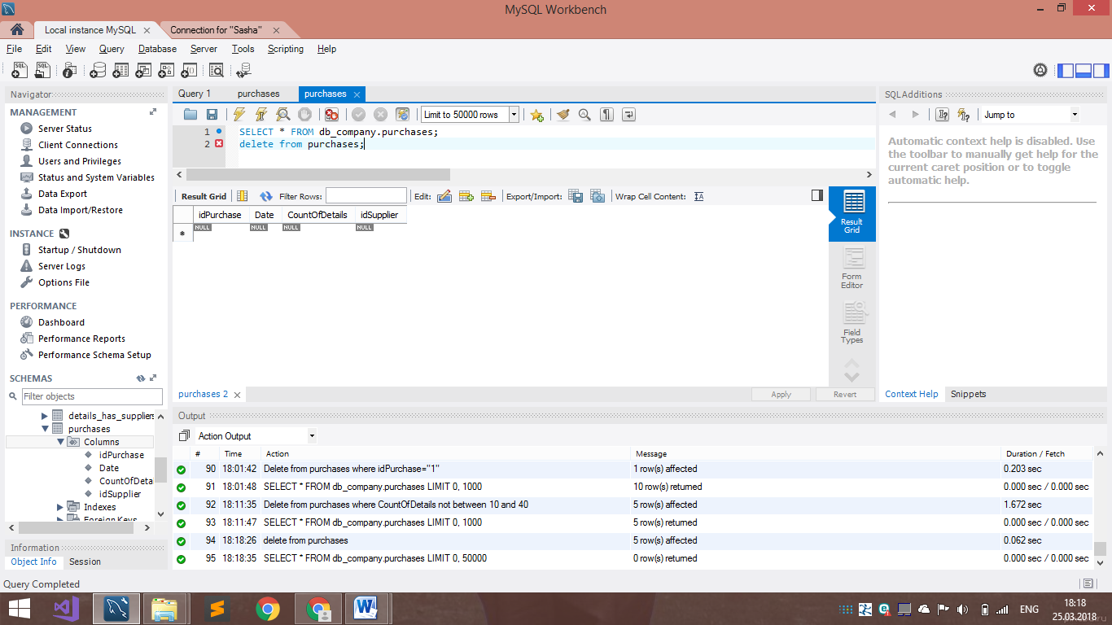

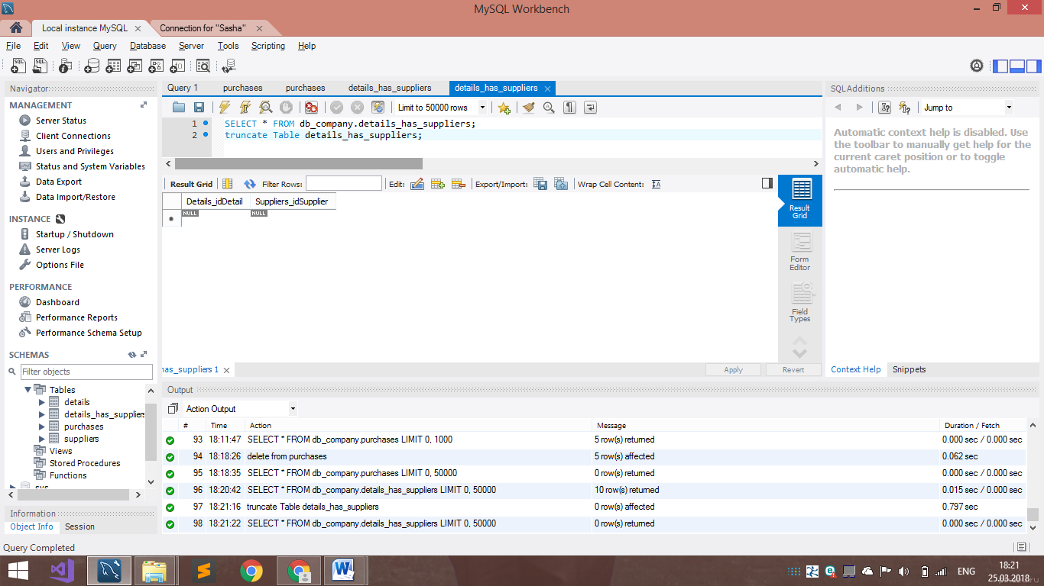

**Пункт 2**

**1 ЗАДАНИЕ**

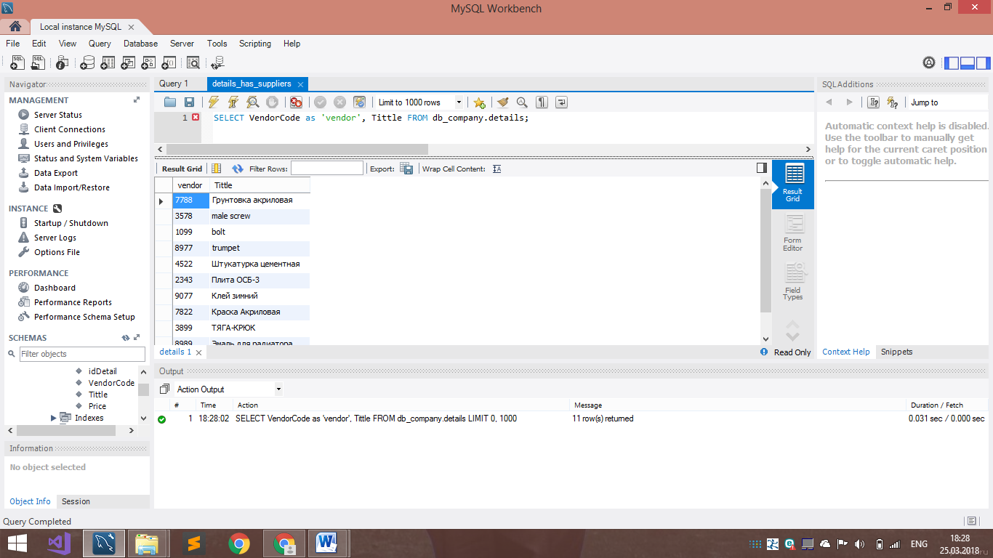

**2 ЗАДАНИЕ**

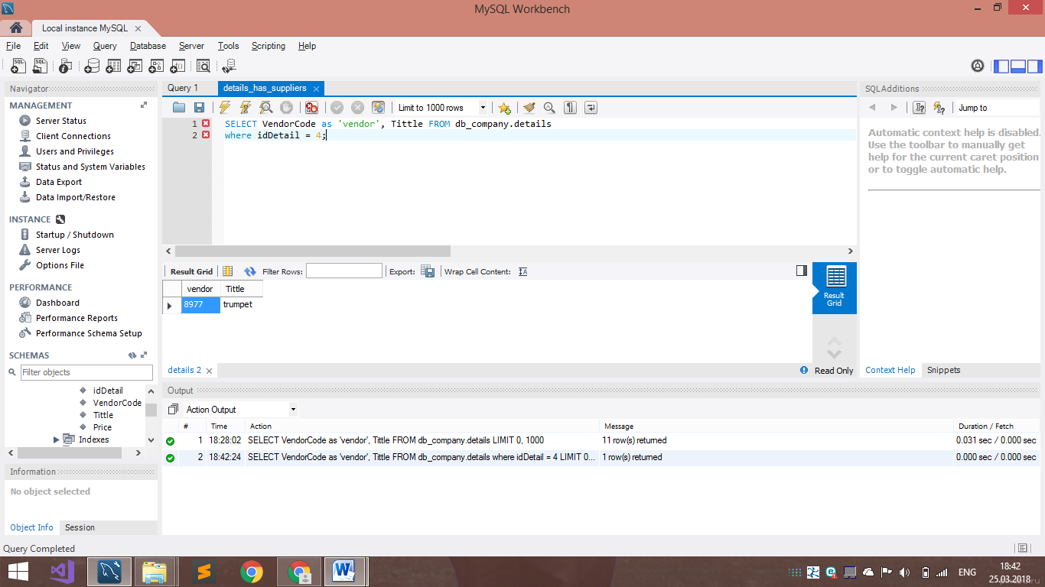

**3 ЗАДАНИЕ**

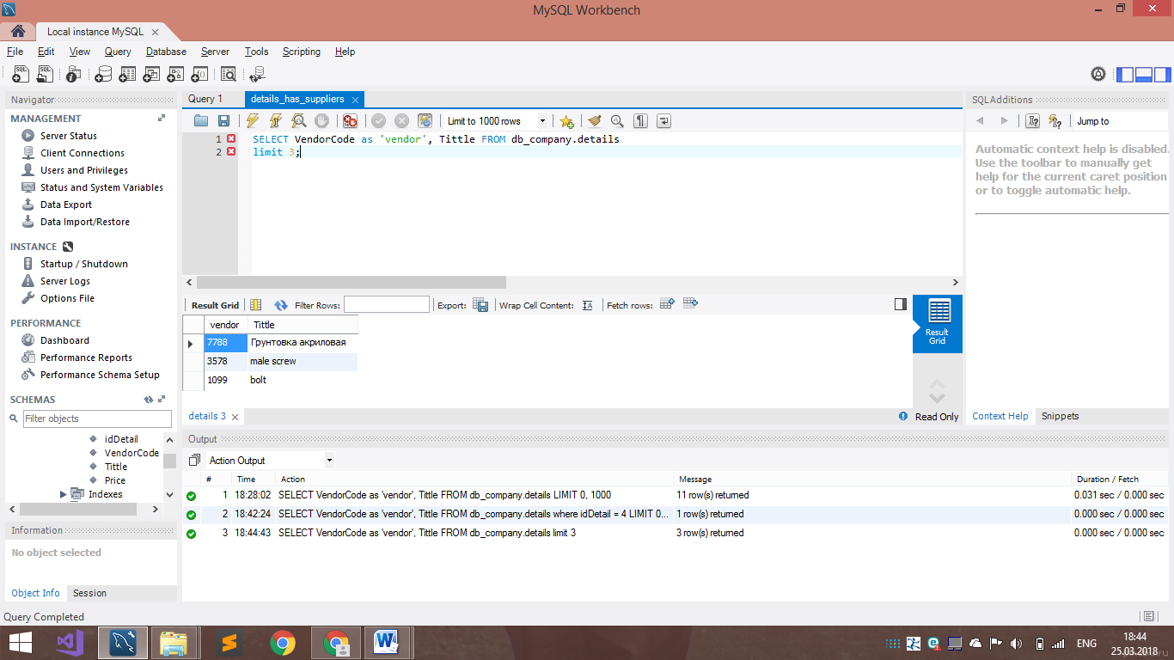

**4 ЗАДАНИЕ**

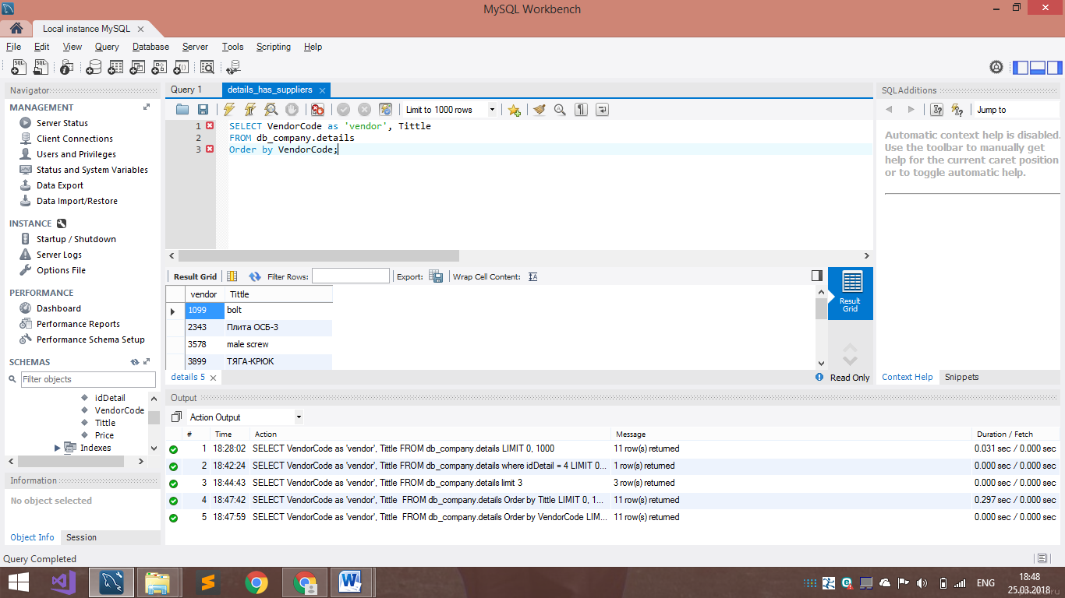

**5 ЗАДАНИЕ**

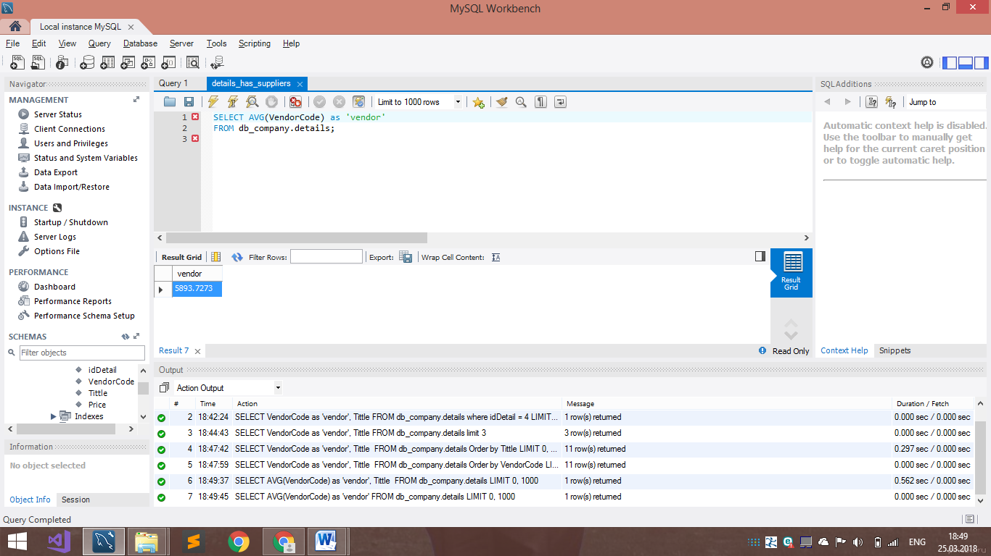

**6 ЗАДАНИЕ**

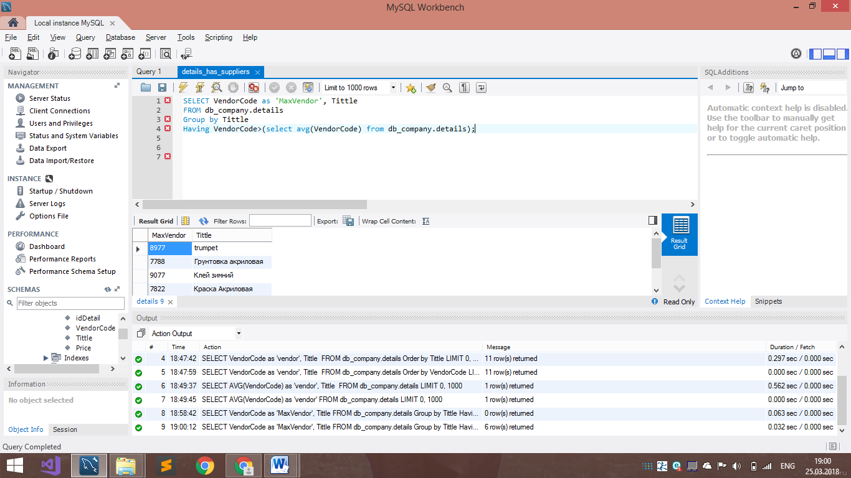

**7 ЗАДАНИЕ**

