**Simple Subnetting**

You have been assigned the following address space:

**200.100.20.0 /24**

Given the topology below, subnet your address space to allow sufficient networks to provide addressing for the topology.

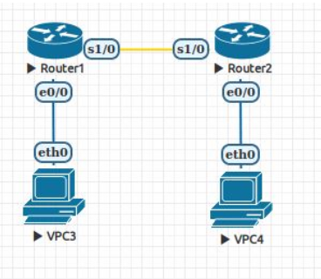

How many networks (subnets) do you need? _____________ Subnets

(Hint: Routers route between networks)

What mask will provide / _____  
for that number of subnets?

______ . ______ . ______ . ______

How many hosts will be supported in each subnet? _____________ Hosts

# Assign Subnets

Allocate and record a subnet (host bits all zero) to each of the following regions:

Perth LAN ______ . ______ . ______ . ______ / _____

Sydney LAN ______ . ______ . ______ . ______ / _____

WAN ______ . ______ . ______ . ______ / _____

# Default gateway address

The use of standards and taking a systematic approach to network addressing and design makes it easier for others to understand and work with your design. It also reduce the likelihood of configuration errors and the introduction of security flaws.

Assign and record the last valid host address in the subnet for use as a router interface in each LAN.

Perth Router e0/0 ______ . ______ . ______ . ______ / _____

Sydney Router e0/0 ______ . ______ . ______ . ______ / _____

# WAN interface addresses

Assign the Perth WAN interface S2/0 the first available IP address in its subnet and record it here:

Perth Router S2/0 ______ . ______ . ______ . ______ / _____

Assign the Sydney WAN interface S2/0 the second available IP address in its subnet and record it here:

Sydney Router S2/0 ______ . ______ . ______ . ______ / _____

# Host IP addresses

Assign and record the first valid host address in the subnet for use as a host address for the PC in each LAN.

Perth host ______ . ______ . ______ . ______ / _____

Sydney host ______ . ______ . ______ . ______ / _____