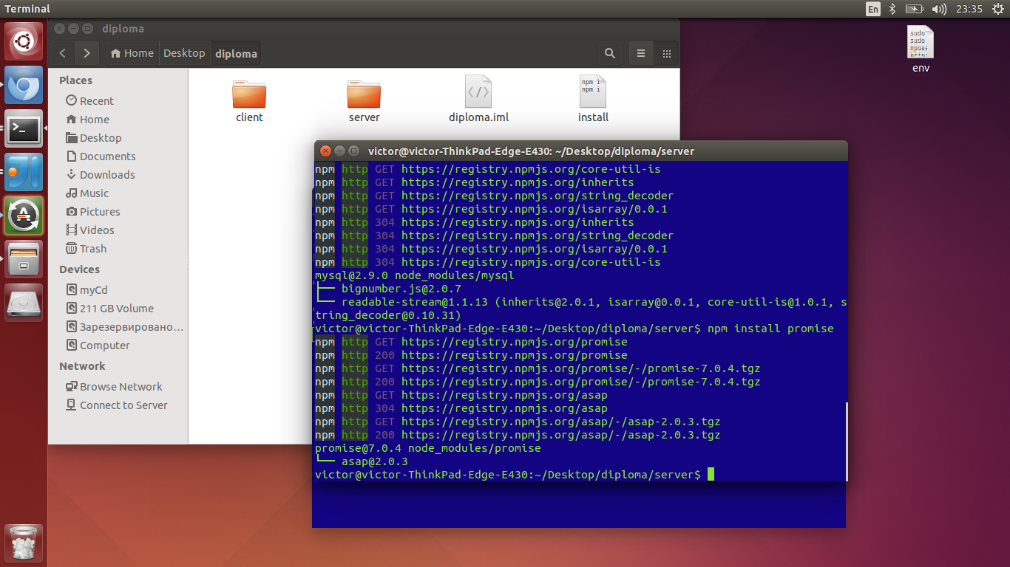
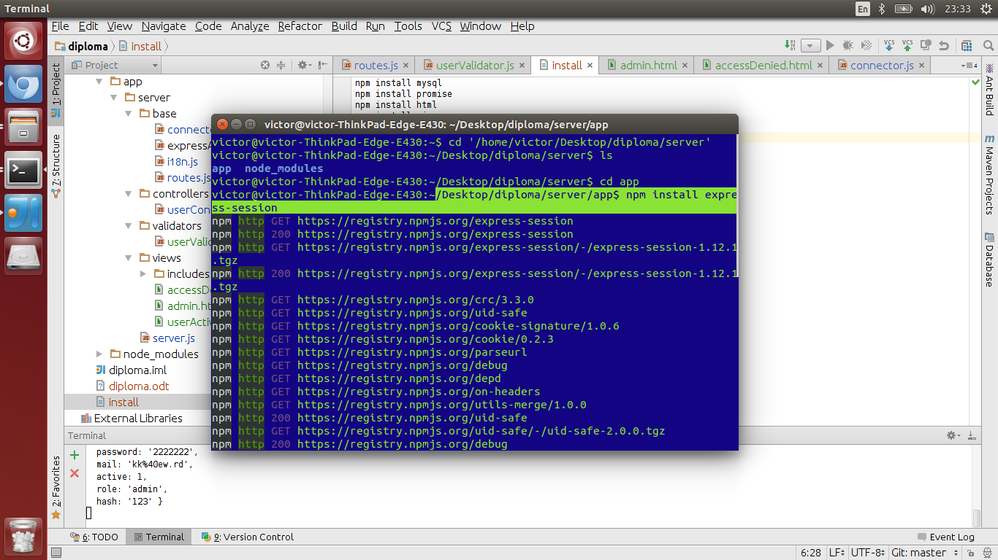

var async = function(){
return new Promise(function(resolve,reject){
setTimeout(function(){resolve('resolved')},2000);
throw 'error';
}).
then(function(res){
console.log(res);
return '';
}).
then(function(){
console.log('last');
// application logic
}).
catch(function(err){
console.err('error occured',err);
});
};

task1(data1,function(){
task2(data2,function(){
task3(data3,function(){
// application logic
})
});
});

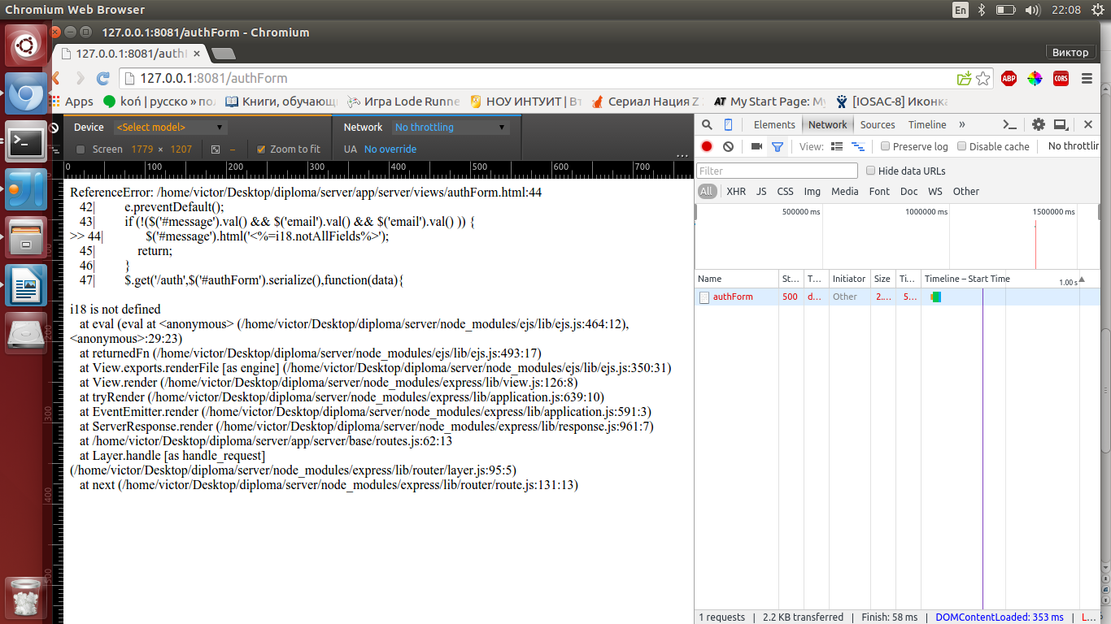

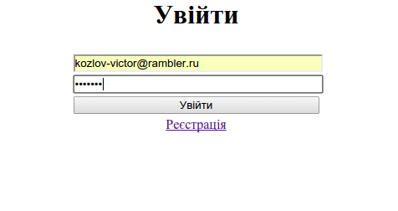

https://learn.javascript.ru/promise

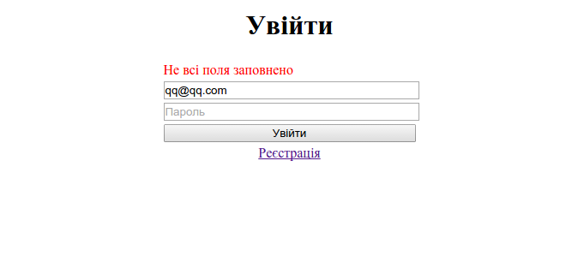
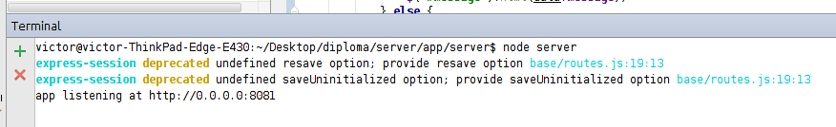

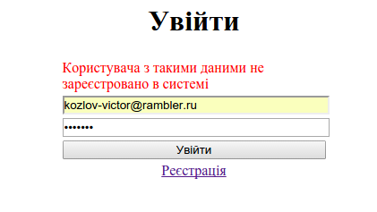

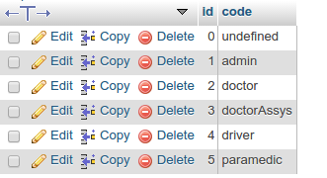

userRole
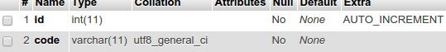

department
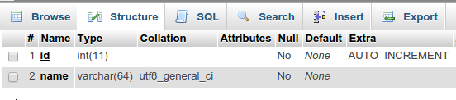
user

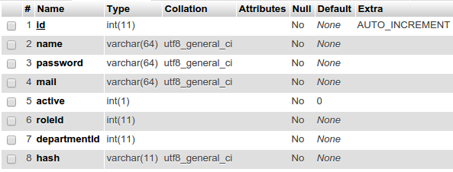
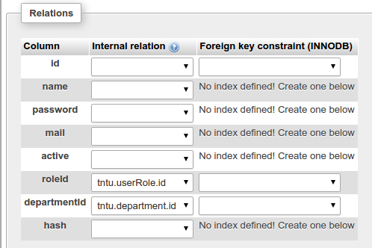

/home/victor/Desktop/diploma/server/node_modules/mysql/lib/protocol/Parser.js:82
throw err;
^
Error: ER_NO_SUCH_TABLE: Table 'tntu.userRoles' doesn't exist
at Query.Sequence._packetToError (/home/victor/Desktop/diploma/server/node_modules/mysql/lib/protocol/sequences/Sequence.js:48:14)
at Query.ErrorPacket (/home/victor/Desktop/diploma/server/node_modules/mysql/lib/protocol/sequences/Query.js:83:18)
at Protocol._parsePacket (/home/victor/Desktop/diploma/server/node_modules/mysql/lib/protocol/Protocol.js:274:23)
at Parser.write (/home/victor/Desktop/diploma/server/node_modules/mysql/lib/protocol/Parser.js:77:12)
at Protocol.write (/home/victor/Desktop/diploma/server/node_modules/mysql/lib/protocol/Protocol.js:39:16)
at Socket.<anonymous> (/home/victor/Desktop/diploma/server/node_modules/mysql/lib/Connection.js:96:28)
at Socket.EventEmitter.emit (events.js:95:17)
at Socket.<anonymous> (_stream_readable.js:746:14)
at Socket.EventEmitter.emit (events.js:92:17)
at emitReadable_ (_stream_readable.js:408:10)
--------------------
at Protocol._enqueue (/home/victor/Desktop/diploma/server/node_modules/mysql/lib/protocol/Protocol.js:135:48)
at Connection.query (/home/victor/Desktop/diploma/server/node_modules/mysql/lib/Connection.js:201:25)
at /home/victor/Desktop/diploma/server/app/server/base/connector.js:27:20
at tryCallTwo (/home/victor/Desktop/diploma/server/node_modules/promise/lib/core.js:45:5)
at doResolve (/home/victor/Desktop/diploma/server/node_modules/promise/lib/core.js:171:13)
at new Promise (/home/victor/Desktop/diploma/server/node_modules/promise/lib/core.js:65:3)
at dbQuery (/home/victor/Desktop/diploma/server/app/server/base/connector.js:25:12)

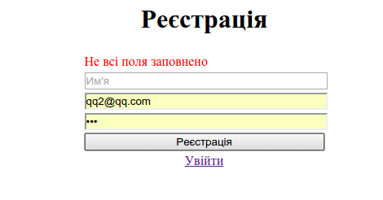

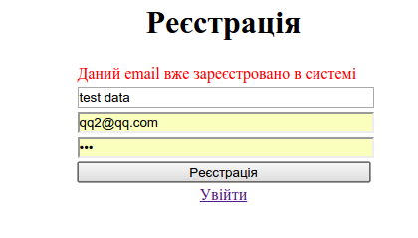

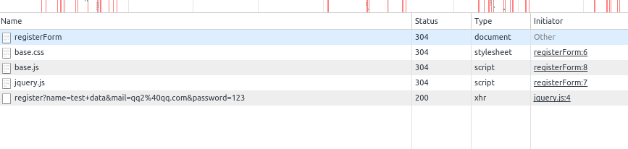
query: select id from user where LOWER(mail)=LOWER(?) limit 1 [ 'qq2@qq.com' ]
accepted rows [ { id: 20 } ]
error cached { success: false,
message: 'Даний email вже зареєстровано в системі' }

echo "# tntu" >> README.md
git init
git add README.md
git commit -m "first commit"
git remote add origin https://github.com/kozlov-victor/tntu.git
git push -u origin master

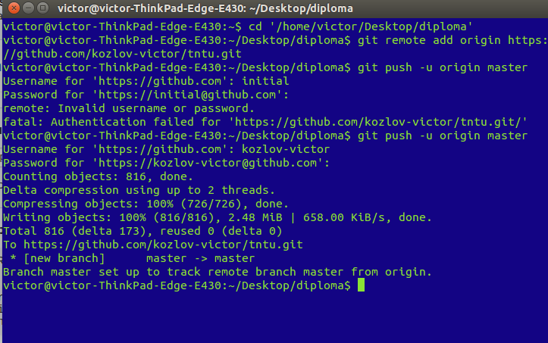
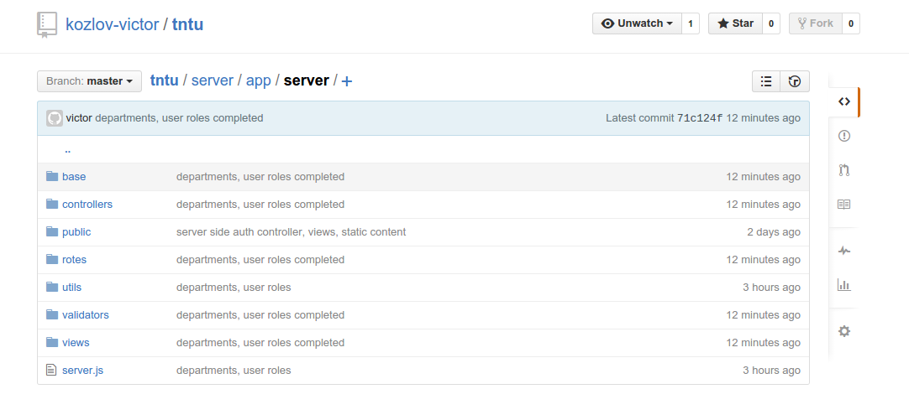

cars
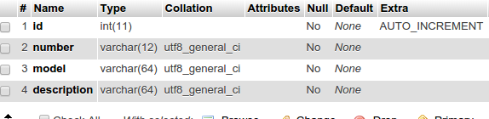

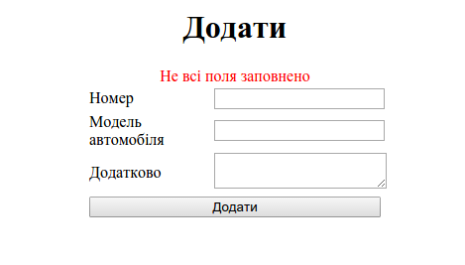

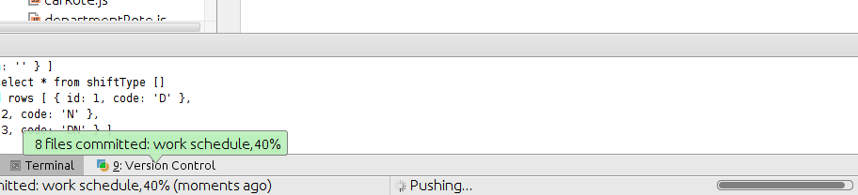
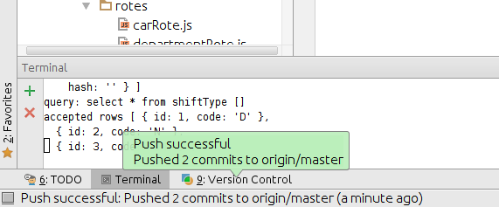


npm body parser
