Django With Docker

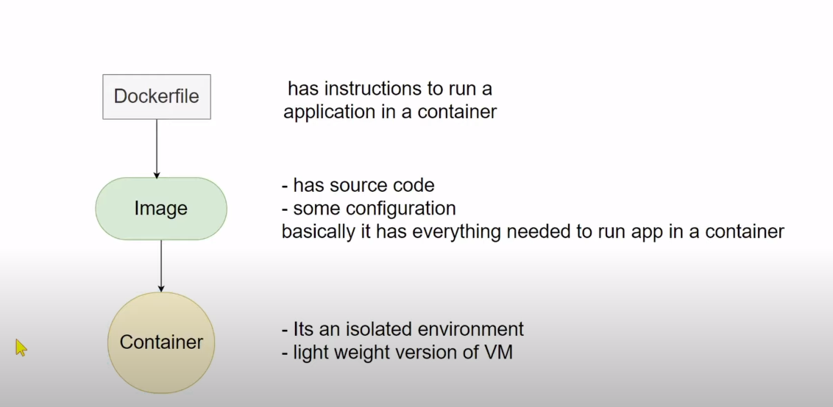

- Install Docker for Ubuntu :
https://docs.docker.com/engine/install/ubuntu/

- Note : For window you need to install/update WSL2 Linx kernal.

- Intall Docker Compose :
https://docs.docker.com/compose/install/

- sudo apt install docker-compose

- Intall Docker Engine :
https://docs.docker.com/engine/install/ubuntu/

- Install Docker Desktop :
https://docs.docker.com/desktop/linux/install/ubuntu/

- See all Docker-Images :
sudo docker image ls

- Delete Docker-Image forcely :
sudo docker image rm --force hello-world\

- Remove all images and container :
docker system prune -a

Start witht_project :

- Create file at root dir of project:
.dockerignore :
env/
2. Create at root dir and put below lines:
Dockerfile :

# base image
FROM python:3.8-slim-buster
# setup environment variable
ENV DockerHOME=/home/app/webapp

# set work directory
RUN mkdir -p $DockerHOME

# where your code lives
WORKDIR $DockerHOME

# set environment variables
ENV PYTHONDONTWRITEBYTECODE 1
ENV PYTHONUNBUFFERED 1

# install dependencies
RUN pip install --upgrade pip

# copy whole project to your docker home directory.
COPY . $DockerHOME
# run this command to install all dependencies
RUN pip install -r requirements.txt && python manage.py makemigrations && python manage.py migrate

# port where the Django app runs
EXPOSE 8000

# start server
CMD python manage.py runserver 0.0.0.0:8000

OR

# ---------------------------> Persional Docker Image Creation <-------------------------------
# base image
FROM python:3.8-slim-buster
# where your code lives
WORKDIR /app
# set environment variables
ENV PYTHONDONTWRITEBYTECODE 1
ENV PYTHONUNBUFFERED 1
# install dependencies
RUN pip install --upgrade pip
# copy whole project to your docker home directory.
ADD . .
# run this command to install all dependencies and db migrations.
RUN pip install -r requirements.txt && python manage.py makemigrations && python manage.py migrate
# port where the Django app runs
EXPOSE 8000
# start server
CMD python manage.py runserver 0.0.0.0:8000

- FROM python:3.8 : This installs a Python image into the Docker image. This is also the version of Python that will run the application in the container.
- ENV DockerHOME=/home/app/webapp: Here we declare the working directory and assign it to the variable name DockerHOME. This will be the root directory of the Django app in the container.
- RUN mkdir -p $DockerHOME: This creates the directory with the specified path assigned to the DockerHOME variable within the image.
- WORKDIR $DockerHOME: This explicitly tells Docker to set the provided directory as the location where the application will reside within the container.
- RUN pip install --upgrade pip: This updates the pip version that will be used to install the dependencies for the application.
- COPY . $DockerHOME: This copies every other necessary file and its respective contents into the app folder that is the root directory of the application within the container.
- RUN pip install -r requirements.txt: This command installs all the dependencies defined in the requirements.txt file into your application within the container.
- EXPOSE 8000: This command releases port 8000 within the container, where the Django app will run.
- CMD python manage.py runserver: This command starts the server and runs the application.

3. Build Docker Image use this command :
- docker build . -t image_name
4. Run Docker image :
- docker run -p 8000:8000 image_name

Running multiple containers with Docker Compose

- Take, for example, a web application with the following components:
- Web server container such as Nginx
- Application container that hosts the Django app
- Database container that hosts the production database, such as PostgreSQL
- A message container that hosts the message broker, such as RabbitMQ

docker-compose.yml :
# version: '3.7'
# services: # the different images that will be running as containers
# nginx: # service name
# # location of the dockerfile that defines the nginx image. The dockerfile will be used to spin up an image during the build stage.
# build: ./nginx
# # map the machine port 1339 to the container port 80. Any traffic from 1339 externally will be passed to port 80 of the NGINX container. You can access this container viea localhost:1339
# ports:
# - 1339:80
# # static storages provisioned since django does not handle static files in production
# # volumes:
# # - static_volume:/app/static
# # will only start if web is up and running
# depends_on:
# - web
# # restart service when it fails
# restart: "on-failure"
# web: # service name
# #build the image for the web service from the dockerfile in parent directory.
# build: .
# # command directive passes the parameters to the service and they will be executed by the service. In this example, these are django commands which will be executed in the container where django lives.
# command: sh -c "python manage.py makemigrations &&
# python manage.py migrate &&
# gunicorn test_project.wsgi:application --bind 0.0.0.0:${APP_PORT}"
# # map data and files from parent directory in host to microservice directory in docker container
# volumes:
# - .:/app
# - static_volume:/app/static
# # file where env variables are stored. Used as best practice so as not to expose secret keys
# env_file:
# - .env # name of the env file
# # name of the image
# image: docker_django
# # expose the port to other services defined here so that they can access this service via the exposed port. In the case of Django, this is 8000 by default
# expose:
# - ${APP_PORT} # retrieved from the .env file
# restart: "on-failure"
# # cannot start if db service is not up and running
# depends_on:
# - db

# db: # service name
# # image name of the postgres database. during build, this will be pulled from dockerhub and a container spun up from it.
# image: postgres:11-alpine
# volumes:
# - ./init.sql:/docker-entrypoint-initdb.d/init.sql
# - postgres_data:/var/lib/postgresql/data/
# # access credentials from the .env file
# environment:
# - POSTGRES_PASSWORD=${PASSWORD}
# - POSTGRES_DB=${NAME}
# - PGPORT=5432
# - POSTGRES_USER=${DB_USER}
# restart: "on-failure"
# volumes:
# postgres_data:
# static_volume:
version: '3.7'
services:
db:
image: postgres:11-alpine
volumes:
- ./data/db:/var/lib/postgresql/data
environment:
- POSTGRES_DB=test_db
- POSTGRES_USER=postgres
- POSTGRES_PASSWORD=1234
container_name: postgres_db
web:
build: .
command: python manage.py runserver 0.0.0.0:8000
image: django_image
volumes:
- .:/app
ports:
- "8000:8000"
environment:
- POSTGRES_NAME=postgres
- POSTGRES_USER=postgres
- POSTGRES_PASSWORD=postgres
container_name: django_container
depends_on:
- db

- Build the image :
sudo docker-compose build
- Run the Image :
sudo docker-compose up
- Check all containers :
docker-compose ps
- Delete the all containers :
docker-compose down

