Node Js

Basic Start

- npm init -y
- npm i express@5.0.0-beta.1
- npm i -D nodemon
- npm start

- package.json :

{
"name": "ch1",
"version": "1.0.0",
"main": "index.js",
"scripts": {
"start": "nodemon index"
},
"keywords": [],
"author": "",
"license": "ISC",
"description": "",
"dependencies": {
"express": "^5.0.0-beta.1"
},
"devDependencies": {
"nodemon": "^2.0.16"
}
}

- Index.js

const express = require('express')
const app = express()
const PORT = 3000

app.get('/',(req,res) => {
res.send("Shreeji")
})

app.listen(PORT,() => {
console.log(`Server is running on http://localhost:${PORT}`);
})

Express Application Generatore

Link : https://expressjs.com/en/resources/template-engines.html

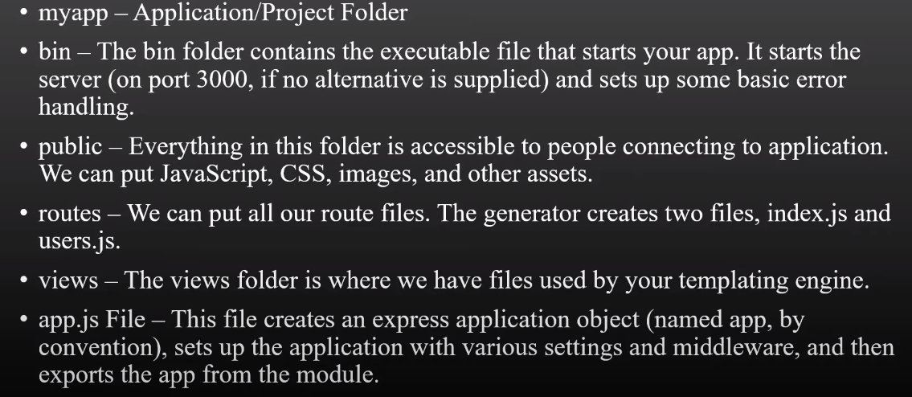

Create App :

- npx express-generator --view=ejs ch2
- cd ch2
- DEBUG=ch2:* npm start

Routing

Multipal Callback in routing :

// Multipal Callback
app.get('/',(req,res,next) => {
console.log("This is first callback!!");
next();
},(req,res) => {
console.log("This is second callback!!");
res.send("This is final result!!")
})

Multipal Callback in array :

// Multipal Callback In Array
cb1 = (req,res,next) => {
console.log("This is first callback!!");
next();
}
cb2 = (req,res,next) => {
console.log("This is second callback!!");
next();
}
cb3 = (req,res) => {
console.log("This is third callback!!");
res.send("This is final result!!")
}
app.get('/mul_arr',[cb1,cb2,cb3])

Chain routing callback :

app.route('/student')
.get((req,res) => {
res.send("This is get method in callback!!")
})
.post((req,res) => {
res.send("This is post method in callback!!")
})
.put((req,res) => {
res.send("This is put method in callback!!")
})

With all :

app.route('/student_all')
.all((req,res,next) => {
console.log("This is all callback method!!!")
next()
})
.get((req,res) => {
res.send("This is get method in callback!!")
})
.post((req,res) => {
res.send("This is post method in callback!!")
})
.put((req,res) => {
res.send("This is put method in callback!!")
})

Dynamic Routes :

routes/index.js :

var express = require('express');
var router = express.Router();

/* GET home page. */
router.get('/', function(req, res, next) {
res.render('index', { title: 'Express' });
});
module.exports = router;

app.js :

var express = require('express');
var app = express();
var indexRouter = require('./routes/index');
app.use('/', indexRouter);

