**In-Class Exercise - 6**

**FERPA**

**Kompliance Krew**

1. 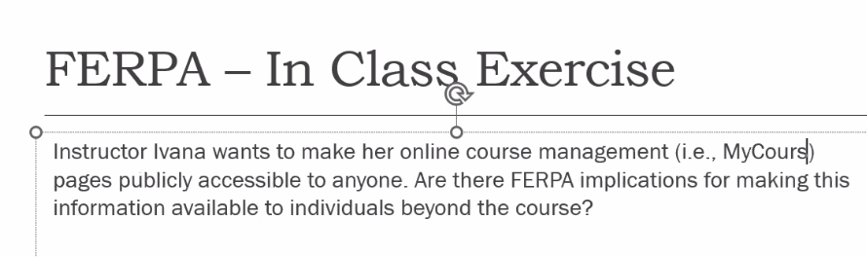

Answer: FERPA is created to protect the privacy of the student education records. Yes, there are some FERPA implications If the material includes student education records like grades, assignment details, and schedules. Sometimes, online portals may have the Email ID and phone number of a particular student as well which are considered as PII. Therefore it needs to be compliant with FERPA.

It won't be a violation of FERPA if the instructor acquired a written agreement or statement from the students whose information is at stake like PII or educational records. However, the instructor needs to be cautious in handling the data which may put harm on the student if leaked. She needs to make sure that data should never be disclosed to a person outside the course with proper authority.

2. 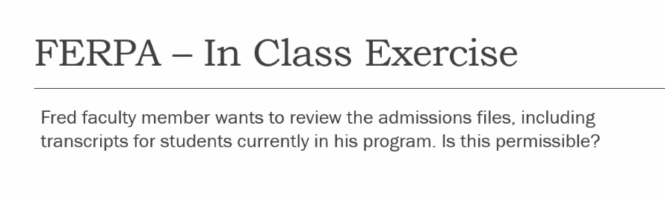

Answer: **Yes**, it is permissible for Fred, the faculty member who has a legit educational interest to access the admission files like transcripts of the students currently enrolled in the program.

According to FERPA, it is allowed for school officials to access the records of the students without their consent if they are going to take responsibility for professionally using that information and for the education institution. As long as Fred needs the information to support the student’s academic progress or fulfill his duties as an instructor or advisor, it is permissible. However, the information should only be used for educational purposes and kept confidential.

3. 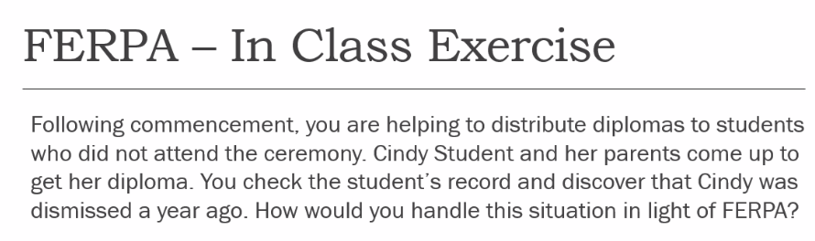

Answer: In light of FERPA, I should never disclose Cindy’s dismissal information in front of her parents without her consent which is against FERPA.

I will handle the situation in the following ways:

* Speak with Cindy directly in a professional way and have some politeness mentioning the exact situation to her that according to her record, she was dismissed a year ago and therefore we don’t have a diploma available for picking up.
* Without Cindy's written consent, don’t share her record and dismissal before their parents. Especially make sure that her parents know this or not because you may leak the information without her permission.
* After talking about the real situation with her, give her some advice that will help her to proceed with this matter like contacting the registrar's office for further information and the status of moving forward with the case that will guide and be beneficial for her life.

This ensures compliance with FERPA by protecting her privacy while addressing the situation.