Krushil Patel  
Arthur Hendela  
Website Development  
October 30, 2019

Project 1 - Sitemap

<https://go.gliffy.com/go/share/s5yqk68xlks7atbg7b1y>

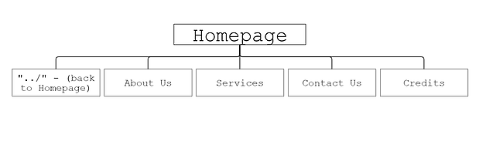

**“../” – (back to Homepage):**This is a tab in my navigation bar that would bring the user back to the homepage if they have navigated away.

**About Us:**I will have a page with the description of our work (an About us). This will introduce the concept of how the whole group came together.

**Services:**  
This tab within the navigation bar will direct the user to the services page. This is where I will describe the varying services my company provides such as installation, delivery, warranty, and recycling.

**Contact Us:**  
This tab is dedicated to the information needed to contact and locate our organization. This tab should provide a phone number, email, a P.O.Box address for inquiries, and address to visit our store site.

**Credits:**  
This tab will pay tribute to all the many different groups that gathered here at our organization to create our product. There’s a group of chemist, biologist, biochemist, and engineers. Each group will have a description of origin including each individuals’ education/work background.