1. What is software? What is software engineering?

Software:

Software refers to a set of instructions or programs that tell a computer how to perform specific tasks. It encompasses a wide range of computer programs, scripts, and applications, including operating systems, word processors, web browsers, games, and more. In essence, software serves as the interface between the hardware of a computer system and the user, enabling the execution of various functions and tasks.

Software Engineering:

Software engineering is a systematic and disciplined approach to the design, development, testing, and maintenance of software. It involves applying engineering principles to the entire software development process to ensure the production of high-quality, reliable, and efficient software systems. Software engineering encompasses a series of well-defined stages, such as requirements analysis, design, implementation, testing, deployment, and maintenance.

2. Explain types of software

**System Software:**

Operating Systems: Examples include Windows, macOS, Linux, and Android. These manage hardware resources and provide services for computer programs.

Device Drivers: Software that enables communication between the operating system and hardware devices like printers, graphics cards, and peripherals.

**Application Software:**

Productivity Software: Includes word processors (e.g., Microsoft Word), spreadsheets (e.g., Microsoft Excel), and presentation software (e.g., Microsoft PowerPoint).

Web Browsers: Programs like Google Chrome, Mozilla Firefox, and Safari used to access and interact with websites.

Multimedia Software: Examples include media players (e.g., VLC), graphic design tools (e.g., Adobe Photoshop), and video editors (e.g., Adobe Premiere).

Communication Software: Email clients (e.g., Microsoft Outlook), instant messaging apps (e.g., WhatsApp), and video conferencing tools (e.g., Zoom).

Entertainment Software: Video games, simulation software, and other forms of entertainment applications.

**Development Software:**

Integrated Development Environments (IDEs): Tools like Visual Studio, Eclipse, and IntelliJ IDEA that provide a comprehensive environment for software development.

Compilers and Interpreters: Convert high-level programming code into machine code or execute it directly without compilation.

**Security Software:**

Antivirus Software: Protects against and removes malicious software.

Firewalls: Monitor and control incoming and outgoing network traffic.

Encryption Software: Secures data by encoding it in a way that only authorized users can access.

3. What is SDLC? Explain each phase of SDLC

SDLC, which stands for Software Development Life Cycle, is a systematic process used by software developers to design, develop, test, and deploy software applications. The purpose of SDLC is to produce high-quality software that meets or exceeds customer expectations, is delivered on time and within budget, and can be maintained and updated easily.

**Requirements Gathering and Analysis:**

Objective: Understand and define the needs and expectations of the end-users and stakeholders.

Activities: Conduct interviews, surveys, and workshops to gather requirements. Analyze and document the gathered information to create a detailed specification.

**Planning:**

Objective: Define project scope, timeline, budget, resources, and risks.

Activities: Create a project plan, allocate resources, establish milestones, and identify potential risks. Develop a schedule and budget for the entire project.

**Design:**

Objective: Create a blueprint or plan for the software based on the gathered requirements.

Activities: Develop system architecture, design specifications, and user interface. This phase may involve creating high-level and low-level designs, specifying data structures, and defining algorithms.

**Implementation (Coding):**

Objective: Translate the design into actual code.

Activities: Write, test, and debug code according to the design specifications. This is the phase where the actual development of the software takes place.

**Testing:**

Objective: Ensure that the software meets the specified requirements and is free of defects.

Activities: Perform various levels of testing, including unit testing, integration testing, system testing, and acceptance testing. Identify and fix defects, and verify that the software works as intended.

Deployment (or Release):

Objective: Deploy the software to the production environment for end-users.

Activities: Develop deployment plans, release the software to end-users, and provide any necessary training and documentation. Monitor the performance and address any issues that may arise during deployment.

**Maintenance and Support:**

Objective: Address issues, update features, and provide ongoing support.

Activities: Fix bugs, make enhancements, and ensure the software remains compatible with new technologies. This phase can continue for the lifespan of the software.

4. What is DFD? Create a DFD diagram on Flipkart

A Data Flow Diagram (DFD) is a visual representation that shows how data flows within a system. It consists of processes, data stores, data flow, and external entities. DFDs are commonly used in systems engineering and software engineering to model the flow of data within a system.

**Customer**: The external entity representing the users of the Flipkart platform.

**Flipkart:** The main system or process that interacts with customers and manages various functions.

**Order Processing:** Handles customer orders, including order placement, order tracking, and order fulfillment.

**Inventory System:** Manages product inventory, updates stock levels, and provides information to the order processing system.

**Payment Processing:** Handles payment transactions, verifies payments, and communicates with financial systems.

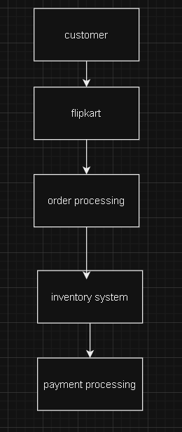

5. What is Flow chart? Create a flowchart to make addition of two numbers 6. What is Use case Diagram? Create a use-case on bill payment on paytm.

A flowchart is a diagram that represents a process, showing the steps involved and the flow of control between those steps. Here's a simple flowchart to illustrate the addition of two numbers:

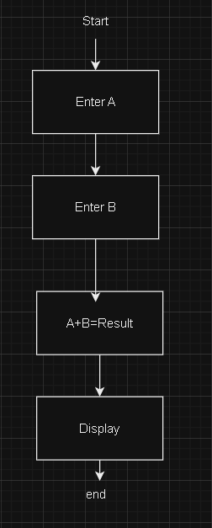

A Use Case Diagram is a visual representation that illustrates how a system interacts with external entities (actors) and the various use cases in which the system is involved. Here's a simplified Use Case Diagram for bill payment on Paytm:

