Milestone Report

Handwritten Answers to Milestone Questions:
(See attached photos and work in subsequent pages)

Specification (what do you think the purpose of this milestone is)
The purpose of this milestone was to create the grammar recognition portion of the parser and ensure that the tokens created by the lexical analyzer fit within the given grammar. This milestone also got me thinking about future milestones in how I want to deal with different scopes through doing the written assignments.

Processing (how did you go about solving the problem)
I started off by drawing out by left factoring and eliminating left recursion in the grammar productions to eliminate ambiguity and create a predictive LL(1) parser. After implementing the initial parser I then came up with several test cases to test both error and error free cases to ensure that the parser was working correctly

Testing Requirement (how did you test for correctness)
I primarily tested for correctness by creating multiple test files to test the various productions such as expr, stmts,, etc. and make sure I parsed the expected output.

Retrospective (what did you learn in this milestone)
From this milestone I learned how to construct a parser from tokens created by the lexical analyzer that would check if the tokens were legal in the given grammar. I also learned about restructuring grammars to make them predictive and eliminate left recursion.
Assignment 1:
What is the shortest length terminal word? Show its derivation. What is the next shortest? Show its/their derivation.

The shortest length terminal word is 0. Its derivation is S => expr => oper => constants => 1. The next shortest would be 12 and it has the same derivation.

Assignment 2:
Demonstrate a terminal word of length n=1, ..., 5 or show that it is impossible to have a word of that particular length.

n = 1: 1
n = 2: ( )
n = 3: ( 1 )
n = 4: ( - 2 )
n = 5: ( + 1 2 )

Assignment 3:
Outline how you could rewrite the parsing algorithm to a program that can generate the legal strings of any length.

One way of accomplishing this would be for length 1 produce a constant and length 2 produce () and lengths > 2 begin with the stmts production and continuously add one more constant/name each time using the exprlist production in the whilestmts production.

Below are three "files". Show the derivation of each file.

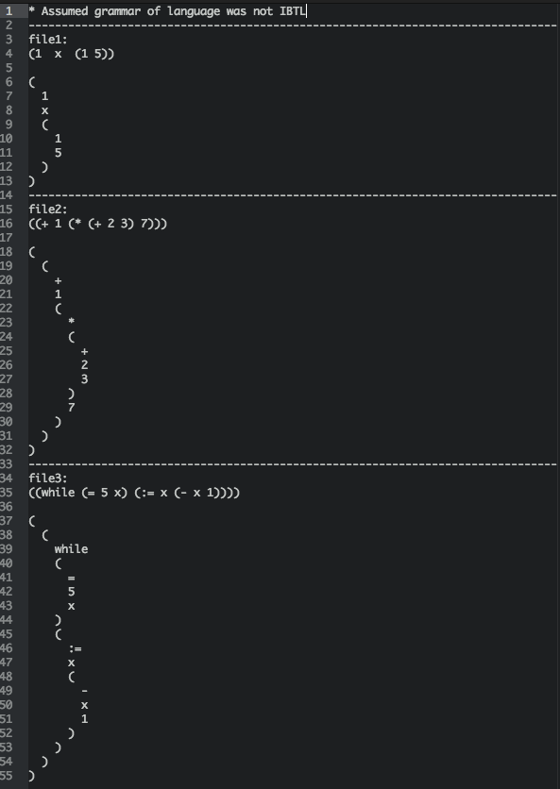

Take the grammar for the project and produce a production system that parses incoming tokens and builds a tree that represents the actual parse tree.

(See parser.py file in source code)

Use pseudo-code to convert the "S" production of the grammar to a program.

S -> (S'S'' | exprS''
S' -> ) | S)
S'' -> SS'' | epsilon

// S Production
if token == “(“:
print token
go down S’ production
then go down S’’ production
else if token is expr:
go down expr production
then go down S’’ production
else:
error

// S’ Production
if token == “)”:
print token
else if token == “(“ or token is expr:
go down S production
if next token == “)”:
print token
else:
error
else:
error

// S’’ Production
if token == “(“ or token is expr:
go down S production
then go down S’’ production

