_________________________________________
DESIGN AND IMPLEMENTATION OF AN ANALOG CLOSED LOOP CONTROL SYSTEM USING OPERATIONAL AMPLIFIERS
Prof. Pramod Kanjalkar, Kunal Pathak, Shreesh Mainde

Abstract
This project presents the design and implementation of an analog closed-loop control system using a proportional–integral–derivative (PID) controller built entirely with operational amplifiers. The system is designed to regulate a process variable analogous to liquid level by comparing it with a reference setpoint and minimizing the error through feedback control. A plant emulator is implemented using an op-amp integrator, while visual feedback is provided using LED comparator ladders. The project demonstrates fundamental control system concepts such as setpoint tracking, error correction, stability, and disturbance handling without the use of microcontrollers, making it suitable for understanding real-time analog control behavior.

Introduction
Control systems are widely used in engineering applications to maintain desired output conditions in the presence of internal and external disturbances. While modern control systems often rely on digital controllers and microprocessors, analog control systems remain important for understanding fundamental control principles and for applications requiring continuous real-time response.
This project focuses on implementing an analog PID controller using operational amplifiers to regulate a simulated plant. The system demonstrates how proportional, integral, and derivative actions affect system behavior and how feedback enables accurate tracking of a desired setpoint.

Motivation
The main challenge we faced in this project was identifying an idea that was both technically meaningful and within the scope of the subject. An initial idea based on a doorbell system was rejected due to syllabus limitations, which prompted us to rethink our approach and select a concept that aligned better with the course objectives.
We were already familiar with PID control through our experience with a line-following robot implemented using digital control. This motivated us to explore the same control concept using purely analog circuits. By implementing PID control with operational amplifiers, we were able to stay within the syllabus while gaining a deeper understanding of how proportional, integral, and derivative actions are realized in hardware.
This project was chosen to strengthen our practical understanding of control systems and operational amplifiers by observing real-time feedback, system response, and stability directly in an analog closed-loop system.

Survey of Related Circuits/ Relevant Document
Control of physical variables such as level, speed, position, and temperature is commonly achieved using feedback control systems. One of the most widely used control strategies is the proportional–integral–derivative (PID) controller. In modern applications, PID control is most often implemented digitally using microcontrollers or programmable logic controllers, where the control law is executed in software. Such implementations are widely discussed in introductory control systems textbooks and application notes.
Apart from digital implementations, PID controllers can also be realized using analog circuits. Classical analog control systems employ operational amplifiers to implement proportional, integral, and derivative actions using basic amplifier, integrator, differentiator, and summing configurations. These analog implementations are commonly used for educational purposes and for understanding real-time continuous control behavior without discrete sampling.
In simpler applications, level control is sometimes achieved using ON–OFF or comparator-based control, where the actuator is switched fully ON or OFF based on threshold levels. While such systems are easy to implement, they suffer from oscillations and lack fine control. This highlights the advantage of PID-based control, which provides smoother response, reduced steady-state error, and better disturbance rejection.

Proposed Block Diagram
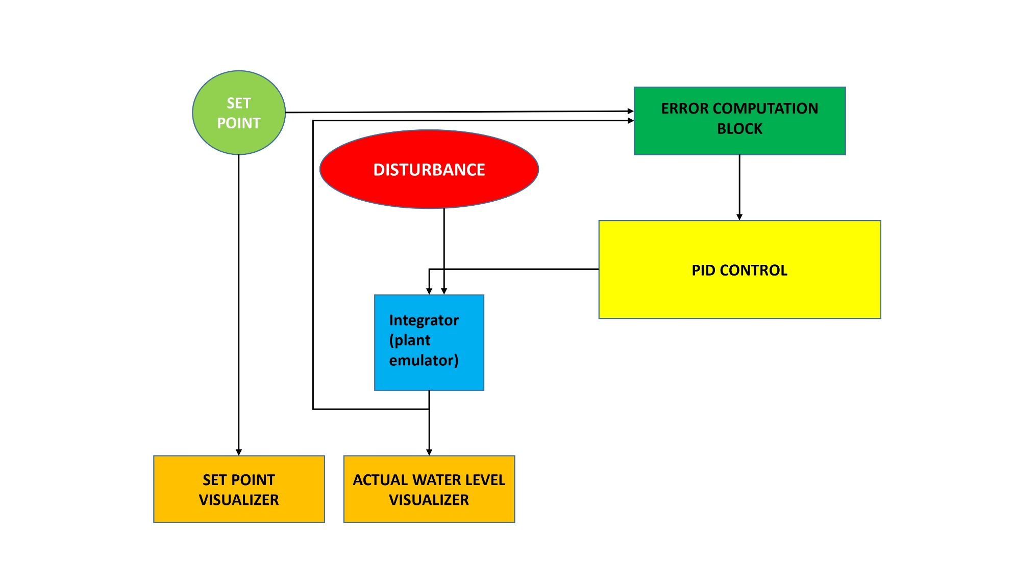

Short Explanation:
- Setpoint is compared with plant output
- Error is processed through P, I, and D blocks
- Outputs are summed and applied to the plant emulator
- Feedback ensures closed-loop control

Circuit Diagram
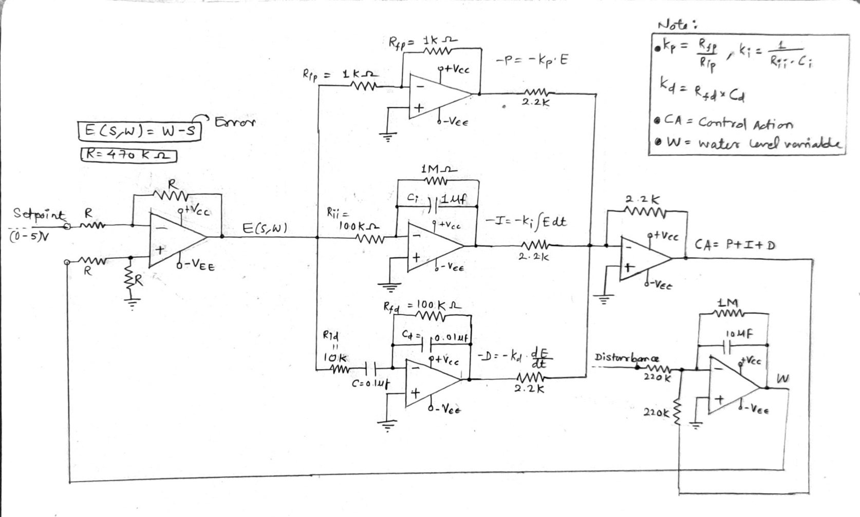
I. Control Loop

ERROR CALUCATION BLOCK

PID CONTROL

PLANT EMULATOR
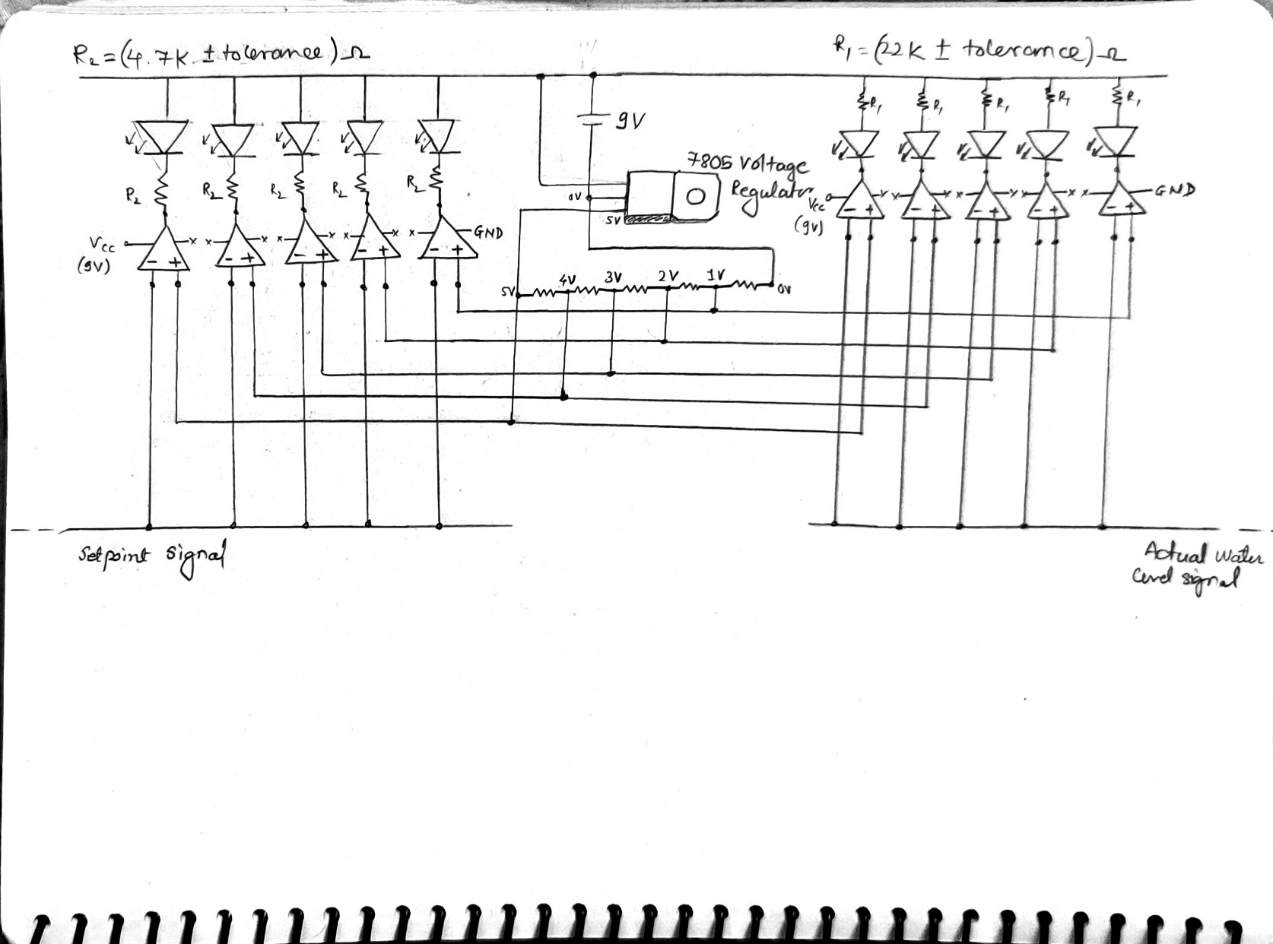
II. Visualizer Block
(W)
List of Components Used
- OP-AMP ICs ( LM324, LM358 )
- Resistors (1k, 2.2k, 10k, 4.7k, 22k, 100k, 220k, 470k, 1M)
- Capacitors (1uf, 10uf [electrolytic] | 0.1uf, 0.01uf [bipolar/ceramic])
- Potentiometers (10k)
- LEDs
- 9V batteries
- 7805 voltage regulators
- Jumpers , single strand wires

Description of the Diagram/ Working
The setpoint voltage is generated using a potentiometer and represents the desired level. The actual level is obtained from the output of the plant emulator. These two signals are fed into a differential amplifier to compute the error.
E(W, S) = W – S
Where E = error, S = setpoint and W = actual water level.
The error signal is processed through proportional, integral, and derivative blocks implemented using op-amp amplifiers, integrators, and differentiators. The outputs of these blocks are summed using an inverting summing amplifier to generate the control signal.
For the project, kp = 1, ki = 10, kd = 0.01 (calculation made using the formulas given in I. Control Loop image.
The plant emulator is implemented as an integrator that accumulates the control action over time, simulating the behavior of a physical system. The output is fed back to the error block, forming a closed-loop system. LED comparator ladders visually indicate both the setpoint and the controlled output level.

Observation/ Readings

Setpoint Voltage | Disturbance | Emulator Output
0.53V | 0V | 0.52V
2.02V | 0V | 1.99V
3.28V | 0V | 3.23V
3.18V | 0V | 3.14V
3.22V | 0.71V | 3.11V
1.10V | 0.02V | 1.09V

Steady State Error Observed
Observed values:
- At low/mid setpoints → error ≈ 0–0.1 V
- Near max setpoint (≈5 V) → error ≈ 0.19 V
- With disturbance → steady-state error increases further

Photograph(s) of the Project
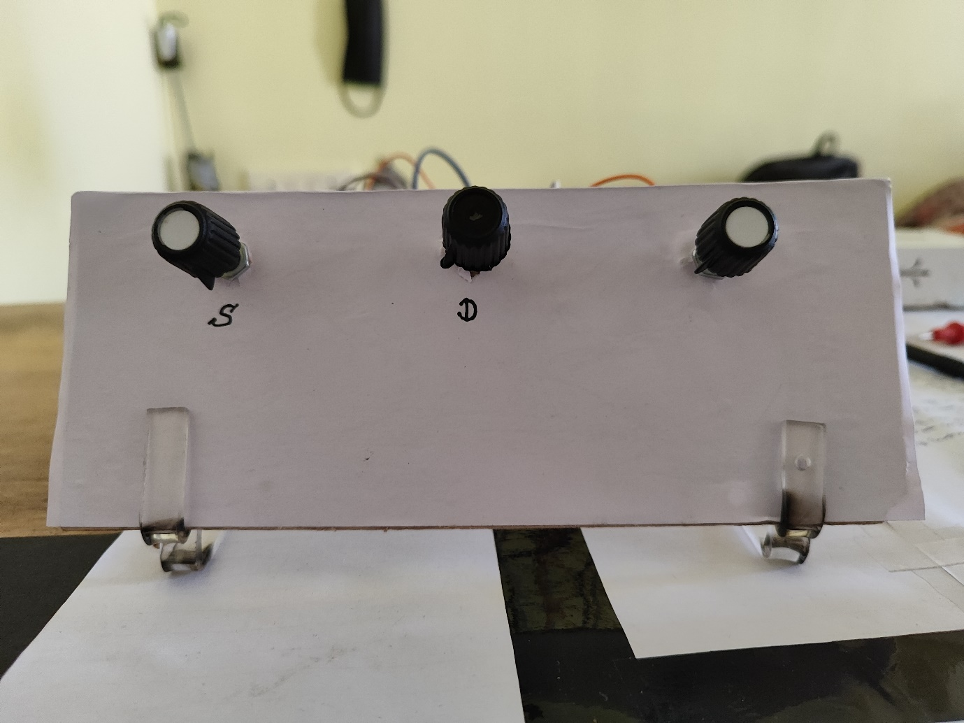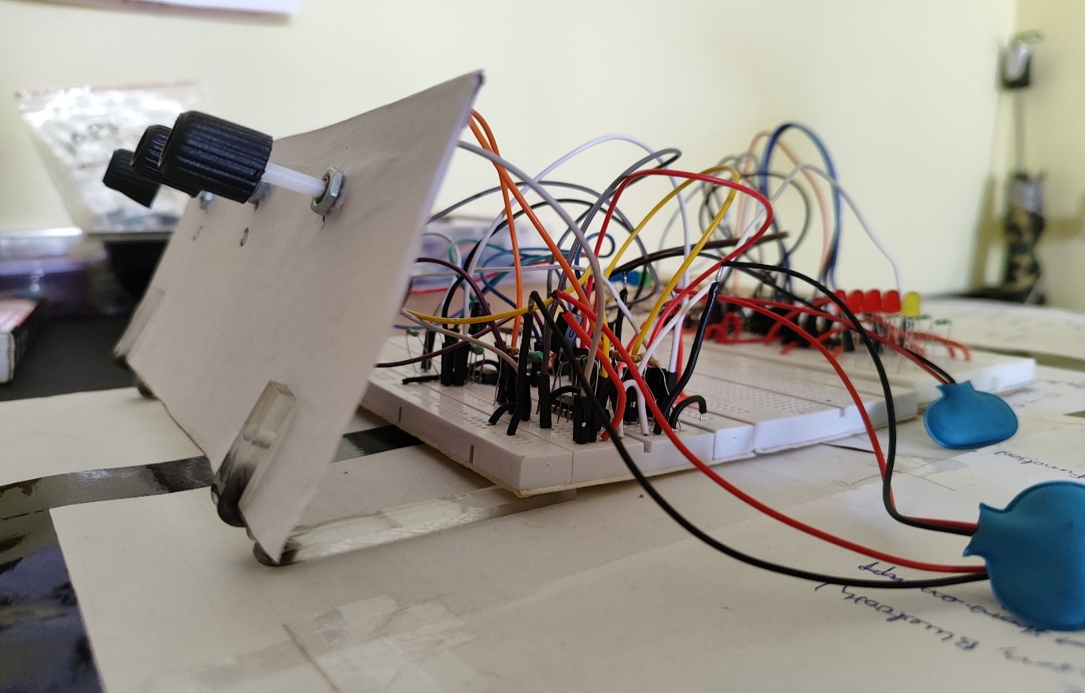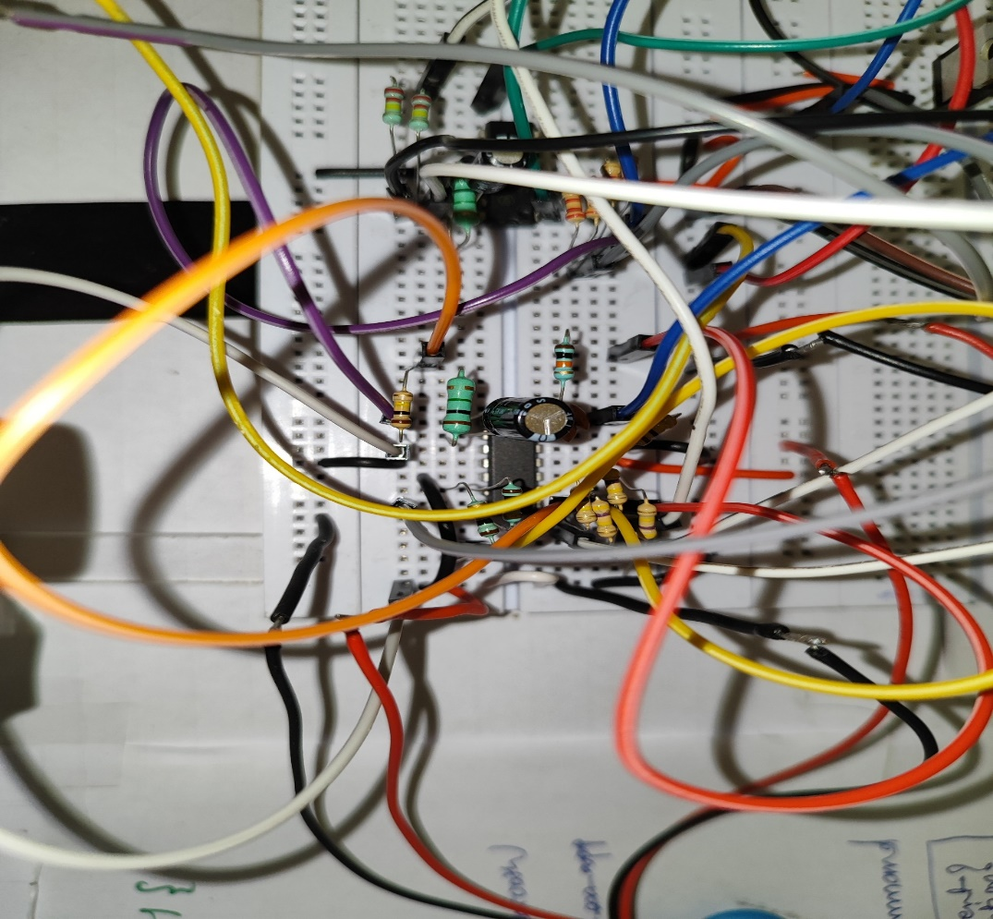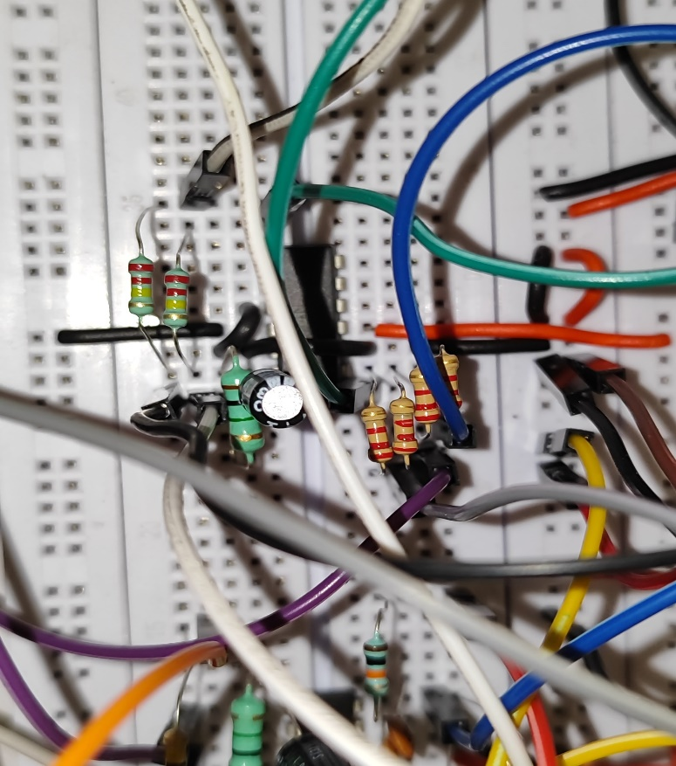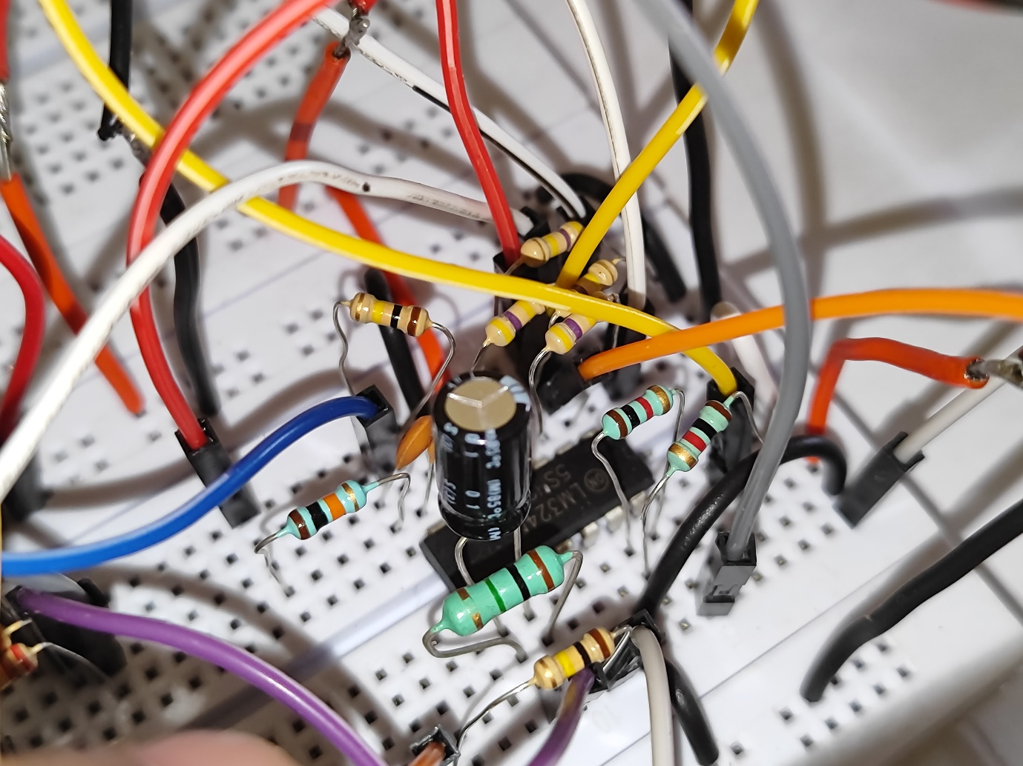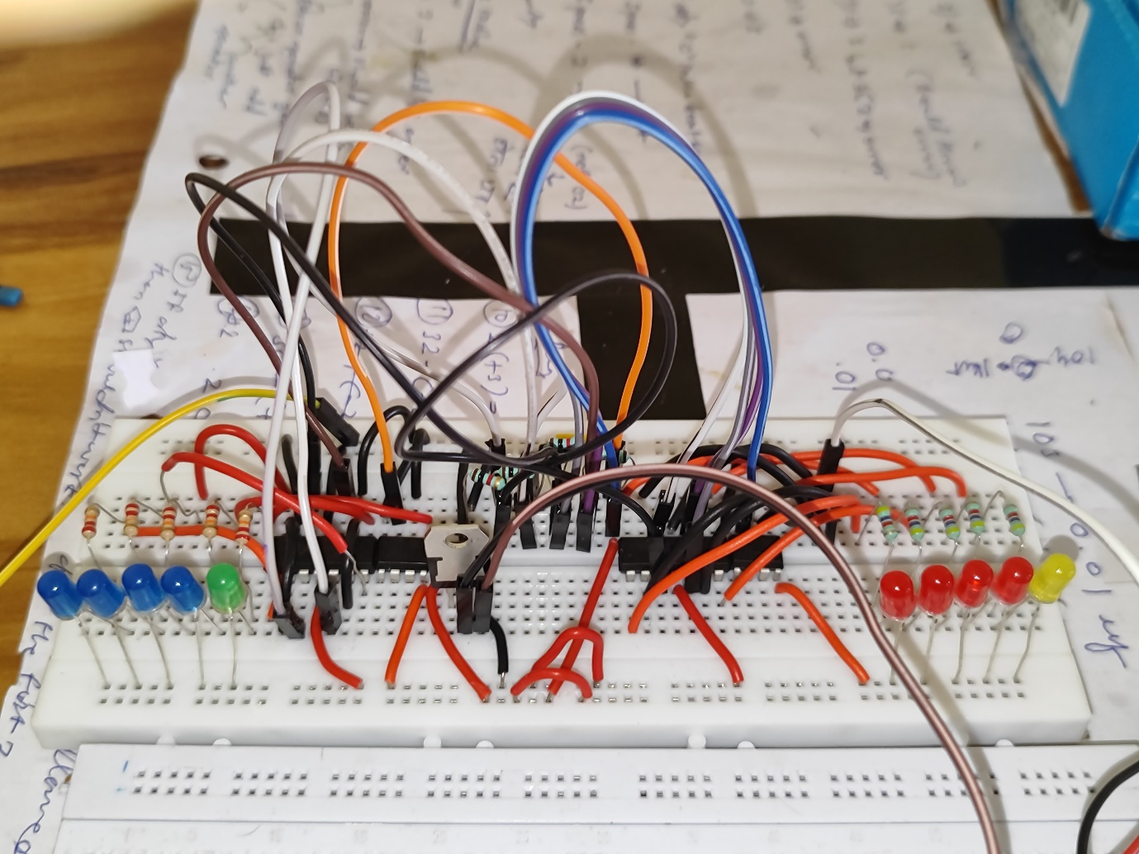
Advantages
- Uses only syllabus-level analog components
- Real-time response without microcontrollers
- Demonstrates fundamental control concepts clearly
- Easy to visualize using LED displays
- Good educational value
Limitations
- Analog components are sensitive to noise and drift
- Precise tuning is difficult compared to digital systems
- Plant is an emulator, not a real physical tank
- Component tolerances affect performance
- Low and discrete resolution of our led comparator ladder visualizers.
- The steady-state error observed at higher setpoints and under disturbance arises due to practical limitations of the analog controller, including finite integral gain and op-amp non-idealities. This error is not visually apparent in the LED display because of its discrete resolution and was observed using multi-meter measurements.

Applications
Level control systems
- Position and speed control of motors
- Servo control systems
- Industrial automation training
- Control systems education laboratories
Conclusion
The project successfully demonstrates an analog closed-loop PID control system using operational amplifiers. The system effectively tracks the setpoint, minimizes error through feedback, and responds to disturbances. This project provides valuable insight into control system behavior, tuning, and stability while reinforcing core electronics and control theory concepts.

References

- Ogata, K., Modern Control Engineering, Prentice Hall
- Op-Amp related online tutorials

